Mark

Team name: | A5
Homework number: | HOMEWORK 7
Due date: | 16/10/2023
Contribution | NO | Partial | Full
Luca Daidone |  |  | x
Leonardo Ritter |  |  | x
Luca Cordaro |  |  | x
Lorenzo Strechelli |  |  | x
Ignazio Neto Dell'Acqua |  |  | x
Notes:

Project name | LED Matrix with SPI
Not done | Partially done  (major problems) | Partially done  (minor problems) | Completed
 |  |  | x
Explanation:
We successfully completed the homework.

Part a) Transmit a letter to the LED matrix using SPI and a timer interrupt:
The idea is to send through SPI the informations needed to update the leds matrix, i.e. we send a new column every 4 ms and we enable and disable the shift registers in order to pass the data from the first shift register to the second one.

CubeIDE Settings:
- First we enable the pin PA5 for the SPI clock, the pin PA7 for the SPI MOSI and the pin PB6 for the RCLK, which toggles the storage registers. The MISO pin is not needed (since we only need to send data to the slave), as well as the slave select, since shift registers are always enabled.
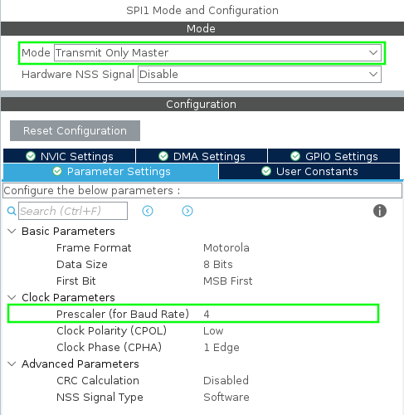
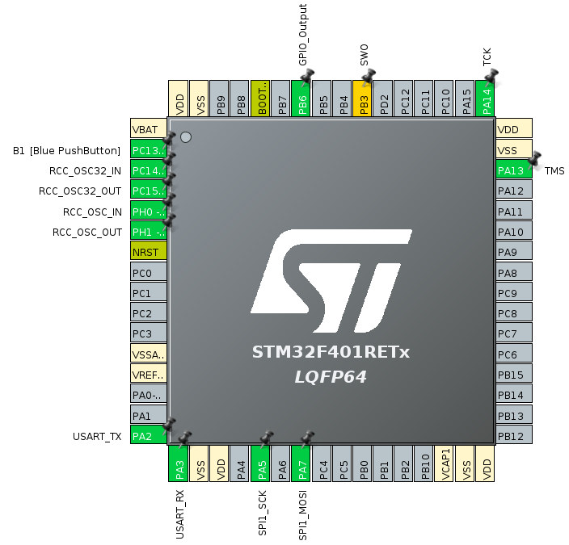

- In the SPI1 Mode and Configuration we set the mode Transmit Only Master and we set the Prescaler to 4.
- We set a timer which fills its ARR in 4 ms and we set the global interrupt of the timer.

Code:
We declared a uint8_t vector containing the coordinates of the matrix as follows: the first two elements tell the shift registers how many leds turn on and for which column (the first in this case), the third and the fourth element tell the shift registers how many leds turn on and for which column (the second in this case) and so on. Then we declared a variable that stores the index of the vector.

Regarding the core of the code, we have started the timer in interrupt mode with HAL_TIM_Base_Start_IT() function and thanks to HAL_TIM_Period_ElapsedCallback() function, every time the timer ARR is filled, the following code is execute. First of all there is a check that the function called by the timer we have set, then the RCLK pin is set LOW, so that on the rising edge the new data is passed from the shift registers to the storage registers. The row and column informations are sent through SPI (thanks to HAL_SPI_Transmit() function), so all the new data is placed in the shift registers. The RCLK pin is set HIGH to pass the data to the output as described. Eventually the index variable is updated (with +2, since though SPI we transmit two bytes), and afterwards we reset the index if the last one was reached.

Part b)

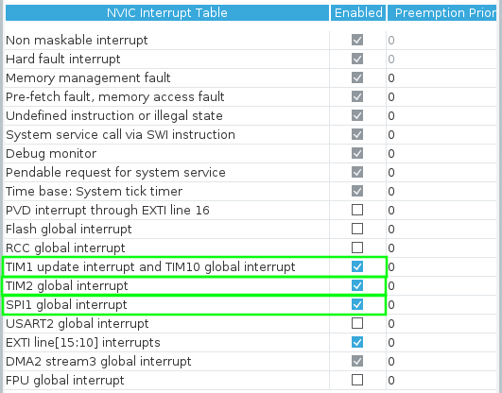
CubeIDE Settings:
We set the pins as before, but then we also set the SPI in order to work with DMA and we configured another timer in order to fill its ARR in a little more than 1 s

Code:
We declared the same variables as before and then we added a char vector (“Word”) (which contains the equivalent ASCII character we are going to display with the led matrix), an int variable (“index_word”) (which helps to keep track of the character that is going to be displayed), a vector that contains informations about a second new character and a uint8_t pointer, which points to one of the vectors, thus avoiding the copy of the entire vector (doing so we spare same time and a vector).
The interrupt service routine of timer 10 is the same as the previous point, except for the SPI function (this time we used HAL_SPI_Transmit_DMA() function) and the fact that we have to wait for its completion before triggering the rising edge. Indeed the HAL function we use this time is non-blocking, so we have to wait that the communication ended before moving the data from the shift registers to the storage registers. This is done through the rising edge in the HAL_SPI_TxCpltCallback().
For what concerns the ISR of the timer 2, we simply used a switch-case structure that associates the uint8_t pointer to the uint8_t vector corresponding to the character stored in the position of the char vector we are looking at. The position of this char vector is changed every time the ISR is called by timer 2.

Problems encountered:

Professor comments:

Althoug if in this first point it is not visible, the even elements are always the same, so the column turn-on order does not change.

