

FUEL-CELL GRADE HYDROGEN PRODUCTION

GROUP 4 – VOLUME 2

|  |  |  |
| --- | --- | --- |
| Ignas Pilvinis | S1452897 | IP |

Contents

1. Introduction 3

2. Aims and Design Basis 3

Aim 3

Design Basis 3

Catalyst 3

Thermodynamics (Process side) 4

Kinetics 4

3. Process flowsheet 5

4. Design Method 6

Design Method Flowchart 6

Preliminary Design Factors 6

Preliminary choice of operating conditions 6

Coke fouling 1

Standard reformer tubes 1

System of equations governing the reactor tubes 1

5. Mass Balance 3

6. Energy Balance 3

7. Startup and Shutdown 3

8. Sensitivity Analysis 3

9. Critical Review 3

10. Nomenclature 4

11. References 5

12. Appendices 5

# Introduction

The steam methane reformer is one of the main critical equipment in the hydrogen production process, responsible for most of hydrogen produced. Since this unit operation is one of the first ones in the hydrogen production unit operation chain, it is crucial to seek the safest, most efficient and economical design.

Overall, steam reforming is a highly endothermic process, requiring high temperature heat source both for reaction equilibrium and sufficient energy supply.

The steam reformer is vertical catalytic tubular reactor, supported in a rectangular insulated high temperature furnace.

# Aims and Design Basis

## Aim

Aim of this report is to provide a design for a reactor capable of producing 66,340.8 metric tonnes of Hydrogen per year.

## Design Basis

Design specifications from Volume I hydrogen plant are shown as follow:

* Operational time: 8000 hours per year, allowing a month of downtime and maintenance
* Ethane and higher hydrocarbons have been completely converted in the pre-reformer and are no longer in the process
* The feed is properly pre-treated to rid of poisoning like sulphur and arsenic, preventing catalyst deactivation that would require frequent maintenance
* Reactor capacity of 66,340.8 metric tonnes per year
* Conversion of 97.5% with regards to methane
* Feed coming from the Pre-reformer is consistent with Volume I and consists of the following:

|  |  |  |
| --- | --- | --- |
| **Component** | **Molar flowrate [kmol/h]** | **Molar fraction** |
| **Methane** | 1292.0 | 0.1804 |
| **Water** | 5350.4 | 0.7472 |
| **Carbon Monoxide** | 149.6 | 0.0209 |
| **Hydrogen** | 367.20 | 0.0513 |
| **Carbon Dioxide** | 0.0 | 0.0000 |

## Catalyst

Catalyst used in steam reforming can be a range of metal catalysts i.e. rhodium, ruthenium, nickel, platinum, palladium etc. Although some precious metals are considerably more active per unit weight than nickel, it is much cheaper and efficient enough to use nickel-based catalysts in steam reforming [CATALYST HANDBOOK], hence it has become the standard base metal for the catalyst used in industry.

Main objectives of choice of catalyst are maximising cost per activity and acceptable pressure drop.

Catalyst used in this design is the widely used and investigated[Rajesh et al] nickel catalyst supported on MgAl2O4 magnesium spinel.

Catalyst takes form of Raschig rings and its properties are listed as follows [RAJESH ET AL]:

|  |  |  |  |
| --- | --- | --- | --- |
| Symbol | Property | Value | Units |
| ε | Void fraction | 0.605 | - |
| ρc | Catalyst density | 2355.2 | kg/m­3 |
| ρb | Bed density | 1362.0 | kg/m­3 |
|  | Dimensions | 16x6x16 | mm |
| Dp | Equivalent diameter | 17.41 | mm |

## Thermodynamics (Process side)

The compounds assumed in this design system are Methane, Water, Carbon monoxide, Hydrogen, Carbon dioxide. Thermodynamic properties for these components are calculated using Shomate’s equation using different equations with following parameters:

|  |  |  |  |  |  |
| --- | --- | --- | --- | --- | --- |
|  | **CH4** | **H2O** | **CO** | **H2** | **CO2** |
| **Range, K** | **298 - 1300** | **500 - 1700** | **298 - 1300** | **298 - 1000** | **298 - 1200** |
| A | -0.703029 | 30.092 | 25.56759 | 33.066178 | 24.99735 |
| B | 108.4773 | 6.832514 | 6.09613 | -11.363417 | 55.18696 |
| C | -42.52157 | 6.793435 | 4.054656 | 11.432816 | -33.69137 |
| D | 5.862788 | -2.53448 | -2.671301 | -2.772874 | 7.948387 |
| E | 0.678565 | 0.082139 | 0.131021 | -0.158558 | -0.136638 |
| F | -76.84376 | -250.881 | -118.0089 | -9.980797 | -403.6075 |
| G | 158.7163 | 223.3967 | 227.3665 | 172.707974 | 228.2431 |
| H | -74.8731 | -241.8264 | -110.5271 | 0 | -393.5224 |

$$t = T(Kelvin)/1000;$$

$$Cp,gas = A + B*t + C*t2 + D*t3 + E/t2;$$

$$H° - H°298.15= A*t + B*t2/2 + C*t3/3 + D*t4/4 - E/t + F - H$$

$$S° = A*ln(t) + B*t + C*t2/2 + D*t3/3 - E/(2*t2) + G$$

## Kinetics

This design assumes the following reversible reactions are taking place simultaneously inside the tubes of the reformer, first proposed by Xu and Fermont[intristic kinetics]:

$$\begin{aligned}CH_{4}+H_{2}O ↔CO+{3H}_{2} ∆H_{R}^{298}=-205.7 kJ/mol\#(1)\end{aligned}$$

$$\begin{aligned}CO+H_{2}O ↔CO_{2}+H_{2} ∆H_{R}^{298}=41.6 kJ/mol\#(2)\end{aligned}$$

$$\begin{aligned}CH_{4}+{2H}_{2}O ↔CO_{2}+{4H}_{2} ∆H_{R}^{298}=-164.1 kJ/mol\#(3)\end{aligned}$$

Note that equation (3) is not an overall combination of equations (1) and (2).

These chemical reactions follow the rate laws proposed by Xu and Froment[reference]:

$$\begin{aligned}r_{1}^{'}={\frac{k_{1}}{p_{H_{2}}^{2.5}}\left(p_{CH_{4}}p_{H_{2}O}-\frac{p_{H_{2}}^{3}p_{CO}}{K_{1}}\right)}/{{\left(DEN\right)}^{2}} \#(4\end{aligned})$$

$$\begin{aligned}r_{2}^{'}={\frac{k_{2}}{p_{H_{2}}}\left(p_{CO}p_{H_{2}O}-\frac{p_{H_{2}}p_{CO_{2}}}{K_{2}}\right)}/{{\left(DEN\right)}^{2}} \#(5\end{aligned})$$

$$\begin{aligned}r_{3}^{'}={\frac{k_{3}}{p_{H_{2}}^{3.5}}\left(p_{CH_{4}}p_{H_{2}O}^{2}-\frac{p_{H_{2}}^{4}p_{CO_{2}}}{K_{3}}\right)}/{{\left(DEN\right)}^{2}} \#(6\end{aligned})$$

$$\begin{aligned}DEN= 1+K_{CO}p_{CO}+ K_{H_{2}}p_{H_{2}}+ K_{CH_{4}}p_{CH_{4}}+ \frac{K_{H_{2}O}p_{H_{2}O}}{p_{H_{2}}} \#(7)\end{aligned}$$

The **reaction rate coefficients** are calculated by the standard expression:

$$\begin{aligned}k_{i}=A_{i}e^{\frac{-E_{a,i}}{RT}} \#(8)\end{aligned}$$

With i indicating reaction number and temperature, T in Kelvin. **Adsorption constants** are calculated by a correlation:

$$\begin{aligned}K_{j}=A_{j}e^{\frac{B_{j}}{T}} \#(9)\end{aligned}$$

With j indicating adsorbing component and temperature, T in Kelvin.

With the following constants:

|  |  |  |  |  |  |  |  |
| --- | --- | --- | --- | --- | --- | --- | --- |
| RXN | Ai | | Ea,I [J/mol] | | Units | | |
| 1 | 4.22*1015 | | 240100 | | kmol bar0.5/ (kgcat h) | | |
| 2 | 1.95*106 | | 67130 | | kmol / (kgcat h) | | |
| 3 | 1.02*1015 | | 243900 | | kmol bar0.5/ (kgcat h) | | |
| Component | | Aj | | Bj | | Units |
| CH4 | | 6.65*10-4 | | 38280 | | bar-1 |
| H2O | | 6.12*10-9 | | 82900 | | - |
| CO | | 8.23*10-5 | | 70650 | | bar-1 |
| H2 | | 1.77*105 | | -88680 | | bar-1 |

Note that in this rate law model, CO2 does not have an adsorption coefficient because it is assumed it does not adsorb during the reaction.

For accuracy, instead of using correlations for **reaction equilibrium constants**, they are derived from thermodynamic principles.

$$\begin{aligned}K_{i}=e^{\frac{-∆G_{i}}{RT}} \#(10)\end{aligned}$$

With Gibbs free energy as a function of enthalpy, entropy and temperature, with delta denoting the difference between products and reactants:

$$\begin{aligned}∆G= ∆H-T∆S \#(11)\end{aligned}$$

All required thermodynamic properties for this equation are calculated via Shomate’s equation, as discussed in the thermodynamics section.

# Process flowsheet

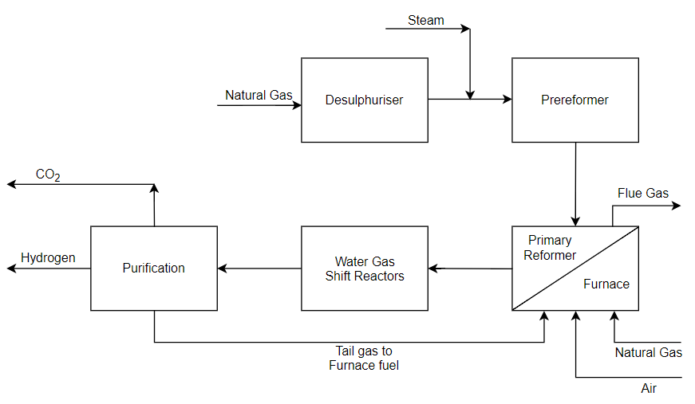

Figure IGAaF illustrates this design unit’s location in the overall process. Pre-treatment of feed in the desulphuriser, minimizes the sulphur content in the feed, making it negligible in the calculations and prolonging the catalyst life. As mentioned before, the pre-reformer is assumed to completely convert to hydrogen and carbon monoxide (included in feed specification)

# Design Method

## Design Method Flowchart

The following flowchart depicts the design process of the primary reformer and shortcut design of the furnace in which it is operated.

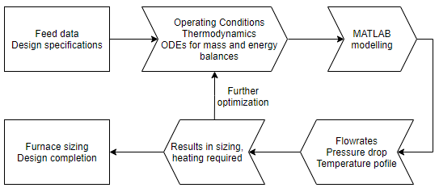

To summarize the design process, using feed data, operating conditions and design specifications, ODEs for mass and energy balances are solved using MATLAB. The algorithm produces reactor sizing specification, component flowrate profiles, temperature and pressure along the tubes and energy consumption. Based on the results the operating conditions can be optimized to provide more efficiency

## Preliminary Design Factors

To model the reactor, we first must acquire data on the reactor process. To get bounds of operating conditions, a preliminary analysis is preformed based on the equilibrium of the reactions taking place in the tubes.

The main reforming reaction XXX is a reversible reaction, which is highly endothermic. At high temperatures the equilibrium will be favoured towards the products. The reaction is non-equimolar, with more moles forming in the products, meaning that high pressure would push the equilibrium towards the reactants.

The second reaction XXX is the water gas shift reaction, that converts carbon monoxide product from the first reaction to additional hydrogen. Unlike the first reaction it is exothermic and for high conversion favours lower temperatures. Since it is equimolar pressure does not influence the equilibrium of this reaction.

The third reaction XXX favours the same conditions as the first reaction XXX. The reactions’ favourable conditions are summarized in Table **ASkfjsalf**:

|  |  |  |
| --- | --- | --- |
| **Reaction** | **Temperature** | **Pressure** |
| Reforming #1 | High | Low |
| Water gas shift | Low | No impact |
| Reforming #2 | High | Low |

## Preliminary choice of operating conditions

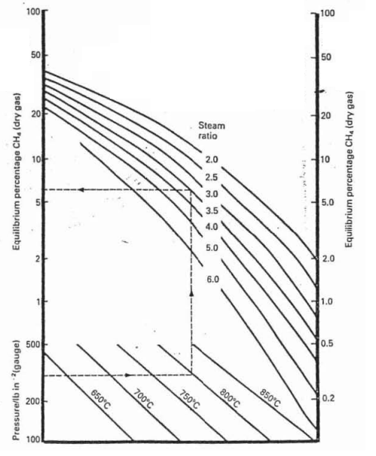

To further illustrate this figure **xxsdfa** shows equilibrium composition of methane as a function of pressure, temperature and steam to methane ratio. This agrees with favoured conditions discussed before. To meet our design specifications, the following preliminary bounds are set. For pressure, although it favours lower, this reactor is in chain of other unit operations, therefore it is constrained by them as well. For that reason, operating pressure range is to be 22 bar or higher.

By equilibrium data from the figure fasfa, the temperature range for required conversion is somewhere from 800-900 °C, however this does not consider reaction kinetics and it might take higher temperatures to push the reaction to required extent, therefore a higher range will be considered as well.

In this design the steam to methane ratio in the feed is already specified, therefore it is a parameter that if wanted can be increased by additional steam injection, however it should be noted that high flowrates lead to bigger dimensions of the reactor.

## Coke fouling

In the reformer methane can thermally crack into elemental carbon and hydrogen at high temperatures. The carbon formed can foul catalyst and deactivate it. It is important to avoid this at the reactor inlet, where the concentration of methane is the highest. To keep this fouling to a minimum temperature at the inlet should be considered in the range of 450-550 °C.

## Standard reformer tubes

Following considerations were made when picking tube dimensions:

* Tube length is preferred over the number of tubes, because number of tubes can complicate inlet and outlet manifolds.
* Maximum tube length is determined by maximum allowable pressure drop
* As the reaction rate in this type of reactor is limited by temperature, smaller tube diameter grants better heat transfer and therefore better conversion

Bounds for tube dimensions were set to be 9-15 meters in length and 7.64 to 10.16 cm in diameter with 1.905 cm wall thickness. These were based on existing designs and industry sizing standards.

## System of equations governing the reactor tubes

Algorithm for solving the non-isothermal non-isobaric multiple reaction system is solved in the following steps, each being a function of consecutive one:

1. Reactions

As listed in the design basis these are the reaction numbered 1 to 3 that take place in the catalyst tubes:

$$\begin{aligned}CH_{4}+H_{2}O ↔CO+{3H}_{2} ∆H_{R}^{298}=-205.7 kJ/mol\#(R1)\end{aligned}$$

$$\begin{aligned}CO+H_{2}O ↔CO_{2}+H_{2} ∆H_{R}^{298}=41.6 kJ/mol\#(R2)\end{aligned}$$

$$\begin{aligned}CH_{4}+{2H}_{2}O ↔CO_{2}+{4H}_{2} ∆H_{R}^{298}=-164.1 kJ/mol\#(R3)\end{aligned}$$

1. Mole Balance

For any component i in the reactor the mole balance is expressed in this differential form (please note that all units are shown in the design basis section):

$$\frac{{dF}_{j}}{dW}=r_{j}^{'}$$

1. Net Rate Laws

Net rate laws for each component depend on stoichiometric coefficients in the reactions, for example, in this case:

$$r_{CH4}^{'}=-r_{1}^{'}+r_{3}^{'}$$

With reaction rates being functions of temperature and partial pressures of components

1. Stoichiometry

With Raoult’s Law, partial pressures are given by this expression:

$$p_{j}=\frac{F_{j}}{F_{T}}P$$

1. Pressure drop

Pressure drop ordinary differential equation is Ergun’s adapted in terms of catalyst mass to fit with reaction rate units.

$$\frac{dP}{dW}= \frac{-\frac{G}{ρ_{0}D_{p}}\left(\frac{1-ε}{ϵ^{3}}\right)\left[\frac{150\left(1-ϵ\right)μ}{D_{p}}+1.75G\right]}{A_{c}\left(1-ϵ\right)ρ_{c}}\frac{P_{0}}{P}\frac{T}{T_{0}}\frac{F_{T}}{F_{T0}}$$

Note that G is the mass flux, and is a function of tube data, therefore the number of tubes and tube inner diameter is predefined, before solving the system of equations.

1. Energy balance

Temperature profiles in the reactor tubes and of the reactor wall

$$\frac{dT}{dW}=\frac{\frac{Ua}{ρ_{b}}\left(T_{w}-T\right)+\sum{(-r_{i}^{'})\left(H_{RX,i}\right)}}{\sum{C_{p,i}F_{i}}}$$

$$\frac{dT_{w}}{dW}=\frac{\frac{σa}{ρ_{b}}\left({T_{f}}^{4}-{T_{w}}^{4}\right)-\frac{Ua}{ρ_{b}}\left(T_{w}-T\right)}{\sum{C_{p,i}F_{i}}}$$

And the furnace temperature is constant.

1. Heat required

$$\frac{dQ}{dW}=\frac{Ua}{ρ_{b}}\left(T_{f}-T_{w}\right)$$

This equation is not required to solve the system, however by solving it, we get the heating required by the tubes, which will be used to estimate furnace size.

1. ODE formation and solving

By utilizing the ode45 function in MATLAB software package, we are able to retrieve flowrate, temperature and pressure profiles over catalyst mass.

From this data catalyst mass required, temperature, pressure, component flowrates for specified conversion is extrapolated, from which reactor sizing data can be calculated (Length of tubes)

# Mass Balance

# Energy Balance

# Startup and Shutdown

# Sensitivity Analysis

# Critical Review

Thermodynamic property estimation temperature range

# Nomenclature

One for roman one for greek

Ez as fuck will take one page two columns

|  |  |  |
| --- | --- | --- |
| Symbol | Description | Units |
|  |  |  |
|  |  |  |
|  |  |  |
|  |  |  |
|  |  |  |
|  |  |  |
|  |  |  |
|  |  |  |
|  |  |  |
|  |  |  |
|  |  |  |
|  |  |  |
|  |  |  |
|  |  |  |

#

# References

# Appendices