Website stack on ca01: checks after a restart
Guenaga Farmazeutika · Erronka 2
12 November 2026 · Server ca01 · Release v1.0.2

1. Summary
On 12 November 2026 the server ca01, which runs the Guenaga Farmazeutika website in Docker, was restarted. This document records the checks made afterwards, what each result means, and one problem that appeared when the site was opened from another computer.
The stack came back correctly. Every service is running and healthy, the database migrations finished without error, and the site answers over HTTPS with its security headers in place. The problem is a matter of how the site is addressed, not a fault in the stack: opened by IP address, the page loses its styles and scripts. The cause is known, and the fix in section 4 was applied later the same day on the PC used for testing: opened by name, the site loads correctly (section 5).
Check | Result | Status
Containers after the restart | nginx, php, mailer, db and mailpit are up and healthy | OK
The migrate job | Exited with code 0: it finished without error | OK
Migration log | Nothing to migrate; the catalogue seeder completed | OK
HTTP on port 80 | 301 redirect to HTTPS | OK
HTTPS on port 443 | 200, with the security headers and cookies expected | OK
Site in a browser, by IP address | Styles, scripts and icon blocked by the Content Security Policy (section 4) | Cause found
Site in a browser, by name | Loads with its styles and scripts, through a hosts entry on the test PC (section 5) | OK

2. Environment
Item | Value
Server | ca01, logged in as administrador
Site address | 192.168.74.65, as reached from the classroom network
Stack | Docker Compose project guenaga-web, defined in web/compose.yaml in the repository
Release | v1.0.2 (images ghcr.io/igna091/guenaga-web-php and ghcr.io/igna091/guenaga-web-mailer)
Site name | www.guenaga.eus, set as APP_URL in web/.env on the server

3. Checks after the restart

3.1 Container state
The first check lists every container, including stopped ones:
sudo docker ps -a
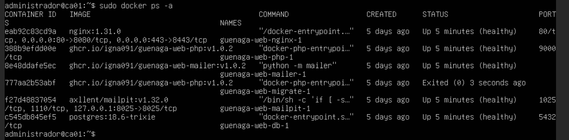
Figure 1. docker ps -a on ca01 a few minutes after the restart.
Container | Image | Status | Ports published
guenaga-web-nginx-1 | nginx:1.31.0 | Up, healthy | 80 and 443, on every interface
guenaga-web-php-1 | guenaga-web-php:v1.0.2 | Up, healthy | None
guenaga-web-mailer-1 | guenaga-web-mailer:v1.0.2 | Up, healthy | None
guenaga-web-db-1 | postgres:18.6-trixie | Up, healthy | None
guenaga-web-mailpit-1 | axllent/mailpit:v1.32.0 | Up, healthy | 8025, on 127.0.0.1 only
guenaga-web-migrate-1 | guenaga-web-php:v1.0.2 | Exited (0) | None

All six containers were created five days earlier; “Up 5 minutes” is the time since the restart. Only Nginx can be reached from the network. Mailpit's inbox is published on 127.0.0.1, so it opens only from ca01 itself, and PHP, the database and the mailer publish nothing.

3.2 Why migrate shows “Exited (0)”
One container was stopped while the rest were running, which looked like a fault. It is the expected state.
migrate is a one-shot job, not a service. It runs php artisan migrate --seed --force --no-interaction, which applies any pending Laravel migrations and loads the shop catalogue, and then it stops. In compose.yaml it is the only service with restart: "no"; all the others have restart: unless-stopped, so Docker starts them again by itself after a restart.
The number in brackets is the exit code, and 0 means the job finished without error. A failed migration would show a different number. On a first start, Compose also waits for it: php and mailer are declared with depends_on: migrate: condition: service_completed_successfully, so they start only once the database schema is ready.
The job's own log confirms the result:
sudo docker logs guenaga-web-migrate-1 | tail
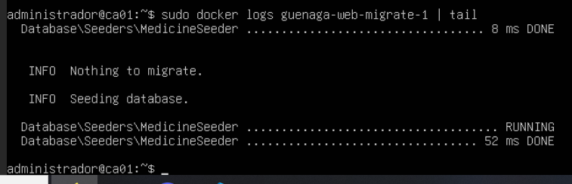
Figure 2. The end of the migrate log.
- Nothing to migrate. The database schema was already up to date.
- MedicineSeeder … DONE. The catalogue seeder ran again without error. It is written to be safe to repeat, so a second run changes nothing.
Figure 1 shows the job had finished 3 seconds before the listing, so it had just been run again. That is harmless for the same reason.

3.3 HTTP redirects to HTTPS
curl -kI http://localhost
-I asks for the response headers only. -k tells curl to accept a certificate this machine does not trust; it matters only for the HTTPS check below.
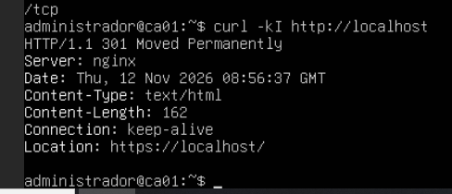
Figure 3. The response on port 80.
The answer is 301 Moved Permanently with Location: https://localhost/. Nginx is running and never serves the site over plain HTTP: its port 80 server does nothing except redirect to HTTPS.

3.4 HTTPS answers
curl -kI https://localhost
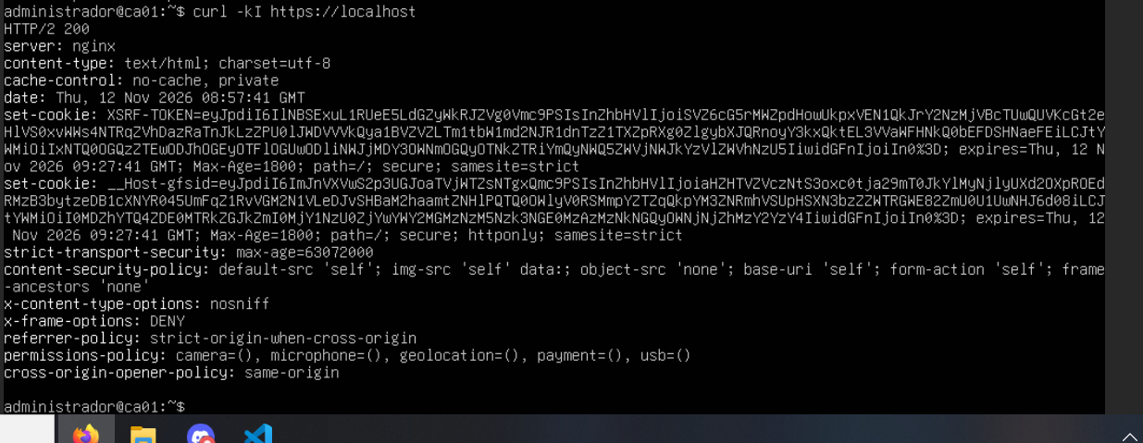
Figure 4. The response on port 443.
The answer is HTTP/2 200. That one line covers the whole chain: Nginx accepted the TLS connection and passed the request to PHP-FPM, and Laravel produced the page and opened a session. Sessions are stored in PostgreSQL (SESSION_DRIVER: database), so the session cookie also shows that PHP reaches the database.
The same response shows the hardening is active:
Header | Value | Effect
strict-transport-security | max-age=63072000 | Browsers use only HTTPS for this site for two years
content-security-policy | default-src 'self'; img-src 'self' data:; object-src 'none'; base-uri 'self'; form-action 'self'; frame-ancestors 'none' | Scripts, styles and images load only from the site's own origin
x-content-type-options | nosniff | The browser does not guess file types
x-frame-options | DENY | The site cannot be shown inside a frame (clickjacking)
referrer-policy | strict-origin-when-cross-origin | Other sites learn the origin only, never the full address
permissions-policy | camera=(), microphone=(), geolocation=(), payment=(), usb=() | Those browser features are switched off
cross-origin-opener-policy | same-origin | Windows from other sites cannot reach this one
cache-control | no-cache, private | Proxies do not store pages that belong to a session

Two cookies are set, both valid for 30 minutes (Max-Age=1800, the configured SESSION_LIFETIME):
- __Host-gfsid, the session cookie: secure, httponly and samesite=strict. JavaScript cannot read it, and it travels only over HTTPS and only on requests that start from the site itself.
- XSRF-TOKEN: secure and samesite=strict, but not httponly. That is Laravel's design: the page's JavaScript has to read this cookie to send the anti-forgery token back with each request.

4. Problem found: no styles when the site is opened by IP address

4.1 Symptom
Opened in Firefox from another computer as 192.168.74.65, the page arrives but without its stylesheet, its script or its icon. The browser console (F12) shows these messages; the browser is in Spanish:
Ha fallado la carga del <script> con origen
"https://www.guenaga.eus/js/site.js?v=1793968326".
Content-Security-Policy: La configuración de la página bloqueó la aplicación de un estilo
(style-src-elem) en https://www.guenaga.eus/css/site.css?v=1793968326 porque viola la
siguiente directiva: “default-src 'self'”
Content-Security-Policy: La configuración de la página bloqueó la ejecución de un script
(script-src-elem) en https://www.guenaga.eus/js/site.js?v=1793968326 porque viola la
siguiente directiva: “default-src 'self'”
Content-Security-Policy: La configuración de la página bloqueó la carga de un recurso
(img-src) en https://www.guenaga.eus/favicon.svg porque viola la siguiente directiva:
“img-src 'self' data:”
In short: the page's Content Security Policy (CSP) stopped the stylesheet, the script and the icon, because all three are requested from https://www.guenaga.eus and the policy allows files only from the page's own origin.

4.2 Cause
- The site builds every link from APP_URL, not from the address typed in the browser. On ca01, APP_URL is https://www.guenaga.eus. This is deliberate (URL::forceRootUrl in AppServiceProvider.php): if links followed the request's Host header, an attacker could forge that header and make a password-reset email point to their own site.
- So the page served at https://192.168.74.65 asks for its files at https://www.guenaga.eus/css/site.css, /js/site.js and /favicon.svg.
- The CSP allows files from 'self' only, meaning the origin the page was opened from. Here that is https://192.168.74.65. To the browser, www.guenaga.eus is a different origin, so it blocks the three files.
- The curl checks in section 3 could not show this. curl downloads the HTML and stops; it never loads the stylesheet or the script.
Nothing in the stack is broken. Two security controls are doing their job, and together they mean the site has to be opened by its name.

4.3 Fix
Open the site as https://www.guenaga.eus. For that, the name has to resolve to 192.168.74.65, which can be done in two ways:
Option | How | Who it fixes it for
Hosts file | Add this line to C:\Windows\System32\drivers\etc\hosts (Windows, editing as administrator) or to /etc/hosts (Linux):  192.168.74.65 www.guenaga.eus | That computer only. Quick, good for a first test
DNS record | On the internal DNS server, add an A record: www.guenaga.eus → 192.168.74.65 | Every client on the network. The lasting fix

With the name in the address bar, every file comes from the page's own origin and the CSP allows it. The name also matches the TLS certificate, which is issued for www.guenaga.eus and not for the IP address.
Relaxing the CSP or removing forceRootUrl would also make the errors disappear, but each removes a protection the site relies on, so neither is an acceptable fix.

5. Fix applied and checked
Later on 12 November the hosts entry from section 4.3 was added on the PC used for testing:
192.168.74.65 www.guenaga.eus
Opened in the browser as https://www.guenaga.eus, the site now shows with its styles and scripts. The same was checked from that PC with curl, requesting the page and then each of the three files the browser had blocked:
Request | Result
https://www.guenaga.eus/ | 200, answered by 192.168.74.65
/css/site.css, /js/site.js and /favicon.svg | 200 each, from the page's own origin, which the CSP allows
http://www.guenaga.eus/ | 301 to https://www.guenaga.eus/

Two things remain:
- A DNS record on the internal DNS server, so that every client resolves www.guenaga.eus. The hosts entry fixes one PC only.
- A browser screenshot of the page loading by name, to add to this document.

