OIMAS-N: a 1D two-pool model for soil organic carbon in tidal wetlands
Based on (Bruns et al., 2025; Kirwan and Mudd, 2012; Mudd et al., 2009)

Introduction

Biomass module
In the biomass module, we distinguish between above-ground and below-ground dynamics. Above-ground biomass dynamics varies through the seasons, according to:
$$B_{ag}\left(t_{day}\right)= \frac{1}{2}\left(B_{min}+B_{max}+\left(B_{min}-B_{max}\right)\cos\left(\frac{2π\left(t_{day}-t_{peak}\right)}{365}\right)\right)$$
Where $B_{ag}$is the biomass over time [kg m⁻²], $B_{min}$is the minimum above-ground biomass [kg], $B_{max}$ is the maximum biomass [kg m⁻²], $t_{day}$ is the day of the year and $t_{peak}$is the day of peak biomass and set at 244 (1 September). The maximum above-ground biomass is, according to Mudd et al. (2009), dependent on the relative elevation in the tidal frame. I am currently, waiting for James biomass maps, to verify this and establish relations between depth below MHHW and biomass. Belowground biomass ($B_{bg}$) is then calculated by a simple shoot-root ratio:

$$B_{bg}\left(t_{day}\right)=θ_{root:shoot}*B_{ag}$$

Previously, this root-shoot ratio has been considered to be constant over time (Mudd et al., 2009; Bruns et al., 2025). However, this is not necessarily the case for the species considered here. In figure 2.1, we illustrate estimated above-ground vs. below-ground biomass dynamics over the seasons, implying that root-shoot ratio’s vary over time.

Vertical variation of below-ground biomass is assumed to decrease exponentially:

$$b_{bg}=b_{0}e^{-d/γ}$$
Where $b_{bg}$is below-ground biomass per unit volume [kg m⁻³], $b_{0}$is the below-ground biomass at the surface, $d$ is depth [m] and $γ$ is the depth [m] at which root biomass is reduced by a factor $e^{-1}$ [m]. $γ$ is calibrated on the belowground biomass samples, collected by Faras and James, with incremental steps of 0.01. An optimal value was selected per primary plant species (figure 2.2).

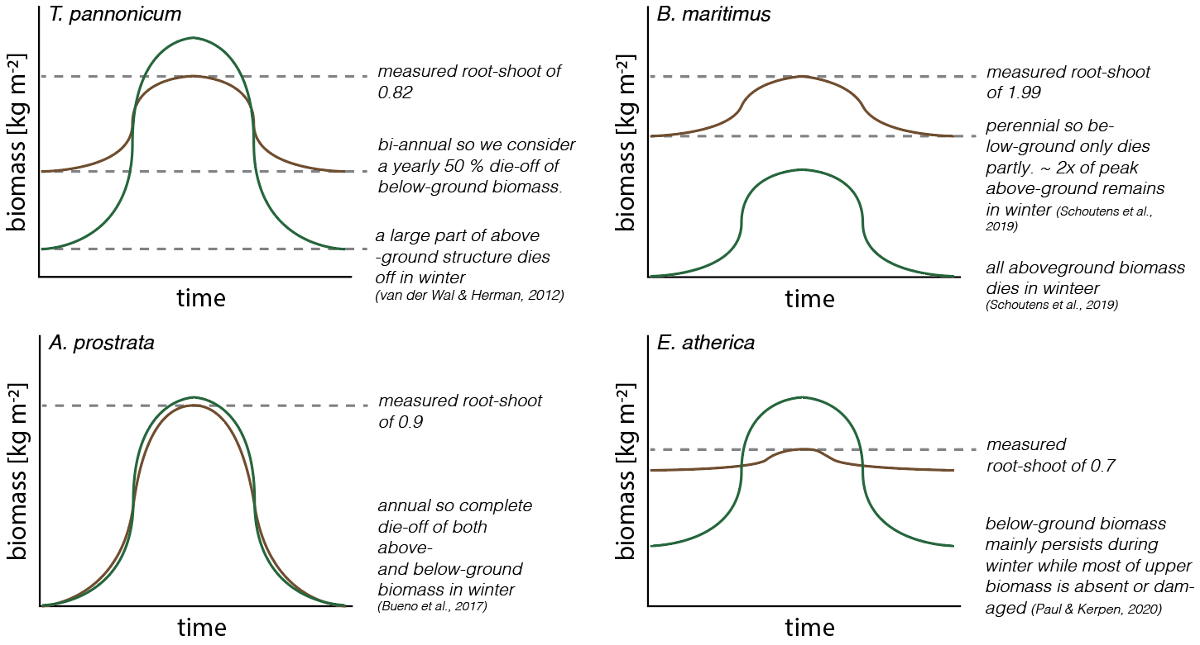
figure 2.1 | above- versus belowground biomass dynamics through the year for the four dominant species in our study area.

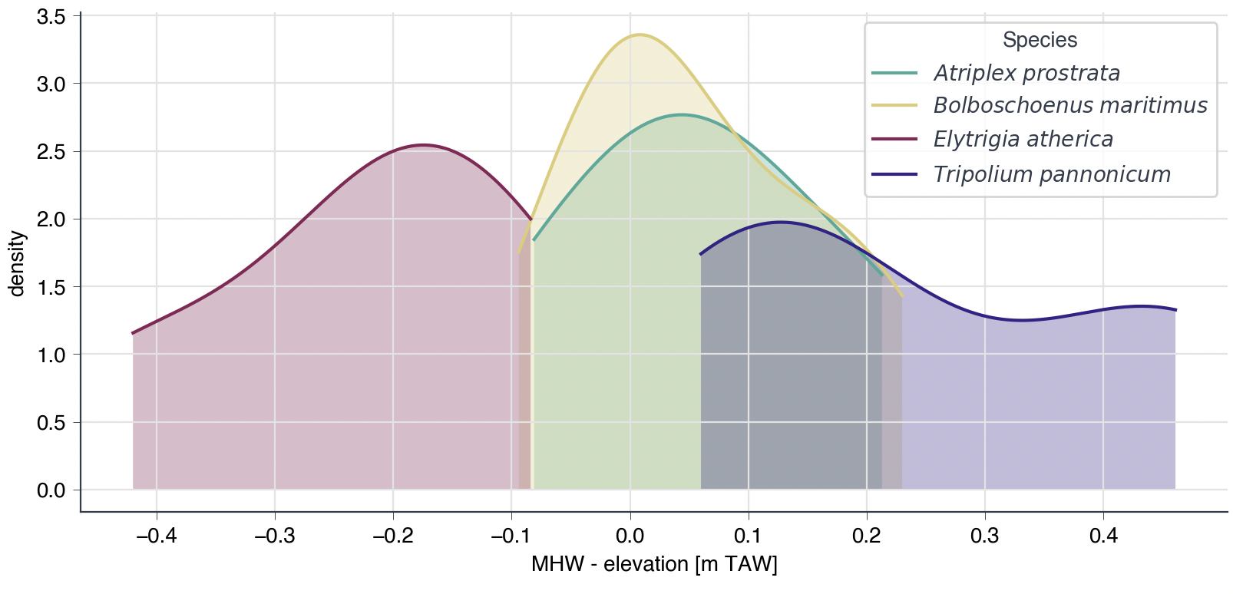
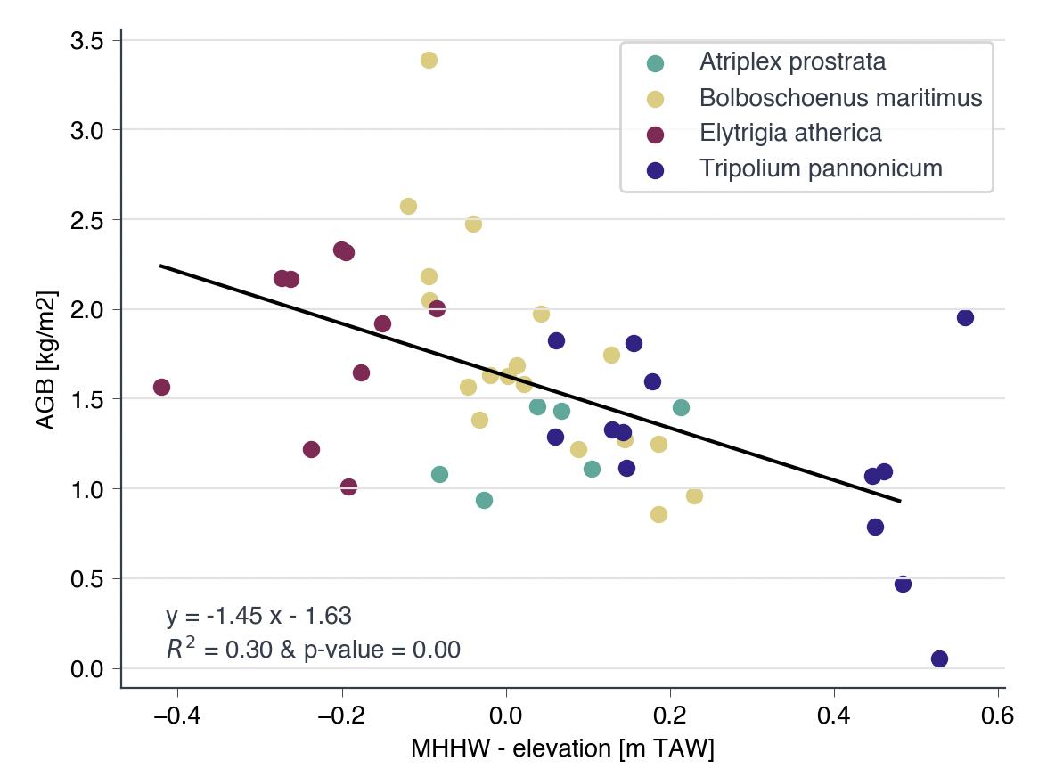
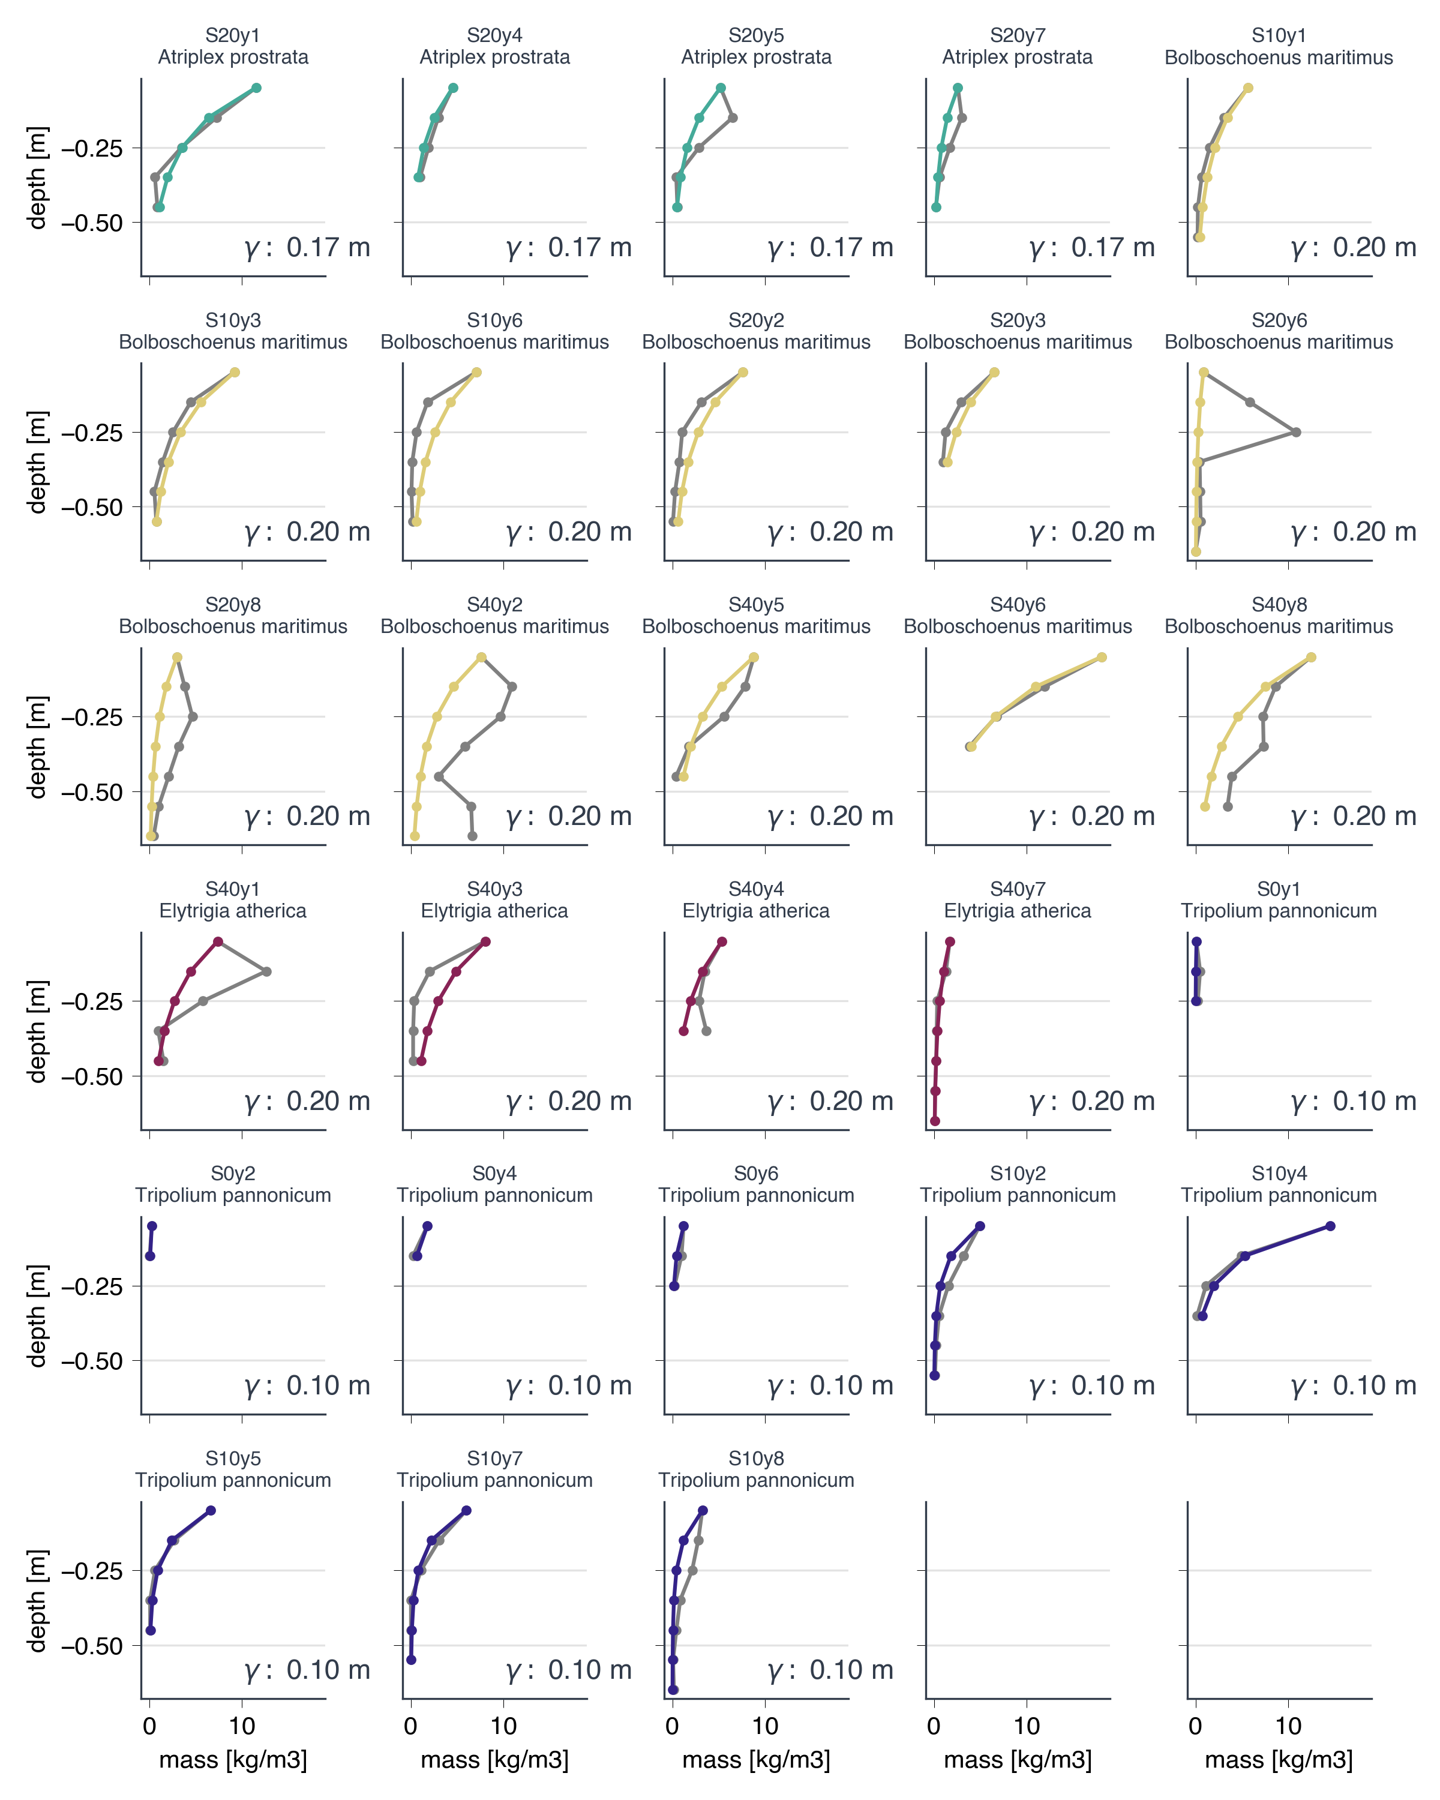
figure 2.2 | Calibration of $γ$ . Optimal values were found per primary plant species and are shown in the bottom right corner of each subgraph (A. prostrata 0.17 m: green lines, B. maritimus 0.20 m: yellow lines, E. atherica 0.20 m : red lines and T. pannonicum 0.10 m: blue lines).

Compaction module

To quantify compaction, the model uses the formulation from Gutierrez & Wangen (2005):

$E_{i}=E_{0}-CI*\log\left(\frac{σ_{eff,i}}{σ_{0}}\right)$ (eq 3.1)

Where E is the void ratio (volume of voids divided by the volume of solids) [-], i is the index of the cohort or ‘layer’ in the model, E₀ is the void ratio at a reference state [-], CI is compression index [-], $σ_{eff}$ is the effective stress [kg s⁻² m⁻¹] and $σ_{0}$ is the stress at a reference state [kg s⁻² m⁻¹]. These are estimated as:

- Void ratio E_{i} : the void ratio is calculated separately for the mineral and organic soil. E₀ and CI are calculated once for the organic matter fraction and once for the mineral fraction.

$E_{i}={E_{om,i}\left(p_{om,i}\right)+\left(1-p_{om},i\right) E}_{min,i}$ (eq. 3.2)

$E_{om,i}=E_{om,0}-CI_{om}*\log\left(\frac{σ_{eff,i}}{σ_{0}}\right)$ (eq. 3.3)

$E_{min,i}=E_{min,0}-CI_{min}*\log\left(\frac{σ_{eff,i}}{σ_{0}}\right)$ (eq. 3.4)

$p_{om}=\frac{mass_{om}}{mass_{min}}$ (eq. 3.5)

- E₀ is the void ratio at reference state, which here is considered to be the upper sediment layer. By assuming the particle densities for the mineral and organic fraction $ρ_{s, min}=2600 kg m^{-3}$ and $ρ_{s, om}=1300 kg m^{-3}$ and C to total organic material ratio of .52 (Ouyang and Lee, 2020), we can calculate E₀ based on dry bulk density (DBD) measurements from the Kopecky samples of the top sediment layer from Faras. Note that these are lumped E₀. We can rewrite eq. 3.2, for E₀:

$E_{0}={(E}_{0, om}{-E}_{0,min})*p_{om}+ E_{0,min}$ (eq. 3.6)
I plotted a linear regression to predict E₀ based on organic matter content. The intercept of that linear regression represents E_{0,min} and equals 0.87, and the sum of the slope and intercept E_{0, om} equal to 27.5. Note the exceptionally high value of E_{0, om} equal, explained by logarithmic E – om relation for organic matter contents > 20 % (Robinson et al., 2022) , and be cautious assuming these values for more organic soils. Organic matter contents were calculated by dividing the C content [%] of each sample by 0.52 (Ouyang and Lee, 2020).

Note that we do not divide E_{0,min} into separate values per grain size class (sand, silt, clay), such as been done by Mudd et al. (2009) or (Polito, 2023; Suravi et al., 2021). This is because:
- Faras only performed grain size analysis on a subset of the samples as it is labour intensive.
- At this point, in our common implementations of Demeter (or rather GAIA), we only consider one sediment class.
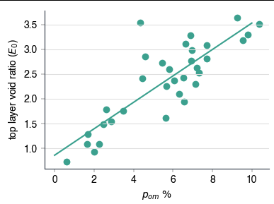
figure 3.1 | lumped void ratio [-] against organic matter content [%] with n = 33 and R² = 0.71.

- $σ_{eff}$is calculated as the buoyant weight of all layers above since we assume hydrostatic pressure (no excess pore pressure). The buoyant weight is here defined as follows (note that the index i refers to cohorts or ‘layers’ in the model):

Dry bulk density per cohort:

$ρ_{dry,i}=\frac{mass_{i}}{h_{i}}$ (eq. 3.7)
where h_{i} is the cohort thickness.

Lumped solid density:
$ρ_{s,i}=ρ_{om} p_{om, i }+ρ_{min}(1-p_{om,i})$ (eq. 3.8)

Effective weight per layer:
$γ_{i}=ρ_{dry,i}\left(\frac{ρ_{s,i}-ρ_{w}}{ρ_{s,i}}\right)g$ (eq. 3.9)
where $ρ_{w}$ is the density of water.

Buoyant weight per layer:

$σ_{eff,i}=\sum_{j=1}^{i}{γ_{j}h_{i}}$ (eq. 3.10)

- $σ_{0}$ is the reference stress [kg s⁻² m⁻¹] for which E equals E₀. This is considered to equal the buoyant weight of half of the upper layer.

Based on $E_{i}$, the new dry bulk density and layer thickness can be calculated:

$ρ_{bulk,i}=\frac{ρ_{s,i}}{1+E_{i}}$ (eq. 3.11)

$h_{i}=\frac{mass_{i}}{ρ_{bulk,i}}$ (eq. 3.12)

- CI_{min} and CI_{om} are the compaction coefficient for the mineral and organic matter partition of the sediments. One single value for CI_{min} was calibrated for the modelled DBD (eq 3.1, not the full OIMAS-N model) to match the median DBD in each age zone (figure 3.2). E_{0,min} and E_{0, om}) were set at the calibrated values of 0.87 and 27.5 . $p_{om}$varies with depth and values are taken from the observations. CI_{om} was assumed to equal 1, after Mudd et al. (2009) as sensitivity of calibrated CI_{min} to CI_{om} was found to be minor (figure 3.3). Best results were found for CI_{min} equal to 0.025, similar to the value for the silt fraction, assumed by Mudd et al. (2009).
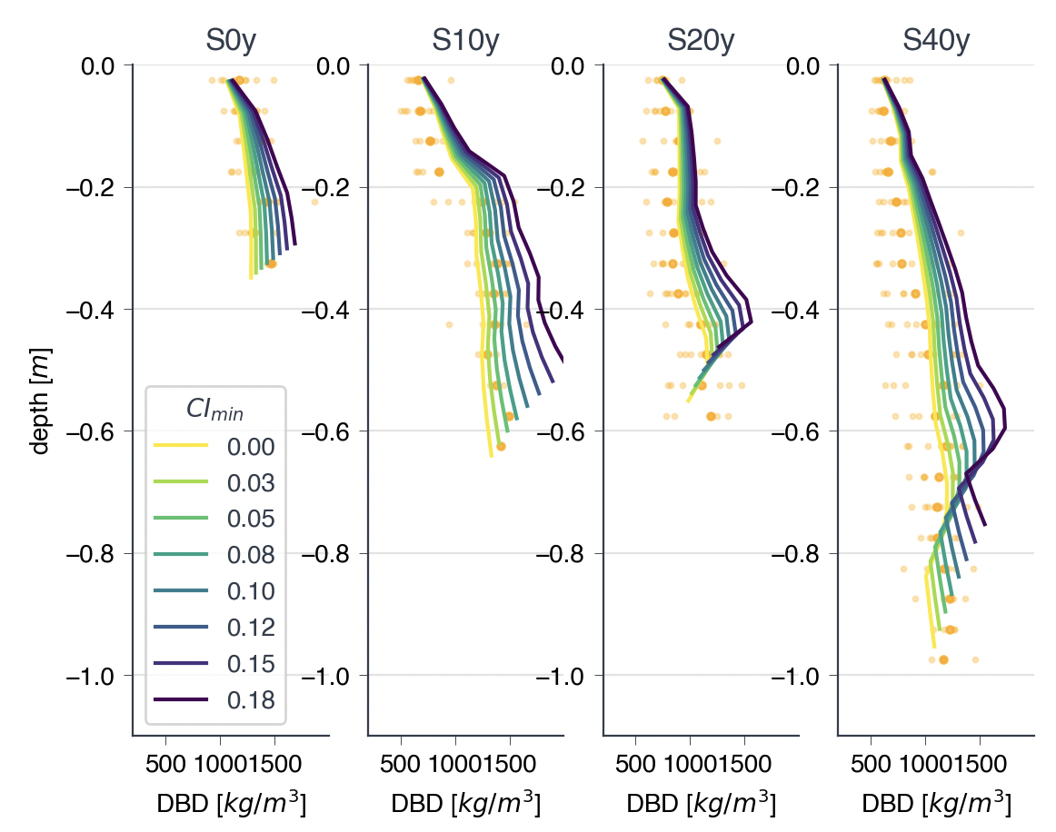
figure 3.2 | Calibration of CI_{min} for modelled DBD (lines) to match the median DBD (per depth, bold orange markers) for the pioneer zone (S0y), 10 year old zone (S10y), 20 year old zone (S20y) and 40 year old zone (S40y). CI_{om} was set at 1 after Mudd et al., 2009.

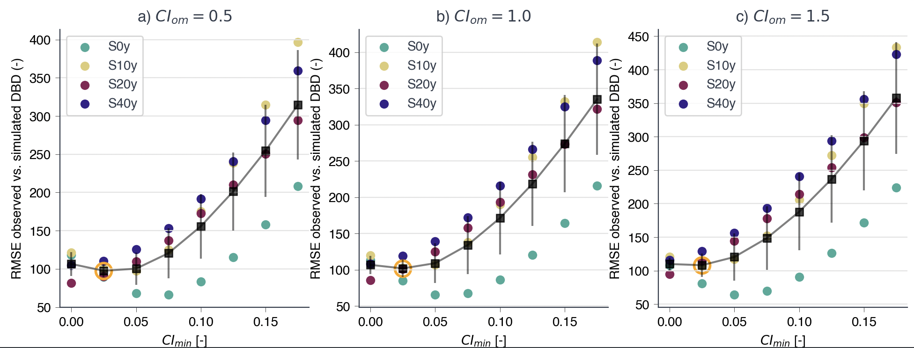
figure 3.3 | Calibration of xx for modelled DBD (lines) to match the median DBD (per depth, bold orange markers) for the pioneer zone (S0y), 10 year old zone (S10y), 20 year old zone (S20y) and 40 year old zone (S40y).

These equations have to be solved iteratively, as the compaction module requires the layer thickness h_{i} to calculate the buoyant weight while also updating h_{i}. The default is 5 iterations (convergence start from 3 iterations but it remains cheap computationally).

http://www.geotechdata.info/parameter/void-ratio

Sedimentation
MARSED (Temmerman et al. 2003,2004)

For Kloosterzande – Baalhoek (2025 data)
MHW = 4.936 m TAW
MHHW = 4.999 m TAW

Average tide:
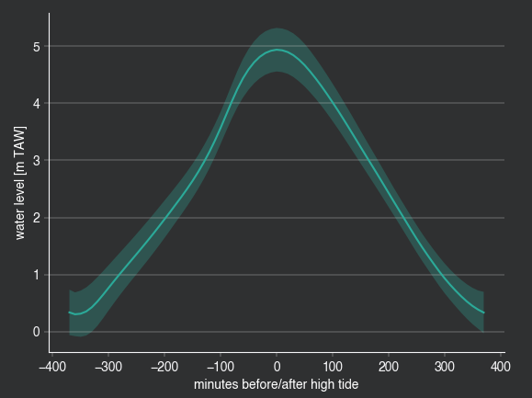
Distribution of high water events (calculated at Kloosterzande based on the data of 2025):
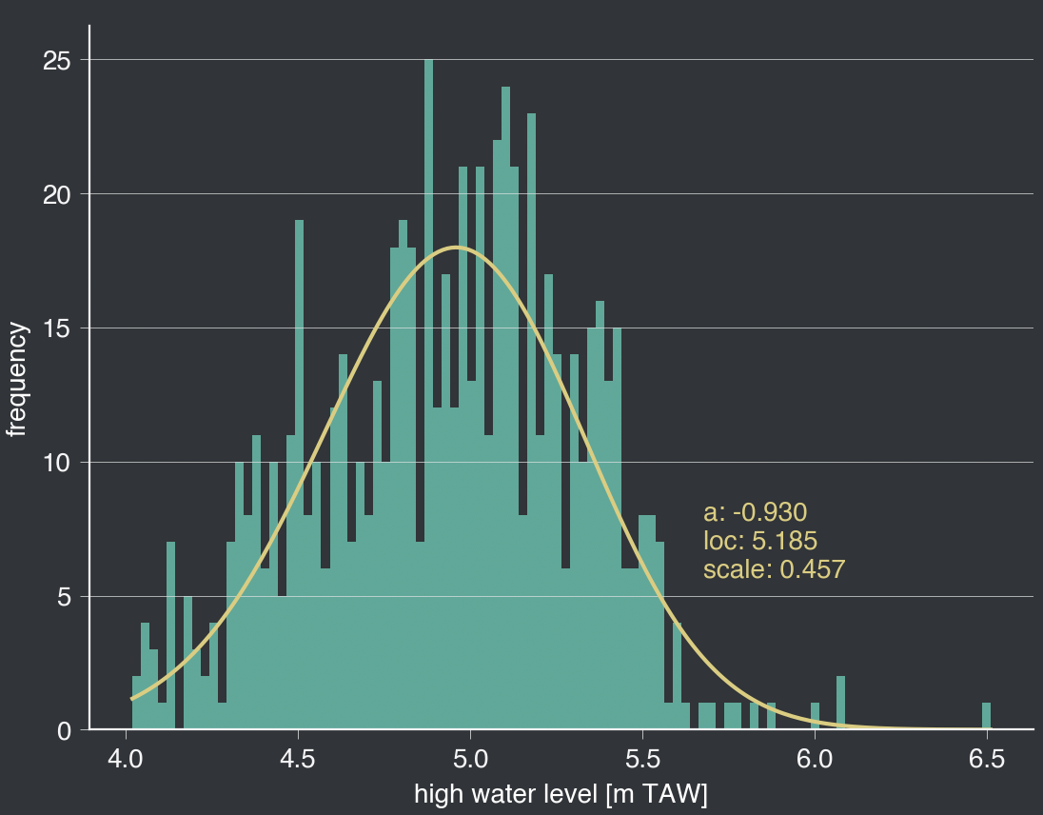

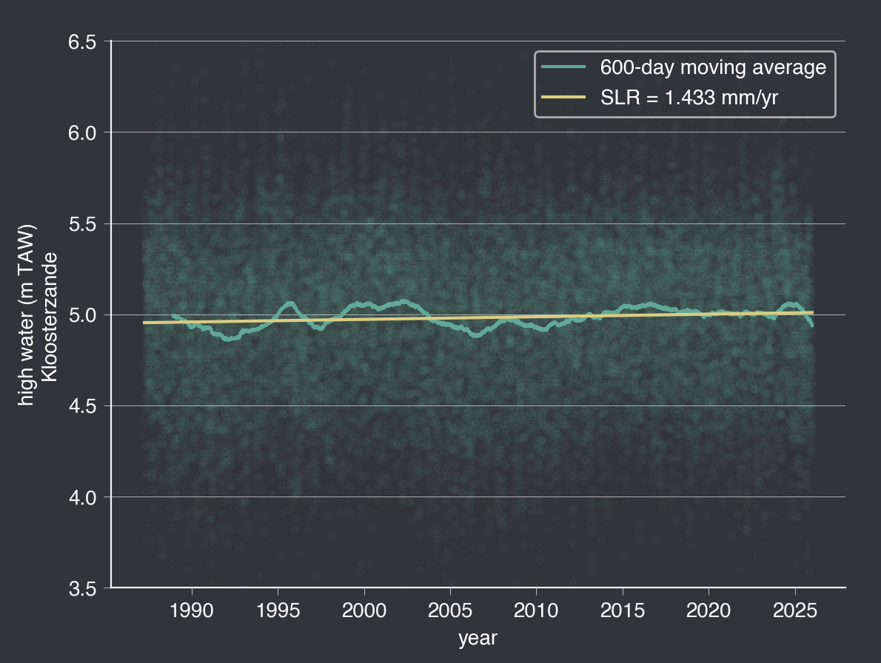
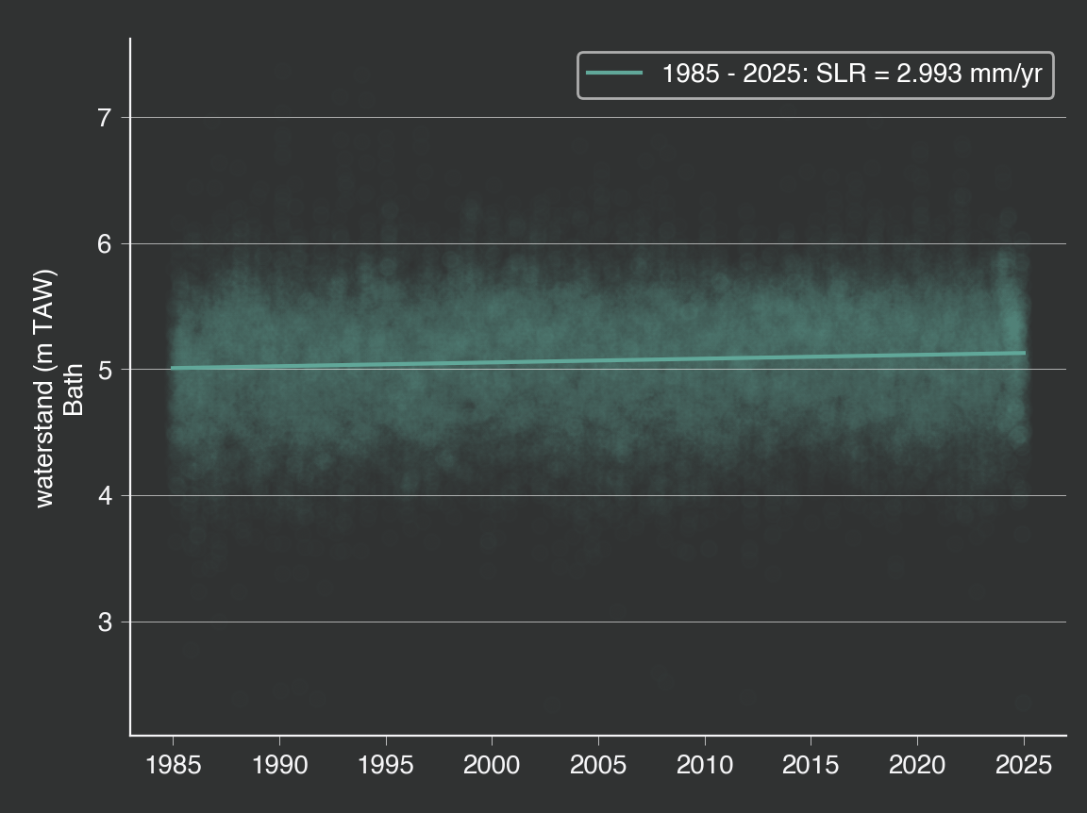
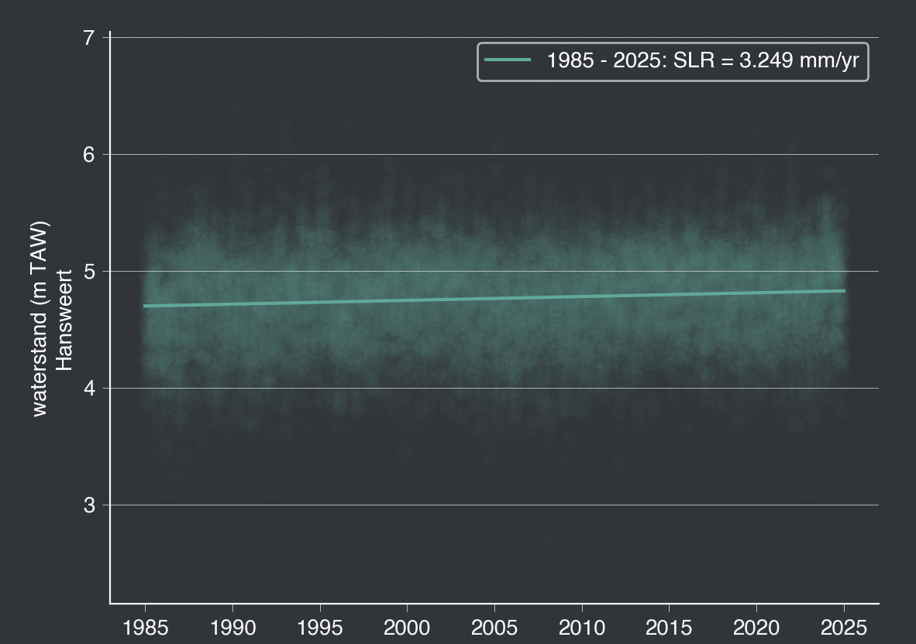

Bruns, N. E., Noyce, G. L., and Kirwan, M. L.: The role of geomorphology in mediating biomass allocation impacts on salt-marsh resilience and carbon accumulation, Estuar., Coast. Shelf Sci., 327, 109549, https://doi.org/10.1016/j.ecss.2025.109549, 2025.
Kirwan, M. L. and Mudd, S. M.: Response of salt-marsh carbon accumulation to climate change, Nature, 489, 550–553, https://doi.org/10.1038/nature11440, 2012.
Mudd, S. M., Howell, S. M., and Morris, J. T.: Impact of dynamic feedbacks between sedimentation, sea-level rise, and biomass production on near-surface marsh stratigraphy and carbon accumulation, Estuar., Coast. Shelf Sci., 82, 377–389, https://doi.org/10.1016/j.ecss.2009.01.028, 2009.
Ouyang, X. and Lee, S. Y.: Improved estimates on global carbon stock and carbon pools in tidal wetlands, Nat. Commun., 11, 317, https://doi.org/10.1038/s41467-019-14120-2, 2020.
Polito, C. P.: Correlations for Estimating Coefficients for the Prediction of Maximum and Minimum Index Void Ratios for Mixtures of Sand and Non-Plastic Silt, Geotechnics, 3, 1033–1046, https://doi.org/10.3390/geotechnics3040056, 2023.
Robinson, D. A., Thomas, A., Reinsch, S., Lebron, I., Feeney, C. J., Maskell, L. C., Wood, C. M., Seaton, F. M., Emmett, B. A., and Cosby, B. J.: Analytical modelling of soil porosity and bulk density across the soil organic matter and land-use continuum, Sci. Rep., 12, 7085, https://doi.org/10.1038/s41598-022-11099-7, 2022.
Suravi, K. N., Attenborough, K., Taherzadeh, S., Macdonald, A. J., Powlson, D. S., Ashton, R. W., and Whalley, W. R.: The effect of organic carbon content on soil compression characteristics, Soil Tillage Res., 209, 104975, https://doi.org/10.1016/j.still.2021.104975, 2021.

LOI – C conversion factor will be updated based on LOI measurements for samples from which C [%] have been measured.

