FOOTBALL PERFORMANCE DEPARTMENT DATA INFRASTRUCTURE
This project replicates the data infrastructure of a professional football performance department.
It builds a complete workflow that transforms raw GPS and wellness CSV exports into a structured SQL database connected to automated Power BI dashboards.
The pipeline demonstrates how training load, wellness, and fitness testing data can be collected, stored, and visualized to support evidence-based decision making in high-performance environments.

💡 Tagline / Subtitle
From raw GPS data to automated analytics — simulating a real club’s performance data ecosystem.

⚙️ Technologies
- Python → data generation, cleaning, automation scripts
- MySQL → relational database for structured storage
- Power BI → dynamic dashboards and performance monitoring
- Pandas / SQLAlchemy → ETL (Extract–Transform–Load) process automation

🔁 Workflow overview
- Data Simulation → synthetic GPS, wellness, and fitness data generated via Python.
- Database Design → relational structure reflecting a real performance department.
- Data Integration → automatic import from CSV exports to MySQL.
- Power BI Connection → dashboards for training load, wellness trends, and testing results.
- Daily Updates → automated script to ingest new CSVs (simulated GPS data) into SQL.

In most football clubs, GPS and wellness data are managed through Excel files exported from systems like Catapult, STATSports, or Wimu. While functional, this approach becomes inefficient and error-prone as data volume grows — with issues like duplicated records, broken formulas, and manual weekly updates.
This project proposes a scalable alternative: a relational SQL-based infrastructure that centralizes and automates the data flow of a football performance department.
Using Python, MySQL, and Power BI, the workflow simulates how raw CSV exports from tracking systems are transformed into a structured database and live dashboards.
SQL replaces manual spreadsheet management by:
- Ensuring data integrity through relational structure (players, sessions, wellness, tests).
- Enabling automation, as new CSVs are imported daily via Python ETL scripts.
- Supporting dynamic analysis, where metrics and KPIs can be recalculated instantly with SQL queries.
- Allowing direct connection with Power BI, keeping dashboards automatically updated as new data arrives.
This setup replicates a realistic data pipeline used in professional environments — turning static spreadsheets into a living, scalable system for monitoring training load, wellness, and player performance.

DATA
HRZones THRZ por utilidad
In practical terms, accumulating approximately 30 minutes per week above 90% HRmax appears to represent a realistic minimal dose for most athletes, while every extra 10 minutes in this zone may translate into an additional ∼1–2% improvement in key fitness markers
However, practically, THRZ offers significant advantages. It is easier to compute, more intuitive to interpret, and more directly applicable for training prescription. In contrast, TRIMPs aggregate efforts across intensities, making it difficult to track or prescribe time at the most effective training loads (90 minutes below 80% HRmax can yield a similar TRIMP value to 45 minutes above 80%HRmax). In practice, THRZ is best suited for micro usage, such as setting and monitoring session- and week-level targets, while TRIMPs are better suited for macro usage, where they can capture cumulative load and dose–response patterns across mesocycles or longer training phases. Ideally, both approaches would be used together to provide complementary information (Ellis 2023). However, resource and implementation constraints often mean practitioners rely primarily on THRZ. TRIMPs remain precious at the conceptual and macro level, but their application depends on how far a team chooses to extend its monitoring system.

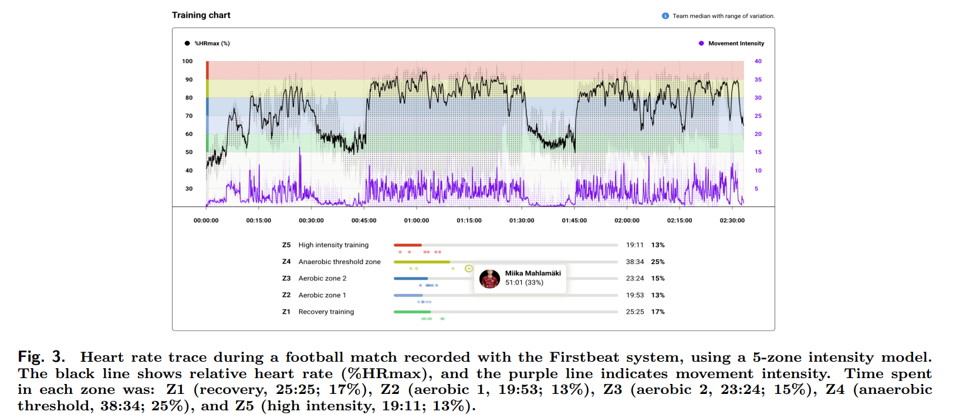

As a practical recommendation, we suggest accumulating 30 (±20) minutes per week above 90% HRmax or the HR corresponding to 4 mmol·L −1 lactate (>85-90% HRmax), to ensure sufficient metabolic and cardiovascular stimulus (Table 3). This threshold provides a usable benchmark for practitioners while allowing flexibility based on individual and contextual variation. In addition, the dose–response slopes across studies suggest that every extra 10 minutes spent in these highintensity zones can yield an average improvement of ∼1–2% in key cardiometabolic fitness markers, which highlights the incremental value of additional time above threshold.

Buchheit M, Akubat I, Ellis M, Campos M, Rabbani A, Castagna C, Malone S. Revisiting dose–response relationships between heart rate zones, TRIMPs, and aerobic-related physiological and performance markers in elite team sports. Sport Perform & Sci Reports 2025 Oct;269:v1.

The quadrant model: where sport science 3.0 meets common sense The quadrant-based model shown in Figure 1 provides, for the first time, a structured framework to differentiate between training load and the associated responses and adaptations across metabolic and neuromuscular domains. It follows the principles of sport science 3.0, emphasizing structured, physiology-driven thinking over technology-led monitoring (Buchheit & Laursen 2024). It addresses the conceptual confusion that has proliferated during the rise of sport science 2.0, where an abundance of tools and metrics, often used outside their intended purpose, has blurred the line between input and outcome, and between physiological systems. By clearly defining terms and mapping tools according to their primary function and target system (Buchheit & Laursen, 2019a, 2019b), this model offers a foundation for more consistent and context-appropriate monitoring practices in elite sport.

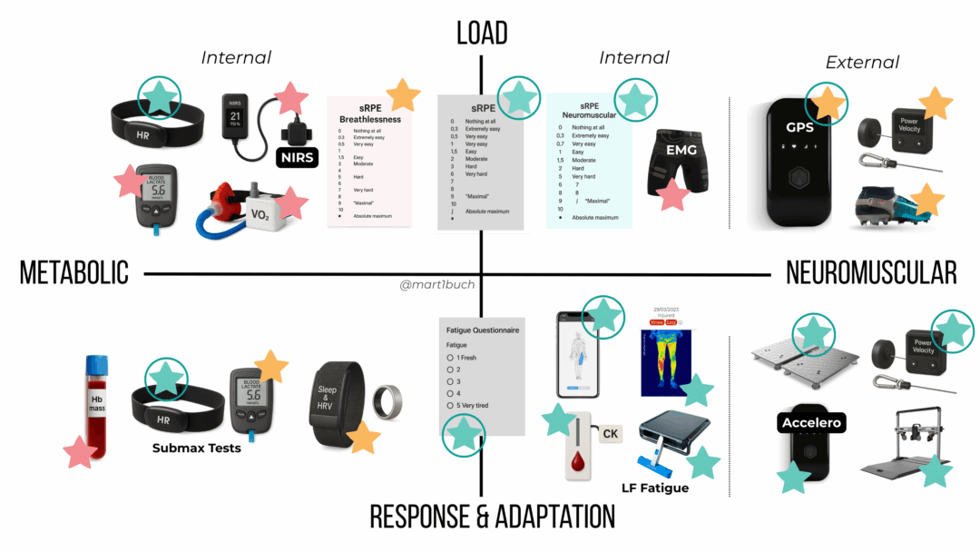
Metabolic Load: HR y RPE (Practicalidad, coste, evidencia)
Neuromuscular Load: GPS y encoders (fuerza, lo dejamos fuera del workflow por simplificar proyecto)
Metabolic adaptation: Submaximal exercise HR/lactate response (test de Carrera 1.500 m a intensidad submáxima, midiendo lactato)
Neuromuscular adaptation: Jump tests, Isometric strength tests (dynamometers), Movement velocity (Squat 1RM y velocidad al 60%)

To ensure comprehensive coverage, at least one variable should be monitored per quadrant (i.e., one proxy for metabolic load, neuromuscular load, metabolic adaptation, and neuromuscular acute response and adaptation), forming the minimum viable monitoring system. – Metabolic Load (Table 2): VO2 is ideal but impractical; HR is a useful proxy once we accept its limitations. – Neuromuscular Load (Table 3): The weakest area; GPS is commonly used but offers little insight into internal neuromuscular strain. – Responses and adaptation (Tables 4 & 5): The strongest two quadrants, with many tools available to guide training based on how players respond.

SQL
- Historical Data:
Multiple CSV files store synthetic player, session, wellness, and fitness test data.
- Database Unification:
  - A SQLite database (football_monitoring.db) is created using Python.
  - Each type of data has its own table (players, session_metrics, wellness, fitness_tests) with proper keys to maintain relationships.
  - Daily CSV updates (*_update.csv) are appended to the database and moved to a done folder to avoid duplicates.
- Visualization:
  - PowerBI connects directly to the SQLite database.
  - Dashboards can combine session metrics, wellness scores, and fitness tests by player, team, and date.
- Advantages:
  - No need for heavy SQL servers; everything runs locally.
  - The workflow is fully reproducible and scalable.
  - Daily updates maintain a historical archive and ensure data consistency.
Automation Note:
- Although not implemented, this process could be automated to detect new CSVs daily, append them to the database, and archive the processed files.
- Tools like Windows Task Scheduler or a lightweight Python loop could manage automatic updates, keeping the database always current for PowerBI.
Portfolio Diagram (example):
CSV Files (data/) ---> Python Script ---> SQLite DB ---> PowerBI
(append updates, move processed CSVs to done/)

Absolutely! Here's a redacted, portfolio-friendly version that keeps it clear but concise:

Football Monitoring Data Workflow
1. Folder Setup
All files are kept in a single project folder:
Project Folder
│
├─ Historical CSVs (players, sessions, wellness, fitness)
├─ create_db.py # create database from historical CSVs
├─ update_db.py # append daily updates
├─ football_monitoring.db # SQLite database created automatically
└─ done/ # archive for processed daily CSVs

2. Creating the Database
- Run create_db.py once to generate the SQLite database from the historical CSVs.
- Outcome: tables for players, sessions, wellness, and fitness are created and populated.
- This can be rerun to rebuild the database from the base CSVs if needed.

3. Adding Daily Updates
- Place new daily CSVs in the same folder.
- Run update_db.py to append the new data to the database.
- Processed CSVs are automatically moved to done/ to avoid duplicates.
- This can be done daily to simulate a live data workflow.

4. Connecting to PowerBI
- Open PowerBI Desktop → Get Data → SQLite Database → select football_monitoring.db.
- Tables can be joined and visualized for metrics such as distances, speeds, HR zones, wellness, and fitness tests.
- As new updates are added, PowerBI can refresh to show the latest data.

5. Notes for Portfolio
- Demonstrates a practical ETL workflow: data generation → database unification → visualization.
- Fully reproducible and scalable.
- Can be automated to handle daily updates without creating duplicates.

-----------------------------------HASTA AQUÍ PUBLICACIÓN 1 (CON FOTO POWERBI Y VÍDEO DE ACTUALIZACIÓN DE DATOS)
POWERBI
Mirar las métricas de los PDF descargados sobre los GPS y SportHorizon
Ignacho02
NaGaBi2002

Creado weeknumber y tabla calendar. Conexión desde calendar Date y player_id al resto

Medidas dinámicas para ver según jugador (suma) o equipo (media) en los KPI TOTAL DISTANCE, HR>90 HRMAX, EXPOSURES.

N8N para la automatización
Perfecto 🔥 — aquí tienes una versión redactada y lista para tu portfolio en inglés, con un tono profesional y muy claro para reclutadores o revisores técnicos 👇

🧩 Automated Data Workflow (n8n Integration)
To make the data pipeline fully automated, I integrated n8n, an open-source workflow automation tool.
This allowed me to connect the data update process between local Python scripts, the SQLite database, and Power BI dashboards — without any manual steps.
The workflow runs automatically every week and performs the following actions:
- Trigger (Cron Node): activates every Monday morning.
- Python Execution (Execute Command Node): runs the update_db.py script, which checks for new CSV files, appends them to the SQLite database, and moves processed files to the /done folder to avoid duplicates.
- Notification (Email or Slack Node): sends a short message confirming the successful update.
- (Optional) Power BI Refresh Node: refreshes the Power BI dataset using the Power BI REST API, ensuring that all dashboards display the latest player, wellness, and performance data.
🧠 This workflow creates a fully automated “Data Update → Database Refresh → Dashboard Sync” pipeline, simulating a real data engineering environment.
💡 Example Workflow (n8n visual layout)
[Cron Trigger] → [Execute Command: update_db.py] → [Power BI Refresh] → [Slack Notification]
This integration demonstrates an end-to-end data flow, connecting raw data ingestion, database management, and business intelligence visualization through automation.
It reflects real-world practices used in professional data analytics pipelines.

¿Quieres que te prepare también una imagen representativa del flujo (tipo diagrama o interfaz visual de n8n) para incluirla en tu portfolio (por ejemplo, en Notion o Power BI description)?
Podría generarte una imagen con los nodos conectados, similar a cómo se vería en la interfaz real de n8n.

