FOOTBALL PERFORMANCE DEPARTMENT DATA INFRASTRUCTURE
From raw GPS and wellness data to automated analytics — simulating a professional club’s performance ecosystem.

🧩 Introduction
In most football clubs, GPS, wellness, and fitness data are managed through Excel spreadsheets exported from tracking systems like Catapult, STATSports, or Wimu. While functional, this manual approach becomes inefficient and error-prone as data volume grows — duplicated records, broken formulas, and inconsistent updates are common issues that compromise long-term analysis.
This project replicates the data infrastructure of a professional football performance department, demonstrating how modern data engineering can transform that fragmented workflow into a scalable, automated system. Using Python, SQLite, and Power BI, the project builds a complete pipeline that converts raw CSV exports into a structured SQL database connected to automated dashboards, supporting evidence-based decision making in a more efficient way.

📊 Data and Metric Selection
The synthetic data (download here) simulates a realistic monitoring setup used in elite football environments. Metric selection was guided by the quadrant model (Buchheit & Laursen, 2024), which ensures at least one monitoring variable per key physiological domain:
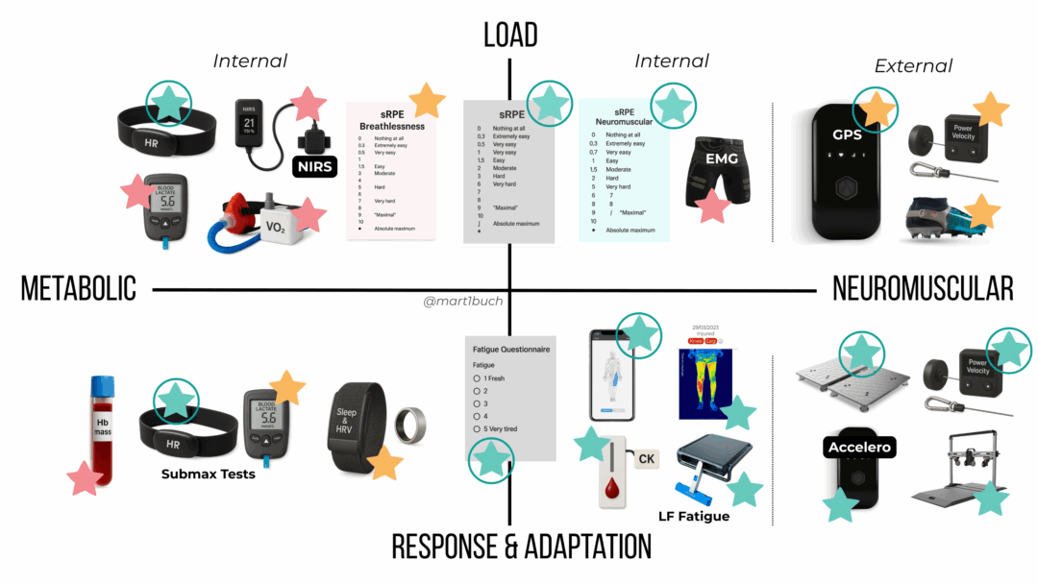

ADAPTAR:
Quadrant | Domain | Example variables (this project) | Rationale / notes
Metabolic Load | Internal effort | Heart Rate (HR), HR Zones, RPE | Practical and cost-effective. HR and RPE are widely validated proxies for internal load and are easy to implement at scale. THRZ (time-above-threshold) is used here for session/weekly micro-targets; TRIMPs are acknowledged for macro analysis.
Neuromuscular Load | External mechanical effort | GPS metrics (distance, high-speed distance, accelerations); (encoders/force plates available in practice) | GPS is a common, pragmatic proxy for external/neuromuscular load. Direct measures (force plates, linear encoders) are more informative for strength-specific neuromuscular strain but are excluded from the pipeline to keep the project realistic and reproducible without specialized hardware.
Metabolic Adaptation | Internal response / chronic change | Submaximal exercise HR and lactate response (e.g., 1500 m submax test with lactate sampling) | Reflects aerobic efficiency and metabolic adaptation. The project simulates a 1500 m submaximal test and stores HR/lactate-like outputs to show how adaptation metrics can be tracked longitudinally.
Neuromuscular Adaptation | Performance capacity / readiness | Jump tests (CMJ), isometric strength tests (dynamometer), movement velocity (e.g., squat 1RM velocity at 60%) | These tests capture neuromuscular capacity and adaptation. The full suite (dynamometers, velocity measures) is noted as best practice; this project simulates jump and basic strength test outputs to illustrate database design and dashboarding.

Heart rate–based load tracking (THRZ) is central to this model. According to Buchheit et al. (2025):
Accumulating ~30 minutes per week above 90% HRmax provides a realistic minimal stimulus for maintaining or improving aerobic fitness. Each additional 10 minutes in this zone may yield an extra 1–2% improvement in key fitness markers.
THRZ offers major practical advantages over aggregated metrics like TRIMPs:
- Easier to compute and interpret
- Directly applicable to session-level load management
- Better suited for micro-level targets (sessions and weeks)

🧱 Database Design and Automation
The database represents the central layer of the system — ensuring data integrity, traceability, and automation.
🧩 Workflow
- Data Simulation → Python scripts generate synthetic GPS, wellness, and testing data.
- Database Creation → create_db.py builds and populates tables (players, sessions, wellness, fitness) from historical CSVs.
- Incremental Updates → update_db.py imports new daily files and archives them to avoid duplicates.
- Power BI Connection → Dashboards connect directly to the SQL database, refreshing automatically.
Once the database is created the workflow simplifies:
(solo hay que meter la nueva data en la carpeta del .py y se actualiza como en el siguiente vídeo: ) MEJOR EN APARTADO DE ACTUALIZACIÓN
📈 Power BI Visualization
The Power BI dashboard consolidates data from all domains into an intuitive and interactive interface.
Key Views:
- Training Load Overview → Total distance, high-speed running, HR zones
- Wellness Dashboard → Sleep, soreness, mood, and recovery trends
- Fitness Testing Panel → Historical results for aerobic and strength assessments
- Player Comparison Tool → Benchmarking across sessions or weeks
Dashboards automatically update when new CSV files are processed, allowing real-time monitoring of player status and load progression.

🔁 Daily Update Workflow
Updating the system is fully automated:
- Drop new daily CSVs into the project folder.
- Run update_db.py.
- Processed files move to /done to prevent duplication.
- Power BI refreshes the latest data instantly.
This short demo video shows how the system updates seamlessly — simulating a live data ecosystem used in professional clubs.

🧠 Summary
This project demonstrates a scalable, automated, and reproducible football performance data pipeline:
- Converts raw CSV exports into a relational SQL database
- Uses Python ETL scripts for daily automation
- Connects to Power BI for dynamic dashboards
- Reflects real-world data workflows used in elite sports environments
Ultimately, it showcases how integrating data engineering and sports science principles can transform static spreadsheets into an intelligent, living monitoring system for performance optimization.

📚 References
- Buchheit M, Akubat I, Ellis M, Campos M, Rabbani A, Castagna C, Malone S. Revisiting dose–response relationships between heart rate zones, TRIMPs, and aerobic-related physiological and performance markers in elite team sports. Sport Perf & Sci Reports, 2025.
- Buchheit, M., & Laursen, P. B. (2024). Data everywhere, insight nowhere: a practical quadrant-based model for monitoring training load vs. response in elite football. Sport Performance & Science Reports, 2024(259), v1.

