FOOTBALL PERFORMANCE DEPARTMENT DATA INFRASTRUCTURE
From raw GPS and wellness data to automated analytics — simulating a professional club’s performance ecosystem.

🧩 Introduction
In most football clubs, GPS, wellness, and fitness data are managed through Excel spreadsheets exported from tracking systems like Catapult, STATSports, or Wimu. While functional, this manual approach becomes inefficient and error-prone as data volume grows — duplicated records, broken formulas, and inconsistent updates are common issues that compromise long-term analysis.
This project replicates the data infrastructure of a professional football performance department, demonstrating how modern data engineering can transform that fragmented workflow into a scalable, automated system. Using Python, SQLite, and Power BI, the project builds a complete pipeline that converts raw CSV exports into a structured SQL database connected to automated dashboards, supporting evidence-based decision making in a more efficient way.

📊 Data and Metric Selection
The synthetic data (download here) simulates a realistic monitoring setup used in elite football environments. Metric selection was guided by the quadrant model (Buchheit & Laursen, 2024), which ensures at least one monitoring variable per key physiological domain:
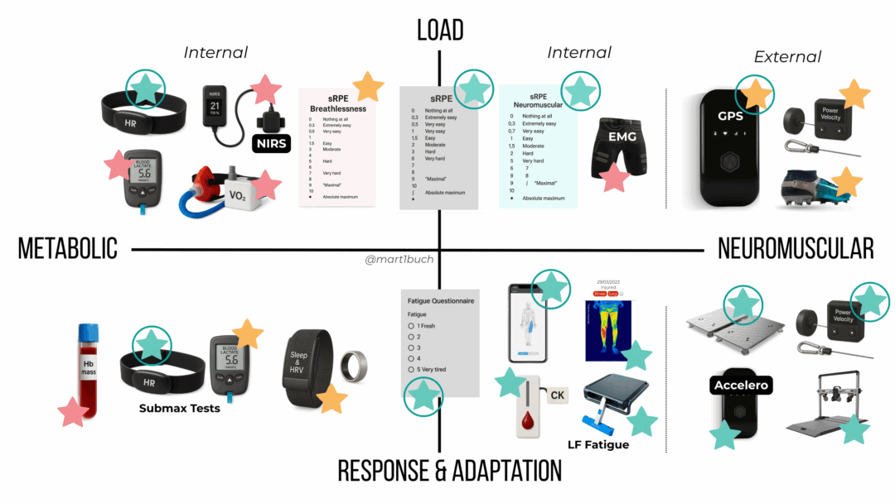

Quadrant | Domain | Selected variables | Explanation
Metabolic Load | Internal | Heart Rate (HR), HR Zones (THRZ), RPE | Practical and cost-effective. HR and RPE are widely validated proxies for internal load, once we accept their limitations, and are easy to implement at scale. THRZ (time-above-threshold) is used here for session/weekly micro-targets.
Neuromuscular Load | Internal and external | RPE and GPS metrics (distance, high-speed distance, accelerations); | GPS is a common, pragmatic proxy for external/neuromuscular load. Direct measures (force plates, linear encoders) are more informative for strength-specific neuromuscular strain but are excluded from the pipeline to keep the project reproducible without specialized hardware.
Metabolic Adaptation | Response and adaptation | Submaximal exercise HR and lactate response (e.g., 1500 m submax test with lactate sampling) | Reflects aerobic efficiency and metabolic adaptation. Fitness tests csv simulates a 1500 m submaximal test and stores HR/lactate-like outputs to show how adaptation metrics can be tracked longitudinally.
Neuromuscular Adaptation | Response and adaptation | Jump tests (CMJ), isometric strength tests (dynamometer), movement velocity (e.g., squat 1RM and velocity at 60% 1RM) | These tests capture neuromuscular capacity and adaptation. Together with the aerobic test, the jump and basic strength tests complete the testing battery for this project.

Heart rate–based load tracking (THRZ) is central to this model. According to Buchheit et al. (2025):
Accumulating ~30 minutes per week above 90% HRmax provides a realistic minimal stimulus for maintaining or improving aerobic fitness. Each additional 10 minutes in this zone may yield an extra 1–2% improvement in key fitness markers.
THRZ offers major practical advantages over aggregated metrics like TRIMPs:
- Easier to compute and interpret
- Directly applicable to session-level load management
- Better suited for micro-level targets (sessions and weeks)

🧱 Database Design and Creation
The database represents the central layer of the workflow — ensuring data integrity, traceability, and automation. All raw CSV exports (GPS, wellness, and fitness data) are unified into a relational structure, which allows Power BI to query updated data directly without manual reprocessing.
The system uses SQLite for simplicity (though the same schema can easily scale to MySQL).
Each table represents a key domain of player monitoring: players, session metrics, wellness, and fitness tests.
⚙️ Script Overview (create_db.py)
The script automatically builds the SQLite database from historical CSV exports.
It performs three main tasks:
- Creates relational tables for players, training sessions, wellness, and fitness tests.
- Imports CSV data (e.g., players.csv, session_metrics.csv, wellness.csv, fitness_tests.csv) and loads them into SQL tables.
- Prepares the database (football_monitoring.db) for direct connection with Power BI, enabling live dashboards without manual updates.
➡️ Full script available here: create_db.py
🗄️ Database Structure
Table | Content | Purpose
players | Player profiles (age, position, anthropometrics) | Reference table for all performance data
session_metrics | GPS and HR data per training session | Quantifies external and internal load
wellness | Daily self-reported metrics (sleep, soreness, mood, etc.) | Monitors recovery and subjective well-being
fitness_tests | Periodic testing data (jumps, submax HR, strength attempts) | Tracks long-term adaptations
The relationships between these tables allow complex queries — for example, correlating weekly training load (from session_metrics) with wellness or testing outcomes.

🔗 Power BI
Once the database (football_monitoring.db) is created, it can be connected directly to Power BI Desktop:
This live connection means that every time new CSVs are processed or appended, Power BI can refresh automatically to reflect the latest data.
Dashboards are built on SQL queries joining players, sessions, wellness, and fitness_tests, allowing flexible visualization of:
- Training load trends (distances, HR zones, RPE load)
- Wellness and recovery profiles
- Fitness test progression and player benchmarking
📊 Power BI Dashboard
The Power BI dashboard used as an example consolidates training and physiological data into an intuitive, interactive interface that mirrors the workflow of a professional performance department.
It allows coaches and sport scientists to visualize weekly load trends, identify high-intensity exposures, and compare players or teams across training days.
🔍 Key Views and Metrics
- Weekly Load Summary → Displays total activity minutes, average RPE, total distance (m), and minutes >90% HRmax, offering a quick overview of physical stress for the selected week or squad. (ALERTANDO POR COLORES)
- Training Distribution by Day → Line charts show total distance and high-speed distance per weekday, highlighting day-to-day load variation (e.g., MD, MD-1, MD-2).
- Acceleration / Deceleration Profile → Bar charts visualize the count of accelerations and decelerations, providing insight into mechanical load and session intensity.
- Internal Load Trends → Combines RPE and time above 90% HRmax per day, illustrating the relationship between perceived effort and physiological demand.
- Speed Exposure Analysis → Identifies sessions with >95% max speed exposures and shows each player’s % of maximum speed reached during the week — a key readiness and performance indicator.
- Filter Controls → Dynamic slicers for Week, Day, Team (First Team, U19, U21, U23), and Player, enabling targeted analysis across groups and individuals.

🔁 Daily Update Workflow
Updating the system is fully automated:
- Drop new daily CSVs into the project folder.
- Run update_db.py.
- Processed files move to /done to prevent duplication.
- Power BI refreshes the latest data instantly.
This short demo video shows how the system updates seamlessly — simulating a live data ecosystem used in professional clubs.

🧠 Summary
This project demonstrates a scalable, automated, and reproducible football performance data pipeline:
- Converts raw CSV exports into a relational SQL database
- Uses Python ETL scripts for daily automation
- Connects to Power BI for dynamic dashboards
- Reflects real-world data workflows used in elite sports environments
Ultimately, it showcases how integrating data engineering and sports science principles can transform static spreadsheets into an intelligent, living monitoring system for performance optimization.

📚 References
- Buchheit, M., Akubat, I., Ellis, M., Campos, M., Rabbani, A., Castagna, C., & Malone, S. (2025). Revisiting dose–response relationships between heart rate zones, TRIMPs, and aerobic-related physiological and performance markers in elite team sports. Sport Performance & Science Reports, 269, v1.
- Buchheit, M., & Laursen, P. B. (2024). Data everywhere, insight nowhere: a practical quadrant-based model for monitoring training load vs. response in elite football. Sport Performance & Science Reports, 2024(259), v1.

