Wave_clus
Unsupervised spike detection and sorting

© Rodrigo Quian Quiroga (2004)

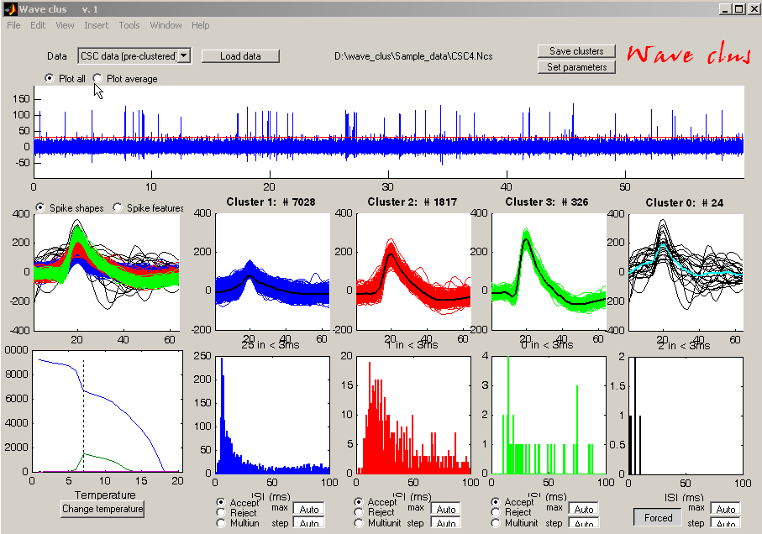

Introduction (~100Kb .pdf) Tutorial (~1Mb .ppt) Talk (~7Mb .ppt) Reference (~10Mb .pdf)

Download codes (~26Mb .zip)
Download Simulated data (~251Mb .zip)
Download Real (human) data (~74Mb .zip)

Back to home

