ASSIGNMENT 2: Telco Customer Churn

Silvia Ferrer and Ignacio Lloret

2023-11-27

Table of content

Data Preparation 1

Missing data and Errors 1

Variable analysis 4

Categorical values 4

Numerical Data 5

Data Quality 7

Multivariate outliers 7

Data Quality Report 8

Per variable 8

Profiling and Feature Selection 9

Interactions between the target and other variables 9

Churn Modelling 11

Modelling using numeric variables 11

Residual analysis 14

Adding factor main effects to the best model containing numeric variables 16

Residual analysis with categorical variables 24

Factor interactions 27

Model Interpretation and residual analysis 31

Goodness of fit 36

Standarize test 36

ANNEXES 39

This project has been carried out through a Github repository:

https://github.com/IgnacioLL/churn-project

# Data Preparation

## Missing data and Errors

Firstly, we removed possible duplicates from the dataset using the distinct function. Then, we factorized the variable SeniorCitizen, as it only has two categories. We then excluded the customerID variable since it is a unique categorical identifier that is not useful for the model, and analyzing its data distribution does not provide meaningful insights.

Checking the missing data in the dataset and which variables have NA’s we can see that the ones with missing values is TotalCharges. Investigating the observations with missing values to understand the underlying reason, we found that all these observations have tenure=0. We decided that the most appropriate option is to manually impute these TotalCharges with 0. If the tenure is 0, it implies that the contract has not started, indicating no debt or amount to be paid. We validated the imputation using density plots and confirmed that the distribution remained unchanged. Therefore, we proceeded with these imputed values.

# Duplicates observations  
df1 <- distinct(df1, .keep_all = TRUE)  
  
# Numeric to factor SeniorCitizen  
df1$SeniorCitizen <- df1$SeniorCitizen %>% as.factor()  
  
# Take off the variable customerID  
df1 <- subset(df1, select = -customerID)  
  
cat_keep <- names(df1)[sapply(df1, function(x) is.character(x))]  
numeric_columns <- names(df1)[sapply(df1, function(x) is.numeric(x))]  
  
df1[cat_keep] <- lapply(df1[cat_keep], as.factor) ## Create Factors  
df1[numeric_columns] <- lapply(df1[numeric_columns], as.numeric)  
  
# Missing values  
plot_missing(df1, missing_only = TRUE, group = list("Low" = 0.05, "Medium"=0.25, "High"=0.5, "Very High" =1), geom_label_args = list("size" = 2))

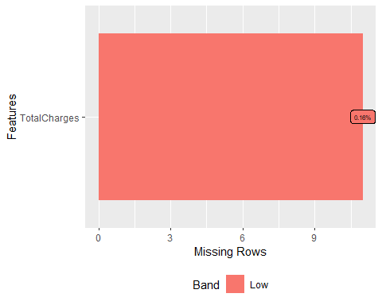

observaciones_na <- df1 %>% filter(is.na(TotalCharges))  
print(observaciones_na$tenure)

## [1] 0 0 0 0 0 0 0 0 0 0 0

# Errors or inconsistencies -> imputed  
df2 <- df1  
df2$TotalCharges <- ifelse(is.na(df2$TotalCharges) & df2$tenure == 0, 0, df2$TotalCharges)  
  
# Validation  
summary(df2$TotalCharges)

## Min. 1st Qu. Median Mean 3rd Qu. Max.   
## 0.0 398.6 1394.5 2279.7 3786.6 8684.8

summary(df1$TotalCharges)

## Min. 1st Qu. Median Mean 3rd Qu. Max. NA's   
## 18.8 401.4 1397.5 2283.3 3794.7 8684.8 11

par(mfrow=c(1,2))  
plot(density(df1$TotalCharges,na.rm=TRUE), main = "Density TotalCharges",   
 xlab = "TotalCharges", ylab = "Density")  
plot(density(df2$TotalCharges,na.rm=TRUE), main = "Density Imputed TotalCharges",   
 xlab = "TotalCharges", ylab = "Density")

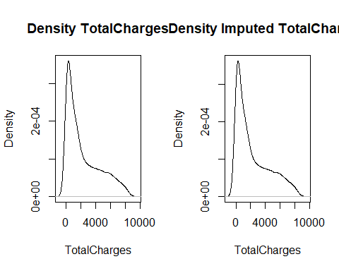

#searching inconsistencies with No phone service or No internet service  
summary(df2) # same frequency of no phone and internet service in the variables

## gender SeniorCitizen Partner Dependents tenure PhoneService  
## Female:3488 0:5901 No :3641 No :4933 Min. : 0.00 No : 682   
## Male :3555 1:1142 Yes:3402 Yes:2110 1st Qu.: 9.00 Yes:6361   
## Median :29.00   
## Mean :32.37   
## 3rd Qu.:55.00   
## Max. :72.00   
## MultipleLines InternetService OnlineSecurity  
## No :3390 DSL :2421 No :3498   
## No phone service: 682 Fiber optic:3096 No internet service:1526   
## Yes :2971 No :1526 Yes :2019   
##   
##   
##   
## OnlineBackup DeviceProtection  
## No :3088 No :3095   
## No internet service:1526 No internet service:1526   
## Yes :2429 Yes :2422   
##   
##   
##   
## TechSupport StreamingTV   
## No :3473 No :2810   
## No internet service:1526 No internet service:1526   
## Yes :2044 Yes :2707   
##   
##   
##   
## StreamingMovies Contract PaperlessBilling  
## No :2785 Month-to-month:3875 No :2872   
## No internet service:1526 One year :1473 Yes:4171   
## Yes :2732 Two year :1695   
##   
##   
##   
## PaymentMethod MonthlyCharges TotalCharges Churn   
## Bank transfer (automatic):1544 Min. : 18.25 Min. : 0.0 No :5174   
## Credit card (automatic) :1522 1st Qu.: 35.50 1st Qu.: 398.6 Yes:1869   
## Electronic check :2365 Median : 70.35 Median :1394.5   
## Mailed check :1612 Mean : 64.76 Mean :2279.7   
## 3rd Qu.: 89.85 3rd Qu.:3786.6   
## Max. :118.75 Max. :8684.8

# Variable analysis

## Categorical values

To analyze the categorical variables, we have depicted a bar plot for each of them in the figure below.

One of the most relevant observations is that our response variable, Churn, is unbalanced, with significantly more negative cases than positive ones.

p1 <- df2 %>%   
 select(all_of(cat_keep)) %>%  
 pivot_longer(cols=everything()) %>%  
 ggplot(data=.) +  
 geom_bar(aes(x=value), col="black", fill="white") +   
 theme(axis.text.x = element_text(angle = 45, hjust = 1)) +  
 facet_wrap(~name, scales="free", ncol=4)  
p1

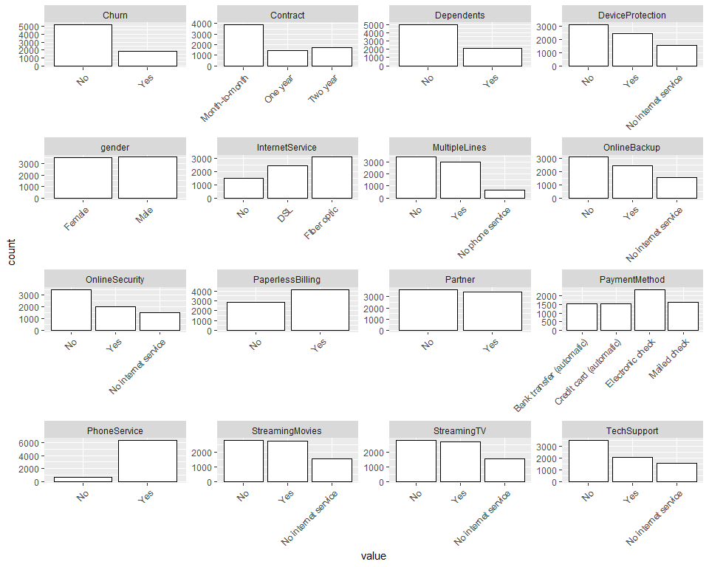

## Numerical Data

In order to analyze the numerical variables, we have represented a boxplot for each of them in the figure below. Notably, none of them show univariate outliers.

Subsequently, we discretized each variable into four quartiles and represented them as factors. We displayed their frequency tables to verify that the data is appropriately distributed across each category.  
p2 <- df2 %>%   
 select(all_of(numeric_columns)) %>%  
 pivot_longer(cols=everything()) %>%  
 ggplot(data=.) +  
 geom_boxplot(aes(y=value), col="black", fill="white") +   
 theme(axis.text.x = element_text(angle = 45, hjust = 1)) +  
 facet_wrap(~name, scales="free", ncol=4)  
p2

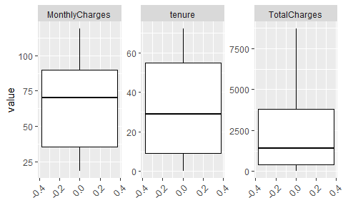

# Create a discretization of numeric variables  
sm <- summary(df2$tenure)  
df2$f.tenure <- ifelse(df2$tenure <= sm["1st Qu."], 1,   
 ifelse(df2$tenure > sm["1st Qu."] & df2$tenure <= sm["Mean"], 2,  
 ifelse(df2$tenure > sm["Mean"] & df2$tenure <= sm["3rd Qu."], 3,   
 ifelse(df2$tenure > sm["3rd Qu."], 4,0))))  
df2$f.tenure <- factor(df2$f.tenure, labels=c("LowTenure","LowMidTenure","HighMidTenure","HighTenure"), order = T, levels=c(1,2,3,4))  
table(df2$f.tenure)

##   
## LowTenure LowMidTenure HighMidTenure HighTenure   
## 1854 1921 1513 1755

sm <- summary(df2$MonthlyCharges)  
df2$f.MonthlyCharges <- ifelse(df2$MonthlyCharges <= sm["1st Qu."], 1,   
 ifelse(df2$MonthlyCharges > sm["1st Qu."] & df2$MonthlyCharges <= sm["Mean"], 2,  
 ifelse(df2$MonthlyCharges > sm["Mean"] & df2$MonthlyCharges <= sm["3rd Qu."], 3,   
 ifelse(df2$MonthlyCharges > sm["3rd Qu."], 4,0))))  
df2$f.MonthlyCharges <- factor(df2$f.MonthlyCharges, labels=c("LowMonthlyCharges","LowMidMonthlyCharges","HighMidMonthlyCharges","HighMonthlyCharges"), order = T, levels=c(1,2,3,4))  
table(df2$f.MonthlyCharges)

##   
## LowMonthlyCharges LowMidMonthlyCharges HighMidMonthlyCharges   
## 1762 1358 2165   
## HighMonthlyCharges   
## 1758

sm <- summary(df2$TotalCharges)  
df2$f.TotalCharges <- ifelse(df2$TotalCharges <= sm["1st Qu."], 1,   
 ifelse(df2$TotalCharges > sm["1st Qu."] & df2$TotalCharges <= sm["Mean"], 2,  
 ifelse(df2$TotalCharges > sm["Mean"] & df2$TotalCharges <= sm["3rd Qu."], 3,   
 ifelse(df2$TotalCharges > sm["3rd Qu."], 4,0))))  
df2$f.TotalCharges <- factor(df2$f.TotalCharges, labels=c("LowTotalCharges","LowMidTotalCharges","HighMidTotalCharges","HighTotalCharges"), order = T, levels=c(1,2,3,4))  
table(df2$f.TotalCharges)

##   
## LowTotalCharges LowMidTotalCharges HighMidTotalCharges HighTotalCharges   
## 1762 2632 888 1761

# Data Quality

## Multivariate outliers

In the initial analysis of multivariate outliers, a significance level of 0.05% was chosen as a very mild threshold. However, the vertical threshold is not visible on the graph as it extends beyond its limits. It is evident that there are no multivariate outliers beyond this threshold. We opted not to set a higher significance level because the observations are very grouped and there is no apparent clear outlier that warrants removal from the dataset.

df_of_interest <- df2[,c(numeric_columns)]  
  
res.out = Moutlier(df_of_interest, quantile = 0.9995, col="green")

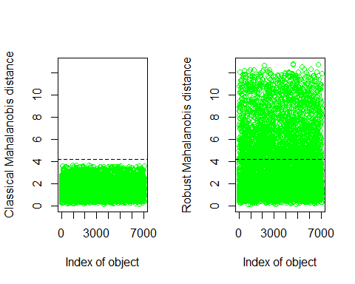

which((res.out$md > res.out$cutoff)&(res.out$rd > res.out$cutoff))

## named integer(0)

length(which((res.out$md > res.out$cutoff)&(res.out$rd > res.out$cutoff)))

## [1] 0

par(mfrow=c(1,1))  
plot( res.out$md, res.out$rd )  
abline(h=res.out$cutoff, col="red")  
abline(v=res.out$cutoff, col="red")

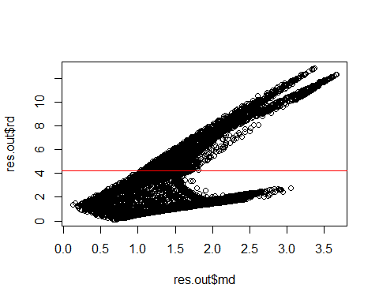

## Data Quality Report

As we have seen before, there are no univariate outliers, therefore, we have left the column empty, although it is represented to consider it as a parameter in the total quality sum. To measure missing values, we have conducted a column count, although we had already seen in the first section that the only column with missing values was TotalCharges, we have taken the values from the not imputed dataframe. Additionally, we consider it an error if the dataset has the tenure value equal to 0. Taking these metrics into account, we observe that the two variables with lower quality are tenure and TotalCharges. We do not believe it is necessary to look at another analysis per individuals to see the correlation with the variables because the two most related variables have been very explicitly identified in the analysis per variable.

### Per variable

dq <- data.frame(colnames(df1[, 1:20]))  
dq$outliers <- 0  
dq$missing <- 0  
dq$errors <- 0  
  
dq$missing <- (colSums(is.na(df1[, 1:20])))  
dq$errors[dq$colnames=="tenure"] <- sum(ifelse(df1$tenure == 0, 1, 0))  
dq$quality <- dq$outliers + dq$missing + dq$errors  
dq

## colnames.df1...1.20.. outliers missing errors quality  
## 1 gender 0 0 0 0  
## 2 SeniorCitizen 0 0 0 0  
## 3 Partner 0 0 0 0  
## 4 Dependents 0 0 0 0  
## 5 tenure 0 0 11 11  
## 6 PhoneService 0 0 0 0  
## 7 MultipleLines 0 0 0 0  
## 8 InternetService 0 0 0 0  
## 9 OnlineSecurity 0 0 0 0  
## 10 OnlineBackup 0 0 0 0  
## 11 DeviceProtection 0 0 0 0  
## 12 TechSupport 0 0 0 0  
## 13 StreamingTV 0 0 0 0  
## 14 StreamingMovies 0 0 0 0  
## 15 Contract 0 0 0 0  
## 16 PaperlessBilling 0 0 0 0  
## 17 PaymentMethod 0 0 0 0  
## 18 MonthlyCharges 0 0 0 0  
## 19 TotalCharges 0 11 0 11  
## 20 Churn 0 0 0 0

# Profiling and Feature Selection

## Interactions between the target and other variables

The results from FactoMinerR::catdes() show the relationship between the variable Churn and both categorical and quantitative variables.

For categorical variables, the chi-square test was used. The p-values for all variables are extremely small, indicating a significant association between these variables and the Churn variable. The variables with the strongest association are ‘Contract’, ‘f.tenure’, ‘OnlineSecurity’, and ‘TechSupport’, as they have the smallest p-values.

The variable Churn is also described by the categories. For the ‘No’ cluster, the categories with the highest v.test values (indicating a strong association) are ‘Contract=Two year’, ‘f.tenure=HighTenure’, and ‘StreamingMovies=No internet service’. For the ‘Yes’ cluster, the categories with the highest v.test values are ‘Contract=Month-to-month’, ‘OnlineSecurity=No’, and ‘TechSupport=No’.

For quantitative variables, the Eta2 statistic was used. The variable ‘tenure’ has the highest Eta2 value, indicating it has the strongest association with the cluster variable. The p-values for all variables are extremely small, indicating a significant association.

The variable Churn is also described by the quantitative variables. For the ‘No’ cluster, the variable with the highest v.test value (indicating a strong association) is ‘tenure’. For the ‘Yes’ cluster, the variable with the highest v.test value is ‘MonthlyCharges’.

As all variables are significant in relation with the variable Churn we will keep all of them at the moment.

catdes(df2, num.var=which(names(df2) == 'Churn'))

##   
## Link between the cluster variable and the categorical variables (chi-square test)  
## =================================================================================  
## p.value df  
## Contract 5.863038e-258 2  
## f.tenure 1.523011e-192 3  
## OnlineSecurity 2.661150e-185 2  
## TechSupport 1.443084e-180 2  
## InternetService 9.571788e-160 2  
## PaymentMethod 3.682355e-140 3  
## OnlineBackup 2.079759e-131 2  
## DeviceProtection 5.505219e-122 2  
## f.TotalCharges 4.965119e-85 3  
## StreamingMovies 2.667757e-82 2  
## StreamingTV 5.528994e-82 2  
## f.MonthlyCharges 4.505436e-76 3  
## PaperlessBilling 2.614597e-58 1  
## Dependents 3.276083e-43 1  
## SeniorCitizen 9.477904e-37 1  
## Partner 1.519037e-36 1  
## MultipleLines 3.464383e-03 2  
##

. . .

## Link between the cluster variable and the quantitative variables  
## ================================================================  
## Eta2 P-value  
## tenure 0.12406504 7.999058e-205  
## TotalCharges 0.03933251 2.127212e-63  
## MonthlyCharges 0.03738671 2.706646e-60  
##   
## Description of each cluster by quantitative variables  
## =====================================================  
## $No  
## v.test Mean in category Overall mean sd in category  
## tenure 29.55784 37.56997 32.37115 24.11145  
## TotalCharges 16.64270 2549.91144 2279.73430 2329.72904  
## MonthlyCharges -16.22582 61.26512 64.76169 31.08964  
## Overall sd p.value  
## tenure 24.55774 5.207314e-192  
## TotalCharges 2266.63354 3.418341e-62  
## MonthlyCharges 30.08791 3.312724e-59  
##   
## $Yes  
## v.test Mean in category Overall mean sd in category  
## MonthlyCharges 16.22582 74.44133 64.76169 24.65945  
## TotalCharges -16.64270 1531.79609 2279.73430 1890.31709  
## tenure -29.55784 17.97913 32.37115 19.52590  
## Overall sd p.value  
## MonthlyCharges 30.08791 3.312724e-59  
## TotalCharges 2266.63354 3.418341e-62  
## tenure 24.55774 5.207314e-192

# Churn Modelling

## Modelling using numeric variables

Initially, we built a model using only the numerical variables in our dataset. Upon examining the initial model with the vif function, we observe that there exists a high correlation between Total Charges and tenure. We will keep tenure variable, because TotalCharges is the variable that is created from tenure, in order to simplify and exclude redundant variables. Subsequent vif analysis confirmed the actual absence of multicorrelation.

Exploring interactions between these two variables gave us insignificant differences, leading us to stay with the less complex model. We tried to exchange these numeric variables with its previously created factor variables were made, but judging by the AIC parameter, the numeric variables give us better results.

Moreover, some transformations were applied to the variables. While the logarithmic transformation produced bad outcomes, the polynomial transformation significantly improved the results for tenure, although not for MonthlyCharges. Based on these findings, we kept the current best performing model which is mod_num6.

Finally, we show the effect plots of the features in the best model, and we can observe that the fewer months you stay with the company (tenure), the more likely you are to leave the company (churn yes), and the same applies in the opposite direction. Instead, the fewer monthly charges you have (MonthlyCharges), the more likely you are to stay with the company (churn no), and again, the same applies in the opposite direction.

set.seed(123)  
rows <- sample(nrow(df2), .75 * nrow(df2))  
train_new <- df2[rows, ]  
test_new <- df2[-rows, ]  
## Start with the numeric variables   
attach(train_new)  
mod_num <- glm(Churn ~ tenure + TotalCharges + MonthlyCharges, family = "binomial", data=train_new )  
vif(mod_num) ## We can see high correlation between Total Charges and tenure. We will keep tenure as it is the most important.

## tenure TotalCharges MonthlyCharges   
## 13.236369 17.243623 2.293439

mod_num2 <- glm(Churn ~ tenure + MonthlyCharges, family = "binomial", data=train_new )  
vif(mod_num2) ## There is not multicorrelation

## tenure MonthlyCharges   
## 1.286659 1.286659

# Let's check if interactions may be needed  
mod_num3 <- glm(Churn ~ tenure*MonthlyCharges, family="binomial", data=train_new)  
anova(mod_num2, mod_num3, test = "Chisq") # Not significant

## Analysis of Deviance Table  
##   
## Model 1: Churn ~ tenure + MonthlyCharges  
## Model 2: Churn ~ tenure * MonthlyCharges  
## Resid. Df Resid. Dev Df Deviance Pr(>Chi)   
## 1 5279 4882.7   
## 2 5278 4879.3 1 3.4271 0.06413 .  
## ---  
## Signif. codes: 0 '***' 0.001 '**' 0.01 '*' 0.05 '.' 0.1 ' ' 1

mod_num2i <- glm(Churn ~ f.tenure + f.MonthlyCharges, family = "binomial", data=train_new )  
AIC(mod_num2);AIC(mod_num2i) ## It is better with the numeric variables

## [1] 4888.737

## [1] 4981.568

mod_num4 <- glm(Churn ~ tenure + log(MonthlyCharges), family = binomial, data=train_new)  
mod_num4

##   
## Call: glm(formula = Churn ~ tenure + log(MonthlyCharges), family = binomial,   
## data = train_new)  
##   
## Coefficients:  
## (Intercept) tenure log(MonthlyCharges)   
## -6.17416 -0.05032 1.59314   
##   
## Degrees of Freedom: 5281 Total (i.e. Null); 5279 Residual  
## Null Deviance: 6171   
## Residual Deviance: 4906 AIC: 4912

AIC(mod_num2);AIC(mod_num4) ## It is better without transformation

## [1] 4888.737

## [1] 4911.624

## Let's check for polynomial transformations  
mod_num5 <- glm(Churn ~ poly(tenure,2) + poly(MonthlyCharges,2), family = binomial, data=train_new)  
summary(mod_num5)

##   
## Call:  
## glm(formula = Churn ~ poly(tenure, 2) + poly(MonthlyCharges,   
## 2), family = binomial, data = train_new)  
##   
## Coefficients:  
## Estimate Std. Error z value Pr(>|z|)   
## (Intercept) -1.37214 0.04201 -32.660 < 2e-16 ***  
## poly(tenure, 2)1 -92.63576 3.63598 -25.478 < 2e-16 ***  
## poly(tenure, 2)2 10.97254 2.80626 3.910 9.23e-05 ***  
## poly(MonthlyCharges, 2)1 70.72197 3.26976 21.629 < 2e-16 ***  
## poly(MonthlyCharges, 2)2 -0.67138 2.82535 -0.238 0.812   
## ---  
## Signif. codes: 0 '***' 0.001 '**' 0.01 '*' 0.05 '.' 0.1 ' ' 1  
##   
## (Dispersion parameter for binomial family taken to be 1)  
##   
## Null deviance: 6171.2 on 5281 degrees of freedom  
## Residual deviance: 4867.6 on 5277 degrees of freedom  
## AIC: 4877.6  
##   
## Number of Fisher Scoring iterations: 5

anova(mod_num2, mod_num5, test="Chisq") ## It is significant but MonthlyCharges is not significant

## Analysis of Deviance Table  
##   
## Model 1: Churn ~ tenure + MonthlyCharges  
## Model 2: Churn ~ poly(tenure, 2) + poly(MonthlyCharges, 2)  
## Resid. Df Resid. Dev Df Deviance Pr(>Chi)   
## 1 5279 4882.7   
## 2 5277 4867.6 2 15.139 0.0005159 ***  
## ---  
## Signif. codes: 0 '***' 0.001 '**' 0.01 '*' 0.05 '.' 0.1 ' ' 1

mod_num6 <- glm(Churn ~ poly(tenure,2) + MonthlyCharges, family = binomial, data=train_new)  
  
anova(mod_num6, mod_num5, test="Chisq") ## We will keep model 6. We could try to make polynomial of higher degrees but would be complicated to understand.

## Analysis of Deviance Table  
##   
## Model 1: Churn ~ poly(tenure, 2) + MonthlyCharges  
## Model 2: Churn ~ poly(tenure, 2) + poly(MonthlyCharges, 2)  
## Resid. Df Resid. Dev Df Deviance Pr(>Chi)  
## 1 5278 4867.7   
## 2 5277 4867.6 1 0.056477 0.8122

plot(allEffects( mod_num6 )) ## We can see how tenure slope is smoothed in high tenure.

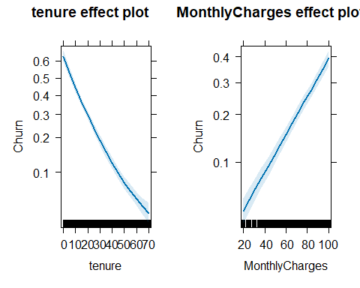

## Residual analysis

Paying attention to the residual plot we observe that it looks pretty flat. Some observations in low MonthlyCharges have higher residuals but is not normal as the predictor has positive correlation, so low MonthlyCharges with Churn are less probable.

Then, looking at the influence plot, there are some observations that have higher residuals than expected but are not very separate from each other.

Finally, the conclusions that we get from the box plot are that we have some influential values but it just because it is rare of low MonthlyCharges to have a Churn. We believe we should keep them in the dataset in order to not manipulate too much the model and have biased results.

residualPlots( mod_num6 )

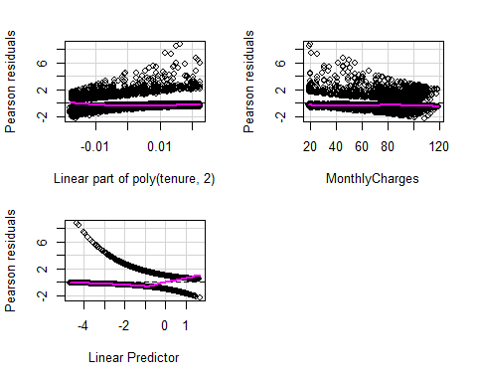

## Test stat Pr(>|Test stat|)  
## poly(tenure, 2)   
## MonthlyCharges 0.0565 0.8122

influencePlot( mod_num6 )

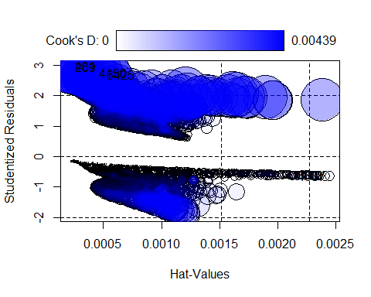

## StudRes Hat CookD  
## 6119 -0.6408156 0.0024069130 0.0001376051  
## 269 2.9282222 0.0002283574 0.0040652746  
## 4587 -0.6460006 0.0024426444 0.0001421684  
## 4150 2.7261200 0.0004340039 0.0043156940  
## 6425 2.6796931 0.0005017285 0.0043859131  
## 431 2.9518147 0.0002246452 0.0042884924

Boxplot(cooks.distance( mod_num6 ))

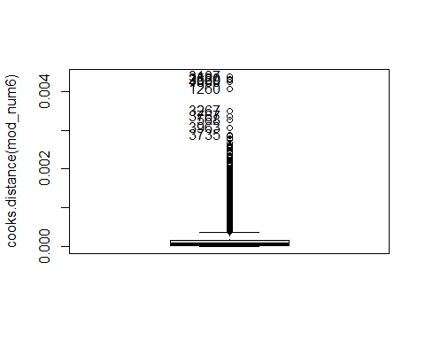

## [1] 3107 2520 3669 4800 1260 3267 3767 568 3963 3735

## Adding factor main effects to the best model containing numeric variables

As a last step to create our model, we introduced all our categorical variables to the model and we run step() to remove non significant predictors. There are multiple variables that are very related with the level No Internet these generate the model to not converge in some betas. As the levels in these variables can be also categorized as No instead of No Internet Service. Also we will be able to aisle the effect of No Internet with the variable InternetService. If more NA generate all the variance will be captured with the variable InternetService or other variable.

After refactoring all the variables that were related to each other we can see that MonthlyCharges is dependent on some of the other variables. We will remove those which are not significant and check whether we should add them or not. With the anova test we can observe that the change is not significant so we can keep the small model with the principle of parsimony. Through the vif we can also see that the multicorrelation has reduced.

Finally, we show the effect plots of the features in the model so we are able to define which category of Churn is more likely to happen when the feature takes the different values.

mod <- glm(Churn ~ gender + SeniorCitizen + Partner + Dependents + poly(tenure, 2) + MultipleLines + InternetService + OnlineSecurity + OnlineBackup + DeviceProtection + TechSupport + StreamingTV + StreamingMovies + Contract + PaperlessBilling + MonthlyCharges, data=train_new, family = binomial)  
summary(mod)

##   
## Call:  
## glm(formula = Churn ~ gender + SeniorCitizen + Partner + Dependents +   
## poly(tenure, 2) + MultipleLines + InternetService + OnlineSecurity +   
## OnlineBackup + DeviceProtection + TechSupport + StreamingTV +   
## StreamingMovies + Contract + PaperlessBilling + MonthlyCharges,   
## family = binomial, data = train_new)  
##   
## Coefficients: (6 not defined because of singularities)  
## Estimate Std. Error z value Pr(>|z|)   
## (Intercept) -0.18593 1.64965 -0.113 0.910259   
## genderMale -0.05053 0.07444 -0.679 0.497271   
## SeniorCitizen1 0.23581 0.09668 2.439 0.014724 *   
## PartnerYes -0.04925 0.08871 -0.555 0.578761   
## DependentsYes -0.14202 0.10256 -1.385 0.166141   
## poly(tenure, 2)1 -48.46940 4.93448 -9.823 < 2e-16 ***  
## poly(tenure, 2)2 23.61501 3.21735 7.340 2.14e-13 ***  
## MultipleLinesNo phone service -0.07058 0.74559 -0.095 0.924582   
## MultipleLinesYes 0.46049 0.20430 2.254 0.024197 *   
## InternetServiceFiber optic 1.70264 0.91938 1.852 0.064034 .   
## InternetServiceNo -1.56283 0.92622 -1.687 0.091544 .   
## OnlineSecurityNo internet service NA NA NA NA   
## OnlineSecurityYes -0.20071 0.20616 -0.974 0.330284   
## OnlineBackupNo internet service NA NA NA NA   
## OnlineBackupYes 0.01276 0.20251 0.063 0.949772   
## DeviceProtectionNo internet service NA NA NA NA   
## DeviceProtectionYes 0.11152 0.20199 0.552 0.580874   
## TechSupportNo internet service NA NA NA NA   
## TechSupportYes -0.16038 0.20871 -0.768 0.442246   
## StreamingTVNo internet service NA NA NA NA   
## StreamingTVYes 0.68356 0.37688 1.814 0.069720 .   
## StreamingMoviesNo internet service NA NA NA NA   
## StreamingMoviesYes 0.64094 0.37613 1.704 0.088375 .   
## ContractOne year -0.77209 0.12386 -6.233 4.56e-10 ***  
## ContractTwo year -2.01393 0.22054 -9.132 < 2e-16 ***  
## PaperlessBillingYes 0.33076 0.08569 3.860 0.000113 ***  
## MonthlyCharges -0.03076 0.03651 -0.842 0.399518   
## ---  
## Signif. codes: 0 '***' 0.001 '**' 0.01 '*' 0.05 '.' 0.1 ' ' 1  
##   
## (Dispersion parameter for binomial family taken to be 1)  
##   
## Null deviance: 6171.2 on 5281 degrees of freedom  
## Residual deviance: 4429.2 on 5261 degrees of freedom  
## AIC: 4471.2  
##   
## Number of Fisher Scoring iterations: 6

step_mod <- step(mod, trace=F)  
summary(step_mod) ## There are multiple variables that are very related with the level No Internet these generate the model to not converge in some betas. As the levels in these variables can be also categorized as No instead of No Internet Service. Also we will be able to aisle the effect of No Internet with the variable InternetService. If more NA generate all the variance will be captured with the variable InternetService or other variable.

##   
## Call:  
## glm(formula = Churn ~ SeniorCitizen + Dependents + poly(tenure,   
## 2) + MultipleLines + InternetService + OnlineSecurity + TechSupport +   
## StreamingTV + StreamingMovies + Contract + PaperlessBilling +   
## MonthlyCharges, family = binomial, data = train_new)  
##   
## Coefficients: (4 not defined because of singularities)  
## Estimate Std. Error z value Pr(>|z|)   
## (Intercept) -0.72477 0.58603 -1.237 0.216187   
## SeniorCitizen1 0.23123 0.09612 2.406 0.016146 *   
## DependentsYes -0.16577 0.09360 -1.771 0.076568 .   
## poly(tenure, 2)1 -49.21233 4.80315 -10.246 < 2e-16 ***  
## poly(tenure, 2)2 23.53228 3.21288 7.324 2.40e-13 ***  
## MultipleLinesNo phone service 0.15021 0.27613 0.544 0.586463   
## MultipleLinesYes 0.40305 0.11079 3.638 0.000275 ***  
## InternetServiceFiber optic 1.42884 0.31802 4.493 7.02e-06 ***  
## InternetServiceNo -1.28719 0.35466 -3.629 0.000284 ***  
## OnlineSecurityNo internet service NA NA NA NA   
## OnlineSecurityYes -0.25551 0.11429 -2.236 0.025384 *   
## TechSupportNo internet service NA NA NA NA   
## TechSupportYes -0.21336 0.11783 -1.811 0.070183 .   
## StreamingTVNo internet service NA NA NA NA   
## StreamingTVYes 0.57871 0.15661 3.695 0.000220 ***  
## StreamingMoviesNo internet service NA NA NA NA   
## StreamingMoviesYes 0.53785 0.15476 3.475 0.000510 ***  
## ContractOne year -0.76559 0.12361 -6.194 5.88e-10 ***  
## ContractTwo year -2.00258 0.22004 -9.101 < 2e-16 ***  
## PaperlessBillingYes 0.32998 0.08556 3.857 0.000115 ***  
## MonthlyCharges -0.01977 0.01192 -1.659 0.097137 .   
## ---  
## Signif. codes: 0 '***' 0.001 '**' 0.01 '*' 0.05 '.' 0.1 ' ' 1  
##   
## (Dispersion parameter for binomial family taken to be 1)  
##   
## Null deviance: 6171.2 on 5281 degrees of freedom  
## Residual deviance: 4430.6 on 5265 degrees of freedom  
## AIC: 4464.6  
##   
## Number of Fisher Scoring iterations: 6

train_new$OnlineBackup <- train_new$OnlineBackup %>% as.character()  
train_new$OnlineSecurity <- train_new$OnlineSecurity %>% as.character()  
train_new$DeviceProtection<- train_new$DeviceProtection %>% as.character()  
train_new$TechSupport <- train_new$TechSupport %>% as.character()  
train_new$StreamingTV <- train_new$StreamingTV %>% as.character()  
train_new$StreamingMovies <- train_new$StreamingMovies %>% as.character()  
  
train_new$OnlineBackup <- ifelse(train_new$OnlineBackup == 'No internet service', 'No', train_new$OnlineBackup)  
train_new$OnlineSecurity <- ifelse(train_new$OnlineSecurity == 'No internet service', 'No', train_new$OnlineSecurity)  
train_new$DeviceProtection <- ifelse(train_new$DeviceProtection == 'No internet service', 'No', train_new$DeviceProtection)  
train_new$TechSupport <- ifelse(train_new$TechSupport == 'No internet service', 'No', train_new$TechSupport)  
train_new$StreamingTV <- ifelse(train_new$StreamingTV == 'No internet service', 'No', train_new$StreamingTV)  
train_new$StreamingMovies <- ifelse(train_new$StreamingMovies == 'No internet service', 'No', train_new$StreamingTV)  
  
train_new$OnlineBackup <- train_new$OnlineBackup %>% as.factor()  
train_new$OnlineSecurity <- train_new$OnlineSecurity %>% as.factor()  
train_new$DeviceProtection<- train_new$DeviceProtection %>% as.factor()  
train_new$TechSupport <- train_new$TechSupport %>% as.factor()  
train_new$StreamingTV <- train_new$StreamingTV %>% as.factor()  
train_new$StreamingMovies <- train_new$StreamingMovies %>% as.factor()  
  
mod2 <- glm(Churn ~ gender + SeniorCitizen + Partner + Dependents + poly(tenure, 2) + MultipleLines + InternetService + OnlineSecurity + OnlineBackup + DeviceProtection + TechSupport + StreamingTV + Contract + PaperlessBilling + MonthlyCharges, data=train_new, family = binomial)  
  
summary(mod2)

##   
## Call:  
## glm(formula = Churn ~ gender + SeniorCitizen + Partner + Dependents +   
## poly(tenure, 2) + MultipleLines + InternetService + OnlineSecurity +   
## OnlineBackup + DeviceProtection + TechSupport + StreamingTV +   
## Contract + PaperlessBilling + MonthlyCharges, family = binomial,   
## data = train_new)  
##   
## Coefficients:  
## Estimate Std. Error z value Pr(>|z|)   
## (Intercept) -2.896568 0.440706 -6.573 4.95e-11 ***  
## genderMale -0.052518 0.074402 -0.706 0.480274   
## SeniorCitizen1 0.235360 0.096630 2.436 0.014863 *   
## PartnerYes -0.045129 0.088617 -0.509 0.610575   
## DependentsYes -0.141823 0.102477 -1.384 0.166377   
## poly(tenure, 2)1 -48.260650 4.930798 -9.788 < 2e-16 ***  
## poly(tenure, 2)2 23.628029 3.216172 7.347 2.03e-13 ***  
## MultipleLinesNo phone service 1.141370 0.225463 5.062 4.14e-07 ***  
## MultipleLinesYes 0.160485 0.103575 1.549 0.121271   
## InternetServiceFiber optic 0.197162 0.253541 0.778 0.436784   
## InternetServiceNo -0.057530 0.279600 -0.206 0.836981   
## OnlineSecurityYes -0.503244 0.105288 -4.780 1.76e-06 ***  
## OnlineBackupYes -0.289194 0.098300 -2.942 0.003262 **   
## DeviceProtectionYes -0.183167 0.104585 -1.751 0.079883 .   
## TechSupportYes -0.463910 0.109343 -4.243 2.21e-05 ***  
## StreamingTVYes 0.090824 0.144934 0.627 0.530884   
## ContractOne year -0.771337 0.123828 -6.229 4.69e-10 ***  
## ContractTwo year -2.009535 0.220525 -9.113 < 2e-16 ***  
## PaperlessBillingYes 0.336985 0.085581 3.938 8.23e-05 ***  
## MonthlyCharges 0.029601 0.008872 3.336 0.000848 ***  
## ---  
## Signif. codes: 0 '***' 0.001 '**' 0.01 '*' 0.05 '.' 0.1 ' ' 1  
##   
## (Dispersion parameter for binomial family taken to be 1)  
##   
## Null deviance: 6171.2 on 5281 degrees of freedom  
## Residual deviance: 4432.1 on 5262 degrees of freedom  
## AIC: 4472.1  
##   
## Number of Fisher Scoring iterations: 6

vif(mod2)

## GVIF Df GVIF^(1/(2*Df))  
## gender 1.002976 1 1.001487  
## SeniorCitizen 1.145921 1 1.070477  
## Partner 1.367963 1 1.169600  
## Dependents 1.274307 1 1.128852  
## poly(tenure, 2) 2.674350 2 1.278806  
## MultipleLines 5.631266 2 1.540464  
## InternetService 26.960139 2 2.278665  
## OnlineSecurity 1.337421 1 1.156469  
## OnlineBackup 1.530548 1 1.237153  
## DeviceProtection 1.710532 1 1.307873  
## TechSupport 1.464988 1 1.210367  
## StreamingTV 3.677450 1 1.917668  
## Contract 1.779049 2 1.154907  
## PaperlessBilling 1.127854 1 1.062005  
## MonthlyCharges 42.016372 1 6.482004

## After refactoring all the variables that were related to each other we can see that MonthlyCharges is dependent on some of the other variables. We will remove those which are not significant and check whether we should add them or not.  
  
Anova(mod2, test="LR")

## Analysis of Deviance Table (Type II tests)  
##   
## Response: Churn  
## LR Chisq Df Pr(>Chisq)   
## gender 0.498 1 0.4802756   
## SeniorCitizen 5.920 1 0.0149664 *   
## Partner 0.259 1 0.6106298   
## Dependents 1.922 1 0.1656116   
## poly(tenure, 2) 226.114 2 < 2.2e-16 ***  
## MultipleLines 33.592 2 5.076e-08 ***  
## InternetService 0.790 2 0.6736513   
## OnlineSecurity 23.205 1 1.456e-06 ***  
## OnlineBackup 8.671 1 0.0032335 **   
## DeviceProtection 3.070 1 0.0797302 .   
## TechSupport 18.222 1 1.966e-05 ***  
## StreamingTV 0.393 1 0.5308566   
## Contract 114.051 2 < 2.2e-16 ***  
## PaperlessBilling 15.596 1 7.840e-05 ***  
## MonthlyCharges 11.194 1 0.0008207 ***  
## ---  
## Signif. codes: 0 '***' 0.001 '**' 0.01 '*' 0.05 '.' 0.1 ' ' 1

mod3 <- glm(Churn ~ SeniorCitizen + poly(tenure, 2) + MultipleLines + OnlineSecurity + OnlineBackup + TechSupport + Contract + PaperlessBilling + MonthlyCharges, data=train_new, family = binomial)  
Anova(mod3, test="LR")

## Analysis of Deviance Table (Type II tests)  
##   
## Response: Churn  
## LR Chisq Df Pr(>Chisq)   
## SeniorCitizen 7.795 1 0.0052386 **   
## poly(tenure, 2) 263.346 2 < 2.2e-16 ***  
## MultipleLines 64.374 2 1.050e-14 ***  
## OnlineSecurity 33.037 1 9.043e-09 ***  
## OnlineBackup 12.465 1 0.0004146 ***  
## TechSupport 27.842 1 1.316e-07 ***  
## Contract 130.953 2 < 2.2e-16 ***  
## PaperlessBilling 17.011 1 3.716e-05 ***  
## MonthlyCharges 298.361 1 < 2.2e-16 ***  
## ---  
## Signif. codes: 0 '***' 0.001 '**' 0.01 '*' 0.05 '.' 0.1 ' ' 1

anova(mod3, mod2, test="Chisq") ## It is not significant so we can keep the small model with the principle of parsimony.

## Analysis of Deviance Table  
##   
## Model 1: Churn ~ SeniorCitizen + poly(tenure, 2) + MultipleLines + OnlineSecurity +   
## OnlineBackup + TechSupport + Contract + PaperlessBilling +   
## MonthlyCharges  
## Model 2: Churn ~ gender + SeniorCitizen + Partner + Dependents + poly(tenure,   
## 2) + MultipleLines + InternetService + OnlineSecurity + OnlineBackup +   
## DeviceProtection + TechSupport + StreamingTV + Contract +   
## PaperlessBilling + MonthlyCharges  
## Resid. Df Resid. Dev Df Deviance Pr(>Chi)  
## 1 5269 4442.2   
## 2 5262 4432.1 7 10.097 0.1832

vif(mod3) ## The multicorrelation has reduced.

## GVIF Df GVIF^(1/(2*Df))  
## SeniorCitizen 1.096933 1 1.047346  
## poly(tenure, 2) 2.432127 2 1.248811  
## MultipleLines 1.922042 2 1.177445  
## OnlineSecurity 1.098729 1 1.048203  
## OnlineBackup 1.260452 1 1.122698  
## TechSupport 1.164474 1 1.079108  
## Contract 1.698638 2 1.141629  
## PaperlessBilling 1.121320 1 1.058924  
## MonthlyCharges 2.260157 1 1.503382

plot(allEffects(mod3))

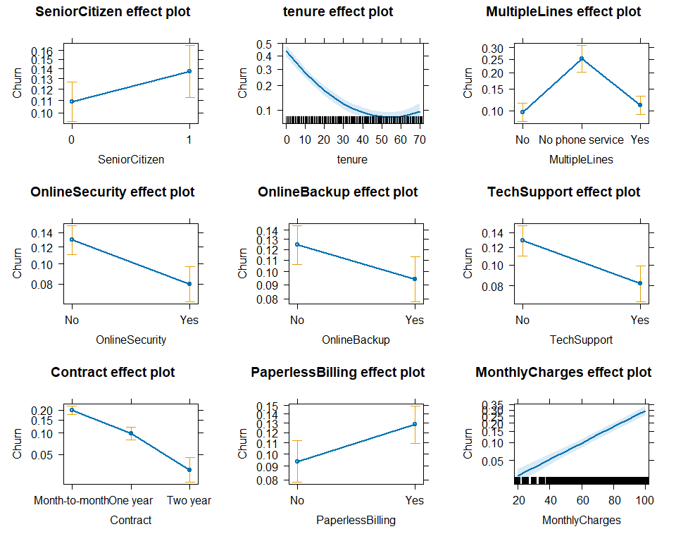

## Residual analysis with categorical variables

For the polynomial transformation (poly(tenure, 2) & MonthlyCharges), no systematic patterns or heteroscedasticity were observed. This suggests that the chosen transformations and the assumed linear relationships for these variables are appropriate.Regarding the factor variables, most observations are centered around 0, indicating consistent model performance across various groups. However, a few observations deviate from 0, suggesting the presence of potentially influential data points.

Marginal Plots illustrate that the model aligns with the real data trend, indicating proper adaptation to variability in these predictors.

In the influence plot, most points don’t really affect the model much. However, there are a few with a high Cook’s distance that could be more influential. We need to check if these points are just a bit different or if they are really unusual.

In the box plot we are seeing a behavior very similar to the previous model, where we observe a lot of influential data with high cook distance.

Therefore, we are following the same approach as before since we are not going to delete any of this data, in order to not manipulate too much the model and have biased results.

residualPlots(mod3)

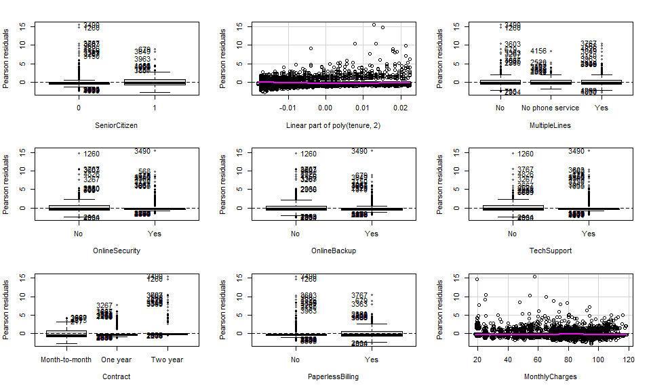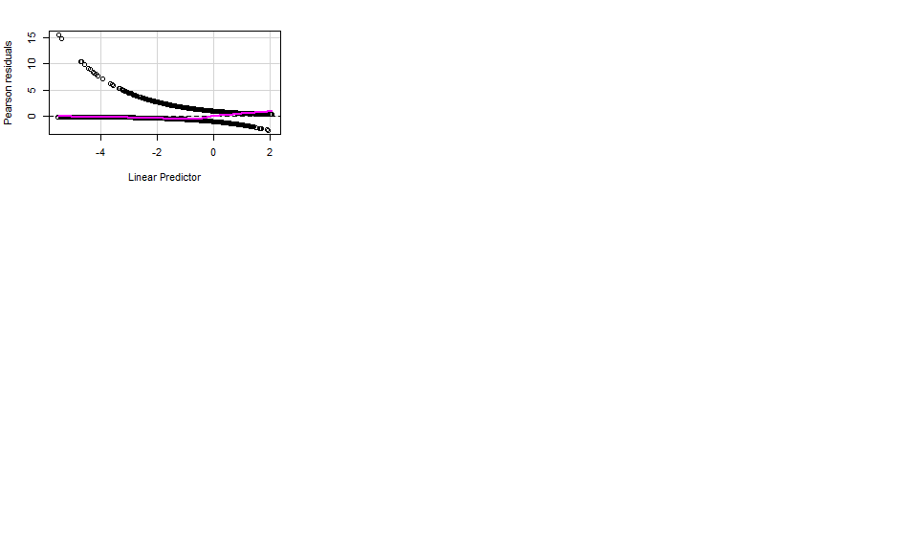

## Test stat Pr(>|Test stat|)  
## SeniorCitizen   
## poly(tenure, 2)   
## MultipleLines   
## OnlineSecurity   
## OnlineBackup   
## TechSupport   
## Contract   
## PaperlessBilling   
## MonthlyCharges 0.4256 0.5142

marginalModelPlots(mod3)

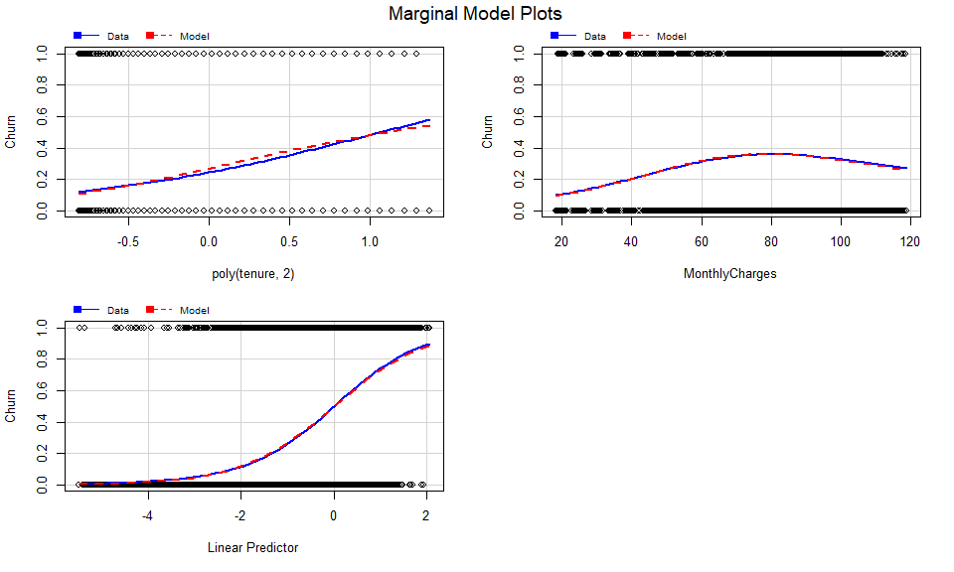

influencePlot(mod3)

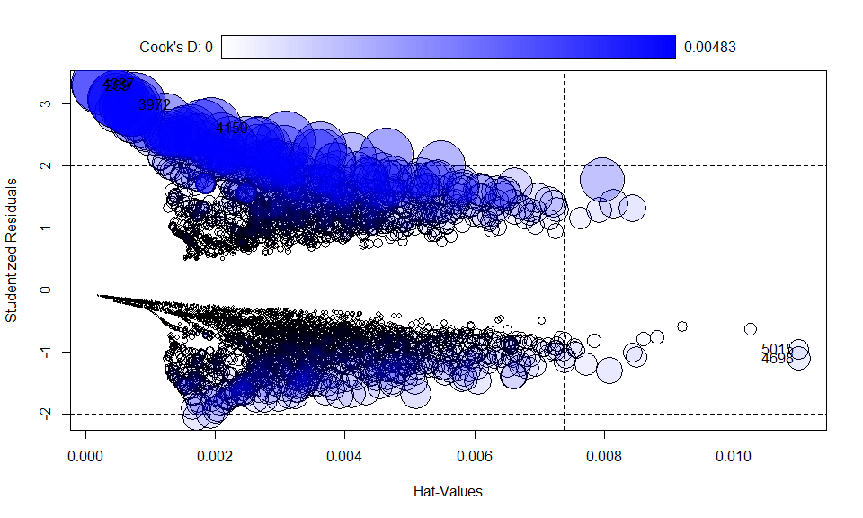

## StudRes Hat CookD  
## 5015 -0.954685 0.0109996750 0.0004950570  
## 269 3.290572 0.0002419871 0.0040538545  
## 4150 2.614033 0.0019388313 0.0042864608  
## 4387 3.318092 0.0002008891 0.0036955404  
## 4698 -1.093540 0.0110005478 0.0007008811  
## 3972 2.989649 0.0007499970 0.0048288428

cook <- Boxplot(cooks.distance(mod3))

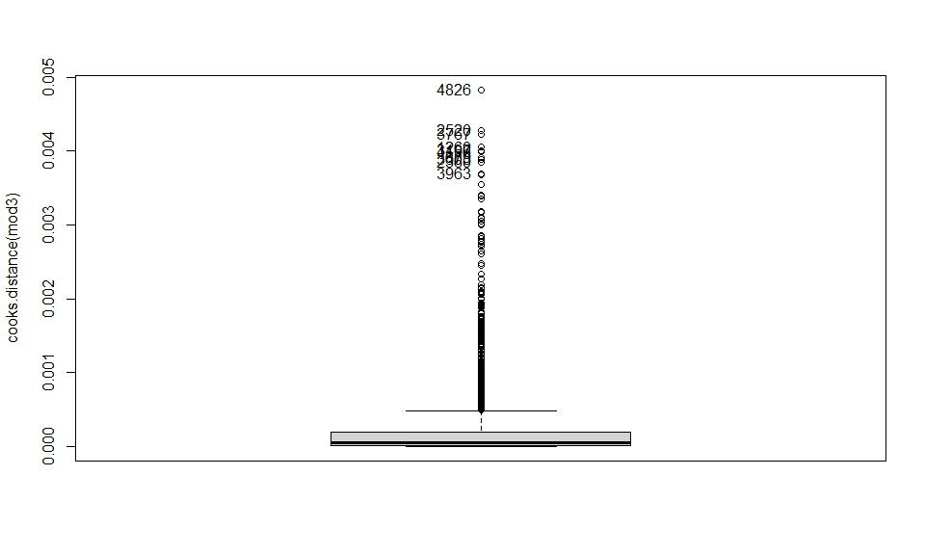

cookd <- sort(cooks.distance(mod3)[cook], decreasing=TRUE)  
cookd

## 3972 4150 4273 269 6425 6814   
## 0.004828843 0.004286461 0.004231198 0.004053854 0.004003822 0.003998106   
## 6725 5590 4528 4514   
## 0.003920864 0.003884925 0.003849025 0.003696433

length(rownames(train_new) %in% names(cookd)) #[1] 5282

## [1] 5282

## Factor interactions

Now, we are searching for interactions between factors in the model, beginning by testing some combinations of variables that had sense for us to have relation between them. We identify the one that yields the best results. But, given the high quantity of variables, manually exploring combinations becomes impractical. Hence, we employ the iterative stepwise method to check different combinations. The iteration providing the best results includes interactions between OnlineSecurity and TechSupport with a high representation, and MultipleLines and TechSupport with minimal representation. We tested the one with more representation alone, and then with both interactions to assess any significant improvement. However, there is no significant change observed, leading us to choose the simpler model, mod7.

mod4 <- glm(Churn ~ SeniorCitizen + poly(tenure, 2) + MultipleLines + OnlineSecurity + OnlineBackup + TechSupport + Contract * PaperlessBilling + MonthlyCharges, data=train_new, family = binomial)  
  
anova(mod3, mod4, test="Chisq")

## Analysis of Deviance Table  
##   
## Model 1: Churn ~ SeniorCitizen + poly(tenure, 2) + MultipleLines + OnlineSecurity +   
## OnlineBackup + TechSupport + Contract + PaperlessBilling +   
## MonthlyCharges  
## Model 2: Churn ~ SeniorCitizen + poly(tenure, 2) + MultipleLines + OnlineSecurity +   
## OnlineBackup + TechSupport + Contract * PaperlessBilling +   
## MonthlyCharges  
## Resid. Df Resid. Dev Df Deviance Pr(>Chi)  
## 1 5269 4442.2   
## 2 5267 4441.7 2 0.54682 0.7608

mod5 <- glm(Churn ~ SeniorCitizen + poly(tenure, 2) + (MultipleLines + OnlineSecurity + OnlineBackup + TechSupport)*MonthlyCharges + Contract + PaperlessBilling, data=train_new, family = binomial)  
  
anova(mod3, mod5, test="Chisq")

## Analysis of Deviance Table  
##   
## Model 1: Churn ~ SeniorCitizen + poly(tenure, 2) + MultipleLines + OnlineSecurity +   
## OnlineBackup + TechSupport + Contract + PaperlessBilling +   
## MonthlyCharges  
## Model 2: Churn ~ SeniorCitizen + poly(tenure, 2) + (MultipleLines + OnlineSecurity +   
## OnlineBackup + TechSupport) * MonthlyCharges + Contract +   
## PaperlessBilling  
## Resid. Df Resid. Dev Df Deviance Pr(>Chi)  
## 1 5269 4442.2   
## 2 5264 4437.4 5 4.7964 0.4412

mod6 <- glm(Churn ~ SeniorCitizen + poly(tenure, 2) + (MultipleLines + OnlineSecurity + OnlineBackup + TechSupport + MonthlyCharges)^2 + Contract + PaperlessBilling, data=train_new, family = binomial)  
  
step_mod <- step(mod6, trace=F) # Many variables make it impractical to manually explore their combinations - we employ the iterative stepwise method  
summary(step_mod)

##   
## Call:  
## glm(formula = Churn ~ SeniorCitizen + poly(tenure, 2) + MultipleLines +   
## OnlineSecurity + OnlineBackup + TechSupport + MonthlyCharges +   
## Contract + PaperlessBilling + MultipleLines:TechSupport +   
## OnlineSecurity:TechSupport, family = binomial, data = train_new)  
##   
## Coefficients:  
## Estimate Std. Error z value  
## (Intercept) -3.145537 0.157115 -20.021  
## SeniorCitizen1 0.259451 0.094679 2.740  
## poly(tenure, 2)1 -50.582871 4.767564 -10.610  
## poly(tenure, 2)2 23.668432 3.226857 7.335  
## MultipleLinesNo phone service 1.289467 0.158374 8.142  
## MultipleLinesYes 0.130584 0.104482 1.250  
## OnlineSecurityYes -0.681131 0.113830 -5.984  
## OnlineBackupYes -0.322770 0.089409 -3.610  
## TechSupportYes -0.631772 0.156778 -4.030  
## MonthlyCharges 0.033872 0.002073 16.341  
## ContractOne year -0.817754 0.121860 -6.711  
## ContractTwo year -2.145683 0.222457 -9.645  
## PaperlessBillingYes 0.345041 0.085413 4.040  
## MultipleLinesNo phone service:TechSupportYes -0.527034 0.320468 -1.645  
## MultipleLinesYes:TechSupportYes 0.092769 0.193980 0.478  
## OnlineSecurityYes:TechSupportYes 0.477683 0.202415 2.360  
## Pr(>|z|)   
## (Intercept) < 2e-16 ***  
## SeniorCitizen1 0.006138 **   
## poly(tenure, 2)1 < 2e-16 ***  
## poly(tenure, 2)2 2.22e-13 ***  
## MultipleLinesNo phone service 3.89e-16 ***  
## MultipleLinesYes 0.211365   
## OnlineSecurityYes 2.18e-09 ***  
## OnlineBackupYes 0.000306 ***  
## TechSupportYes 5.58e-05 ***  
## MonthlyCharges < 2e-16 ***  
## ContractOne year 1.94e-11 ***  
## ContractTwo year < 2e-16 ***  
## PaperlessBillingYes 5.35e-05 ***  
## MultipleLinesNo phone service:TechSupportYes 0.100058   
## MultipleLinesYes:TechSupportYes 0.632478   
## OnlineSecurityYes:TechSupportYes 0.018279 *   
## ---  
## Signif. codes: 0 '***' 0.001 '**' 0.01 '*' 0.05 '.' 0.1 ' ' 1  
##   
## (Dispersion parameter for binomial family taken to be 1)  
##   
## Null deviance: 6171.2 on 5281 degrees of freedom  
## Residual deviance: 4432.6 on 5266 degrees of freedom  
## AIC: 4464.6  
##   
## Number of Fisher Scoring iterations: 6

mod7 <- glm(Churn ~ SeniorCitizen + poly(tenure, 2) + MultipleLines + OnlineSecurity*TechSupport + OnlineBackup + MonthlyCharges + Contract + PaperlessBilling, data=train_new, family = binomial)  
  
anova(mod3, mod7, test="Chisq")

## Analysis of Deviance Table  
##   
## Model 1: Churn ~ SeniorCitizen + poly(tenure, 2) + MultipleLines + OnlineSecurity +   
## OnlineBackup + TechSupport + Contract + PaperlessBilling +   
## MonthlyCharges  
## Model 2: Churn ~ SeniorCitizen + poly(tenure, 2) + MultipleLines + OnlineSecurity *   
## TechSupport + OnlineBackup + MonthlyCharges + Contract +   
## PaperlessBilling  
## Resid. Df Resid. Dev Df Deviance Pr(>Chi)   
## 1 5269 4442.2   
## 2 5268 4436.7 1 5.5334 0.01866 *  
## ---  
## Signif. codes: 0 '***' 0.001 '**' 0.01 '*' 0.05 '.' 0.1 ' ' 1

mod8 <- glm(Churn ~ SeniorCitizen + poly(tenure, 2) + (MultipleLines + OnlineSecurity)*TechSupport + OnlineBackup + MonthlyCharges + Contract + PaperlessBilling, data=train_new, family = binomial)  
  
anova(mod7, mod8, test="Chisq") # No significant changes were observed; thus, we stick with the simpler model, mod7

## Analysis of Deviance Table  
##   
## Model 1: Churn ~ SeniorCitizen + poly(tenure, 2) + MultipleLines + OnlineSecurity *   
## TechSupport + OnlineBackup + MonthlyCharges + Contract +   
## PaperlessBilling  
## Model 2: Churn ~ SeniorCitizen + poly(tenure, 2) + (MultipleLines + OnlineSecurity) *   
## TechSupport + OnlineBackup + MonthlyCharges + Contract +   
## PaperlessBilling  
## Resid. Df Resid. Dev Df Deviance Pr(>Chi)  
## 1 5268 4436.7   
## 2 5266 4432.6 2 4.068 0.1308

## Model Interpretation and residual analysis

From the effects plots and the betas we can draw the following conclusions:

* Senior Citizen are more likely to Churn than no Senior Citizens as the have an odds of 1.3 against non senior citizens.
* We can understand tenure very easily thanks to the plot of effects. We can see how old clients of the company (old in terms of months in the company) are less probable to live the company although it smoothes this behavior as the client reaches 40 months, this is a very important variable in order to explain churns.
* Those clients who don’t have a phone service have an odds of 3.2 for leaving compared to those who only have 1 line.
* The clients who have Online Backup are less likely to live the company, with an odds of 0.72 compared to those who have not.
* Monthly charges has a linear relation with the probability of Churn, in other words, the probability of leaving is higher as the MonthlyCharges become higher. The odds of leaving for every unit of Monthly Charges is 1.0344. This is also a very important variable in our model.
* Those clients which have a shorter contract effect are more prone to leave than the others. We can see how the odds of leaving for Two year effect contracts is 0.11 compared to Month-to-Month. So the probability of leaving for those who have month-to-month contract are 9 times higher.
* Paperless Billing has also an effect with an odds ratio of 1.42 of yes against no.
* Lastly we can check the effect of the interaction between Online Security and Tech Support. If the client has Tech Support will be less likely to leave, otherwise will be more likely to leave, especially if she/he has not Online Security either.

We can see the effects on having an unbalanced dataset in our residual/Goodness of fit analysis. We can interpret from the plots that our residuals are far more likely to have extreme positive values rather than negative ones. In fact they are very related to the conclusions of the model interpretation. As the combination of variables gets more prone to not churn we will see more influential values in the positive axis.

summary(mod7)

##   
## Call:  
## glm(formula = Churn ~ SeniorCitizen + poly(tenure, 2) + MultipleLines +   
## OnlineSecurity * TechSupport + OnlineBackup + MonthlyCharges +   
## Contract + PaperlessBilling, family = binomial, data = train_new)  
##   
## Coefficients:  
## Estimate Std. Error z value Pr(>|z|)   
## (Intercept) -3.142762 0.156737 -20.051 < 2e-16 ***  
## SeniorCitizen1 0.261661 0.094745 2.762 0.005749 **   
## poly(tenure, 2)1 -50.095970 4.742029 -10.564 < 2e-16 ***  
## poly(tenure, 2)2 23.855515 3.211963 7.427 1.11e-13 ***  
## MultipleLinesNo phone service 1.163172 0.141899 8.197 2.46e-16 ***  
## MultipleLinesYes 0.149771 0.094602 1.583 0.113384   
## OnlineSecurityYes -0.682007 0.113778 -5.994 2.04e-09 ***  
## TechSupportYes -0.646185 0.114362 -5.650 1.60e-08 ***  
## OnlineBackupYes -0.321563 0.089315 -3.600 0.000318 ***  
## MonthlyCharges 0.033880 0.002066 16.395 < 2e-16 ***  
## ContractOne year -0.818931 0.121691 -6.730 1.70e-11 ***  
## ContractTwo year -2.152023 0.221340 -9.723 < 2e-16 ***  
## PaperlessBillingYes 0.350968 0.085270 4.116 3.86e-05 ***  
## OnlineSecurityYes:TechSupportYes 0.477552 0.202089 2.363 0.018124 *   
## ---  
## Signif. codes: 0 '***' 0.001 '**' 0.01 '*' 0.05 '.' 0.1 ' ' 1  
##   
## (Dispersion parameter for binomial family taken to be 1)  
##   
## Null deviance: 6171.2 on 5281 degrees of freedom  
## Residual deviance: 4436.7 on 5268 degrees of freedom  
## AIC: 4464.7  
##   
## Number of Fisher Scoring iterations: 6

vif(mod7)

## there are higher-order terms (interactions) in this model  
## consider setting type = 'predictor'; see ?vif

## GVIF Df GVIF^(1/(2*Df))  
## SeniorCitizen 1.097232 1 1.047489  
## poly(tenure, 2) 2.448750 2 1.250939  
## MultipleLines 1.924345 2 1.177798  
## OnlineSecurity 1.586071 1 1.259393  
## TechSupport 1.625500 1 1.274951  
## OnlineBackup 1.264149 1 1.124344  
## MonthlyCharges 2.270735 1 1.506896  
## Contract 1.754205 2 1.150854  
## PaperlessBilling 1.122019 1 1.059254  
## OnlineSecurity:TechSupport 2.158190 1 1.469078

exp(mod7$coefficients)

## (Intercept) SeniorCitizen1   
## 4.316340e-02 1.299086e+00   
## poly(tenure, 2)1 poly(tenure, 2)2   
## 1.752252e-22 2.292549e+10   
## MultipleLinesNo phone service MultipleLinesYes   
## 3.200069e+00 1.161568e+00   
## OnlineSecurityYes TechSupportYes   
## 5.056011e-01 5.240411e-01   
## OnlineBackupYes MonthlyCharges   
## 7.250153e-01 1.034460e+00   
## ContractOne year ContractTwo year   
## 4.409028e-01 1.162488e-01   
## PaperlessBillingYes OnlineSecurityYes:TechSupportYes   
## 1.420442e+00 1.612123e+00

par(mfrow=c(1,2))  
plot(allEffects(mod = mod7))

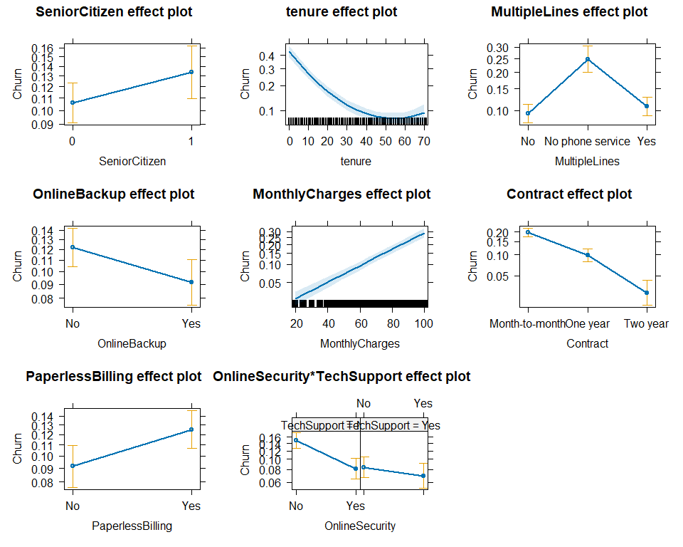

sum( resid( mod7, "pearson") ^2 )

## [1] 5607.608

residualPlots(mod7)

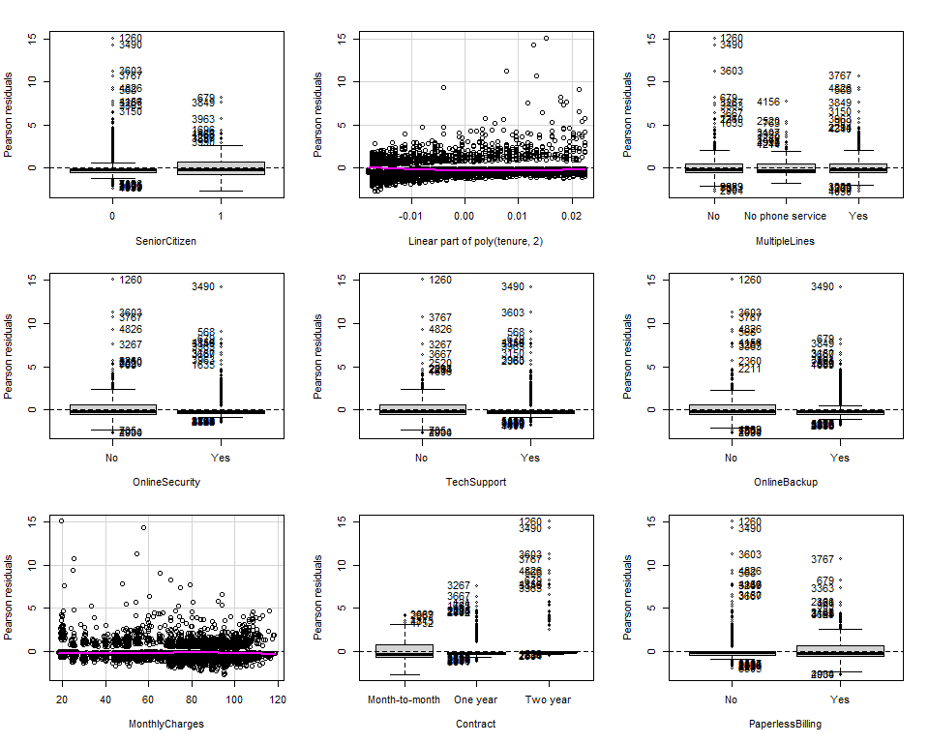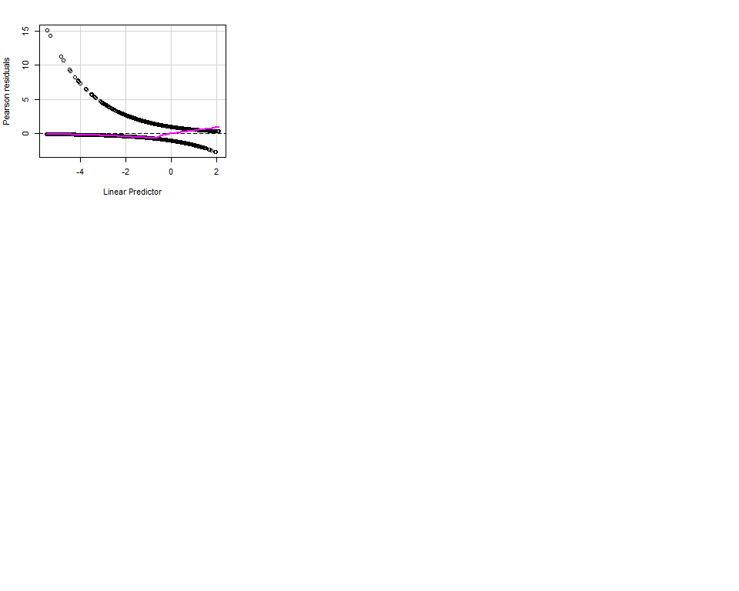

## Test stat Pr(>|Test stat|)  
## SeniorCitizen   
## poly(tenure, 2)   
## MultipleLines   
## OnlineSecurity   
## TechSupport   
## OnlineBackup   
## MonthlyCharges 0.2991 0.5844  
## Contract   
## PaperlessBilling

influencePlot(mod7)

## StudRes Hat CookD  
## 5015 -0.9669999 0.0111716287 0.0004821169  
## 269 3.3050018 0.0002356469 0.0038429673  
## 4387 3.2718677 0.0002489926 0.0036447601  
## 5590 3.1264571 0.0004481656 0.0040966086  
## 4698 -1.1103032 0.0111496498 0.0006869491  
## 3972 3.0060673 0.0007301710 0.0045848121

cook <- Boxplot(cooks.distance(mod7))

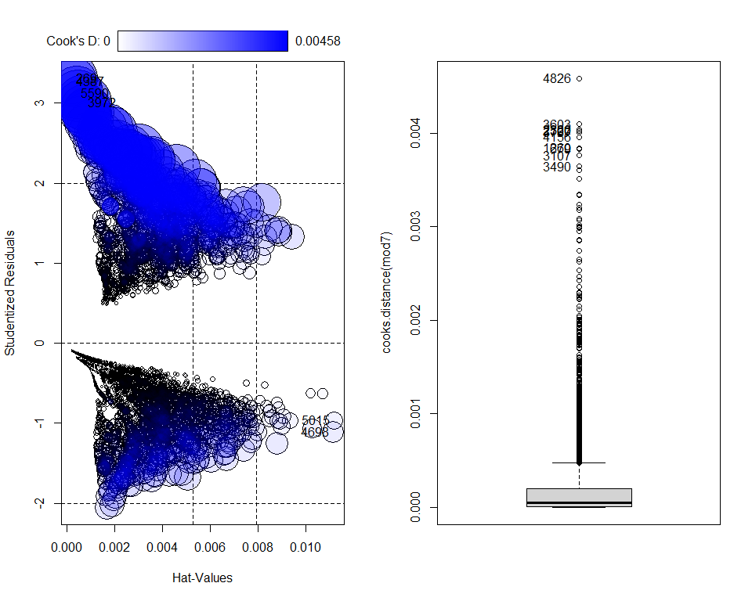

cookd <- sort(cooks.distance(mod7)[cook], decreasing=TRUE)  
cookd

## 3972 5590 4528 4150 4273 6814   
## 0.004584812 0.004096609 0.004038624 0.004026787 0.004008097 0.003957548   
## 269 6725 6425 4387   
## 0.003842967 0.003832726 0.003761736 0.003644760

length(rownames(train_new) %in% names(cookd)) #[1] 5282

## [1] 5282

The final model has this form.

$$\begin{matrix}y= & -3.1427α+β_{\text{SeniorCitizen1}}0.26+β_{\text{tenure}}\left(-50.09\right)+β_{{\text{tenure}}^{2}}23.85 \\ & +β_{\text{MultipleLinesNo phone service}}1.16+β_{\text{MultipleLinesYes}}0.14+β_{\text{OnlineSecurityYes}}\left(-0.68\right) \\ & +β_{\text{TechSupportYes}}\left(-0.64\right)+β_{\text{OnlineBackupYes}}\left(-0.32\right)+β_{\text{MonthlyCharges}}0.03 \\ & +β_{\text{ContractOne year}}\left(-0.81\right)+β_{\text{ContractTwo year}}\left(-2.15\right)+β_{\text{PaperlessBillingYes}}0.35 \\ & +β_{\text{OnlineSecurityYes:TechSupportYes}}0.47\end{matrix}$$

## Goodness of fit

### Standarize test

test_new$OnlineBackup <- test_new$OnlineBackup %>% as.character()  
test_new$OnlineSecurity <- test_new$OnlineSecurity %>% as.character()  
test_new$DeviceProtection<- test_new$DeviceProtection %>% as.character()  
test_new$TechSupport <- test_new$TechSupport %>% as.character()  
test_new$StreamingTV <- test_new$StreamingTV %>% as.character()  
test_new$StreamingMovies <- test_new$StreamingMovies %>% as.character()  
  
test_new$OnlineBackup <- ifelse(test_new$OnlineBackup == 'No internet service', 'No', test_new$OnlineBackup)  
test_new$OnlineSecurity <- ifelse(test_new$OnlineSecurity == 'No internet service', 'No', test_new$OnlineSecurity)  
test_new$DeviceProtection <- ifelse(test_new$DeviceProtection == 'No internet service', 'No', test_new$DeviceProtection)  
test_new$TechSupport <- ifelse(test_new$TechSupport == 'No internet service', 'No', test_new$TechSupport)  
test_new$StreamingTV <- ifelse(test_new$StreamingTV == 'No internet service', 'No', test_new$StreamingTV)  
test_new$StreamingMovies <- ifelse(test_new$StreamingMovies == 'No internet service', 'No', test_new$StreamingTV)  
  
test_new$OnlineBackup <- test_new$OnlineBackup %>% as.factor()  
test_new$OnlineSecurity <- test_new$OnlineSecurity %>% as.factor()  
test_new$DeviceProtection<- test_new$DeviceProtection %>% as.factor()  
test_new$TechSupport <- test_new$TechSupport %>% as.factor()  
test_new$StreamingTV <- test_new$StreamingTV %>% as.factor()  
test_new$StreamingMovies <- test_new$StreamingMovies %>% as.factor()

We utilized 20% of our data to establish the goodness of fit, applying the final model to predict churn within our test set. Subsequently, we applied a 0.5 threshold, obtaining an accuracy of 0.83. Notwithstanding the semblance of a good fit, misleading interpretations could arise due to an imbalanced dataset.

Exploration of the metrics table highlights a F1 score of 0.62 and a recall of 0.57, providing a clearer picture. It led us to the decision of changing the threshold to 0.4 based on the Receiver Operating Characteristic (ROC) curve. Despite a minor decrease in accuracy to 0.81, we noted an improvement in the F1 score to 0.64 and a significant increase in recall (0.68). We consider this shift important because the company is more concerned about false positives since they have a greater impact on the business than false negatives.

final_model <- mod7  
dim(test_new)

## [1] 1761 23

predictions <- predict(final_model,test_new, type="response")  
test_new$PredictedChurn <- ifelse(predictions > 0.5,"Yes","No") %>% as.factor  
val <- table(test_new$PredictedChurn, test_new$Churn)  
  
val %>% knitr::kable()

|  | No | Yes |
| --- | --- | --- |
| No | 1210 | 189 |
| Yes | 113 | 249 |

accuracy <- sum(diag(val))/sum(val)  
TP <- val[2,2]  
FN <- val[1,2]  
FP <- val[2,1]  
  
accuracy <- sum(diag(val))/sum(val)  
Recall <- TP/(TP+FN)  
Precision <- TP / (TP + FP)  
F1 <- 2 * (Precision * Recall) / (Precision + Recall)  
  
GOF <- rbind(accuracy, Recall, Precision, F1)  
colnames(GOF) <- "Metrics"  
GOF %>% round(2) %>% knitr::kable()

|  | Metrics |
| --- | --- |
| accuracy | 0.83 |
| Recall | 0.57 |
| Precision | 0.69 |
| F1 | 0.62 |

library("ROCR")

## Warning: package 'ROCR' was built under R version 4.3.2

dadesroc<-prediction(predict(final_model, newdata = test_new,type="response"),test_new$Churn)  
par(mfrow=c(1,2))  
plot(performance(dadesroc,"err"))  
plot(performance(dadesroc,"tpr","fpr"))  
abline(0,1,lty=2)

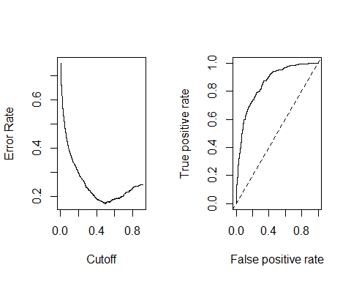

predictions <- predict(final_model,test_new, type="response")  
test_new$PredictedChurn <- ifelse(predictions > 0.4,"Yes","No") %>% as.factor  
val <- table(test_new$PredictedChurn, test_new$Churn)  
  
table(test_new$PredictedChurn)

##   
## No Yes   
## 1263 498

table(test_new$Churn)

##   
## No Yes   
## 1323 438

TP <- val[2,2]  
FN <- val[1,2]  
FP <- val[2,1]  
  
accuracy <- sum(diag(val))/sum(val)  
Recall <- TP/(TP+FN)  
Precision <- TP / (TP + FP)  
F1 <- 2 * (Precision * Recall) / (Precision + Recall)  
  
GOF <- rbind(accuracy, Recall, Precision, F1)  
colnames(GOF) <- "Metrics"  
GOF %>% round(2) %>% knitr::kable()

|  | Metrics |
| --- | --- |
| accuracy | 0.81 |
| Recall | 0.68 |
| Precision | 0.60 |
| F1 | 0.64 |

## F1 improves so we will keep the second threshold

# ANNEXES

In this section we are including a continuation of the *catdes* function that we show in the Profiling section.

## Description of each cluster by the categories  
## =============================================  
## $No  
## Cla/Mod Mod/Cla Global  
## Contract=Two year 97.16814 31.83224 24.06645  
## f.tenure=HighTenure 92.25071 31.29107 24.91836  
## StreamingMovies=No internet service 92.59502 27.30963 21.66690  
## StreamingTV=No internet service 92.59502 27.30963 21.66690  
## TechSupport=No internet service 92.59502 27.30963 21.66690  
## DeviceProtection=No internet service 92.59502 27.30963 21.66690  
## OnlineBackup=No internet service 92.59502 27.30963 21.66690  
## OnlineSecurity=No internet service 92.59502 27.30963 21.66690  
## InternetService=No 92.59502 27.30963 21.66690  
## f.MonthlyCharges=LowMonthlyCharges 88.76277 30.22806 25.01775  
## PaperlessBilling=No 83.66992 46.44376 40.77808  
## Contract=One year 88.73048 25.26092 20.91438  
## OnlineSecurity=Yes 85.38881 33.32045 28.66676  
## TechSupport=Yes 84.83366 33.51372 29.02172  
## Dependents=Yes 84.54976 34.48009 29.95882  
## f.TotalCharges=HighTotalCharges 85.51959 29.10707 25.00355  
## Partner=Yes 80.33510 52.82180 48.30328  
## SeniorCitizen=0 76.39383 87.12795 83.78532  
## PaymentMethod=Credit card (automatic) 84.75690 24.93235 21.61011  
## InternetService=DSL 81.04089 37.92037 34.37456  
## PaymentMethod=Bank transfer (automatic) 83.29016 24.85504 21.92248  
## f.tenure=HighMidTenure 81.95638 23.96598 21.48232  
## PaymentMethod=Mailed check 80.89330 25.20294 22.88797  
## OnlineBackup=Yes 78.46851 36.83804 34.48814  
## DeviceProtection=Yes 77.49794 36.27754 34.38875  
## f.TotalCharges=LowMidTotalCharges 76.02584 38.67414 37.37044  
## f.MonthlyCharges=LowMidMonthlyCharges 76.73049 20.13916 19.28156  
## MultipleLines=No 74.95575 49.11094 48.13290  
## MultipleLines=Yes 71.39010 40.99343 42.18373  
## StreamingMovies=Yes 70.05857 36.99266 38.79029  
## StreamingTV=Yes 69.92981 36.58678 38.43533  
## f.MonthlyCharges=HighMonthlyCharges 67.12173 22.80634 24.96095  
## StreamingTV=No 66.47687 36.10359 39.89777  
## StreamingMovies=No 66.31957 35.69772 39.54281  
## f.MonthlyCharges=HighMidMonthlyCharges 64.11085 26.82644 30.73974  
## SeniorCitizen=1 58.31874 12.87205 16.21468  
## Partner=No 67.04202 47.17820 51.69672  
## Dependents=No 68.72086 65.51991 70.04118  
## PaperlessBilling=Yes 66.43491 53.55624 59.22192  
## f.TotalCharges=LowTotalCharges 56.75369 19.32741 25.01775  
## DeviceProtection=No 60.87237 36.41283 43.94434  
## OnlineBackup=No 60.07124 35.85234 43.84495  
## PaymentMethod=Electronic check 54.71459 25.00966 33.57944  
## f.tenure=LowTenure 50.21575 17.99382 26.32401  
## InternetService=Fiber optic 58.10724 34.77000 43.95854  
## TechSupport=No 58.36453 39.17665 49.31137  
## OnlineSecurity=No 58.23328 39.36993 49.66634  
## Contract=Month-to-month 57.29032 42.90684 55.01917  
## p.value v.test  
## Contract=Two year 3.588830e-187 29.178937  
## f.tenure=HighTenure 2.648159e-111 22.417648  
## StreamingMovies=No internet service 6.584621e-98 20.999812  
## StreamingTV=No internet service 6.584621e-98 20.999812  
## TechSupport=No internet service 6.584621e-98 20.999812  
## DeviceProtection=No internet service 6.584621e-98 20.999812  
## OnlineBackup=No internet service 6.584621e-98 20.999812  
## OnlineSecurity=No internet service 6.584621e-98 20.999812  
## InternetService=No 6.584621e-98 20.999812  
## f.MonthlyCharges=LowMonthlyCharges 2.427769e-71 17.859738  
## PaperlessBilling=No 1.072745e-60 16.435085  
## Contract=One year 3.593041e-57 15.935502  
## OnlineSecurity=Yes 1.606459e-50 14.947938  
## TechSupport=Yes 1.323174e-46 14.334963  
## Dependents=Yes 3.572324e-46 14.265846  
## f.TotalCharges=HighTotalCharges 1.961203e-43 13.818871  
## Partner=Yes 6.170871e-37 12.696658  
## SeniorCitizen=0 3.024931e-34 12.202212  
## PaymentMethod=Credit card (automatic) 6.408166e-32 11.758206  
## InternetService=DSL 2.545367e-26 10.614727  
## PaymentMethod=Bank transfer (automatic) 1.180908e-24 10.250207  
## f.tenure=HighMidTenure 3.472392e-18 8.694866  
## PaymentMethod=Mailed check 3.226893e-15 7.881803  
## OnlineBackup=Yes 3.021982e-12 6.976698  
## DeviceProtection=Yes 2.173366e-08 5.597602  
## f.TotalCharges=LowMidTotalCharges 1.584501e-04 3.777438  
## f.MonthlyCharges=LowMidMonthlyCharges 2.193215e-03 3.062739  
## MultipleLines=No 6.262488e-03 2.733712  
## MultipleLines=Yes 7.843169e-04 -3.358271  
## StreamingMovies=Yes 2.922571e-07 -5.128373  
## StreamingTV=Yes 1.283457e-07 -5.281193  
## f.MonthlyCharges=HighMonthlyCharges 7.414051e-12 -6.849438  
## StreamingTV=No 6.049871e-27 -10.748094  
## StreamingMovies=No 1.092934e-27 -10.904833  
## f.MonthlyCharges=HighMidMonthlyCharges 2.251358e-31 -11.651621  
## SeniorCitizen=1 3.024931e-34 -12.202212  
## Partner=No 6.170871e-37 -12.696658  
## Dependents=No 3.572324e-46 -14.265846  
## PaperlessBilling=Yes 1.072745e-60 -16.435085  
## f.TotalCharges=LowTotalCharges 8.566779e-71 -17.789218  
## DeviceProtection=No 1.116896e-99 -21.192627  
## OnlineBackup=No 3.366400e-112 -22.509287  
## PaymentMethod=Electronic check 1.790860e-136 -24.864755  
## f.tenure=LowTenure 1.176431e-143 -25.520203  
## InternetService=Fiber optic 2.289126e-148 -25.941138  
## TechSupport=No 1.899538e-183 -28.883947  
## OnlineSecurity=No 6.171504e-190 -29.396034  
## Contract=Month-to-month 3.620915e-283 -35.959308  
##   
## $Yes  
## Cla/Mod Mod/Cla Global  
## Contract=Month-to-month 42.709677 88.550027 55.01917  
## OnlineSecurity=No 41.766724 78.170144 49.66634  
## TechSupport=No 41.635474 77.367576 49.31137  
## InternetService=Fiber optic 41.892765 69.395399 43.95854  
## f.tenure=LowTenure 49.784250 49.384698 26.32401  
## PaymentMethod=Electronic check 45.285412 57.303371 33.57944  
## OnlineBackup=No 39.928756 65.971108 43.84495  
## DeviceProtection=No 39.127625 64.794007 43.94434  
## f.TotalCharges=LowTotalCharges 43.246311 40.770465 25.01775  
## PaperlessBilling=Yes 33.565092 74.906367 59.22192  
## Dependents=No 31.279140 82.557517 70.04118  
## Partner=No 32.957979 64.205457 51.69672  
## SeniorCitizen=1 41.681261 25.468165 16.21468  
## f.MonthlyCharges=HighMidMonthlyCharges 35.889145 41.573034 30.73974  
## StreamingMovies=No 33.680431 50.187266 39.54281  
## StreamingTV=No 33.523132 50.401284 39.89777  
## f.MonthlyCharges=HighMonthlyCharges 32.878271 30.925629 24.96095  
## StreamingTV=Yes 30.070188 43.552702 38.43533  
## StreamingMovies=Yes 29.941435 43.766720 38.79029  
## MultipleLines=Yes 28.609896 45.478866 42.18373  
## MultipleLines=No 25.044248 45.425361 48.13290  
## f.MonthlyCharges=LowMidMonthlyCharges 23.269514 16.907437 19.28156  
## f.TotalCharges=LowMidTotalCharges 23.974164 33.761370 37.37044  
## DeviceProtection=Yes 22.502064 29.159979 34.38875  
## OnlineBackup=Yes 21.531494 27.982879 34.48814  
## PaymentMethod=Mailed check 19.106700 16.479401 22.88797  
## f.tenure=HighMidTenure 18.043622 14.606742 21.48232  
## PaymentMethod=Bank transfer (automatic) 16.709845 13.804173 21.92248  
## InternetService=DSL 18.959108 24.558587 34.37456  
## PaymentMethod=Credit card (automatic) 15.243101 12.413055 21.61011  
## SeniorCitizen=0 23.606168 74.531835 83.78532  
## Partner=Yes 19.664903 35.794543 48.30328  
## f.TotalCharges=HighTotalCharges 14.480409 13.643660 25.00355  
## Dependents=Yes 15.450237 17.442483 29.95882  
## TechSupport=Yes 15.166341 16.586410 29.02172  
## OnlineSecurity=Yes 14.611194 15.783842 28.66676  
## Contract=One year 11.269518 8.881755 20.91438  
## PaperlessBilling=No 16.330084 25.093633 40.77808  
## f.MonthlyCharges=LowMonthlyCharges 11.237230 10.593900 25.01775  
## StreamingMovies=No internet service 7.404980 6.046014 21.66690  
## StreamingTV=No internet service 7.404980 6.046014 21.66690  
## TechSupport=No internet service 7.404980 6.046014 21.66690  
## DeviceProtection=No internet service 7.404980 6.046014 21.66690  
## OnlineBackup=No internet service 7.404980 6.046014 21.66690  
## OnlineSecurity=No internet service 7.404980 6.046014 21.66690  
## InternetService=No 7.404980 6.046014 21.66690  
## f.tenure=HighTenure 7.749288 7.276619 24.91836  
## Contract=Two year 2.831858 2.568218 24.06645  
## p.value v.test  
## Contract=Month-to-month 3.620915e-283 35.959308  
## OnlineSecurity=No 6.171504e-190 29.396034  
## TechSupport=No 1.899538e-183 28.883947  
## InternetService=Fiber optic 2.289126e-148 25.941138  
## f.tenure=LowTenure 1.176431e-143 25.520203  
## PaymentMethod=Electronic check 1.790860e-136 24.864755  
## OnlineBackup=No 3.366400e-112 22.509287  
## DeviceProtection=No 1.116896e-99 21.192627  
## f.TotalCharges=LowTotalCharges 8.566779e-71 17.789218  
## PaperlessBilling=Yes 1.072745e-60 16.435085  
## Dependents=No 3.572324e-46 14.265846  
## Partner=No 6.170871e-37 12.696658  
## SeniorCitizen=1 3.024931e-34 12.202212  
## f.MonthlyCharges=HighMidMonthlyCharges 2.251358e-31 11.651621  
## StreamingMovies=No 1.092934e-27 10.904833  
## StreamingTV=No 6.049871e-27 10.748094  
## f.MonthlyCharges=HighMonthlyCharges 7.414051e-12 6.849438  
## StreamingTV=Yes 1.283457e-07 5.281193  
## StreamingMovies=Yes 2.922571e-07 5.128373  
## MultipleLines=Yes 7.843169e-04 3.358271  
## MultipleLines=No 6.262488e-03 -2.733712  
## f.MonthlyCharges=LowMidMonthlyCharges 2.193215e-03 -3.062739  
## f.TotalCharges=LowMidTotalCharges 1.584501e-04 -3.777438  
## DeviceProtection=Yes 2.173366e-08 -5.597602  
## OnlineBackup=Yes 3.021982e-12 -6.976698  
## PaymentMethod=Mailed check 3.226893e-15 -7.881803  
## f.tenure=HighMidTenure 3.472392e-18 -8.694866  
## PaymentMethod=Bank transfer (automatic) 1.180908e-24 -10.250207  
## InternetService=DSL 2.545367e-26 -10.614727  
## PaymentMethod=Credit card (automatic) 6.408166e-32 -11.758206  
## SeniorCitizen=0 3.024931e-34 -12.202212  
## Partner=Yes 6.170871e-37 -12.696658  
## f.TotalCharges=HighTotalCharges 1.961203e-43 -13.818871  
## Dependents=Yes 3.572324e-46 -14.265846  
## TechSupport=Yes 1.323174e-46 -14.334963  
## OnlineSecurity=Yes 1.606459e-50 -14.947938  
## Contract=One year 3.593041e-57 -15.935502  
## PaperlessBilling=No 1.072745e-60 -16.435085  
## f.MonthlyCharges=LowMonthlyCharges 2.427769e-71 -17.859738  
## StreamingMovies=No internet service 6.584621e-98 -20.999812  
## StreamingTV=No internet service 6.584621e-98 -20.999812  
## TechSupport=No internet service 6.584621e-98 -20.999812  
## DeviceProtection=No internet service 6.584621e-98 -20.999812  
## OnlineBackup=No internet service 6.584621e-98 -20.999812  
## OnlineSecurity=No internet service 6.584621e-98 -20.999812  
## InternetService=No 6.584621e-98 -20.999812  
## f.tenure=HighTenure 2.648159e-111 -22.417648  
## Contract=Two year 3.588830e-187 -29.178937  
##   
##