GitHub Repository Link: https://github.com/IgnacioLY9/CS5833Project/
GitHub PR Link:
YouTube Demo:

Group Members and Contributions:
Ignacio Yockers, 113498513, Ignacio.l.yockers-1@ou.edu
As this was an individual project, there was no collaboration or communication with other group members.

Introduction
The goal of this project was to contribute to an existing Ethereum of Web3 project/application. This project improved the Blobscan repository. New API endpoints were added. Documentation for certain existing endpoints was improved. The installation guide for local use was updated.

Background
What is a blob?
It is a way of scaling the Ethereum blockchain.
They carry data and transactions that can not be accessed by the EVM, but they are still included in the consensus of the chain.
They are meant to be a sort of short term storage and they can be safely deleted after a brief amount of time.
Why would the Ethereum blockchain want blobs?
Allows for more transactions to be performed off-chain. This reduces the load on the main block chain and reduces gas prices for users.
Why is Blobscan important. Why should it be contributed to as a repository?
It gives users the ability to focus primarily on blobs. Using Blobscan, users and developers can more easily look at real-time, or historical, information about blobs on the Ethereum blockchain to better estimate gas prices.
It provides users with an API they can use to directly query information they would like about blobs.

Methodology and Contributions
The Blobscan API is limited. Some users expressed disappointment. To contribute to this repository, new API endpoints were added.
Additionally, there are “issues” with the API endpoints only because of a lack of documentation.
New API endpoints were added along with corresponding test files.
Getgassummary.
Originally, users were only able to query information about avg blob gas prices. A user would not be able to directly query additional information about the distribution of gas prices.
The Blobscan repository keeps track of some overall statistics about blobs. These statistics are updated every 15 minutes and stored in the database. Whenever a user wants to see the overall statistics, the API fetches the results from the table in the database.
Added a 5 number summary. I implemented this by adding a new table in the database to store the summary. Just like the original table, it is updated every 15 minutes and the entries are returned to the user whenever a request is made.
Blobtransactions
This endpoint returns the transactions contained within a blob. It searches for a specific blob by versioned hash or kzg commit.
Blockgasprice
Returns the total blob gas price of a specific block. Limitations: the Blobscan database only stores blocks that contain blobs. So a valid block id could be entered and the endpoint will return a 404 error. This is made clear in the documentation. Similarly, the previous endpoint block/{id} also has the same limitation. This was not mentioned anywhere. It has been added to the documentation.
Gastime
Retrieves the avgblob gas price of certain time ranges. This allows users to see how the avg blob gas price has changed of over the last day/week/etc or all time.
The returned gas prices come with timestamps.
Initial installation of the Blobscan repository
Difficult and kept kept crashing
Decide to update the installation page

Results
Original blobs API endpoints:
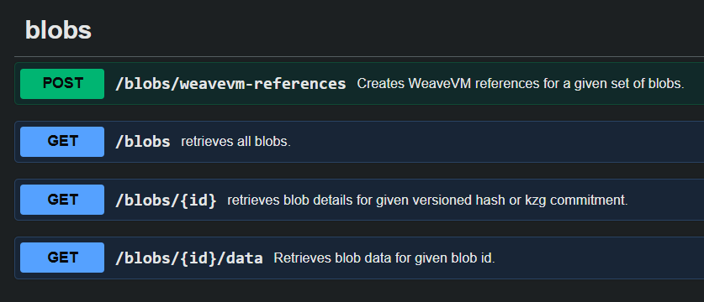
Updated blobs API endpoints:
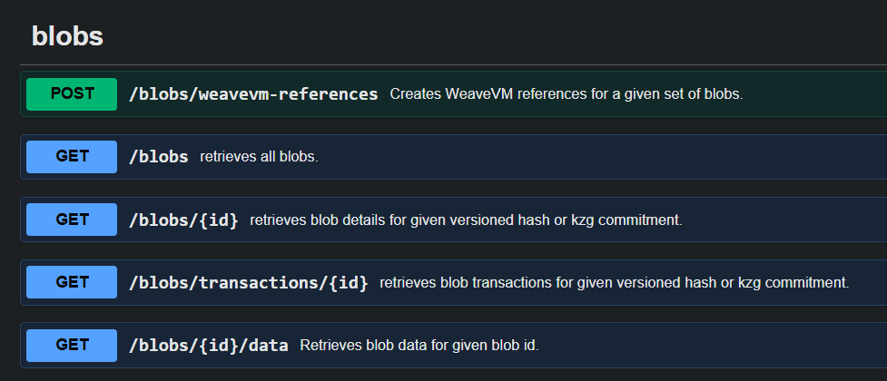
Original blocks API endpoints:
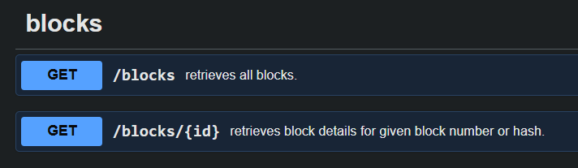
Updated blocks API endpoints:
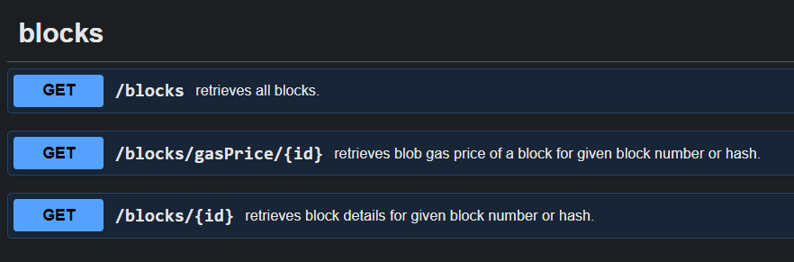
Original stats API endpoints:
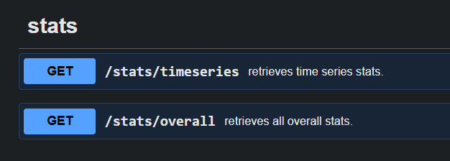
Updated stats API endpoints:
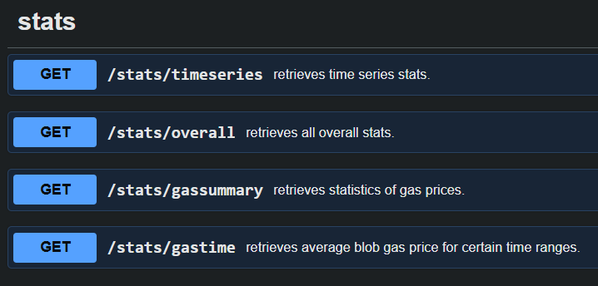
The code for the added API endpoints can be found within /packages/api/src/routers. The specific files added were:
- /stats/getGasSummary.ts
- /stats/getGasTime.ts
- /blob/getBlobTransactions.ts
- /block/getBlockGasPrice.ts
The corresponding test file for each added API endpoint can found within /packages/api/test. The specific files added and their associated successful tests were:
- /stats/getGasSummary.test.ts
- /stats/getGasTime.test.ts
- /blob/getBlobTransactions..test.ts
- /block/getBlockGasPrice.test.ts
The required updates to the database schema can be found in /packages/db/prisma/schema.prisma. The model GasStats previously did not exist and was added.
A PR was submitted to the original Blobscan repository. Only the updated documentation and installation guides were included. The API endpoints and their tests were not included because of the required changes to the database.

Conclusion

References
https://eips.ethereum.org/EIPS/eip-4844

Final Project Grading Rubric (90 points)
1. Technical Implementation & Contribution Quality (25 pts)
- Correctness and functionality: the contribution works as intended and proposed objectives are fully implemented (10)
- Depth and originality: non-trivial work that goes meaningfully beyond boilerplate; reflects genuine engagement with the target codebase (8)
- Code quality: logical structure, readable style, appropriate comments, adherence to the upstream project's conventions (4)
- Alignment with proposal: delivered work matches the contribution type committed to (bug fix, feature, tests, tooling, security, docs+code, or integration), or deviations are justified (3)
2. Engagement with the Open Source Project (15 pts)
- Contribution-quality artifact produced: well-documented issue, tested implementation, meaningful pull request, or high-quality fork with clear upstream relevance (6)
- Adherence to the upstream project's contribution guidelines, style, and review norms (4)
- Evidence of real interaction with the codebase: issue discussion, draft PR, maintainer feedback, or detailed write-up of why upstreaming is or is not yet feasible (5)
3. Evaluation & Validation (15 pts)
- Concrete evidence the work functions: unit or integration tests, reproducible local setup, testnet deployment where applicable (7)
- Quantitative or qualitative results: transaction traces, gas measurements, benchmarks, before/after comparisons, screenshots, or logs (5)
- Evaluation matches what the proposal committed to, with explanation for any deviation (3)
4. Final Report (15 pts)
- Organization and readability: introduction, background, methodology, results, conclusion flow logically; up to 10 pages, PDF or DOCX, with public GitHub repo URL at the start (5)
- Depth and accuracy: tools, frameworks, and methodology clearly explained; results presented with charts, data, or analysis where appropriate (6)
- Citations and references to relevant prior work, documentation, and the upstream project (4)
5. GitHub Activity & Repository Organization (10 pts)
- Commit regularity and quality: frequent commits across the 3-week window with meaningful messages, showing progressive work rather than a single end-of-term dump (6)
- Repository organization: public repo with clear README, folder structure, and instructions to build, run, and test (4)
6. Team Collaboration & Contribution (5 pts)
- Role definition: each member's contributions clearly listed for 2-person teams; clear scope and effort statement for solo students (3)
- Evidence of coordination: shared commit history, issues, or write-up indicating effective collaboration (2)
7. Self-Recorded Video & Presentation (5 pts)
- Approximately 5 minutes, linked in the report; covers goals, approach, key features, and a demo of the working contribution (3)
- Clear delivery with acceptable audio and video quality (2)
Total: 90 points

