Bitácora SILOS:

info util
# a-esima iteración de trayectoria | curva de distancia de largo 128*anglerepetition
# ^ ^
# | |
# distances_date_tuple_list[0][a][b][1]
# ^
# |
# b-esimo punto

Oct 23:

El objetivo de esta semana será el definir el algoritmo de detección de peaks. Para esto se estduió el libro <<Principles of modern Radars>> de Mark A. Richards. En este se halló que previo a definir el algoritmo de detección es necesario definir los siguientes puntos.

- First, will detection be based on a single fast-time sample or multiple samples? In the latter case, are the data organized into one or several CPIs? Using multiple samples requires more radar resources to collect and process the data but obtains better results for a given single-sample SNR.
- What integration strategies will be used? There are three choices: coherent, non-coherent, and binary integration.
- If using noncoherent integration, what type of single-sample envelope detection

- law will be used? Common choices are linear and square law, as will be seen
shortly; log detectors are also used.
- What target fluctuation model will be assumed? This requires specification of both a
probability density function and a decorrelation model for the target samples. (Note
that if detection is based on a single sample, decorrelation models are irrelevant.)
- Finally, will detection be based on a fixed threshold or on an adaptive threshold
that responds to changes in the interference level?

RCS = Radar Cross Section
LRT = Likelyhood Radar Test

primer idea de algortimo:

curva_corregida = curva – curva_al_infinto
curva_suavizada = savgol_filter(curva_corregida)
maxPeak = max(curva_suavizada)
<<encontrar puntos de derivada = 0 anteriores al maxPeak>>
<<encontrar primer punto máximo que supere un umbral a definir>>

oct 24:

Revisar derivada de 3 puntos

nov 14:

para conectarse a vpn de la u por terminal de pc usar comando

$printf 'USERNAME\nPASSWORD\ny' | /opt/cisco/anyconnect/bin/vpn -s connect HOST

HOST = vpn.uchile.cl

para deconectar

$/opt/cisco/anyconnect/bin/vpn disconnect

para instalar openconnect en raspberry

sudo apt install openconnect -y
sudo apt install network-manager-openconnect-gnome
sudo openconnect -u ignacio.velez -b vpn.uchile.cl
sudo kill -9 $(pgrep openconnect | awk '{print $1}')

Dic 18:

Se quiere decidir el tipo de interpolación para las curvas de cada medición, de momento las opciones son:
*.- CubicSplin con overshoot, pasa por cada uno de los puntos.
*.- Average moving Window de 3 muestras
*.- Kringing por estudiar

Guía instalación desde 0

OS- Raspian 64bits

1.-instalar ipython3
- sudo apt-get install ipython3
2.- Habilitar SSH connection:
-run $ sudo raspiconfig
->Interface Options > SSH enable
- desde un pc que tenga la carpeta silos, enviar los archivos id_ed25519 y id_ed25519.pub a la carpeta ~/.ssh/ de la raspberry en cuestión
3.- Clone git repository:
- $git –version: to check if git is already installed
- $git clone git@github.com:IgnacioVelezA/silos.git
4.- Install RealVNC
- $sudo raspi-config
- >Interfaces Options > VNC enable
- $sudo apt-get install realvnc-vnc-server
5.- Install openconnect para vpn
-$sudo apt install openconnect -y
-$sudo apt install network-manager-openconnect-gnome
6.- Openconnect para cloud connection
- En rasperry, entrar a OpCon,
- >menu>licensing>ingresar cuenta y nombre de conexión
Dependencias:

1.- arduino:
* motor_stepper.ino:
-#include <AccelStepper.h>

2.- can_communication:
* init_can.py:
- import os (y)
- import can (x)(y)
- from src.config.logging import logging (in)
* motor_can.py:
- import can
* stop_can.py:
- import os
- import can
- from src.config.logging import logging (in)

3.- config:
* logging.py:
- import json (y)
- import logging (y)
- import logging.config (y)
- import os

4.- motor:
* motor.py:
- import src.can_communication.motor_can as motor_can (in)
- import can
- import RPi.GPIO as GPIO (y)(!)
- import time (y)
- from datetime import datetime, timedelta (y)
* rpi_interrupt.py:
- import signal (y)
- import sys (y)
- import RPi.GPIO as GPIO

5.- radar_communication:
* serial_radar.py:
- import time
- import serial (y)
- import numpy as np (y)
- import struct (y)
- import crcmod (x)(y)

6.- scripts:
> backgroundScripts:
* parametros.py:
- import os
- import glob (y)
- import time
- import datetime
> remoteConnection:
* bot.py:
- import os
- import sys
- import telebot (x)
* plot_radar_curve.py:
- from src.radar_communication import serial_radar (in)
- import matplotlib.pyplot as plt (y)
- import matplotlib.animation as animation (y)
- import numpy as np
- import argparse (y)
- from src.test_scripts import distanceFinder (in)
* plot_silos_markers.py:
- import pickle as pkl (y)
- import numpy as np
- import argparse
- import matplotlib.pyplot as plt
- import itertools (y)
- import csv(y), ipdb (x)(y)
- from shapely.geometry import Point (x)(y)
- from geopandas import GeoSeries (x)(y)
- from src.test_scripts import distanceFinder (in)
- import os
- import plotly.graph_objects as go (x)
- from scipy.signal import savgol_filter (y)
- import scipy.interpolate (y)
* plot_silos_measurement.py:
- import pickle as pkl
- import numpy as np
- import argparse
- import matplotlib.pyplot as plt
- import itertools
- import csv, ipdb
- from shapely.geometry import Point
- from geopandas import GeoSeries
- from src.scripts import distanceFinder (in)
- import os
* recover_data.py:
- import pickle as pkl
- import subprocess(y)
- import argparse
- import os
- import csv
- import numpy as np
* silos_measurement_hex.py:
- from src.radar_communication import serial_radar (in)
- from src.stepper_motor import serial_arduino (in)
- from src.stepper_motor import stepper_motor (in)
- import RPi.GPIO as GPIO
- import time
- import math(y)
- from datetime import datetime, timedelta, date
- import pickle as pkl
- import argparse
- from src.trajectory import hex_trajectory (in)
- from src.test_scripts import special_trajectorys (in)

7.- stepper_motor:
* serial_arduino.py:
- import time
- import serial
- import numpy as np
* stepper_motor.py:
- import src.stepper_motor.serial_arduino as serial_arduino (in)
- import RPi.GPIO as GPIO
- import time
- from datetime import datetime, timedelta
- import argparse

8.- test_scripts:
* distanceFinder.py:
- import numpy as np
- from scipy.signal import savgol_filter
#from scipy.interpolate import interp1d
- from scipy.interpolate import CubicSpline, interp1d

9.- trajectory:
* hex_trajectory.py
- import numpy as np
- import argparse

librerías python por instalar:
sudo apt python3-xyz con xyz el módulo por instalar

módulos: can, crcmod, ipdb, shapely(shapely.geometry), geopandas, plotly.graph_objects, scipy



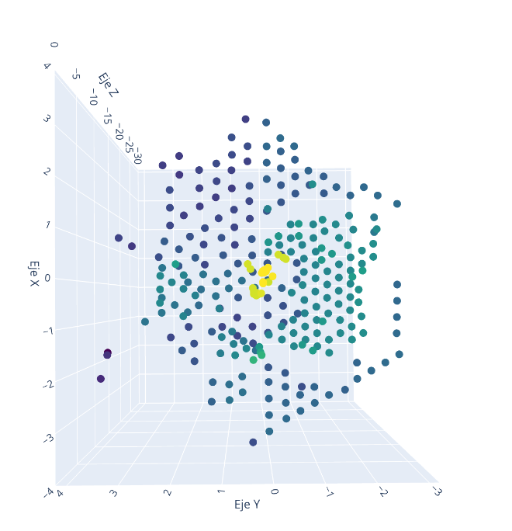

jul 1

SD 2, usuario summer psswrd: summer123
Dynamic DNS, email: ignacio.velez@ing.uchile.cl pssword: Summer123
pin de seguridad numero lost

para solucionar el tema del backlash se sumará un offset de 5 grados al elevación cuando sea negativo

traj =[(0, 0), (90, 5.0), (30.0, 5.0), (-30.0, 5.0), (-90, 5.0), (30.0, -10.0), (-30.0, -10.0), (90, 10.0), (61.12, 8.5652), (30.0, 10.0), (1.12, 8.5652), (-30.0, 10.0), (-58.88, 8.5652), (-90, 10.0), (61.12, -13.5653), (30.0, -15.0), (1.12, -13.5652), (-30.0, -15.0), (-58.88, -13.5652), (90, 15.0), (71.69, 13.1667), (50.4, 12.9789), (30.0, 15.0), (11.69, 13.1667), (-9.6, 12.9789), (-30.0, 15.0), (-48.31, 13.1667), (-69.6, 12.9789), (-90, 15.0), (71.69, -18.1667), (50.4, -17.9789), (30.0, -20.0), (11.69, -18.1667), (-9.6, -17.9789), (-30.0, -20.0), (-48.31, -18.1667), (-69.6, -17.9789), (90, 20.0), (76.7, 17.9823), (61.12, 17.1304), (45.21, 17.6143), (30.0, 20.0), (16.7, 17.9823), (1.12, 17.1304), (-14.79, 17.6143), (-30.0, 20.0), (-43.3, 17.9823), (-58.88, 17.1304), (-74.79, 17.6143), (-90, 20.0), (76.7, -22.9823), (61.12, -22.1304), (45.21, -22.6144), (30.0, -25.0), (16.7, -22.9823), (1.12, -22.1304), (-14.79, -22.6144), (-30.0, -25.0), (-43.3, -22.9823), (-58.88, -22.1304), (-74.79, -22.6143), (90, 25.0), (79.58, 22.8771), (67.53, 21.6437), (54.66, 21.4538), (42.19, 22.3339), (30.0, 25.0), (19.58, 22.8771), (7.53, 21.6438), (-5.34, 21.4538), (-17.81, 22.3339), (-30.0, 25.0), (-40.42, 22.8771), (-52.47, 21.6437), (-65.34, 21.4538), (-77.81, 22.3339), (-90, 25.0), (79.58, -27.8771), (67.53, -26.6438), (54.66, -26.4538), (42.19, -27.3339), (30.0, -30.0), (19.58, -27.8771), (7.53, -26.6438), (-5.34, -26.4538), (-17.81, -27.3339), (-30.0, -30.0), (-40.42, -27.8771), (-52.47, -26.6437), (-65.34, -26.4538), (-77.81, -27.3339)]
#-------------

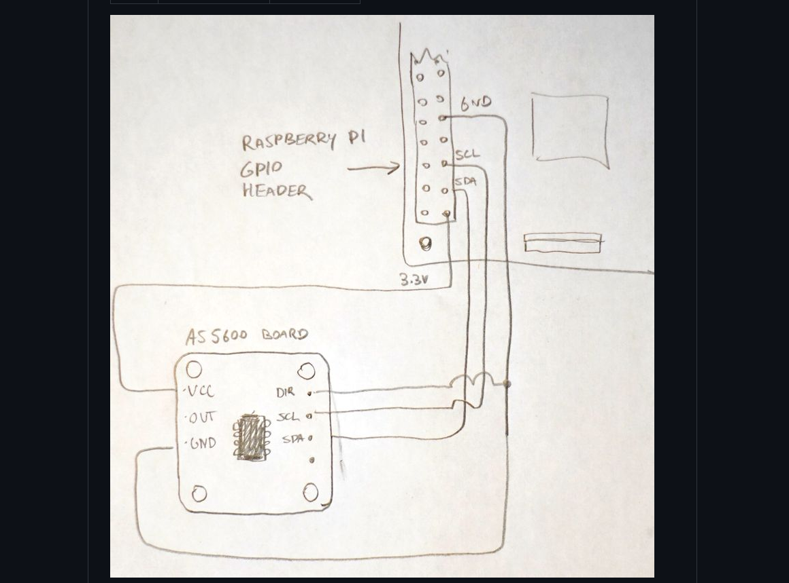
traj =[(0, 0), (90, 5.0), (30.0, 5.0), (-30.0, 5.0), (-90, 5.0), (25.0, -10.0), (-35.0, -10.0), (90, 10.0), (61.12, 8.5652), (30.0, 10.0), (1.12, 8.5652), (-30.0, 10.0), (-58.88, 8.5652), (-90, 10.0), (56.12, -13.5653), (25.0, -15.0), (-4.12, -13.5652), (-35.0, -15.0), (-63.88, -13.5652), (90, 15.0), (71.69, 13.1667), (50.4, 12.9789), (30.0, 15.0), (11.69, 13.1667), (-9.6, 12.9789), (-30.0, 15.0), (-48.31, 13.1667), (-69.6, 12.9789), (-90, 15.0), (66.69, -18.1667), (45.4, -17.9789), (25.0, -20.0), (6.69, -18.1667), (-14.6, -17.9789), (-35.0, -20.0), (-53.31, -18.1667), (-79.6, -17.9789), (90, 20.0), (76.7, 17.9823), (61.12, 17.1304), (45.21, 17.6143), (30.0, 20.0), (16.7, 17.9823), (1.12, 17.1304), (-14.79, 17.6143), (-30.0, 20.0), (-43.3, 17.9823), (-58.88, 17.1304), (-74.79, 17.6143), (-90, 20.0), (71.7, -22.9823), (56.12, -22.1304), (40.21, -22.6144), (25.0, -25.0), (11.7, -22.9823), (-4.12, -22.1304), (-19.79, -22.6144), (-35.0, -25.0), (-48.3, -22.9823), (-63.88, -22.1304), (-79.79, -22.6143), (90, 25.0), (79.58, 22.8771), (67.53, 21.6437), (54.66, 21.4538), (42.19, 22.3339), (30.0, 25.0), (19.58, 22.8771), (7.53, 21.6438), (-5.34, 21.4538), (-17.81, 22.3339), (-30.0, 25.0), (-40.42, 22.8771), (-52.47, 21.6437), (-65.34, 21.4538), (-77.81, 22.3339), (-90, 25.0), (74.58, -27.8771), (62.53, -26.6438), (49.66, -26.4538), (32.19, -27.3339), (20.0, -30.0), (9.58, -27.8771), (-3.53, -26.6438), (-15.34, -26.4538), (-22.81, -27.3339), (-35.0, -30.0), (-45.42, -27.8771), (-57.47, -26.6437), (-70.34, -26.4538), (-82.81, -27.3339)]
#-------------

Se va a hacer que un bot de telegram envíe a mi numero un mensaje en caso de que ocurra algun error que termine el programa

