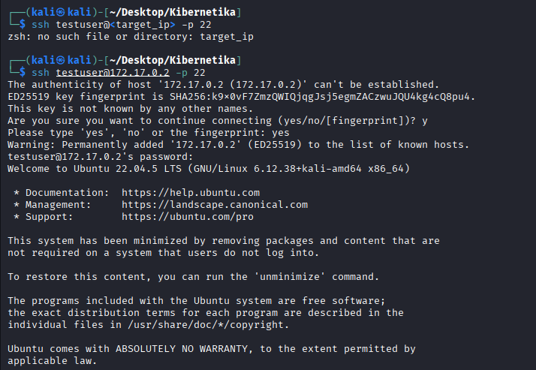
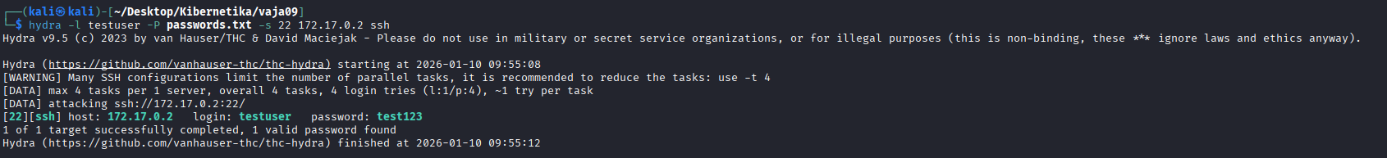
"SecondaryIPAddresses": null,
"IPAddress": "172.17.0.2",
"IPAddress": "172.17.0.2",
Starting Nmap 7.95 ( https://nmap.org ) at 2026-01-10 09:38 EST
Nmap scan report for 172.17.0.2
Host is up (0.000070s latency).
Not shown: 65534 closed tcp ports (reset)
PORT STATE SERVICE VERSION
22/tcp open ssh OpenSSH 8.9p1 Ubuntu 3ubuntu0.13 (Ubuntu Linux; protocol 2.0)
MAC Address: 02:42:AC:11:00:02 (Unknown)
Device type: general purpose|router
Running: Linux 4.X|5.X, MikroTik RouterOS 7.X
OS CPE: cpe:/o:linux:linux_kernel:4 cpe:/o:linux:linux_kernel:5 cpe:/o:mikrotik:routeros:7 cpe:/o:linux:linux_kernel:5.6.3
OS details: Linux 4.15 - 5.19, OpenWrt 21.02 (Linux 5.4), MikroTik RouterOS 7.2 - 7.5 (Linux 5.6.3)
Network Distance: 1 hop
Service Info: OS: Linux; CPE: cpe:/o:linux:linux_kernel

OS and Service detection performed. Please report any incorrect results at https://nmap.org/submit/ .
Nmap done: 1 IP address (1 host up) scanned in 2.65 seconds
Hydra v9.5 (c) 2023 by van Hauser/THC & David Maciejak - Please do not use in military or secret service organizations, or for illegal purposes (this is non-binding, these *** ignore laws and ethics anyway).

Hydra (https://github.com/vanhauser-thc/thc-hydra) starting at 2026-01-10 09:55:50
[DATA] max 4 tasks per 1 server, overall 4 tasks, 4 login tries (l:1/p:4), ~1 try per task
[DATA] attacking ssh://172.17.0.2:22/
[22][ssh] host: 172.17.0.2 login: testuser password: test123
1 of 1 target successfully completed, 1 valid password found
Hydra (https://github.com/vanhauser-thc/thc-hydra) finished at 2026-01-10 09:55:55

Kratek komentar: zakaj je uporaba šibkih gesel nevarna in zakaj zapirati neuporabljene porte
Ker se lažje brutforcajo ali pa uganijo zaradi manj možnosti, kobinacij.
Ker predstavljajo še dodatno točko iz katere lahko napademo, zaradi potencialnih šibkosti. Hkrati imamo lažje upravljanje in nadzor nad sistemom, ter enostavnejše odpravljanje težav.
Kako bi zaščitili SSH strežnik pred brute-force napadi?
Z avtentikacijo s ključi in z onemogočanje prijave uporabnika root

Katere dodatne ukrepe (npr. omejitve po številu prijav, uporaba javno-zasebnih ključev, firewall) bi priporočili?
Časovno blokiranje po večih napačnih prijavah, zaprianje portov, Z avtentikacijo s ključi.
Kako se spremeni rezultat, če uporabimo zelo močno geslo?
Brute-force postane praktično neizvedljiv, še vedno ga pa lahko ukradejo.

