Nama : Ignatius Christian Ovtavianus Situmorang
Nim : 255314057
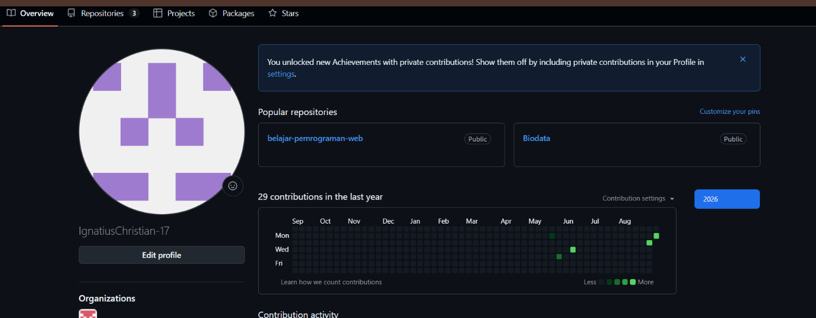

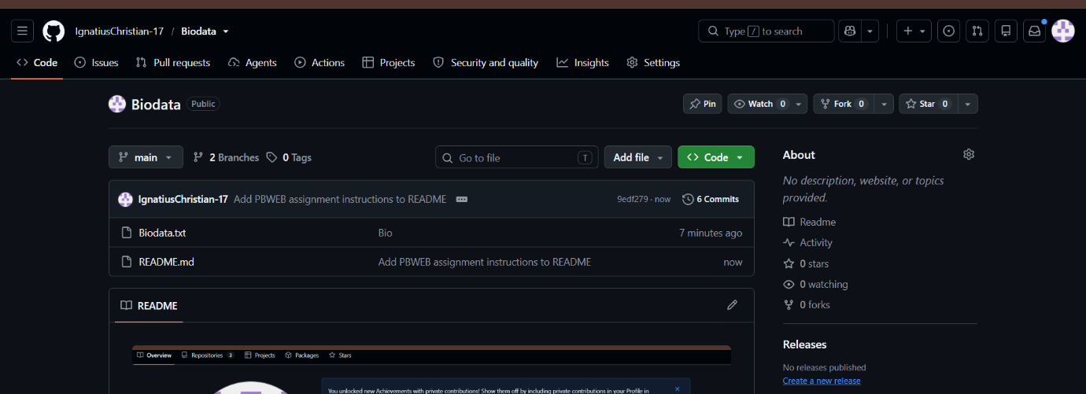

LINK GITHUB https://github.com/IgnatiusChristian-17/Biodata/tree/main

