This document will outline the plan for this project, with scene progressions and behaviours found within each scene.

Scene 1:

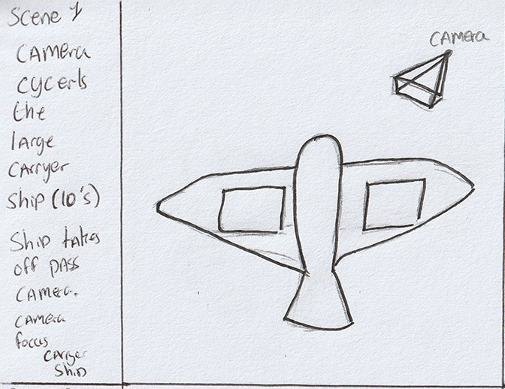

* Big carrier ship (Wonder) fly’s through space with a wonder behaviour.
* Camera (Path Follow) circles the carer ship.
* Carrier ship (Seek) jumps to FTL.

Scene 2-3:

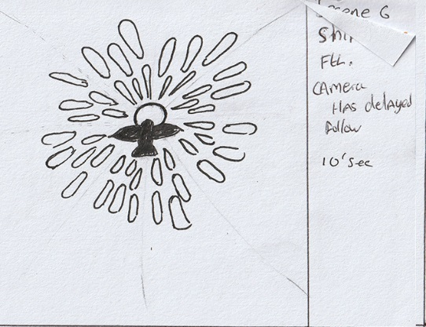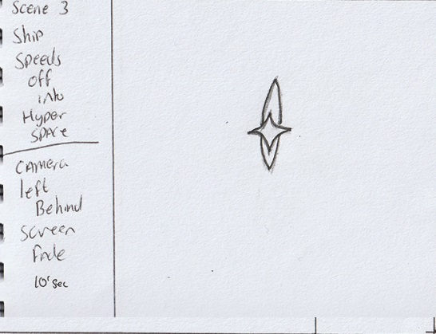

* Camera (Seek Behaviour) follow the ship as the fly’s in hyperspace effect.
* Camera (remove All active Behaviours after a few seconds camera becomes inactive) slows down as ship disappears in a flash of light.

Scene 4:

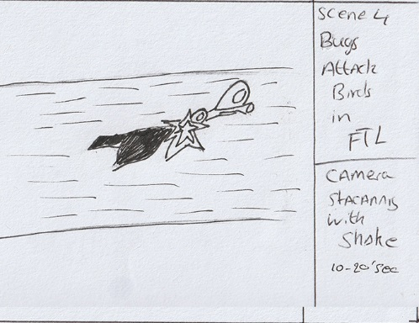

* Mother ship (Seek Behaviour) attacks the carrier ship knocking it out of hyperspace.
* Camera shake at point of impact.
* Both ships are knocked out the hyperspace.

Scene 5:

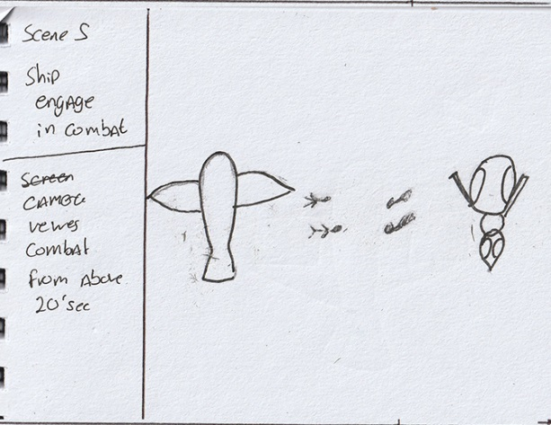

* Both ships start to cycle each other (Path following).
* Lots of little ships begin to fight emerging form mother larger ships (Seek, obstacle avoidance, pursue, off set pursue).

Scene 6:

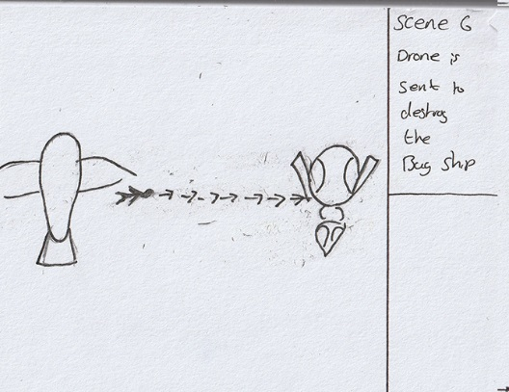

* Large ships launch bombers to destroy the other (Pursue).

Scene 7:

* Depending on the outcome of the attack runs one of the ships is destroyed and the other ship jumps to FTL to end the simulation.