MCP(Model Context Protocol) Server
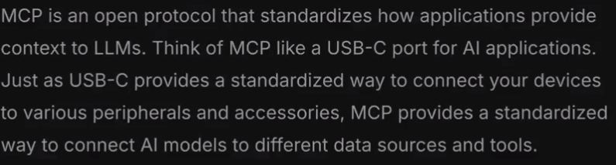

- Model :- AI model
- Protocol :- of feeeding context to model.
- MCP does standardization.
People usually give APIs and nowadays mcp server for their project,basically using their project by our LLM.
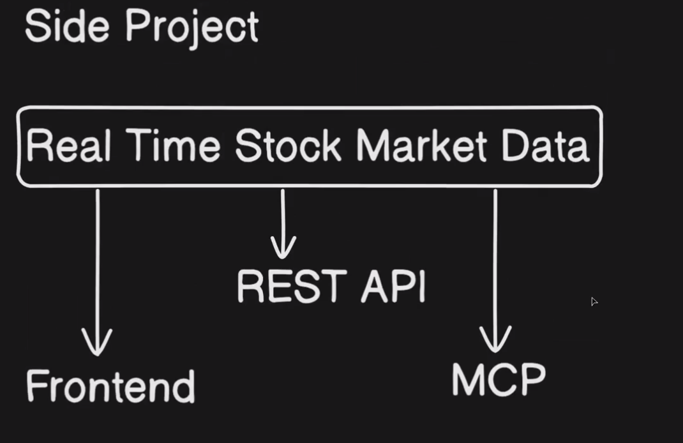

- Here in the above project MCP is used to operate this project through LLM basically connecting with AI.
- If here MCP was not there we would have made any tool lets say.
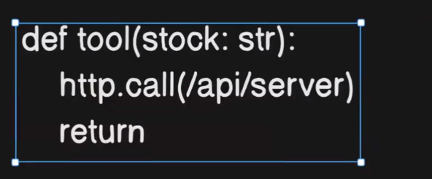

- Basically making cutom tool and doing manually similar to SDK.
- So at the end MCP is just doing tool calling based on user behalf,taking the overhead from the user.
- MCP was introduced by Anthropic and it has also made Claude.
- Server Flow
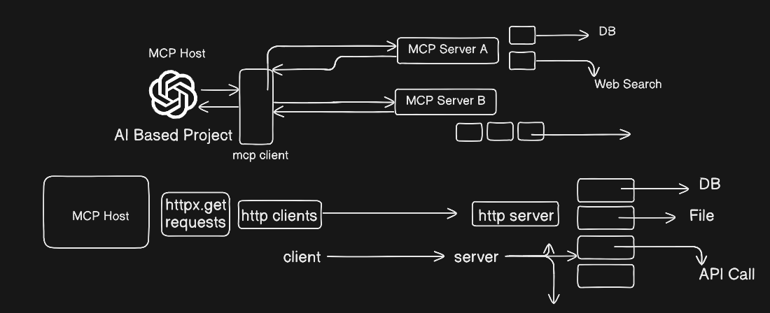
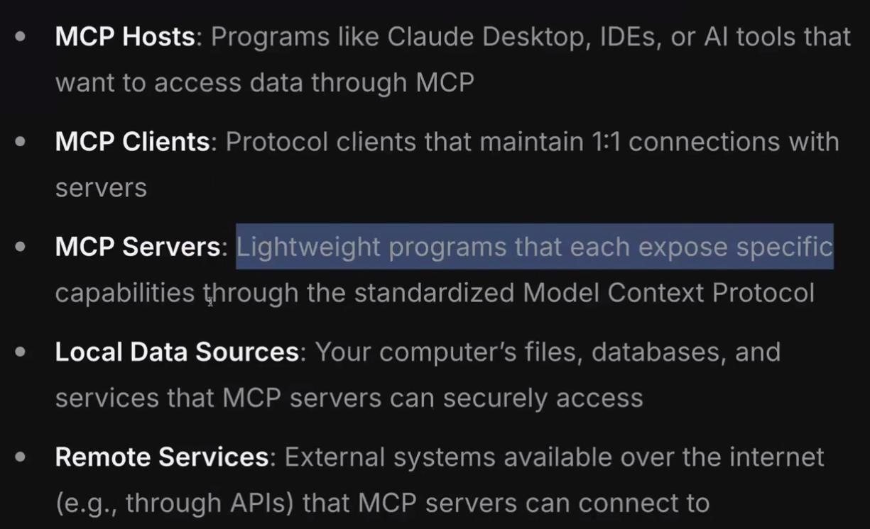

- Initially it was a tool.
- But now
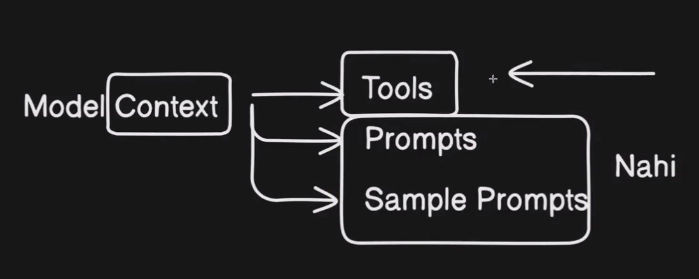
- We can save our prompts also in MCP.
- We can also do prompt rewritting and can keep sample prompt.
- But above 2 are not in use much
For example:
- We want to send email from gmail
- Send_email() :- tool
- Here we are using our prompt to send mail.
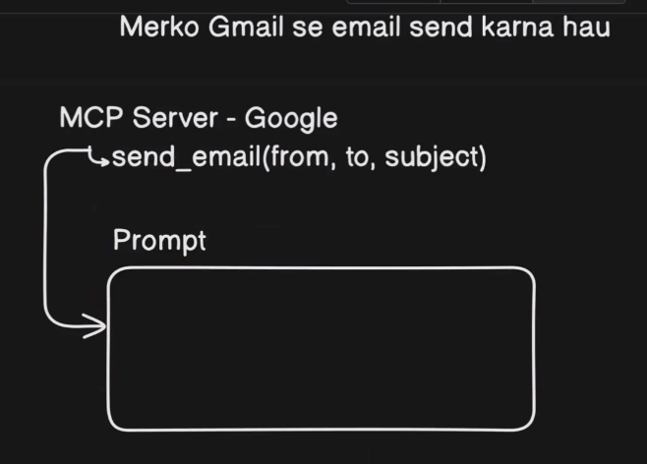

- Trimming down video using API
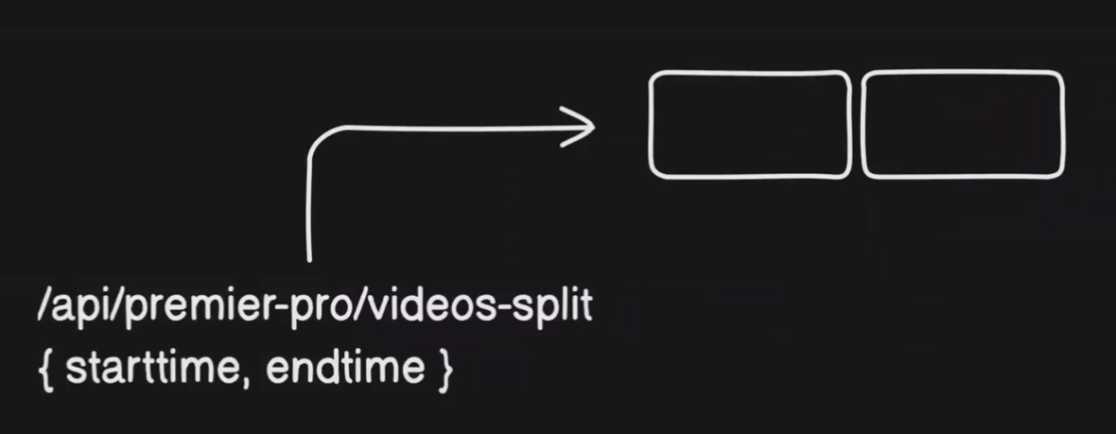

Deep Dive into Protocol
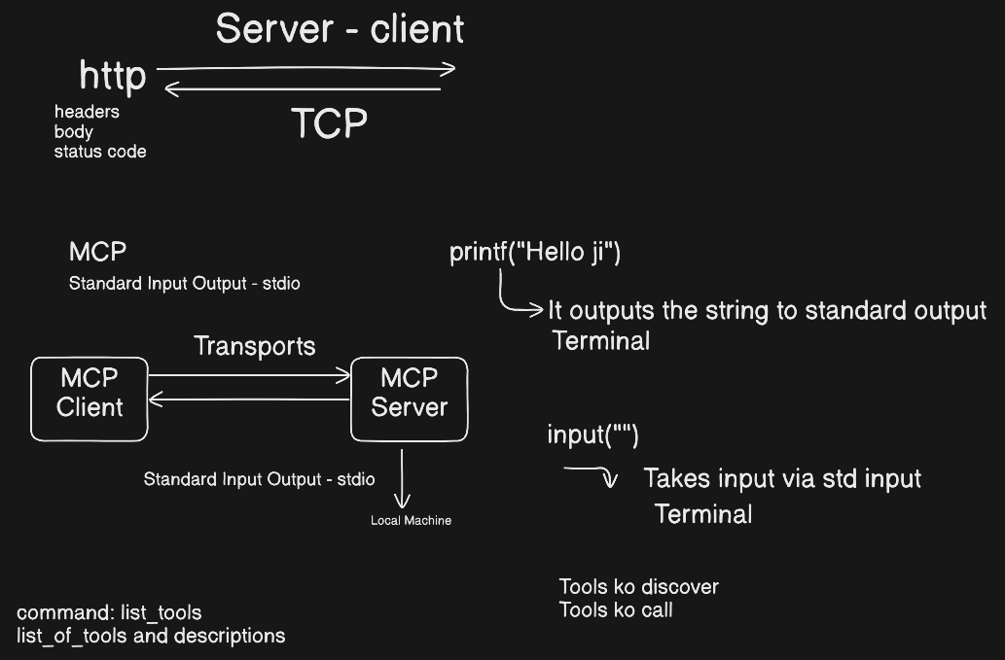

- HTTP protcol send data over TCP and uses special format(header,body).
- MCP uses standard input output(stdio)
- So here in MCP client and MCP Server uses stdio as the communication channel.
- So basically MCP server should be on local machine as there is no network between them.
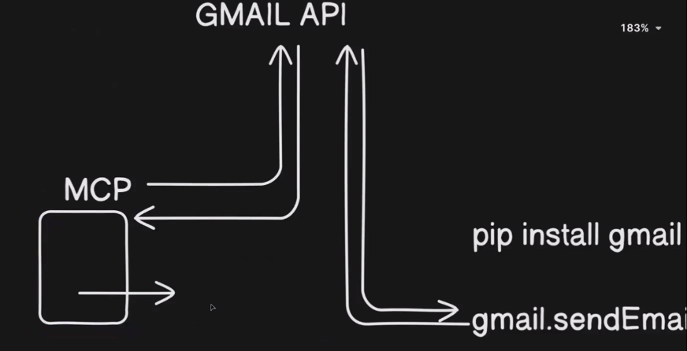

- Technically we don’t write function inside MCP for calling tool.
- It’s a kind of SDK.
- So basically MCP has every tool(Sending mail,receiving mail).
So how client and server operate.
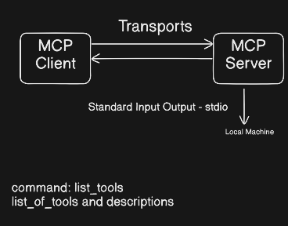
- MCP client fires command list_of_tools.
- Server returns list_of_tool with descriptions.
- Now my client knows available tools.
- Just like header goes and comes in HTTP.
Example
- Claude does command add_number(2,5) and it passes to Server(MCP),so when claude recieves the answer it will frame it using NLP.
- “Hey thee result of 2,5 is 7.
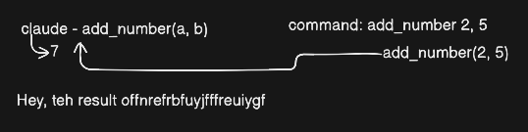
- Here it discovers tools and commands by their own.
- We just need to write route and tool.
- When someone does get_tool() so the tool will be called.
- MCP has 2 transports(STDIO,SSE(Server Sent Events)).
- How SSE works
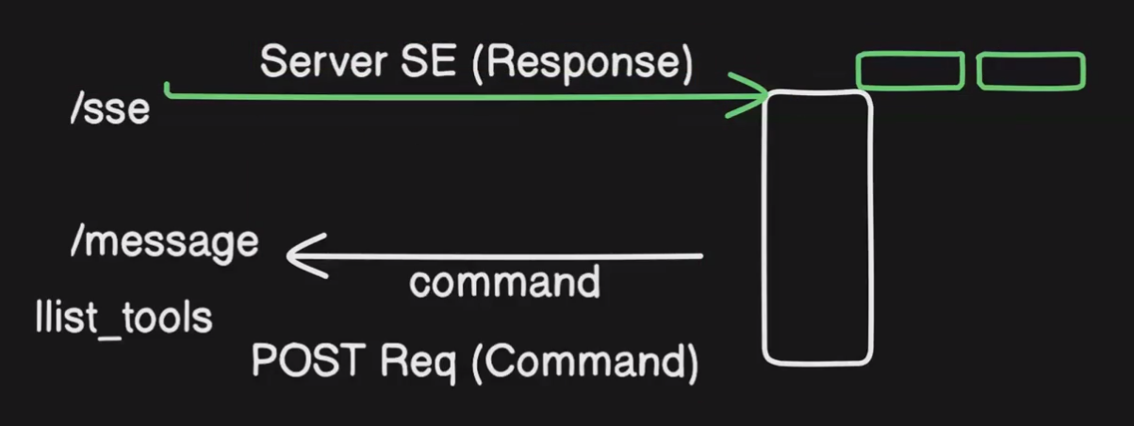
- Sending command to server using POST Req
- And receiving it using Server SE(Response)
- How to connect
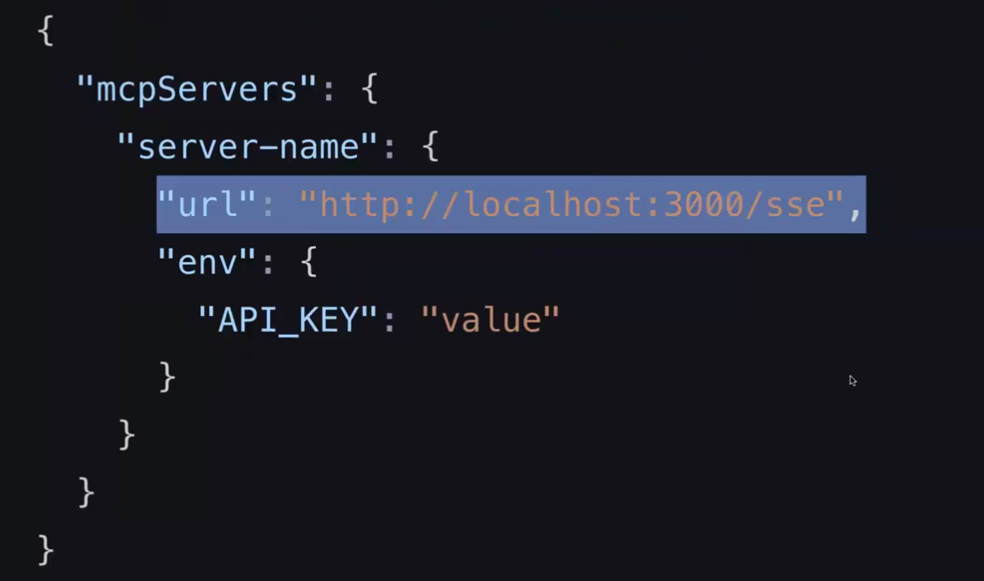
- Tell URL in server name when connecting over the internet.
- And if locally then tell command()
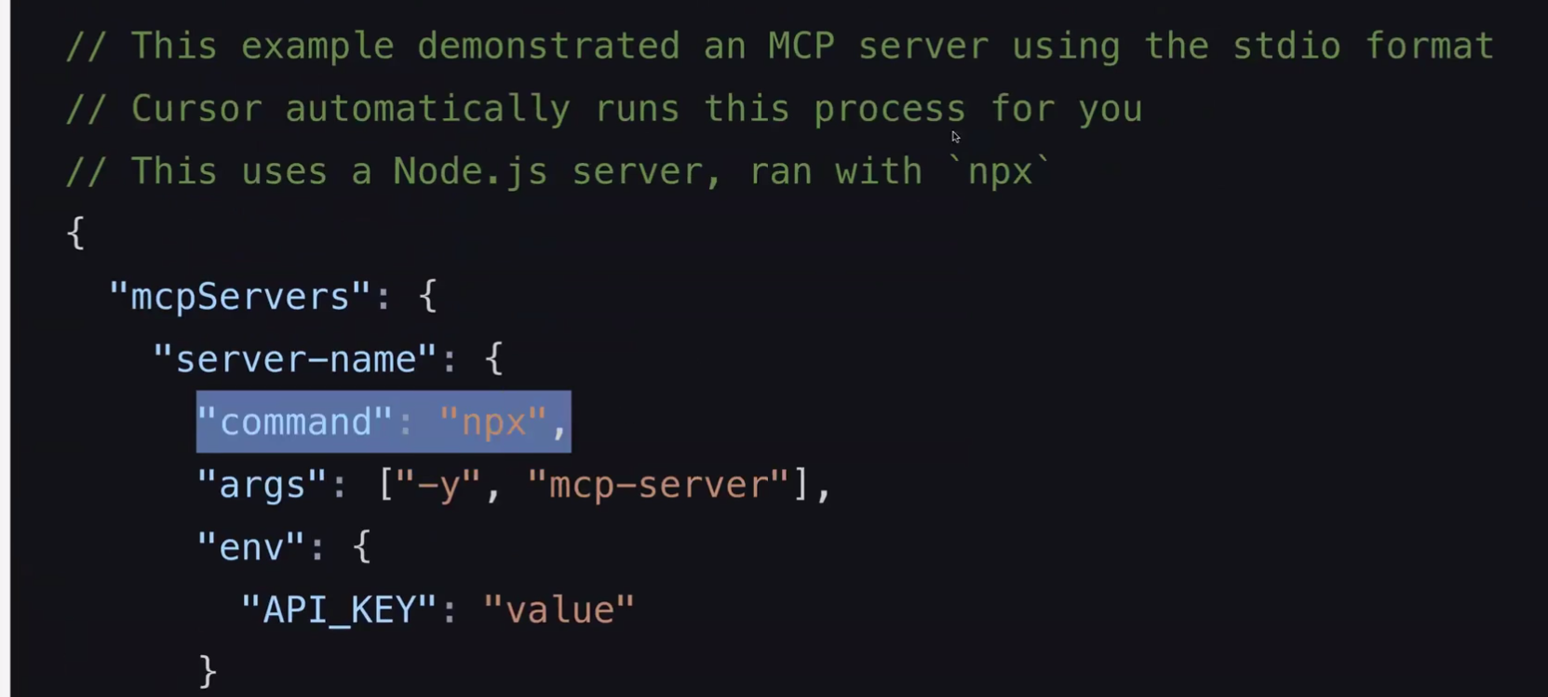
Questions:
- What does API do and MCP do?
- Api for HTTP communication and MCP for tool calling or wherever LLM is used.
- Specific to LLM.
Code for inspecting MCP server
npx @modelcontextprotocol/inspector python server.py

