- RAG
- RAG: Putting up relevant data into prompt so that LLM take a context of the prompt.
- Context window :- At a given piece of time how much token can be processed.

- Every LLM has fixed winodw size means fixed context window size.
- Gpt-3 was having very small context window
- Gpt-4.1 has 1M token context window

- So if data has 10k rows and only 40 rows is required so discard that left data using RAG and it is optimization.
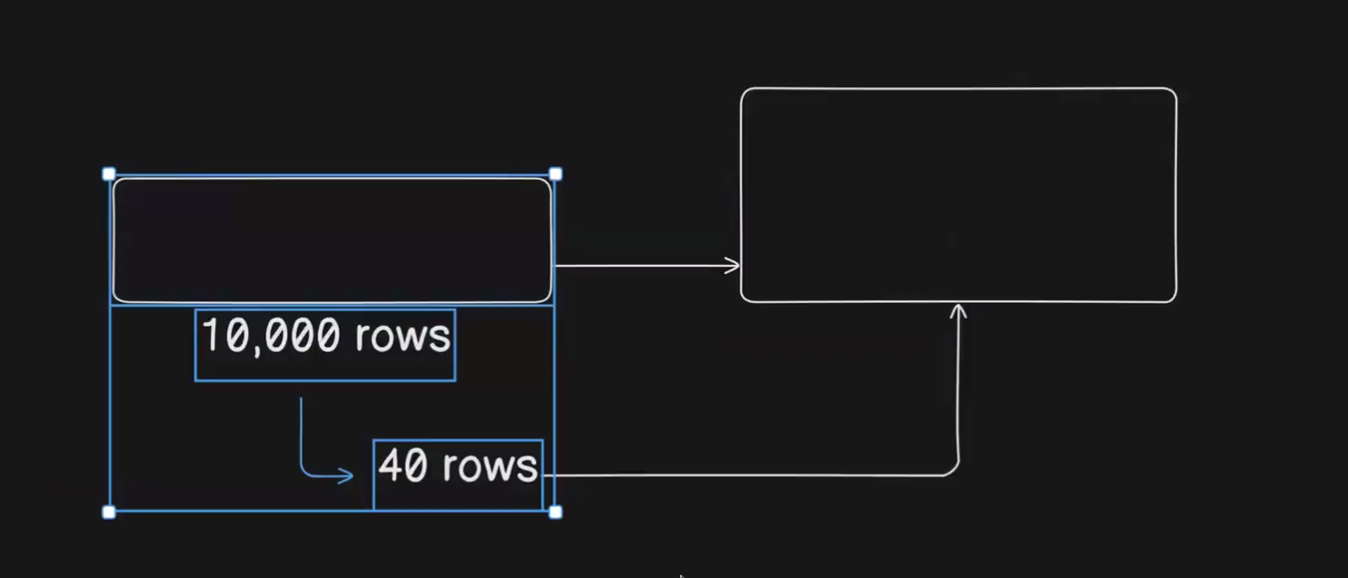

- So context should be very relavant without using lossing any data.
- So,
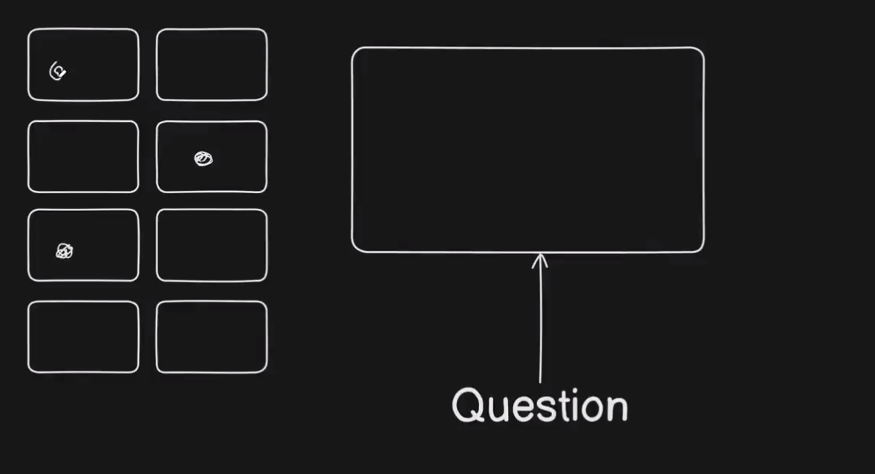
- Extracting only relevant features from the data and getting LLM answer over it with user queryis known RAG.
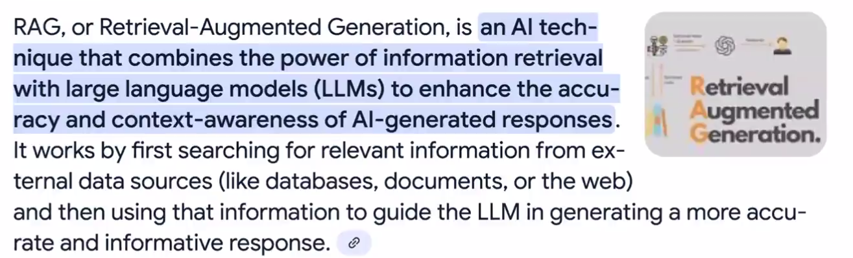
Simple RAG
Vector embedding :- Giving semantic meaning in a 3D space.

- RAG uses vector a lot.
- RAG needs semantic meaning for data retrival.
- What happen in normal DB,it is doing value based searchin
E.g:- Lets say if user asks give me car info it is not going to mention honda unless it is not mentioned specifically
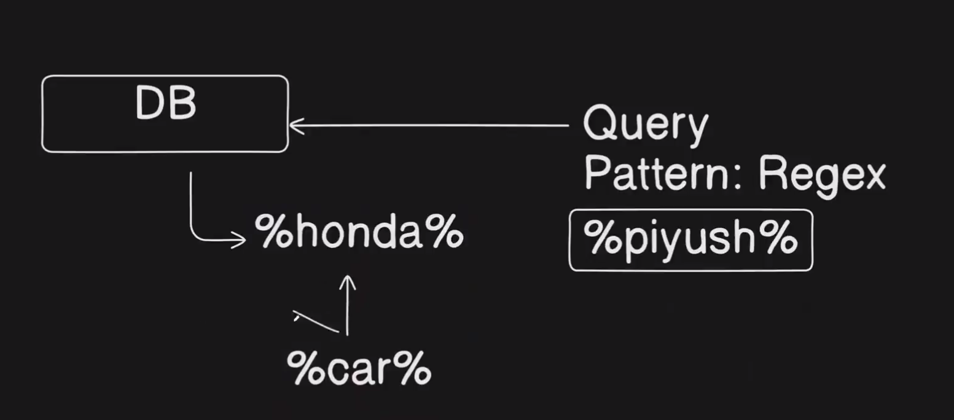

- But in vector DB it works on semantic search.
E.g: How many cars in the DB,so it will give the info.
Example of simple RAG
- Take pdf convert into text(chunks).
- Make system prompt(You are an agent….)
- Put text(chunks). of pdf with prompt now chat.
- Now LLM will get authentic answer because LLM have context of my data.
- Problem will arise if pdf size is big then we will receive context error.
- So here we will do
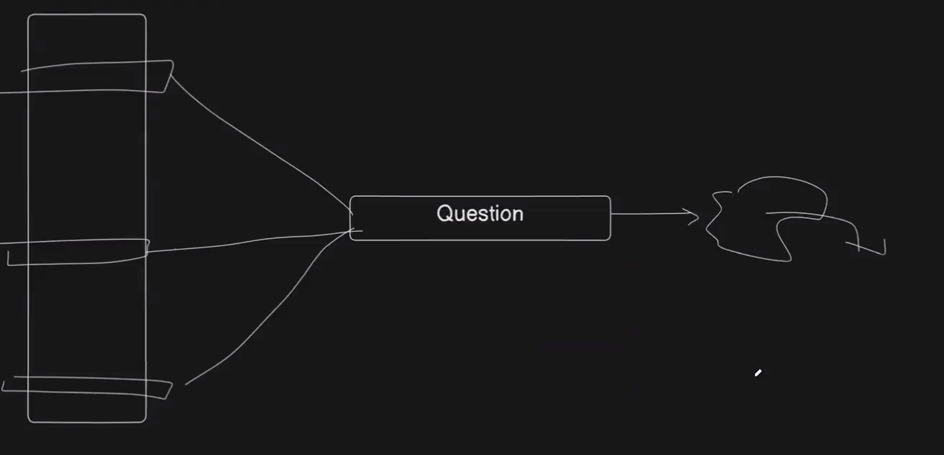
- Bring out only relevant info from pdf file.
- Here comes 1st part of RAG which is Indexing.
- Index the input source like this such that if tomorrow user asks any questions LLM answers accordingly.

Indexing
- So in indexing we are diving the pages of pdf para by para or page by page into chunks.
- And linearly putting every chunks into LLM(OpenAI) for making semantic meaning and storing this vector embedding(e,g:1,2,3) into vector db.
- Above is the ingestion process.
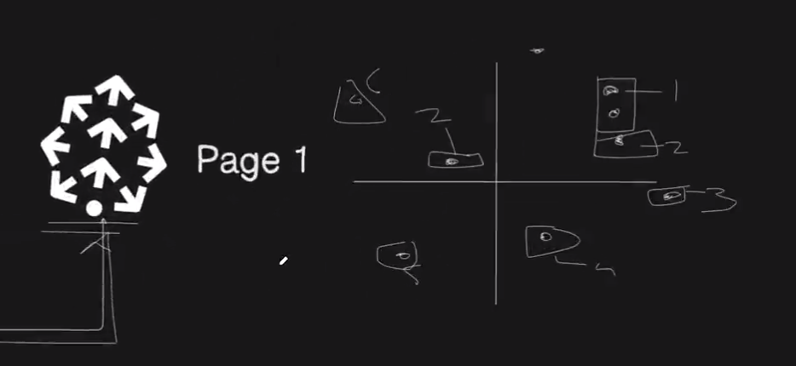

- Now user asks a question(what is remote?).
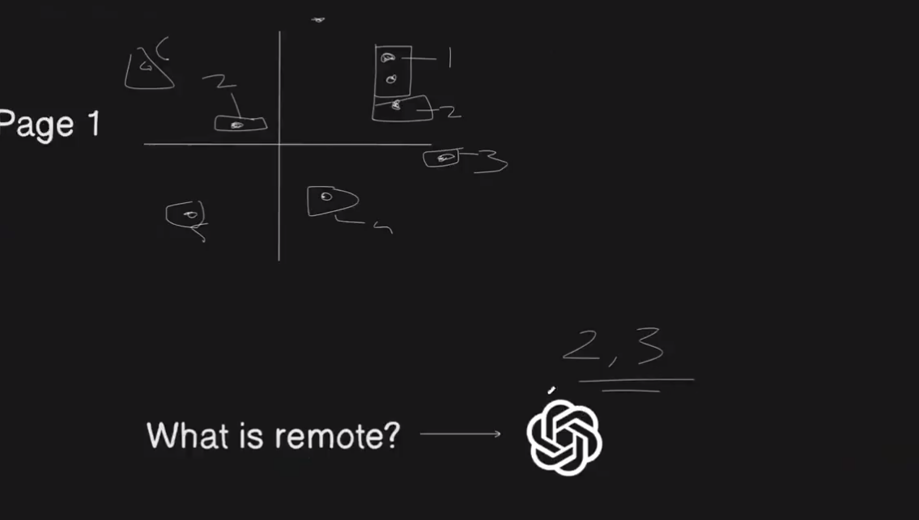
- We need to have semantic meaning of user query also so using LLM again to make vector embedding(lets 2,3)

Now user vector embedding will be searched in the in the data embedding for the relevant search.
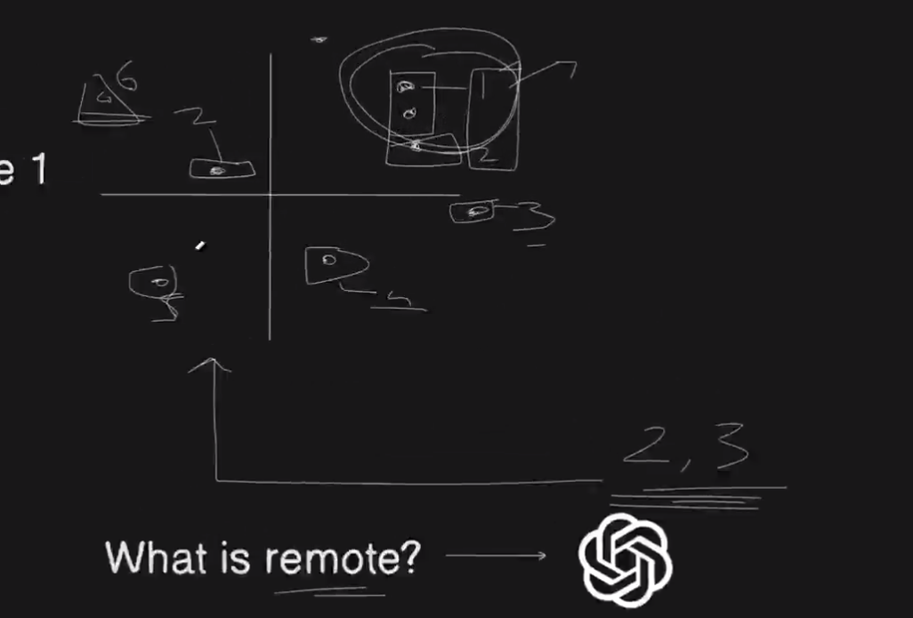
- Lets say 1 and 2 is the most relevant chunks according to user query,so we will pick it up.
- Now, we will use LLM and putting page 1 and 2 of pdf along with user query.
- Here we will get better response.
Overflow
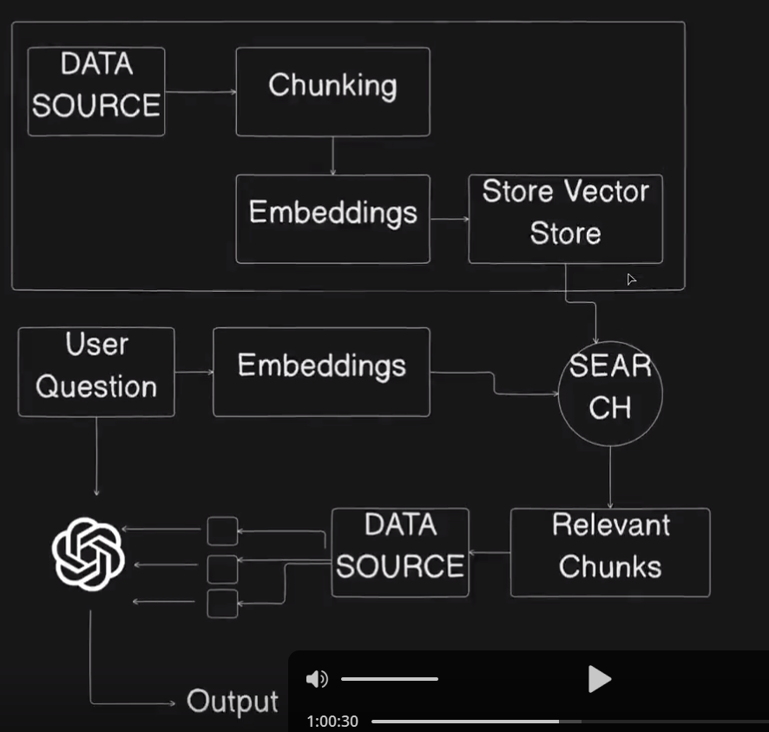
Here in relevant chunks we have page number and for accessing data we need to go to data source again.
- Here we have chains so here langchain comes into picture for taking wrapper because we don’t need to write functions manually.
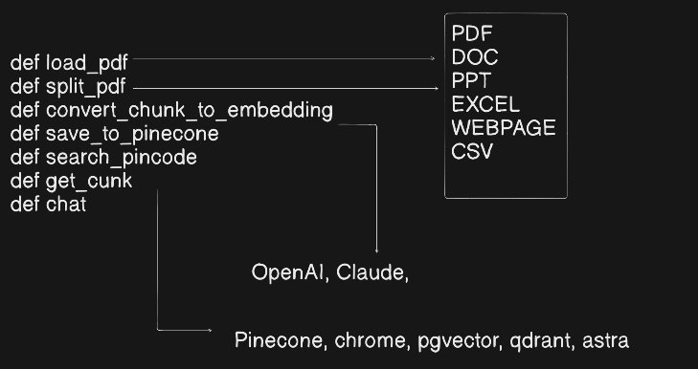
So we will make chain of wrapper using langchain.
Ingest chain
- Loader (loader = pdf_loader(path))
- Splitter (splitter = text_splitter()
- Embedding model embedding = OpenAI()
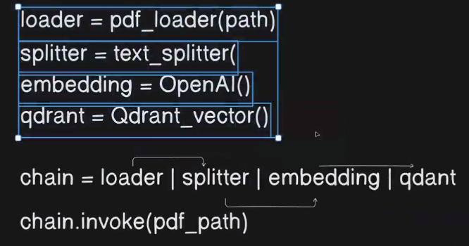
- Vector store quadrant = Quadrant_vector()

Problem in Langchain
- Too much abstraction no control in hand of developer.
- Brings lots of unnecessary abstraction.

Next Phase Of RAG
- User can ask any dumb query(e.g:what is fs).
- So here Query translation comes here.
- In this user query is been translated(rewritten) by LLM into more(e.g:- 3,4) forms this is known as Enrichment node.
- Then we do a break down of user query.
- Now on these transformed query above RAG approach is applied(vector embedding,embedding) to get the chunks.
- And the user query chunks is also made.
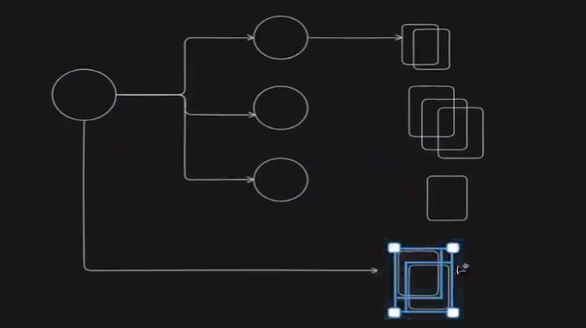

- Now here we do reciporcal rank fusion,basically ranking docs(how much time they comes),their relevance,accuracy.
- Now based on the ranking we got docs relevancy wise
- And here we get the docs which user might not have asked but wanted to ask.
- Now based on these docs we can generate Arbitrary docs.
  - E.g:- what is fs module?
    - Give context about modules.
Why doing these?
Might be what user wanted to ask they are not asking in a relevant way.
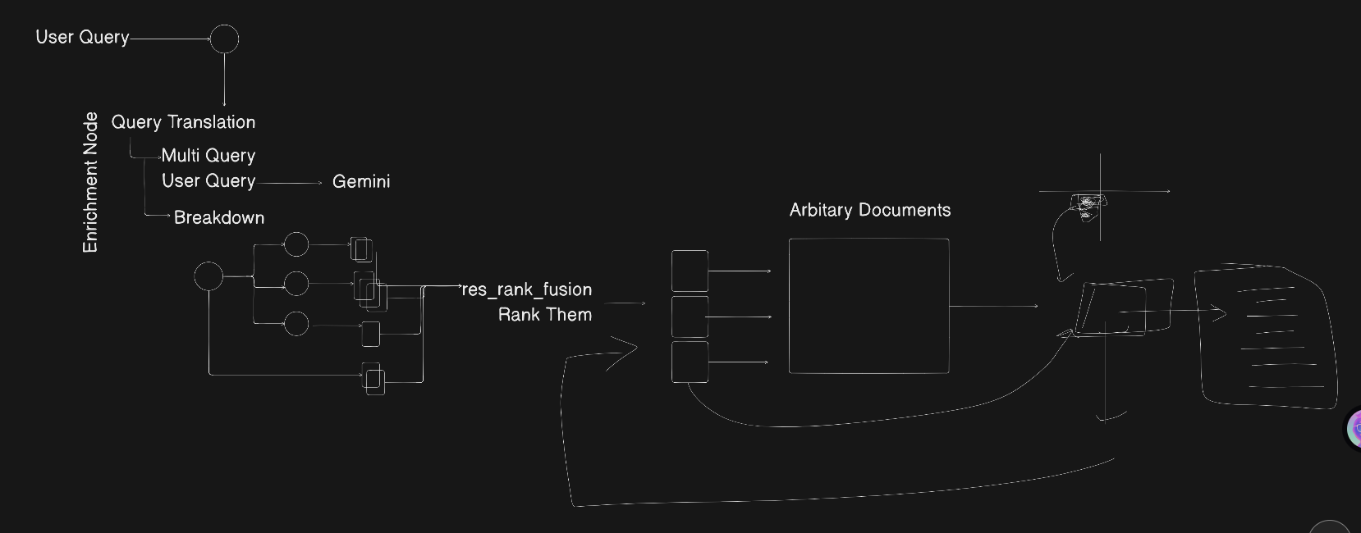
There is something called Corrective RAG(if user query is not correct LLM will tranform it and pass it to the system)
2. Query Transformation
RAG Step
- Indexing :- Data is been converted into chunks beacause of context window then embeddiing is been made using openAI then these embedding was stored in vector DB.
- Retrieval :- User prompt is getting converted into embedding then by applying similiarity_search() we are getting only relevant chunks from docs(vectorDB)
- Generation:- User prompt and final chunks was given to openai to get desired output.
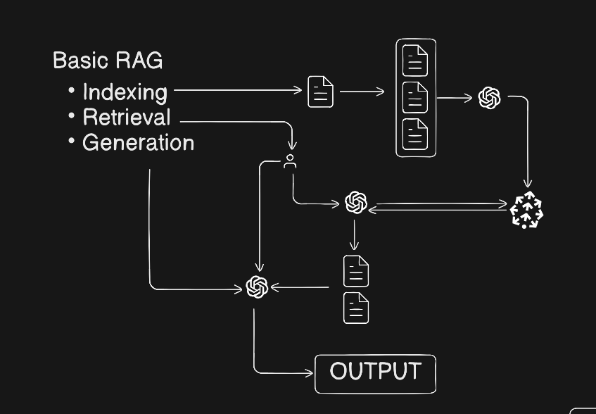
Problem
- In reality we would be having end no of data(sparse) so here simple RAG fails.
Advance RAG(for increasing accuracy of RAG)
- Advance RAG comes here to increase accuracy of RAG pipeline.
- So in this we do query transformation/translation.
- Then Routing comes.
- Then query construction.
- Then indexing.
- Retriveal.
- Generation.
Query Translation
- Query :- User input
- Transformation :- Change query

Intuition
- In reality user don’t know what they want(like just giviing song glimpse to get correct song name)
- If user query is ambiguous then output would also be ambiguous.
- So why ambiguous lets say user entering any random query then it might happen that it has many answers.
- So we can’t trust on user query.
- So by any chance if user ambiguous query we somehow get to know then it would be great to answer.
So query translation says to improve the user prompt
How to do it?
Abstraction
- Abstraction :- I want to drink water.
- Less Abstraction :- I want to have water of some temperature in some glass…
- So here we need abstraction approach(direct approach) and sometime less abstraction also.
- So we need to apply both on user query.
- And we need to make the balance.
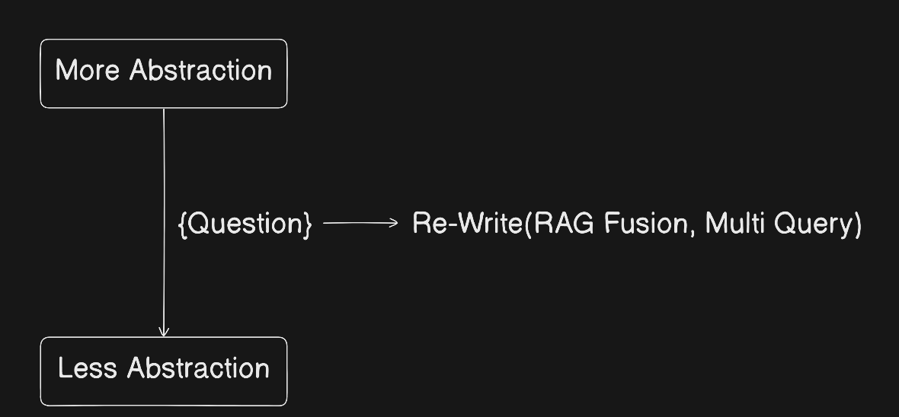
- User query lies between these two.
- So rewritting the user query through AI using 2 approach.
- RAG Fusion
- Multi Query
Parallel query(Fan out) Retrieval
Fan out :- Putting one event in multiple queues(After amazon order we receive messages on diff platform)
Parallel :- Transformed query is been running in parallel.
- Here we make changes in indexing and retrieval but not in generation.
- So when user query is rewritting we do by Parallel query(Fan out) Retrieval.
- So user query is getting transformed into end no of transformed queries based on the given no, we are doing this to get the those context which user has not used in their query or has done spelling mistakes so removing such issue we do transformation.
- Then transformed query is converted into vector embedding parallely to apply similarity search on original user query for getting accurate chunks from vectorDB.
- Then we got document embedding(chunks(colorful pdf icon))
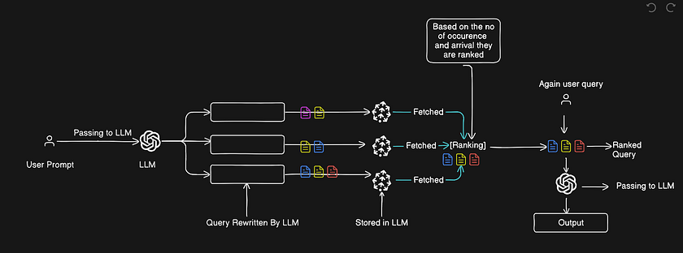
.

- Then these docs is been getting intersection so basically filtering unique.
- So we got unique chunks.
- So giving these chunks with user original query in LLM then we got more relevant result.
- So here accuracy is more by trading-of time.
Reciprocate Rank Fusion Technique

Problem
- Theres was a problem earlier where we were giving entire info(extra info) unnecessarily.
Solution
- So instead that rank the docs(chunks) and give only the most relvant chunks to LLM based on ranking and arrival term.
- So basically we do ranking here.
Formula for RANK
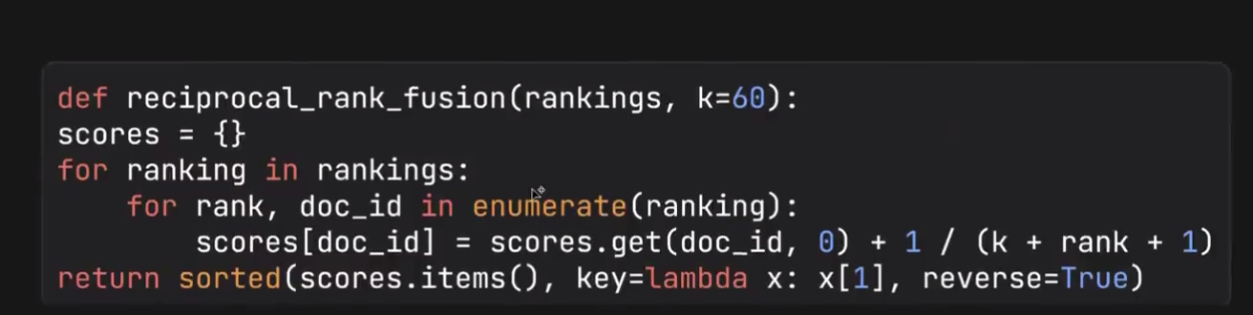

For :- Iterating on each ranking
Then applying reciprocal formula.
Then sorting based on score
K :- Decide how much weight to give high and low rank
Query Decompostion
- Query decomopositon :- Breaking down query
- Making user query either less or more abstract.
- For abstarcting we have algo known as Step back prompting.
So here is query What is python prog language?
Abstract :- What is python,What is programming langauge.
Less Abstract :- what is python prg used for,How python prg installed.
COT(Chain of thought)(Less Abstarct)
- Here we have use COT(Chain of thought) in less abstarct .
- Basically breaking down the user query
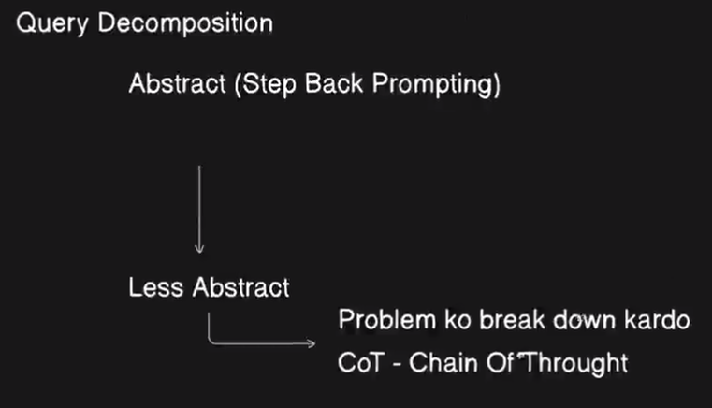

- Here what happens,User query is been breaking down into more problem.
E.g:- Think Machine Learning
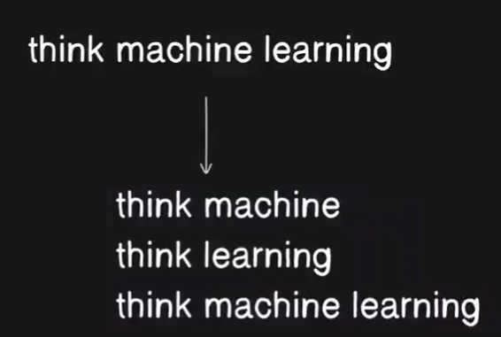

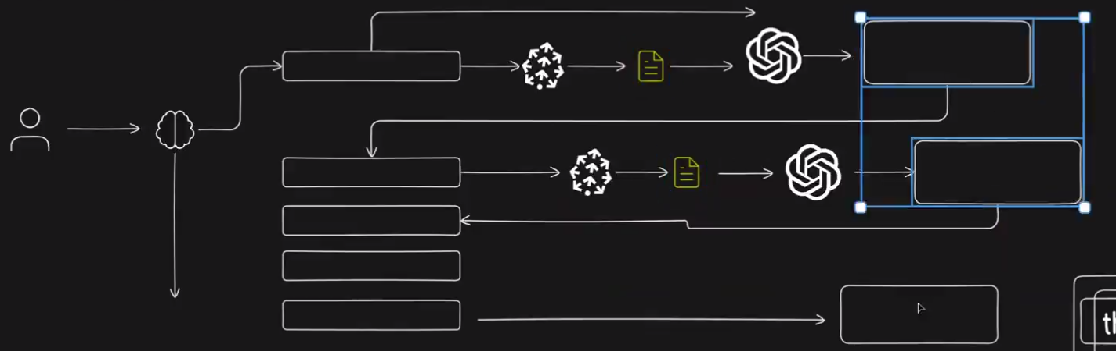

- So here lets say think machine query is been passed and stored into first vectorDB then chunks is been taken out and LLM is been applied and whatever answer we got we pass it to next question as reference.
- Now I know what is machine next question is what Is learning like wise it at the end we ill be having 3 transformed general AI answer.
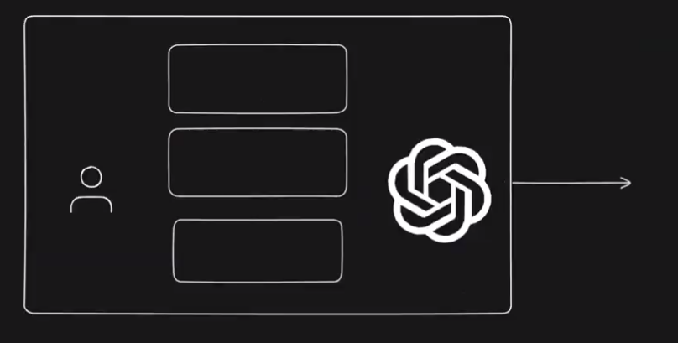
- Now user query and these 3 AI generated is been passed to LLM and now the answer is more precise.

- We have seen very context seperatly and have more context.
- Taking the diff aspects from diff vectors in vector space and having more context.
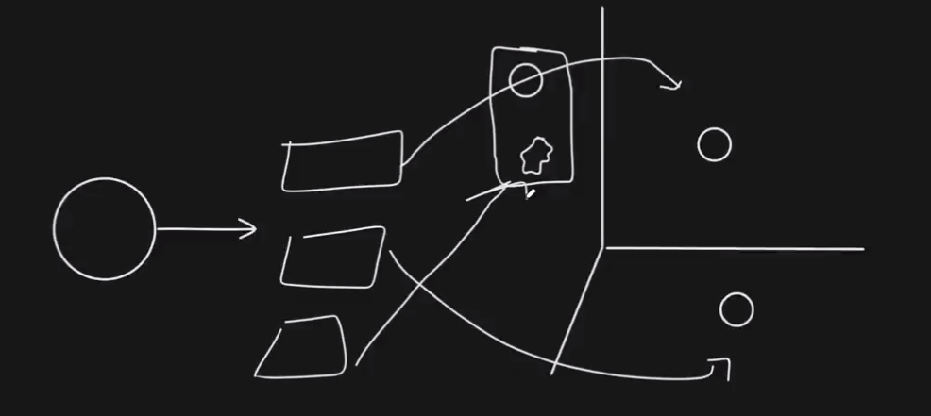
- So we are doing this for the area where accuracy is more important than processing time
E.g:- Medical Domain.
Step Back Prompting(More Abstract)

- Few shot prompting is used
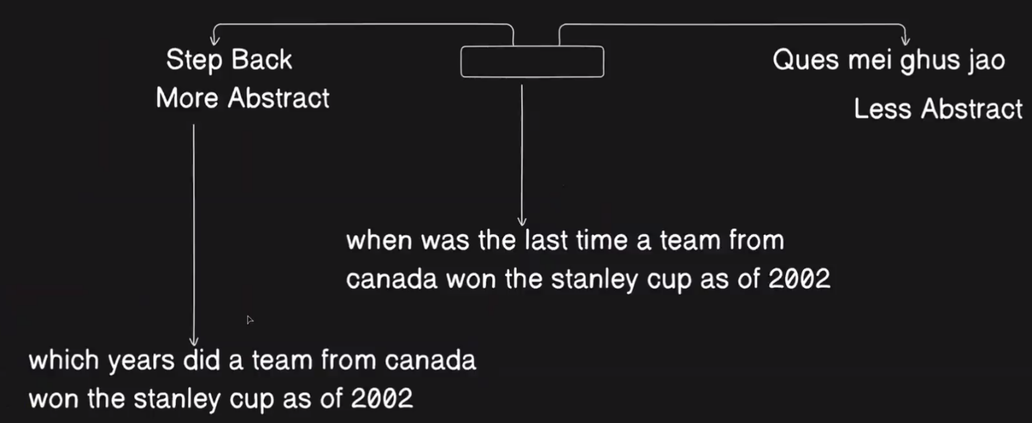

- Basically taking the context from pretrained data before answering the actual question.
- Coming one step back from problem.
- So getting more elaborative answer and making the vector embedding of this elaborative answer and cater more things.

HYDE(Hypothetical Document Embedding)
- In this highly capable model(GPT-4.1) is used.
- Which is having more context.
Intuition
- User query is given.
- Writing docs(hypothetical(doesn’t existt in realit)) on user query using LLM(large model used here).
- Now generating vector embedding of this docs.
- So it will help in capturing more area in vectorDB.
- Here I am interested In having data where it is present in my dataset.
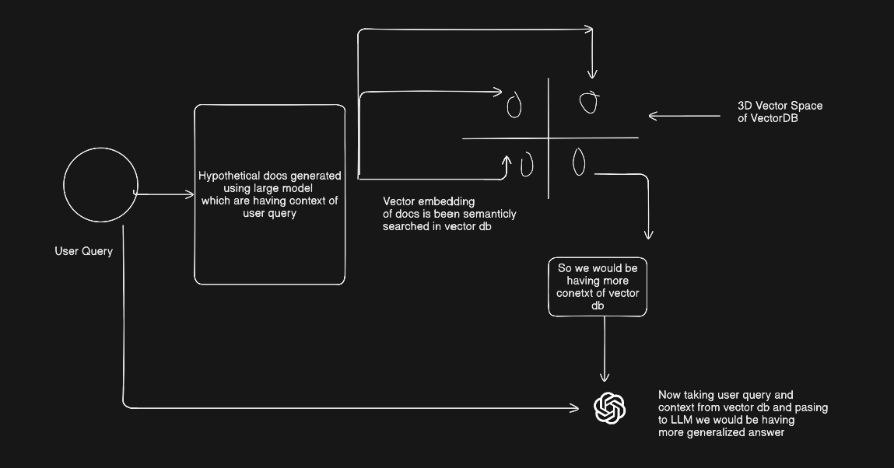

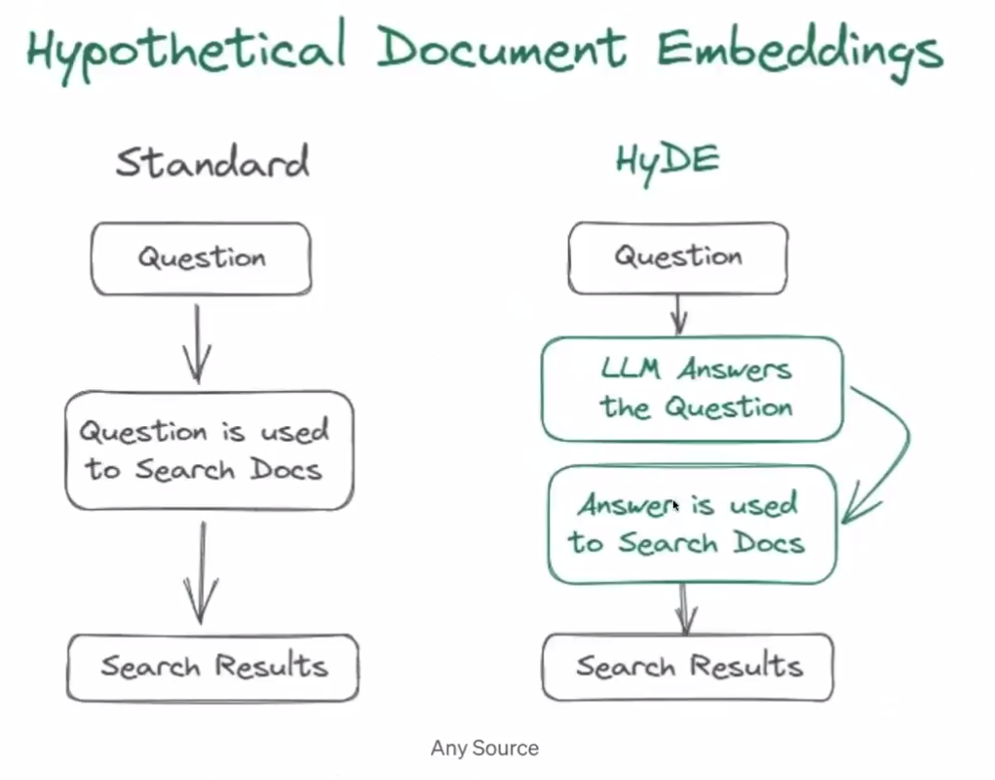

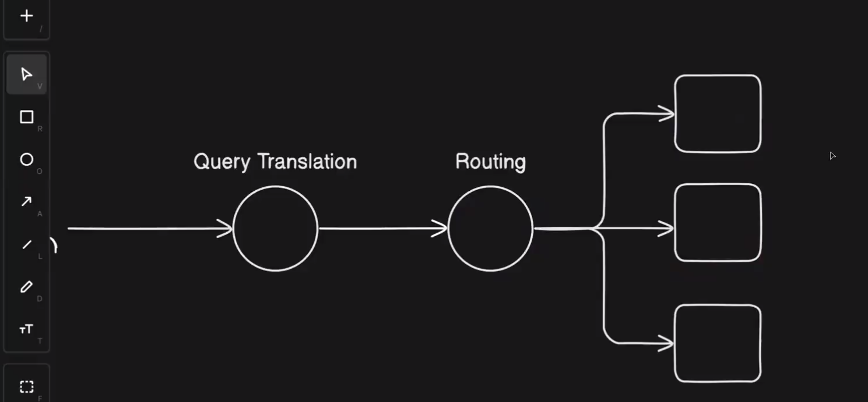
Routing
Routing :-
Types
- Logical Routing :- Routing user based on some condition
- Semantic Routing :-
Logical routing
- Pointing towards correct data first.
- Means points towards relevant data from DB.
E.g:- Data source having (python,js….)
User query :- write 2 number addition code in python
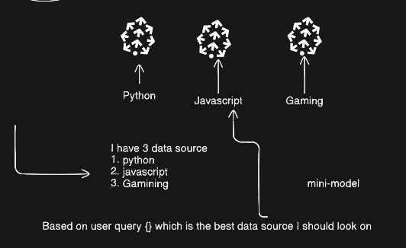

- So here it will go to python first.
- Then write the code in python
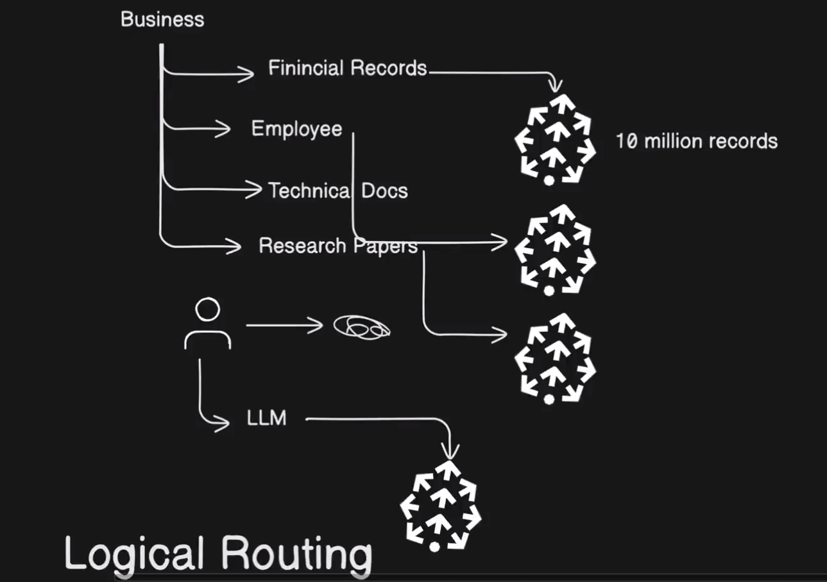
If user query is from multiple collections
- So here query getting rephrased and based on the rephrased query taking the collections reference and then ranking the collections then do the searching.
- Even we can route the LLM also.
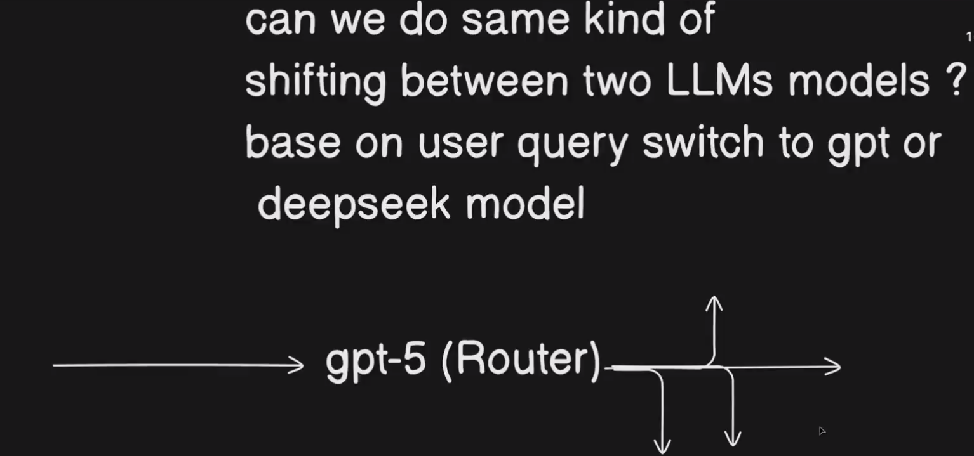
Knowledge Graph
- Vector embedding doesn’t store relation of data.
- That is why knowledge graph is used to have relation between data.
- Representing data in knowledge graph
Challenge is from where to start.
- Storing the meaning of every node in the vectorDB
- Storing address of nodes in the chunks.
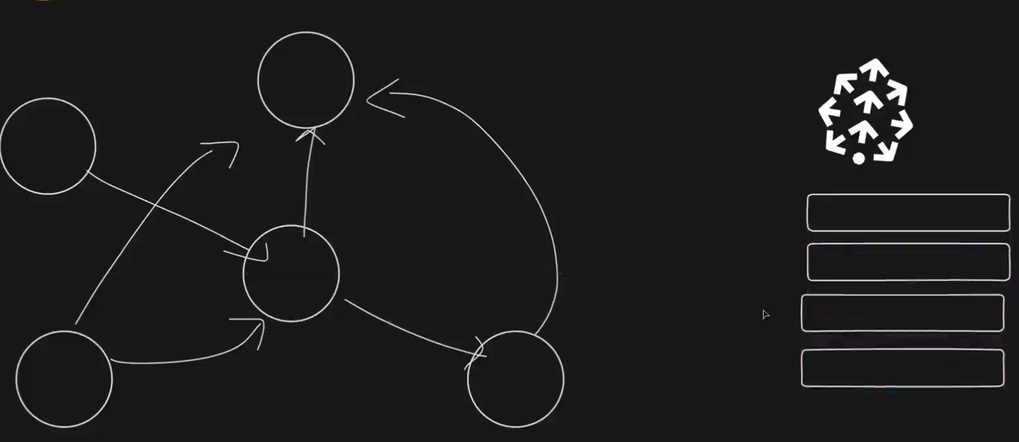
- User query is getting passed into vector db and relevant chunks is been fetched out.
- 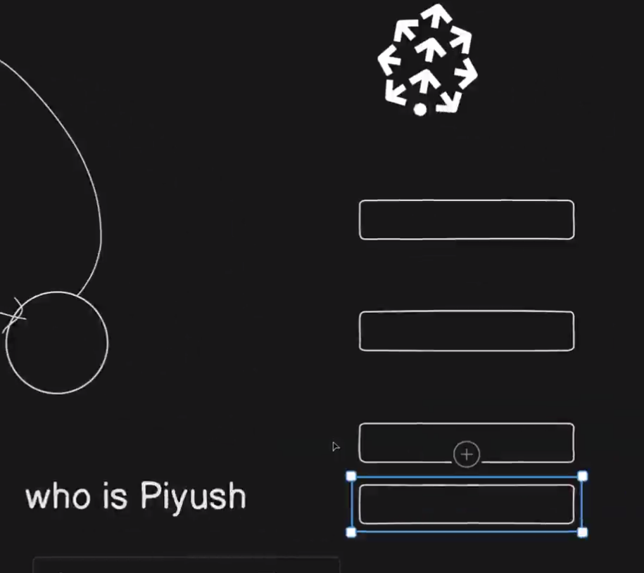

- And those chunks has nodes address as well.
- So bascially chunks with relation.
- And once we reach out to node we get the relation also.
- Neo4j is used for graphDB and cypher query is used here.
- Terminology
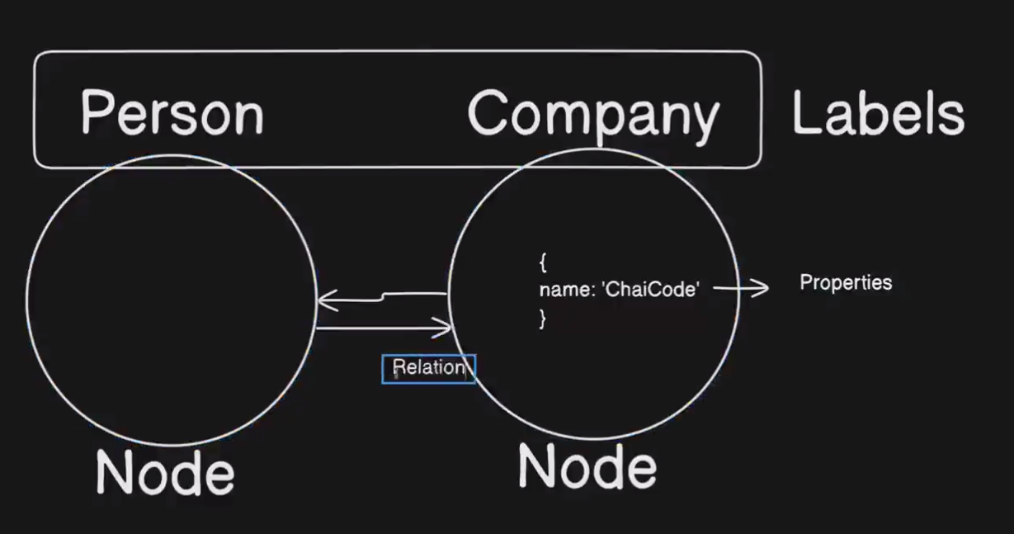
Command for making nodes
CREATE (c:Company{name:'ChaiCode'}) return c
- C :- variable
- Company :- variable name
- Name:- chaicode

Selecting 2 nodes
MATCH (n:Perosn{name:"Aman"}),
(c:Company{name:'ChaiCode'}) return n,c

Now
Indexing :- RAW,Langchain,Memory(mem0)
Retrieval :-
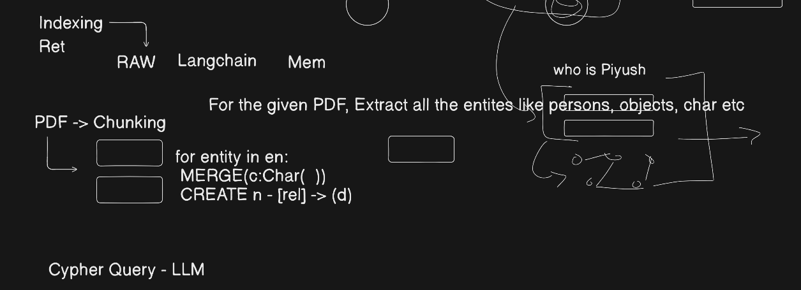
Usage of knowledge graph
- Memory.
- Recommendation Engine
- Real world entity(medical record)
- Voice assitant
Pre-requisites
Before bulding the knowledge graph feed the initial content about the usecase.

