**How to Play** **IGNITE** 

*2+ Players*  *Ages 10+*  *10 - 20 min*



**IGNITE** is a fast-paced game where you race to destroy opposing **forges** by com­manding your minions to ignite, attack, and combo your way to victory!

**Contents**:

|  |  |
| --- | --- |
| Each player has:  ● A 30 card **forge** (deck)  ● A game board  ● 4 **energy tokens** | This box also has:  ● 12 **damage counters**  ● 1 **turn tracker**  ● 2 **ignite dice** (six-sided dice)  ● This rulebook (hopefully...) |

**Winning**:

If your **forge** is **destroyed**, you lose. The last one standing wins. If a **forge** takes damage, remove that many cards and place them face up into your **scrapheap**. When your **forge** is empty and takes damage, it’s **destroyed** and you lose.

**Starting the Game**:

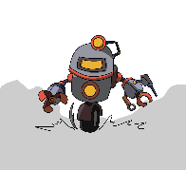Both players shuffle then place their **forge** face down onto their board. Roll dice to determine who goes first. Each player draws 5 cards. In 3+ player games, players take turns in clockwise order.

**Board**:

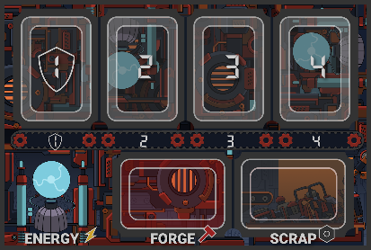https://lh6.googleusercontent.com/R9ZnjCKv3vn_6xILvf88Mrf-PI51EokaMekfO6u9_tfEeiHTe55SR251L5qVrq9LZxrXF4yoWRtZYkf3TFP85JIYyKbDzvmx0Gx6nW_KYxyqa9WKMcqFM_7EQkVCEJ_MhQ_mV1HS Forge:

Your **forge** is your deck. It’s filled with minions, and kept face down.

https://lh4.googleusercontent.com/JXiJ9KGAz3G2Df-TZkW62X0J2ZSqsznN6PnURKlpl4onvnqW5grvCqSBYl9ttEuSZo4LdA4RVzp3FJNRrxNOieBVFV20aUVYInkvQ8Wy_ti5teOw7SGNroNQUSgbQjSzCUpd3gWm Scrapheap:

The **scrapheap** is where **destroyed** minions go. It’s face up.

 Capacitor:

The **capacitor** is where you store **energy**. **Energy** is refreshed at the start of your turn. It’s used to **summon** minions and draw cards. Flip **energy tokens** to represent using **energy**.

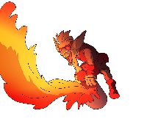Lineup:

Your **lineup** is the top 4 **slots** on your board. It’s where your **summoned** minions go.

Hand:

Keep your **hand** hidden from your opponents.

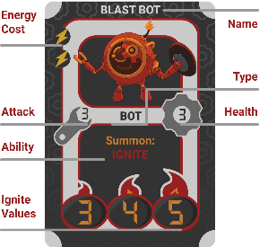**Cards**:

Name — What the card is called.

 Energy Cost — How much **energy** it costs to **summon**.

https://lh5.googleusercontent.com/PYaTaCh1KNNEpYxApc195BNIQnZRKZUAjmrXT7yyB5s7n7jkQQxpWwYXXwCoTZgsa5BxCaXJEQAPkomduwXR4qLOIybzXdOM2shS1vjnSX4Us9x3k75whe-_lWOyVDWPgmjKu-WY Attack — How much damage it deals when attacking.

https://lh4.googleusercontent.com/kOQhkGs8qTFqhiszeNDobfbPxAL7Bb81oEQsN9uhNX8zAyPpPyFb3yRb5qh3YHJLq4LBI8qyfHNMa7swPMFUtpx1SjmPCckSa784NUjHs8d56qqK7-wVH7aTb9tzbaDuqYr1Ujwh Health — How much damagecan take before it’s **destroyed**.

Ignite Values (**bots** only) — Values used for the **ignite** ability. See ***Ignite***.

Type — Whether it is a **bot**. Some cards only affect **bots**.

Ability — What the card does. Many cards have abilities that occur when **summoned** or **destroyed**. Abilities only affect the game when the card is on your **lineup**.

**Igniting**:

When your **bot ignites**, roll the two **ignite dice**. The number on the **target die** determines which target is hit. Rolling 1-4 hits that opposing slot number, and the **forge** icon, hits the opposing player’s **forge**.

     

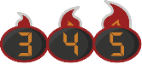The amount of damage is determined by the **explosion die**, which has three flame icons corresponding to the igniting **bot’s ignite values**. The damage dealt is the **ignite value** (on the **bot** which **ignited**) that corresponds to the icon rolled. See ***Cards*** for **ignite values**.

     

**Abilities**:

**Summon** **abilities** occur after the minion is **summoned**, and **scrap abilities** occur after it’s **destroyed**. See ***Building*** and ***Damage*** for when they occur.

**Turns**:

 *Recharge* — At the start of each player’s turn, their **capacitor** charges up to 4 **energy**. The first player starts their first turn with only 2 **energy**.

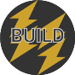Turns have two parts: **attacking** and **building**. You can use the included **turn tracker** to keep track of this.  
https://lh5.googleusercontent.com/PYaTaCh1KNNEpYxApc195BNIQnZRKZUAjmrXT7yyB5s7n7jkQQxpWwYXXwCoTZgsa5BxCaXJEQAPkomduwXR4qLOIybzXdOM2shS1vjnSX4Us9x3k75whe-_lWOyVDWPgmjKu-WY1. Attacking:  
Attack with one minion at a time. You may attack with any number of minions, including none, and in any order. Each minion may only attack up to once each turn.

1. Select the minion to attack with and its target (an opposing minion or **forge**).

*https://lh5.googleusercontent.com/eH9NqLdoUIydqkHWnjp3RJo7zUCXBUVbuDQQA-b_Te1B1ed3By4n068NfzdYtDsV4OCqPZ_Fkw6iTRP3DYLhh6YY2MugobYGWFdAc22XRzGiUJpO_raIRJpIDID4CUdIZKXJSwr0 Forge Guardian* — If the defending player has a **forge guardian** (minion on **slot 1**), that minion must be attacked and **destroyed** before any other target can be attacked.

1. *Attacking* — If a minion is attacked, each minion deals damage to the other equal to their **attack**. If a **forge** is attacked, the **forge** takes damage equal to the minion’s attack. See ***Damage*** and ***Cards***.
2. Any minions with 0 or less **health** are put into their player’s **scrapheap** (see ***Damage***) and their **scrap** **abilities** (if any) occur. See ***Abilities*** for more.

 2. Building:

Players can choose to **summon** any number of minions in their **hands** within two limitations:

1. They must have enough **energy**.
2. They must have an empty **slot** on their **lineup**.

When you **summon** a minion, spend **energy** equal to its **energy cost**, then they choose an empty **slot** to **summon** it to. Then, its **summon abilities** (if any) occur. See ***Abilities***.

*Crafting* — Players may also spend 1 **energy** to draw a card during **building**. This ability is repeatable.**Damage**:

Forge: *Scrapping* — If a **forge** takes damage, remove that ­many cards from it and place them face up into your **scrapheap**. If your **forge** would take damage and doesn’t have enough cards, instead remove all of them. If your **forge** takes damage and has no cards, it’s **destroyed** and you lose.



Minions: When a minion takes damage, place that many **damage counters** on it, to indicate the damage it’s taken. Damage reduces the minion’s **attack** AND **health** by the amount of damage. If a minion’s health becomes less than one, it’s **destroyed**. After a minion is **destroyed**, any **damage counters** on it are removed, and the minion’s **scrap ability** (if any) occur.

Drawing: Drawing cards counts as taking damage.

**Clarifications**:

*Igniting* — **Igniting** is not the same as attacking. It can happen at any time, and the igniting **bot** doesn’t take damage back. You can **ignite** past the opponent’s **forge guardian**.

*Drawing* — To draw a card, move it from **forge** to **hand**.

*Building* — Players can **summon** and draw cards with their **energy** in any order, if they have enough **energy**.

**3+ Players**:

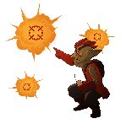Players sit in a circle. All players start with 4 **energy**. Players can only attack adjacent opponents, and **ignites** hit both adjacent players! When a player loses, they are removed from the circle. Last one standing wins!

**Game Variants**:

*Reclaim* — You may **destroy** one of your minions to get its **energy** cost back. You must wait a turn after **summoning** it, and may only use this ability when you are **building**.

*Conveyor Belt* — At the start of your turn, **destroy** your minion on slot 4 and move your minions right slot.

**Additional Rules**:

● All abilities occur starting with the current player, and then going clockwise. Once all abilities finish, minions with more damage than health die, and their **scrap abilities** occur.

For example, if your opponent **ignites** twice, and first hits your **Deconstructor** then hits your **Unstable Bot**, **Unstable Bot** will still ignite twice, because it dies at the same time as **Deconstructor**.

● Minions go to the **scrapheap** before their **scrap abilities** occur. Minions are **summoned** before their **summon abilities** occur.

● A minion with a **summon ability** must trigger its ability if possible, however if not possible it may still be summoned. For example, you may summon **Scrapbot** without any cards in any **scrapheaps**, however if there are cards you activate its ability. **Scrap abilities** also must be triggered if possible.

● Minions that can summon to **destroy** one of your minions cannot be played onto that minion’s slot. **Flamebringer** can however, **destroy** itself if you have an empty slot, because its **summon ability** occurs after it’s summoned..

● Since **scrapheaps** are revealed, the card returned with **Scrapbot** is revealed as well.

● With 3+ players, if a player loses and their **bot** is **destroyed** at the same time, the **bot’s** **scrap abilities** still occur. Also, if a player loses during a series of **ignites**, resolve all **ignites** before **igniting** the new adjacent player.

● With 3+ players, abilities that affect ALL minions include ALL minions, not just yours and adjacent players’. For example, **Repair Bot**, and **Molten Maniac.**

● If multiple **ignites** would occur at the same time hitting a player’s **forge**, they take damage one **ignite** at a time. For example, if you have 3 cards and take 5 then 5 damage, your **forge** is destroyed and you lose.