|  |  |
| --- | --- |
| Use Case: | Add/read/remove messages to the editor for articles/newspapers. |
| Actor: | Customer, Employees, Managers, Owners |
| Precondition: | The database exists how it was initially designed, and the actor has clearance to do the command. |
| Main Success  Scenario: | 1: The Actor chooses to add a message to the editor on an article/newspaper after reading it.  2: The Actor gives them a message line by line in the console, however many lines it needs.  3: The Actor enters q on the last line when they are done, and hits enter to quit. |
| Extensions: | 1a: The Actor chooses to not give them a message.  2a: Does not happen if 1a occurs.  3a: Does not happen if 1a occurs.  1b: The Actor chooses to read messages to the editor.  2c: If 1b occurs, then the program prints out all messages to the editor in the console.  3b: If 1b and 2c occur, then the program does not have a third step.  1c: The actor chooses to remove a message to the editor.  2d: If 1c occurs, then it prints out the identifier for the message (the name of the article or volume/issue of the newspaper) along with an index, which the actor chooses from.  3c: If 1c and 2d occur, then it removes the message and saves the change to the initialization file.  3d: If 2d shows that there are no messages, then it does not allow any selections or saves. |

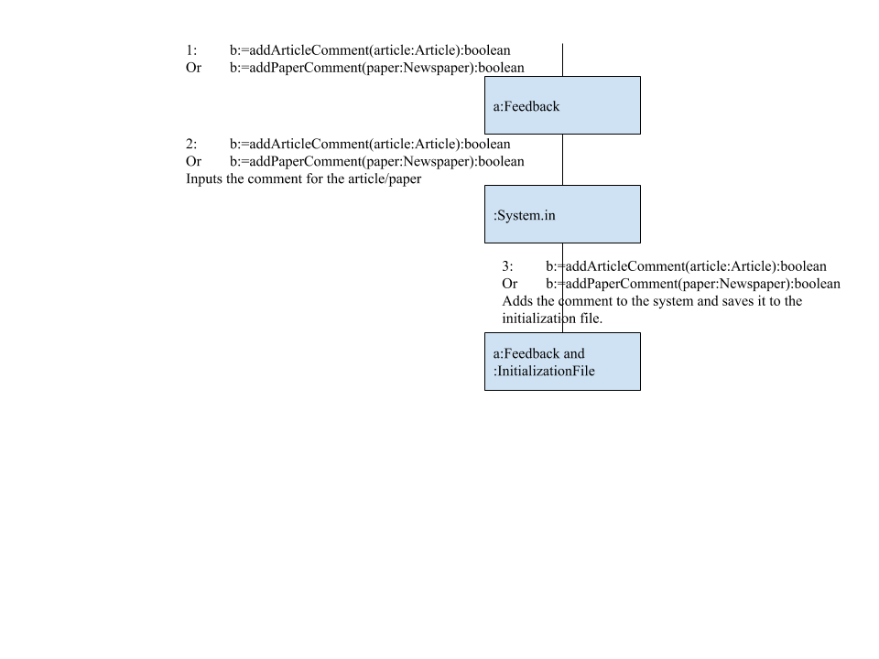

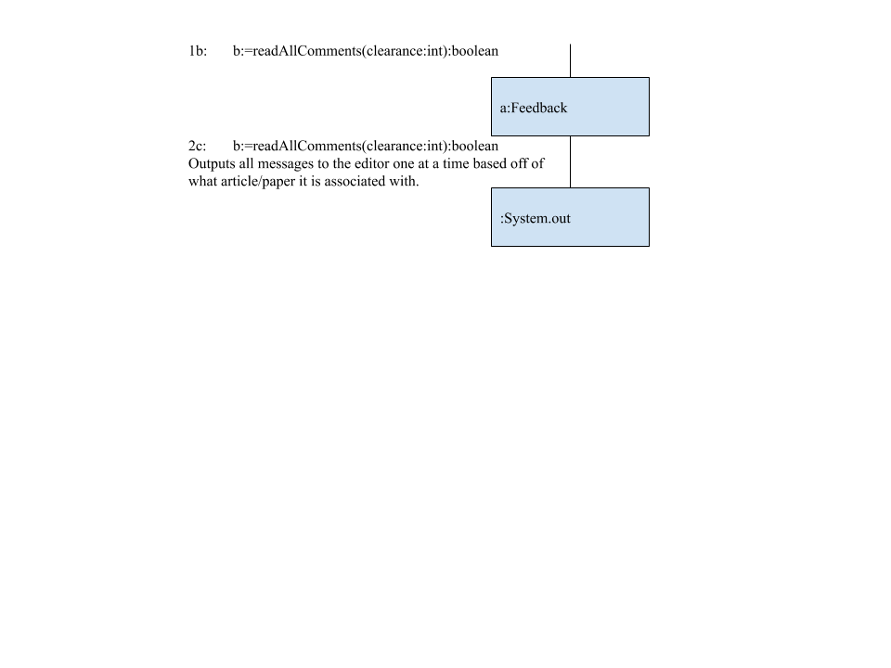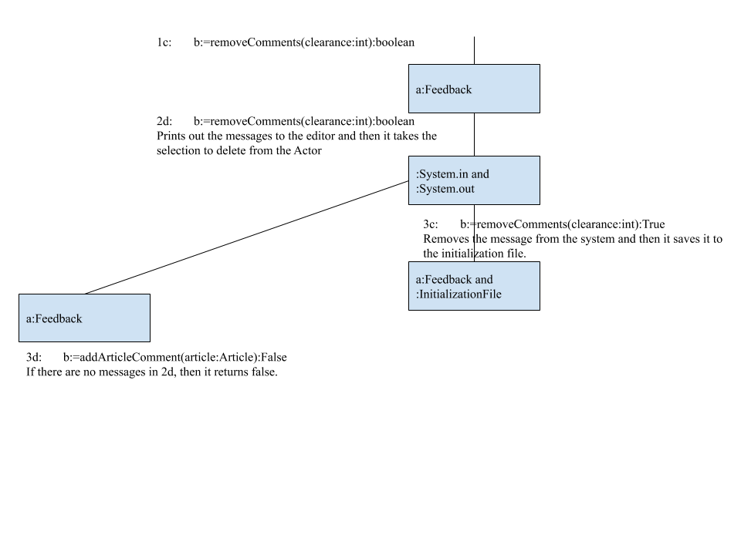

|  |  |
| --- | --- |
| Use Case: | Add, remove, or read the feedback for the company |
| Actor: | Customer, Employees, Managers, Owners |
| Precondition: | The database exists how it was initially designed, and the actor has clearance to do the command. |
| Main Success  Scenario: | 1: The Actor chooses to add feedback to the company.  2: The Actor chooses to give the program an email.  3: The Actor gives an integer rating.  4: The Actor gives a suggestion/message along with all this to be part of the review.  5: The program saves this all to the initialization file and immediately makes it available. |
| Extensions: | 1a: The Actor chooses to not give feedback, so none of the following steps will happen.  2a: If the Actor chooses to not give an email, it says the email is Anonymous with a random number after it.  3a: If the number inputted can not be read as an integer, it kicks them out.  4a: If they choose to not give a suggestion/message, it just says no comment.  5a: If 3a happens, then this step does not happen.  1b: If the Actor chooses to remove a review.  2b: It lists out all reviews with indexes.  3b: The Actor chooses an index to get removed.  4b: The program removes it from immediate access.  5b: After leaving, the program saves all changes to the file.  1c: The Actor chooses to read all reviews.  2c: The program prints out all reviews along with an average rating. |

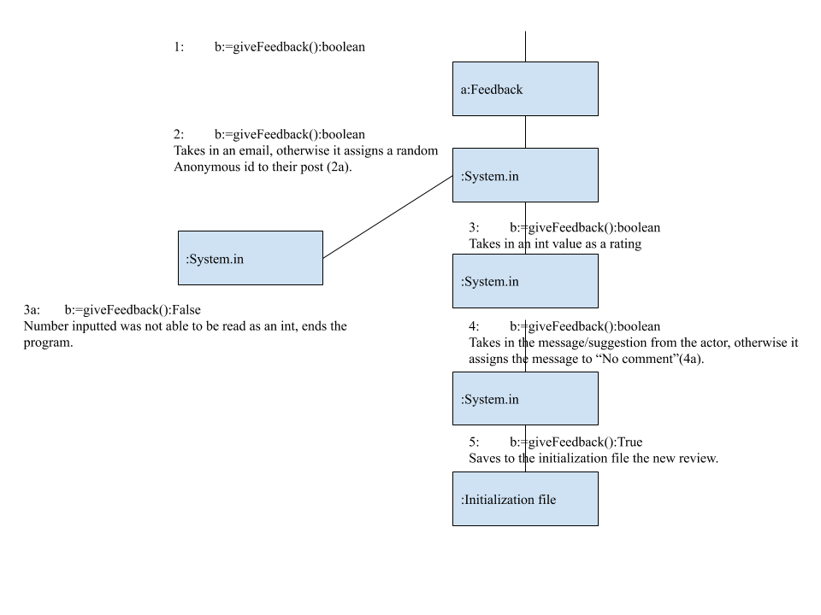

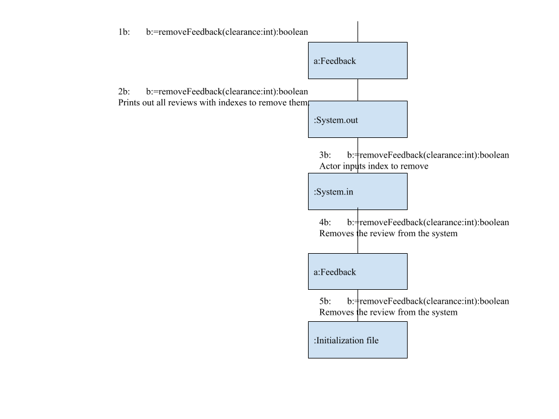

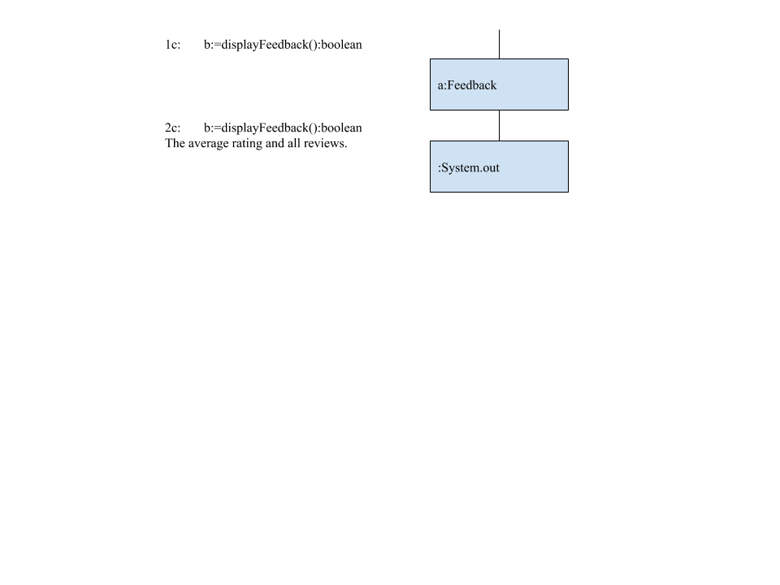

Class Diagrams:

|  |
| --- |
| Feedback |
|  |
| b:=removeFeedback(clearance:int):boolean  b:=giveFeedback():boolean  b:=displayFeedback():boolean |

|  |
| --- |
| DMEditor |
|  |
| b:=addArticleComment(article:Article):boolean  b:=addPaperComment(paper:Newspaper):boolean  b:=readAllComments(clearance:int):boolean  b:=removeComments(clearance:int):boolean |