|  |  |
| --- | --- |
| Use Case: | Add, read, or order newspaper(s) |
| Actor: | Customer, Employees, Managers, Owners |
| Precondition: | The database exists how it was initially designed, and the actor has clearance to do the command. |
| Main Success  Scenario: | 1: The Actor chooses to add a newspaper.  2: The Actor gives the program the files for a newspaper, the issue/volume numbers, and the date.  3: The program records this in the database and updates the program’s map of newspapers. |

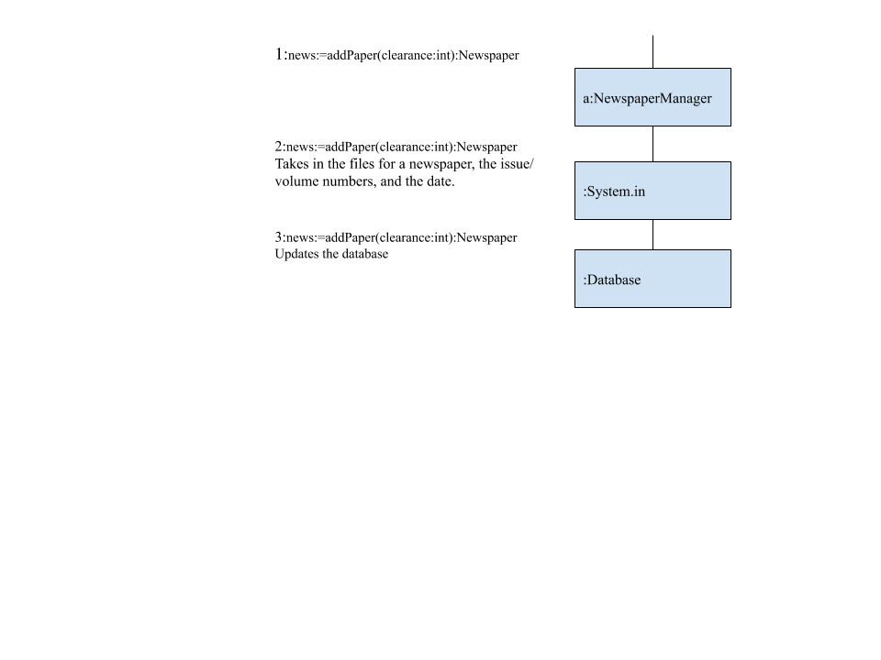

Extension: “a” path

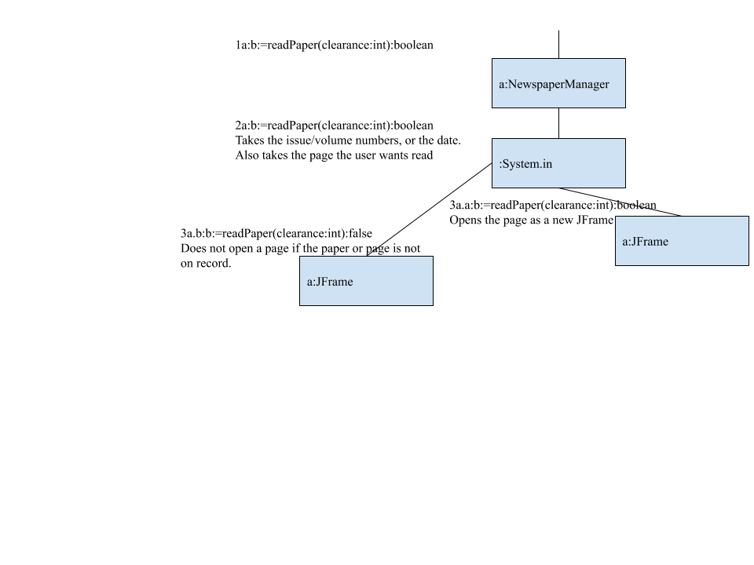

Extension: “b” path

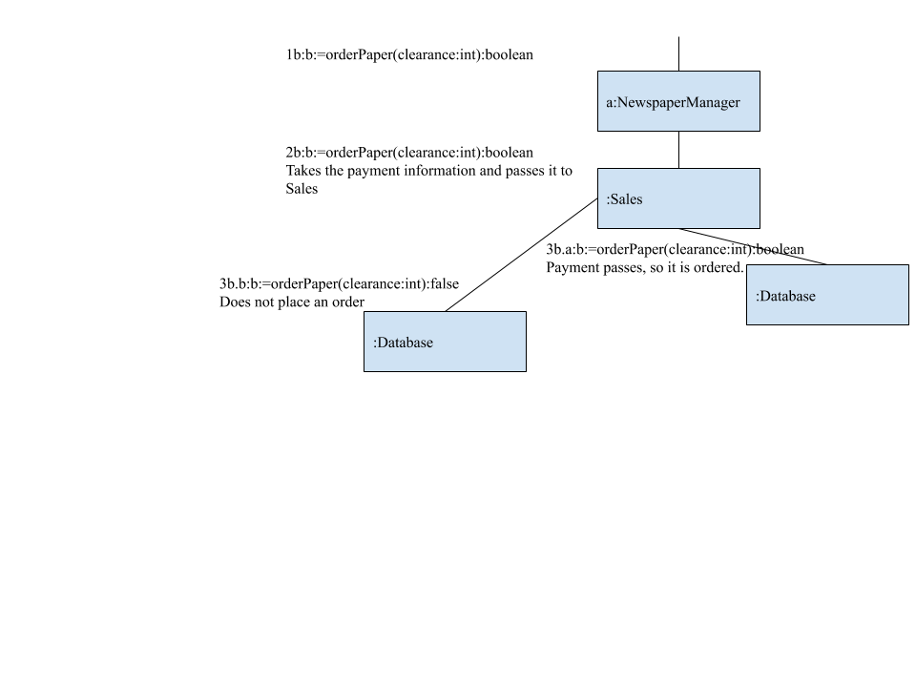

Extension: “c” path

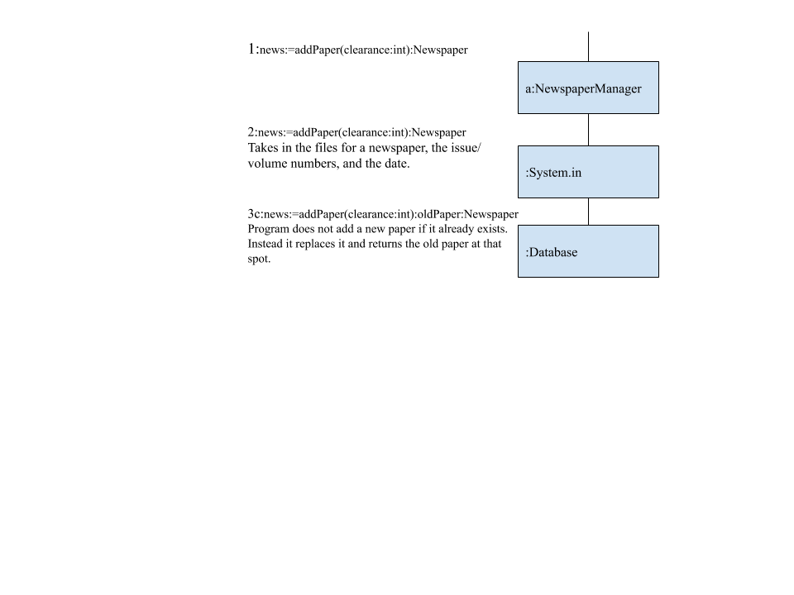

|  |  |
| --- | --- |
| Use Case: | Search for article |
| Actor: | Customer, Employees, Managers, Owners |
| Precondition: | The database exists how it was initially designed. |
| Main Success  Scenario: | 1: The actor inputs the name, date, volume/issue, or description of the article  2: The program fetches the file from the database.  3: The program returns the list of articles matching inputs |

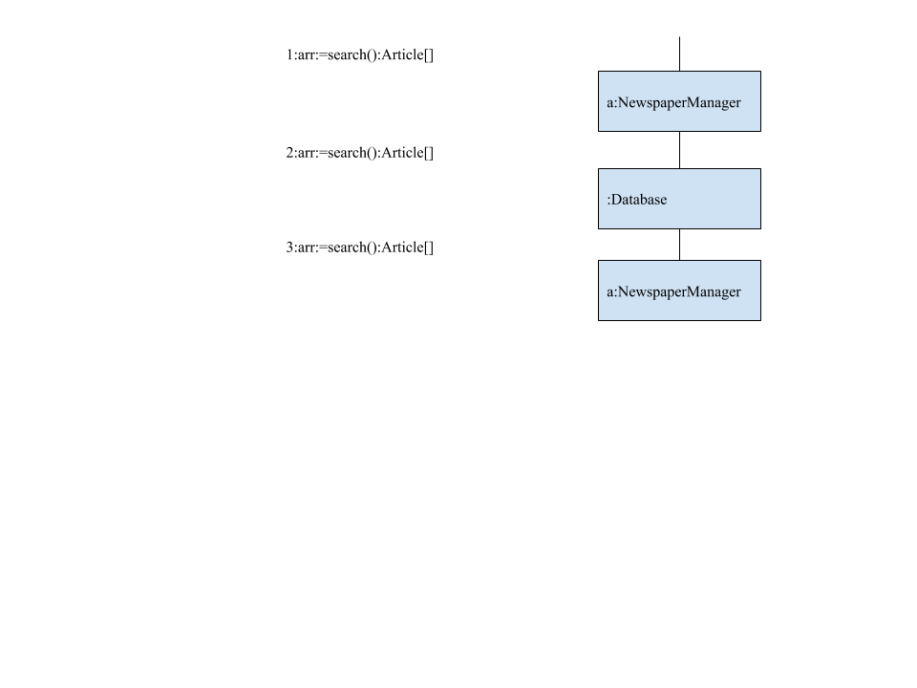

Extensions: (If 1a happens, so does 2a and 3a. If 2a happens, so does 3a.)

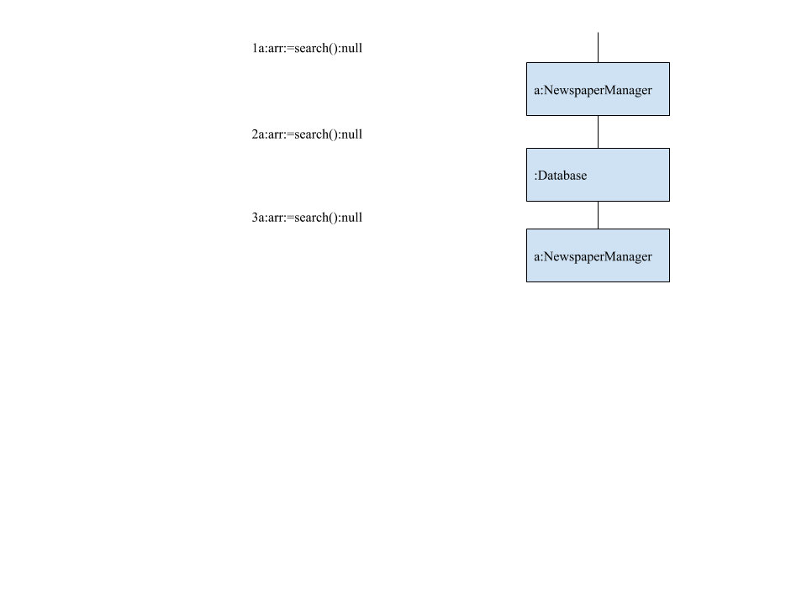

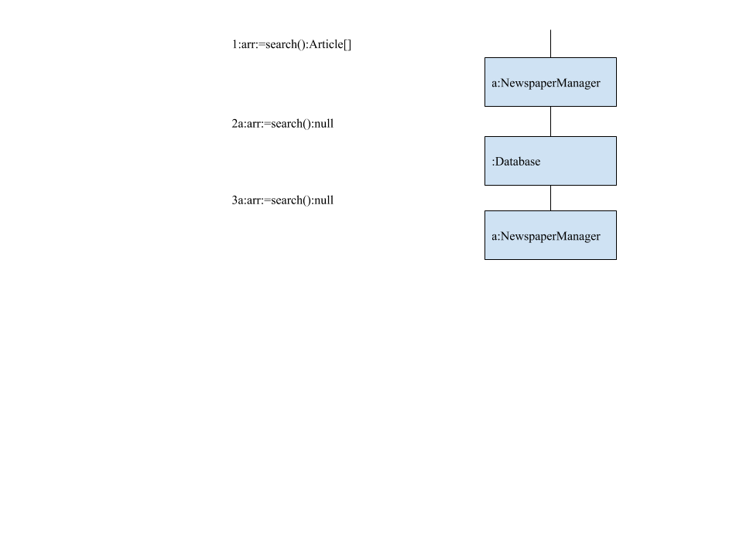

Class Diagrams:

|  |
| --- |
| Article |
|  |
| i:=getVolume():int  i:=getIssue():int  i:=getDay():int  i:=getMonth():int  i:=getYear():int  b:=isFinalized():boolean  s:=getName():String  s:=getDesc():String  s:=path():String |

|  |
| --- |
| FinishedArticle |
|  |
| b:=readArticle(clearance:int):boolean  b:=finalizeArticle(clearance:int):boolean  b:=editArticle(clearance:int):boolean |

|  |
| --- |
| Newspaper |
|  |
| b:=getPublished:boolean  b:=finalizePaper(clearance:int):boolean  b:=readPaper(clearance:int):boolean  b:=orderPaper(clearance:int):boolean  setFinal():void  b:=printPage():boolean  arr:=getInfo():int[] |

|  |
| --- |
| NewspaperManager |
|  |
| news:=search():Newspaper  news:=addPaper(clearance:int):Newspaper  news:=findPaper(paper:int[]):Newspaper  b:=init():boolean  b:=save():boolean  s:=editPaper(n:Newspaper, clearance:int):String |

|  |
| --- |
| ArticleManager |
|  |
| arr:=search():Article[]  b:=addArticle():boolean  b:=init():boolean  arr:=getArticles():ArrayList<Article>  a:=getArticle(name:String):Article |