**NECESSARY TOOLS AND WHY**   
  
**++ Programming Languages:**

**Python:** Python is an open-source programming language widely used in scientific computing and machine learning research

**++ Optimization Libraries:**

**scikit-optimize:** scikit-optimize is an open-source Python library for sequential model-based optimization, including Bayesian optimization. It offers implementations of various surrogate models, acquisition functions, and optimization algorithms.

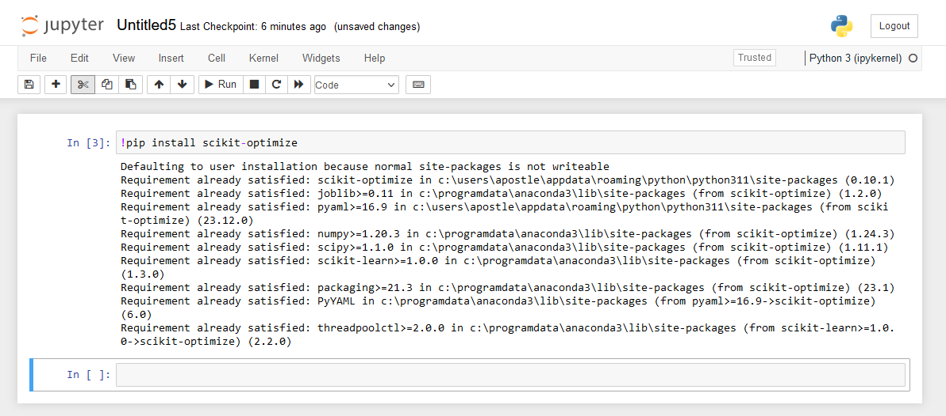

**GPyOpt:** GPyOpt is a Python library specifically designed for Bayesian optimization. It provides implementations of Gaussian process regression and various acquisition functions.

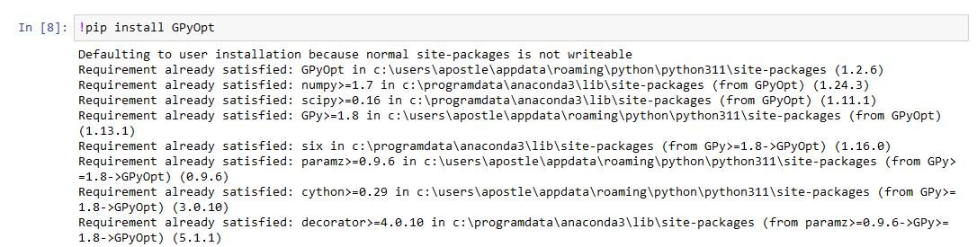

**++ Simulation and Experimentation Tools:**

**Jupyter Notebooks:** Jupyter Notebooks provide an open-source interactive computing environment for running Python code, visualizing results, and documenting experiments.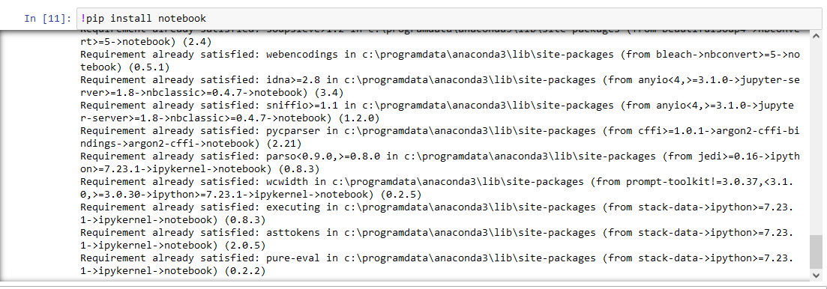

**++ Data Analysis and Visualization Tools:**

**NumPy and pandas:** NumPy and pandas are open-source Python libraries for data manipulation and analysis. We can use them to handle datasets, perform statistical analysis, and preprocess experimental data.

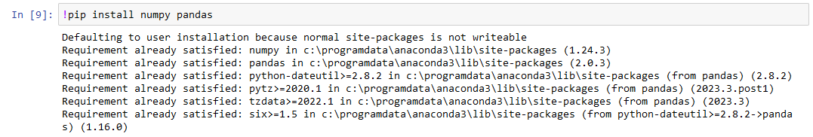

**Matplotlib and Seaborn:** Matplotlib and Seaborn are open-source Python libraries for creating visualizations and plots.

