1.

import matplotlib.pyplot as plt

x = [1,2,3]

y = [5,7,4]

plt.plot(x,y)

plt.xlabel('Plot Number')

plt.ylabel('Important var')

plt.title('Interesting Graph')

plt.show()

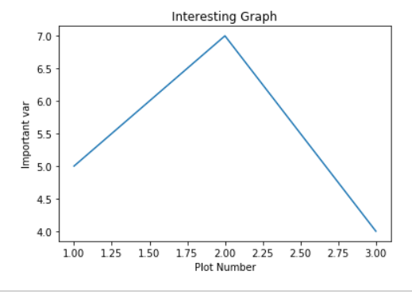

2.

import matplotlib.pyplot as plt

x = [1,2,3]

y = [5,7,4]

x2 = [1,2,3]

y2 = [10,14,12]

plt.plot(x,y, label = 'First Line')

plt.plot(x2,y2, label = 'Second Line')

plt.xlabel('Plot Number')

plt.ylabel('Important var')

plt.title('Interesting Graph')

plt.legend()

plt.show()

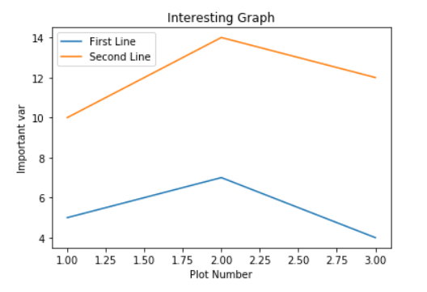

3.

import matplotlib.pyplot as plt

x = [2,4,6,8,10]

y = [6,7,8,2,4]

plt.bar(x,y,label = 'Bars1')

plt.xlabel('Plot Number')

plt.ylabel('Important var')

plt.title('Interesting Graph\nCheckk it out')

plt.legend()

plt.show()

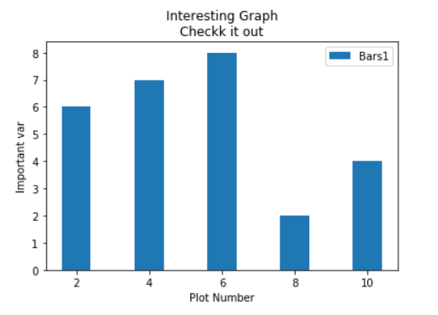

4.

import matplotlib.pyplot as plt

x = [2,4,6,8,10]

y = [6,7,8,2,4]

x2 = [1,3,5,9,11]

y2 = [7,8,2,4,2]

plt.bar(x,y,label='Bars1')

plt.bar(x2,y2,label='Bars2')

plt.xlabel('x')

plt.ylabel('y')

plt.title('Interesting Graph\nCheck it out')

plt.legend()

plt.show()

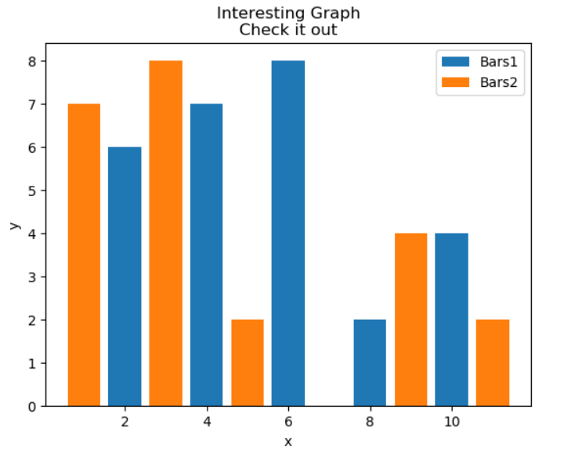

5.

import matplotlib.pyplot as plt

x = [2,4,6,8,10]

y = [6,7,8,2,4]

x2 = [1,3,5,9,11]

y2 = [7,8,2,4,2]

plt.bar(x,y,label='Bars1', color = 'r')

plt.bar(x2,y2,label='Bars2', color = 'c')

plt.xlabel('x')

plt.ylabel('y')

plt.title('Interesting Graph\nCheck it out')

plt.legend()

plt.show()

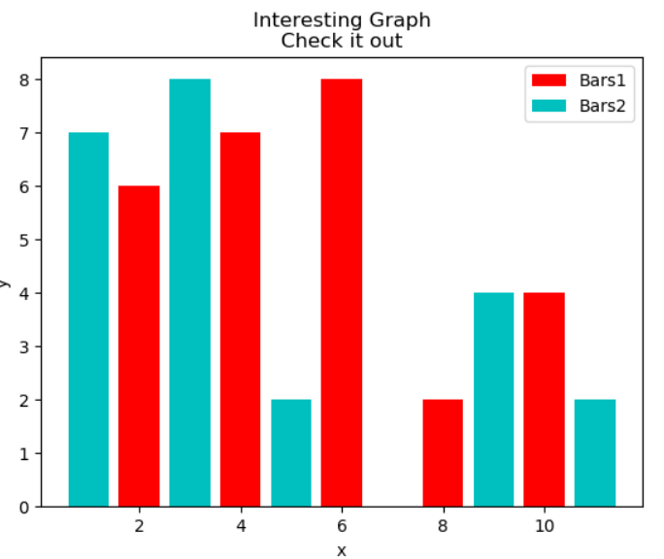

6.

import matplotlib.pyplot as plt

population_ages = [22,55,62,45,21,22,34,42,42,4,99,102,110,120,121,122,130,111,115,112,80,75,65,54,44,43,42,48]

bins = [0,10,20,30,40,50,60,70,80,90,100,120,130]

plt.hist(population_ages,bins,histtype = 'bar',rwidth = 0.8)

plt.xlabel('x')

plt.ylabel('y')

plt.title('Interesting Graph\nCheck it out')

plt.legend()

plt.show()

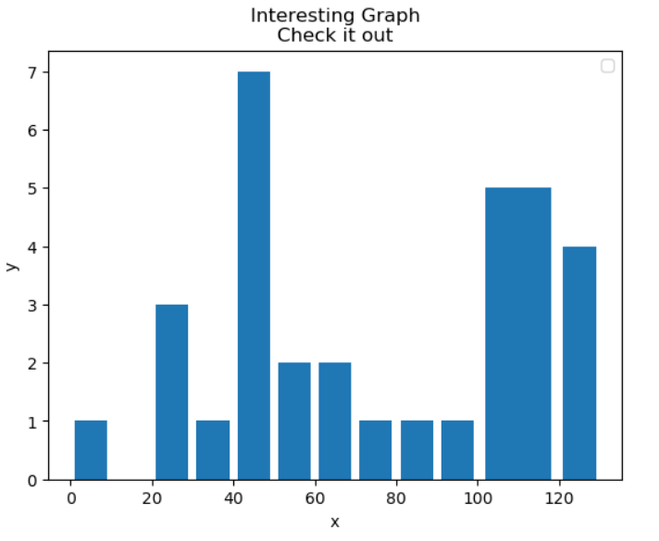

7.

import matplotlib.pyplot as plt

x = [1,2,3,4,5,6,7,8]

y = [5,2,4,2,1,4,5,2]

plt.scatter(x,y,label = 'skitcat',color = 'k')

plt.xlabel('x')

plt.ylabel('y')

plt.title('Interesting Graph\nCheck it out')

plt.legend()

plt.show()

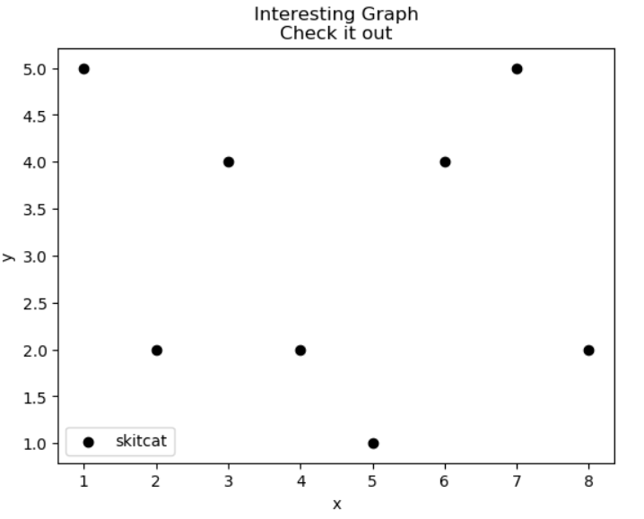

8.

import matplotlib.pyplot as plt

x = [1,2,3,4,5,6,7,8]

y = [5,2,4,2,1,4,5,2]

plt.scatter(x,y,label = 'skitcat',color = 'k', s = 500)

plt.xlabel('x')

plt.ylabel('y')

plt.title('Interesting Graph\nCheck it out')

plt.legend()

plt.show()

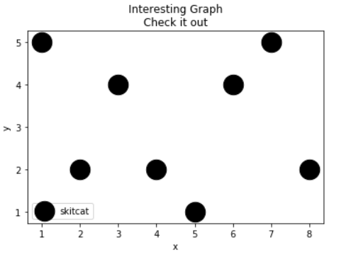

9.

import matplotlib.pyplot as plt

x = [1,2,3,4,5,6,7,8]

y = [5,2,4,2,1,4,5,2]

plt.scatter(x,y,label = 'skitcat',color = 'k', s = 500, marker = “x)

plt.xlabel('x')

plt.ylabel('x')

plt.title('Interesting Graph\nCheck it out')

plt.legend()

plt.show()

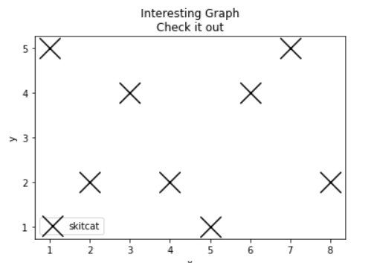

10.

import matplotlib.pyplot as plt

import numpy as np

def heavisaid(x,a):

return 1*(x>a)

a = 2

xi = np.arange(-5,5,1e-2)

f = heavisaid(xi,a)

plt.plot(xi,f)

plt.show()

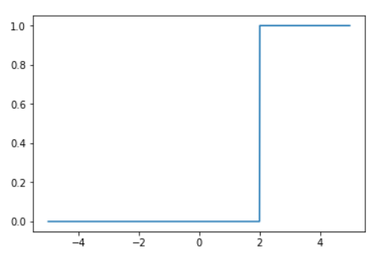

11.

import matplotlib.pyplot as plt

import numpy as np

def heavisaind(x,a):

return 1*(x>a)

a=2

xi=np.arange(-5,5,1e-2)

f=heavisaind(xi,a)

plt.plot(xi,f)

plt.axis([-6,6,-0.5,1.5])

plt.xlabel(r'$x$', fontsize=14, color='black')

plt.ylabel(r'$\theta(x)$', fontsize=14, color='black')

plt.grid(True)

plt.show()

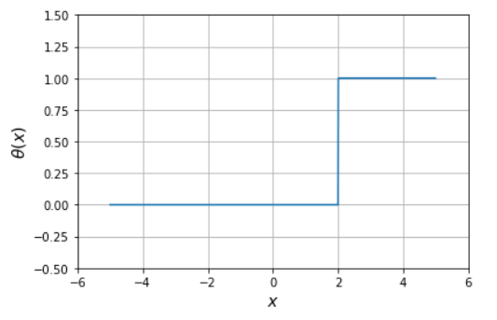

12.

import matplotlib.pyplot as plt

import numpy as np

def heavisaind(x,a):

return 1*(x>a)

data=np.array([1.5,5.2,8.6,3,9.5,6.6,6.5,5.4])

N=len(data)

fig=plt.gcf()

fig.set_size_inches(10,5)

plt.subplot(121)

n=np.arange(1,N+1,1)

plt.plot(n,data,'ro--')

plt.axis([0,N+1,0,max(data)+1])

plt.xlabel(r'$n$', fontsize=14, color='black')

plt.ylabel(r'$data$', fontsize=14, color='black')

plt.xticks(np.arange(0,N+1,1))

plt.grid()

plt.subplot(122)

m=1000

x=np.linspace(0,max(data)+1,m)

sumtheta=np.zeros(m)

for i in range(N):

sumtheta+=heavisaind(x,data[i])

F=sumtheta/N

plt.plot(x,F)

plt.axis([0,max(data)+2,0,1.3])

plt.xlabel(r'$x$', fontsize=14, color='black')

plt.ylabel(r'$F$', fontsize=14, color='black')

plt.xticks(np.arange(0,max(data)+2,1))

plt.grid()

plt.show()

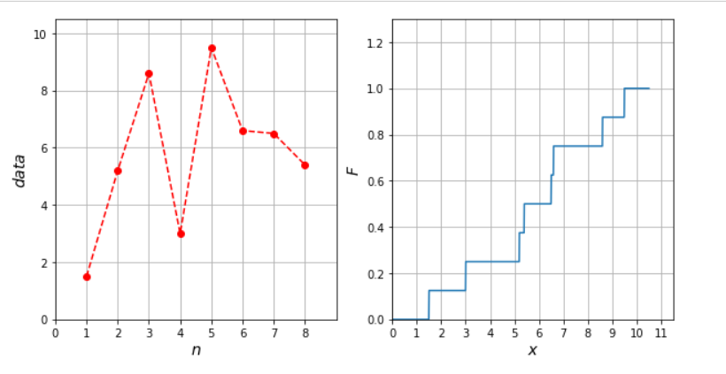

13-14.

import matplotlib.pyplot as plt; plt.rcdefaults()

import numpy as np

import matplotlib.pyplot as plt

objects=('Python','C++','Java','Perl','Scala','Lisp')

y_pos=np.arange(len(objects))

performance=[10,8,6,4,2,1]

plt.bar(y_pos,performance,align='center',alpha=0.5)

plt.xticks(y_pos,objects)

plt.ylabel('Usage')

plt.title('Programming language usage')

plt.show()

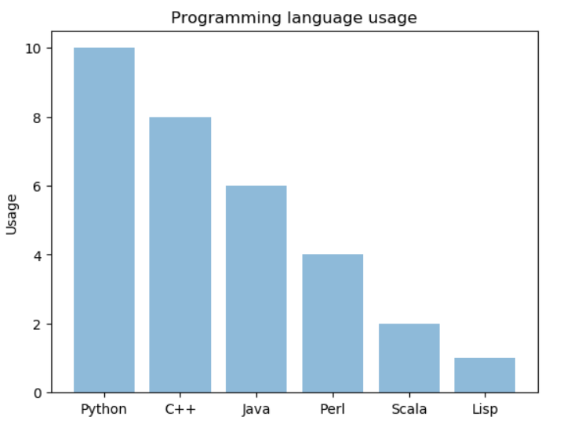

15.

import matplotlib.mlab as mlab

import numpy as np

import matplotlib.pyplot as plt

x=[21,22,23,4,5,6,77,8,9,10,31,32,33,34,35,36,37,18,49,50,100]

num_bins=5

n, bins, patches=plt.hist(x,num_bins,facecolor='blue',alpha=0.5)

plt.show()

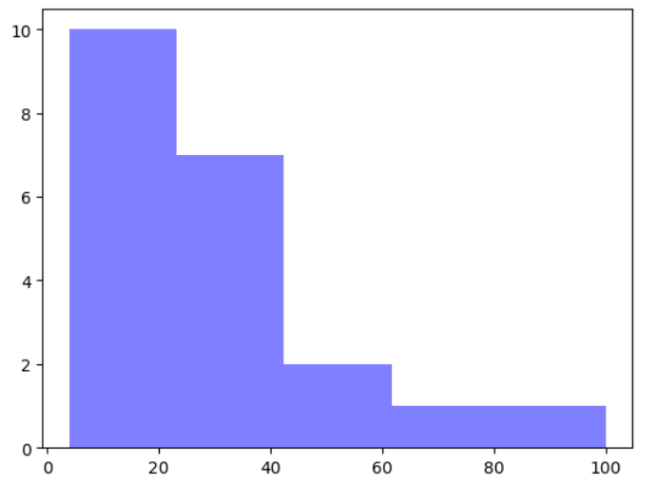

16.1

import scipy.stats as sank

import numpy as np

import matplotlib.pyplot as plt

mu=100

sigma=15

x=mu+sigma*np.random.randn(10000)

num_bins=20

n, bins, patches=plt.hist(x,num_bins,normed=1,facecolor='blue',alpha=0.5)

y=sank.norm.pdf(bins,mu,sigma)

plt.plot(bins,y,'r--')

plt.xlabel('Smarts')

plt.ylabel('Probability')

plt.title(r'Histogram of IQ: $\mu=100$, $\sigma=15$')

plt.subplots_adjust(left=0.15)

plt.show()

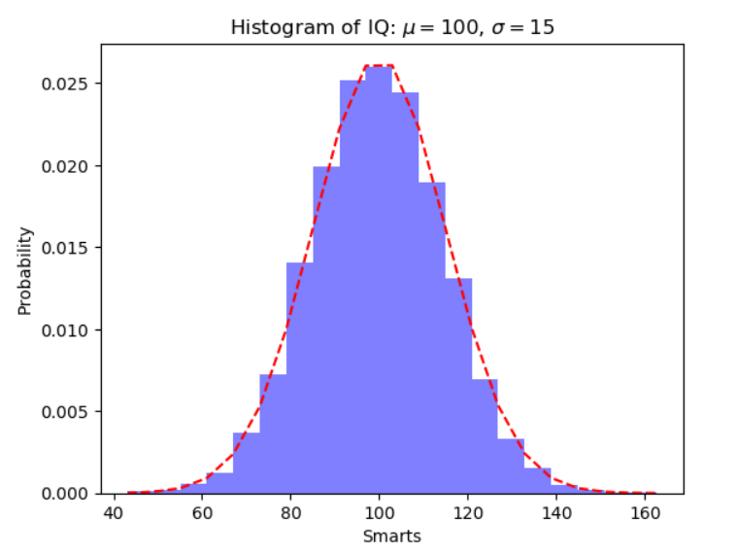

16.2

import scipy.stats as sank

import numpy as np

import matplotlib.pyplot as plt

mu=100

sigma=15

x=mu+sigma*np.random.randn(10000)

num_bins=20

n, bins, patches=plt.hist(x,num_bins,density = True,facecolor='green',alpha=0.5)

import scipy.stats

y = scipy.stats.norm.pdf(bins,mu,sigma)

plt.plot(bins,y,'r--')

plt.subplots_adjust(left=0.15)

plt.show()

