PERMISSION AND ACCESS SUBSYSTEM

Users:
- Student
- Professor
- Technical support unit
- Supervisor
- Security unit
- Interested person(any user from this list)

Role:
- Provide ability to access certain room (lecture hall, laboratory, etc.) using personal pass card.
- Provide ability to gain permission to access certain room (lecture hall, laboratory, etc.) using personal pass card.

Usecases:
- Register in the system
- Add new permission
- Request permission to access room
- Gain permission to access room
- Access room
- Open room
- Lock room

Register in the system usecase

Condition:
Interested person is permitted to register by Supervisor.

Actors:
- Interested person (IP)
- System

Goal:
Interested person needs to register.

Main scenario:
- Interested person requests to be registered.
- System sends form to specify his identity and role.
- IP submits filled form.
- System registers IP in Database.
- System makes a pass card for IP’s passid.
- System gives pass card to IP.

Result:
IP is registered in the system and has pass card.

Diagram:

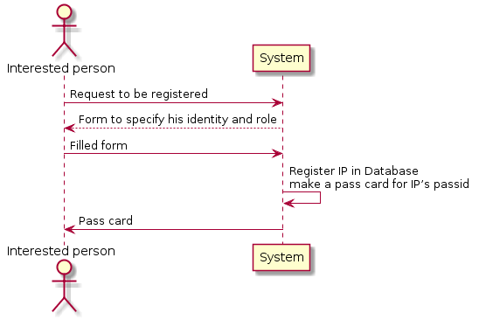

Plantuml code:
@startuml
actor "Interested person" as iper
participant System as sys
iper -> sys : Request to be registered
iper <-- sys : Form to specify his identity and role
iper -> sys : Filled form
sys -> sys : Register IP in Database \nmake a pass card for IP’s passid
sys -> iper : Pass card
@enduml
Add new permission usecase

Actors:
- Supervisor (SV)
- System

Goal:
Add new permission to access a room for an interested person (IP).

Main scenario:
- SV sends request to add a new permission to access a room.
- System sends form (Full_Name (field), Role (radiobutton list), Period (field), Room_ID (field), Purpose (radiobutton list), Other (optional field), Submit (button)) to specify the request.
- SV submits filled form by pressing “submit” button.
- System updates IP’s permissions.
- System report about the successful update.

Result:
Permission is granted.

Diagram:

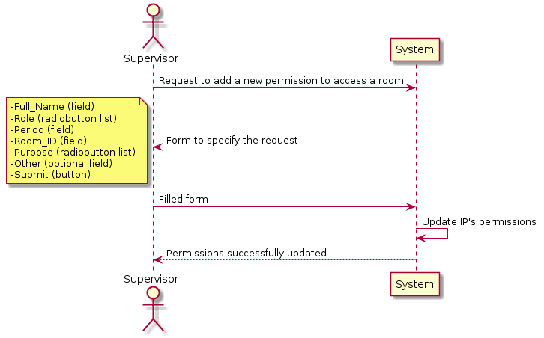

Plantuml code:
@startuml
actor Supervisor as sv
participant System as sys
sv -> sys : Request to add a new permission to access a room
sv <-- sys : Form to specify the request

note left
-Full_Name (field)
-Role (radiobutton list)
-Period (field)
-Room_ID (field)
-Purpose (radiobutton list)
-Other (optional field)
-Submit (button)
end note

sv -> sys : Filled form
sys -> sys : Update IP's permissions
sys --> sv : Permissions successfully updated
@enduml
Request permission to access room usecase

Actors:
- Interested person (IP)
- System

Goal:
Supervisor will consider granting a permission.

Main scenario:
- IP sends request to gain access to a room.
- System sends form (Full_Name (field), Role (radiobutton list), Period (field), Room_ID (field), Purpose (radiobutton list), Other (optional field), Submit (button)) to specify the request.
- IP submits filled form by pressing “submit” button.

Result:
Request is created.

Diagram:

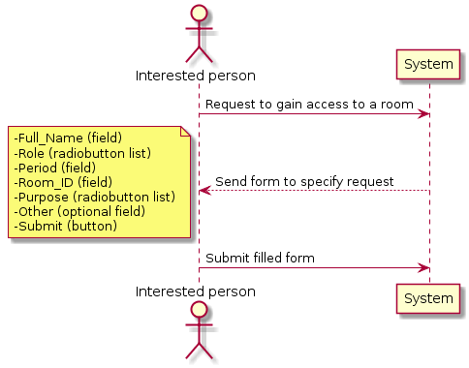

Plantuml code:
@startuml
actor "Interested person" as iper
participant System as sys
iper -> sys : Request to gain access to a room
sys --> iper : Send form to specify request

note left
-Full_Name (field)
-Role (radiobutton list)
-Period (field)
-Room_ID (field)
-Purpose (radiobutton list)
-Other (optional field)
-Submit (button)
end note

iper -> sys : Submit filled form
@enduml
Gain permission to access room usecase

Conditions:
- Interested person made a request.
- Supervisor looked into the request and approved it.

Actors:
- Interested person (IP)
- System

Goal:
Interested person can access a certain room.

Main scenario:
- IP requests system to inform him/her about the status of his/her previous request.
- System sends a positive reply and ask IP to read about responsibility of accessing a room, check “I accept” checkbox and press “OK” button.
- IP perform given instructions.
- System updates IP’s permissions.
- System report about the successful update.

Result:
Permission is granted.

Diagram:

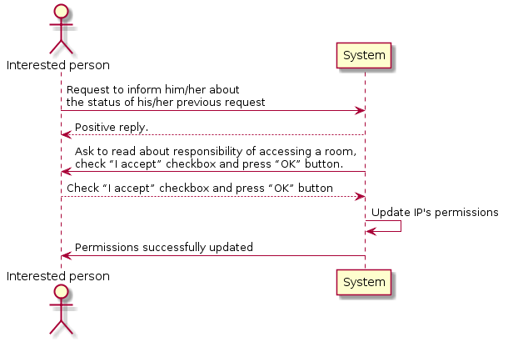

Plantuml code:
@startuml
actor "Interested person" as iper
participant System as sys
iper -> sys : Request to inform him/her about \nthe status of his/her previous request
sys --> iper : Positive reply.
sys -> iper : Ask to read about responsibility of accessing a room, \ncheck “I accept” checkbox and press “OK” button.
sys <-- iper : Check “I accept” checkbox and press “OK” button
sys -> sys : Update IP's permissions
sys -> iper : Permissions successfully updated
@enduml
Access room usecase

Conditions:
Permission is granted to the interested person.

Actors:
- Interested person (IP)
- System

Goal:
Interested person can open a certain room.

Main scenario:
- IP sends request to access a certain room by inserting his pass card in the room’s detector.
- System creates a log entry about accessing the room.
- System sends message “Access granted”.

Result:
The access is granted. Log is updated.

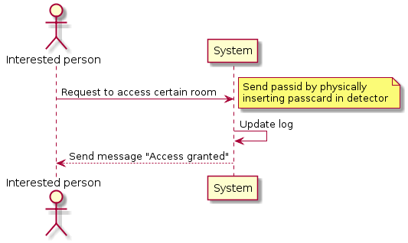
Diagram:

Plantuml code:

@startuml

actor "Interested person" as iper
participant System as sys
iper -> sys : Request to access certain room
note right : Send passid by physically\ninserting passcard in detector
sys -> sys : Update log
iper <-- sys : Send message "Access granted"

@enduml

Open room usecase

Conditions:
Access granted to the room.

Actors:
- Interested person (IP), not only the person, whom the system granted access.
- System

Goal:
Log the opening process.

Main scenario:
- IP opens a door.
- System create a log entry about opening.
- Release "Bip" sound signal.
- IP closes a door.

Result:
Log is updated.

Diagram:

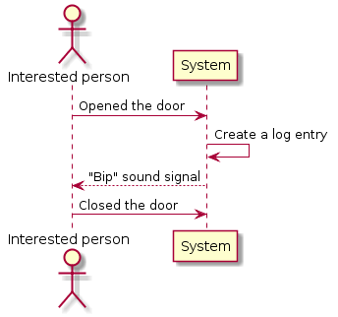

Plantuml code:
@startuml
actor "Interested person" as iper
participant System as sys
iper -> sys : Opened the door
sys -> sys : Create a log entry
sys --> iper : "Bip" sound signal
iper -> sys : Closed the door
@enduml
Lock room usecase

Conditions:
- Access is granted to the interested person.
- The door is closed.

Actors:
- Interested person
- System

Goal:
Lock the door, make open room usecase unavailable.

Main scenario:
- IP sends request to lock the door by inserting his/her pass card into the room’s detector.
- System lock the room.
- System create a log entry about locking the room.
- System sends message “Locked”.

Result:
Room is locked. Log is updated.

Diagram:

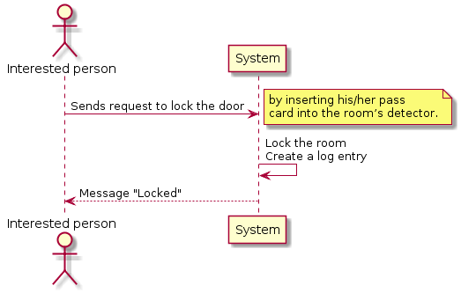

Plantuml code:
@startuml
actor "Interested person" as iper
participant System as sys
iper -> sys : Sends request to lock the door
note right : by inserting his/her pass \ncard into the room’s detector.
sys -> sys : Lock the room \nCreate a log entry
sys --> iper : Message "Locked"
@enduml

