Leak conductance in aeif_cond_alpha model

Introduction

The model

Nest simulator offers several neuron models. This exercise focuses on the `aeif_cond_alpha` model, which is an adaptive exponential integrate-and-fire (aeif) model, combining different strategies to avoid previous limitation (i.e. linear filtering of inputs currents and a strict voltage threshold).

Firstly, the use of quadratic ([Ermentrout 1996](https://journals.physiology.org/doi/full/10.1152/jn.00686.2005#R6), [Latham et al. 2000](https://journals.physiology.org/doi/full/10.1152/jn.00686.2005#R17); in [Brette](https://journals.physiology.org/doi/full/10.1152/jn.00686.2005) & [Gerstner](https://journals.physiology.org/doi/full/10.1152/jn.00686.2005), 2005) or exponential integrate-and-fire ([Fourcaud-Trocme et al. 2003](https://journals.physiology.org/doi/full/10.1152/jn.00686.2005" \l "R7); in [Brette](https://journals.physiology.org/doi/full/10.1152/jn.00686.2005) & [Gerstner](https://journals.physiology.org/doi/full/10.1152/jn.00686.2005), 2005) neurons returns in a more realistic smooth spike initiation zone.

This results in `f(V)` function, describing the passive properties of the spiking neuron:

 (1)

In a quadratic model we can observe a spike when potential *V* grows rapidly towards infinity. In fact, when V = Vt, a spike is triggered for a fraction of millisecond. Then, *V* is reset to VR = EL.

For slope factor ΔT → 0, we obtain a traditional integrate-and-fire model, with the previous limits described before.

Second, the addition of a second variable allows inclusion of subthreshold resonances or adaptation  ([Izhikevich 2003](https://journals.physiology.org/doi/full/10.1152/jn.00686.2005" \l "R12), [Richardson et al. 2003](https://journals.physiology.org/doi/full/10.1152/jn.00686.2005#R23); in [Brette](https://journals.physiology.org/doi/full/10.1152/jn.00686.2005) & [Gerstner](https://journals.physiology.org/doi/full/10.1152/jn.00686.2005), 2005).

In the model we can find the adaptation current *w*:

 (2)

At each firing time, the variable *w* is increased by an amount *b,* which accounts for spike-triggered adaptation.

Third, a change in the stimulation paradigm from current injection to conductance injection allows moving the integrate-and-fire models closer to a situation that cortical neurons would experience in vivo ([Destexhe et al. 2003](https://journals.physiology.org/doi/full/10.1152/jn.00686.2005" \l "R5); in [Brette](https://journals.physiology.org/doi/full/10.1152/jn.00686.2005) & [Gerstner](https://journals.physiology.org/doi/full/10.1152/jn.00686.2005), 2005).

The model is defined by the following equation:

 (3)

Where `f(V)` and *w* have been defined above.

Research question

The aim of this exercise is to investigate further the difference between an integrate and fire model and a leaky integrate and fire model. Using the `aeif_cond_alpha` model, it is possible to switch from one to the other type of model by varying the leak conductance g_L (default value: 30.0).

In order to accomplish this task, different simulations have been run varying inputs and g_L.

Methods

A new model has been created modifying some variables of the `aeif_cond_alpha` model with the following dictionary:

params = {

"t_ref": 1.59,

"C_m": 14.6,

"V_th": -60.0,

"V_reset": -78.0,

"E_L": -66.0,

"tau_syn_ex": 0.64,

"tau_syn_in": 2.0,

"g_L": g_L

}

Where *g_L* is an integer varying from 1.0 to 100.0 (g_L = 0 is to avoid, since it would lead `f(V)` to be 0 *(see (1))* ).

For every value of g_L, 1000 simulation of a single neuron create using this new model have been run. In each simulation the frequency of the input of a generator device (`poisson_generator`) linked to the neuron varied from 0Hz to 1000Hz.

Results & Discussion

Firstly the relationship between g_L values and the output of neuron has been investigated. With “output” is meant the frequency of spikes generated by the neuron.

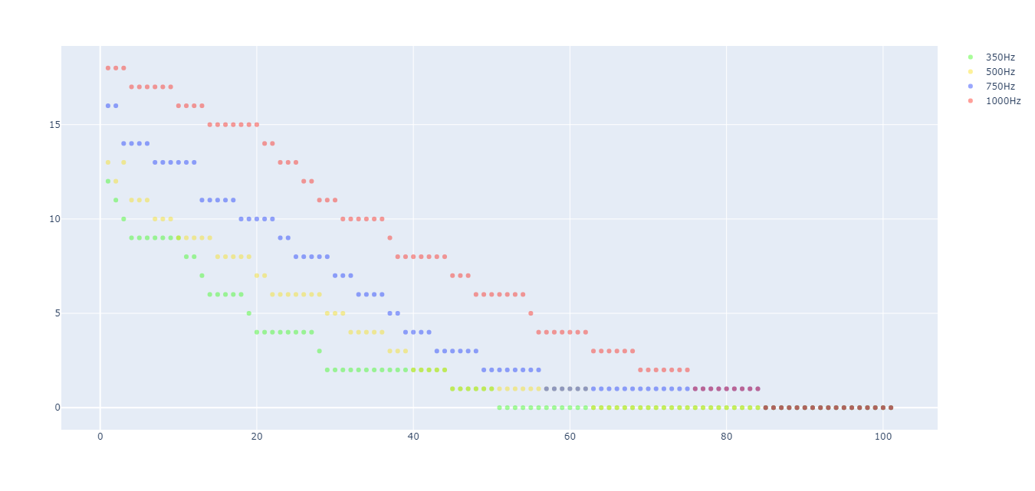

Figure 1. spikes per second (Y axis) in function of `g_L` (X axis). In green when input frequency is 350Hz, in yellow 500Hz, in blue 750Hz and red 1000Hz.

As shown in Figure 1, increasing the value of the leak conductance will decrease the number of spikes/second. The relationship seems to be exponential for middle values of input frequencies, while it becomes linear for stronger inputs. This means that the leak property given by *g_L* becomes negligible as long as the inputs gets stronger.

While in integrate-and-fire neuron model spike/s and frequency input have a linear relationship, it is not the same for leaky integrate-and fire. In fact in leaky integrate-and-fire models low inputs in “leaks away” before in+1 is given. This results in an exponential relationship as leak conductance increase (in a theoretical framework where input frequency can increase towards infinity), as shown in Figure 2.

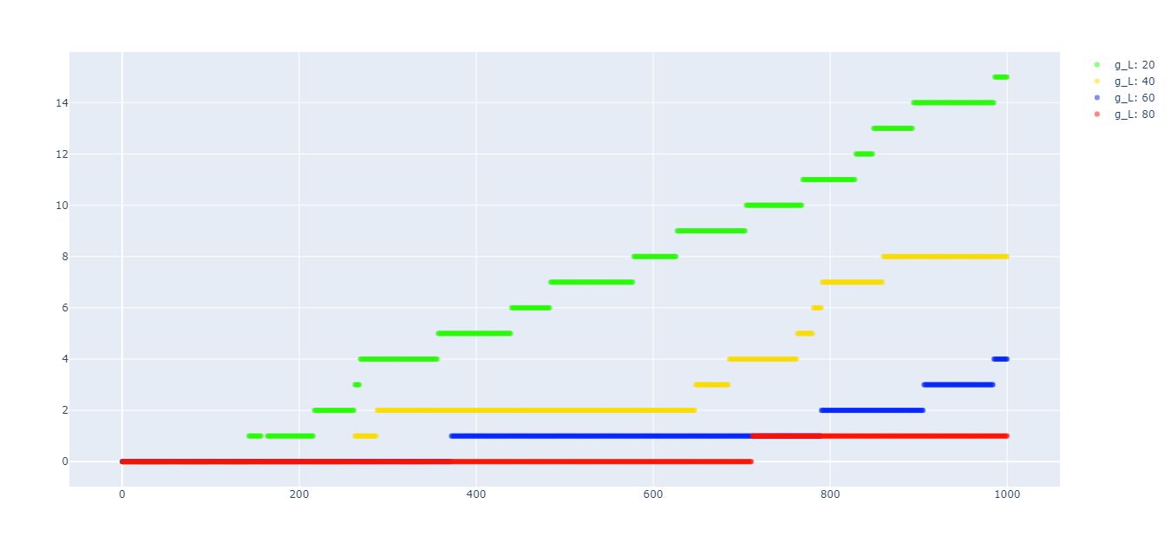

Figure 2. spike frequency (y axis) in function of input frequency (y axis) at various g_L values (20 in green, 40 in yellow, 60 in blue, 80 in red, 100 in black (no spikes) ).

To understand why for lower frequencies we can observe any input, it is useful the concept of *rheobase frequency*: which is definable as is the minimum stimulus amplitude needed to elicit a response at infinitely long pulse durations.Time duration can be considered of about 300ms.

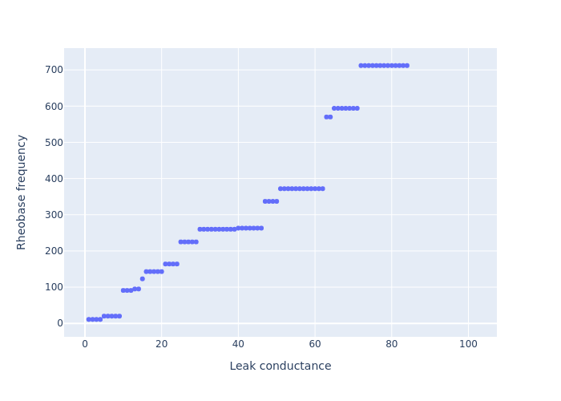

Figure 3. Rheobase frequency varying in function of leak conductance.

Figure 3 represents how rheobase frequency (rf) varies in function of leak conductance.

We can still notice an exponential relationship. Since inputs usually do not overcome 300Hz, reasonable values to model *g_L* ranges from 10 to 50. In particular g_L > 80 is to avoid because its rf  > 1000Hz.

References

Brette, R., & Gerstner, W. (2005). Adaptive exponential integrate-and-fire model as an effective description of neuronal activity. *Journal of neurophysiology*, *94*(5), 3637-3642.

Destexhe, A., Rudolph, M., & Paré, D. (2003). The high-conductance state of neocortical neurons in vivo. *Nature reviews neuroscience*, *4*(9), 739-751.

Ermentrout, B. (1996). Type I membranes, phase resetting curves, and synchrony. *Neural computation*, *8*(5), 979-1001.

Fourcaud-Trocmé, N., Hansel, D., Van Vreeswijk, C., & Brunel, N. (2003). How spike generation mechanisms determine the neuronal response to fluctuating inputs. *Journal of neuroscience*, *23*(37), 11628-11640.

Izhikevich, E. M. (2003). Simple model of spiking neurons. *IEEE Transactions on neural networks*, *14*(6), 1569-1572.

Latham, P. E., Richmond, B. J., Nelson, P. G., & Nirenberg, S. (2000). Intrinsic dynamics in neuronal networks. I. Theory. *Journal of neurophysiology*, *83*(2), 808-827.

Richardson, M. J., Brunel, N., & Hakim, V. (2003). From subthreshold to firing-rate resonance. *Journal of neurophysiology*, *89*(5), 2538-2554.