Leak conductance in aeif_cond_alpha model

Introduction

The model

Nest simulator offers several neuron models. This exercise focuses on the `aeif_cond_alpha` model, which is an adaptive exponential integrate-and-fire (AEIF) model that combines different strategies to avoid previous limitation (i.e. linear filtering of inputs currents and a strict voltage threshold).

Firstly, the use of quadratic ([Ermentrout 1996](https://journals.physiology.org/doi/full/10.1152/jn.00686.2005#R6), [Latham et al. 2000](https://journals.physiology.org/doi/full/10.1152/jn.00686.2005#R17); in [Brette](https://journals.physiology.org/doi/full/10.1152/jn.00686.2005) & [Gerstner](https://journals.physiology.org/doi/full/10.1152/jn.00686.2005), 2005) or exponential integrate-and-fire (EIF, [Fourcaud-Trocme et al. 2003](https://journals.physiology.org/doi/full/10.1152/jn.00686.2005#R7); in [Brette](https://journals.physiology.org/doi/full/10.1152/jn.00686.2005) & [Gerstner](https://journals.physiology.org/doi/full/10.1152/jn.00686.2005), 2005) neurons results in a more realistic smooth spike initiation zone.

This results in `f(V)` function, that describes the passive properties of the spiking neuron:

 (1)

In a quadratic model we can observe a spike when the potential *V* grows rapidly towards infinity. In fact, when V = Vt, a spike is triggered, then *V* is reset to VR = EL.

For slope factor ΔT → 0, we obtain a traditional integrate-and-fire (IF) model, with the previous limits described before.

Second, the addition of a second variable allows inclusion of subthreshold resonances or adaptation  ([Izhikevich 2003](https://journals.physiology.org/doi/full/10.1152/jn.00686.2005#R12), [Richardson et al. 2003](https://journals.physiology.org/doi/full/10.1152/jn.00686.2005#R23); in [Brette](https://journals.physiology.org/doi/full/10.1152/jn.00686.2005) & [Gerstner](https://journals.physiology.org/doi/full/10.1152/jn.00686.2005), 2005).

In the model we can find the adaptation current *w*:

 (2)

At each firing time, the variable *w* is increased by an amount *b,* which accounts for spike-triggered adaptation.

Third, a change in the stimulation paradigm from current injection to conductance injection allows moving the integrate-and-fire models closer to a situation that cortical neurons would experience in vivo ([Destexhe et al. 2003](https://journals.physiology.org/doi/full/10.1152/jn.00686.2005#R5); in [Brette](https://journals.physiology.org/doi/full/10.1152/jn.00686.2005) & [Gerstner](https://journals.physiology.org/doi/full/10.1152/jn.00686.2005), 2005).

The model is defined by the following equation:

 (3)

Where `f(V)` and *w* are defined in Equation (1) and (2) respectively.

Research question

The aim of this exercise is to investigate the difference between an IF model and a leaky IF model (LIF). Using the `aeif_cond_alpha` model, it is possible to switch from one to the other type of model by varying the leak conductance g_L (default value: 30.0).

In order to accomplish this task, different simulations have been run varying inputs and g_L.

Methods

A new model has been created implementing the following dictionary in the `aeif_cond_alpha` models:

params = {

"t_ref": 1.59,

"C_m": 14.6,

"V_th": -60.0,

"V_reset": -78.0,

"E_L": -66.0,

"tau_syn_ex": 0.64,

"tau_syn_in": 2.0,

"g_L": g_L

}

Where *g_L* is an integer varying from 1.0 to 100.0 (g_L = 0 is to avoid, since it would lead `f(V)` to be 0 *(see (1))* ).

For every value of g_L, 1000 simulations of a single neuron created using this new model have been run. In each simulation the frequency of the input of a generator device (`poisson_generator`) linked to the neuron varied from 0Hz to 1000Hz, with 1Hz increments between simulations. The frequency of spikes has been recorded in every simulation as output of the cell.

Another set of simulation was run with a limited set of g_L values (20, 40, 60, 80, 100) and the same input as described above. The frequency of spikes has been recorded in every simulation as output of the cell.

Results & Discussion

Firstly the relationship between g_L values and the output of neuron has been investigated.

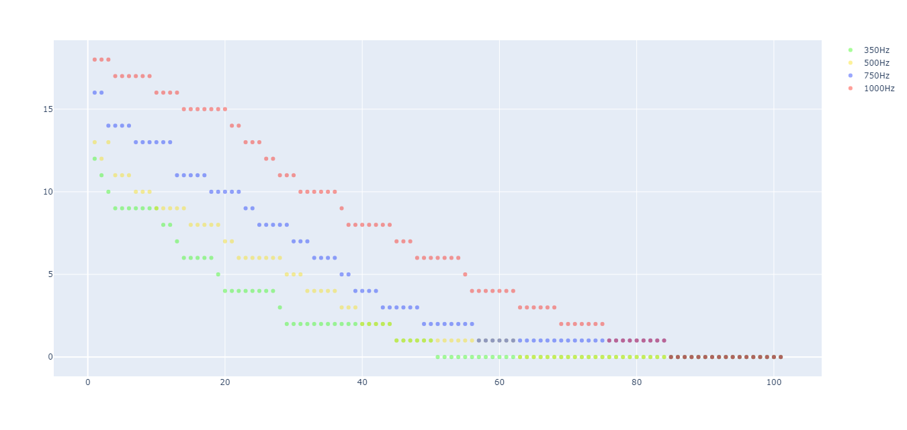

Figure 1. spikes per second (Y axis) in function of `g_L` (X axis). In green when input frequency is 350Hz, in yellow 500Hz, in blue 750Hz and red 1000Hz.

As shown in Figure 1, increasing the value of the leak conductance will decrease the number of spikes/second. In Table 1 the R2 are shown for every condition and different models.

Since the dependent variable is always positive and cannot assume values < 0, in order to establish the nature of the relationship we have to cut values where ‘y = 0’ that could bias our analysis

|  |  |  |
| --- | --- | --- |
| Input frequency | R2: y’ = mx’ + q | R2: y’ = log(x’) |
| 350Hz | . 8985 | .9151 |
| 500Hz | .9465 | .8922 |
| 750Hz | .8992 | .8977 |
| 1000Hz | .9818 | .8287 |

Table 1. Coefficient of determination for several inputs.

Despite R2 seems to be good for a linear model, different assumptions of the linear regression are violated (e.g. linearity and homoscedasticity). In figure 2 an example is available.

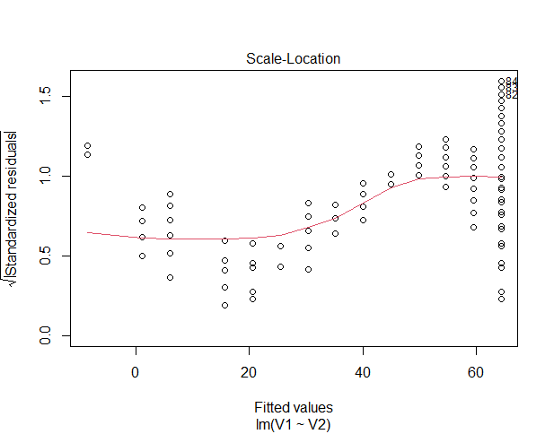

Figure 2. Scale-Location plot for input = 750Hz.

From figure 2 the heteroscedastisity (i.e. dishomogeneity of variances) is clear because the standardized residuals are not homogeneously distributed around 0. Furthermore, we can observe that data are not randomly distributed but they follow a pattern: this indicates the absence of linearity.

In order to overcome these limitations, weighted least square regressions have been performed. Regarding lower inputs (i.e. from 350Hz to 750Hz), despite an enhancement of R2, no improvement for linearity and heteroscedasticity was observed. On the other hand, performing a weighted least square regression in the case of 1000Hz inputs brought different results (i.e. R2 = .9851; see Fig 3).

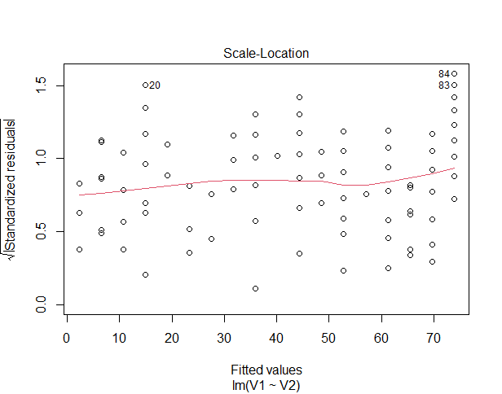

Figure 3. Scale-Location plot of weight least square regression for input = 1000Hz.

Despite the presence of heteroscedasticity, the correction with weights added linearity to the model (see Fig 3: data are randomly distributed).

It seems that with low-medium inputs, *g_L* and spikes/s have a non-linear relationship, which becomes linear as inputs grow.

In IF models it is observable a linear relationship between input and output frequency, for LIF models this relationship complicates. In LIF models the current in leaks away before in+1 is given. This results in the relationship shown in Figure 4: as leak conductance increase the output will be more difficult to obtain.

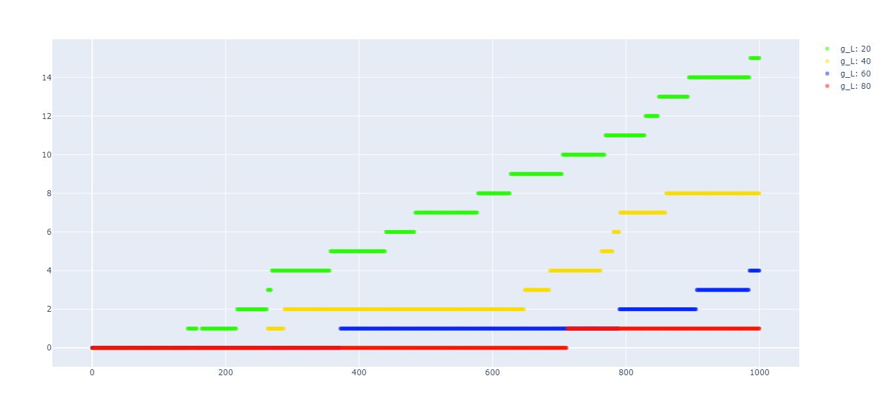

Figure 4. spike frequency (Y axis) in function of input frequency (X axis) at various g_L values (20 in green, 40 in yellow, 60 in blue, 80 in red, 100 in black (no spikes) ).

Considering observation presented with the first analysis (i.e. Fig 1 – Fig 3), we may hypothesize that the non-linearity is due to the input/output frequency relationship of LIF model observed in Fig 4. Furthermore, we may hypothesize that if the input is strong enough leaky behaviour is negligible, and this is why the relationship becomes linear. This would mean that there is no difference between an IF model and a LIF model in presence of strong enough inputs.

To understand why in Fig 4 for lower frequencies we can observe any input, it is useful the concept of *rheobase frequency*, the minimum stimulus amplitude needed to elicit a response at infinitely long pulse durations.

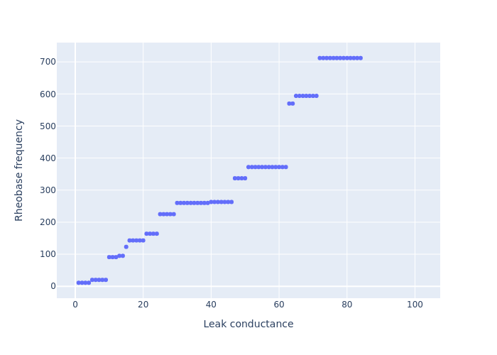

Figure 5. Rheobase frequency varying in function of leak conductance.

Figure 5 represents how rheobase frequency (*rf*) varies in function of leak conductance.

We can still notice a linear relationship. Since inputs usually do not overcome 300Hz, reasonable values to model *g_L* ranges from 10 to 50. In particular *g_L* > 80 should be carefully treated because its *rf* > 1000Hz.

References

Brette, R., & Gerstner, W. (2005). Adaptive exponential integrate-and-fire model as an effective description of neuronal activity. *Journal of neurophysiology*, *94*(5), 3637-3642.

<https://nest-simulator.readthedocs.io/en/v2.18.0/models/neurons.html?highlight=aeif_cond_alpha#_CPPv4N4nest15aeif_cond_alphaE>