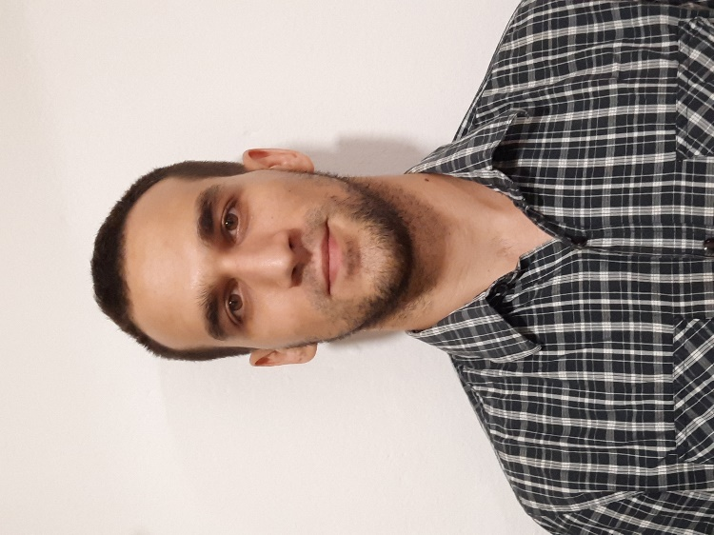

Igor Zivkovic

Vidovdanska 135

37000 Krusevac

Date of birth: 23/06/1995

Mobile phone: +381614007879

Email: [igorbussineszivkovic95@gmail.com](mailto:igorbussineszivkovic95@gmail.com)



**PROFESSIONAL EXPERIENCES**

**May 2018 – March 2019 Copywriter- (Online)**

**June 2017 – December 2018 English Teacher** - Itutor (China) online

**March 2019 – July 2020 Customer Support Agent (local vinyl clocks bussines)**

**September 2020 – September 2022 Web Developer, Mock-up & Vector drawings designer - (local vinyl clocks bussines)**

**2022-Present Worked on various web development projects as a freelancer and/or part-time developer**



**EDUCATION**

2011 – 2015 **Chemical Technology School (Printing Graphic Artist)**

**University of Singidunum Toursim and Hospitality**

**Private english school (2002 - 2010)**

**1 year of Graphic Design at IT Academy Blegrade, Serbia**

**Self-taught Frontend developer (2019-present)**

**SKILLS**

**Languages Serbian** - mother tongue

**English** – C2

**Russian –** Basic

**Italian -** Basic

**Communication skills** Excellent comunications skills

Polite

Communicative

Respectful to others

Patient with people

Good listener

**Organisational skills** Good at working in groups

Good at working alone

Sociable

Administrative

Creative

**Always willing to learn more and improve!**

**Computer skills** Adobe Illustrator & Photoshop, Web Development (HTML5, CSS3, Bootstrap, JQuerry, JavaScript (ES6), Wordpress, React, My SQL (basics), PHP (basics), Node.js, JSON)

Microsoft Office

Cubase (basics)

**HOBBIES** Basketball

Swimming

Playing guitar