“___________” Original Oil Painting, 28x35.6 cm with depth 1.5 cm.

360 EUR.

Surface: High Quality Professional Oil Paint on gallery-grade, deep edge cotton canvas, with the painting wrapping around the sides.

Finish: Varnished. Dated on the back side. Edges painted and ready to be framed or just to hang without frame.

To buy art, please send your order to [info@linadonets.art](mailto:info@linadonets.art) and I will provide you with my Paypal account.

I will aim to dispatch items within 2 days. Items within Germany should arrive within 5-7 days of the date of purchase. Please allow app. 2 weeks for international deliveries.

Shipping cost is included in the price. Customs fee if any – not included. All sales are final.

Внизу сайта написать о копирайтах

[© ART BY LINA DONETS 2022](https://www.estelleday.com/copyright)

All images found on this website are copyrighted material of LINA DONETS. You may not use any image on this site without the express written consent of LINA DONETS.

ART BY LINA DONETS

ABOUT

Story Behind the Art

I am largely a self-taught artist with my best teacher being the great outdoors. My sincere wish to become a painter was always blocked by real life commitments but the desire never left me. With the required time now available I am pursuing this ambition, ultimately painting in oils this universe. I’m originally from Ukraine living in Germany. Hope, soon I’ll be back home. Glory to Ukraine!

I am an exuberant artist and paint in my own fashion as broadly as my mood allows with spirit and fantasy sense. My favorite color is white and I love when there are a lot of cream oils on my canvas what allows me to create an unusual texture, relief and line by sculpting oil paint with my palette knife.

My work always tries to demonstrate the inspiring connection and response to my real surroundings. I strive to create paintings which celebrate life and excite the soul. My aim is for people to feel good and peaceful when looking at my creations.

I hope that my work transports you to another place and time.

Enjoy what is created when my palette knife applies paint to canvas!

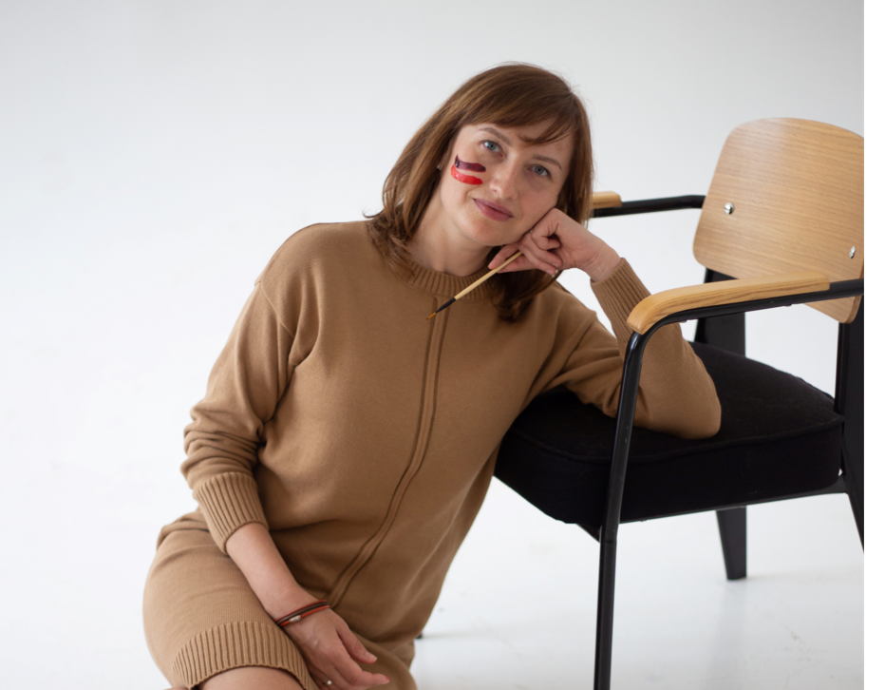

Collection Heavenly Signs

Going out for a walk here in Germany, I notice different unusual lines in the sky:

[ниже две фото размести их параллельно друг другу - в одной строке]

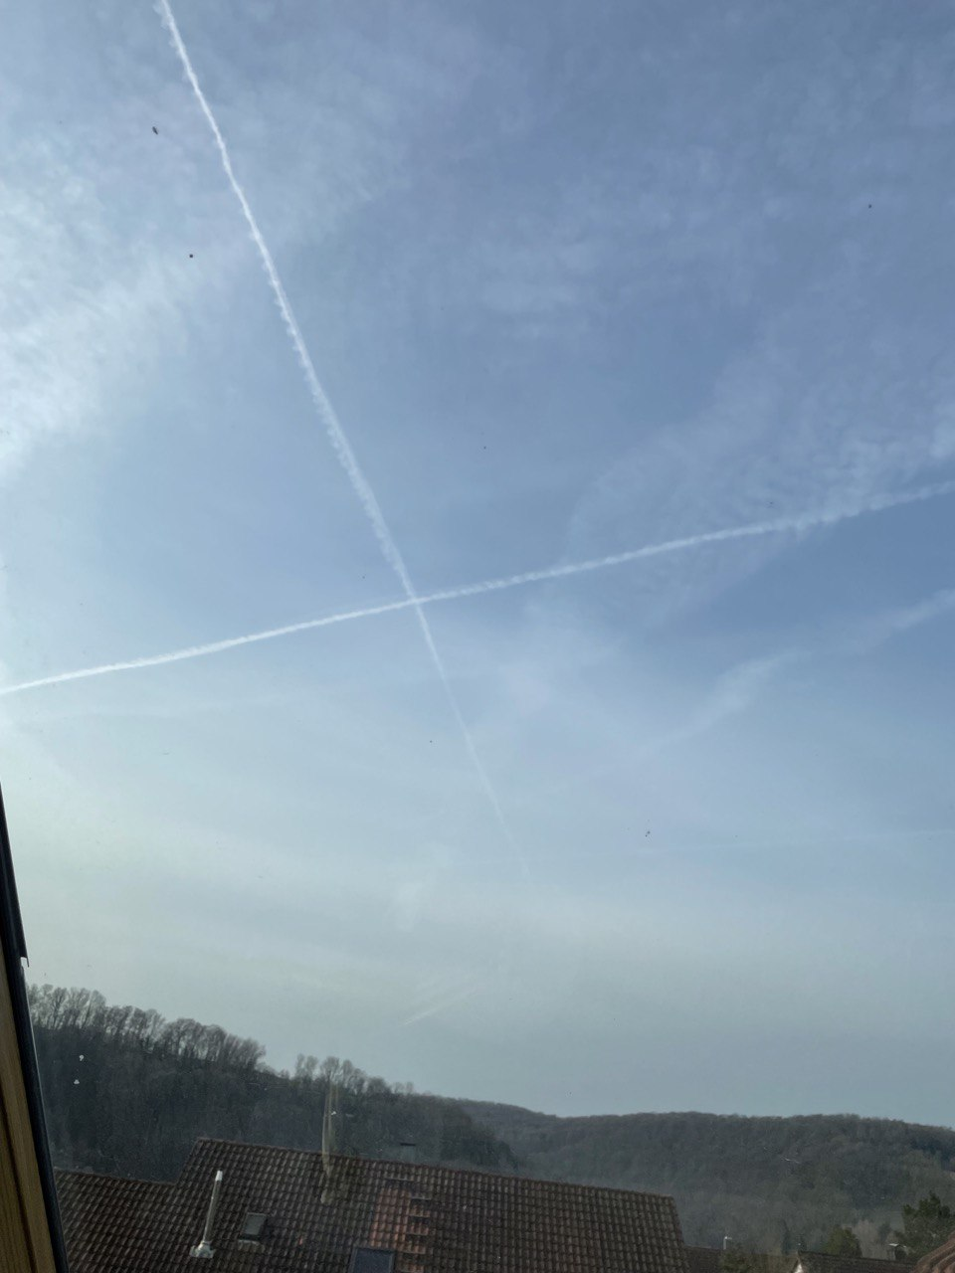

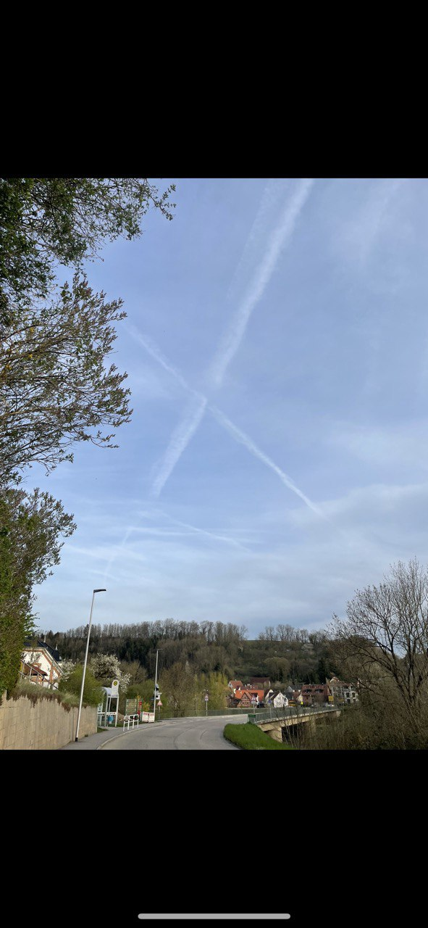

Now, you can find this sky geometry in my paintings and read the signs.