**Distributed Transaction Coordinator**

On Windows, there is an OS-level service called the DTC which manages transactions that need to span multiple resources - like queues and databases. This service isn't always configured correctly and may require some trouble-shooting. First of all, you'll need to download a tool called [DTCPing](http://www.microsoft.com/downloads/details.aspx?displaylang=en&FamilyID=5e325025-4dcd-4658-a549-1d549ac17644). This tool will help you find out if one machine is able to access a remote machine over the DTC. Here's what that tool looks like:

[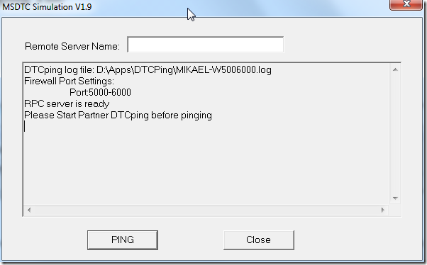](http://blog.zoolutions.se/image.axd?picture=image.png)

If you get an error referring to the RPC Endpoint Mapper, go to the command prompt and run "dcomcnfg". After you start dcomcnfg you should see the Component Services screen below.

[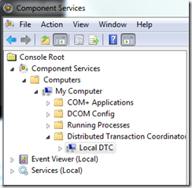](http://blog.zoolutions.se/image.axd?picture=dtc_dcomcnfg_1.png)

From here, what needs to be done is open some ports. To do this, right-click "My Computer" and go to the "Default Protocols" tab. From there, select "Connection-oriented TCP/IP" and click the "Properties" button. In the "Properties for COM Internet Services" dialog that opens, check that the Port Ranges includes "5000-6000" as shown in the following image:

[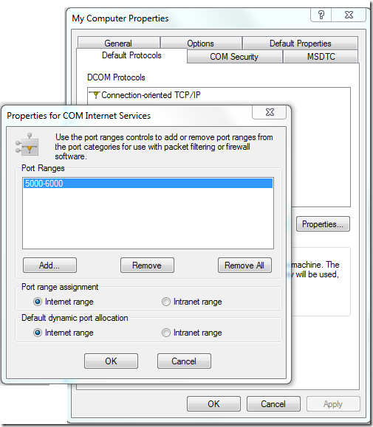](http://blog.zoolutions.se/image.axd?picture=dtc_dcomcnfg_2.png)

If the list of Port Ranges is empty, click the "Add..." button and enter "5000-6000" in the dialog box that opens up. After doing so, your screen should look like the image above. You can probably make do with less than 1000 open ports, but it depends on the number of machines you are looking to connect to each other over the DTC.

After clicking OK and returning to the Component Services screen, navigate to the "Local DTC" node under the Distributed Transaction Coordinator folder, right click, and select "Properties". In the dialog that opens, select the Security tab as shown below:

[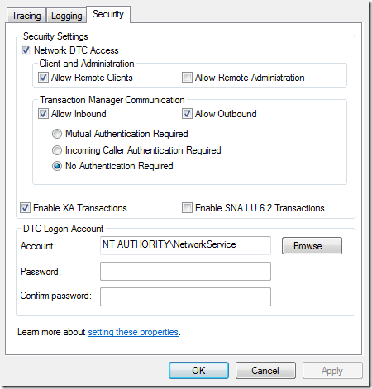](http://blog.zoolutions.se/image.axd?picture=dtc_dcomcnfg_3.png)

Ensure that the properties you see are the same as the above.

After finishing all the steps above, restart the computer.

If DTCPing isn't working after all of the above, check that the needed ports are open in the firewall. Consider removing the DTC exceptions in the firewall and add them again to make sure.

If DTCPing gives you a message about finding the name but not reaching it, the first thing to do is a simple ping by running “ping computer_name” in the command prompt. If you discover that the machine cannot be reached by ping, it could be that you have a DNS problem that may require your Network Administrator's help.

Make sure you perform all of the above steps not just on the servers that connect to the database, but also on the database servers as well.

Finally, check the TCP ports in use on the servers making sure that each has a different port configured as the communication is bi-directional. At this point, you should be able to run transactional NServiceBus endpoints.

Content in this section derived from [Mikael Henriksson's](http://blog.zoolutions.se/post/2010/04/01/Conquering-NServiceBus-part-5-e28093-Troubleshooting-DTC.aspx) blog.

Fonte: <http://www.nservicebus.com/Transactions.aspx>