Dive into Django Web Development:

A Streamlined Guide

Ever feel frustrated returning to Django after a break, only to be confronted by mountains of documentation? Or perhaps you're switching from another framework and feeling overwhelmed? This book cuts through the clutter to provide you with a concise and practical guide to basic Django development.

Forget spending hours deciphering complex documentation or wading through irrelevant information. This book is your on-the-go companion, offering a quick reference for any stage of your project. Need a refresher on views? Flip to that section. Stuck on user authentication? A dedicated chapter provides a clear overview.
This book is designed to complement, not replace, your existing resources. Utilize AI assistants, comprehensive documentation, and online communities like Stack Overflow to delve deeper into specific topics. But for a high-level overview and instant refreshers, this book is your go-to guide.

Target Audience:
- Seasoned Developers: Switching frameworks and need a quick Django refresher? This book provides the perfect starting point.
- Django Learners: Enhance your knowledge with constant refreshers, ensuring information stays at your fingertips.
- Returning Developers: Get back up to speed after a hiatus with this comprehensive yet concise guide.

Key Benefits:
- Focus on Building: Minimize re-learning and maximize your development time.
- Information at Your Fingertips: Leverage the book alongside AI assistants, documentation, and online forums for in-depth exploration.
- Quick Reference: Find the information you need, exactly when you need it.

With this book as your constant companion, you'll navigate Django development with confidence and efficiency. Let's get started!

Django Basics:

1. Views and Urls:
- set up virtual environment for project
- start project (project name)
settings.py - main app configuration for project - configure apps,
middleware, templates, database setup...
urls - url navigation for website
wsgi - web server gateway interface
asgi - async server gateway interface
- start app (app name)
admin - admin interface menagment
models - database tables
views - logic for urls

- link app in settings.py:

INSTALLED_APPS = [
...
'projects.apps.ProjectsConfig',
]
- will explain later on why we don’t just linj app name 'projects'.
(page xy)

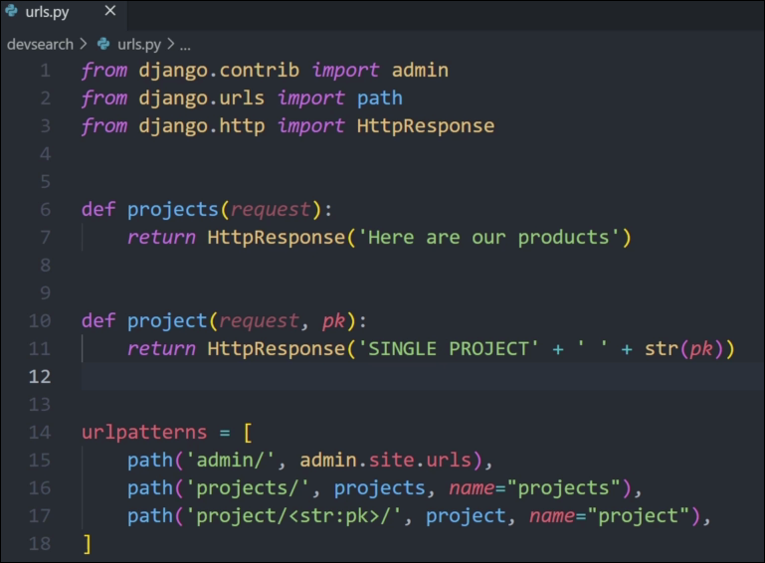
- inside project urls you can create urls and define functions (note: by default functions take routes as first parameter)

INERESTING SHIT IGNORE FOR NOW:

Vote{{project.vote_total|pluralize:"s"}}) – if vote number > 1 add s to word Vote – Vote(s)

<h5>{{profile.short_intro|slice:"60"}}</h5> - if we have some kind of card or some element that can contain user input text we usually want to limit its size to prevent too much text from breaking the page. Full text should be displayed either on another page or in a popup box. Works on loops too: {% for skill in profile.skill_set.all|slice:"5" %}

in the time of ai dominating the information gathering system books like these tend to get unecessarily long and a waste of time for readers so instead of detailed instructions and docummentation this books aims to serve as a simple guide and reminder of most important parts of creating a Django web project. It is not meant to be datailed or to go into any uneccesery depth it is purely meant to be a quick reminder by guiding a reader trough simple project creation and allowing him to open the book at any page at any part of development process and take a quick reminder/guide on how to do the desired part of the process which is something ai is struggling to assist with nowdays. This book dosent aim to make AI information gathering obsolete instead it is meant to be used with AI thechnology in mind and allow users to check certain topics in more depth either by looking stuff up/asking AI/reading docummentation. It is a huge time save to have a point of reference at every point of website development instead of having to learn and relearn read and re-read the entire process time and time again every part you get stuck at some point in development.
- for cleaner code go inside app and create urls.py to store urls and views.py to store function definitions, link app views and url's and link project urls with app urls

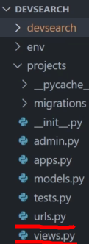
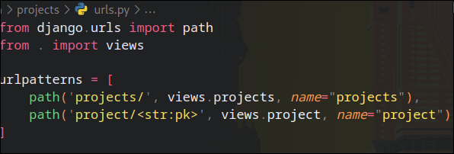
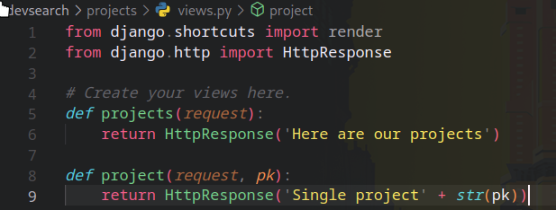

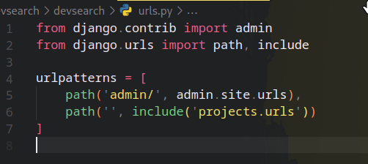

in short:
urls file created
urls linked to views
and written
views is written
urls (p) is linked to
urls (app)
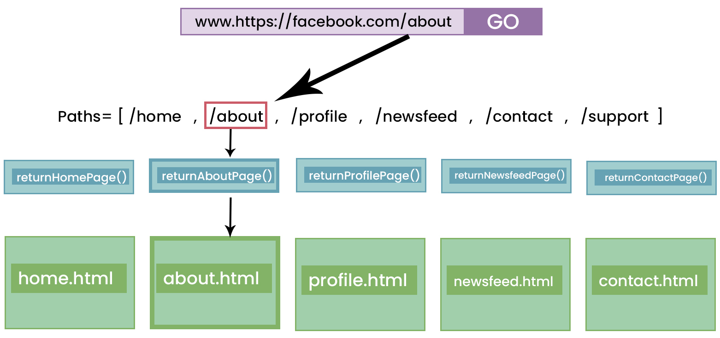

2. Templates

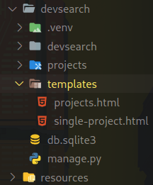
- Create new folder named “Templates” in root directory
- Inside of templates create html files
- Link templates to project by going to settings and addig import os (not necessary in new django)
and inside TEPLATES = [{}] inside ‘DIRS’: [] add
os.path.join(BASE_DIR, ‘templates’),
Point to root folder (BASE_DIR) and folder named
templates
- return template by linking it to a route in views.py
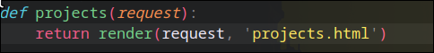

2.1 Extending templates:
- Django uses Jinja as templating languge that allows writing code inside of html. Common use (layout/main/navbar.htm and extend pages)
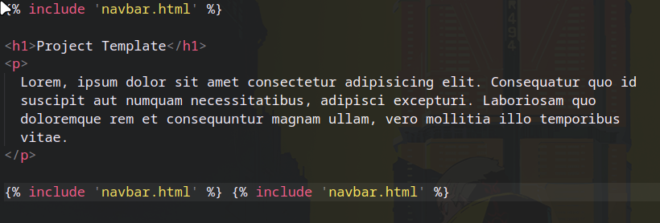
- Create new file navbar.html and include it into projects.html to extend one html with another.

- To utilize this the best create main.html/layout.html that will contain the common website theme (navbar/sidebar and all other elements) we will extend this main website skeleton with content
<!DOCTYPE html>
<html lang="en">
<head>
<meta charset="UTF-8" />
<meta name="viewport" content="width=device-width, initial-scale=1.0" />
<title>DevSearch</title>
</head>
<body>
<h1>This is the main template</h1>
</body>
</html>

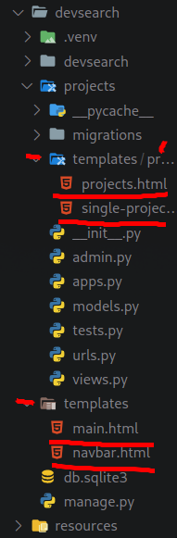
main.html will contain basic html structure.
To extend it we can use:

{% include 'navbar.html' %}
- this will insert code from another html document or

{% block content %} {% endblock content %}
- this marks area where different files should extend the page and we need to put tags in those files as well

{% extends 'main.html' %}
{% block content %}
{% endblock content %}

- this tells our content file to extend the main file content

2.2 Seperate templates into different apps
Inside app folder create another templates folder
and inside of that temolates folder create another
folder with same name as your app and move
profiles.html and single-profile.html inside that folder
(all files related to that specific app)
so that final structure looks like this ---------------->
Now inside views we need to modify return statements
so that they point to new templates folder now.

def projects(request):
return render(request, 'projects/projects.html')

Just add projects/ to the beginning of route
3. Rendering Data to Templates

Django website has doccumentation explaining each {} template marker.

To pass the data to our .html we need to go into views.py define the data that we want to pass inside of a function and return it together with the page that is returned with that function
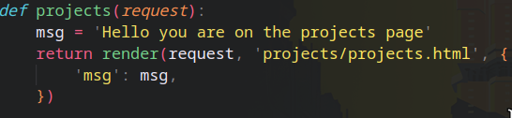

We are now passing vairable msg as ‘msg’ to the page and we can include it in that page:
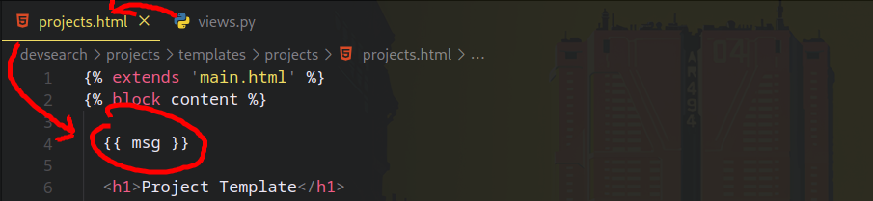
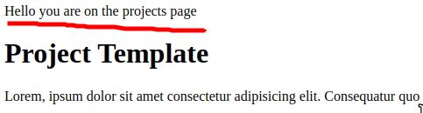

As seen above msg variable is now displayed on the page

- Lets say we have multiple variables that we want to display on page we can either send multiple pariables inside of return or we can store them all inside one variable (context) and send that one variable:

def projects(request):
page = 'page text'
number = 11
context = {'page':page, 'number':number }
return render(request, 'projects/projects.html', context)

or

def projects(request):
page = 'page text'
number = 11
return render(request, 'projects/projects.html', {
'page': page,
'number': number,
})

both will work the same.

- We can use if else statements inside html thanks to django templating, usually we want to check for code changes

{% if number > 10 %}
<p>Number is greater than 10</p>

{% elif number == 10 %}
<p>Numver is equal to 10</p>
{% else %}
<p>Number is less than 10</p>
{% endif %}

- We can check the number that we passed earlier and depending on its value display different content on the page

3.1 Display more dinamic data

projectsList = [
{
'id': '1',
'title': 'Ecommerce Website',
'description': 'Fully functional ecommerce website'
},
{
'id': '2',
'title': 'Portfolio Website',
'description': 'A personal website to write articles and display work'
},
{
'id': '3',
'title': 'Social Network',
'description': 'An open source project built by the community'
}
]

def projects(request):
page = 'page text'
number = 11

context = {'page':page, 'number':number, 'projects':projectsList }

return render(request, 'projects/projects.html', context)

- Lets put some list into our views.py and pass it to our website.

<h1>Projects</h1>
<ul>
{% for project in projects %}
<li>Title: <ahref="/project/{{project.id}}">{{project.title}}</a>
</li>
{% endfor %}
</ul>

Using for loop we are creating new list element for each projectList value displaying its title and linking it to single-page.html of that project.

- Lets say we visit link for /project/2 where we want displayed data about project 2 from list above:

first in views.py we want to check if passed primary key matches element from list:

def project(request, pk):
projectObj = None
for i in projectsList:
if i['id'] == pk:
projectObj = i

return render(request, 'projects/single-project.html', {
"project": projectObj
})

Here we are running trough the list and comparing pk with each list item id. If we find the match we set that whole object as our projectObj and pass it to website.

{% extends 'main.html' %}
{% block content %}
<h1>{{project.title}}</h1>
<br>
<p>{{project.description}}</p>
{% endblock content %}

Now in our html we are displaying elements from that object and filling our website dynamically with data from that object.
This is a good time to mention name parameter of url in urls.py:
path('project/<str:pk>', views.project, name="project")

let say we want to change

'project/<str:pk>' to 'project-obj/<str:pk>'

Logic dictates that we would have to go to each file containgin adress to ‘project/id’ ex:
<a href="/project/{{project.id}}">{{project.title}}</a>
and change project/ part manually

However we can utilize name="project" and replace:

href="/project/{{project.id}}"
with
href="{% url 'project' project.id %}"

and now even if we were to change path to:

path('fdgdfgdfgfd/<str:pk>', views.project, name="project")

and our link will still be funcional because our name is still “porject” and url targets the name of a path.

3. Database and Models

- Initially django comes with empty db.sqlite3

- By default database is linked to project in settings inside DATABASES object

- Django has some default tables already prepared for this database like sessions, user, model, etc.

- To apply these defaults and start working we need to run:
python manage.py migrate

- Now we have access to admin panel but we need to create a user with top level permissions/authorization (admin) (page xy authentication for more details) so we run:
python manage.py createsuperuser

- By default admin panel is linked to /admin, one we log into the panel we can see graphical representation of data from our db.sqlite3. We can create update and delete from here.

- We can create new tables for database using djangos models.py that lets us define django models that django will turn into database tables. As seen on image below:
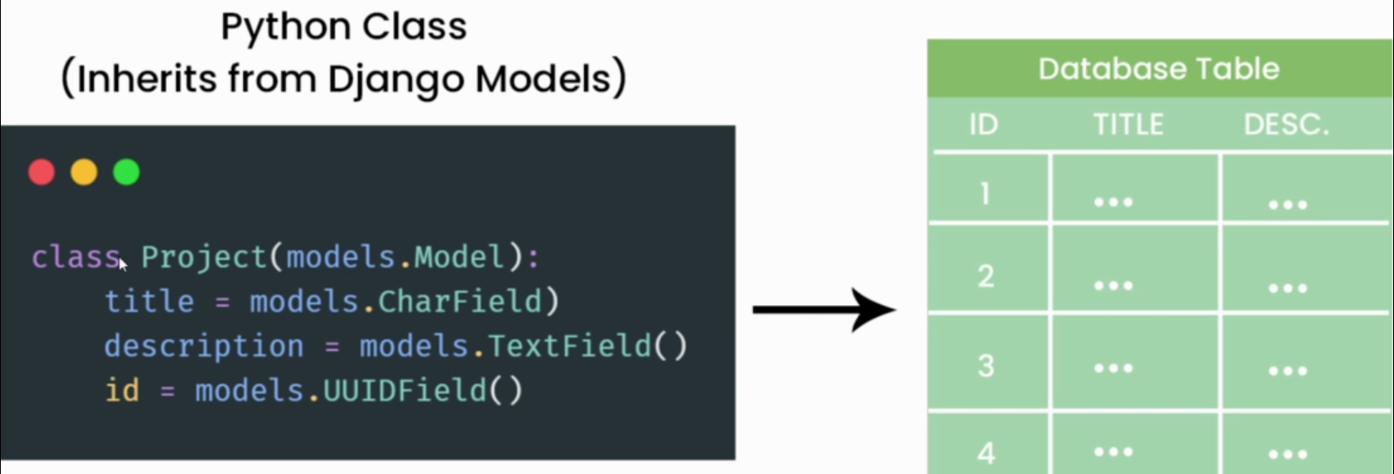
- Create your database model. Class name will be turned into tabele name and class atributes will turn into columns/fields. Inside () we can define rules for each field. Each entry will become new row. Basic field rules:

- null=True telling sqlite that entry can be created even with this field empty
- default=0 – set default value of a field

- blank=True telling django that form is allowed to be submitted with this field empty

- max_length= max length of text inside of this field

- created = models.DateTimeField(auto_now_add=True) – saves time at which model was created

- id = models.UUIDField(default=uuid.uuid4, unique=True, primary_key=True, editable=False) – better id will turn link from /project/1 to /project/7ad1a3db-e581-4adc-97f3-e85038217da7

After we create new model we need to write it to database:

python manage.py makemigrations - when we run this command django creates new file inide migrations folder containging all changes that will be made to database

python manage.py migrate – this will migrate changes to db

Now to see new tables inside admin panel we have to register new models inside admin.py

from django.contrib import admin
from .models import Project – import model to file

admin.site.register(Project) – register model

We can also format how model is displayed in admin panel
in this example only title field will be shown in panel:
def __str__(self):
return self.title
3.1 Database Relations
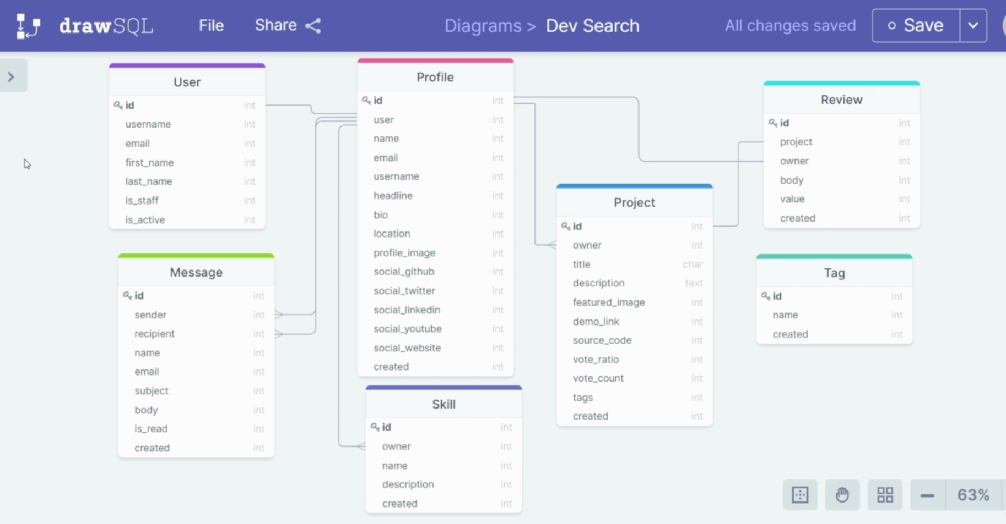
Above is the image of database planned and drawn on drawSQl website. This is graphical representation of our future database.
Tables can have multiple types of relations:

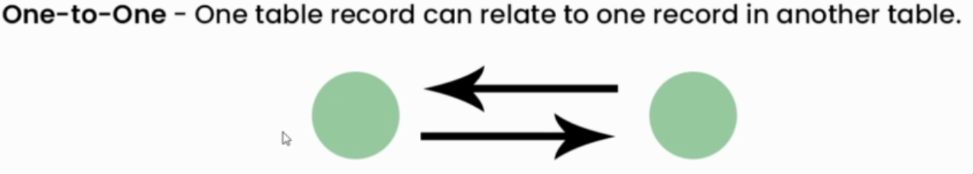
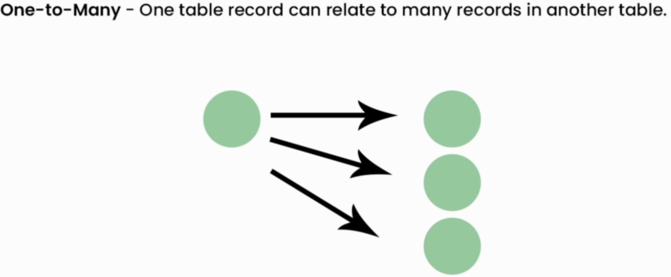
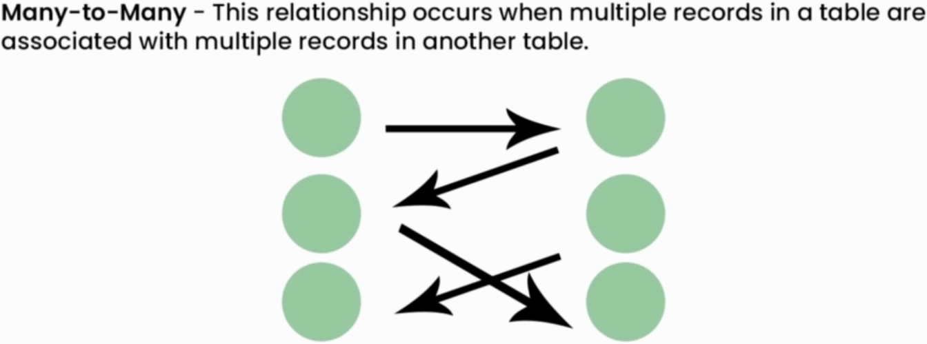

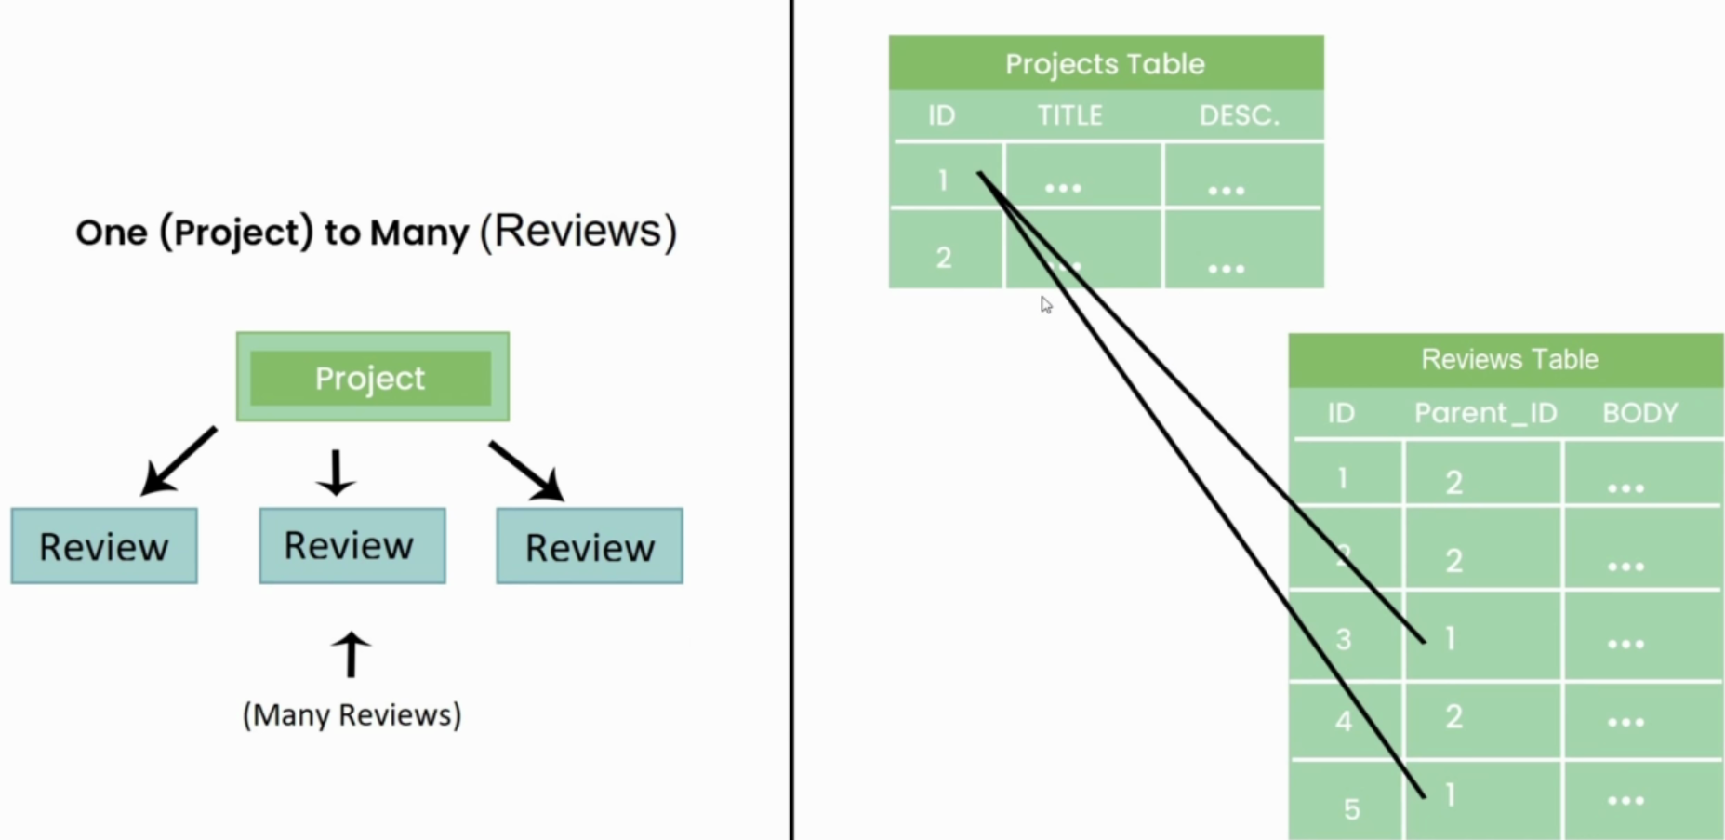
One project table row can be connected to multiple review rows. One project has many reviews.

Many to many example:
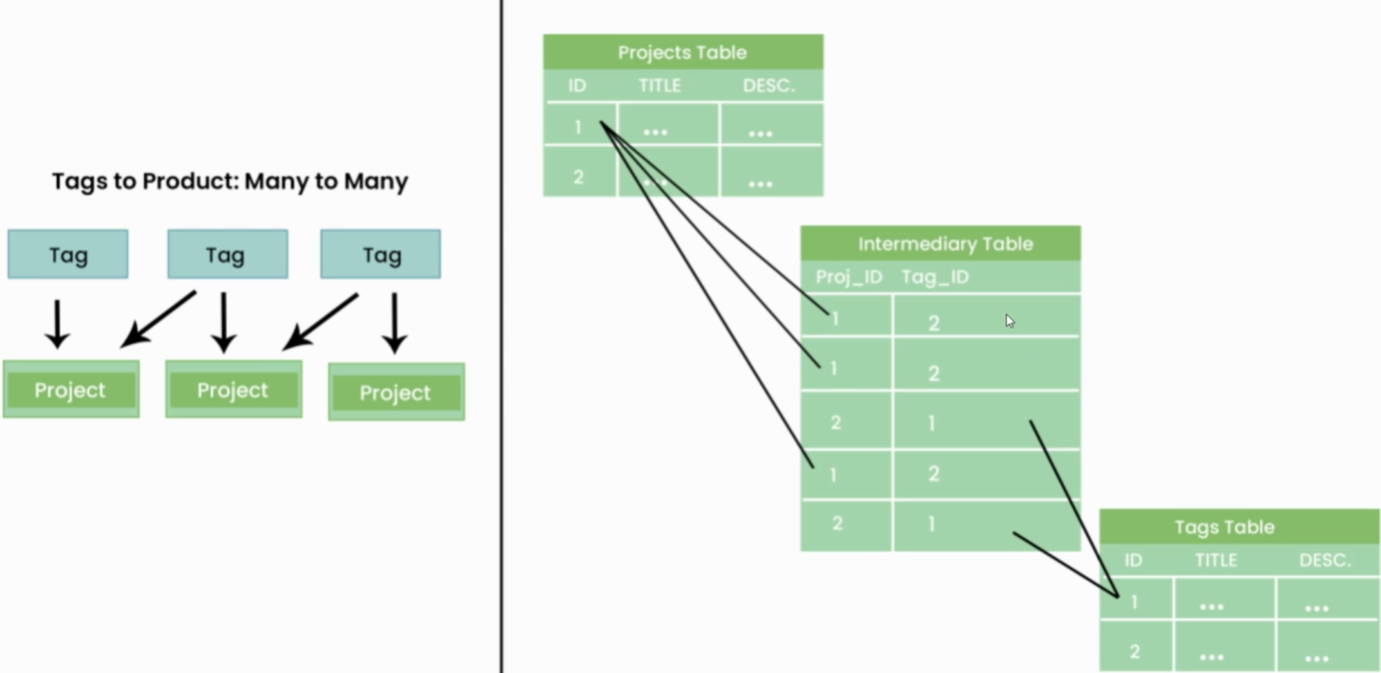
If we want to have many to many relationship between Projects Table and Tags Table we need an Intermidiary Table that is automatically created and that stores the relations of those 2 tables.

Now lets create one to many Project and Review relationship in our models:
First lets upgrade our Projects model:
class Project(models.Model):
title = models.CharField(max_length=200)
description = models.TextField(null=True, blank=True)
demo_link = models.CharField(max_length=2000, null=True, blank=True)
source_link = models.CharField(max_length=2000, null=True, blank=True)
created = models.DateTimeField(auto_now_add=True)
id = models.UUIDField(default=uuid.uuid4, unique=True, primary_key=True, editable=False)
def __str__(self):
return self.title
Now our Project has title, description, demo_link, soure_link, date of creation and our improved id field
(date of creation and improved id fields should be copied to pretty much any model)
class Review(models.Model):
VOTE_TYPE = (
('up','Up Vote'),
('down', 'Down Vote'),
)
#owner =
project = models.ForeignKey(Project, on_delete=models.CASCADE)
body = models.TextField(null=True, blank=True)
value = models.CharField(max_length=200, choices=VOTE_TYPE)
created = models.DateTimeField(auto_now_add=True)
id = models.UUIDField(default=uuid.uuid4, unique=True, primary_key=True, editable=False)

def __str__(self):
return self.value

Review tabele has a VOTE_TYPE field represents the different types of votes that can be associated with a Review.

value field is turned into multiple choice field with choices of VOTE_TYPE meaning you can either select vote 'up' or 'down'.

project field creates one to many relationship between Review and Project by utilizing ForeignKey that points to Project and has on_delete=models.CASCADE that in case of project deletion removes all children (Reviews) related to that Project from database we can also use =models.SET_NULL so that all Reviews will be left alone and projects field will be set to NULL (not usefull in this care but good to know)

we also have body, created and id fields and we will fill owner field in one to one relatinship part when we create a user model (page xy)

Now we have 2 tables with one to many relationship.

Since we have this relationship now we can add more fields to Projects model like:

vote_total = models.IntegerField(default=0, null=True, blank=True) – later we will use this field to track ammount of Reviews project has (initially 0)

vote_ratio = models.IntegerField(default=0, null=True, blank=True) – later we will use this field to track the ratio between upvotes and downvotes

Lets create many to many relationship between tags and projects table:

lets write Tag model that will represent types of projects:

class Tag(models.Model):
name = models.CharField(max_length=200)
created = models.DateTimeField(auto_now_add=True)
id = models.UUIDField(default=uuid.uuid4, unique=True, primary_key=True, editable=False)

def __str__(self):
return self.name

Just a tag name and basic date and id fields.
To establis a many to many relationship we only need to add many to many field to model that is going to contain that relationship (in this case Project model):

tags = models.ManyToManyField('Tag', blank=True) – since Tag model is located below Project model inside models.py we need to tell django to wait for all models to load and than search for Tag model by adding single quotes (‘’).

REGISTER ALL THE MODELS IN ADMIN PANEL AND CHECK THEM ON: /admin

Inisde projects you will be able to create projects and select all the tags you want for that project, inside reviews you will be able to attack review to a project, inside tags you will be able to create tags.
In the end models.py should have:

class Project(models.Model):
title = models.CharField(max_length=200)
description = models.TextField(null=True, blank=True)
demo_link = models.CharField(max_length=2000, null=True, blank=True)
source_link = models.CharField(max_length=2000, null=True, blank=True)
tags = models.ManyToManyField('Tag', blank=True)
vote_total = models.IntegerField(default=0, null=True, blank=True)
vote_ratio = models.IntegerField(default=0, null=True, blank=True)
created = models.DateTimeField(auto_now_add=True)
id = models.UUIDField(default=uuid.uuid4, unique=True, primary_key=True, editable=False)

def __str__(self):
return self.title

class Review(models.Model):
VOTE_TYPE = (
('up','Up Vote'),
('down', 'Down Vote'),
)
#owner =
project = models.ForeignKey(Project, on_delete=models.CASCADE)
body = models.TextField(null=True, blank=True)
value = models.CharField(max_length=200, choices=VOTE_TYPE)
created = models.DateTimeField(auto_now_add=True)
id = models.UUIDField(default=uuid.uuid4, unique=True, primary_key=True, editable=False)

def __str__(self):
return self.value

class Tag(models.Model):
name = models.CharField(max_length=200)
created = models.DateTimeField(auto_now_add=True)
id = models.UUIDField(default=uuid.uuid4, unique=True, primary_key=True, editable=False)

def __str__(self):
return self.name

5. Database Queries
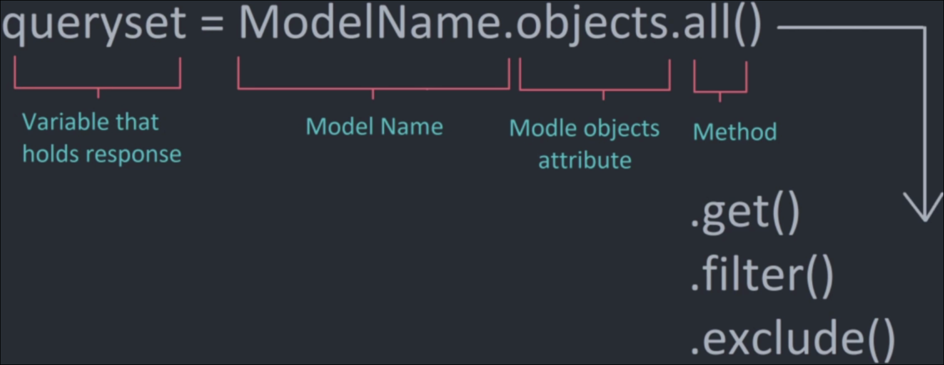
How standard query works?

queryzet – variable that will keep response usually list of objects (queryset) or a single object

.all() returns all objects from specified model in database

.get() returns a single object based on passed attribute

.filer() returns same as all() but we can pas attributes to specify which objects we want to get

.exclude() similar to filer except we specify which objects we don’t want returned

Query database from shell:

Check querysets image for details on different queries. Here are some examples:

python manage.py shell

from projects.models import Project

projects = Project.objects.all()

project = Project.objects.get(title=”Ecommerce Website”)

print(project)

print(project.review_set.all()) - more complicated (projereview has to be lowercase) but this returns all children of project

print(project.tags.all()) - many to many, to get all the connections we need to query the name of the field that contains many to many relationship.

Query from views.py

We can query our database from our views.py and pass that information into our html and display it on a website. Lets rewrite our project and projects views:
def projects(request):
projects = Project.objects.all()
context = {'projects':projects}
return render(request, 'projects/projects.html', context) – returns all projects

def project(request, pk):
projectObj = Project.objects.get(id=pk)
tags = projectObj.tags.all()
return render(request, 'projects/single-project.html', {
"project": projectObj,
"tags": tags,
}) - returns project wth requested pk/id that’s passed in url and tags connected to that project of that project

single-project.html:
{% extends 'main.html' %}
{% block content %}

<h1>{{project.title}}</h1>
<hr>
{% for tag in tags %}
<span style="border:1px solid grey">{{tag}}</span>
% endfor %}
<hr>
<br>
<p>{{project.description}}</p>
{% endblock content %}

Display passed project info and connected tags.

Query from html Django template:

Lets get our tags displayed in another way:
We can remove tags from project view:
def project(request, pk):
projectObj = Project.objects.get(id=pk)
return render(request, 'projects/single-project.html', {
"project": projectObj,
})

and instead query for tags inside for loop in html by replacing tag in tags with tag in project.tags.all:

{% for tag in project.tags.all %}
<span style="border:1px solid grey">{{tag}}</span>
{% endfor %}

- this will give us the same result

We can query for all the info about all the projects on our projects.html and display it as a table:
{% extends 'main.html' %}
{% block content %}

<h1>Projects</h1>

<table>
<tr>
<th>ID</th>
<th>Project</th>
<th>Positive Votes</th>
<th>Votes</th>
<th></th>
</tr>
{% for project in projects %}
<tr>
<td>{{project.id}}</td>
<td>{{project.title}}</td>
<td>{{project.vote_ratio}}%</td>
<td>{{project.vote_total}}</td>
<td>{{project.created}}</td>
<td><a href="{% url 'project' project.id %}">View</a></td>
</tr>
{% endfor %}
</table>

{% endblock content %}

6. Django Forms

When we want to use Forms in django we can either chreate them manually inside our html like we would normally or we can use
Django-Forms

First lets create new template called single_form.html:

{% extends main.html %}
{% block content %}

<h1>Project Form</h1>

<form method="POST">
{% csrf_token %}

<input type="submit" >
</form>

{% endblock %}

All we need is to specify the method as "POST" since we will be sending data (posting) to our views.py, input field that we will use to submit the form and every django form needs csrf_token which is a security thing that makes sure data wasnt manipulated.

For now lets just create a simple view and url connecting to this page.

views.py:
def createProject(request):
context = {}
return render(request, "projects/project_form.html", context)

urls.py:
path('create-project/', views.createProject, name="create-project"),

and lets create a link to the page in our navbar.html template:
<a href="{% url 'create-project' %}">Add Project</a>

- Now we are able to visit the page and see an empty form
Lets create our django form now:
- first inside our project folder create a new file forms.py that will
contain all of our future forms
forms.py:
from django.forms import ModelForm
from .models import Project

class ProjectForm(ModelForm):
class Meta:
model = Project
fields = '__all__' #fields = ['title', …]

- For conventional naming we usualy do ProjectNameForm(), and below we specify which fields we want our form to have either __all__ will inherit all of the model fields (except for non editable and auto generated fields like id or created fields) or we can specify a list of fields that we want.

- Now we import our form inside our views.py and add pass form to html trough createProject view:

from .forms import ProjectForm

def createProject(request):
form = ProjectForm()
context = {'form': form}
return render(request, "projects/project_form.html", context)

- If we visit our /create-project we can see our form with all of the fields now.
- We can customize our form:
{{form.as_p}} – wrap form fields inside <p></p> tags
{{form.title}} – form will only contain title field
{{form.title.label}} – only label of the field

{% for field in form %} - wrap fields in for loop
{{field.label}}
{{field}}
{% endfor %}

For more detailed form customization check Django documentation on model forms.

6.1 Create, Read, Update, Delete (CRUD)

We already have did Read part by displaying data from database now we will use our form for create and update.

First we will change the fields that user can manipulate inside forms.py:

fields = ['title', 'description', 'demo_link', 'source_link', 'tags']

We can catch our form POST and print it with request method:

views.py:
def createProject(request):
form = ProjectForm()

if request.method == 'POST':
print(request.POST)
# form = ProjectForm(request.POST)

context = {'form': form}
return render(request, "projects/project_form.html", context)

Now to create a new Project with our form:

if request.method == 'POST':
form = ProjectForm(request.POST)
if form.is_valid():
form.save()
return redirect('projects')

If we submit the form now it will send field data to our view, our post will catch it, it will check if form is filled propperly with djangos .is_valid() function and it will create tabele object with posted data and save it to database with .save() and redirect user to projects page.

Lets create UpdateProject form now that will allow us to change existing project with our form:

updateProject view will be almost the same as createProject:

def updateProject(request, pk):
project = Project.objects.get(id=pk)
form = ProjectForm(instance=project)
if request.method == 'POST':
form = ProjectForm(request.POST, instance=project)
if form.is_valid():
form.save()
return redirect('projects')
context = {'form': form}
return render(request, "projects/project_form.html", context)

Differences:
- we need to pass primary key of the form we are editing
- we need project variable that will contain data of the project that
we want to edit:
project = Project.objects.get(id=pk)
- we pre fill the form with existing project data:
form = ProjectForm(instance=project)
- when we submit instead of just request.POST we also need to pass:
instance=project to let the django know which form we are editing

Template of update is the same as template of create so we don’t need to create a new form and the page that displays the form is dynamically displaying the wanted form so we don’t need the new page only thing we need to add is a new url for update form:

urls.py:
path('update-project/<str:pk>/', views.createProject, name="create- project"),

and we can link /update-project to our projects page by adding new link next to view link:

<td><a href="{% url 'update-project' project.id %}">Edit</a></td>

Lets create the final part which is DELETE with confirmation page
(deletion is usually done by javascript only other way to delete is to use a django form):

- first lets create delete_template.html that will contain the delete/confirm form:

<form action="" method="POST">
{% csrf_token %}
<p>Are you sure you want to delete "{{object}}"?</p>
<a href="{% url 'projects' %}">
Go Back
</a>
<input type="submit" value="Confirm" />
</form>

- if user wants to delete they just submit otherwise they can just go back to projects page.

- we need to add views.py:

def deleteProject(request, pk):
project = Project.objects.get(id=pk)
if request.method == 'POST':
project.delete()
return redirect('projects')
context = {'object': project}
return render(request, 'projects/delete_template.html', context)
- we take request, pk, we get Project with the id of pk, and if user posts (clicks on confirm) we delete object from database and return him to projects page. By default if user enters this page with get request we just display the project and go back and confirm buttons.

- lastly we add delete button in projects.html:
<td><a href="{% url 'delete-project' project.id %}">Delete</a></td>

- and we add url for delete view:
path('delete-project/<str:pk>/', views.deleteProject,
name="delete-project"),

Now we have the full CRUD for our Project.
7. Static Files
create folder static and inside create folder styles js and images
*image
create main.css file and write some css
*image
Now we need to connect our styles folder with our project:
go into settings and find STATIC_URL and underneath create:
STATICFILES_DIRS = [
os.path.join(BASE_DIR, 'static'), #or in newer django: BASE_DIR / 'static'
]

note STATIC_DIRS is not custom variable django tells us to use this in docummentation.
7.1 load styles
Now inside main.html we just link our styles and load static files:
{% load static %} - underneath <!DOCTYPE> tag

-Note {% load static %} wont be inherited to extended html files you have to load it in every file that uses static

<link rel="stylesheet" type="text/css" media="screen" href="{% static 'styles/main.css' %}">

now we can see changed css.
7.2 load svg:
- add some logo svg to images folder
- go to navbar.hml
{% load static %}

<img src="{% static 'images/logo.svg' %}"

7.3 load static image into css as attribute might look like this:
background: url(../images/pattern.jpg);
7.3 Loading images from user
go to models.py and add a field to Project model:
featured_image = models.ImageField(null=True, blank=True, default="default.jpg")

- Image field that can be left blank and if no image is uploaded it will load default.jpg from static/images folder which will be the filler image so add some image to that folder.
- Images need image processing library so run:
python -m install Pillow
By default if we were to add an image to project trough admin panel it would be sent to our root folder which we don’t want so we will redirect it.
- open settings.py
- below static link define media link:
MEDIA_ROOT = os.path.join(BASE_DIR, 'static/images')

Render the image:
go into project/templates/single-page.html and add:
<img src="{{ project.featured_image.url }}">

we don’t want to use static because we are loading variable from Project model: modelName.fieldName.url is the syntax for loading images from database.
- now we have the url to the image but we don’t have url to MEDIA files. Inside of settings below STATIC_URL we need to add:
MEDIA_URL = '/images/'

now inside project urls.py we need to link the MEDIA url. Add 2 imports and new urlpatterns that will be appended to original every time new image is uploaded
from django.contrib import admin
from django.urls import path, include

from django.conf import settings
from django.conf.urls.static import static

urlpatterns = [
path('admin/', admin.site.urls),
path('', include('projects.urls'))
]

urlpatterns += static(settings.MEDIA_URL, document_root=settings.py.MEDIA_ROOT)

Lets add image upload to user form:
1. add ‘featured_image’ to forms.py Project form.
2. change add enctype to project_form.html:
<form action="" method="POST" enctype="multipart/form-data">
now when user submits the image image gets sent to our views
3. inside views.py change createProject view so that it accepts files:
form = ProjectForm(request.POST, request.FILES)

4. also change updateProject:
form = ProjectForm(request.POST, request.FILES, instance=project)

Done users can now upload their images.

7.4 Serving static in production
(see page xy for more details)

During testing above method will work fine but in production we need to seperate static files with 3rd party library because django is not built for serving static files in production.
To see what happens in production in settings we can change:
DEBUG = True to DEBUG = False

Now we are not able to serve static files from our static folder
We need to have STATIC_ROOT which will define the locaiton of our static files in production:
STATIC_ROOT = os.path.join(BASE_DIR, 'staticfiles')

One we set up the folder name we need to run:
python manage.py collectstatic
this will collect all of the static files boundle them together and create the defined folder with all of the static files. We usually do this before deployment of our website. Example on deployment at page xy. We still need 3rd party package to display thease. If we try to run the server now it wont work because we set DEBUG = False and now we need to specify domains that are allowed to connect to our website. Example:
ALLOWED_HOSTS = ['localhost', '127.0.0.1', mywebsite.com]
- localhost is what we use to run website locally and mywebsite.com is example of our future website domain.
Now we can run our page but static is not being served. To point django to our staticfiles folder we need to go to urls.py and add:
urlpatterns += static(settings.STATIC_URL, document_root=settings.STATIC_ROOT)

Now we need to install 3rd party library for python static file serving:
pip install whitenoise
MIDDLEWARE = [
#...
'django.middleware.security.SecurityMiddleware',
"whitenoise.middleware.WhiteNoiseMiddleware",
#...
]
Whitenouse wont serve user uploaded content for that we need another 3rd party app which we add on page xy.
Return DEBUG = True for now.
8. Theme installation

In case you have a theme (bought or made by designer usually) you will need to install it into the project. Usually theme will have stuff like uikit, html pages, css
Explain ui-kit and designer stuff.
“Installing Theme” just means merging its elements with your project:
- Put uikit into your static folder
- Put styles into project styles
To merge html:
- Usually there is index.html and some pages
- Take index.html and put it into project templates folder
- Take index.html head tag content copy it and replace existing
main.html head tag with it
- Most likley there will be links to your uikit and styles so replace
existing static links with your django dynamic links example:
"uikit/styles/uikit.css" → {% static 'uikit/styles/uikit.css' %}

- index.html will also have a navbar inside <header> so copy that
header and replace your navbar.html with it. Again fix the links.

- Now just take pages that you need from theme folder and start replacing your app pages html with theme page html and fixing up the links and adjusting the pages as you see fit.

- To theme form fields take existing form take single field and wrap it in loop and change field label, field
{% for field in form %}
<div class="form__field">
<label for="formInput#text">{{ field.label }} </label>
{{ field }}
</div>

Now to customize a specific field you either have to use javascript to find field names by id and modify that or customize model form and apply class in model form. So lets edit our form:

forms.py:
from django.forms import ModelForm
from django import forms
from .models import Project

class ProjectForm(ModelForm):
class Meta:
model = Project
fields = ['title', 'featured_image', 'description', 'demo_link', 'source_link', 'tags']
widgets = {
'tags': forms.CheckboxSelectMultiple(),
}
def __init__(self, *args, **kwarg):
super(ProjectForm, self).__init__(*args, **kwarg)
self.fields['title'].widget.attrs.update({'class':'input'})

- at 'tags': we used widget and turned tags into checkbox field.
- to add a class to field we wend to field title with __init__ method we selected widgets attributes and updated class attribute by adding input to class attribute. We can also loop all fields and apply same attributes to them:
def __init__(self, *args, **kwarg):
super(ProjectForm, self).__init__(*args, **kwarg)

for name, field in self.fields.items():
field.widget.attributes.update({'class':'input'})

9. Add more apps
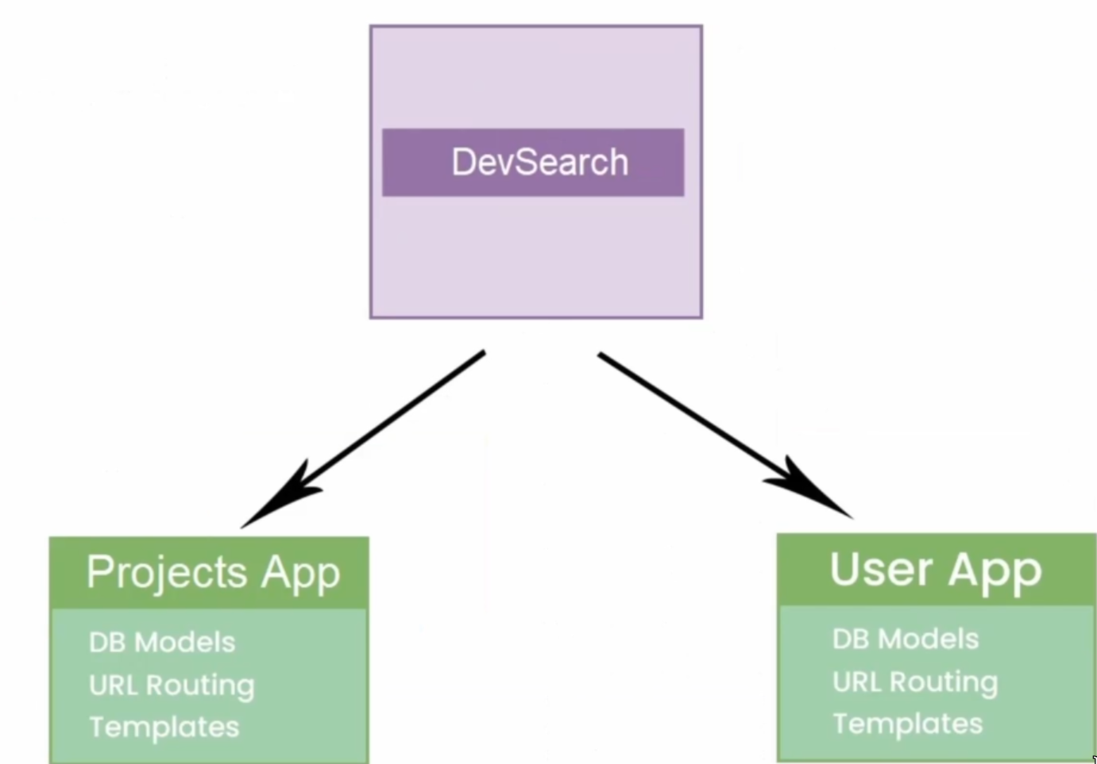
Lets split our project into 2 apps Projects App and User App.
python manage.py startapp users
Now we have created a new app (see page xy for new app layout).
Quick rundown (see page xy for detailed setup):
- link app in settings
'users.apps.UsersConfig',
- create templates folder and inside another folder with app name
- create profiles.html that will exted on main.html:
{% extends 'main.html' %} {% block content %} {% endblock content %}
- in views.py link html:
def profiles(request):
return render(request, 'users/profiles.html')
- create and link urls.py inside app:
from django.urls import path
from . import views

urlpatterns = [
path('', views.profiles, name="profiles"),
]
- in project urls.py link the app urls.py so that every time someone visits users/ project connects to users.urls:
path('users/', include('users.urls')),
or we can set users as home page with '/' and move projects to 'projects/' django dynamic names will sort paths in templates

9.1 User model
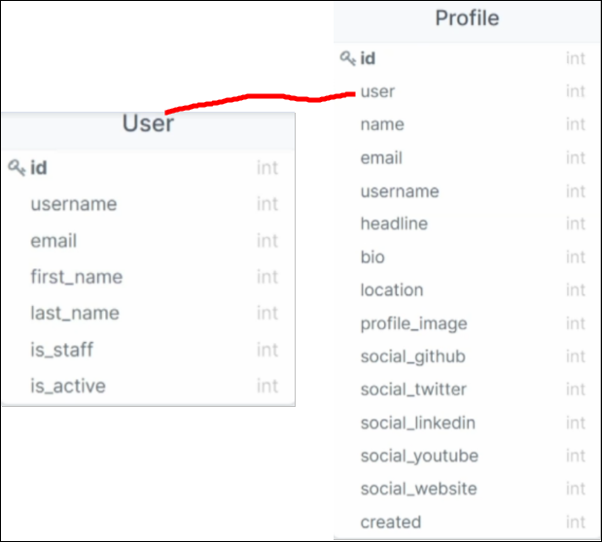

Its good to create 2 tables User will handle user authentication and there is already one made by django by default (how we create superuser and other users) so we will have User handling the authenticatin and Profile to store the user information. Some fileds such as username name and username are taken from User. These tables have a one to one relation. The reason we do this is because it can get hard to modify the User tabe.
So inside users/models.py create Profile model and make one to one relationship with djangos User model (check django user model docummentation for details on this default User model).
- Lets create fields from table image above, important fields to look at are user which establishes one to one relationship and profile_image that links to images/profiles folder that will store profile pictures:

from django.db import models
from django.contrib.auth.models import User
import uuid

class Profile(models.Model):
user = models.OneToOneField(User, on_delete=models.CASCADE, null=True, blank=True)
name = models.CharField(max_length=200, blank=True, null=True)
username= models.CharField(max_length=200, blank=True, null=True)
email = models.EmailField(max_length=500, blank=True, null=True)
location = models.CharField(max_length=200, blank=True, null=True)
short_intro = models.CharField(max_length=200, blank=True, null=True)
bio = models.TextField(blank=True, null=True)
profile_image = models.ImageField(null=True, blank=True, upload_to='profiles/', default="profiles/user-default.png")
social_github = models.CharField(max_length=200, blank=True, null=True)
social_twitter = models.CharField(max_length=200, blank=True, null=True)
social_linkedin = models.CharField(max_length=200, blank=True, null=True)
social_youtube = models.CharField(max_length=200, blank=True, null=True)
social_website = models.CharField(max_length=200, blank=True, null=True)
created = models.DateTimeField(auto_now_add=True)
id = models.UUIDField(default=uuid.uuid4, unique=True, primary_key=True, editable=False)

def __str__(self):
return str(self.user.username)

- create profiles folder inside static/images and add user-default.png that will serve as default profile picture
- imports are importing models, default User model and uuid for our id field.
- link Profile in admin.py of users app.
Now lets connect Profile to Projects with one to many relationship by editing Projects model.

Import Profile model:

from users.models import Profile

Add one to many relationship field to Projects model:

class Project(models.Model):
owner= models.ForeignKey(Profile, null=True, blan=true, on_delete=models.SET_NULL)

Now just display owner username on a projects page project (page xy Rendering Data To template) for details. You can do it by reverse searching Profile trough Project:

{{ project.owner.name }}

9.2 Add User Profiles Page

- create profiles.html page that will display all profiles
- link it in your navbar
- in views.py pass profiles to your html page:
def profiles(request):
profiles = Profile.objects.all()
context = {'profiles': profiles}
return render(request, 'users/profiles.html', context)

- on profiles page make some kind of card that will display user profile information
- loop trough profiles and repeat card for each profile:
{% for profile in profiles %}
<div class="column card">
<img
class="avatar avatar--md"
src="{{ profile.profile_image.url }}"
alt="image"
/>
<h3>{{ profile.name }}</h3>
<h5>{{profile.short_intro|slice:"60"}}</h5>
...
{% endfor %}

9.3 Add user profile page:
This will be similar to view project on (page xy)
- create user-profile.html that extends main page
- add url that takes user id as argument:
path('profile/<str:pk>/', views.userProfile, name="user-profile"),

- add views.py function that takes the passed primary key:
def userProfile(request, pk):
profile = Profile.objects.get(id=pk)
context = {'profiles': profiles}
return render(request, 'users/user-profile.html', context)

- in profiles.html wrap card body in link tag and make it so that if one of the profile cards is clicked url is passed with id of clicked profile and user is redirected to user-profile:

<a href="{% url 'user-profile' profile.id %}">

- edit the user-profile.html or install theme onto it and start displaying user information on the page (dynamic django templates page xy, install theme page xy)
9.4 Skill model:

lets add 3rd model that will be connected to Profile model:
class Skill(models.Model):
owner = models.ForeignKey(Profile, on_delete=models.CASCADE, null=True, blank=True)
name = models.CharField(max_length=200, blank=True, null=True)
description = models.TextField(null=True, blank=True)
created = models.DateTimeField(auto_now_add=True)
id = models.UUIDField(default=uuid.uuid4, unique=True, primary_key=True, editable=False)
def __str__(self):
return str(self.name)

- This will track all the skills of a developer and description of those skills.
- Lets say on our profiles page inside our cards we want to display those skills
- Skills is a child of Profile model. We can query for a Child element trough Profile like this:
{% for skill in profile.skil_set.all %}
<span class="tag tag--pill tag--main">
<small>{{skill}}</small>
</span>
{% endfor %}

- so syntax for child query is: parent.child_set.all
10. Django Signals

Before we talk about user registration lets talk about django signals.
Lets say we want ot register someone user fills form and submits and we want to send user the imal leting them know they have an account now with welcome message. This is where signals come into play. So signals are just a way for us to listen to user actions performed in our aplication and they can fire off certain events. In this case we would add singal to submit action and wait until new user was added to the database and fire a signal. Signals are conprised of senders and recievers in this case sender would be that action or that instence of that user being crteation and reciever would be the function that hears that action and than fires off a different action.
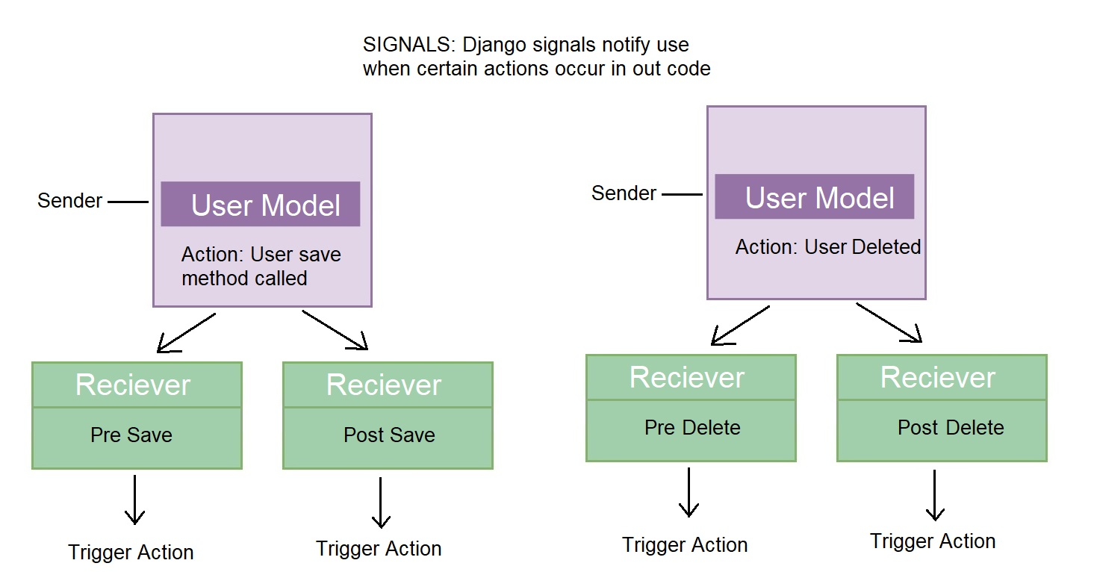

Lets update user/models.py with signals

from django.db.models.signals import post_save

def profileUpdated(sender, instanc, created, **kwargs):
print("Profile Saved")

post_save.connect(profileUpdated, sender=Profile)

- import post_save signal
- every time save method is called on a profile model after save method is completed trigger profileUpdated method
- now if we go into admin panel go to some Profile and save it we will print “Profile Saved” in console.
print("Instance:", instance)
print("Created:", created)

- we can also print stuff like who was save performd on and was the saved Profile just created or did it already exist.
- if new profile is created it will print Created: True as expected
- Now lets try the delete user signal that will notify us when we delete a Profile.
from django.db.models.signals import post_save, post_delete

def deleteUser(sender, instance, **kwargs):
print('Deleting user...')

post_delete.connect(deleteUser, sender=Profile)

Now it should print Deleting user after Profile deletion. We will finish this later to actually delete User connected to delted Profile. We already set up profile deleting on user deletion within our models with CASCADE attribute.
(page xy)

Decorator – instead of using post_(action).connect we can use decorators, its just another way of doing the same thing:

from django.dispatch import receiver

@receiver(post_save, sender=Profile)
def profileUpdated(sender, instance, created, **kwargs):
print("Profile Saved")
print("Instance:", instance)
print("Created:", created)

# post_save.connect(profileUpdated, sender=Profile)

We got same result now but instead of writing the full line of code we just put it inside of a decorator above our function, which one you will use is up to your preference

Now lets create a signal that creates user Profile any time User is created/registred in our project.

First replace profileUpdated method we just made

def createProfile(sender, instance, created, **kwargs):
if created:
user = instance
profile = Profile.objects.create (
user=user,
username=user.username,
email=user.email,
name=user.first_name,
)
post_save.connect(createProfile, sender=User)

Lets finish deleteUser:
def deleteUser(sender, instance, **kwargs):
user = instance.user
user.delete()
print('Deleting user...')

- Now not only is Profile delted on after user is deleted but User is delteted when profile is deleted
Usually we don’t want to write our signals inside our models.py so lets create signals.py inside users app and move our signals there.
signals.py:

from django.db.models.signals import post_save, post_delete
from django.dispatch import receiver

from django.contrib.auth.models import User
from .models import Profile

def createProfile(sender, instance, created, **kwargs):
if created:
user = instance
profile = Profile.objects.create(
user=user,
username=user.username,
email=user.email,
name=user.first_name,
)
def deleteUser(sender, instance, **kwargs):
user = instance.user
user.delete()
print('Deleting user...')

post_save.connect(createProfile, sender=User)
post_delete.connect(deleteUser, sender=Profile)

We also need to link this inside our users apps.py:
class UsersConfig(AppConfig):
default_auto_field = 'django.db.models.BigAutoField'
name = 'users'

def ready(self):
import users.signals

We just added def ready... to our UsersConfig and now signals are connected. This is why we register ‘users.apps.UserConfig’ inside our settings instead of just writing ‘users’. We want app config registred in our project settings not whole app. (page xy)

Reverse signals that update user when profile form is updated on (page xy – account settings)
11. Authentication

Authentication vs Authorization

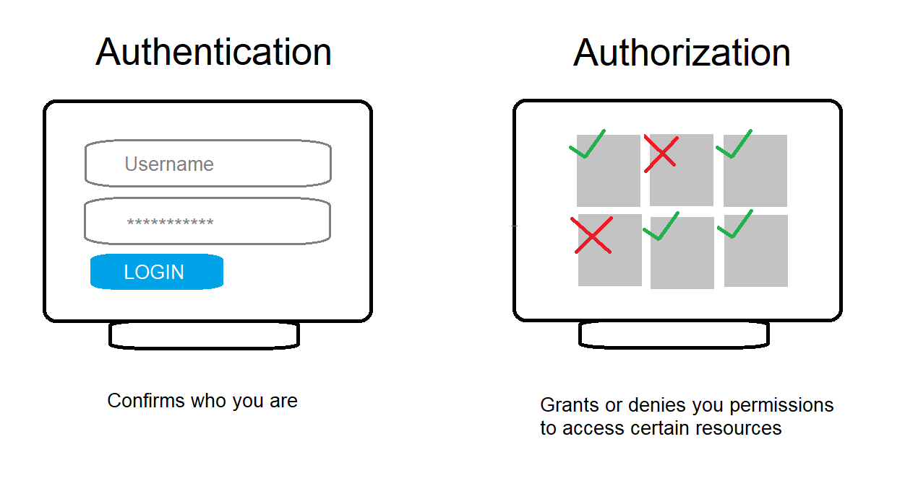
- Authentication checks if user exists and who is the user
- Authorizatin seperates users and administrators where users can only browse the website and do allowed actions while admins can menage users and website data.
*explain sessions(07 Authentication /001 User Login) and cookiesd, add pictures of database and admin panel and admin login that we are replacint etc.
Lets create login page:
- in users tempaltes create login_register.html and some simple login form for now:
{% extends 'main.html' %} {% block content %}

<form action="{% url 'login' %}" method="POST">
{% csrf_token %}
<input type="text" name="username" placeholder="Username" />
<input type="password" name="password" placeholder="Enter password" />
<input type="submit" name="value" />
</form>

{% endblock content %}

- in urls.py add login url:
path('login/', views.loginUser, name="login"),

- in views.py add create function for login page (don’t name it just login we will be importing login method later):
def loginUser(request):
if request.method == 'POST':
print(request.POST)
return render(request, 'users/login_register.html')

- link login to navbar

- Now we can see our login form on our login page if we submit we will print dictionary with csrf_token value, username, password and to our console.
- We can extract and store username and password from POST request into variables:

def loginPage(request):
if request.method == 'POST':
username = request.POST['username']
password = request.POST['password']
return render(request, 'users/login_register.html')

Check if user exists:

from django.contrib.auth.models import User

try:
user = User.objects.get(username=username)
except:
print('Username does not exist')

In our method we want to add try and except that will check if login user exists in the database (for that we need to import User), for now we are just printing that user dosent exsit later we will make a flash message to notify the user.

Loging:

from django.contrib.auth import login, authenticate

user = authenticate(request, username=username, password=password)

if user is not None:
login(request, user)
return redirect('profiles')
else:
print('Username OR password is incorrect')

user = authenticate will take the username and password and check if they match with database username and password and it will either return user instance or None.

Then we check if user is not None (user exists) and log in the instance of that user (create session for user in database and add it to browser cookies) and we just return user to the home page. Otherwise (user dosent exist) we print a message that username and password don’t match any database users later we will also trun this into a flash message to notify the user. Also import redirect if you havent already.

We can log out of our admin panel and try to log in using our new form which should log us in the same way now.

Logout:

- in our views we want to add logout import on top of our login and authenticate imports:

from django.contrib.auth import login, authenticate, logout

- add simple logout function

def logoutUser(request):
logout(request)
return redirect('login')

- add logout url:

path('logout/', views.logoutUser, name="logout"),

Now we want to make login button in our navbar change to logout button once user is logged in.
{% if request.user.is_authenticated %}
<li><a href="{% url 'logout' %}">Logout</a></li>
{% else %}
<li><a href="{% url 'login' %}">Login/Sign Up</a></li>
{% endif %}

We are using if statement to display buttons depending on users authentication status. Also we should move all of the pages that should be accessible only to users that are logged in like
(add page form) to this if statement so that they are only visible if user is authenticated.

{% if request.user.is_authenticated %}
<li><a href="{% url 'create-project' %}">Add project</a></li>
<li><a href="{% url 'logout' %}">Logout</a></li>
{% else %}
<li><a href="{% url 'login' %}">Login/Sign Up</a></li>
{% endif %}

Now non logged in user should only see default pages+login page in navbar but he can still acces other pages with url which we will manage inside our views.
Page view acces based on authentication:

First lets make it so that if authenticated user tries to visit login page to be simply redirected to the home page by checking if user is authenticated when accesing loginUser view since user that is logged in has no need for login page:

def loginUser(request):

if request.user.is_authenticated:
return redirect('profiles')
...

And we can make it so that non authenticated users cant visit pages like our Add Project form page or logout page that they shouldn’t be able to access. We can do this in multiple ways: custom middleware with class based views (class based views page xy), mixins, etc. but we will just import decorators for now since we have function based views. You can also try making your custom decorators but that is up to you to research and outside of scope of this book.

from django.contrib.auth.decorators import login_required
So we need to import login_required decorator in all of our view.py files and it will sit on top of every function view that should be accesible to authenticated users only

examples:

projects/views.py:

@login_required(login_url="login")
def createProject(request):
...

We should put this decorator on top of every view that requires login and we can also specify login_url= that represents page that user vill be redirected to if he tries to acces @login_required page view.

Django flash messages:

- Explain what django flash messages are:
- give basic django message syntax

For now if user fails to log in nothing happens no error message nothing. We want to make it so that message flashes once user is logged in/fails to log in. To use django messages we can just replace our console error messages we used so far like print('Username does not exist')
with messages.error(request, 'Username does not exist'). This will pass message to our html. Now to render thease messages inside our main.html we can just put:

{% if messages %}
<ul class="messages">
{% for message in messages %}
<li {% if message.tags %} class="{{ message.tags }}"{% endif %}>{{ message }}</li>
{% endfor %}
</ul>
{% endif %}

Since every page extends main.html messages will be displayed no matter which view is sending them.
12 User Registration

- create register views.py with same html page as login we will render this page conditionaly to be either register or login
def registerUser(request):
page = 'register'
context = []
return render(request, 'users/login_register.html', context)

- add page = 'login' to loginUser

- add url path:
path('register/', views.registerUser, name="register"),

- wrap our login_register page into conditional if statement that checks the passed page value.
{% if page == 'register' %}
<form>Register User Form</form>
<p>Have an account<a href="{% url 'login' %}">Sign In</a></p>

{% else %}

<form >
Login User Form
<p>Dont have an account<a href="{% url 'register' %}">Sign Up</a></p>
</form>
{% endif %}

- if page is accessed with register view function it will display register form otherwise it will display login form and both forms link to each other.
from django.contrib.auth.forms import UserCreationForm

def registerUser(request):
page = 'register'
form = UserCreationForm()

if request.method == 'POST':
form = UserCreationForm(request.POST)
if form.is_valid():
user = form.save(commit=False)
user.username = user.username.lower()
user.save()

messages.success(request, 'User was sucessfully created')

login (request, user)
return redirect('profiles')
else:
messages.error(request, 'Registration failed')

context = {'page': page, 'form': form, }
return render(request, 'users/login_register.html', context)

Using default django user creation form and passing it to html.
form equals to dictionary passed by user register
if form is valis take form dictionary and put it into user without saving to database (this is usually done if we want to further manipulate the data before saving it)
convert username to lowercase we don’t want case sensitive usernames
save to database and flash a message
use login method to login auser after creation (this is a good use for creating user with commit=False) and redirect to main page.
Otherwise flash the message that register failed.
12.1 User Register form

In users app create forms.py:
class CustomUserCreationForm(UserCreationForm):
class Meta:
model = User
fields = ['first_name', 'email', 'username', 'password1', 'password2']

Defualt user creation form first field is called password1 and second password2 you can check this in django documentation

You can remove UserCreationFrom import from views and replace it with new custom form:
from .forms import CustomUserCreationForm

also replace thease 2 fields:
form = UserCreationForm() → form = CustomUserCr2eationForm()

form = UserCreationForm(request.POST)
→ form = CustomUserCreationForm(request.POST)

Now just theme/style login/register forms. Form styling (page xy), theme the fields (Section: theme isntallation)
Forgot password link (page xy)

{% for error in field.errors %}
<p style="color:red">{{error}}</p>
{% endfor %}

If form has error arguments (password too short etc.) we can display it after incorrect submision with this loop. Check doccummentation for more info on default form fields.
12.2 Customize flash messages:

For now we have flash messages that pop on correct and incorrect form submision. They work by django creating new flash message element inside a cache of page that is removed after page refresh.
So far we had this in our main.html:
{% if messages %}
<ul class="messages">
{% for message in messages %}
<li {% if message.tags %} class="{{ message.tags }}" {% endif %}>
{{ message }}
</li>
{% endfor %}
</ul>
{% endif %}

{% if messages %}
{% for message in messages %}
<div class="alert alert--{{message.tags}}">
<p class="alert__message">{{message}}</p>
<button class="alert__close">⨯</button>
</div>
{% endfor %}
{% endif %}

- if messages exist loop trough them and display each one.
- alert alert—{{message.tags}} first class is just some styling for alret message but the oter one specifes which type of alert message we are working with by taking message.tags from our views.py:
messages.error()

in this case its error message.
For all message types check the django flash message documentation.
13. Account Settings

Lets imagine we have a page for customizing profile. We need to display same stuff as on profile and add edit and delete button next to elements and later add CRUD functionality to those buttons. Thats pretty much it so:
1. Basic display:
Create account settings html page
link url and create views for it (must be login required page obv)
trough views pass stuff like currenttly logged user as profile, skills and projects table.
Display all of the necessary information that you passed.
Add edit and delete buttons.

2. Create edit account

create edit account html page
create urls and views with login required
create profile edit forms.py model:
from .models import Profile
class ProfileForm(ModelForm):
class Meta:
model = Profile
fields = '__all__'

pass form on edit account view and render it to the html

3. Create signals

Now we can create singlas that will update user when profile is updated. – no idea whats going on further explanation needed
if statement is to avoid infinite loop?
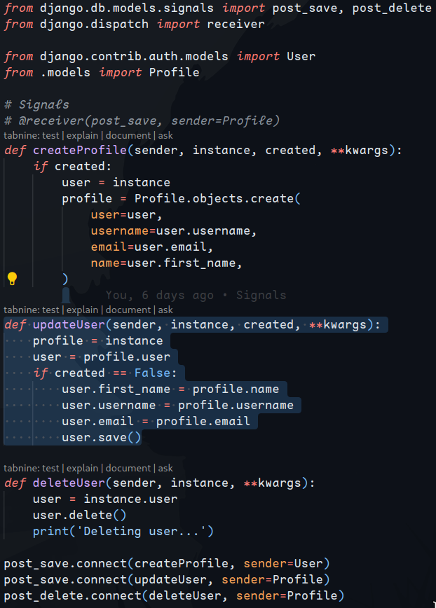
4. Update form:

edit-form.html
<form method="POST" action="{% url 'edit-account' %}", enctype="multipart/form-data">
{% csrf_token %}
{{ form.as_p }}
<input type="submit" value="Submit" />
</form>

views.py:
@login_required(login_url='login')
def editAccount(request):
profile = request.user.profile
form = ProfileForm(instance=profile)
if request.method == 'POST':
form = ProfileForm(request.POST, request.FILES, instance=profile.profile)
if form.is_valid():
form.save()
messages.success(request, 'Profile was updated!')
return redirect('account')
context = {'form': form, }
return render(request, 'users/profile_form.html', context)

1.
Retrieve User Profile: The function starts by retrieving the profile of the currently logged-in user with profile = request.user.profile. This assumes that the User model has a one-to-one relationship with a Profile model, accessible via the profile attribute.
2.
Initialize Profile Form: A ProfileForm instance is created and initialized with the user's profile data using form = ProfileForm(instance=profile). This form is likely a Django ModelForm designed to handle the input fields for the Profile model.
3.
Handle POST Request: The function checks if the current request method is POST, which indicates that the form has been submitted. If so, it re-initializes the ProfileForm with the submitted data (request.POST) and files (request.FILES), along with the instance of the profile to be updated (instance=profile.profile). This line seems to contain an error; it should probably be instance=profile instead of instance=profile.profile, assuming that profile is the instance to be updated.
4.
Form Validation and Save: If the form is valid (form.is_valid()), it is saved with form.save(). This updates the user's profile with the submitted data.
5.
Success Message and Redirect: Upon successfully saving the form, a success message is added using messages.success(request, 'Profile was updated!'), and the user is redirected to the 'account' page with return redirect('account').
6.
Context and Template Rendering: If the request method is not POST or if the form is not valid, the function prepares the context dictionary with the form ({'form': form, }) and renders the users/profile_form.html template. This template is expected to display the profile form, allowing the user to edit their profile information.

urls.py
path('edit-account/', views.editAccount, name="edit-account"),

forms.py:
class ProfileForm(ModelForm):
class Meta:
model = Profile
fields = ['name', 'email', 'username', 'location', 'bio',
'short_intro', 'profile_image', 'social_github',
'social_linkedin', 'social_twitter', 'social_youtube',
'social_website', ]

We create form on our html page pre fill it with all profile info edit it submit and return user to their profile page.

Theme your form
5. Give users CRUD on their projects:

<a href="{% url 'create-project' %}"><i class="la la-plus"></i> Add Project</a>

Create link to create project page where user can add a project. Before creating project we need to have that new project connected to user that added it. As of now project will just be added to database but no user will be connected to it. We need to edit our createProject function in projects app views.py:

profile = request.user.profile – this will take currently logged user
project = form.save(commit=False) – create instance of project
project.owner = profile – set owner of project to current user
project.save() - save to database

Updated createProject function:
@login_required(login_url="login")
def createProject(request):
profile = request.user.profile
form = ProjectForm()
if request.method == 'POST':
form = ProjectForm(request.POST, request.FILES)
if form.is_valid():
project = form.save(commit=False)
project.owner = profile
project.save()
return redirect('projects')
context = {'form': form}
return render(request, "projects/project_form.html", context)

6. Prevent other users from editing our project by pasting pasting project id in url we need to change updateProfile function:

def updateProject(request, pk):
profile = request.user.profile - +added this
project = Project.objects.get(id=pk) → project = profile.project_set.get(id=pk) – change this

we take currently logged user
we return only the projects of the logged user instead of all

- do the same for deleteProject function.

