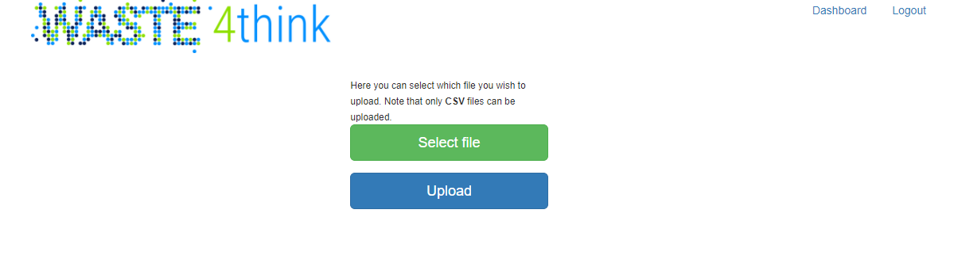

UC 01: File upload

**How it works**: User clicks on the “select file” button. After he makes his choice, he then he clicks on the “upload” button to upload the file he selected. He can only upload CSV files.

**Reference user story**: Upload CSV.

UC 02: Logout

**How it works**: User clicks on “logout” link and is taken back to login page.

**Reference user story**: User handling.

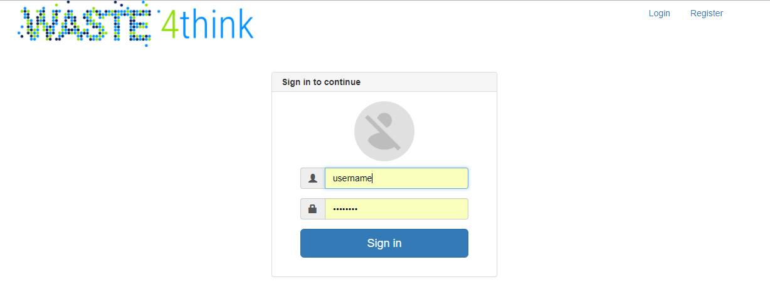

UC 03: Login

**How it works**: User inputs his user name and password in provided text fields. He clicks on “sign in” button afterwards and, if his credentials are valid, is directed to upload page.

**Reference user story**: User authentication, User handling.