Temporal weather signatures associated with soybean seed decay in the Brazilian Cerrado

Igor Fernandes Erhardt¹, Cláudia Vieira Godoy^{2*}, Luana Belufi³, Alana Tomen⁴, Austeclino Lopes de Farias Neto⁵, Jorge Lulu⁶, Eder Novaes Moreira⁷, Emerson Medeiros Del Ponte^{1*}

¹Departamento de Fitopatologia, Universidade Federal de Viçosa, Viçosa, MG 36570-900
²Embrapa Soja, Londrina, PR, 86085-981
³Fundação Rio Verde, Lucas do Rio Verde, MT, 78460-417
⁴Proteplan, Sorriso, MT, 78065-075
⁵Embrapa Cerrados, Planaltina, DF, 73310-970
⁶Embrapa Territorial, Campinas, SP, 13070-115
⁷Fitolab Pesquisa e Desenvolvimento Agrícola, Sorriso, MT, 78896-970

*Corresponding authors: Emerson M. Del Ponte (delponte@ufv.br); Cláudia V. Godoy (claudia.godoy@embrapa.br)

Abstract
In recent years, soybean seed decay has led to substantial yield and quality losses in tropical Brazil, yet the timing of weather conditions associated with damaged grains (DG) remains poorly understood. We analyzed DG percentages from 72 field trials conducted during four growing seasons (2022/2023 to 2025/2026) in Mato Grosso and Rondônia using 80-day weather trajectories preceding the corrected grain-evaluation date. Daily maximum and minimum temperature, relative humidity, and rainfall were obtained from an explicitly pinned ERA5 product. Each weather variable was analyzed separately using season-adjusted linear regression across eight prespecified 10-day intervals and scalar-on-function regression. Inference accounted for dependence among trials sharing an ERA5 grid cell within the same season. Log-transformed rainfall showed the strongest cross-method concordance. The interval model identified its largest positive estimate during −50 to −41 days, whereas the scalar-on-function analysis supported a broader positive region extending approximately from −60 to −31 days. Minimum temperature showed secondary positive estimates earlier and negative estimates later in the domain, but process-level evidence was weaker and season-dependent. Relative humidity and maximum temperature were not reproduced as coherent smooth temporal patterns. The rainfall association weakened after exclusion of the highest-DG trials and varied across leave-one-season-out analyses. Overall, the most consistent finding was a broad rainfall-associated retrospective period approximately 60 to 40 days before grain evaluation. This pattern should be considered an observational hypothesis for prospective microclimate studies and validation in larger independent datasets.
Keywords: Glycine max; Diaporthe; Fusarium; functional data analysis;

Introduction
Soybean (Glycine max (L.) Merr.) production in tropical regions of Brazil has recently faced increasing concern over seed decay symptoms, particularly in Mid-Northern Mato Grosso and Rondônia. This concern has emerged in the context of changes in soybean production systems, including earlier sowing dates to allow sufficient time for the establishment of a second crop of maize or cotton within the same agricultural season, as well as the adoption of new soybean cultivars with different agronomic and genetic backgrounds.
Symptoms begin on pods at R5 and include water-soaked areas or dark green discoloration, with no apparent necrosis or pod opening. When opened, the pods contain seeds showing partial or complete decay, irregularly distributed among pods and seeds, which compromises grain quality (Kudlawiec et al. 2023). The symptoms resemble Diaporthe seed decay caused by Diaporthe species, although pod symptoms have been observed earlier than previously described in the literature (Petrović et al. 2021). In addition to Diaporthe, several other fungi have been isolated from symptomatic seeds and pods; species from the genera Colletotrichum, Fusarium, and Moniliophthora are frequently recovered from decayed seeds with or without symptoms; however, the relative contribution of these taxa to disease onset, progression, and final grain deterioration remains uncertain (Dos Santos et al. 2024; Nascimento et al. 2025; Ramos et al. 2026).
Seed decay is an important constraint to soybean seed quality and production, as fungal infection and deterioration can reduce germination and seed vigor, impair seedling establishment, and compromise the physiological quality of stored seed (Brown et al. 1987; Gillen et al. 2012). In Brazil, soybean grain quality is regulated according to the occurrence and severity of defects such as moldy, fermented, germinated, and damaged grains. Soybean grain is commercially classified according to official quality standards, with a maximum tolerance of 8% for total damaged grains. Grain lots exceeding this threshold may be subject to commercial discounts, depending on the buyer and applicable contract (Brasil, 2007).
Weather may influence seed decay through multiple biological pathways. Atmospheric moisture and rainfall can affect fungal sporulation, dispersal of inoculum, infection, and subsequent seed colonization, whereas temperature and plant water status can influence host physiology, reproductive development, and the susceptibility of developing pods and seeds to deterioration (Shortt et al. 1981; Tekrony et al. 1983; Rupe and Ferriss 1986; Balducchi and McGee 1987; Westgate et al. 1989). These effects may also vary across crop development. Studies of the Diaporthe complex showed that infected soybean residue can serve as an important inoculum source and that rainfall promotes short-distance dispersal of conidia, while latent infections may become established in immature soybean tissues, including pods (Kmetz et al., 1979). At broader scales, rainfall during pod filling and crop maturation was strongly associated with subsequent seed decay (Shortt et al., 1981), while moisture-related conditions, particularly minimum relative humidity during seed development and maturation, were more consistently associated with seed infection than precipitation totals alone (TeKrony et al., 1983). Experimental and observational studies further indicate that the effect of moisture depends on developmental timing: wet periods beginning around flowering and extending into pod development have been associated with greater pod infection, whereas high pod water content, relative humidity, and favorable temperature near physiological maturity can promote seed infection and subsequent fungal growth (Lamka and McGee, 1986; Rupe and Ferriss, 1986; Balducchi and McGee, 1987).
Weather conditions favoring infection during pod formation and grain filling may therefore differ from those that promote later colonization, symptom expression, or amplification of damage in previously infected or predisposed tissues. This distinction is particularly important in field datasets where the response is the final percentage of damaged grains rather than pathogen-specific incidence. The observed phenotype may integrate multiple processes occurring at different times, including infection, latent colonization, physiological stress, seed development, and late-season tissue deterioration. Latent Diaporthe infections may remain asymptomatic in immature tissues and become more evident as pods and seeds approach senescence and maturity, further separating the timing of infection from the timing of visible damage (Kmetz et al., 1979; Rupe and Ferriss, 1987). Consequently, weather associations detected retrospectively may reflect different stages of disease development rather than a single infection period.
Despite the economic significance of soybean grain deterioration, the relationship between weather dynamics during reproductive crop development and final grain damage remains poorly characterized in the tropics of Brazil. Lehner et al. (2025) reported approximately 1.7-fold greater cumulative precipitation during the reproductive stage in a late-planted trial that developed substantially more damaged grains. Their analysis, however, besides being based on a limited number of experiments, summarized rainfall across the entire reproductive period, providing limited information on when weather conditions may be most strongly associated with subsequent grain damage.
In this study, we examined weather conditions associated with soybean grain damage in 72 field experiments conducted in Mato Grosso and Rondônia, Brazil. We hypothesized that final grain damage may reflect temporally structured environmental processes occurring before grain evaluation. Because pathogen infection, canopy microclimate, and intermediate phenological stages were not observed directly, the analysis was designed to identify retrospective weather-associated patterns rather than infection windows or causal mechanisms.
We evaluated 80-day meteorological trajectories preceding the corrected grain-evaluation date using complementary prespecified 10-day interval and scalar-on-function regression analyses. The objective was to identify broad temporal patterns in rainfall, relative humidity, and temperature associated with final DG. Given the modest number of trials, model complexity was deliberately restricted, uncertainty accounted for clustering by ERA5 grid cell within season, and interpretation emphasized effect magnitude, temporal concordance, and stability rather than isolated P-value thresholds.

Materials and Methods

Field trials dataset and response variable
The dataset comprised 72 field trials conducted across four growing seasons (2022/2023 to 2025/2026) in commercial soybean-producing municipalities in Mato Grosso (MT) and Rondônia (RO), Brazil (Fig. 1). These trials evaluated fungicides or planting dates (Kudlawiec et al. 2023; Belufi et al. 2024; Belufi et al. 2025; Belufi et al. 2026; Farias-Neto et al. 2023; Farias-Neto et al. 2024). We used data from two major commercial cultivars considered susceptible to seed decay: Brasmax Desafio RR (8473RSF; n = 52) and Brasmax Olimpo IPRO (80I82RSF IPRO; n = 20). The interval from sowing to the corrected grain-evaluation date ranged from 93 to 137 days, with a median of 118 days. The primary response was the mean percentage of damaged grains (DG) from non-fungicide-treated plots. Samples of 25–125 g of grain per plot were collected after harvest and reduced using a sample divider or homogenizer. DG was determined according to Brazilian official grain-classification standards and included burned, moldy, fermented, damaged, immature, shriveled, sprouted, and heat-damaged grains.

Weather temporal series
Daily meteorological series for the coordinates of each trial were retrieved with r4pde::get_era5() using models = "era5", thereby pinning temperature, relative humidity, and precipitation to one named weather product. Field collaborators clarified that grain evaluation occurred 20 days after the date recorded in the source evaluation_date field. The operational anchor was therefore defined as the recorded date plus 20 calendar days (t = 0), and the primary exposure window comprised t = −80 to −1 days; day 0 was excluded. Because observed intermediate phenological stages were unavailable and sowing-to-evaluation duration varied among trials, retrospective lags were not assigned automatically to specific crop stages.
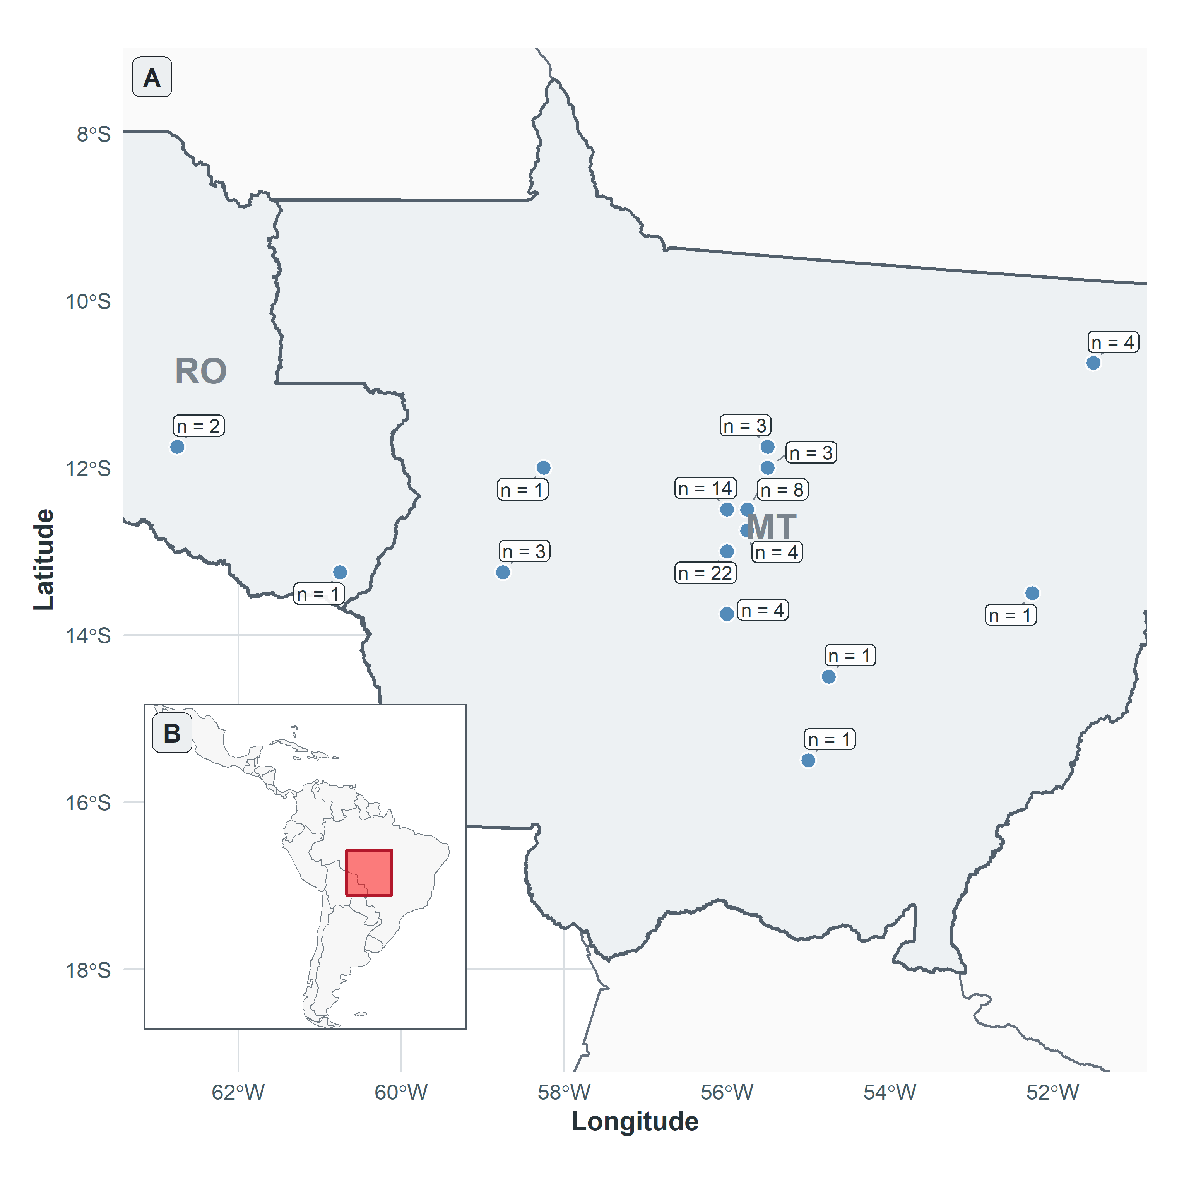
Figure 1. Geographical distribution of the meteorological exposure locations. Points represent ERA5 grid-cell centroids assigned to the 72 soybean trials conducted in Mato Grosso (MT) and Rondônia (RO), Brazil, across the 2022/2023 to 2025/2026 growing seasons. Labels indicate the number of trial records assigned to each grid cell.

Meteorological Variables
Four continuous meteorological variables were considered: daily maximum temperature (Tmax), minimum temperature (Tmin), relative humidity (RH), and log-transformed rainfall amount (LogRain). The latter was log-transformed to reduce the strong right-skewness of daily precipitation and limit the influence of extreme rainfall events while retaining information on rainfall magnitude. The transformation was defined as:
$LogRain_{i}\left(t\right)=ln​\left[1+\frac{Rain_{i}\left(t\right)}{1 mm}\right].$ (2)

10-day interval regression analysis
The 80-day period preceding the corrected grain-evaluation date was divided a priori into eight non-overlapping 10-day intervals: −80 to −71, −70 to −61, −60 to −51, −50 to −41, −40 to −31, −30 to −21, −20 to −11, and −10 to −1 days. Day 0 was excluded. Each meteorological process was analyzed separately using a Gaussian multiple linear regression. The eight standardized interval summaries for a process were entered simultaneously, with growing season included as a fixed effect. The process-specific models can be represented as:
$DG_{i}=α+\sum_{s}{}δ_{s}Season_{is}+\sum_{k=1}^{8}{}β_{pk}X_{ipk}+ϵ_{i},$ (3)
where βpk represents the difference in DG percentage points associated with a one-standard-deviation increase in process p during interval k, conditional on growing season and the other seven intervals of the same process, with
$ϵ_{i}∼N(0,σ^{2})$. (4)
Coefficients were estimated using all 72 trials. Statistical uncertainty was calculated with a CR2 cluster-robust covariance estimator using ERA5 grid-cell-by-season combinations as clusters (36 clusters). Trials remained separate observations, while residuals were allowed to be correlated and heteroscedastic within a cluster. For each process, a cluster-robust Wald-type F test with an approximate Hotelling T² small-sample correction jointly tested whether all eight interval coefficients were zero. This provided the process-level assessment beyond growing-season differences while accounting for shared weather support within the same grid cell and season.
Incremental R² was calculated as the difference between the ordinary in-sample R² values of the full and season-only models. It represents the additional proportion of observed DG variation accounted for by the eight interval summaries beyond growing season. Because it was calculated from the fitting data, incremental R² was interpreted as an in-sample association measure rather than validated predictive performance.
Interval-specific coefficients were reported with Wald-type 95% confidence intervals calculated from CR2 cluster-robust standard errors and Satterthwaite-adjusted degrees of freedom. Estimates were interpreted with the process-level test, their uncertainty, concordance with scalar-on-function regression, and stability across the prespecified sensitivity analyses.

Scalar on function analysis
Each daily meteorological process was also evaluated separately using scalar-on-function regression. Unlike the 10-day interval analysis, this approach allowed the association to vary continuously across the 80 days preceding the corrected grain-evaluation date. For trial i, the model was:
$DG_{i}=α+\sum_{t=−80}^{−1}{}\{X_{i}(t)−\underline{X}(t)\}β_{p}(t)+\sum_{s}{}δ_{s}Season_{is}+ϵ_{i}.$ (5)
with
$ϵ_{i}∼N(0,σ^{2})$ (6)
where DGi is the damaged-grain percentage for trial i; Xi(t) is the value of the meteorological process on lag day t; X̄(t) is the across-trial mean exposure at the same lag; βp(t) is the process-specific time-varying coefficient function; Seasonis denotes the growing-season indicators; and δs denotes differences in mean DG among seasons.
The coefficient function βp(t) represents the estimated difference in DG percentage points associated with a one-unit increase in exposure at lag t, conditional on growing season and the smooth temporal structure. It was represented by a cubic B-spline basis with four fixed degrees of freedom across the full 80-day domain, following Ramsay and Silverman (2005). Daily exposures were centered at each lag, and the same deliberately low basis dimension was used for every process. Because adjacent coefficients are mathematically linked through the basis, interpretation focused on direction, magnitude, and broad temporal location rather than isolated days.
The fixed, unpenalized four-degree-of-freedom specification was primary because its low, prespecified complexity provided a transparent and directly comparable representation across processes without selecting smoothing separately according to the response. As a sensitivity analysis, models were refitted using refund::pfr() with a cubic P-spline functional term, maximum basis dimension k = 4, a second-order difference penalty, and smoothing selected by restricted maximum likelihood. This allowed the effective degrees of freedom to decrease below four when supported by the data and assessed dependence of the temporal patterns on the absence of penalization.
For each process, the joint null hypothesis that all four spline-score coefficients were zero was evaluated using a cluster-robust Wald-type F test. The CR2 covariance estimator used the 36 ERA5 grid-cell-by-season combinations as clusters, and an approximate Hotelling T² correction accommodated the limited number of clusters. The test therefore assessed whether the complete functional trajectory contributed information about DG beyond growing season while allowing dependence among trials sharing a grid cell within a season.
Uncertainty in the coefficient function was estimated using 999 season-stratified cluster-bootstrap samples. ERA5 grid-cell-by-season clusters were sampled with replacement within season; whenever a cluster was selected, all trial records belonging to it were included together, without averaging their outcomes. The full functional model was refitted in each bootstrap sample. A 95% simultaneous confidence band was constructed from the 95th percentile of the maximum standardized bootstrap deviation across the entire 80-day domain:
${{\hat{β}}^{}}_{p}(t)±c_{p,0.95}^{max}{SE}_{boot,p}(t)$ (7)
where SEboot,p(t) is the bootstrap standard error at lag t and cmaxp,0.95 is the 95th percentile of the maximum standardized deviations. The band reflects uncertainty in the coefficient function as a whole and controls simultaneous coverage across the complete lag domain rather than providing separate pointwise intervals.
For each prespecified 10-day interval Bk, an interval-integrated contrast Cpk was calculated by summing the estimated daily coefficient function over the interval:
$C_{pk}=\sum_{t∈B_{k}}{}{β^{^}}_{p}(t)$ (8)
For every bootstrap sample, coefficients were summed over the same interval. The 95% confidence interval for each integrated contrast was defined by the 2.5th and 97.5th percentiles of that cluster-bootstrap distribution. These percentile intervals differ from the simultaneous ribbon: the ribbon evaluates the entire daily curve, whereas an integrated contrast evaluates the cumulative association within one prespecified interval.
Given the correlation among meteorological variables and the exploratory nature of the study, P-values were not subjected to multiplicity adjustment and were interpreted continuously rather than using a fixed significance threshold (Bender and Lange 2001; Wasserstein et al. 2019). Interpretation therefore emphasized effect magnitude and uncertainty, temporal concordance between analytical approaches, and stability across sensitivity analyses rather than isolated P-value thresholds.

Stability analyses
Stability analyses assessed whether the estimated associations depended materially on outcome scale, the sparse upper tail of DG, covariate adjustment, or individual growing seasons. Both primary model types were refitted using log(1 + DG); after excluding the three outcome-only high-DG observations; with sowing day of year and cultivar added to growing season; and with sowing-to-evaluation duration and cultivar added to growing season. Leave-one-season-out refits were conducted separately. Stability was judged by process-level evidence, effect magnitude and uncertainty, preservation of direction and broad temporal location, and concordance between the two primary analytical views.

Outcome-scale sensitivity.
The primary outcome was DG expressed in percentage points. To evaluate sensitivity to its right-skewed distribution, the models were repeated using:
DGlogᵢ = ln(1 + DGᵢ) (10)
The addition of 1 permits the transformation of observations with DG equal to zero. On this scale, large DG observations receive less influence than in an untransformed Gaussian model. Coefficients from the original and log-transformed models were not compared directly because they are expressed on different outcome scales.

Sensitivity to high DG observations
Potentially influential outcome observations were identified using an outcome-only rule before considering their weather histories. The upper Tukey fence was calculated as:
Upper fence = Q₃ + 1.5 × IQR , (11)
where:
IQR = Q₃ − Q₁ . (12)
Three observations had DG values above this boundary. These observations were retained in the primary analysis because they were not documented as data or experimental errors. The primary analysis was repeated after excluding them to determine how strongly the estimated associations depended on the sparsely represented upper portion of the DG distribution.
Weakening of an association after this exclusion was not interpreted automatically as evidence that the primary result was erroneous. Because the dataset contained few trials with high DG, some loss of magnitude and precision was expected. Nevertheless, a marked change in process-level evidence, coefficient direction, or temporal location indicated that the estimated association was strongly informed by a small number of high-outcome trials and therefore required cautious interpretation.

Leave-one-season-out analysis
Internal season stability was evaluated by fitting four additional models, each omitting one season. Both the broad-interval and scalar-on-function models were refitted using the remaining three seasons with the same cell-by-season clustered inference. Because each omission removed a substantial and potentially distinctive portion of a four-season dataset, these analyses were treated as internal stress tests rather than external validation. Particular concern was assigned to major reversals, disappearance of the temporal pattern, or movement to a biologically different part of the retrospective domain.

Residual diagnostics
Model adequacy was evaluated separately for every season-adjusted broad-interval and scalar-on-function model using residual-versus-fitted and normal Q-Q plots. Residual-versus-fitted plots were examined for systematic curvature and changes in residual dispersion across fitted DG values. Normal Q-Q plots compared standardized residuals with theoretical normal quantiles to identify departures from the Gaussian residual assumption. These diagnostics were interpreted graphically and were not used to select meteorological processes or alter the temporal specification.

Data analysis, availability and reproducibility
All analyses were conducted in R 4.5.0 (R Core Team 2025). Primary broad-interval and scalar-on-function models were fitted as Gaussian linear models using base R and cubic B-spline basis functions from splines. Cluster-robust covariance estimation, Satterthwaite degrees of freedom, and approximate Hotelling T² joint tests were implemented with clubSandwich using ERA5 grid-cell-by-season clusters. Functional simultaneous bands and integrated-contrast intervals were obtained from 999 season-stratified cluster-bootstrap samples. The penalized sensitivity used refund::pfr() with REML-selected smoothing. Data preparation, model fitting, sensitivities, leave-one-season-out analyses, figures, and verification were implemented in reproducible R scripts. Data and code are available at https://github.com/IgorErhardt/SeedDecay_TemporalWeatherSignal.

Results

Descriptive statistics
Damaged-grain percentage was strongly right-skewed, with most trials showing relatively low DG values and a small number of high-damage observations exceeding 30–40% (Fig. 2A). The log(1 + DG) transformation substantially reduced this skewness and produced a more symmetric distribution (Fig. 2B). DG varied among growing seasons, with broadly similar medians in 2022/2023, 2023/2024, and 2024/2025, with 2025/2026 tending toward higher central DG values. High-DG observations occurred in multiple seasons rather than being confined to a single year (Fig. 2C). The two cultivars, Brasmax Desafio RR and Brasmax Olimpo IPRO, showed overlapping DG distributions, with substantial within-cultivar variability and occasional high-damage observations in both groups (Fig. 2D).
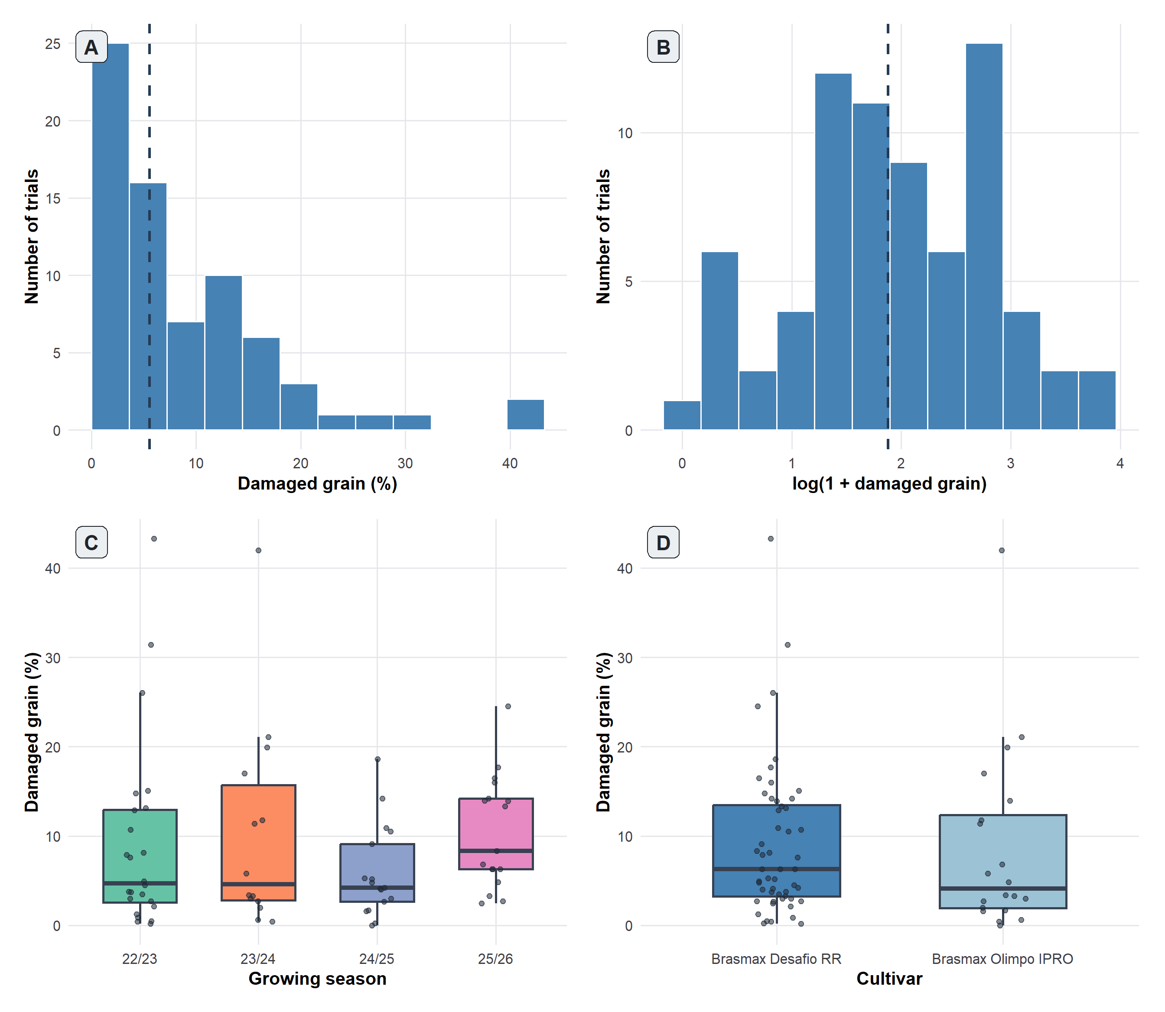
Figure 2. Distribution of damaged-grain percentage across trials, growing seasons, and cultivars. (A) Distribution of observed damaged-grain percentage (DG). (B) Distribution after log transformation, log(1 + DG). Dashed vertical lines indicate the mean in panels A and B. (C) DG distributions by growing season. (D) DG distributions by cultivar. Boxplots show the median and interquartile range, with individual trial observations overlaid.

10 day-interval regression analysis
Log-transformed rainfall provided the clearest broad-interval pattern, although the CR2 process-level evidence was modest (global P = 0.083; incremental R² = 0.257) (Table 1). The largest estimate occurred during −50 to −41 days (+3.40 DG percentage points per one-standard-deviation increase; 95% CI: 1.71 to 5.10), while the adjacent −60 to −51-day estimate was positive but its interval narrowly included zero (Fig. 3A). Process-level evidence was similar after log outcome transformation (P = 0.050) and adjustment for sowing day and cultivar (P = 0.056), but weakened after exclusion of the three high-DG observations (P = 0.313) and with cycle duration and cultivar adjustment (P = 0.110) (Fig. 4A). Leave-one-season-out global P values ranged from 0.224 to 0.560, indicating appreciable season dependence (Fig. 5A).
Relative humidity showed modest process-level evidence (global P = 0.074; incremental R² = 0.270) (Table 1). Positive estimates were supported during −50 to −41 days (+2.55; 95% CI: 0.14 to 4.96) and −20 to −11 days (+4.22; 95% CI: 1.79 to 6.65) (Fig. 3B), but the separated intervals did not define a single continuous temporal region. Global P values ranged from 0.040 to 0.241 across the shared sensitivities and from 0.249 to 0.457 after omitting individual seasons (Figs. 4B and 5B), supporting cautious interpretation.
Maximum temperature also showed a heterogeneous broad-interval pattern (global P = 0.070; incremental R² = 0.250). Higher Tmax was associated with greater DG during −40 to −31 days (+5.16; 95% CI: 1.58 to 8.74) and lower DG during −20 to −11 days (−3.94; 95% CI: −6.79 to −1.08) (Fig. 3C; Table 1). The process-level result was stronger after excluding the three high-DG observations (P = 0.037) but otherwise remained near P = 0.061–0.104 across the prespecified sensitivities; leave-one-season-out values ranged from 0.057 to 0.354. The directional reversal and season dependence limit a simple interpretation.
Minimum temperature provided weaker broad process-level evidence (global P = 0.309; incremental R² = 0.185). Supported interval estimates were positive during −70 to −61 days (+6.27; 95% CI: 1.85 to 10.68) and negative during −30 to −21 days (−3.70; 95% CI: −7.35 to −0.04) (Fig. 3D; Table 1). Global P values ranged from 0.103 to 0.330 across shared sensitivities and from 0.423 to 0.704 after individual season omissions, providing limited support for a stable broad-interval Tmin process.
Table 1. Summary of the primary 10-day interval regression models. Global P values are from CR2 cluster-robust Wald-type F tests with approximate Hotelling T² correction using 36 ERA5 grid-cell-by-season clusters. Interval effects are DG percentage-point differences per one-standard-deviation increase in the corresponding weather summary, with CR2/Satterthwaite 95% confidence intervals. Incremental R² is the in-sample increase over the season-only model.
Variable | Primary global P; incremental R² | Supported interval(s) and effect on DG (95% CR2 CI) | Shared sensitivity global P | LOSO global P range
Log rainfall | 0.083; 0.257 | −50 to −41: +3.40 (1.71, 5.10) | log(DG): 0.050  Exclude high DG: 0.313  Sowing day + cultivar: 0.056  Cycle duration + cultivar: 0.110 | 0.224–0.560
Relative humidity | 0.074; 0.270 | −50 to −41: +2.55 (0.14, 4.96)  −20 to −11: +4.22 (1.79, 6.65) | log(DG): 0.040  Exclude high DG: 0.240  Sowing day + cultivar: 0.074  Cycle duration + cultivar: 0.133 | 0.249–0.457
Maximum temperature | 0.070; 0.250 | −40 to −31: +5.16 (1.58, 8.74)  −20 to −11: −3.94 (−6.79, −1.08) | log(DG): 0.061  Exclude high DG: 0.037  Sowing day + cultivar: 0.070  Cycle duration + cultivar: 0.104 | 0.057–0.354
Minimum temperature | 0.309; 0.185 | −70 to −61: +6.27 (1.85, 10.68)  −30 to −21: −3.70 (−7.35, −0.04) | log(DG): 0.103  Exclude high DG: 0.330  Sowing day + cultivar: 0.228  Cycle duration + cultivar: 0.326 | 0.423–0.704

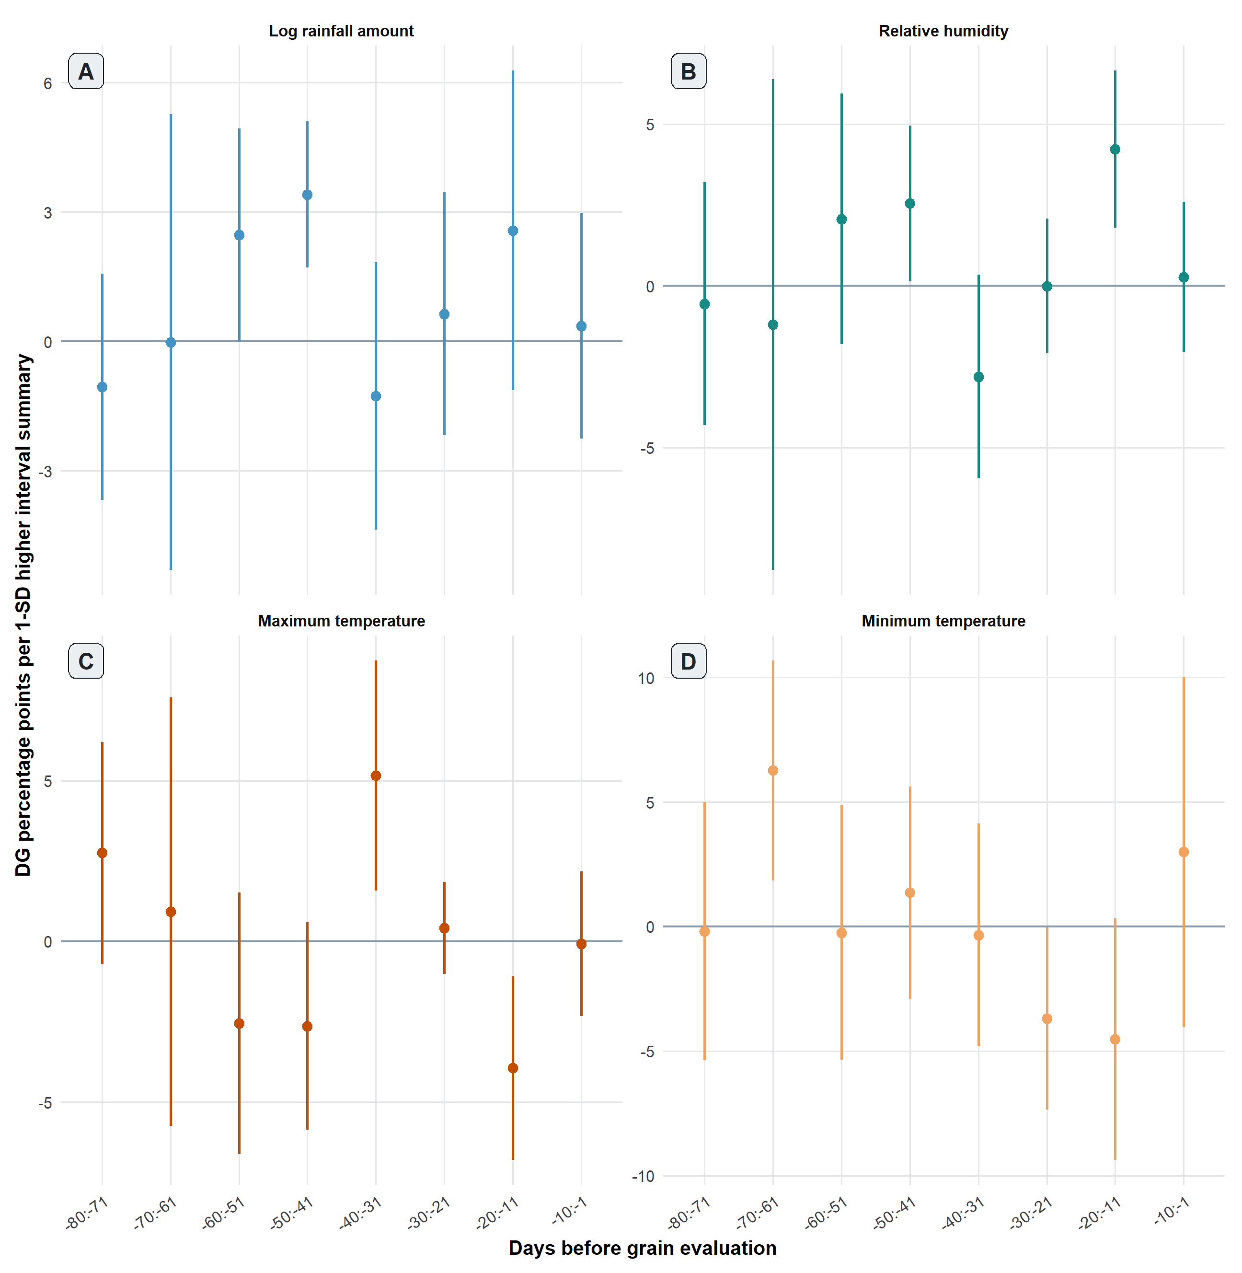
Figure 3. Associations between weather conditions during eight prespecified 10-day intervals and damaged-grain percentage (DG). Points are interval-specific coefficients and vertical lines are CR2/Satterthwaite 95% confidence intervals from separate season-adjusted models for (A) log-transformed rainfall, (B) relative humidity, (C) maximum temperature, and (D) minimum temperature. All eight standardized interval summaries for a process were entered simultaneously. Coefficients are DG percentage-point differences per one-standard-deviation increase, conditional on season and the other seven intervals of the same process.

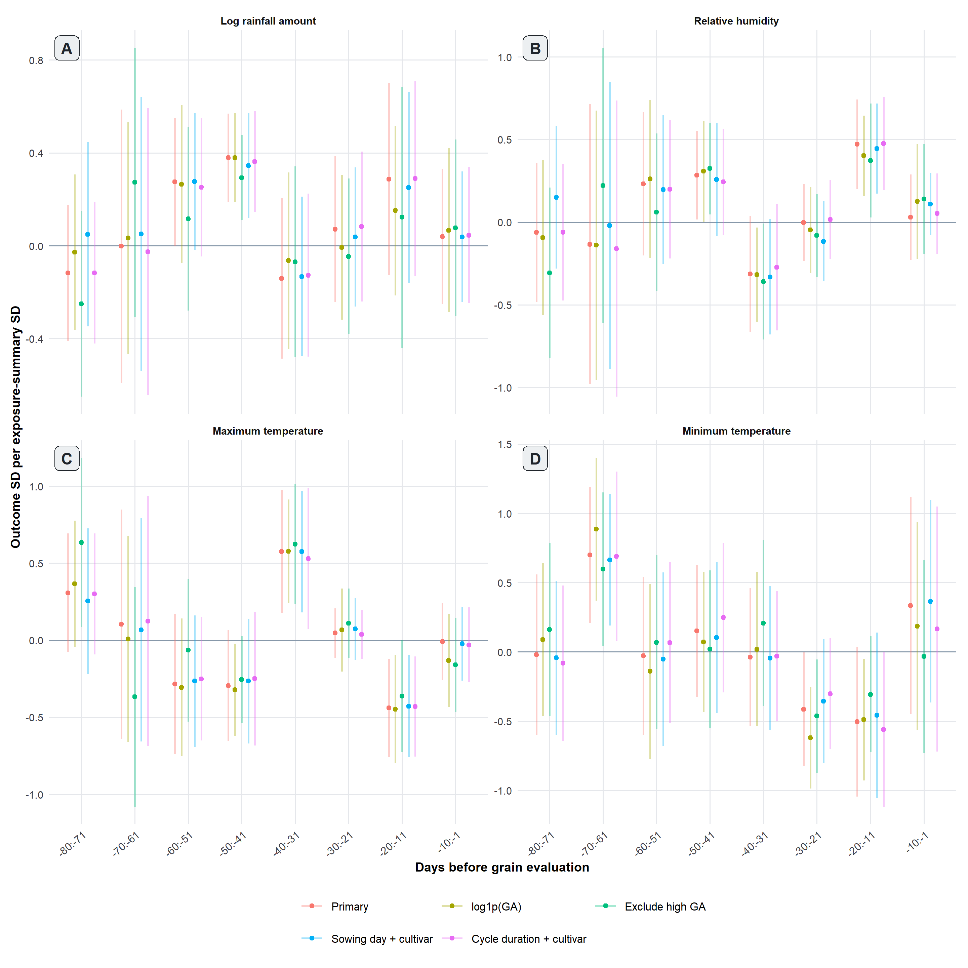
Figure 4. Sensitivity of the eight 10-day interval estimates to alternative specifications. Points are standardized coefficients and lines are CR2/Satterthwaite 95% confidence intervals for log(1 + DG), exclusion of the three high-DG observations, sowing-day-plus-cultivar adjustment, and cycle-duration-plus-cultivar adjustment. Coefficients are expressed as outcome standard deviations per one-standard-deviation increase in the interval summary.

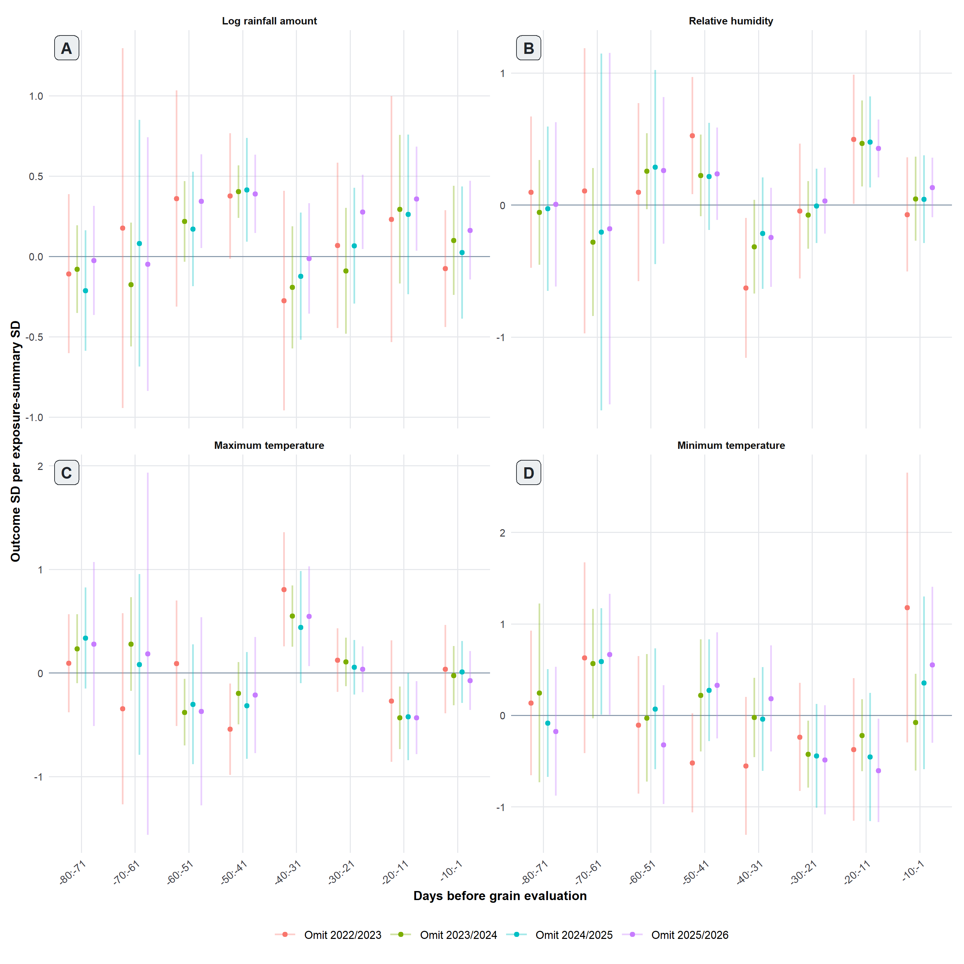
Figure 5. Leave-one-season-out stability of the eight 10-day interval estimates. Points are standardized coefficients and lines are CR2/Satterthwaite 95% confidence intervals after omitting the indicated season. Coefficients are outcome standard deviations per one-standard-deviation increase in the interval weather summary.

Scalar-on-function analysis
The scalar-on-function analysis provided the strongest process-level evidence for log-transformed rainfall (global P = 0.011; incremental R² = 0.153) (Fig. 6A; Table 2). The simultaneous confidence band excluded zero approximately from −59 to −38 days. Positive integrated contrasts occurred during −60 to −51 days (+4.08; 95% bootstrap CI: 1.44 to 5.72), −50 to −41 days (+4.81; 2.54 to 6.88), and −40 to −31 days (+4.45; 1.19 to 8.21). Process-level evidence remained under outcome transformation (P = 0.045), sowing-day-plus-cultivar adjustment (P = 0.043), and cycle-duration-plus-cultivar adjustment (P = 0.026), but weakened after excluding high-DG observations (P = 0.122). Leave-one-season-out P values ranged from 0.005 to 0.116, showing variable strength despite a recognizable broad coefficient shape (Figs. 7A and 8A).
Relative humidity showed suggestive functional evidence (global P = 0.057; incremental R² = 0.103) (Fig. 6B; Table 2). Its integrated contrast for −50 to −41 days was positive (+2.13; 95% bootstrap CI: 0.36 to 3.51), but the simultaneous confidence band included zero throughout the domain. Global P values ranged from 0.135 to 0.276 across shared sensitivities except in the primary analysis, and from 0.037 to 0.392 across season omissions (Figs. 7B and 8B). The evidence therefore did not support a consistently resolved smooth RH trajectory.
Maximum temperature showed little evidence of a coherent functional association (global P = 0.463; incremental R² = 0.057) (Fig. 6C; Table 2). Neither the simultaneous band nor any integrated 10-day contrast excluded zero. Global P values ranged from 0.341 to 0.829 across shared sensitivities and from 0.307 to 0.780 across season omissions (Figs. 7C and 8C). Thus, the opposing Tmax estimates in the interval model were not reproduced as a supported smooth temporal pattern.
Minimum temperature showed positive functional regions earlier and negative regions later in the domain, but the process-level evidence was uncertain (global P = 0.112; incremental R² = 0.151) (Fig. 6D; Table 2). Positive integrated contrasts occurred during −70 to −61 (+4.43; 95% bootstrap CI: 2.13 to 6.83) and −60 to −51 days (+3.91; 1.32 to 6.69), with negative contrasts during −30 to −21 (−3.66; −5.90 to −1.51) and −20 to −11 days (−3.36; −5.48 to −1.61). The simultaneous band excluded zero approximately during −69 to −56 and −27 to −14 days. Nevertheless, global evidence weakened across sensitivities (P = 0.070–0.259) and season omissions (P = 0.160–0.331), so the temporal reversal remains a secondary, unstable hypothesis.
Table 2. Summary of the primary scalar-on-function models. Global P values are from CR2 cluster-robust Wald-type F tests with approximate Hotelling T² correction using 36 ERA5 grid-cell-by-season clusters. Integrated contrasts are DG percentage-point differences for a one-standard-deviation higher process across the complete 10-day interval; 95% intervals are percentile cell-by-season cluster-bootstrap intervals. Incremental R² is the in-sample increase over the season-only model.
Variable | Primary global P; incremental R² | Supported integrated interval(s) and contrast (95% bootstrap CI) | Shared sensitivity global P | LOSO global P range
Log rainfall | 0.011; 0.153 | −60 to −51: +4.08 (1.44, 5.72)  −50 to −41: +4.81 (2.54, 6.88)  −40 to −31: +4.45 (1.19, 8.21) | log(DG): 0.045  Exclude high DG: 0.122  Sowing day + cultivar: 0.043  Cycle duration + cultivar: 0.026 | 0.005–0.116
Relative humidity | 0.057; 0.103 | −50 to −41: +2.13 (0.36, 3.51) | log(DG): 0.250  Exclude high DG: 0.276  Sowing day + cultivar: 0.147  Cycle duration + cultivar: 0.135 | 0.037–0.392
Maximum temperature | 0.463; 0.057 | No integrated contrast with 95% CI excluding zero | log(DG): 0.341  Exclude high DG: 0.368  Sowing day + cultivar: 0.829  Cycle duration + cultivar: 0.476 | 0.307–0.780
Minimum temperature | 0.112; 0.151 | −70 to −61: +4.43 (2.13, 6.83)  −60 to −51: +3.91 (1.32, 6.69)  −30 to −21: −3.66 (−5.90, −1.51)  −20 to −11: −3.36 (−5.48, −1.61) | log(DG): 0.070  Exclude high DG: 0.259  Sowing day + cultivar: 0.183  Cycle duration + cultivar: 0.113 | 0.160–0.331

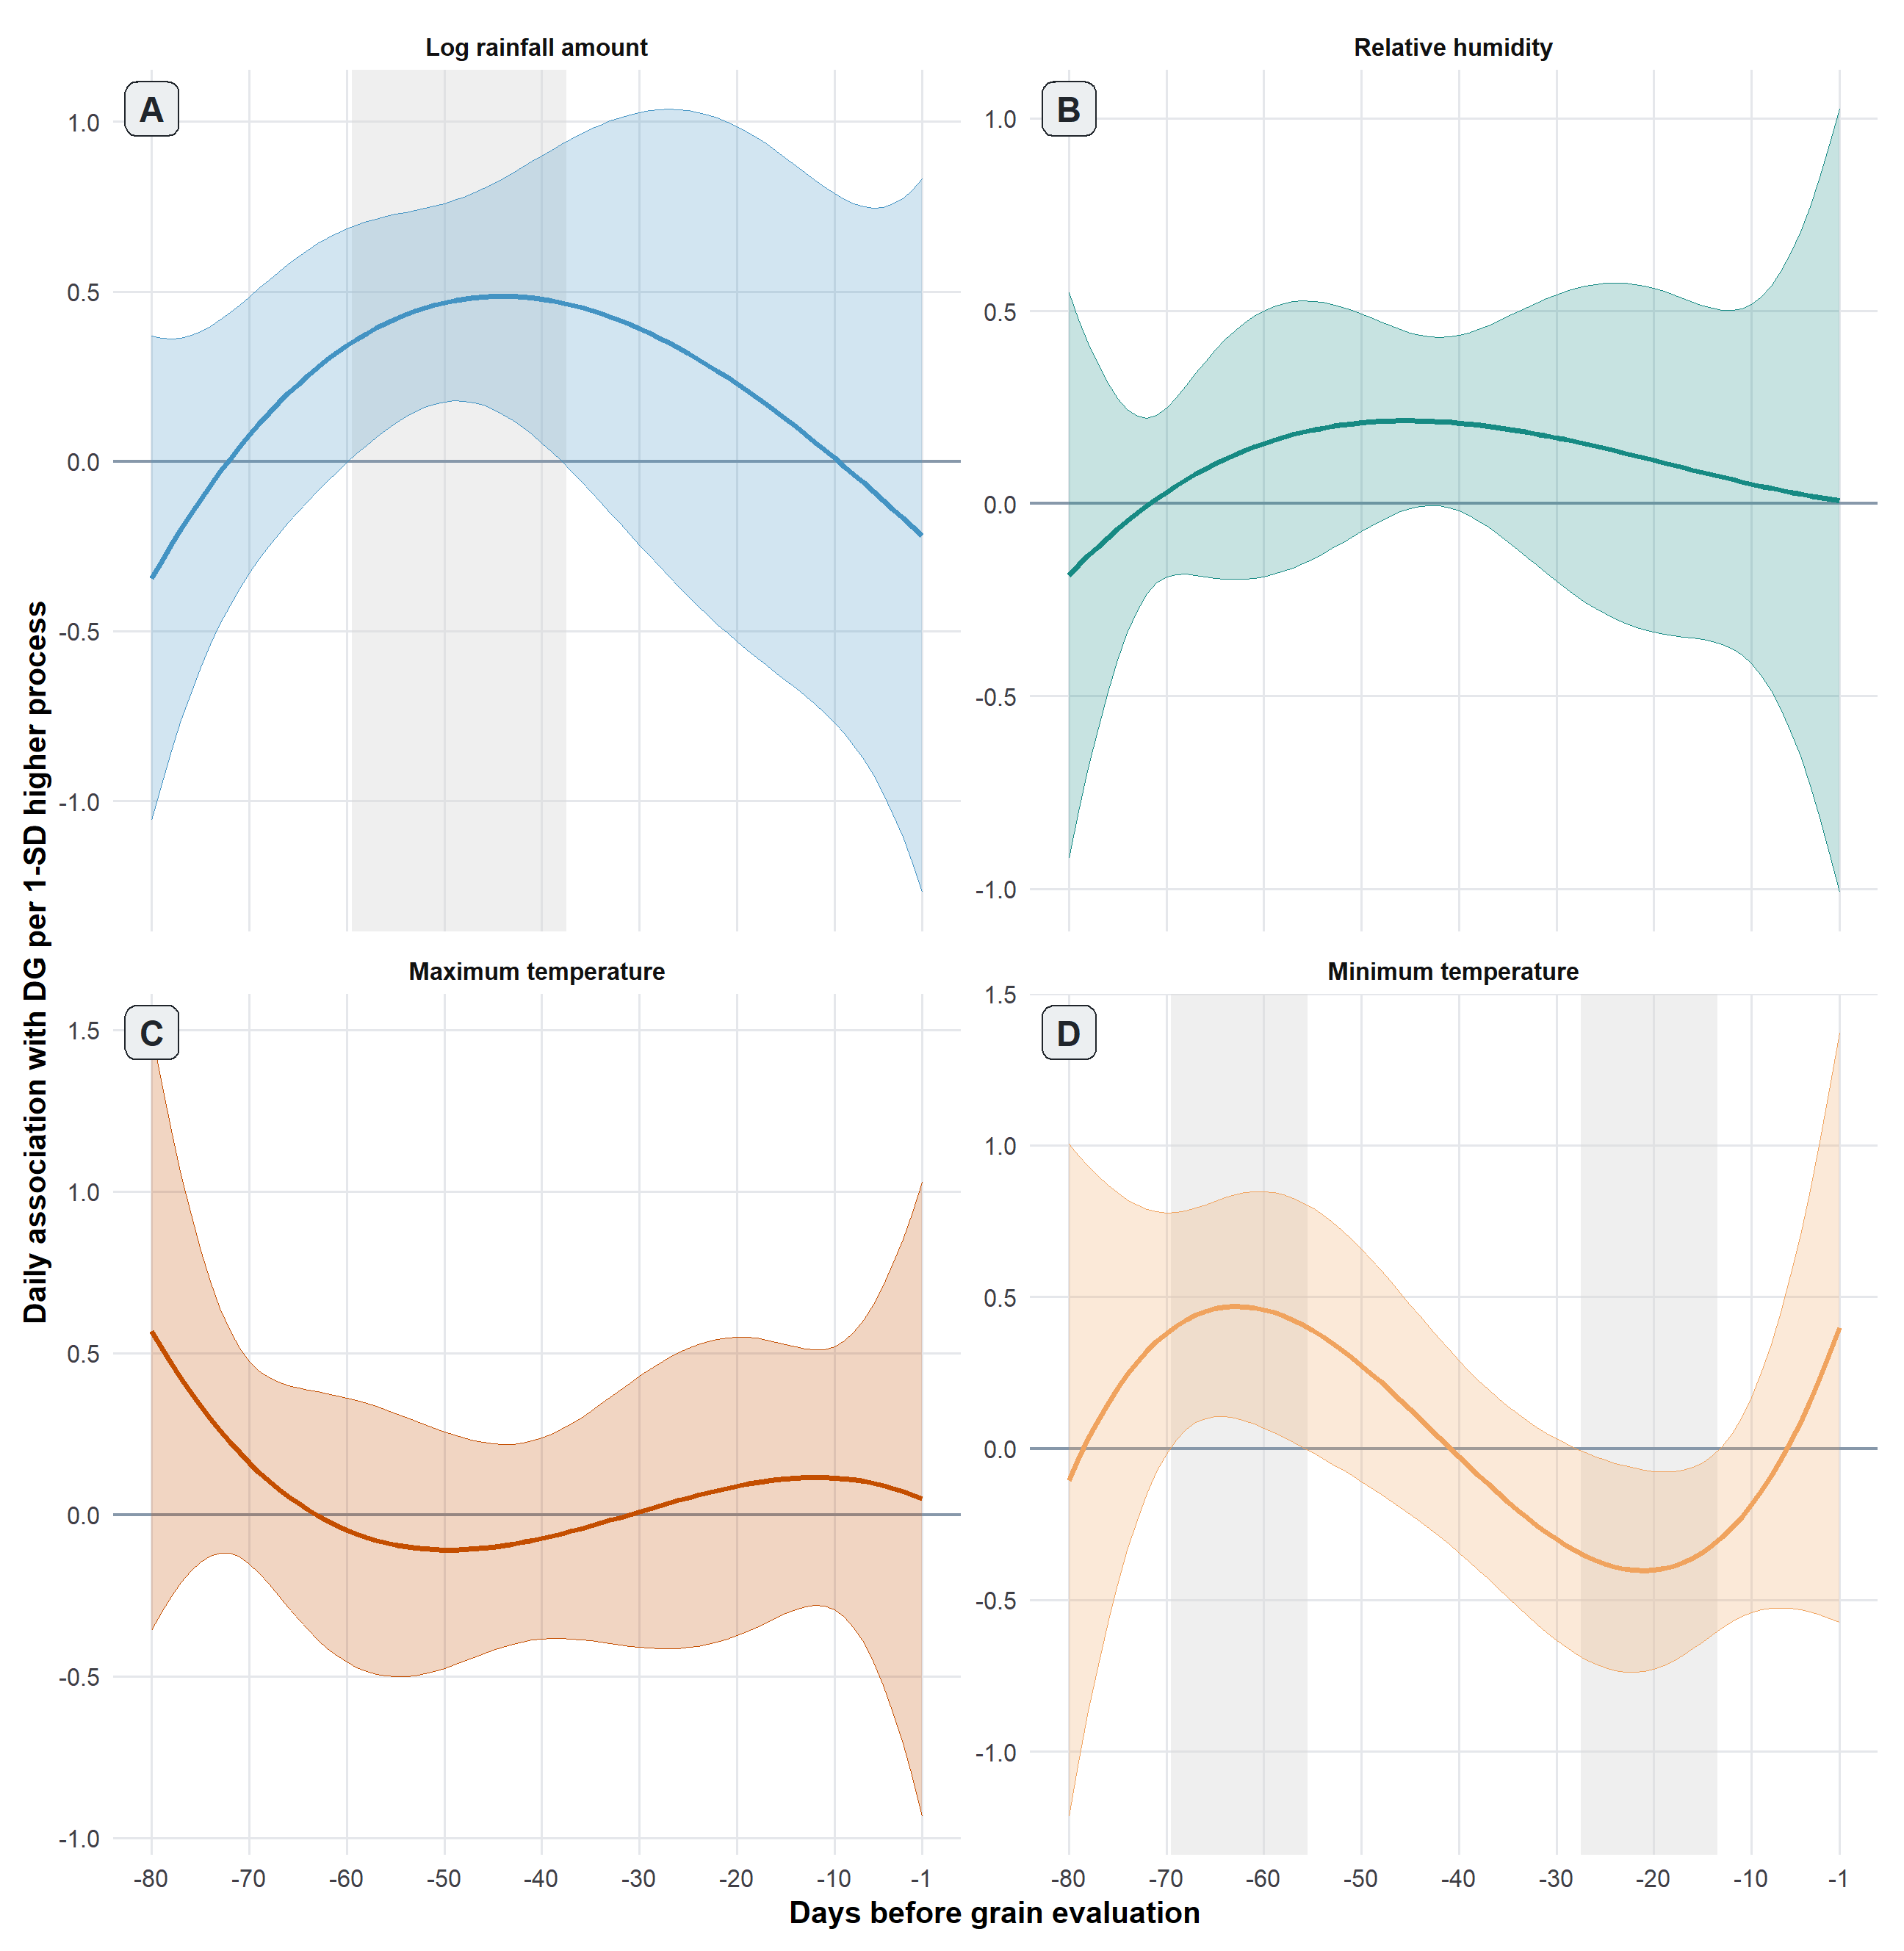
Figure 6. Primary low-dimensional scalar-on-function associations. Curves are scaled per one overall standard deviation of the daily process. Grey ribbons are 95% simultaneous confidence bands obtained from 999 season-stratified ERA5 grid-cell-by-season cluster-bootstrap samples.
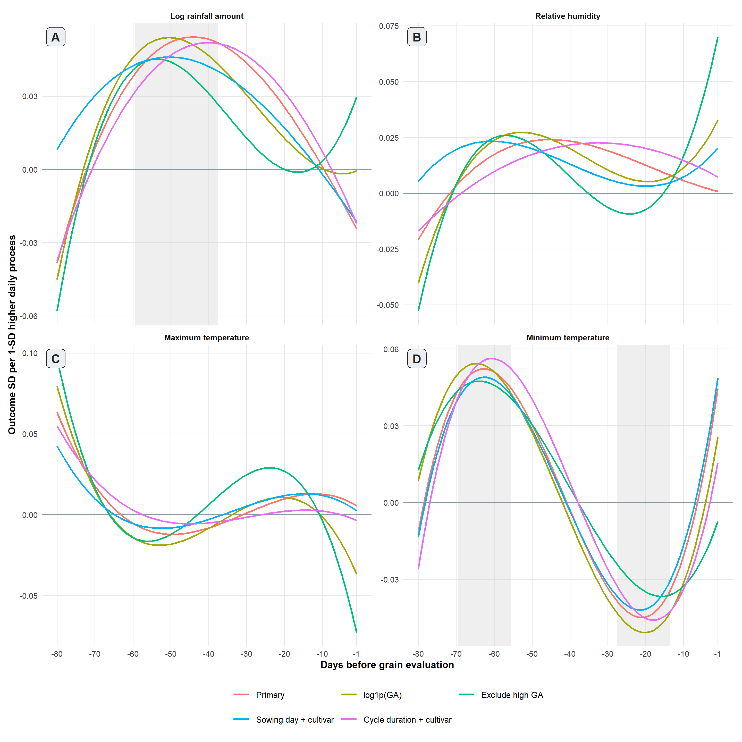
Figure 7. Continuous scalar-on-function sensitivity analyses. The red line is the primary fit and its grey ribbon is the primary 95% simultaneous cell-by-season cluster-bootstrap band. Colored lines show refits using log(1 + DG), exclusion of the three high-DG observations, sowing-day-plus-cultivar adjustment, or cycle-duration-plus-cultivar adjustment. Coefficients are standardized within each analysis.
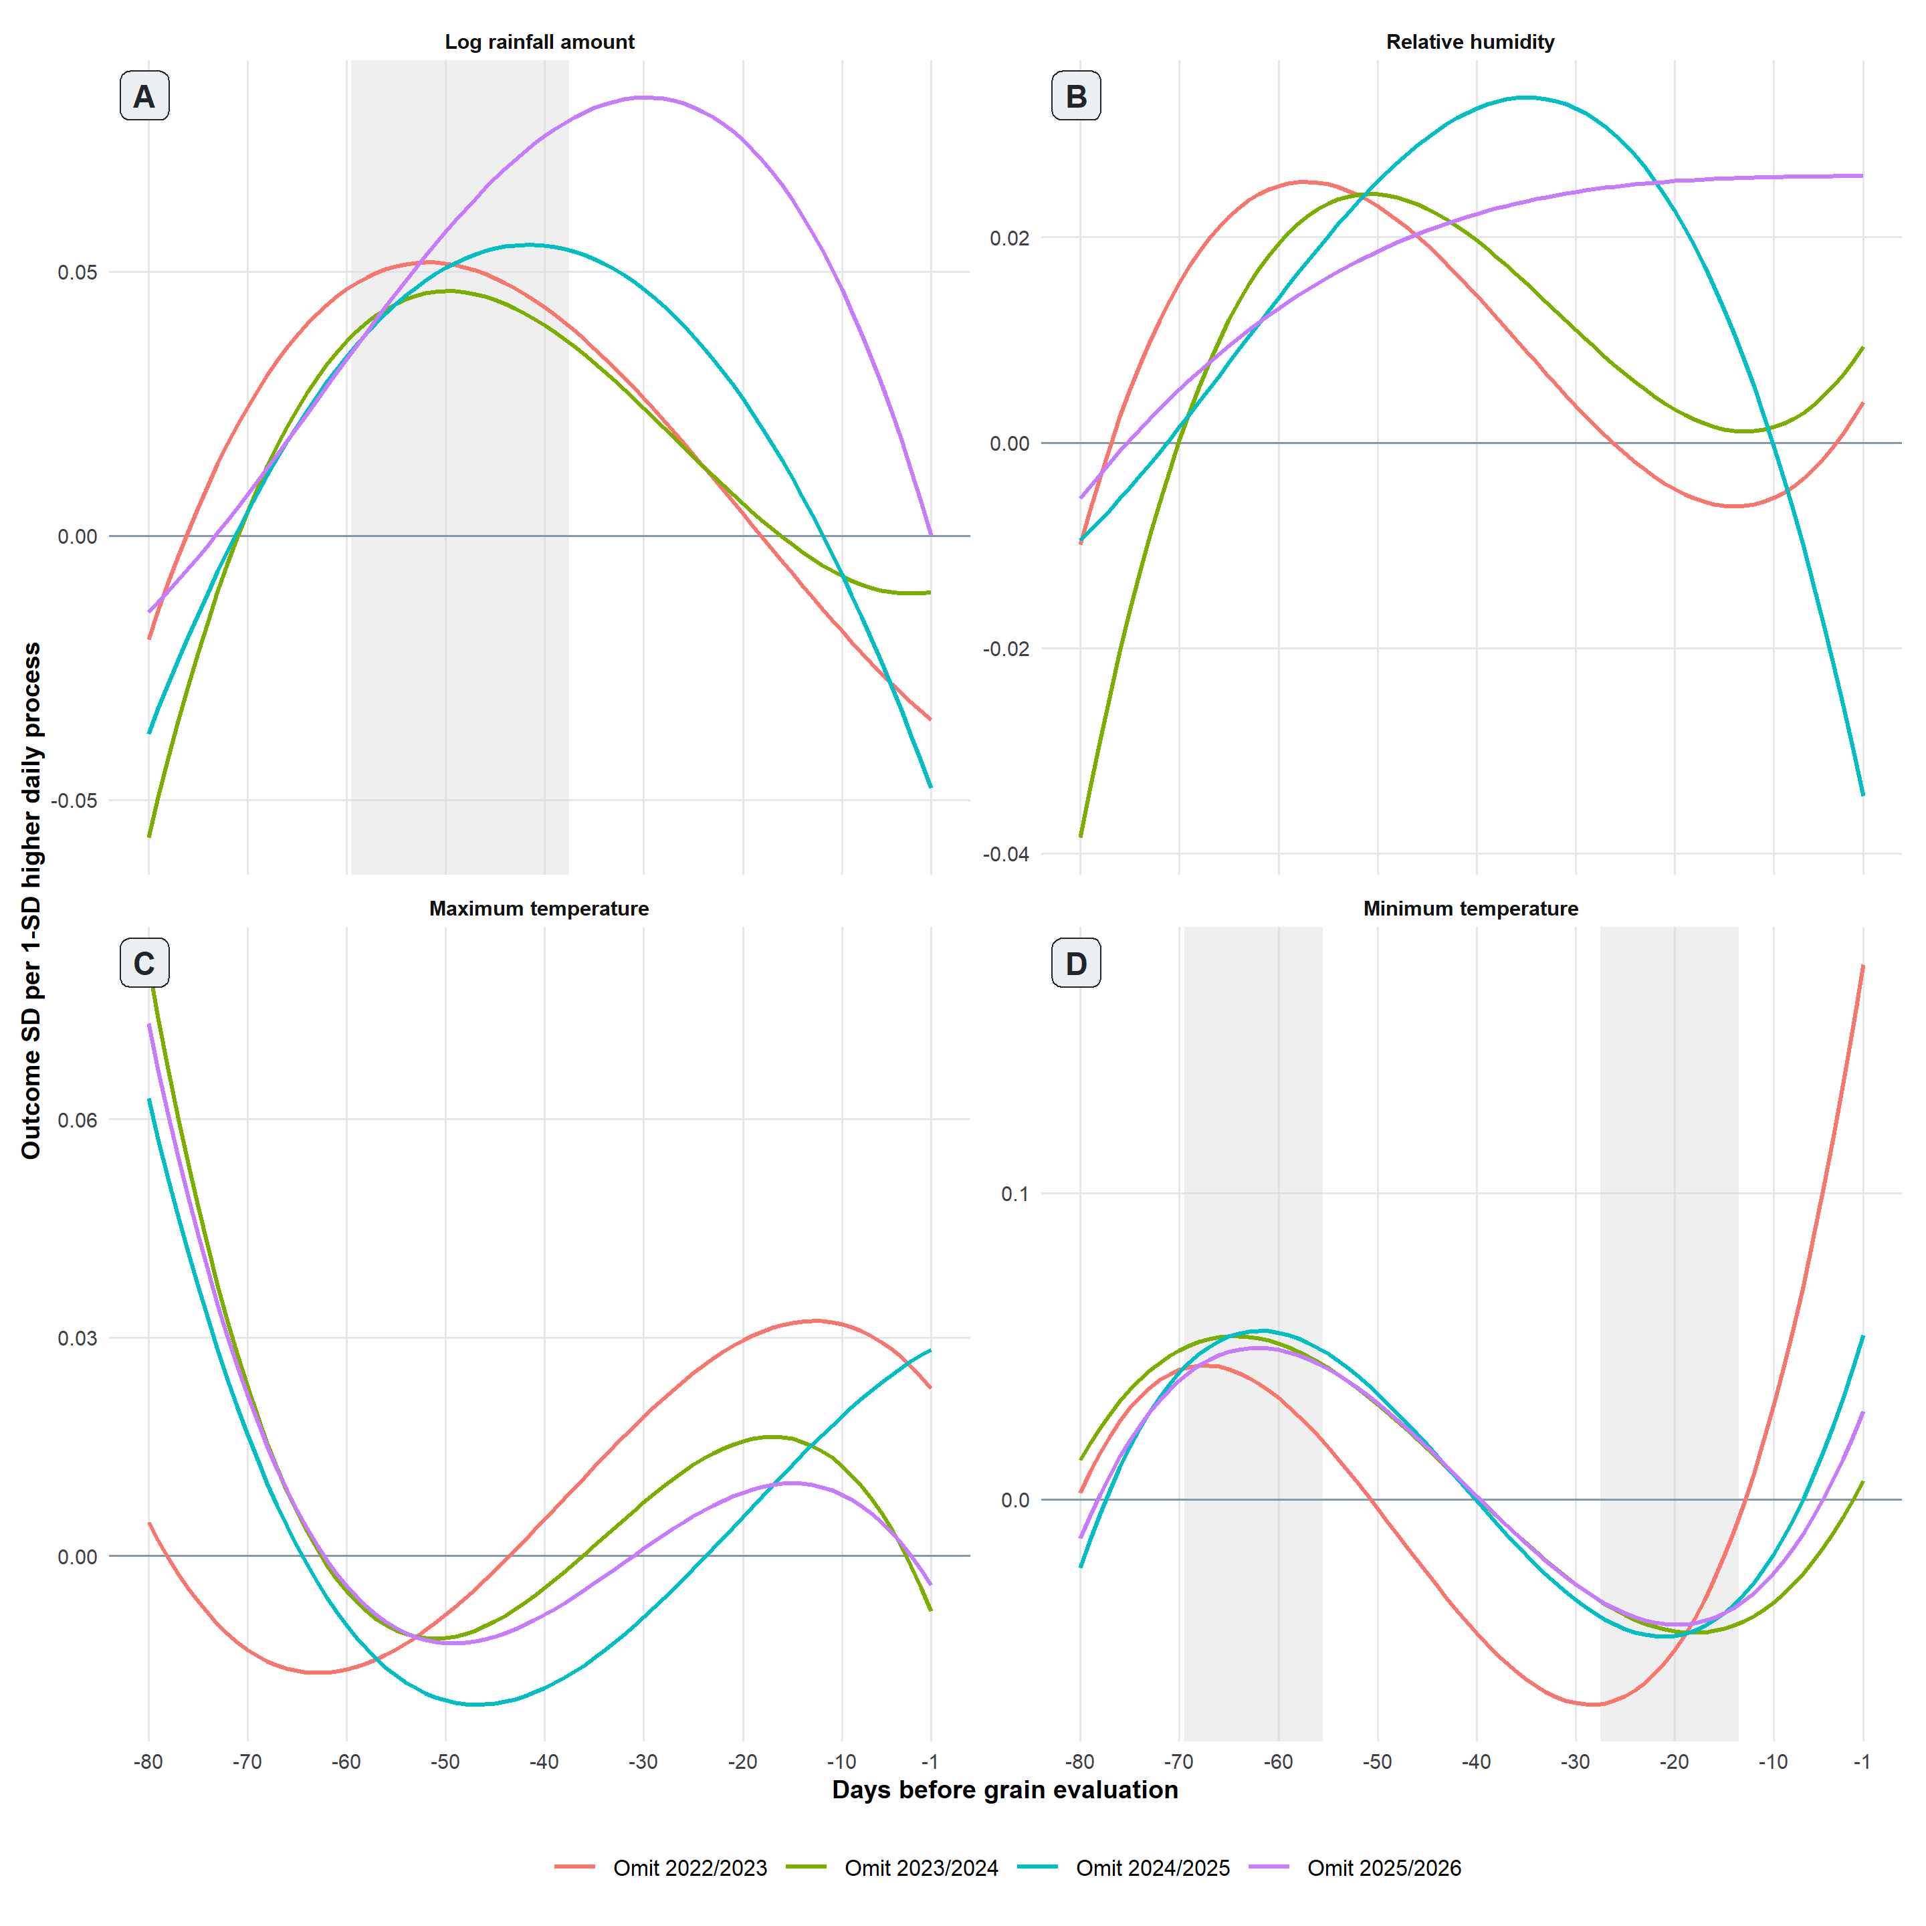
Figure 8. Continuous scalar-on-function leave-one-season-out analysis. Colored lines show the coefficient function after omitting one growing season. The grey ribbon is the primary 95% simultaneous confidence band obtained from 999 season-stratified ERA5 grid-cell-by-season cluster-bootstrap samples.

Cross-method concordance
Log-transformed rainfall showed the strongest concordance between the broad-interval and scalar-on-function analyses. Both approaches identified positive estimates centered approximately 60 to 40 days before grain evaluation, while functional integrated contrasts extended through −31 days. The largest estimate in each analysis occurred during −50 to −41 days: +3.40 DG percentage points in the broad model and +4.81 for the functional integrated contrast, after their analysis-specific standardization. The values are not identical estimands, but they agree in direction and temporal location. The REML-penalized sensitivity retained similar process-level evidence (P = 0.020; incremental R² = 0.149) and positive integrated contrasts from −60 to −31 days (Figs. S6 and S7), indicating that the rainfall pattern was not dependent on the absence of penalization.
Minimum temperature showed secondary cross-method agreement in the direction and timing of selected interval contrasts: positive estimates earlier and negative estimates later in the domain. The penalized functional model retained positive contrasts during −70 to −51 days and a negative contrast during −20 to −11 days (Fig. S7). However, broad and functional CR2 process-level tests were uncertain (P = 0.309 and 0.112), the penalized model reduced the effective degrees of freedom and had a simultaneous band including zero throughout the domain, and leave-one-season-out evidence was weak. Tmin should therefore be regarded as a secondary temporal hypothesis, not a reproducible process-level association.

Residual diagnostics
Residual diagnostics showed similar patterns for the prespecified 10-day interval and scalar-on-function models (Figs. S2–S5). In the normal Q–Q plots, standardized residuals followed the reference line reasonably closely through the central portion of the distribution, with the clearest departures occurring in the upper tail (Figs. S3 and S5). A small number of large positive residuals indicated substantial underestimation of DG in several high-damage trials, suggesting that departures from normality were concentrated mainly among the most severe outcomes. Residual-versus-fitted plots showed most observations centered around zero, but suggested increasing dispersion with fitted DG in several models and some curvature in the smoothed residual trends (Figs. S2 and S4). These patterns are consistent with possible nonconstant variance and some limitation in the fitted mean structure, although behavior near the extremes was informed by relatively few observations. Overall, the diagnostics indicated that the models represented typical DG outcomes better than the most severe cases.

Discussion
The most consistent result was a broad rainfall-associated retrospective period centered approximately 60 to 40 days before grain evaluation. The temporal location agreed between the prespecified interval and scalar-on-function analyses, although the clustered global test was stronger for the functional model than for the interval model. Minimum temperature showed a secondary reversal from positive estimates earlier to negative estimates later in the domain, but global and leave-one-season-out evidence was weaker. Relative humidity and maximum temperature were not reproduced as coherent smooth trajectories.
The rainfall pattern is consistent with previous observations from tropical Brazil. Lehner et al. (2025) reported approximately 1.7-fold greater cumulative precipitation during the reproductive stage in a late-planted soybean trial that also developed substantially more damaged grains. Our analysis adds temporal resolution by locating the strongest association approximately 60 to 40 days before grain evaluation. Rainfall can promote splash dispersal, prolong surface wetness, and favor fungal infection or colonization; work with the Diaporthe complex has shown dispersal from infected debris and latent infection of immature soybean tissues (Kmetz et al. 1979), and field studies have linked moisture during pod filling and maturation with later seed infection and decay (Shortt et al. 1981; TeKrony et al. 1983). Nevertheless, intermediate phenology, canopy wetness, pathogen abundance, and infection were not measured here. The retrospective lags therefore cannot be labeled as a specific crop stage or infection window, and the association should be interpreted as a broader moisture-related hypothesis.
The Tmin contrasts suggest a possible time-dependent thermal pattern, but the evidence is less secure than for rainfall. Warm nights can reduce soybean seed germination and vigor and alter seed composition during development (Gibson and Mullen 1996; Keigley and Mullen 1986; Chebrolu et al. 2016; Krishnan et al. 2020), while Diaporthe infection is temperature dependent and may interact with moisture availability (Rupe 1990; Rupe and Ferriss 1987). These mechanisms provide biological context but do not validate the observed lag pattern. The uncertain process-level tests, attenuation under penalization, and season dependence mean that the early positive and later negative Tmin contrasts should be treated as hypotheses for prospective evaluation rather than as evidence of a demonstrated stage-dependent sequence.
A strength of this study was the use of a continuous DG response, preserving quantitative variation and allowing associations to be expressed in percentage points. Combining eight prespecified 10-day intervals with a low-dimensional scalar-on-function model constrained temporal complexity while providing complementary temporal views. Dependence among trials sharing an ERA5 grid cell within a season was addressed through CR2 clustered inference and cluster bootstrap rather than by treating all trial records as meteorologically independent.
Several limitations remain. The 72 trials represented only four growing seasons and 36 ERA5 grid-cell-by-season clusters, limiting precision for resolving subtle nonlinearities, interactions, or cultivar-specific patterns. Gridded ERA5 weather may not reproduce canopy-level temperature, humidity, rainfall exposure, or surface wetness. The operational date anchor required a uniform 20-day correction based on field clarification, and intermediate phenological observations were unavailable; the same retrospective lag may therefore correspond to different crop ages among trials. The sparse upper tail of DG also materially informed the rainfall association, as shown by attenuation after exclusion of the three high-DG observations. Finally, DG is a syndromic endpoint that may combine pathogen infection, latent colonization, physiological deterioration, and other grain defects. Although Diaporthe ueckeri and D. longicolla can reproduce pod and grain rot symptoms (Nascimento et al. 2025), diverse fungal taxa occur in symptomatic and asymptomatic tissues (Ramos et al. 2026); the present associations cannot be attributed to a single causal agent.
Overall, the data support a temporally structured rainfall-associated pattern rather than a sharply defined infection window or causal mechanism. The most defensible candidate region extends approximately 60 to 40 days before corrected grain evaluation, with functional evidence extending through −31 days. Temperature and relative humidity patterns were less stable, and the Tmin reversal remains secondary. Prospective field studies with measured phenology, canopy microclimate, pathogen dynamics, and a larger number of independent seasons are needed to test whether the rainfall-associated temporal region is reproducible and epidemiologically informative.

Artificial intelligence use declaration
Generative and agentic artificial intelligence tools (OpenAI ChatGPT/Codex) were used as part of the computational workflow to assist in exploring analytical strategies, generating and revising R code, implementing candidate models, conducting exploratory and diagnostic analyses, and summarizing computational outputs. The AI tools were used iteratively to expand and interrogate the analytical space rather than to determine the scientific objectives or make final analytical decisions. The authors defined the research questions and analytical constraints, evaluated alternative approaches, selected the analyses reported in the manuscript, and interpreted the results. All AI-generated code and analytical outputs used in the study were inspected, verified, and, where necessary, modified by the authors. Final reported analyses were reproduced from the validated analysis scripts, and the authors take full responsibility for the methods, results, and conclusions.

Authors contribution statement
IFE: Formal analysis; Writing – original draft. CVG: Data curation; Project administration; Writing – review & editing. ALFN: Data curation; Writing – review & editing. EMD: Project administration; Formal analysis; Writing – original draft; Writing – review & editing. All other authors: Resources; Writing – review & editing.

Acknowledgements
IFE is thankful to CAPES (Financial code 001) for the scholarship and Banco Central do Brasil/ Embrapa for the support via the project Monitor Proagro number 10.25.00.157.00.00. EMD is thankful to CNPq for a productivity research fellowship (312882/2023-8).

References
Balducchi, A. J., & McGee, D. C. (1987). Environmental factors influencing infection of soybean seeds by Phomopsis and Diaporthe species during seed maturation. Plant Disease, 71(3), 209–212. https://doi.org/10.1094/PD-71-0209
Belufi, L. M. de R., Godoy, C. V., Lopes, I. de O. N., Utiamada, C. M., Meyer, M. C., Campos, H. D., Tomen, A., Ramos, D. T., Wruck, D. S. M., Moreira, E. N., Gheno, E. A., Constantino, E. J., Siqueri, F., Tavares, G. de O., Cacique, I. S., Araújo Júnior, I. P., Santos, J. dos, Gomes, L. M. M. R., Lima, L. A. de S., Sichocki, D., Dan, H. de A., Goussain Júnior, M. M., Camargo, M. P. de, Müller, M. A., Porto, V. B. C., Galbieri, R., & Bonaldo, S. M. (2026). Eficácia de fungicidas para o controle da podridão de vagens e de grãos da soja, na safra 2025/2026: Resultados sumarizados dos ensaios cooperativos (Séries Técnicas Fitossanidade Tropical, Comunicado Técnico nº 6). Rede Fitossanidade Tropical. https://doi.org/10.47328/stft.v1i24327
Belufi, L. M. de R., Tomen, A., Wruck, D. S. M., Ramos, D. T., Moreira, E. N., Gheno, E. A., Tavares, G. de O., Constantino, E. J., Siqueri, F., Araújo Júnior, I. P., Cacique, I. S., Ascari, J. P., Goussain Júnior, M. M., Müller, M. A., Galbieri, R., Bonaldo, S. M., Godoy, C. V., Lopes, I. de O. N., Utiamada, C. M., Meyer, M. C., & Campos, H. D. (2024). Eficiência de fungicidas para o controle da podridão de grãos da soja, na safra 2023/2024: Resultados sumarizados dos ensaios cooperativos (Circular Técnica 207). Embrapa Soja.
Belufi, L. M. de R., Tomen, A., Wruck, D. S. M., Ramos, D. T., Moreira, E. N., Gheno, E. A., Tavares, G. de O., Constantino, E. J., Siqueri, F., Araújo Júnior, I. P., Cacique, I. S., Ascari, J. P., Goussain Júnior, M. M., Müller, M. A., Galbieri, R., Bonaldo, S. M., Santos, J. dos, Gomes, L. M. M. R., Bergamin, L. P. P., Bergamin, A. C., Godoy, C. V., Lopes, I. de O. N., Utiamada, C. M., Meyer, M. C., & Campos, H. D. (2025). Eficácia de fungicidas para o controle da podridão de vagens e de grãos da soja, na safra 2024/2025: Resultados sumarizados dos ensaios cooperativos (Circular Técnica 220). Embrapa Soja.
Bender, R., & Lange, S. (2001). Adjusting for multiple testing—when and how? Journal of Clinical Epidemiology, 54, 343–349. https://doi.org/10.1016/S0895-4356(00)00314-0
Brasil. Ministério da Agricultura, Pecuária e Abastecimento. 2007. Instrução Normativa nº 11, de 15 de maio de 2007. Regulamento Técnico da Soja, as amended by Instrução Normativa nº 37, de 27 de julho de 2007.
Brown, E. A., Minor, H. C., & Calvert, O. H. (1987). A soybean genotype resistant to Phomopsis seed decay. Crop Science, 27, 895–898. https://doi.org/10.2135/cropsci1987.0011183X002700050012x
Chebrolu, K. K., Fritschi, F. B., Ye, S., Krishnan, H. B., Smith, J. R., & Gillman, J. D. (2016). Impact of heat stress during seed development on soybean seed metabolome. Metabolomics, 12, 28. https://doi.org/10.1007/s11306-015-0941-1
Dos Santos, G. C., Horn, L. M. L., Casa, R. T., Soardi, K., Lopes, M. A., do Nascimento, S. C., Santi, V. M., da Silva, F. N., Kór, D. G., Gonçalves, M. J., & Gorayeb, E. S. (2024). First report of seed decay caused by Diaporthe ueckeri on soybean in Brazil. Plant Disease, 108(9). https://doi.org/10.1094/PDIS-04-24-0814-PDN
Farias Neto, A. L. de, Oda, M., Kudlawiec, K., Araújo, F. A., Costa, D. A. D., Muniz, F., Tomen, A., Bergamin, A. C., Bergamin, L. P. P., Zulli, M. R., Wruck, D. S. M., Moreira, E. N., Gheno, E. A., Constantino, E. J., Rojas, E. P., Araújo Júnior, I. P., Cacique, I. S., Ascari, J. P., Belufi, L. M. de R., Pittelkow, F. K., Lopes, I. de O. N., Müller, M. A., Lulu, J., Ramos Junior, E. U., Locatelli, M., Amorim, V. A., Resende, N. C. V., & Tavares, G. de O. (2023). Cultivares de soja e épocas de semeadura para reação à podridão de grãos da soja (Documentos 409). Embrapa Cerrados.
Farias Neto, A. L. de, Pego, S. P. S., Lulu, J., Ramos Junior, E. U., Costa, D. A. D., Moreira, E. A., Gheno, E. N., Belufi, L. M. R., Pittelkow, F., Locatelli, M., Bergamin, A. C., Muniz, F., Tomen, A., & Constantino, E. J. (2024). Épocas de semeadura para reação à podridão de grãos da soja. In 39ª Reunião de Pesquisa de Soja: Resumos expandidos (pp. 42–46). Embrapa Soja. (Embrapa Soja. Eventos Técnicos & Científicos, 3).
Gibson, L. R., & Mullen, R. E. (1996). Soybean seed quality reductions by high day and night temperature. Crop Science, 36, 1615–1619. https://doi.org/10.2135/cropsci1996.0011183X003600060034x
Gillen, A. M., Smith, J. R., Mengistu, A., & Bellaloui, N. (2012). Effects of maturity and Phomopsis on germination and vigor of soybean seed of near-isogenic lines. Crop Science, 52, 2757–2766
Goldsmith, J., Bobb, J., Crainiceanu, C. M., Caffo, B., & Reich, D. (2011). Penalized functional regression. Journal of Computational and Graphical Statistics, 20, 830–851.
Keigley, P. J., & Mullen, R. E. (1986). Changes in soybean seed quality from high temperature during seed fill and maturation. Crop Science, 26(6), 1212–1216. https://doi.org/10.2135/cropsci1986.0011183X002600060028x
Kmetz, K. T., Ellett, C. W., & Schmitthenner, A. F. (1979). Soybean seed decay: Sources of inoculum and nature of infection. Phytopathology, 69(8), 798–801. https://doi.org/10.1094/Phyto-69-798
Krishnan, H. B., Kim, W.-S., Oehrle, N. W., Smith, J. R., & Gillman, J. D. (2020). Effect of heat stress on seed protein composition and ultrastructure of protein storage vacuoles in the cotyledonary parenchyma cells of soybean genotypes that are either tolerant or sensitive to elevated temperatures. International Journal of Molecular Sciences, 21, 4775. https://doi.org/10.3390/ijms21134775
Kudlawiec, K., Tomen, A., Bergamin, A. C., Wruck, D. S. M., Moreira, E. N., Gheno, E. A., Poletto, E. M., Constantino, E. J., Rojas, E. P., Araújo Júnior, I. P., Cacique, I. S., Ascari, J. P., Bergamin, L. P. P., Belufi, L. M. de R., Zulli, M. R., Müller, M. A., Bonaldo, S. M., Godoy, C. V., Lopes, I. de O. N., Utiamada, C. M., Meyer, M. C., & Campos, H. D. (2023). Eficiência de fungicidas para o controle da podridão de grãos da soja, na safra 2022/2023: Resultados sumarizados dos ensaios cooperativos (Circular Técnica 197). Embrapa Soja.
Lehner, M. S., Almeida, K. A., Nalin, R. S., Silveira, G. D., Spolti, P., & Mizubuti, E. S. G. (2025). Germplasm and planting date effects on pod and grain rot of soybeans in Mato Grosso State, Brazil. Tropical Plant Pathology, 50, Article 33. https://doi.org/10.1007/s40858-025-00725-0
Lamka, G. L., & McGee, D. C. (1986). Environmental and genetic factors affecting Phomopsis pod infection of soybeans measured at the R6 growth stage. Iowa Seed Science, 8, 2–4.
Mengistu, A., Smith, J. R., Bellaloui, N., Paris, R. L., & Wrather, J. A. (2010). Irrigation and time of harvest effects on evaluation of selected soybean accessions against Phomopsis longicolla. Crop Science, 50(5), 2055–2064. https://doi.org/10.2135/cropsci2009.11.0657
Nascimento, C. R. B., Anjos, R. S., Rosa, R. B., Silva, H. A. O., Leite, I. C. H. L., Sousa, D. Y. X., Lehner, M. S., Diniz, J. M., & Mizubuti, E. S. G. (2025). First report of Diaporthe ueckeri and D. longicolla as the causal agents of pod and grain rot of soybean in Brazil. Plant Disease, 109(2), 506. https://doi.org/10.1094/PDIS-10-24-2255-PDN
Petrović, K., Skaltsas, D., Castlebury, L. A., Kontz, B., Allen, T. W., Chilvers, M. I., Gregory, N., Kelly, H. M., Koehler, A. M., Kleczewski, N. M., Mueller, D. S., Price, P. P., III, Smith, D. L., & Mathew, F. M. (2021). Diaporthe seed decay of soybean [Glycine max (L.) Merr.] is endemic in the United States, but new fungi are involved. Plant Disease, 105(6), 1621–1629. https://doi.org/10.1094/PDIS-03-20-0604-RE
R Core Team. (2025). R: A language and environment for statistical computing. R Foundation for Statistical Computing, Vienna, Austria.
Ramos, L. G., Bonaldo, S. M., Farias, G., dos Santos, C. G. T., de Jesus, J. G., Zanuzo, M. R., & Gilio, T. A. S. (2026). Molecular and phylogenetic identification of fungal taxa associated with soybean anomaly in Brazil. Microbiology Research, 17(8), 159. https://doi.org/10.3390/microbiolres17080159
Ramsay, J. O., & Silverman, B. W. (2005). Functional data analysis. New York, NY: Springer New York. https://doi.org/10.1002/0470013192.bsa239
Rupe, J. C., & Ferriss, R. S. (1986). Effects of pod moisture on soybean seed infection by Phomopsis sp. Phytopathology, 76(3), 273–277. https://doi.org/10.1094/Phyto-76-273
Shortt, B. J., Grybauskas, A. P., Tenne, F. D., & Sinclair, J. B. (1981). Epidemiology of Phomopsis seed decay of soybean in Illinois. Plant Disease, 65(1), 62–64.
TeKrony, D. M., Egli, D. B., Stuckey, R. E., & Balles, J. (1983). Relationship between weather and soybean seed infection by Phomopsis sp. Phytopathology, 73(6), 914–918. https://doi.org/10.1094/Phyto-73-914
Wang, L., Ma, H., Song, L., Shu, Y., & Gu, W. (2012). Comparative proteomics analysis reveals the mechanism of pre-harvest seed deterioration of soybean under high temperature and humidity stress. Journal of Proteomics, 75(7), 2109–2127. https://doi.org/10.1016/j.jprot.2012.01.007
Wasserstein, R. L., Schirm, A. L., & Lazar, N. A. (2019). Moving to a world beyond “p < 0.05.” The American Statistician, 73(sup1), 1–19. https://doi.org/10.1080/00031305.2019.1583913⁠
Westgate, M. E., Schussler, J. R., Reicosky, D. C., & Brenner, M. L. (1989). Effect of water deficits on seed development in soybean. II. Conservation of seed growth rate. Plant Physiology, 91, 980–985. https://doi.org/10.1104/pp.91.3.980

Supplementary materials

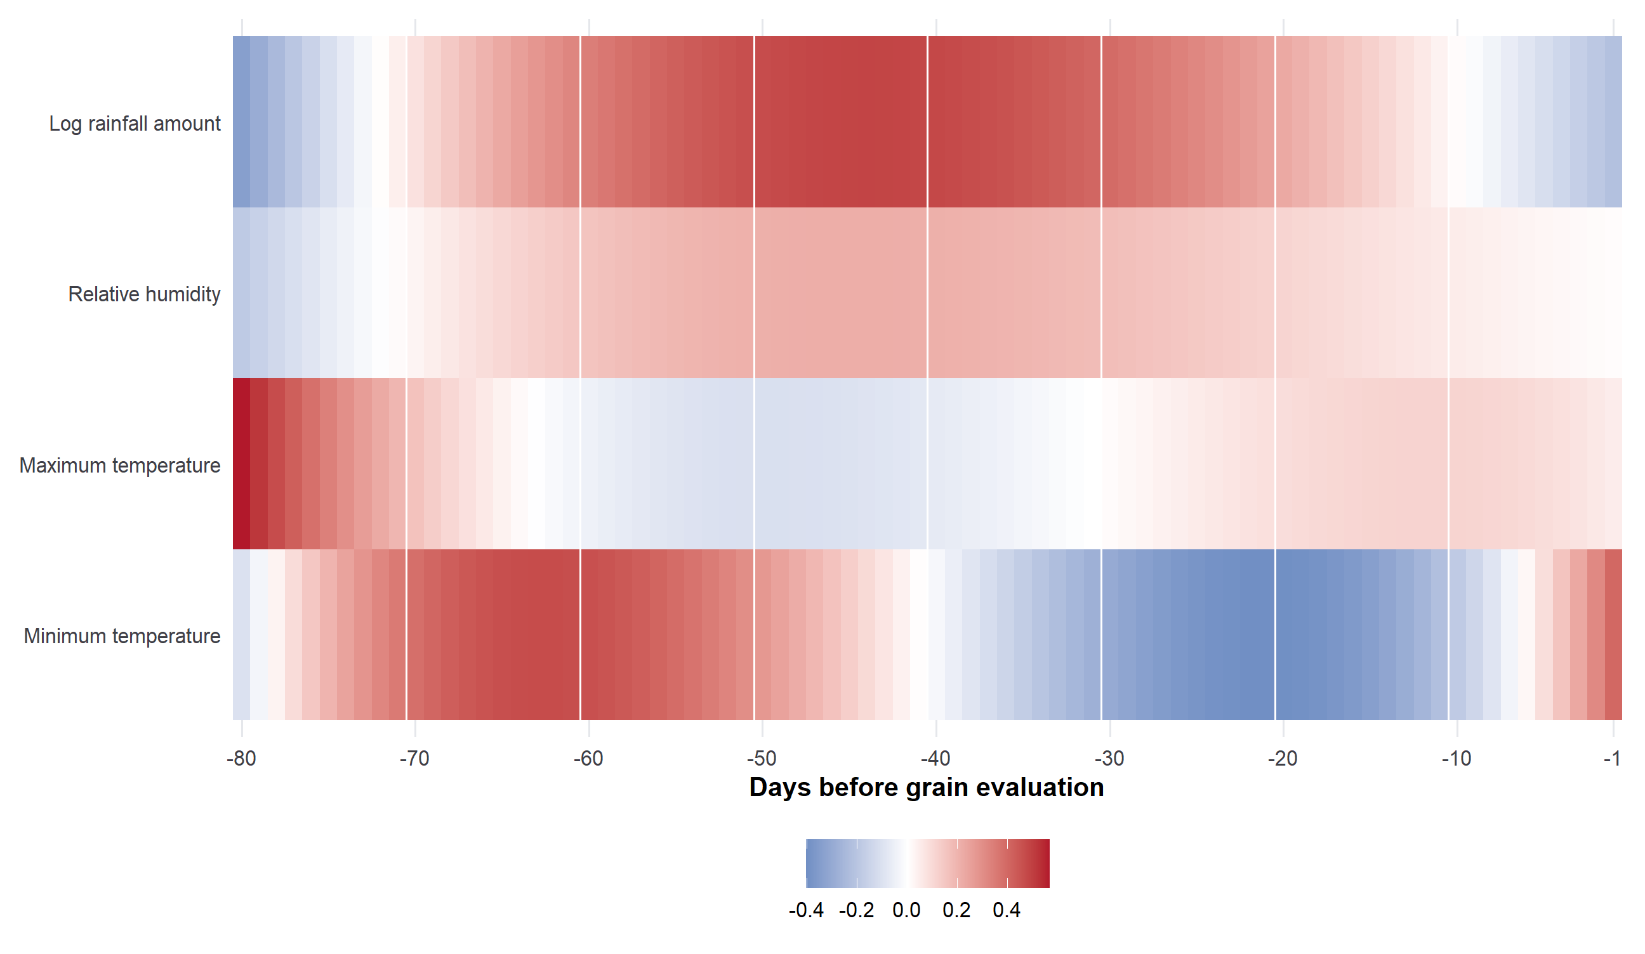
Figure S1. Temporal heatmap of primary scalar-on-function coefficient estimates. Rows are separate season-adjusted models and columns are days from 80 to 1 before the corrected grain-evaluation date. Coefficients are DG percentage points per one overall standard deviation of the corresponding daily process.

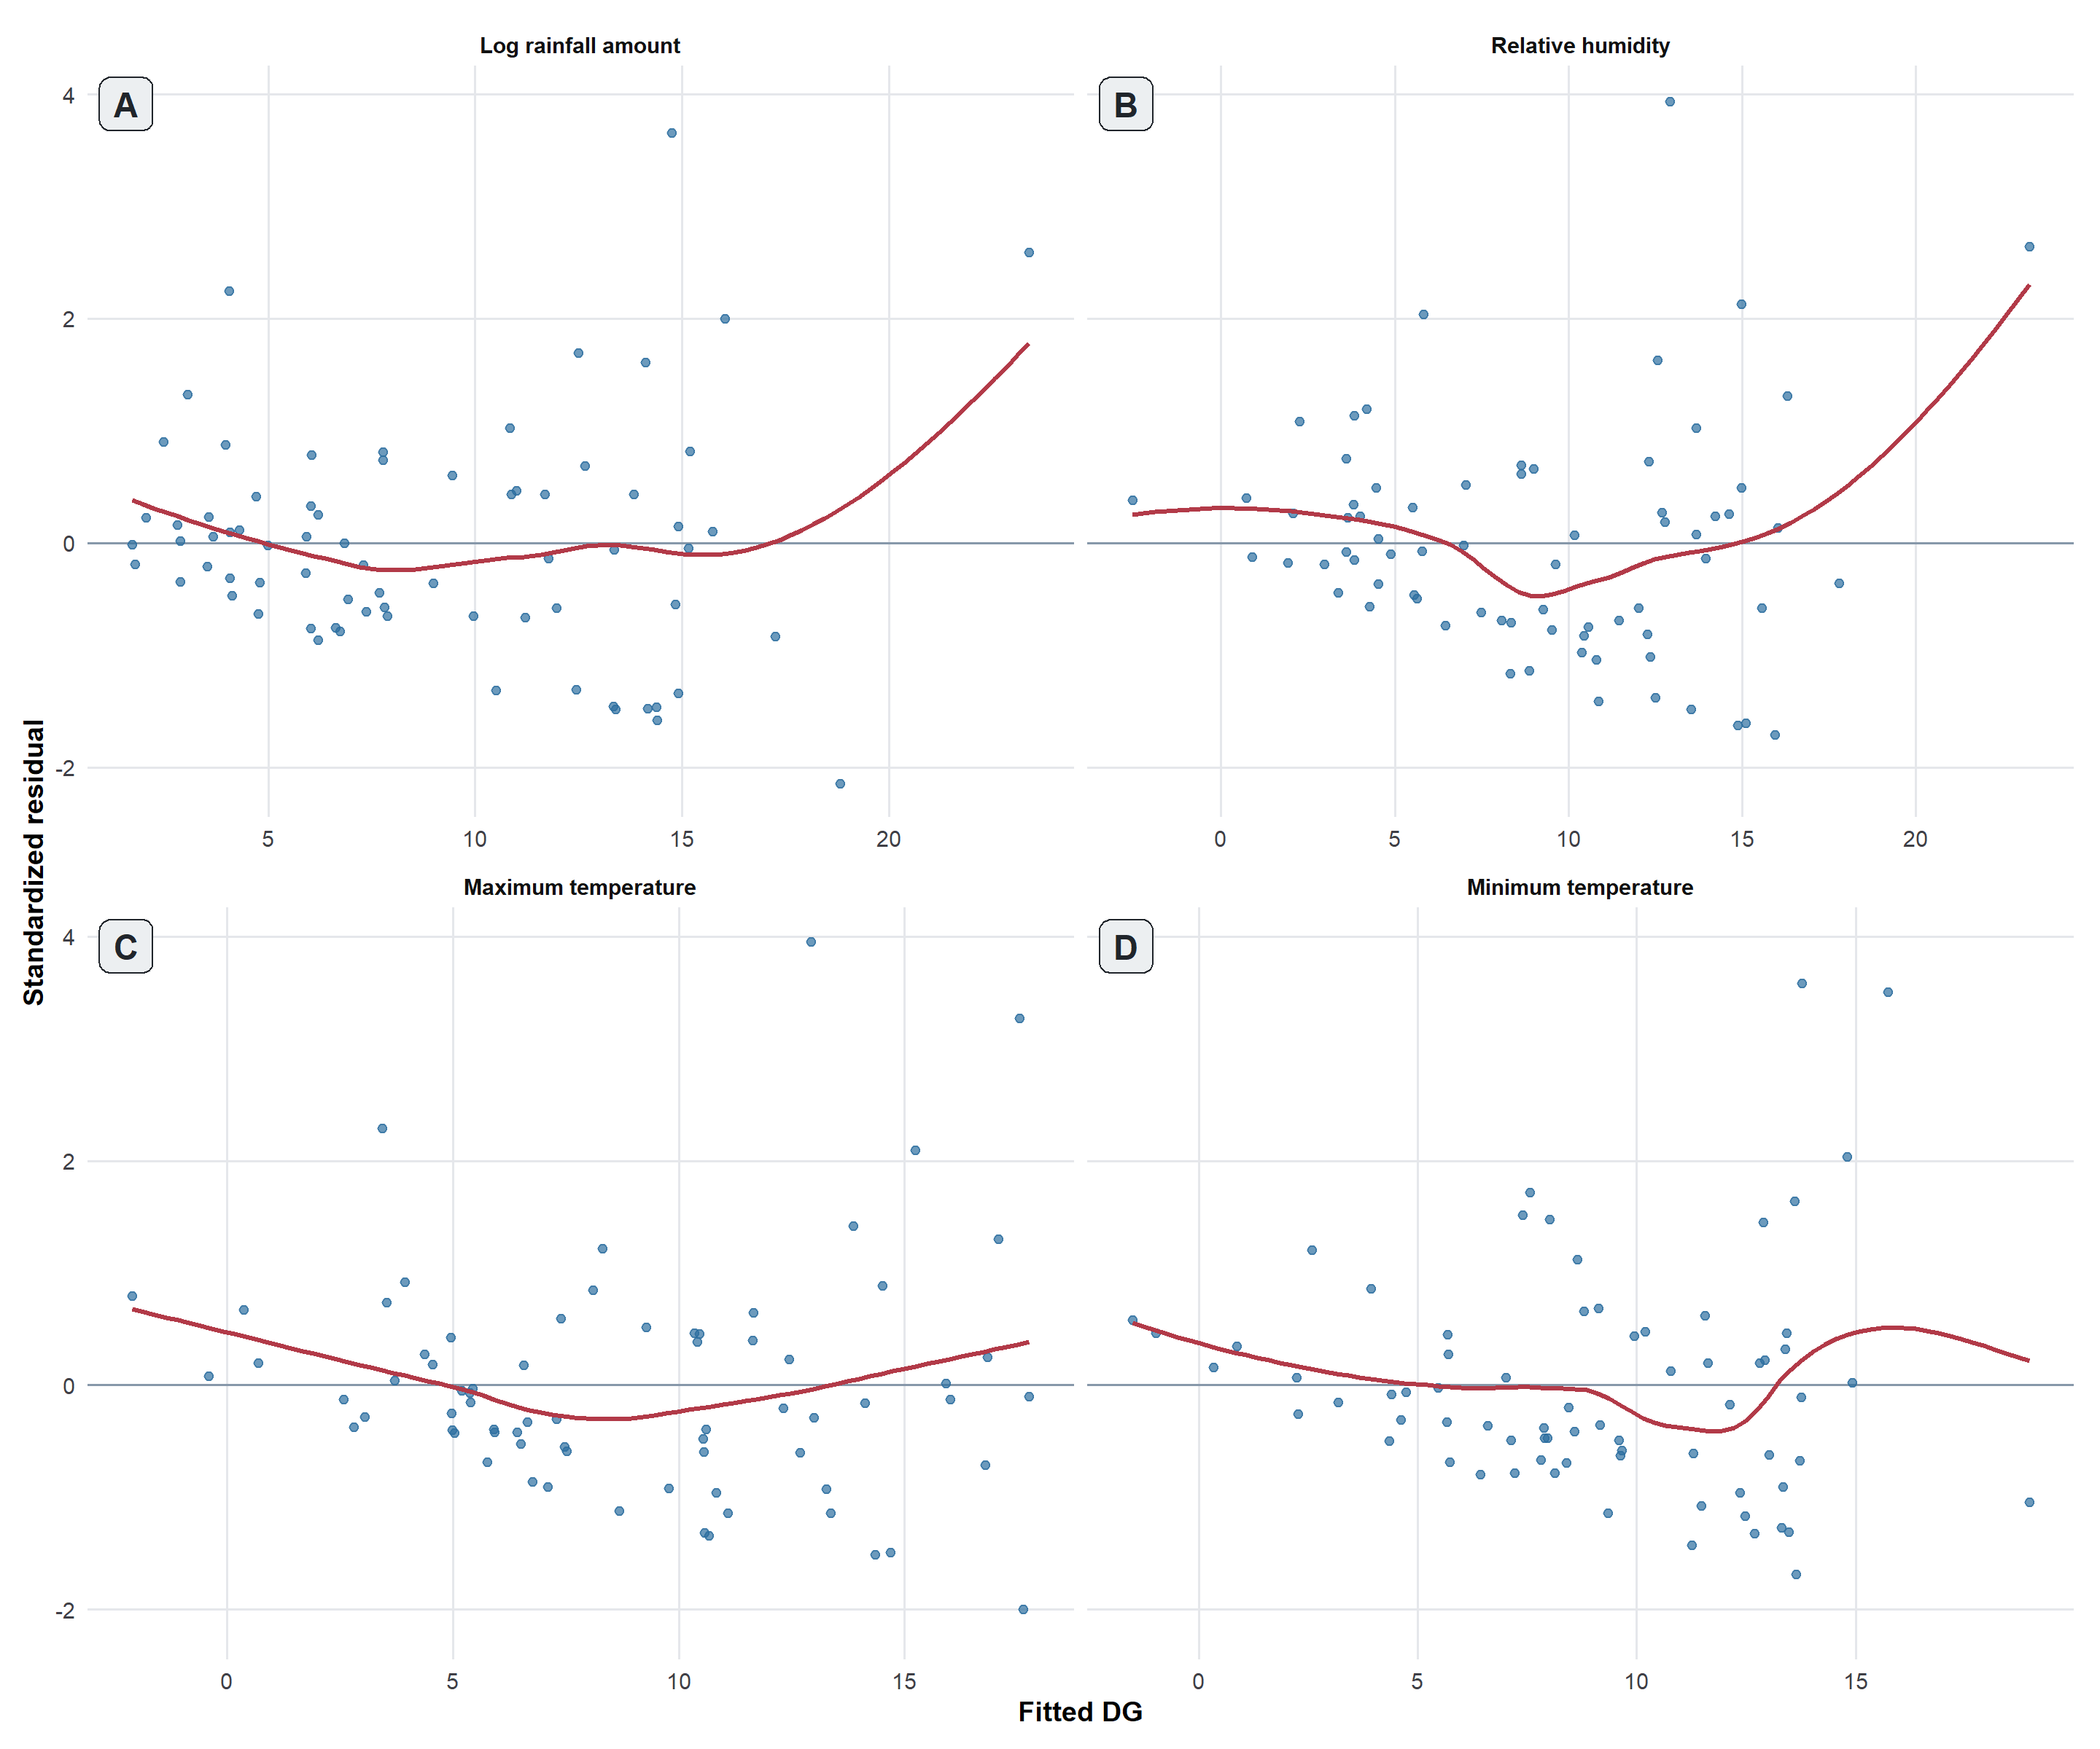
Figure S2: Broad-interval residual-versus-fitted plots. Residuals (observed minus fitted damaged-grain percentage) plotted against fitted values for each weather process in separate season-adjusted models. Each point represents one trial. The horizontal line marks zero, and the red smooth line highlights the overall pattern.
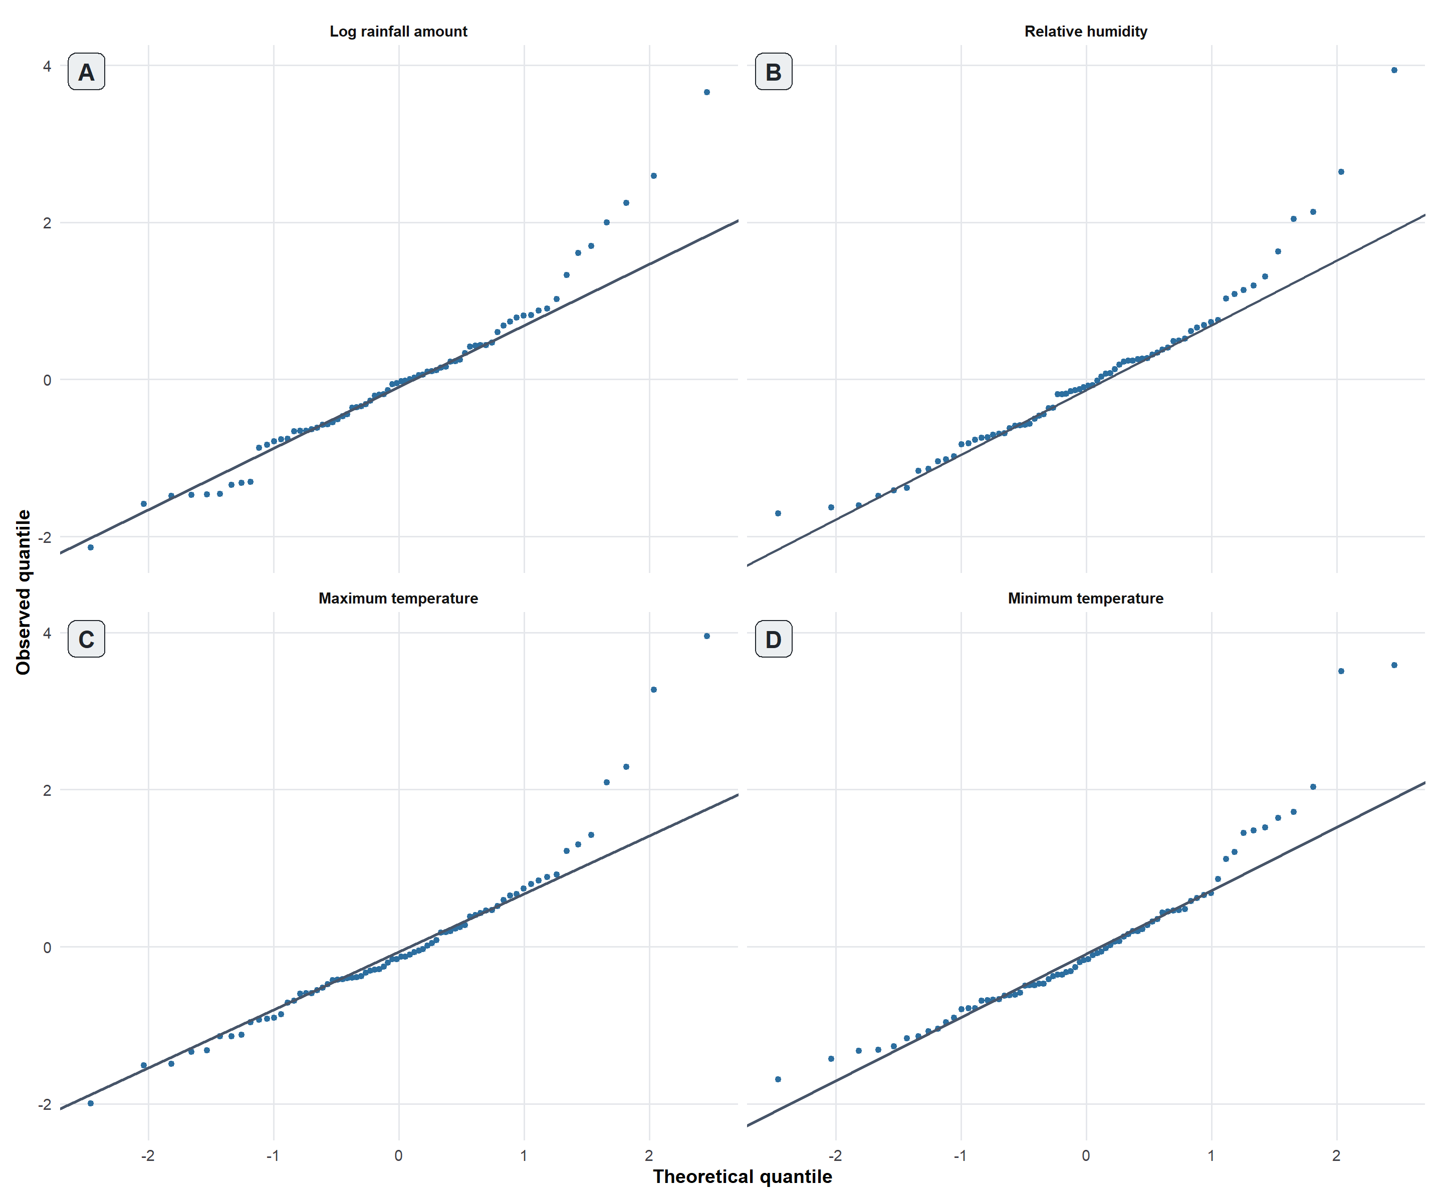
Figure S3: Broad-interval normal Q-Q plots. Standardized residuals plotted against theoretical normal quantiles for each weather process. Each point represents one trial, and the solid line is the normal-distribution reference line.
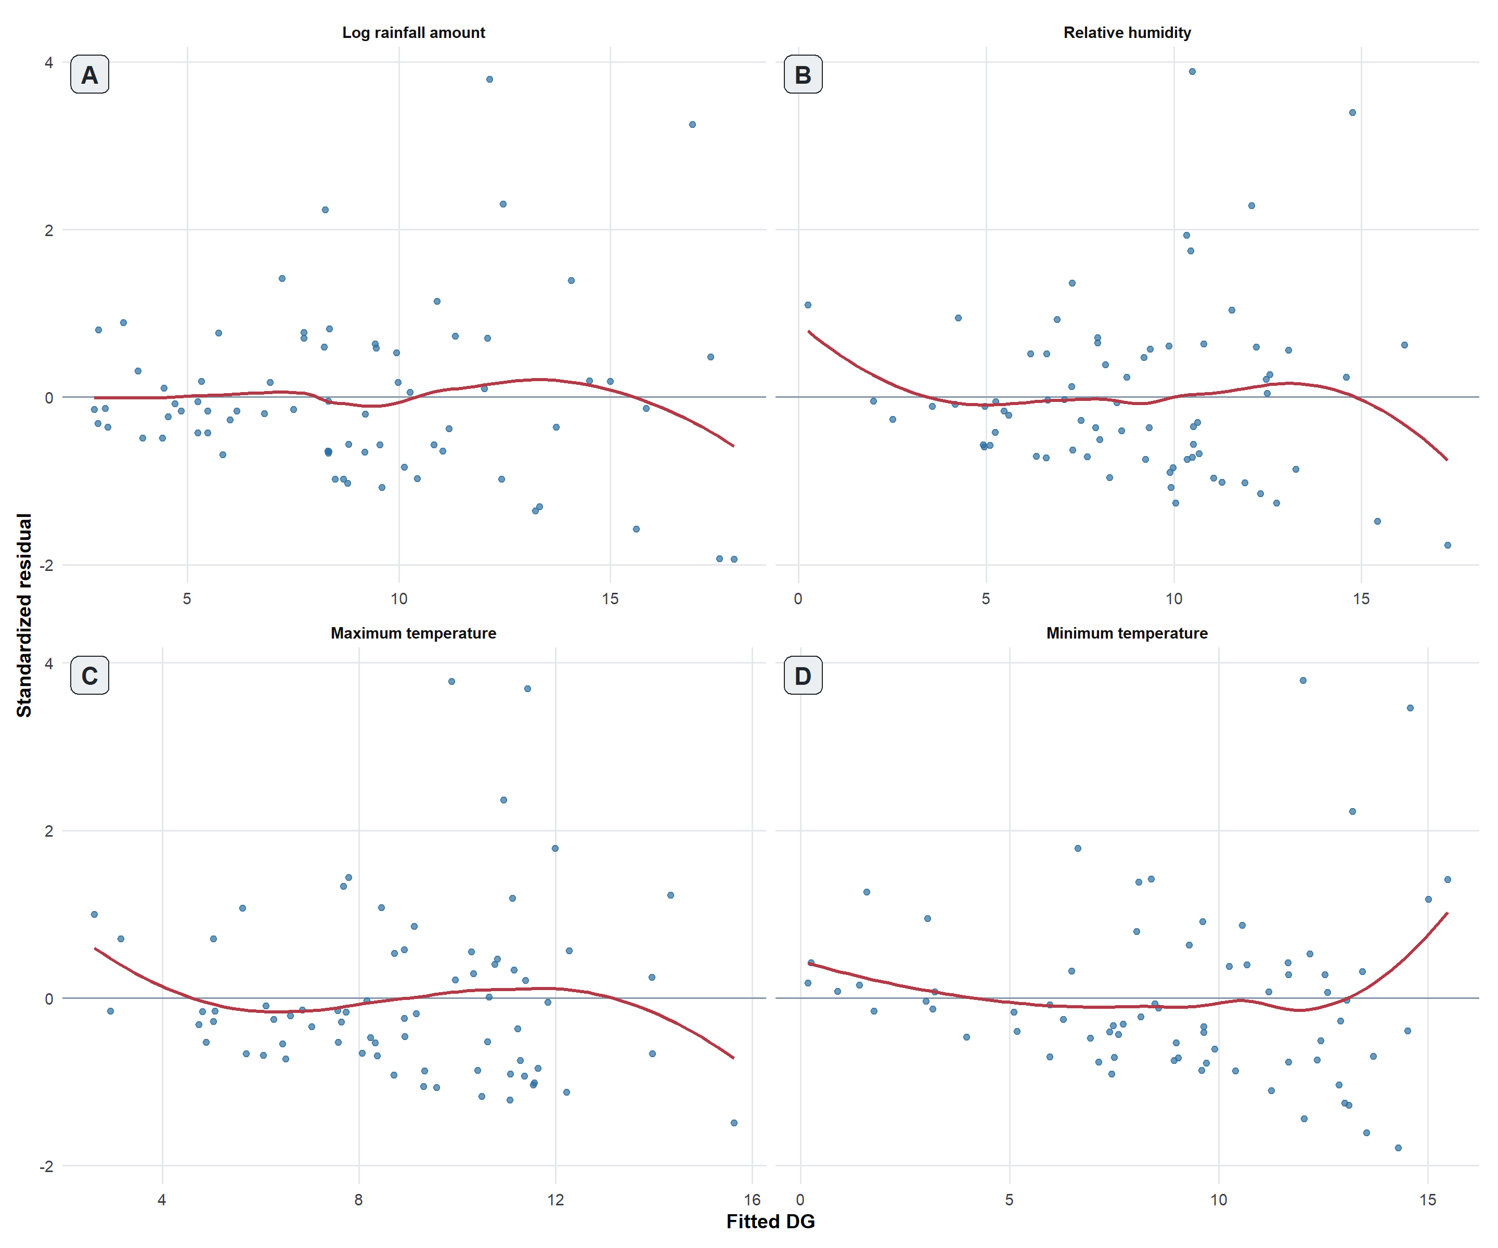
Figure S4: Scalar-on-function residual-versus-fitted plots. Residuals (observed minus fitted damaged-grain percentage) plotted against fitted values for each weather process in separate season-adjusted models. Each point represents one trial. The horizontal line marks zero, and the red smooth line highlights the overall pattern.
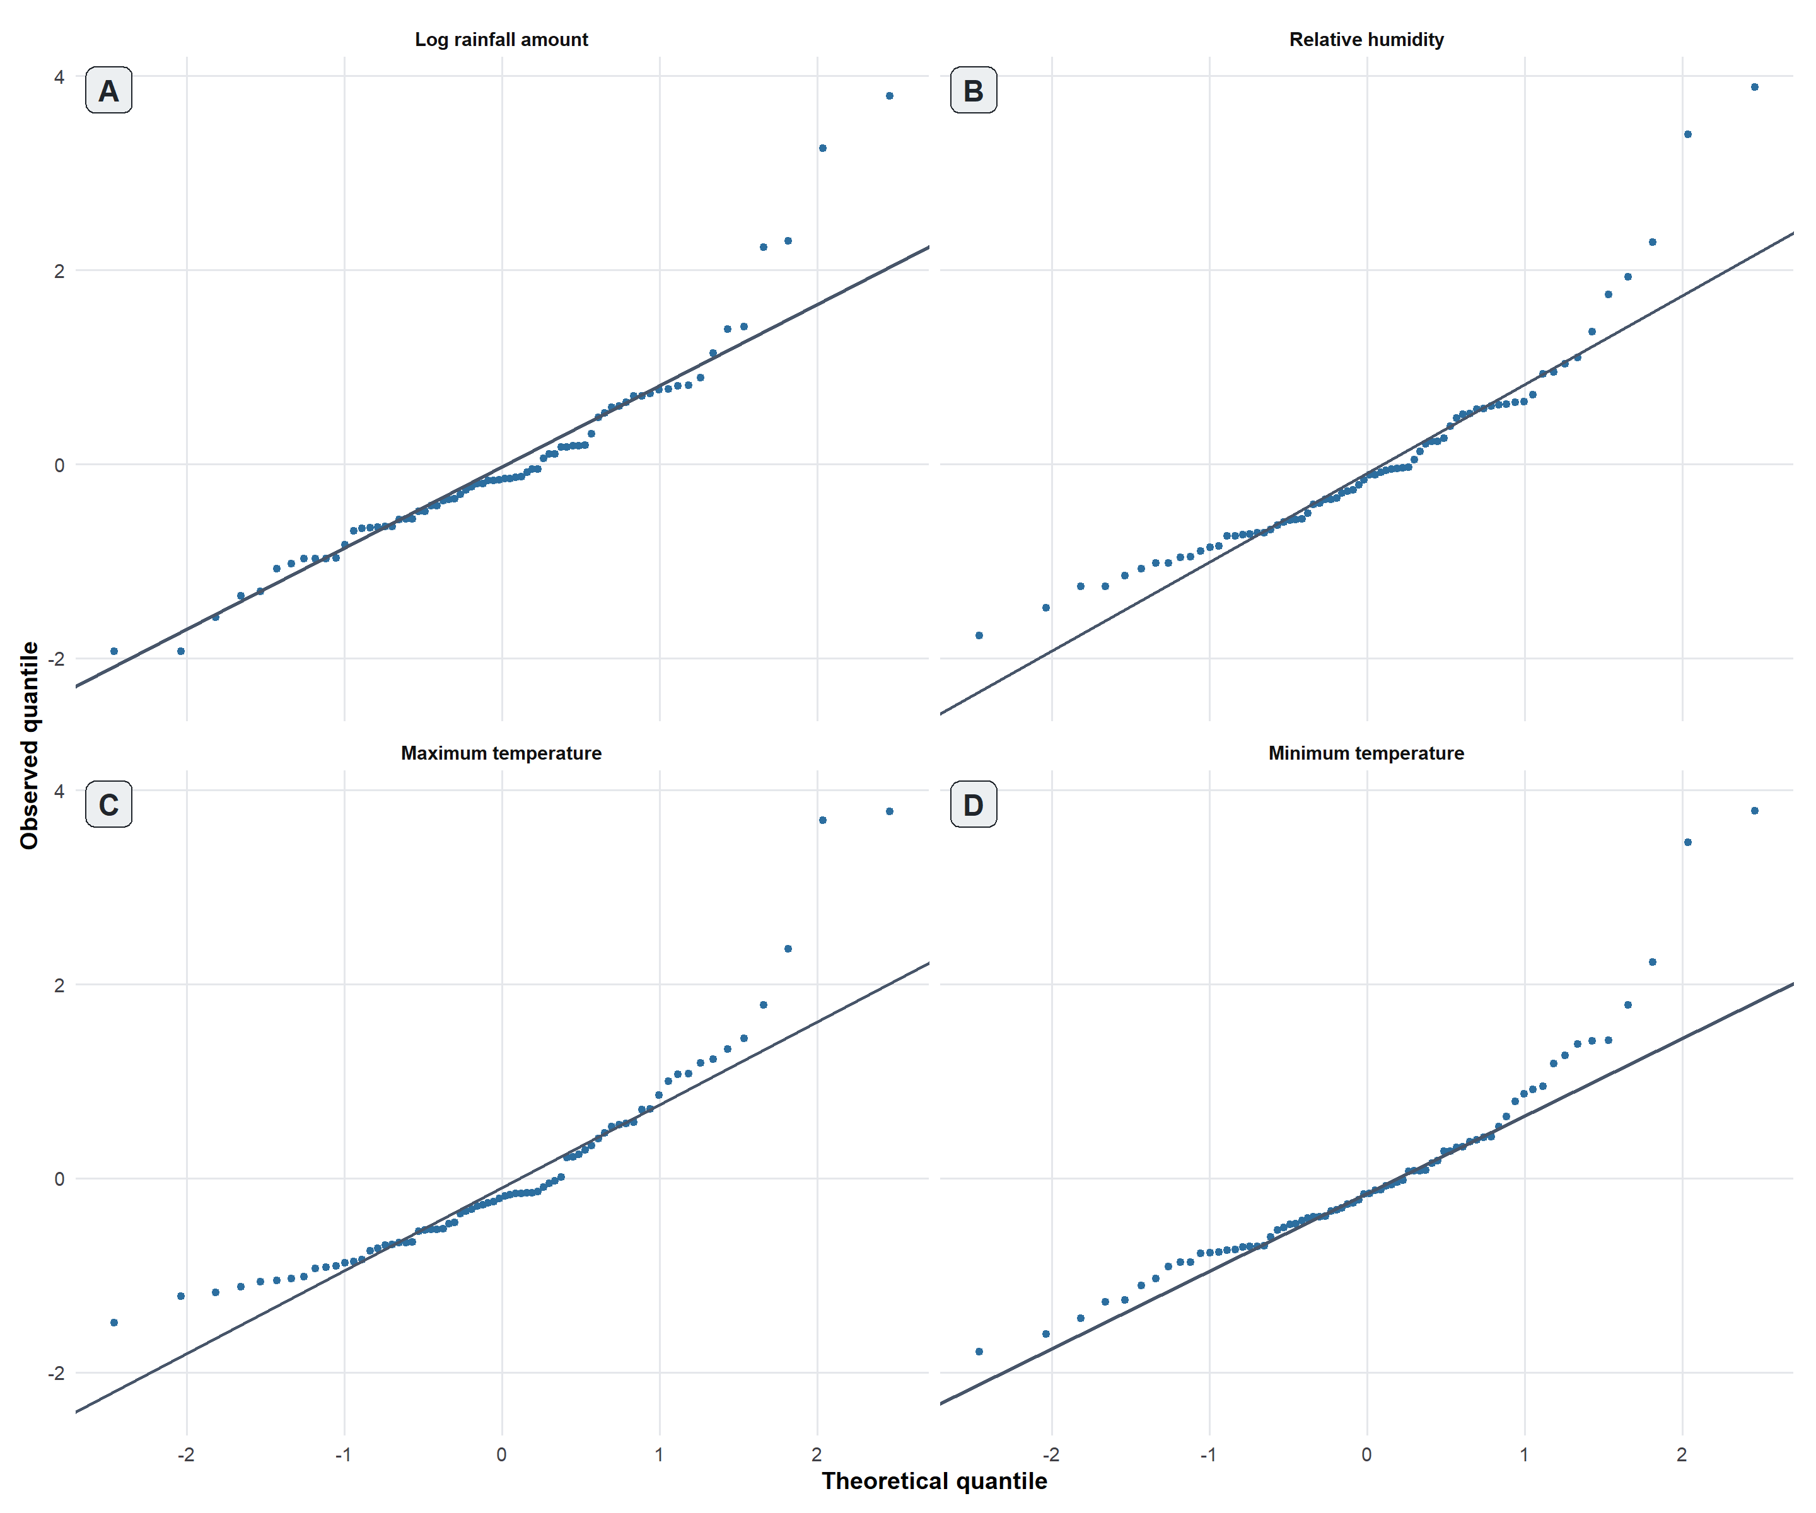
Figure S5: Scalar-on-function normal Q-Q plots. Standardized residuals plotted against theoretical normal quantiles for each weather process. Each point represents one trial, and the solid line is the normal-distribution reference line.
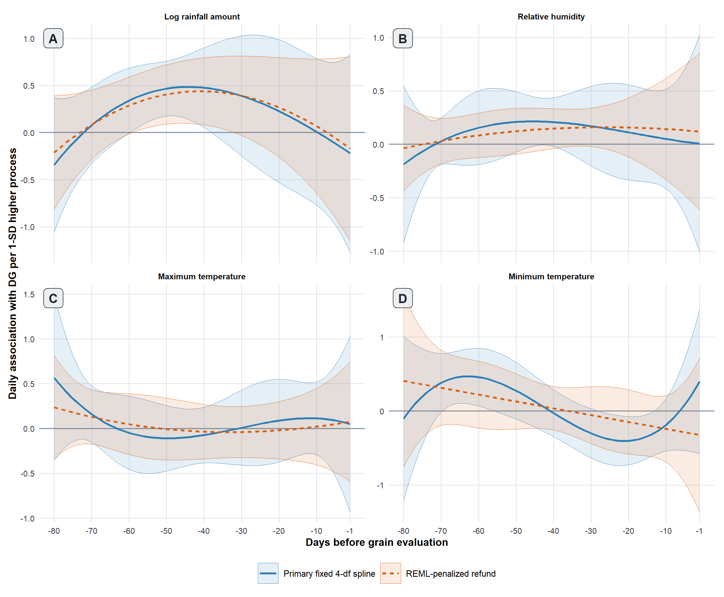
Figure S6. Primary unpenalized cubic B-spline coefficient functions with four fixed degrees of freedom (solid blue) and refund::pfr() REML-penalized cubic P-spline sensitivity functions with maximum basis dimension k = 4 and a second-order difference penalty (dashed orange). Ribbons are separate 95% simultaneous bands from 999 season-stratified ERA5 grid-cell-by-season cluster-bootstrap samples. Coefficients are scaled per one overall standard deviation. Panels show (A) log-transformed rainfall, (B) relative humidity, (C) maximum temperature, and (D) minimum temperature.

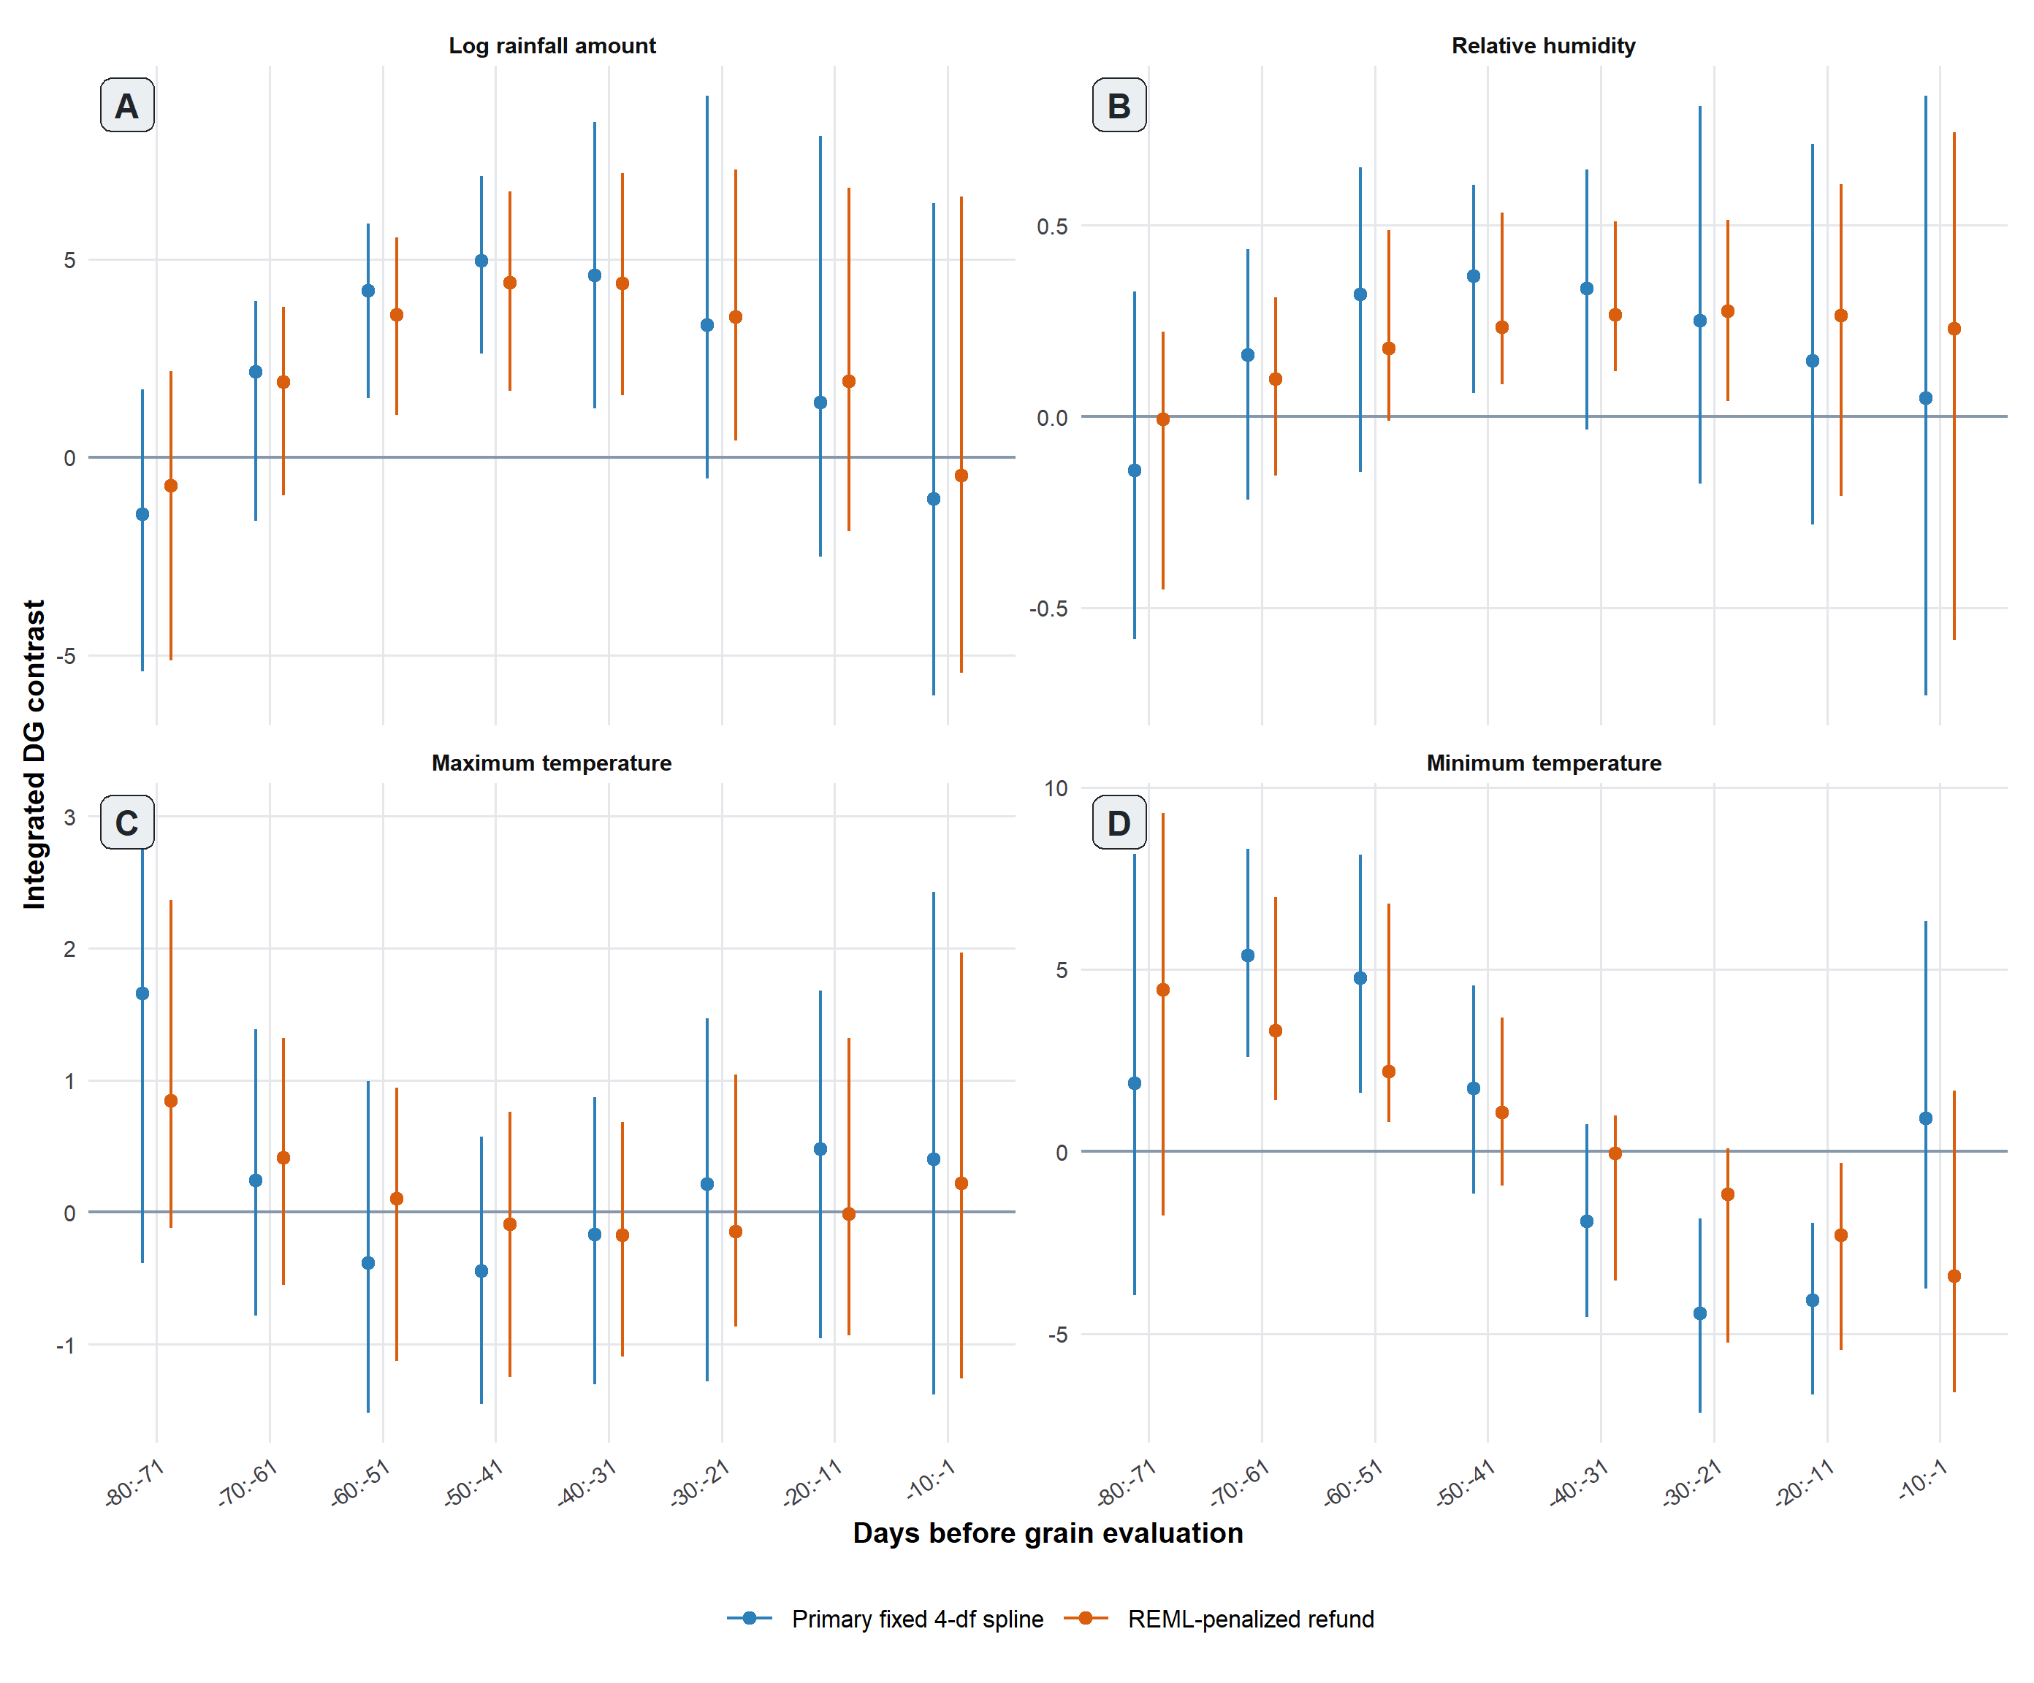
Figure S7. Integrated 10-day contrasts from the primary and REML-penalized scalar-on-function models. Points are coefficient functions integrated over each of the eight prespecified intervals; error bars are 95% percentile intervals from season-stratified ERA5 grid-cell-by-season cluster-bootstrap samples. Contrasts are DG percentage points for a one-standard-deviation higher process throughout the interval. Panels show (A) log-transformed rainfall, (B) relative humidity, (C) maximum temperature, and (D) minimum temperature.

