Homework 4: Machine Learning

Igor Kuznetsov

2023-06-08

Table of Contents

## [[1]]  
## [1] TRUE  
##   
## [[2]]  
## [1] TRUE  
##   
## [[3]]  
## [1] TRUE  
##   
## [[4]]  
## [1] TRUE  
##   
## [[5]]  
## [1] TRUE  
##   
## [[6]]  
## [1] TRUE  
##   
## [[7]]  
## [1] TRUE  
##   
## [[8]]  
## [1] TRUE  
##   
## [[9]]  
## [1] TRUE  
##   
## [[10]]  
## [1] TRUE  
##   
## [[11]]  
## [1] TRUE  
##   
## [[12]]  
## [1] TRUE  
##   
## [[13]]  
## [1] TRUE  
##   
## [[14]]  
## [1] TRUE  
##   
## [[15]]  
## [1] TRUE  
##   
## [[16]]  
## [1] TRUE  
##   
## [[17]]  
## [1] TRUE  
##   
## [[18]]  
## [1] TRUE  
##   
## [[19]]  
## [1] FALSE

# The Bechdel Test

<https://fivethirtyeight.com/features/the-dollar-and-cents-case-against-hollywoods-exclusion-of-women/>

The [Bechdel test](https://bechdeltest.com) is a way to assess how women are depicted in Hollywood movies. In order for a movie to pass the test:

1. It has to have at least two [named] women in it
2. Who talk to each other
3. About something besides a man

There is a nice article and analysis you can find here <https://fivethirtyeight.com/features/the-dollar-and-cents-case-against-hollywoods-exclusion-of-women/> We have a sample of 1394 movies and we want to fit a model to predict whether a film passes the test or not.

bechdel <- read_csv(here::here("data", "bechdel.csv")) %>%   
 mutate(test = factor(test))

## Rows: 1394 Columns: 10  
## ── Column specification ────────────────────────────────────────────────────────  
## Delimiter: ","  
## chr (4): title, test, rated, genre  
## dbl (6): year, budget_2013, domgross_2013, intgross_2013, metascore, imdb_ra...  
##   
## ℹ Use `spec()` to retrieve the full column specification for this data.  
## ℹ Specify the column types or set `show_col_types = FALSE` to quiet this message.

glimpse(bechdel)

## Rows: 1,394  
## Columns: 10  
## $ year <dbl> 2013, 2013, 2013, 2013, 2013, 2013, 2013, 2013, 2013, 20…  
## $ title <chr> "12 Years a Slave", "2 Guns", "42", "47 Ronin", "A Good …  
## $ test <fct> Fail, Fail, Fail, Fail, Fail, Pass, Pass, Fail, Pass, Pa…  
## $ budget_2013 <dbl> 2.00, 6.10, 4.00, 22.50, 9.20, 1.20, 1.30, 13.00, 4.00, …  
## $ domgross_2013 <dbl> 5.3107035, 7.5612460, 9.5020213, 3.8362475, 6.7349198, 1…  
## $ intgross_2013 <dbl> 15.8607035, 13.2493015, 9.5020213, 14.5803842, 30.424919…  
## $ rated <chr> "R", "R", "PG-13", "PG-13", "R", "R", "PG-13", "PG-13", …  
## $ metascore <dbl> 97, 55, 62, 29, 28, 55, 48, 33, 90, 58, 52, 78, 83, 53, …  
## $ imdb_rating <dbl> 8.3, 6.8, 7.6, 6.6, 5.4, 7.8, 5.7, 5.0, 7.5, 7.4, 6.2, 7…  
## $ genre <chr> "Biography", "Action", "Biography", "Action", "Action", …

How many films fail/pass the test, both as a number and as a %?

skimr::skim(bechdel %>% mutate(test=factor(test)))

Data summary

|  |  |
| --- | --- |
| Name | bechdel %>% mutate(test =… |
| Number of rows | 1394 |
| Number of columns | 10 |
| _______________________ |  |
| Column type frequency: |  |
| character | 3 |
| factor | 1 |
| numeric | 6 |
| ________________________ |  |
| Group variables | None |

**Variable type: character**

| skim_variable | n_missing | complete_rate | min | max | empty | n_unique | whitespace |
| --- | --- | --- | --- | --- | --- | --- | --- |
| title | 0 | 1 | 1 | 83 | 0 | 1385 | 0 |
| rated | 0 | 1 | 1 | 5 | 0 | 5 | 0 |
| genre | 0 | 1 | 5 | 11 | 0 | 14 | 0 |

**Variable type: factor**

| skim_variable | n_missing | complete_rate | ordered | n_unique | top_counts |
| --- | --- | --- | --- | --- | --- |
| test | 0 | 1 | FALSE | 2 | Fai: 772, Pas: 622 |

**Variable type: numeric**

| skim_variable | n_missing | complete_rate | mean | sd | p0 | p25 | p50 | p75 | p100 | hist |
| --- | --- | --- | --- | --- | --- | --- | --- | --- | --- | --- |
| year | 0 | 1 | 2003.97 | 7.57 | 1971.0 | 2000.00 | 2005.00 | 2010.00 | 2013.00 | ▁▁▁▅▇ |
| budget_2013 | 0 | 1 | 5.86 | 5.64 | 0.0 | 1.70 | 3.89 | 8.62 | 46.14 | ▇▂▁▁▁ |
| domgross_2013 | 0 | 1 | 9.54 | 11.96 | 0.0 | 2.14 | 5.61 | 12.25 | 112.53 | ▇▁▁▁▁ |
| intgross_2013 | 0 | 1 | 20.60 | 28.69 | 0.0 | 3.75 | 9.97 | 25.40 | 317.19 | ▇▁▁▁▁ |
| metascore | 0 | 1 | 58.88 | 17.25 | 11.0 | 47.00 | 59.00 | 72.00 | 100.00 | ▁▅▇▆▂ |
| imdb_rating | 0 | 1 | 6.79 | 0.96 | 2.1 | 6.20 | 6.90 | 7.47 | 9.30 | ▁▁▅▇▂ |

bechdel %>% mutate(test=factor(test)) %>% mutate(total_count = n()) %>% group_by(test) %>% summarise(group_count=n(),fraction = n()/mean(total_count))

## # A tibble: 2 × 3  
## test group_count fraction  
## <fct> <int> <dbl>  
## 1 Fail 772 0.554  
## 2 Pass 622 0.446

## Movie scores

ggplot(data = bechdel, aes(  
 x = metascore,  
 y = imdb_rating,  
 colour = test  
)) +  
 geom_point(alpha = .3, size = 3) +  
 scale_colour_manual(values = c("tomato", "olivedrab")) +  
 labs(  
 x = "Metacritic score",  
 y = "IMDB rating",  
 colour = "Bechdel test"  
 ) +  
 theme_light()

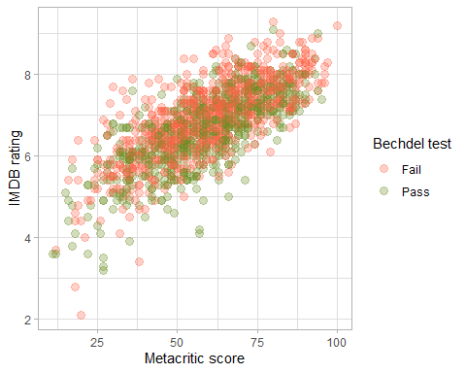

# Split the data

# **Split the data**  
  
set.seed(123)  
  
data_split <- initial_split(bechdel, # updated data  
 prop = 0.8,   
 strata = test)  
  
bechdel_train <- training(data_split)   
bechdel_test <- testing(data_split)

Check the counts and % (proportions) of the test variable in each set.

bechdel_train %>% mutate(test=factor(test)) %>% mutate(total_count = n()) %>% group_by(test) %>% summarise(group_count=n(),fraction = n()/mean(total_count))

## # A tibble: 2 × 3  
## test group_count fraction  
## <fct> <int> <dbl>  
## 1 Fail 617 0.554  
## 2 Pass 497 0.446

bechdel_test %>% mutate(test=factor(test)) %>% mutate(total_count = n()) %>% group_by(test) %>% summarise(group_count=n(),fraction = n()/mean(total_count))

## # A tibble: 2 × 3  
## test group_count fraction  
## <fct> <int> <dbl>  
## 1 Fail 155 0.554  
## 2 Pass 125 0.446

## Feature exploration

## Any outliers?

# IK: all the LHS variables except for metascore have outliers

bechdel %>%   
 select(test, budget_2013, domgross_2013, intgross_2013, imdb_rating, metascore) %>%   
  
 pivot_longer(cols = 2:6,  
 names_to = "feature",  
 values_to = "value") %>%   
 ggplot()+  
 aes(x=test, y = value, fill = test)+  
 coord_flip()+  
 geom_boxplot()+  
 facet_wrap(~feature, scales = "free")+  
 theme_bw()+  
 theme(legend.position = "none")+  
 labs(x=NULL,y = NULL)

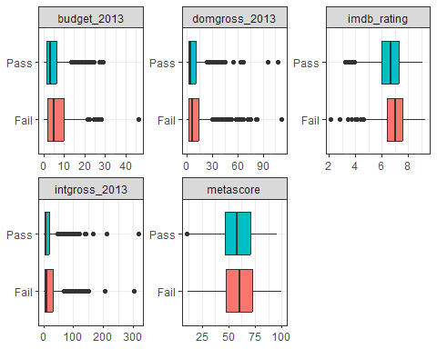

## Scatterplot - Correlation Matrix

Write a paragraph discussing the output of the following

IK: we also need to log transform budget_2013, domgross_2013, intgross_2013 as they have skewed distributions with long LHS tails. It appears that the predictors of the test should be budget_2013, domgross_2013, intgross_2013, and may be imdb_rating while there does not seem to be a meaningful difference in metascore for test groups. There also seems to be a very high correpation between domgross_2013 and intgross_2013 so we may consider dropping one of them as there no additional signal (predictive power) from including both of them.

bechdel %>%   
 select(test, budget_2013, domgross_2013, intgross_2013, imdb_rating, metascore)%>%   
 ggpairs(aes(colour=test), alpha=0.2)+  
 theme_bw()

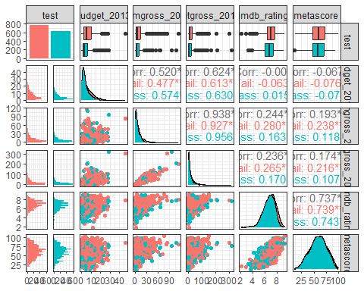

## Categorical variables

Write a paragraph discussing the output of the following

IK: It appears that there is a substantial variation in the proportion of the failed tests across movies ganres. Thus, action movies fail the test in more than 70% of the sample (the highest rate) while comedy movies fail only in 42.7% cases (the lowest rate). The same is true for movie ratings. There seems to be more test values for G rated movies compared to all others except for NC-17 movies. However, NC-17 movie variation is not reliable because of very few observations in this category.

bechdel %>%   
 group_by(genre, test) %>%  
 summarise(n = n()) %>%   
 mutate(prop = n/sum(n))

## `summarise()` has grouped output by 'genre'. You can override using the  
## `.groups` argument.

## # A tibble: 24 × 4  
## # Groups: genre [14]  
## genre test n prop  
## <chr> <fct> <int> <dbl>  
## 1 Action Fail 260 0.707  
## 2 Action Pass 108 0.293  
## 3 Adventure Fail 52 0.559  
## 4 Adventure Pass 41 0.441  
## 5 Animation Fail 63 0.677  
## 6 Animation Pass 30 0.323  
## 7 Biography Fail 36 0.554  
## 8 Biography Pass 29 0.446  
## 9 Comedy Fail 138 0.427  
## 10 Comedy Pass 185 0.573  
## # ℹ 14 more rows

bechdel %>%   
 group_by(rated, test) %>%  
 summarise(n = n()) %>%   
 mutate(prop = n/sum(n))

## `summarise()` has grouped output by 'rated'. You can override using the  
## `.groups` argument.

## # A tibble: 10 × 4  
## # Groups: rated [5]  
## rated test n prop  
## <chr> <fct> <int> <dbl>  
## 1 G Fail 16 0.615  
## 2 G Pass 10 0.385  
## 3 NC-17 Fail 5 0.833  
## 4 NC-17 Pass 1 0.167  
## 5 PG Fail 115 0.561  
## 6 PG Pass 90 0.439  
## 7 PG-13 Fail 283 0.529  
## 8 PG-13 Pass 252 0.471  
## 9 R Fail 353 0.568  
## 10 R Pass 269 0.432

# Train first models. test ~ metascore + imdb_rating

lr_mod <- logistic_reg() %>%   
 set_engine(engine = "glm") %>%   
 set_mode("classification")  
  
lr_mod

## Logistic Regression Model Specification (classification)  
##   
## Computational engine: glm

tree_mod <- decision_tree() %>%   
 set_engine(engine = "C5.0") %>%   
 set_mode("classification")  
  
tree_mod

## Decision Tree Model Specification (classification)  
##   
## Computational engine: C5.0

lr_fit <- lr_mod %>% # parsnip model  
 fit(test ~ metascore + imdb_rating, # a formula  
 data = bechdel_train # dataframe  
 )  
  
tree_fit <- tree_mod %>% # parsnip model  
 fit(test ~ metascore + imdb_rating, # a formula  
 data = bechdel_train # dataframe  
 )

## Logistic regression

lr_fit %>%  
 broom::tidy()

## # A tibble: 3 × 5  
## term estimate std.error statistic p.value  
## <chr> <dbl> <dbl> <dbl> <dbl>  
## 1 (Intercept) 2.80 0.494 5.68 1.35e- 8  
## 2 metascore 0.0207 0.00536 3.86 1.13e- 4  
## 3 imdb_rating -0.625 0.100 -6.24 4.36e-10

lr_preds <- lr_fit %>%  
 augment(new_data = bechdel_train) %>%  
 mutate(.pred_match = if_else(test == .pred_class, 1, 0))

### Confusion matrix

lr_preds %>%   
 conf_mat(truth = test, estimate = .pred_class) %>%   
 autoplot(type = "heatmap")

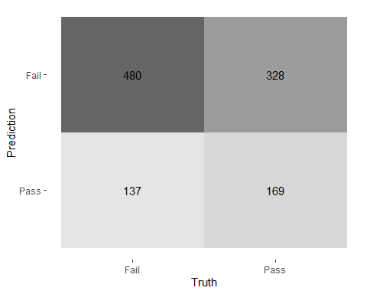

## Decision Tree

tree_preds <- tree_fit %>%  
 augment(new_data = bechdel) %>%  
 mutate(.pred_match = if_else(test == .pred_class, 1, 0))

tree_preds %>%   
 conf_mat(truth = test, estimate = .pred_class) %>%   
 autoplot(type = "heatmap")

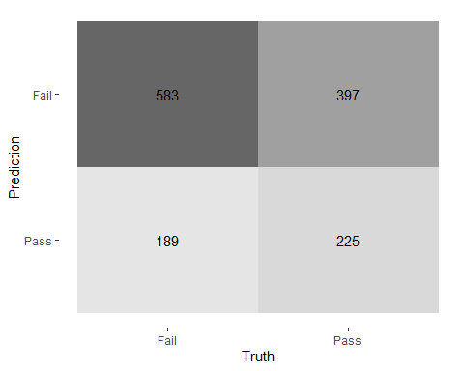

## Draw the decision tree

draw_tree <-   
 rpart::rpart(  
 test ~ metascore + imdb_rating,  
 data = bechdel_train, # uses data that contains both birth weight and `low`  
 control = rpart::rpart.control(maxdepth = 5, cp = 0, minsplit = 10)  
 ) %>%   
 partykit::as.party()  
plot(draw_tree)

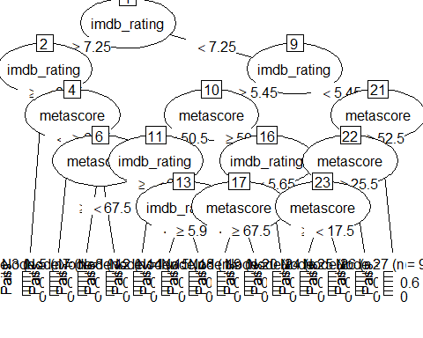

# Cross Validation

Run the code below. What does it return?

IK: it returns an object that divides training dataset bechdel_train into 10 folds for cross validation

set.seed(123)  
bechdel_folds <- vfold_cv(data = bechdel_train,   
 v = 10,   
 strata = test)  
class(bechdel_folds)

## [1] "vfold_cv" "rset" "tbl_df" "tbl" "data.frame"

## fit_resamples()

Trains and tests a resampled model.

lr_fit <- lr_mod %>%  
 fit_resamples(  
 test ~ metascore + imdb_rating,  
 resamples = bechdel_folds  
 )  
  
  
tree_fit <- tree_mod %>%  
 fit_resamples(  
 test ~ metascore + imdb_rating,  
 resamples = bechdel_folds  
 )

## collect_metrics()

Unnest the metrics column from a tidymodels fit_resamples()

collect_metrics(lr_fit)

## # A tibble: 2 × 6  
## .metric .estimator mean n std_err .config   
## <chr> <chr> <dbl> <int> <dbl> <chr>   
## 1 accuracy binary 0.575 10 0.0149 Preprocessor1_Model1  
## 2 roc_auc binary 0.606 10 0.0189 Preprocessor1_Model1

collect_metrics(tree_fit)

## # A tibble: 2 × 6  
## .metric .estimator mean n std_err .config   
## <chr> <chr> <dbl> <int> <dbl> <chr>   
## 1 accuracy binary 0.571 10 0.0156 Preprocessor1_Model1  
## 2 roc_auc binary 0.547 10 0.0201 Preprocessor1_Model1

tree_preds <- tree_mod %>%   
 fit_resamples(  
 test ~ metascore + imdb_rating,   
 resamples = bechdel_folds,  
 control = control_resamples(save_pred = TRUE) #<<  
 )  
  
# What does the data for ROC look like?  
tree_preds %>%   
 collect_predictions() %>%   
 roc_curve(truth = test, .pred_Fail)

## # A tibble: 29 × 3  
## .threshold specificity sensitivity  
## <dbl> <dbl> <dbl>  
## 1 -Inf 0 1   
## 2 0.262 0 1   
## 3 0.317 0.00201 0.989  
## 4 0.373 0.00805 0.982  
## 5 0.440 0.0181 0.976  
## 6 0.459 0.0443 0.943  
## 7 0.460 0.0765 0.924  
## 8 0.464 0.115 0.901  
## 9 0.465 0.147 0.887  
## 10 0.465 0.191 0.864  
## # ℹ 19 more rows

# Draw the ROC  
tree_preds %>%   
 collect_predictions() %>%   
 roc_curve(truth = test, .pred_Fail) %>%   
 autoplot()

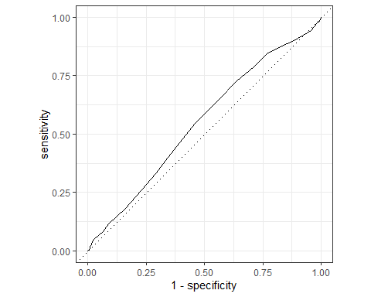

# Build a better training set with recipes

## Preprocessing options

* Encode categorical predictors
* Center and scale variables
* Handle class imbalance
* Impute missing data
* Perform dimensionality reduction
* … …

## To build a recipe

1. Start the recipe()
2. Define the variables involved
3. Describe **prep**rocessing [step-by-step]

## Collapse Some Categorical Levels

Do we have any genre with few observations? Assign genres that have less than 3% to a new category ‘Other’

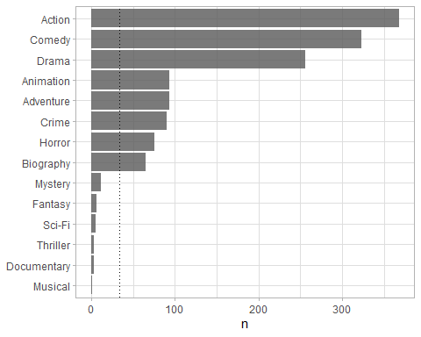

movie_rec <-  
 recipe(test ~ .,  
 data = bechdel_train) %>%  
   
 # Genres with less than 5% will be in a catewgory 'Other'  
 step_other(genre, threshold = .03)

## Before recipe

## # A tibble: 14 × 2  
## genre n  
## <chr> <int>  
## 1 Action 293  
## 2 Comedy 254  
## 3 Drama 213  
## 4 Adventure 75  
## 5 Animation 72  
## 6 Crime 68  
## 7 Horror 68  
## 8 Biography 50  
## 9 Mystery 7  
## 10 Fantasy 5  
## 11 Sci-Fi 3  
## 12 Thriller 3  
## 13 Documentary 2  
## 14 Musical 1

## After recipe

movie_rec %>%   
 prep() %>%   
 bake(new_data = bechdel_train) %>%   
 count(genre, sort = TRUE)

## # A tibble: 9 × 2  
## genre n  
## <fct> <int>  
## 1 Action 293  
## 2 Comedy 254  
## 3 Drama 213  
## 4 Adventure 75  
## 5 Animation 72  
## 6 Crime 68  
## 7 Horror 68  
## 8 Biography 50  
## 9 other 21

## step_dummy()

Converts nominal data into numeric dummy variables

movie_rec <- recipe(test ~ ., data = bechdel) %>%  
 step_other(genre, threshold = .03) %>%   
 step_dummy(all_nominal_predictors())   
  
movie_rec

##

## ── Recipe ──────────────────────────────────────────────────────────────────────

##

## ── Inputs

## Number of variables by role

## outcome: 1  
## predictor: 9

##

## ── Operations

## • Collapsing factor levels for: genre

## • Dummy variables from: all_nominal_predictors()

## Let’s think about the modelling

What if there were no films with rated NC-17 in the training data?

* Will the model have a coefficient for rated NC-17?

IK: it will not have a coefficient. It depends on the alorithm but most likely it would be dropped as it would have a perfect colliniarity with the default group.

* What will happen if the test data includes a film with rated NC-17?

IK: this information would not be used to predict the test. It would have the same effect as being in the default category.

## step_novel()

Adds a catch-all level to a factor for any new values not encountered in model training, which lets R intelligently predict new levels in the test set.

movie_rec <- recipe(test ~ ., data = bechdel) %>%  
 step_other(genre, threshold = .03) %>%   
 step_novel(all_nominal_predictors) %>% # Use *before* `step_dummy()` so new level is dummified  
 step_dummy(all_nominal_predictors())

## step_zv()

Intelligently handles zero variance variables (variables that contain only a single value)

movie_rec <- recipe(test ~ ., data = bechdel) %>%  
 step_other(genre, threshold = .03) %>%   
 step_novel(all_nominal(), -all_outcomes()) %>% # Use *before* `step_dummy()` so new level is dummified  
 step_dummy(all_nominal(), -all_outcomes()) %>%   
 step_zv(all_numeric(), -all_outcomes())

## step_normalize()

Centers then scales numeric variable (mean = 0, sd = 1)

movie_rec <- recipe(test ~ ., data = bechdel) %>%  
 step_other(genre, threshold = .03) %>%   
 step_novel(all_nominal(), -all_outcomes()) %>% # Use *before* `step_dummy()` so new level is dummified  
 step_dummy(all_nominal(), -all_outcomes()) %>%   
 step_zv(all_numeric(), -all_outcomes()) %>%   
 step_normalize(all_numeric())

## step_corr()

Removes highly correlated variables

movie_rec <- recipe(test ~ ., data = bechdel) %>%  
 step_other(genre, threshold = .03) %>%   
 step_novel(all_nominal(), -all_outcomes()) %>% # Use *before* `step_dummy()` so new level is dummified  
 step_dummy(all_nominal(), -all_outcomes()) %>%   
 step_zv(all_numeric(), -all_outcomes()) %>%   
 step_normalize(all_numeric()) %>%   
 step_corr(all_predictors(), threshold = 0.75, method = "spearman")   
  
  
  
movie_rec

##

## ── Recipe ──────────────────────────────────────────────────────────────────────

##

## ── Inputs

## Number of variables by role

## outcome: 1  
## predictor: 9

##

## ── Operations

## • Collapsing factor levels for: genre

## • Novel factor level assignment for: all_nominal(), -all_outcomes()

## • Dummy variables from: all_nominal(), -all_outcomes()

## • Zero variance filter on: all_numeric(), -all_outcomes()

## • Centering and scaling for: all_numeric()

## • Correlation filter on: all_predictors()

# Define different models to fit

## Model Building  
  
# 1. Pick a `model type`  
# 2. set the `engine`  
# 3. Set the `mode`: regression or classification  
  
# Logistic regression  
log_spec <- logistic_reg() %>% # model type  
 set_engine(engine = "glm") %>% # model engine  
 set_mode("classification") # model mode  
  
# Show your model specification  
log_spec

## Logistic Regression Model Specification (classification)  
##   
## Computational engine: glm

# Decision Tree  
tree_spec <- decision_tree() %>%  
 set_engine(engine = "C5.0") %>%  
 set_mode("classification")  
  
tree_spec

## Decision Tree Model Specification (classification)  
##   
## Computational engine: C5.0

# Random Forest  
library(ranger)  
  
rf_spec <-   
 rand_forest() %>%   
 set_engine("ranger", importance = "impurity") %>%   
 set_mode("classification")  
  
  
# Boosted tree (XGBoost)  
library(xgboost)

##   
## Attaching package: 'xgboost'

## The following object is masked from 'package:dplyr':  
##   
## slice

xgb_spec <-   
 boost_tree() %>%   
 set_engine("xgboost") %>%   
 set_mode("classification")   
  
# K-nearest neighbour (k-NN)  
knn_spec <-   
 nearest_neighbor(neighbors = 4) %>% # we can adjust the number of neighbors   
 set_engine("kknn") %>%   
 set_mode("classification")

# Bundle recipe and model with workflows

log_wflow <- # new workflow object  
 workflow() %>% # use workflow function  
 add_recipe(movie_rec) %>% # use the new recipe  
 add_model(log_spec) # add your model spec  
  
# show object  
log_wflow

## ══ Workflow ════════════════════════════════════════════════════════════════════  
## Preprocessor: Recipe  
## Model: logistic_reg()  
##   
## ── Preprocessor ────────────────────────────────────────────────────────────────  
## 6 Recipe Steps  
##   
## • step_other()  
## • step_novel()  
## • step_dummy()  
## • step_zv()  
## • step_normalize()  
## • step_corr()  
##   
## ── Model ───────────────────────────────────────────────────────────────────────  
## Logistic Regression Model Specification (classification)  
##   
## Computational engine: glm

## A few more workflows  
  
tree_wflow <-  
 workflow() %>%  
 add_recipe(movie_rec) %>%   
 add_model(tree_spec)   
  
rf_wflow <-  
 workflow() %>%  
 add_recipe(movie_rec) %>%   
 add_model(rf_spec)   
  
xgb_wflow <-  
 workflow() %>%  
 add_recipe(movie_rec) %>%   
 add_model(xgb_spec)  
  
knn_wflow <-  
 workflow() %>%  
 add_recipe(movie_rec) %>%   
 add_model(knn_spec)

HEADS UP

1. How many models have you specified? IK: It depends on what we mean by “models” here. Do we consider models neing different if they have different tuning parameters? We have 5 model types specified.
2. What’s the difference between a model specification and a workflow? IK: Model specification is just initiation of the model object and setting up the required parameters. Workflow, on the other hand, tracks the whole process from data cleaning to model estimation and fitting process and generating the metrics (post-processing).
3. Do you need to add a formula (e.g., test ~ .) if you have a recipe?

IK: it is not clear in the question where one has to add this formula. We just specify this structure at the beginning when we initiate the recipe() and that is it, then we do transformation for the specified variables.

# Model Comparison

You now have all your models. Adapt the code from slides code-from-slides-CA-housing.R, line 400 onwards to assess which model gives you the best classification.

## Evaluate Models  
  
## Logistic regression results{.smaller}  
  
log_res <- log_wflow %>%   
 fit_resamples(  
 resamples = bechdel_folds,   
 metrics = metric_set(  
 recall, precision, f_meas, accuracy,  
 kap, roc_auc, sens, spec),  
 control = control_resamples(save_pred = TRUE))

## → A | warning: glm.fit: algorithm did not converge

## There were issues with some computations A: x1 → B | warning: prediction from a rank-deficient fit may be misleading  
## There were issues with some computations A: x1There were issues with some computations A: x1 B: x1There were issues with some computations A: x2 B: x1There were issues with some computations A: x2 B: x2There were issues with some computations A: x3 B: x2There were issues with some computations A: x3 B: x3There were issues with some computations A: x4 B: x3There were issues with some computations A: x4 B: x4There were issues with some computations A: x5 B: x4There were issues with some computations A: x5 B: x5There were issues with some computations A: x6 B: x5There were issues with some computations A: x6 B: x6There were issues with some computations A: x7 B: x6There were issues with some computations A: x7 B: x7There were issues with some computations A: x8 B: x7There were issues with some computations A: x8 B: x8There were issues with some computations A: x9 B: x8There were issues with some computations A: x10 B: x9There were issues with some computations A: x10 B: x10There were issues with some computations A: x10 B: x10

# Show average performance over all folds (note that we use log_res):  
log_res %>% collect_metrics(summarize = TRUE)

## # A tibble: 8 × 6  
## .metric .estimator mean n std_err .config   
## <chr> <chr> <dbl> <int> <dbl> <chr>   
## 1 accuracy binary 0.453 10 0.0305 Preprocessor1_Model1  
## 2 f_meas binary 0.409 10 0.0451 Preprocessor1_Model1  
## 3 kap binary -0.0670 10 0.0553 Preprocessor1_Model1  
## 4 precision binary 0.490 10 0.0338 Preprocessor1_Model1  
## 5 recall binary 0.358 10 0.0517 Preprocessor1_Model1  
## 6 roc_auc binary 0.449 10 0.0314 Preprocessor1_Model1  
## 7 sens binary 0.358 10 0.0517 Preprocessor1_Model1  
## 8 spec binary 0.570 10 0.0202 Preprocessor1_Model1

# Show performance for every single fold:  
log_res %>% collect_metrics(summarize = FALSE)

## # A tibble: 80 × 5  
## id .metric .estimator .estimate .config   
## <chr> <chr> <chr> <dbl> <chr>   
## 1 Fold01 recall binary 0.710 Preprocessor1_Model1  
## 2 Fold01 precision binary 0.677 Preprocessor1_Model1  
## 3 Fold01 f_meas binary 0.693 Preprocessor1_Model1  
## 4 Fold01 accuracy binary 0.652 Preprocessor1_Model1  
## 5 Fold01 kap binary 0.291 Preprocessor1_Model1  
## 6 Fold01 sens binary 0.710 Preprocessor1_Model1  
## 7 Fold01 spec binary 0.58 Preprocessor1_Model1  
## 8 Fold01 roc_auc binary 0.664 Preprocessor1_Model1  
## 9 Fold02 recall binary 0.339 Preprocessor1_Model1  
## 10 Fold02 precision binary 0.477 Preprocessor1_Model1  
## # ℹ 70 more rows

## `collect_predictions()` and get confusion matrix{.smaller}  
  
log_pred <- log_res %>% collect_predictions()  
  
log_pred %>% conf_mat(test, .pred_class)

## Truth  
## Prediction Fail Pass  
## Fail 221 214  
## Pass 396 283

log_pred %>%   
 conf_mat(test, .pred_class) %>%   
 autoplot(type = "mosaic") +  
 geom_label(aes(  
 x = (xmax + xmin) / 2,   
 y = (ymax + ymin) / 2,   
 label = c("TP", "FN", "FP", "TN")))

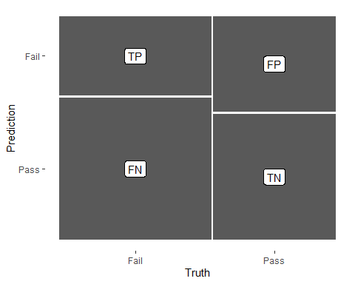

log_pred %>%   
 conf_mat(test, .pred_class) %>%   
 autoplot(type = "heatmap")

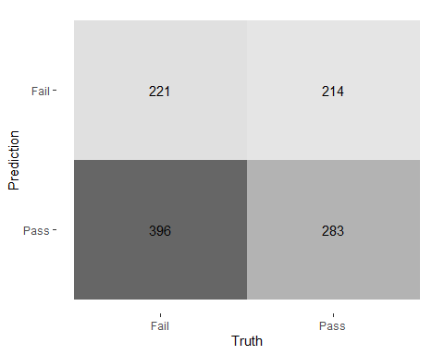

## ROC Curve  
  
# log_pred %>%   
# group_by(id) %>% # id contains our folds  
# roc_curve(test, .pred_above) %>%   
# autoplot()  
#

## Decision Tree results  
  
tree_res <-  
 tree_wflow %>%   
 fit_resamples(  
 resamples = bechdel_folds,   
 metrics = metric_set(  
 recall, precision, f_meas,   
 accuracy, kap,  
 roc_auc, sens, spec),  
 control = control_resamples(save_pred = TRUE)  
 )   
  
tree_res %>% collect_metrics(summarize = TRUE)

## # A tibble: 8 × 6  
## .metric .estimator mean n std_err .config   
## <chr> <chr> <dbl> <int> <dbl> <chr>   
## 1 accuracy binary 0.584 10 0.0117 Preprocessor1_Model1  
## 2 f_meas binary 0.630 10 0.0103 Preprocessor1_Model1  
## 3 kap binary 0.155 10 0.0256 Preprocessor1_Model1  
## 4 precision binary 0.623 10 0.0121 Preprocessor1_Model1  
## 5 recall binary 0.640 10 0.0177 Preprocessor1_Model1  
## 6 roc_auc binary 0.591 10 0.0160 Preprocessor1_Model1  
## 7 sens binary 0.640 10 0.0177 Preprocessor1_Model1  
## 8 spec binary 0.514 10 0.0304 Preprocessor1_Model1

## Random Forest  
  
rf_res <-  
 rf_wflow %>%   
 fit_resamples(  
 resamples = bechdel_folds,   
 metrics = metric_set(  
 recall, precision, f_meas,   
 accuracy, kap,  
 roc_auc, sens, spec),  
 control = control_resamples(save_pred = TRUE)  
 )   
  
rf_res %>% collect_metrics(summarize = TRUE)

## # A tibble: 8 × 6  
## .metric .estimator mean n std_err .config   
## <chr> <chr> <dbl> <int> <dbl> <chr>   
## 1 accuracy binary 0.643 10 0.0150 Preprocessor1_Model1  
## 2 f_meas binary 0.708 10 0.0119 Preprocessor1_Model1  
## 3 kap binary 0.258 10 0.0317 Preprocessor1_Model1  
## 4 precision binary 0.648 10 0.0126 Preprocessor1_Model1  
## 5 recall binary 0.781 10 0.0159 Preprocessor1_Model1  
## 6 roc_auc binary 0.667 10 0.0213 Preprocessor1_Model1  
## 7 sens binary 0.781 10 0.0159 Preprocessor1_Model1  
## 8 spec binary 0.470 10 0.0259 Preprocessor1_Model1

## Boosted tree - XGBoost  
  
xgb_res <-   
 xgb_wflow %>%   
 fit_resamples(  
 resamples = bechdel_folds,   
 metrics = metric_set(  
 recall, precision, f_meas,   
 accuracy, kap,  
 roc_auc, sens, spec),  
 control = control_resamples(save_pred = TRUE)  
 )   
  
xgb_res %>% collect_metrics(summarize = TRUE)

## # A tibble: 8 × 6  
## .metric .estimator mean n std_err .config   
## <chr> <chr> <dbl> <int> <dbl> <chr>   
## 1 accuracy binary 0.613 10 0.0128 Preprocessor1_Model1  
## 2 f_meas binary 0.661 10 0.0122 Preprocessor1_Model1  
## 3 kap binary 0.210 10 0.0271 Preprocessor1_Model1  
## 4 precision binary 0.644 10 0.0137 Preprocessor1_Model1  
## 5 recall binary 0.686 10 0.0226 Preprocessor1_Model1  
## 6 roc_auc binary 0.648 10 0.0185 Preprocessor1_Model1  
## 7 sens binary 0.686 10 0.0226 Preprocessor1_Model1  
## 8 spec binary 0.523 10 0.0324 Preprocessor1_Model1

library(kknn)  
## K-nearest neighbour  
  
knn_res <-   
 knn_wflow %>%   
 fit_resamples(  
 resamples = bechdel_folds,   
 metrics = metric_set(  
 recall, precision, f_meas,   
 accuracy, kap,  
 roc_auc, sens, spec),  
 control = control_resamples(save_pred = TRUE)  
 )

## → A | warning: While computing binary `precision()`, no predicted events were detected (i.e. `true_positive + false_positive = 0`).   
## Precision is undefined in this case, and `NA` will be returned.  
## Note that 61 true event(s) actually occured for the problematic event level, 'Fail'.

## There were issues with some computations A: x1There were issues with some computations A: x1

knn_res %>% collect_metrics(summarize = TRUE)

## # A tibble: 8 × 6  
## .metric .estimator mean n std_err .config   
## <chr> <chr> <dbl> <int> <dbl> <chr>   
## 1 accuracy binary 0.543 10 0.0110 Preprocessor1_Model1  
## 2 f_meas binary 0.712 9 0.00136 Preprocessor1_Model1  
## 3 kap binary 0.000823 10 0.00424 Preprocessor1_Model1  
## 4 precision binary 0.554 9 0.00102 Preprocessor1_Model1  
## 5 recall binary 0.897 10 0.0997 Preprocessor1_Model1  
## 6 roc_auc binary 0.541 10 0.0246 Preprocessor1_Model1  
## 7 sens binary 0.897 10 0.0997 Preprocessor1_Model1  
## 8 spec binary 0.104 10 0.0996 Preprocessor1_Model1

## Model Comparison  
  
log_metrics <-   
 log_res %>%   
 collect_metrics(summarise = TRUE) %>%  
 # add the name of the model to every row  
 mutate(model = "Logistic Regression")   
  
tree_metrics <-   
 tree_res %>%   
 collect_metrics(summarise = TRUE) %>%  
 mutate(model = "Decision Tree")  
  
rf_metrics <-   
 rf_res %>%   
 collect_metrics(summarise = TRUE) %>%  
 mutate(model = "Random Forest")  
  
xgb_metrics <-   
 xgb_res %>%   
 collect_metrics(summarise = TRUE) %>%  
 mutate(model = "XGBoost")  
  
knn_metrics <-   
 knn_res %>%   
 collect_metrics(summarise = TRUE) %>%  
 mutate(model = "Knn")

# create dataframe with all models  
model_compare <- bind_rows(log_metrics,  
 tree_metrics,  
 rf_metrics,  
 xgb_metrics,  
 knn_metrics)   
  
#Pivot wider to create barplot  
 model_comp <- model_compare %>%   
 select(model, .metric, mean, std_err) %>%   
 pivot_wider(names_from = .metric, values_from = c(mean, std_err))   
  
# show mean are under the curve (ROC-AUC) for every model  
model_comp %>%   
 arrange(mean_roc_auc) %>%   
 mutate(model = fct_reorder(model, mean_roc_auc)) %>% # order results  
 ggplot(aes(model, mean_roc_auc, fill=model)) +  
 geom_col() +  
 coord_flip() +  
 scale_fill_brewer(palette = "Blues") +  
 geom_text(  
 size = 3,  
 aes(label = round(mean_roc_auc, 2),   
 y = mean_roc_auc + 0.08),  
 vjust = 1  
 )+  
 theme_light()+  
 theme(legend.position = "none")+  
 labs(y = NULL)

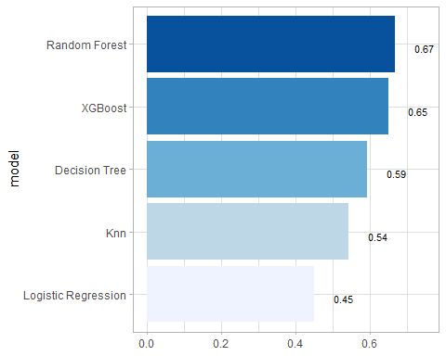

## `last_fit()` on test set  
  
# - `last_fit()` fits a model to the whole training data and evaluates it on the test set.   
# - provide the workflow object of the best model as well as the data split object (not the training data).   
   
last_fit_xgb <- last_fit(xgb_wflow,   
 split = data_split,  
 metrics = metric_set(  
 accuracy, f_meas, kap, precision,  
 recall, roc_auc, sens, spec))  
  
last_fit_xgb %>% collect_metrics(summarize = TRUE)

## # A tibble: 8 × 4  
## .metric .estimator .estimate .config   
## <chr> <chr> <dbl> <chr>   
## 1 accuracy binary 0.579 Preprocessor1_Model1  
## 2 f_meas binary 0.642 Preprocessor1_Model1  
## 3 kap binary 0.134 Preprocessor1_Model1  
## 4 precision binary 0.606 Preprocessor1_Model1  
## 5 recall binary 0.684 Preprocessor1_Model1  
## 6 sens binary 0.684 Preprocessor1_Model1  
## 7 spec binary 0.448 Preprocessor1_Model1  
## 8 roc_auc binary 0.598 Preprocessor1_Model1

#Compare to training  
xgb_res %>% collect_metrics(summarize = TRUE)

## # A tibble: 8 × 6  
## .metric .estimator mean n std_err .config   
## <chr> <chr> <dbl> <int> <dbl> <chr>   
## 1 accuracy binary 0.613 10 0.0128 Preprocessor1_Model1  
## 2 f_meas binary 0.661 10 0.0122 Preprocessor1_Model1  
## 3 kap binary 0.210 10 0.0271 Preprocessor1_Model1  
## 4 precision binary 0.644 10 0.0137 Preprocessor1_Model1  
## 5 recall binary 0.686 10 0.0226 Preprocessor1_Model1  
## 6 roc_auc binary 0.648 10 0.0185 Preprocessor1_Model1  
## 7 sens binary 0.686 10 0.0226 Preprocessor1_Model1  
## 8 spec binary 0.523 10 0.0324 Preprocessor1_Model1

## Variable importance using `{vip}` package  
  
library(vip)  
  
last_fit_xgb %>%   
 pluck(".workflow", 1) %>%   
 pull_workflow_fit() %>%   
 vip(num_features = 10) +  
 theme_light()

## Warning: `pull_workflow_fit()` was deprecated in workflows 0.2.3.  
## ℹ Please use `extract_fit_parsnip()` instead.  
## This warning is displayed once every 8 hours.  
## Call `lifecycle::last_lifecycle_warnings()` to see where this warning was  
## generated.

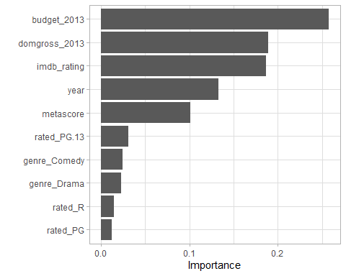

## Final Confusion Matrix  
  
last_fit_xgb %>%  
 collect_predictions() %>%   
 conf_mat(test, .pred_class) %>%   
 autoplot(type = "heatmap")

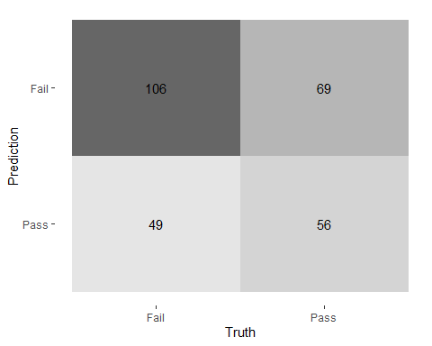

# library(yardstick)  
# ## Final ROC curve  
# last_fit_xgb %>%   
# collect_predictions() %>%   
# roc_curve(test, .pred_above) %>%   
# autoplot()

# Deliverables

There is a lot of explanatory text, comments, etc. You do not need these, so delete them and produce a stand-alone document that you could share with someone. Knit the edited and completed R Markdown (Rmd) file as a Word or HTML document (use the “Knit” button at the top of the script editor window) and upload it to Canvas. You must be commiting and pushing your changes to your own Github repo as you go along.

# Details

* Who did you collaborate with: TYPE NAMES HERE
* Approximately how much time did you spend on this problem set: ANSWER HERE
* What, if anything, gave you the most trouble: ANSWER HERE

**Please seek out help when you need it,** and remember the [15-minute rule](https://dsb2023.netlify.app/syllabus/#the-15-minute-rule). You know enough R (and have enough examples of code from class and your readings) to be able to do this. If you get stuck, ask for help from others, post a question on Slack– and remember that I am here to help too!

As a true test to yourself, do you understand the code you submitted and are you able to explain it to someone else?

# Rubric

13/13: Problem set is 100% completed. Every question was attempted and answered, and most answers are correct. Code is well-documented (both self-documented and with additional comments as necessary). Used tidyverse, instead of base R. Graphs and tables are properly labelled. Analysis is clear and easy to follow, either because graphs are labeled clearly or you’ve written additional text to describe how you interpret the output. Multiple Github commits. Work is exceptional. I will not assign these often.

8/13: Problem set is 60–80% complete and most answers are correct. This is the expected level of performance. Solid effort. Hits all the elements. No clear mistakes. Easy to follow (both the code and the output). A few Github commits.

5/13: Problem set is less than 60% complete and/or most answers are incorrect. This indicates that you need to improve next time. I will hopefully not assign these often. Displays minimal effort. Doesn’t complete all components. Code is poorly written and not documented. Uses the same type of plot for each graph, or doesn’t use plots appropriate for the variables being analyzed. No Github commits.