Igor Krol-323230102. and shai kaikov-312531031.

**The project:**

In part A we select uniformly and randomly points data from the circle that his center (0,0),with radius 2 than build a line of neurons between -2<x,y<2.

In part B we select uniformly and randomly points data from the circle that his center (0,0),with radius 2 than build a circle of neurons between on the circle of the data.

In part C we select uniformly and randomly points data from the circle that his center (0,0),with radius 2 than build a 5x5 of neurons.

In part D we select randomly points data from the circle that his center (0,0),with radius 2 and return on A,B,C but with proportional to the distance from the center.

In part E we select randomly points data from the circle that his center (0,0),between radius 2 and 4 and return of parts A and B.

**Part A-performance:**

As we see the neurons are scattered in very good way from the 20 iteration. The scattering is caused by the neighboring and according the input from the circle.

. 29 and below that 39(iteration). 1 iteration and below the number 2

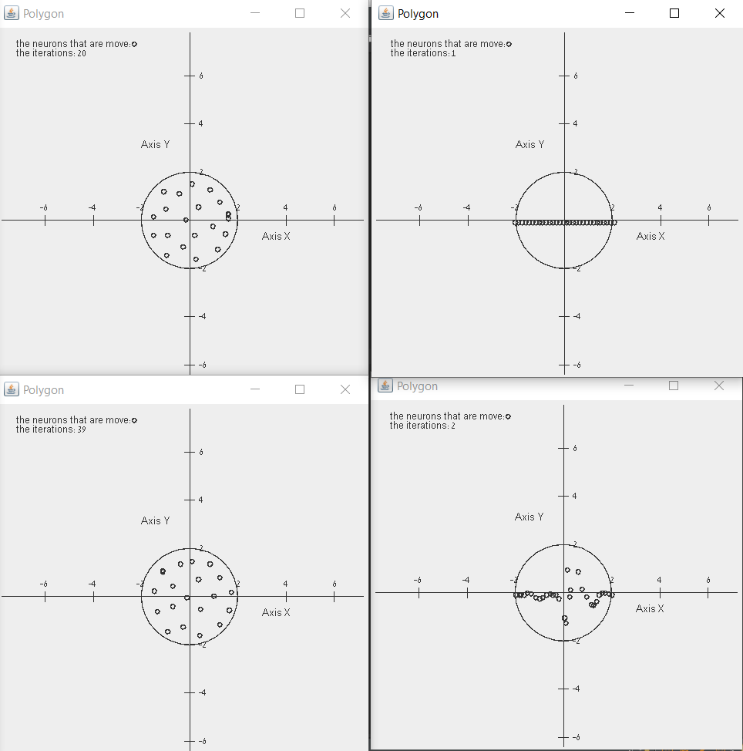

95 and below that 100. 60 and below that 81.

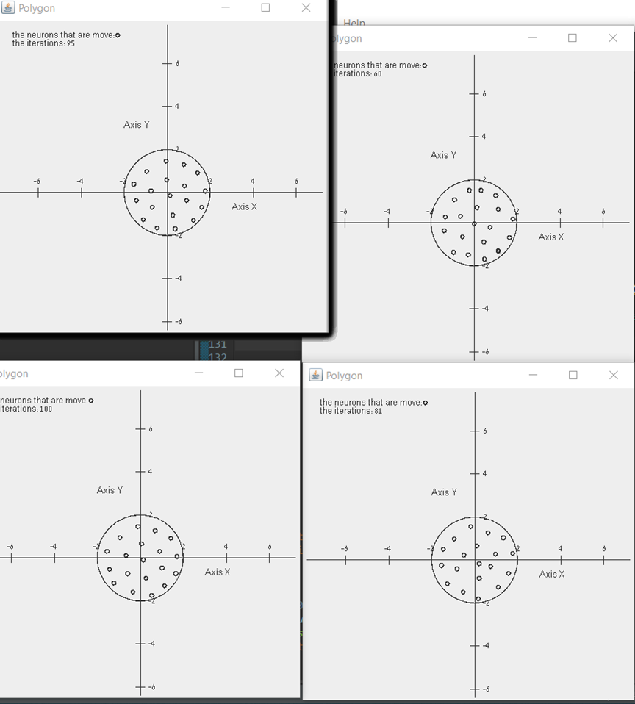

**Part B-performance:**

6 and below that 45. 1 and below that 2.

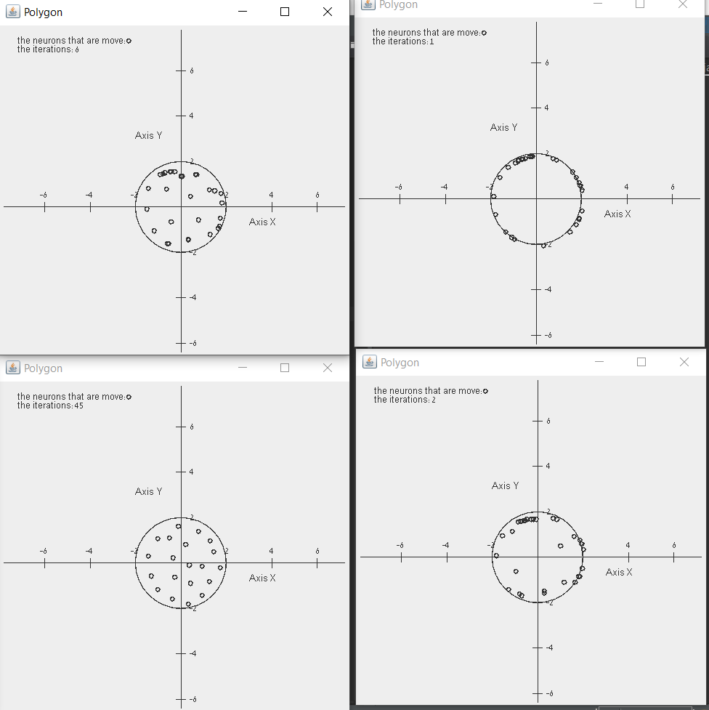

95 and below that 100. 65 and below that 85.

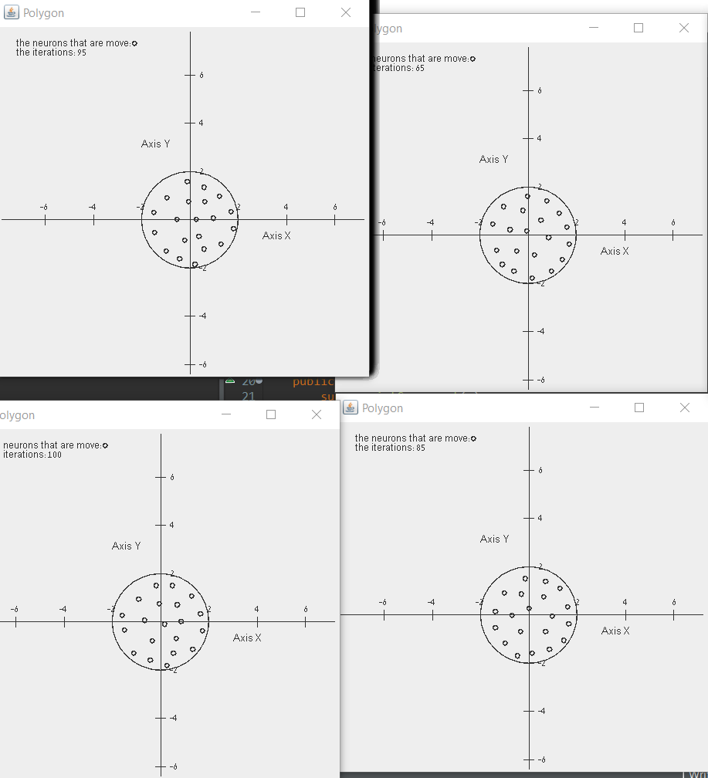

**Part C-performance:**

22 and below 45. 1 and below 11.

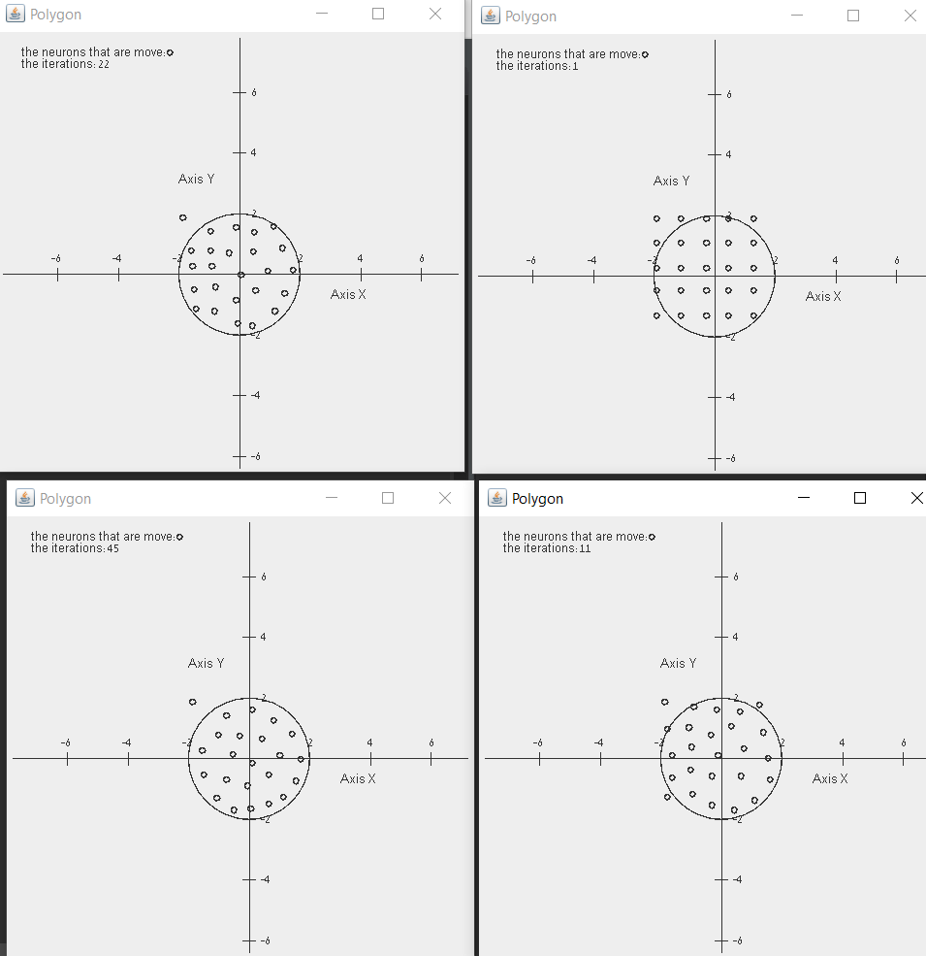

81 and below 100

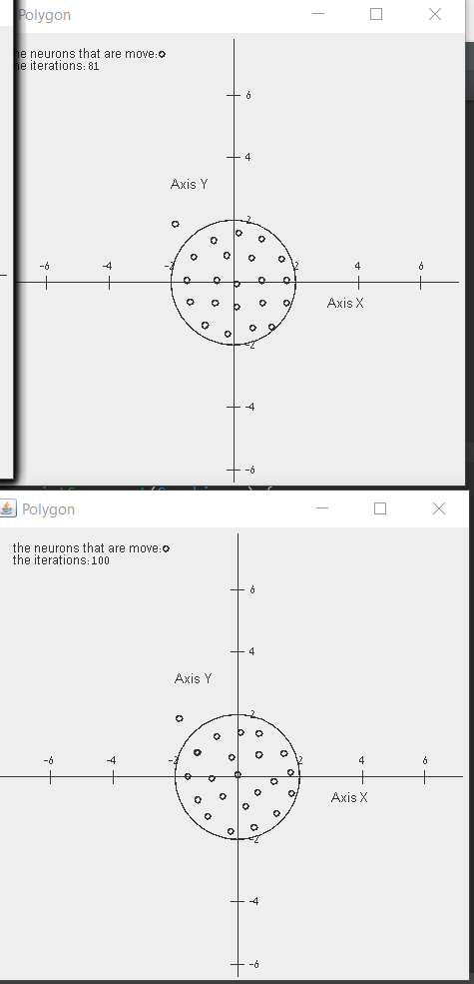

**Part D-performance-with the A part-the line:**

14 and below 59. 1 and below 3.

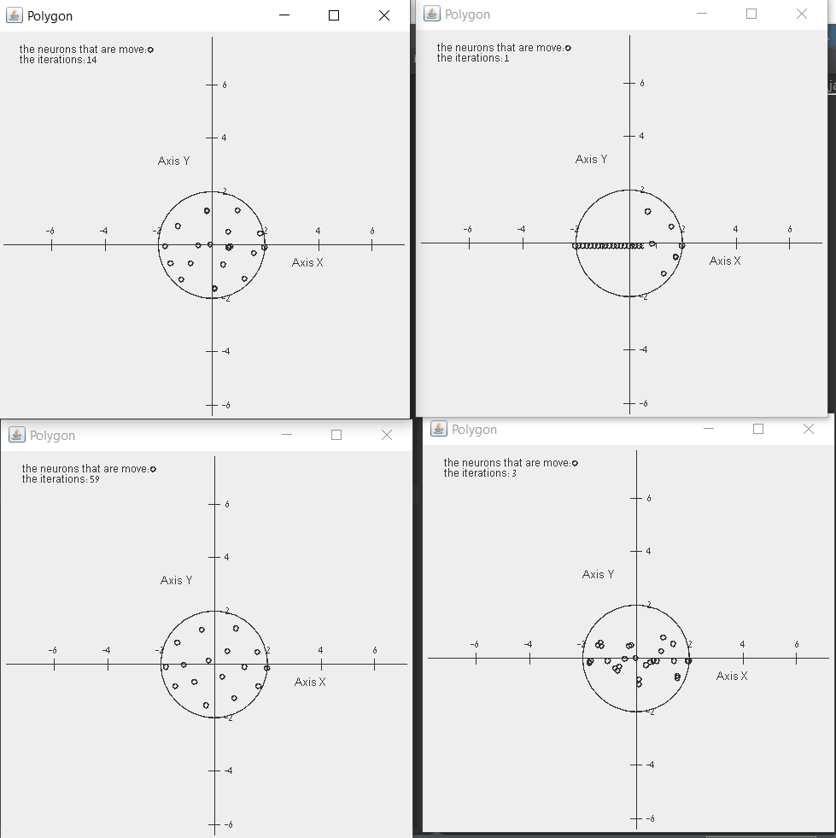

91 and below 100.

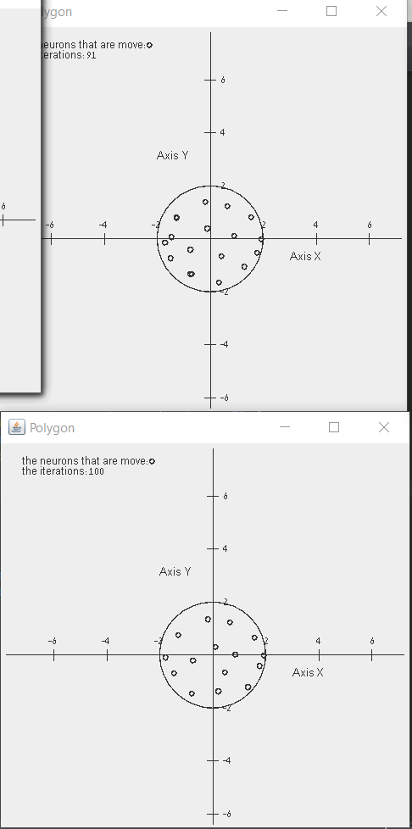

**Part D-performance-with the B part-the circle:**

20 and below 40. 1 and below 4.

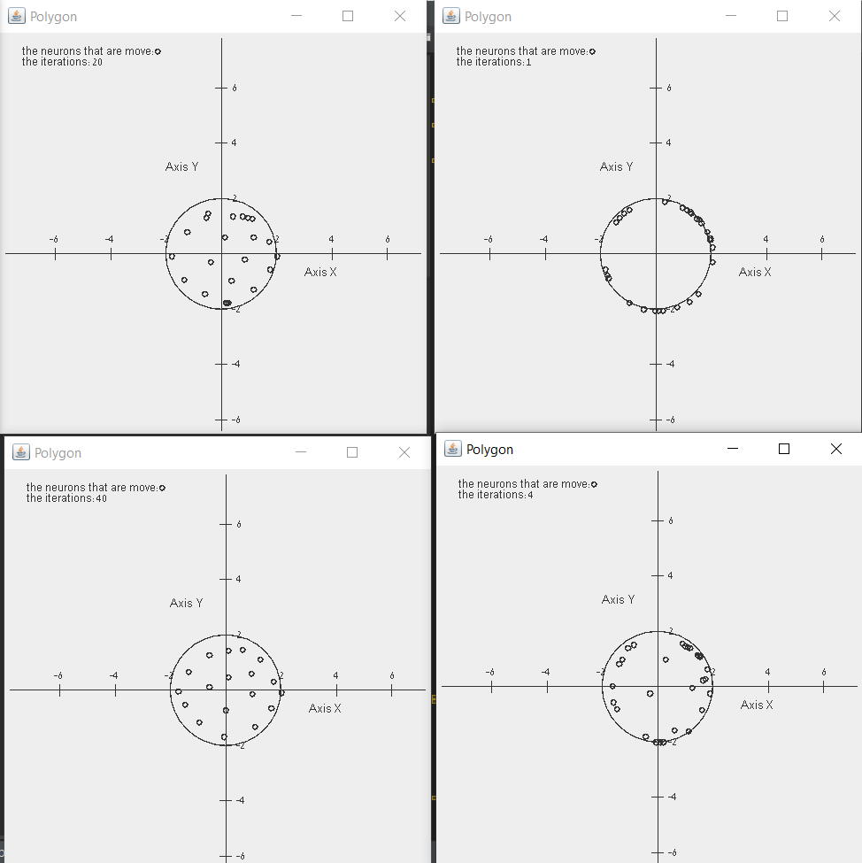

81 and below 100.

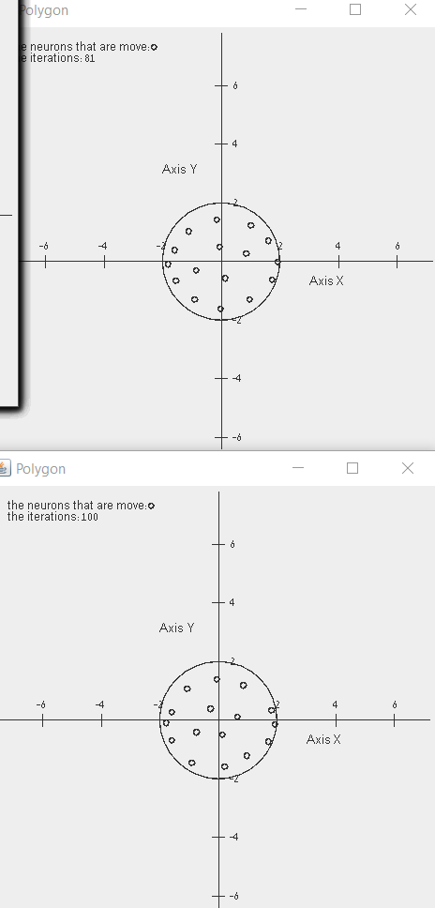

**Part D-performance-with the C part-the 5X5:**

6 and below 23. 1 and below 4.

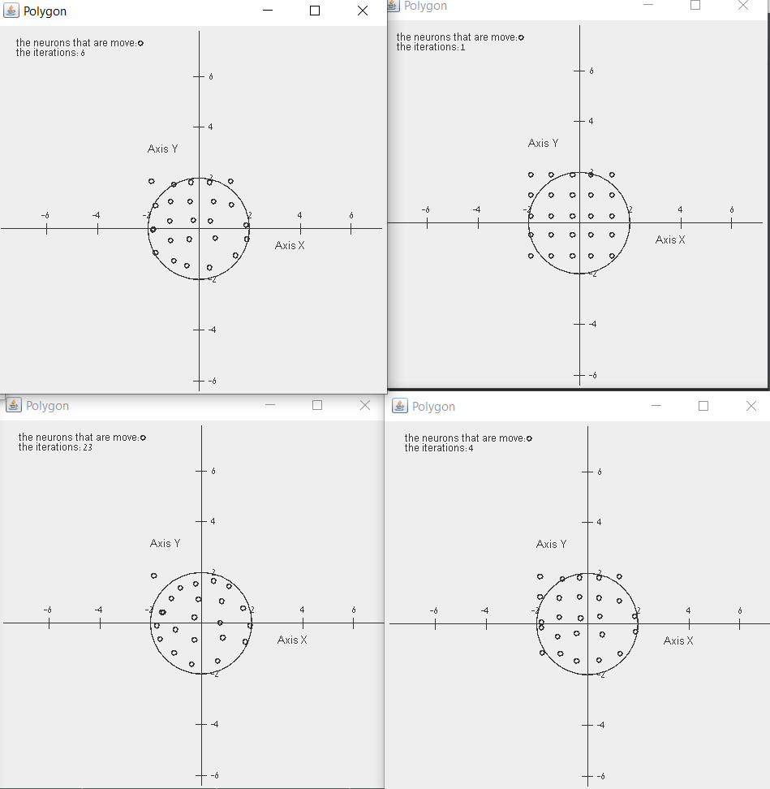

75 and below 100.

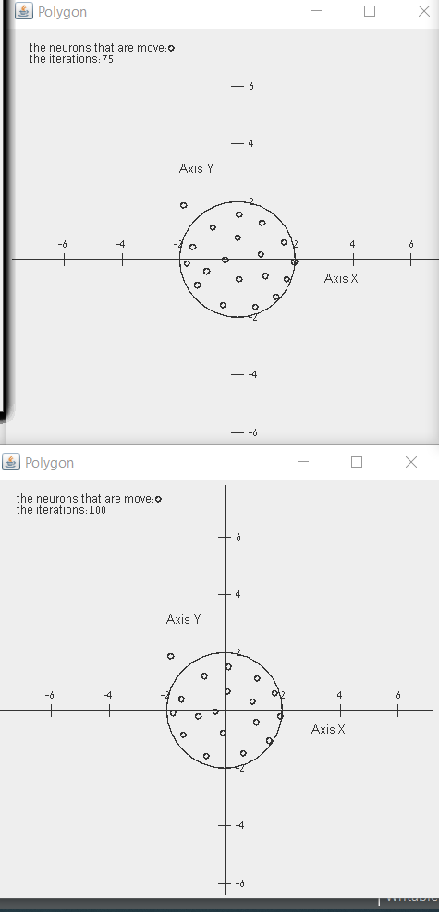

**Part E-performance--with the A part-the line:**

17 and below 65. 1 and below 2.

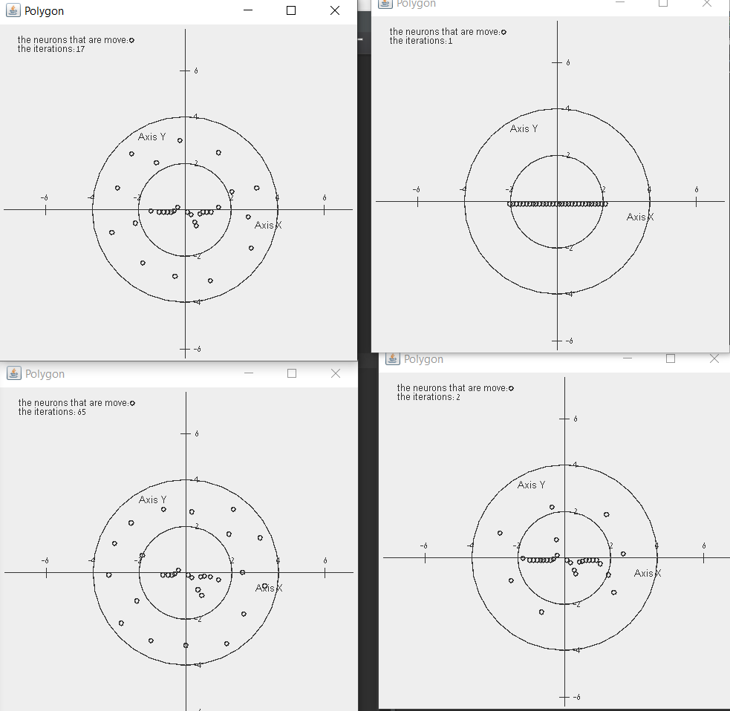

80 and below 100.

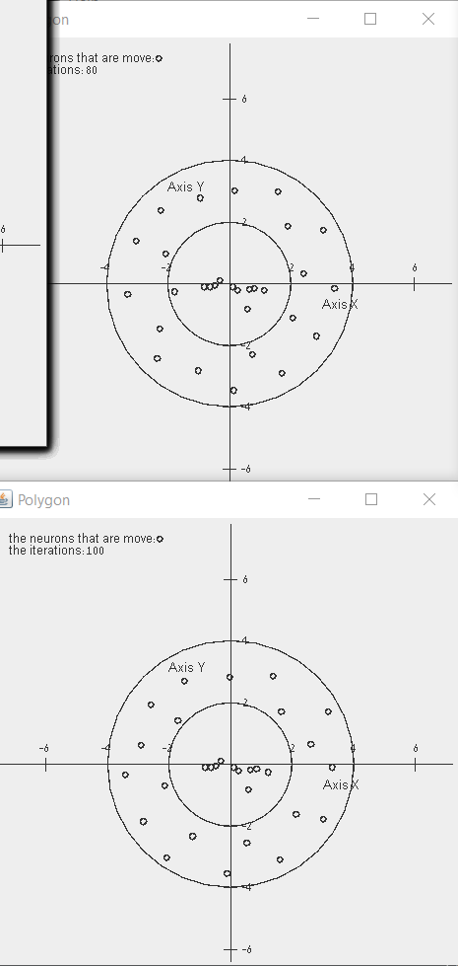

**Part E-performance--with the B part-the circle:**

11 and below 21. 1 and below 3.

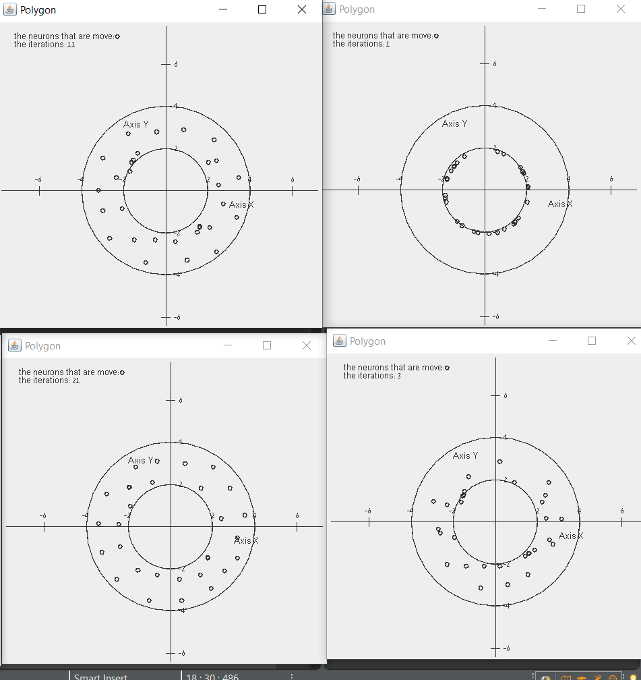

80 and below 100.

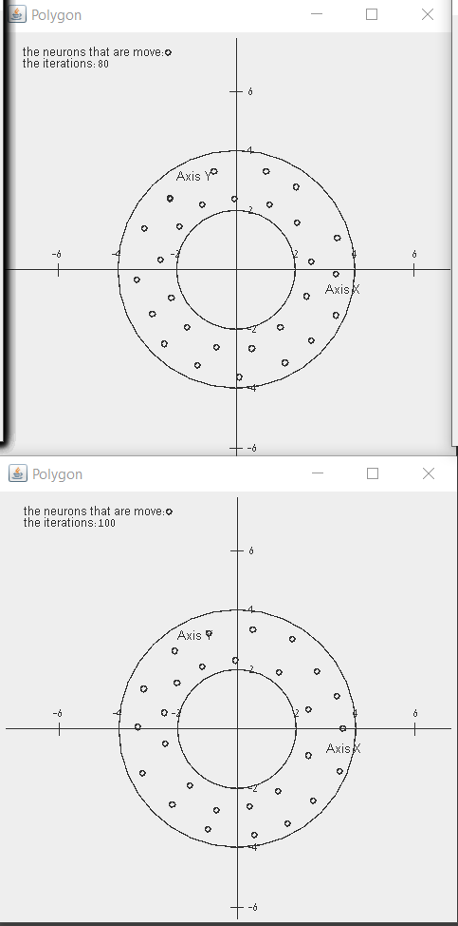

**Conclusion:**

Our learning rate was 0.1-that was the best for us .we saw in average that after 20-40(every iteration is 50 rounds in the algorithm) iterations the neurons are ordered on the topology that we wanted. every algorithm finished after 100 iterations the gaussian function was start from 0.2.

We first update the closet neurons to the input and than his neighbors and we did that after every iteration.in the end almost all neurons after 100 iterations built according the topology of the circle data.