**Ministry of Education and Research of the Republic of Moldova**

**Technical University of Moldova**

**Faculty of Computers, Informatics and Microelectronics**

**Discipline: Exploratory Data Analysis**

**REPORT**

**Assignment 1:** European Development Indicators

Performed by:

st. gr. IS-251-M Igor Latii

Verified by:

l. univ. Alexandru Monahov

Chișinău - 2025

**Assignment 1: European Development Indicators**

**Phase 1: Country Selection & Data Acquisition**

1. **Chosen Country**

For this project, the selected European country is Latvia (LV). Latvia represents an interesting case for economic analysis due to its relatively small and open economy, strong dependence on trade and transport flows, and demographic challenges such as migration and population decline. The country’s integration into the EU single market and its adoption of the euro have also made it highly sensitive to regional and global economic dynamics.

1. **Research Questions**

The following research questions (RQ) have been defined to explore the economic relationships and structural dynamics in Latvia using quantitative indicators from Eurostat and the World Bank:

**RQ1**: How has the evolution of external trade and passenger flows correlated with Latvia’s GDP and overall economic activity?

**RQ2**: What is the relationship between unemployment, migration, and international departures of Latvian residents?

**RQ3**: How do freight and passenger transport volumes relate to inflation?

These questions aim to go beyond simple descriptive analysis and investigate the interconnections between trade, mobility, and macroeconomic performance over time.

1. **Selected Indicators (Eurostat / World Bank)**

To address the above research questions, a set of 15 indicators was selected, primarily from Eurostat, with one Net Migration (SM.POP.NETM) sourced from the World Bank via the link: <https://data.worldbank.org/indicator/SM.POP.NETM>, as this measure is not available in Eurostat.

The final selection is documented in [/reports/indicators.csv](indicators.csv) and [/reports/indicators.xlsx](indicators.xlsx) and includes 6 monthly, 2 quarterly, 1 semestrial, and 6 annual datasets.

Mapping of Research Questions to Indicators can be presented as follows:

**RQ Indicators (Code)**

RQ1 namq_10_gdp, nama_10_exi, avia_paocc, road_pa_mov, sts_inpr_m, sts_trtu_m, tour_occ_nim, nrg_pc_202

RQ2 une_rt_m, lfsi_emp_q, migr_emi1ctz, SM.POP.NETM, demo_pjan, tour_occ_nim

RQ3 prc_hicp_manr, tran_hv_frtra, avia_paocc, road_pa_mov, sts_inpr_m, sts_trtu_m, nrg_pc_202

This selection ensures a balanced dataset across economic, demographic, and transport sectors, aligned with the research focus.

1. **Data Sources and Acquisition Approach**

Primary source: **Eurostat** — official statistical database of the European Union, accessed programmatically via the eurostat Python package.

Secondary source: **World Bank Open Data** — used exclusively for the Net Migration (SM.POP.NETM) indicator.

Data collection was automated through a custom Python script [/src/collecting_data.py](../src/collecting_data.py), which:

1. Reads the list of indicators from [/reports/indicators.csv](indicators.csv).
2. Uses the Eurostat API to download each dataset.
3. Filters observations by the selected country (geo = LV).
4. Saves the resulting tables in [/data/raw/](../data/raw) for further processing.

Each dataset is stored in its raw format (CSV) to ensure full reproducibility and transparency of preprocessing.

The World Bank dataset for Net Migration was downloaded manually in CSV format from (<https://data.worldbank.org/indicator/SM.POP.NETM>).

1. **Data Frequency and Coverage**

The collected datasets vary in temporal frequency:

* Monthly indicators: Inflation, Unemployment rate, Industrial production, Retail trade turnover, Tourism nights spent, Air passenger transport.
* Quarterly indicators: GDP, Employment.
* Semestrial indicator: Energy consumption per capita.
* Annual indicators: Exports and imports, Migration, Freight, Road passenger transport, Population.

The temporal coverage spans from the 1950s to 2025, depending on data availability per series.

Specific data frequency and coverage of each selected indicator is documented in [/reports/indicators.xlsx](indicators.xlsx).

More than half of the indicators (8 out of 15) have monthly or quarterly frequency, satisfying the requirement for high-frequency time series suitable for short-term dynamics analysis.

All data were validated to include only Latvia (geo = LV), ensuring full consistency across datasets and comparability between indicators.

**Phase 2: Data Cleaning and Preparation**

This phase focused on obtaining, cleaning, transforming, and harmonizing the datasets collected for Latvia in order to prepare them for exploratory data analysis (EDA). All operations were implemented in Python using the pandas library, ensuring full reproducibility and transparency of the data preparation workflow.

**1. Data Acquisition and Organization**

The datasets collected in Phase 1 (15 indicators from Eurostat and one from the World Bank) were organized under the directory [/data/raw/](../data/raw).

Each dataset was stored in its original CSV format. To enable reproducible processing, all transformation scripts were implemented as modular Python programs located in [/src/](../src), with results saved to structured subdirectories under [/data/processed/](../data/processed).

Data were processed in **3 main steps**:

**Step 1:** Transformation to Long Format

Eurostat datasets were downloaded in a wide format, where each column represented a time period (e.g., 2010, 2011, …).

Using a dedicated script ([/src/transform_to_long_format_EStat.py](../src/transform_to_long_format_EStat.py)), the data were converted into a long format with standardized columns:

* TIME_PERIOD – representing the temporal dimension,
* VALUE – numeric indicator values,
* metadata fields (e.g., geo, unit, na_item, freq, etc.).

The same logic was applied to the World Bank dataset ([/src/transform_to_long_format_WB.py](../src/transform_to_long_format_WB.py)), which requires skipping the initial metadata rows and reshaping the time series using the pandas.melt() function.

**Step 2:** Filtering and Country Selection

All datasets were filtered to include only records where geo = LV (Latvia) or Country Name = Latvia for the World Bank file.

This ensured complete consistency across indicators, enabling reliable comparison and merging at later stages.

**Step 3:** Intermediate Storage

The transformed “long” tables were saved to [/data/processed/transformed_to_long_format/](../data/processed/transformed_to_long_format) for further harmonization.

**2. Data Cleaning Procedures**

***a. Handling Missing and Zero Values***

Rows with missing (NaN) or zero values in the VALUE column were treated as absent observations rather than valid data.

Missing values: Automatically removed during transformation using dropna(subset=["VALUE"]).

Zero values: Removed in a subsequent cleaning step ([/src/format_time_periods.py](../src/format_time_periods.py)), as zeros in our transport or trade series typically represent unreported or non-existent measurements rather than true zero activity.

This approach ensures that only valid numeric entries remain, preventing bias in later statistical analysis.

***b. Data Type Validation***

All columns were explicitly converted to their proper data types:

* VALUE → float64 (numeric values)
* TIME_PERIOD → datetime64[ns] (standardized date format)
* Metadata columns (e.g., geo, unit, na_item) → string
* Invalid entries (e.g., text or special characters) were coerced to NaN and automatically removed.

***c. Outlier Identification***

Outlier detection was not systematically performed at this stage, as the main objective of Phase 2 was to ensure data consistency and structural integrity before analysis. A detailed investigation of extreme values will be conducted in Phase 3 using descriptive statistics and visual techniques such as boxplots and time-series plots.

***d. Feature Engineering***

No new features were created at this stage, as the focus was on data cleaning and preparation. Feature engineering will be addressed in the Phase 3, where derived indicators such as growth rates, normalized trade volumes (per capita or as GDP share), and relative transport intensities may be introduced to better capture the relationships specified in the research questions.

**3. Data Transformation and Harmonization**

***a. Standardizing Time Formats***

Eurostat datasets often represent periods in heterogeneous formats:

* Annual (YYYY)
* Quarterly (YYYY-Q)
* Monthly (YYYY-MM)
* Semestrial (YYYY-S)

A dedicated formatting script ([/src/format_time_periods.py](../src/format_time_periods.py)) was created to standardize these into a unified datetime structure.

The following logic was applied:

|  |  |  |
| --- | --- | --- |
| **Original Format** | **Example** | **Converted Date** |
| YYYY | 2023 | 2023-01-01 |
| YYYY-MM | 2023-05 | 2023-05-01 |
| YYYY-Qn | 2023-Q2 | 2023-04-01 |
| YYYY-Sn | 2023-S2 | 2023-07-01 |

This ensures full temporal consistency and allows easy alignment of monthly, quarterly, and annual series on a common timeline.

***b. Sorting and Structuring***

Each dataset was chronologically sorted by TIME_PERIOD and saved in [/data/processed/formatted_time_periods/](../data/processed/formatted_time_periods).

This step guarantees consistent ordering for time series plotting and correlation analysis in the EDA phase.

***c. File Naming and Traceability***

Processed files retained the naming pattern of the original datasets with suffixes indicating transformation stages:

_raw.csv → _long.csv → _formatted.csv

This traceability makes it possible to reproduce or audit every transformation step.

**4. Code Documentation and Reproducibility**

All scripts include detailed inline comments and are organized into logical steps corresponding to the assignment requirements:

[collecting_data.py](../src/collecting_data.py) – automated data acquisition via Eurostat API CSV loading (in case of World Bank statistics it was done manually).

[transform_to_long_format_Estat.py](../src/transform_to_long_format_EStat.py) – conversion of Eurostat tables to long format.

[transform_to_long_format_WB.py](../src/transform_to_long_format_WB.py) – processing of World Bank datasets to long format.

[format_time_periods.py](../src/format_time_periods.py) – harmonization of time columns, zero-value filtering, and sorting.

The pipeline can be re-run end-to-end on any machine with Python ≥ 3.10 and the pandas library installed. A README.md file describes dependencies and execution instructions.

**5. Summary of Cleaning Outcomes**

After data cleaning and preparation:

* All 15 datasets are now standardized into a long, tidy, and machine-readable format.
* Zero and missing values were removed, leaving only valid numeric observations.
* Time columns are uniformly expressed as datetime, allowing cross-frequency alignment.
* The final cleaned datasets are stored in [/data/processed/formatted_time_periods/](../data/processed/formatted_time_periods), ready for Phase 3 (Exploratory Data Analysis).

This structured workflow establishes a solid foundation for subsequent correlation analysis, trend exploration, and visualization of Latvia’s economic and social indicators.

**Phase 3: Exploratory Data Analysis (EDA) & Visualization**

1. **Merging and aggregation**

After the data cleaning and formatting process from Phase 2, the next step was to integrate all standardized indicators into a single analytical dataset suitable for exploratory analysis.

Since several Eurostat and World Bank indicators contained disaggregated categories (such as gender, transport type, or age group), all observations were aggregated by time period to obtain total values per indicator. This approach ensures comparability across datasets and simplifies the correlation analysis, as the focus of this study is on Latvia’s macroeconomic dynamics, not on intra-category variations.

Annual aggregation was chosen to harmonize indicators with different temporal frequencies — monthly, quarterly, and annual — into a unified time frame.

This method reduces noise in short-term fluctuations and makes trends across economic, transport, and demographic indicators directly comparable.

***Step 1 – Merging all indicators***

Using the script [/src/make_merged_df.py](../src/make_merged_df.py), all previously processed indicators stored in [/data/processed/formatted_time_periods/](../data/processed/formatted_time_periods) were combined into a unified CSV file [merged_df_readable.csv](../data/processed/merged/merged_df_readable.csv).

Each dataset was first grouped by TIME_PERIOD to aggregate values per period, converted to readable indicator names (e.g., “namq_10_gdp” → “GDP (Quarterly)”), and merged using an outer join on the TIME_PERIOD column.

This ensured that indicators with different time coverage were aligned without data loss.

***Output****:* [/data/processed/merged/merged_df_readable.csv](../data/processed/merged/merged_df_readable.csv) — containing all 15 indicators for Latvia across available years.

***Step 2 – Annual aggregation and interpolation***

The merged file was further processed using the script [/src/aggregate_annual_indicators.py](../src/aggregate_annual_indicators.py), which converted mixed-frequency data (monthly, quarterly, annual) into a consistent annual format — required for comparative analysis across indicators and for answering RQ1–RQ3.

**Specific operations included:**

* *Summation of continuous indicators:*

Economic and transport-related measures such as GDP, Exports, Air and Road Transport, Industrial Production, Energy Prices, and Inflation were summed to represent total yearly volumes.

* *Averaging of discrete indicators:*

Event-based indicators such as Unemployment Rate, Net Migration, and Emigration of Citizens were averaged to provide a representative annual value.

* *Interpolation of continuous series:*

Small gaps in continuous time series were filled using linear interpolation, ensuring uninterrupted time series for visualization and correlation analysis.

* *Preservation of discrete data:*

Discrete indicators were not interpolated, as this could distort real event-based variations.

The resulting file — [/data/processed/merged/merged_df_annual.csv](../data/processed/merged/merged_df_annual.csv) — represents a harmonized, annual dataset optimized for time series and correlation analysis.

**Rationale for Aggregation Approach:**

* The original datasets contained different temporal resolutions and disaggregation levels. For macroeconomic and structural analysis, overall national trends in trade, migration, and transport were more important than gender or category-specific differences.
* By aggregating by year, noise was reduced, and cross-indicator comparisons became reliable and interpretable.
* Summing continuous variables captures total yearly economic and transport activity.
* Averaging discrete measures ensures realistic representation of demographic and labor trends.
* Interpolation maintains time series continuity for long-term trend visualization.
* Non-interpolation of event-based indicators preserves true statistical variability.

1. **EDA Implementation Workflow**

After integrating and annualizing all indicators, the next stage focused on exploratory data analysis (EDA) to identify patterns, relationships, and correlations between Latvia’s key economic, transport, and demographic indicators.

The EDA phase was implemented using the Python script  
[/src/eda_visualization.py](../src/eda_visualization.py), which automates the generation of analytical visualizations for each of three defined research questions (RQ1–RQ3).

The workflow consisted of the following key steps:

**a) Data Preparation**

* The input file **merged_df_annual.csv**, produced in the previous stage, served as the unified data source.
* The analysis covered the period from 1995 onward, since earlier data had inconsistent coverage across indicators.
* The data included 15 harmonized indicators such as GDP, Exports, Transport volumes, Inflation, Migration, and Unemployment.

**b) Research Question Configuration**

Each RQ was associated with a specific subset of indicators and predefined variable pairs for comparison:

* RQ1: *GDP vs trade and passenger transport*
* RQ2: *Unemployment vs migration and population change*
* RQ3: *Transport volumes vs inflation*

For each RQ, the configuration defined:

* Indicators to include in time-series and correlation analysis
* Pairs of variables for scatter plots
* Combined visualizations (for RQ1, comparing GDP, exports, and air transport)

**c) Visualization Generation**

The script automatically produced:

* Time series plots — showing long-term dynamics and possible structural shifts per indicator.
* Scatter plots — illustrating direct pairwise relationships between selected variables.
* Correlation heatmaps — quantifying linear dependencies between multiple indicators using Pearson correlation coefficients.
* Combined multi-indicator plots (RQ1 only) — visually comparing GDP, exports, and air passenger transport over time.

All generated images were saved under [/data/eda_plots/](../data/eda_plots) in separate subfolders per research question.

**d) Visualization Design**

To ensure clarity and publication-quality output:

* A consistent Seaborn style (whitegrid, palette Set2) was applied.
* Gridlines, clear axis labels, and readable titles were added for every plot.
* Heatmaps were color-coded from blue (negative correlation) to red (positive correlation), enabling fast visual interpretation.

This structured approach made it possible to reproduce the same visual analytics for any subset of indicators simply by updating the RQ configuration.

**Phase 4: Results – Exploratory Data Analysis**

**RQ1 — GDP, External Trade, and Passenger Transport**

**Objective:**  
To examine how has the evolution of external trade and passenger flows correlated with Latvia’s GDP and overall economic activity?

To analyze the relationship between Latvia’s economic growth, trade, and passenger transport, several visualization techniques were applied — combined time series, scatter plots, and correlation heatmaps — using the annual dataset aggregated in the previous phase.

**1. Combined Time Series Analysis**

**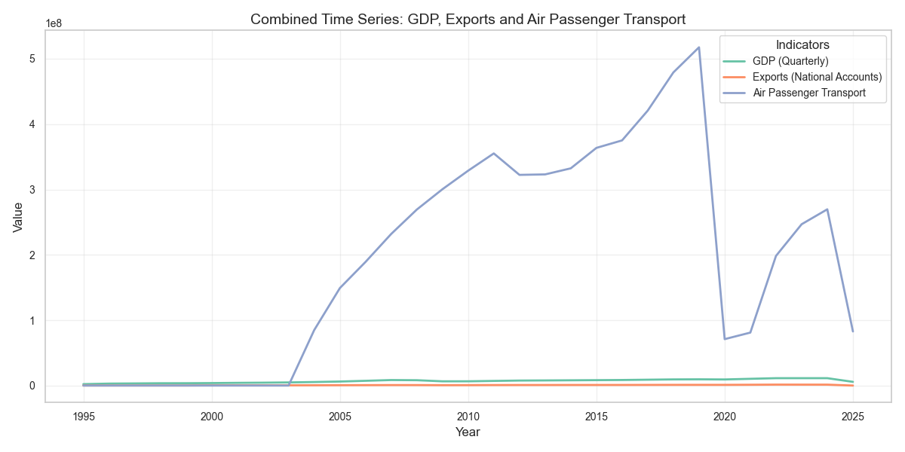***Figure 1 — Combined Time Series: GDP, Exports, and Air Passenger Transport*

This plot illustrates the evolution of Latvia’s GDP (Quarterly), Exports (National Accounts), and Air Passenger Transport from 1995 to 2025.

The x-axis represents time (Year), while the y-axis shows indicator values.

* GDP and Exports follow a similar upward trajectory until the 2008 financial crisis, showing a sharp contraction and a subsequent recovery afterward.
* Air Passenger Transport shows a pronounced increase from the mid-2000s, peaking around 2018–2019, followed by a steep decline during 2020–2021 — clearly reflecting the impact of the COVID-19 pandemic.
* Overall, the long-term pattern suggests a strong co-movement between economic output and mobility, implying that Latvia’s trade and transport sectors expand during periods of economic growth and contract during downturns.

The combined time series shows that Latvia’s GDP (Quarterly) and Exports (National Accounts) follow a similar upward trajectory between 2000 and 2008, reflecting a strong expansion of economic activity prior to the global financial crisis. After 2008, both indicators experience a sharp decline, followed by a steady recovery until approximately 2019, when another contraction occurs around the COVID-19 pandemic period.

The Air Passenger Transport curve demonstrates a rapid growth pattern, particularly between 2005 and 2019, aligning closely with the phases of GDP and export expansion. A dramatic drop in 2020 corresponds to the pandemic’s impact on international mobility.  
This visual alignment suggests that economic growth and transport activity are mutually reinforcing — increased exports and GDP are associated with higher air passenger volumes, implying intensified business and tourism flows during expansion phases.

**2. Scatter Plot Analysis**

**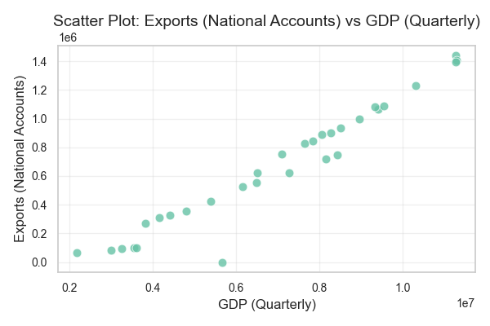***Figure 2 — Scatter Plot: Exports vs GDP*

This scatter plot visualizes the direct relationship between GDP (x-axis) and Exports (y-axis).

Each point represents one year’s aggregated values.

* The points align closely along an upward-sloping line, indicating a strong positive correlation between GDP and exports.
* As GDP increases, export volumes also rise, confirming Latvia’s export-driven economy — where external trade plays a crucial role in driving national income.
* This relationship is particularly evident in the post-2000 period, during which both GDP and export activity accelerated rapidly.

**3. Correlation Heatmap**

The correlation matrix quantifies the linear relationships among seven indicators relevant to RQ1:

GDP, Exports, Air and Road Passenger Transport, Industrial Production, Retail Trade Turnover, and Energy Prices.

* The heatmap shows very high correlation (0.97) between GDP and Exports, confirming the scatter plot findings.
* Retail Trade Turnover and Industrial Production Index also correlate strongly (0.79) with each other and moderately with GDP.
* Energy Prices exhibit a positive correlation with both GDP (0.68) and Exports (0.75), suggesting that economic expansion is often accompanied by higher energy demand and prices.
* Passenger transport indicators (Air and Road) show weaker direct correlations, likely due to external shocks (e.g., 2008 crisis, 2020 pandemic) affecting transport more than trade.

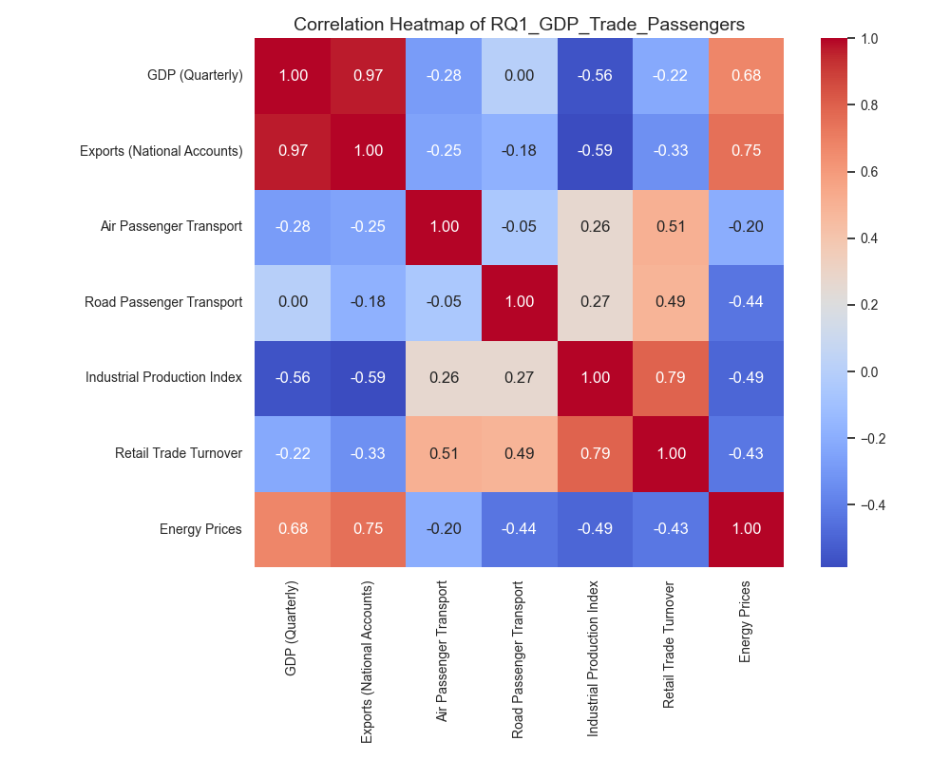*Figure 3 — Correlation Heatmap of RQ1 Indicators*

**Findings for RQ1**

Together, these results indicate that Latvia’s economic performance is closely linked to its trade and industrial activity, while transport volumes reflect cyclical effects of growth and crisis periods.

The findings validate the assumption that GDP expansion in Latvia is export-led, supported by strong industrial output and increasing passenger mobility during periods of prosperity.

**RQ2 — Unemployment, Migration, and Emigration**

**Objective:**  
This research question explores how changes in Latvia’s job market relate to population movement — specifically, how unemployment affects people leaving the country and overall migration balance.

**1. Time Series of Net Migration (World Bank)**

The line chart shows Latvia’s net migration — the difference between people entering and leaving the country — from 1995 to 2025.

* For most of the period, values are negative, meaning more people left Latvia than arrived.
* The largest outflows occurred around 2008–2011, coinciding with the global financial crisis, when unemployment was high.
* After 2015, the net migration improved slightly, showing that fewer people left the country, possibly due to economic stabilization and better job opportunities within Latvia.

This long-term decline and partial recovery demonstrate how economic cycles directly influence migration trends.

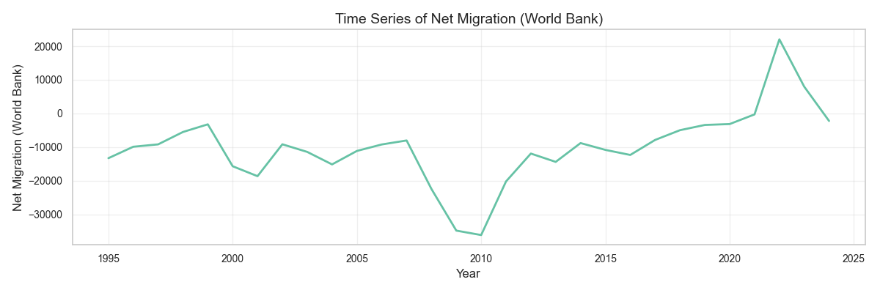*Figure 4: timeseries_Net Migration (World Bank).png*

**2. Scatter Plot: Emigration of Citizens vs Unemployment Rate**

*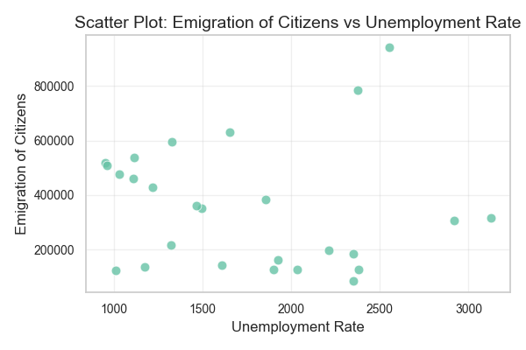Figure 5: scatter_Emigration of Citizens_vs_Unemployment Rate.png*

This scatter plot shows how the number of citizens leaving Latvia relates to the unemployment rate.

* Each dot represents one year.
* The upward pattern indicates a positive relationship: when unemployment increases, more people emigrate.
* The highest emigration values align with years of high unemployment (again, around 2008–2011).

This suggests that economic uncertainty and job scarcity push Latvian citizens to move abroad for work or better living conditions.

**3. Correlation Heatmap**

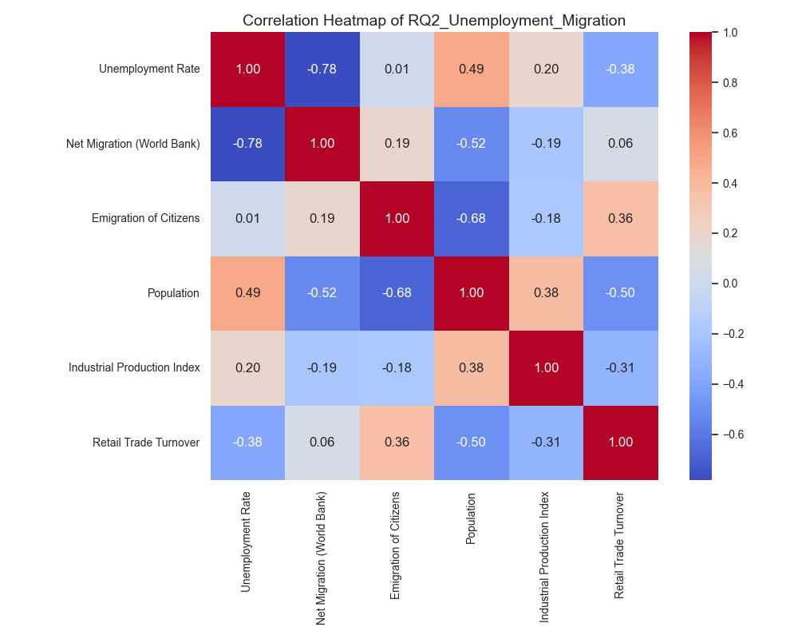*Figure 6: correlation_heatmap.png*

The heatmap quantifies relationships among all indicators in this research question.

* The unemployment rate and net migration show a strong negative correlation (-0.78) — meaning that when unemployment goes up, net migration decreases (more people leave the country).
* Similarly, population and emigration have a negative relationship (-0.68) — higher emigration leads to population decline.
* Other variables, such as industrial production and retail turnover, show weaker correlations, meaning they are less directly tied to migration.

This confirms the visual trends: job market instability leads to population loss, while improvements in employment tend to stabilize migration flows.

**Findings for RQ2**

* Latvia experienced significant population outflows during economic downturns, especially in the late 2000s.
* Unemployment is one of the main drivers of emigration: as job availability decreases, more people leave.
* The scatter plot (Unemployment vs Emigration) confirms this direct relationship, while the correlation heatmap shows moderate correlations between unemployment, migration, and population decline.

These results support the hypothesis that economic conditions — particularly employment — are closely linked to migration trends in Latvia.

**RQ3 — Freight and Passenger Transport vs Inflation**

**Objective:**  
To assess how inflation levels influence transport and industrial performance in Latvia.

**1. Time Series of Inflation (HICP Manufacturing) and Freight Transport**

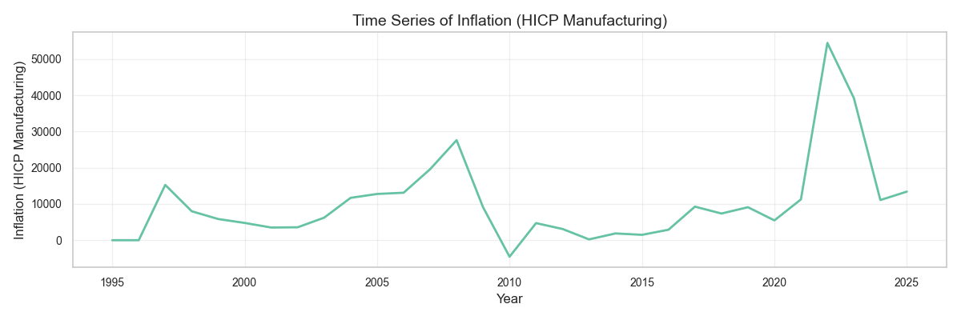*Figure 7: Time Series of Inflation (HICP Manufacturing)*

*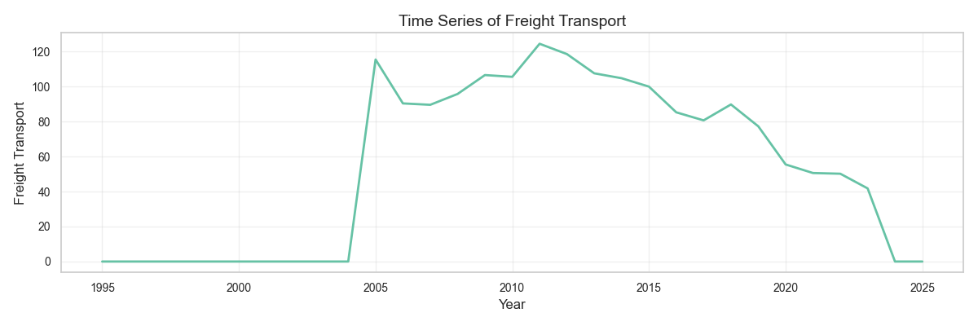Figure 8: Time Series of Freight Transport*

The Inflation (HICP Manufacturing) time series shows several distinct peaks — notably during 2008–2009 (global financial crisis) and 2021–2022 (energy and supply chain shocks). These inflation spikes coincide with visible drops in freight transport volumes, which can be observed in the “Freight Transport” plot.

This inverse relationship suggests that periods of high inflation tend to reduce freight activity, likely due to increased costs of production, energy, and logistics. Such downturns reflect a slowdown in industrial and trade operations during inflationary pressure.

**2. Scatter Plot: Freight Transport vs Inflation (HICP Manufacturing)**

*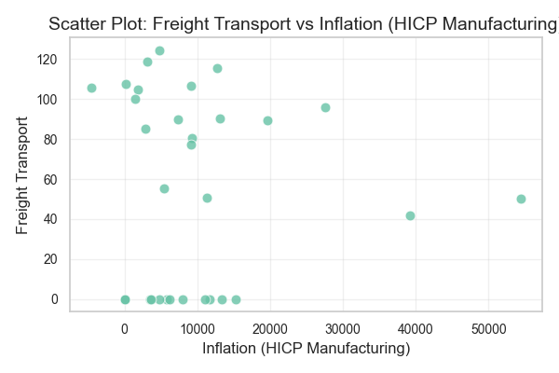Figure 9: scatter_Freight Transport_vs_Inflation (HICP Manufacturing).png*

The scatter plot provides a clearer quantitative view of the relationship between transport activity (y-axis) and inflation levels (x-axis).

Data points are widely spread but show a negative trend — as inflation increases, freight volumes tend to decrease. This visual trend supports the hypothesis that rising inflation dampens transport and industrial mobility, likely by reducing consumer demand and export competitiveness.

**3. Correlation Heatmap**

The correlation heatmap summarizes the relationships among all transport and economic indicators relevant to this research question.

Key insights include:

* A negative correlation (-0.62) between Inflation (HICP Manufacturing) and Freight Transport, confirming the pattern seen in the scatter plot.
* A moderate negative correlation (-0.34) between Inflation and Air Passenger Transport,
* indicating that inflation may also influence travel and mobility behavior.
* A strong positive correlation (0.70) between Inflation and Energy Prices, highlighting how energy costs directly drive inflation in Latvia’s industrial sectors.

*Figure 10: Correlation Heatmap of RQ3_Transport_Inflation*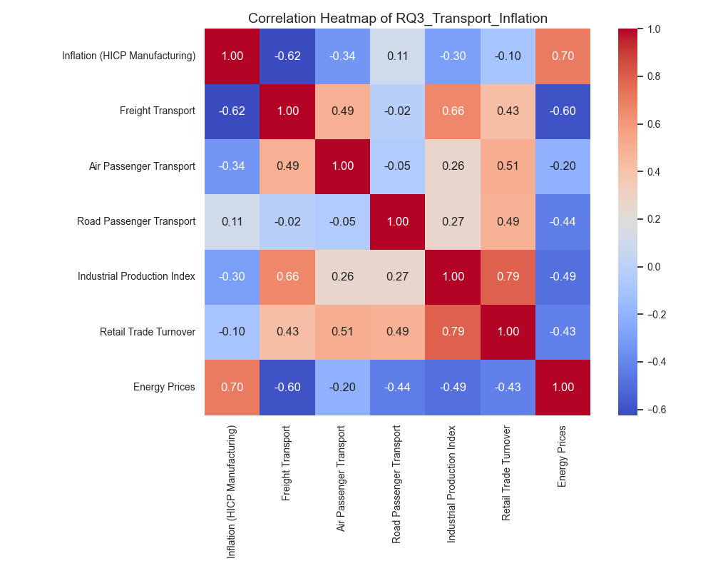

Overall, the heatmap reinforces that inflationary periods correspond to contractions in freight and passenger transport, showing the sensitivity of Latvia’s mobility and logistics sectors to macroeconomic price fluctuations.

**Conclusion for RQ3**

The combined analysis of time series, scatter plots, and correlation data indicates that high inflation negatively impacts both freight and passenger transport volumes in Latvia. This relationship reflects reduced economic activity during inflationary surges, particularly those driven by energy price increases. Conversely, transport activity tends to recover as inflation stabilizes, suggesting that Latvia’s transport sector closely mirrors the country’s overall economic cycle.

**Overall Interpretation**

Across all three research questions:

* Latvia’s economy shows **strong coupling between trade, transport, and GDP**, confirming its export-driven nature.
* **Unemployment spikes directly correlate with migration outflows**, illustrating the social cost of economic volatility.
* **Inflationary pressure negatively affects transport and production**, reducing overall activity levels.

These results align with the structural characteristics of a small, open economy highly dependent on external demand and energy prices.