Case 1
Delivery Performance and Customer Satisfaction in E-Commerce
OPIM 5603 - Statistics in Business Analytics
(analyzed on the full Kaggle dataset by Igor Lopes, October, 2026)

Executive Summary
This report evaluates the marketplace's delivery performance and customer satisfaction against three management targets, using the public Olist Brazilian E-Commerce dataset (99,441 orders, September 2016 to October 2018). All results are reproduced by the accompanying Python notebook on Kaggle.
Table 1. Performance Against Case Targets
Metric | Sample estimate | 95% confidence interval | Target | Assessment
Average delivery time | 12.09 days | 12.03 - 12.15 | 13 days or less | Target met
Late-delivery rate | 7.87% | 7.70% - 8.04% | 10% or less | Target met
Average review score | 4.09 | 4.08 - 4.09 | 4.20 or higher | Not met

Key findings
- Average delivery speed meets the target. The entire confidence interval (12.03-12.15 days) lies below 13 days.
- Late deliveries are within target. 7.87% of orders arrived after the promised date, and the whole interval (7.70%-8.04%) lies below 10%.
- Customer satisfaction falls short of 4.20. The average of 4.09 is below the target, and the entire interval (4.08-4.09) lies below it.
- Late deliveries drive low ratings. Customers whose orders arrived on time rated 4.21 on average versus 2.57 for late orders. Late orders had a median delivery time of 29 days versus 9 for on-time orders, and 5,025 orders (5.2%) took longer than 28.5 days.

Recommendations
- Focus improvement on late and unusually long deliveries rather than on average speed.
- Investigate the root causes of the longest deliveries (carrier, region, product type) to reduce extreme delays.
- Track the late-delivery rate and review score together, with confidence intervals, to see whether better reliability is followed by higher satisfaction.

Business Context and Objective
Delivery reliability is a key part of the customer experience in e-commerce. Customers buy with an expectation of when orders will arrive, so meeting the promised date matters as much as overall speed. An acceptable average can also hide individual orders that arrive far later than promised.
Management wants an evidence-based assessment of delivery performance and customer satisfaction to decide where to focus operational improvement. The analysis therefore (1) evaluates performance against the three case targets in Table 1, (2) examines whether averages are distorted by extreme observations, and (3) explores how delivery performance relates to customer ratings. Because the data are observational, relationships are interpreted as associations, not causes.

Data and Methods

Data
The analysis uses the Brazilian E-Commerce Public Dataset by Olist (Kaggle), real marketplace data covering 99,441 orders placed between September 2016 and October 2018. Five of its nine tables were joined on order, customer and product IDs: orders (99,441 rows), reviews (99,224), customers (99,441), order items (112,650) and products (32,951). The original version of this case used a 1,000-order synthetic teaching sample calibrated to the same data; this version replaces it with the full public dataset.

Data preparation and quality checks
- No duplicate order IDs were found. Missing values were limited to expected fields: 2,965 orders have no customer delivery date (shipped, canceled, unavailable or still processing), 160 have no approval date, and 610 products have no category.
- Values were plausible: review scores were whole numbers from 1 to 5, and prices, freight and delivery times were non-negative. The 99,224 reviews cover 98,673 distinct orders, so a few orders have more than one review; all reviews were kept.
- Derived variables: delivery time is purchase to customer delivery in whole days; delay is the delivery date minus the estimated delivery date in calendar days; an order is late when it was delivered after the estimated date. Every late order has a delay of zero or more days. Because the estimate has no time of day, 1,292 orders delivered on the estimated date itself are counted as late.
- Date columns were converted to datetimes and product categories were translated to English. Orders without a delivery date are excluded from delivery-time statistics and counted as not late in the late-delivery rate, matching the notebook; a delivered-orders-only check is reported with the confidence intervals. No records were imputed and the source CSVs were not edited.

Statistical methods
- Descriptive statistics: n, mean, median, SD, Q1, Q3, IQR, minimum, maximum, skewness and excess kurtosis for the five numeric variables (order value and freight are summed across the items in each order); counts and percentages for categorical variables.
- Outliers: the 1.5 × IQR rule for delivery time and order value. Summary statistics were compared with and without outliers, but outliers were retained in the main analysis.
- Confidence intervals (95%): one-sample t-intervals for mean delivery time and mean review score; the Wilson score interval for the late-delivery proportion (the normal approximation used in the notebook gives the same result to two decimals at this sample size).

Results

Descriptive statistics
Table 2. Descriptive Statistics (99,224 reviews; 96,476 delivered orders; 98,666 orders with items)
Statistic | Review score | Delivery (days) | Delay (days) | Order value (BRL) | Freight (BRL)
Mean | 4.09 | 12.09 | -11.88 | 137.75 | 22.82
Median | 5.00 | 10.00 | -12.00 | 86.90 | 17.17
SD | 1.35 | 9.55 | 10.18 | 210.65 | 21.65
Q1 | 4.00 | 6.00 | -17.00 | 45.90 | 13.85
Q3 | 5.00 | 15.00 | -7.00 | 149.90 | 24.04
IQR | 1.00 | 9.00 | 10.00 | 104.00 | 10.19
Minimum | 1 | 0 | -147 | 0.85 | 0.00
Maximum | 5 | 209 | 188 | 13,440.00 | 1,794.96
Skewness | -1.36 | 3.83 | 2.01 | 9.73 | 12.05
Excess kurtosis | 0.51 | 39.26 | 28.05 | 266.07 | 565.34
Note. Excess kurtosis uses 0 as the normal-distribution benchmark. Negative delay means the order arrived before the promised date.
- Review score: ratings are polarized: the median is 5 and 57.8% of reviews give 5 stars, but 11.5% give 1 star. The negative skew (-1.36) reflects this tail of low ratings, which pulls the mean down to 4.09.
- Delivery time: the typical order arrives in 6-15 days (median 10), but the strong right skew (3.83) and a maximum of 209 days show that a minority of very long deliveries raises the mean and the SD (9.55 days).
- Delivery delay: orders arrive on average 11.88 days before the estimated date (median 12 days early), so estimates are conservative. However, the range runs from 147 days early to 188 days late, and the positive skew (2.01) marks a tail of late arrivals.
- Order value and freight: both are extremely right-skewed. Mean order value (BRL 137.75) is well above the median (BRL 86.90) because a few large orders reach BRL 13,440; excess kurtosis of 266 confirms very heavy tails. The median is the better measure of a typical order.

Late deliveries and order mix
Table 3. Late-Delivery Status
Late delivery | Orders | Percentage
No (incl. 2,965 not delivered) | 91,614 | 92.13%
Yes | 7,827 | 7.87%

7,827 orders (7.87% of all 99,441 orders) arrived after the estimated date, about 2.1 percentage points below the 10% target. Measured against the 96,476 orders that were actually delivered, the rate is 8.11%, still below target.
Table 4. Top Customer States and Product Categories by Order Volume
Customer state | Orders | % | Product category | Orders | %
SP | 41,746 | 42.0 | Bed, bath & table | 9,417 | 9.5
RJ | 12,852 | 12.9 | Health & beauty | 8,836 | 9.0
MG | 11,635 | 11.7 | Sports & leisure | 7,720 | 7.8
RS | 5,466 | 5.5 | Computers & accessories | 6,689 | 6.8
PR | 5,045 | 5.1 | Furniture & décor | 6,449 | 6.5
Other states | 22,697 | 22.8 | Other categories | 59,662 | 60.5

Orders are concentrated geographically, with SP, RJ and MG accounting for 66.6% of volume, while product demand is spread broadly: each top-five category appears in 6.5%–9.5% of orders, and 60.5% of orders contain none of them. Category counts are distinct orders containing that category, so an order with items from several categories is counted in each. These counts describe the sales mix; they do not show which states or categories have weaker delivery performance.

Outlier analysis
Table 5. Effect of Outliers (1.5 × IQR Rule)
Variable | Group | n | Mean | Median | SD
Delivery (days) | All orders | 96,476 | 12.09 | 10.00 | 9.55
 | Excluding 5,025 outliers (> 28.5 days) | 91,451 | 10.56 | 9.00 | 6.06
Order value (BRL) | All orders | 98,666 | 137.75 | 86.90 | 210.65
 | Excluding 7,913 outliers (> BRL 305.90) | 90,753 | 94.44 | 79.00 | 66.06

- Delivery time: 5,025 orders (5.2%) exceeded the upper fence of 28.5 days. Excluding them lowers the mean by about 1.5 days and the SD from 9.55 to 6.06, but both means remain below the 13-day target, so the conclusion on average speed is not sensitive to these observations.
- Order value: 7,913 orders (8.0%) were unusually large. They raise the mean by about BRL 43 while the median moves by about BRL 8.
- Quality checks found no errors in these records, so they appear to be valid extreme business observations. They were retained because removing them would hide the experience of customers who waited longest.

Visual analysis
Figure 1. Distribution of Delivery Times  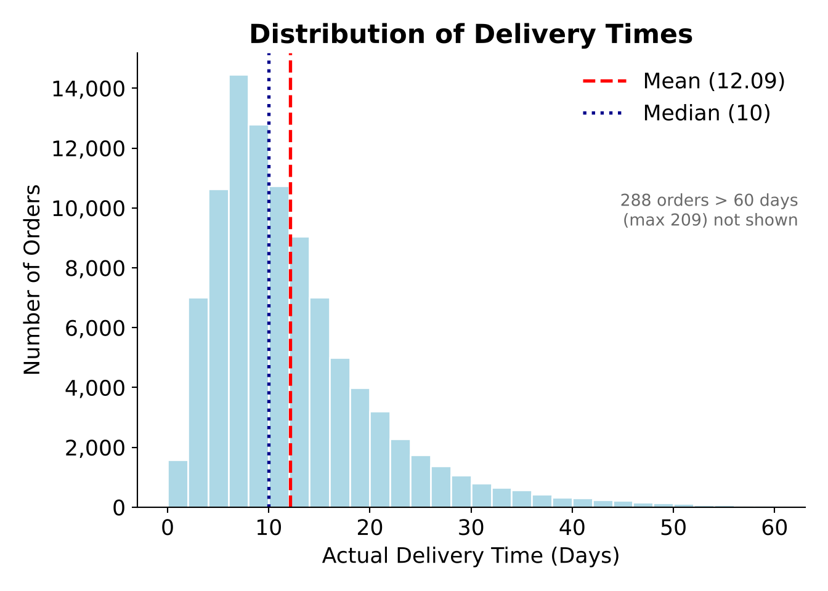 | Figure 2. Distribution of Order Values  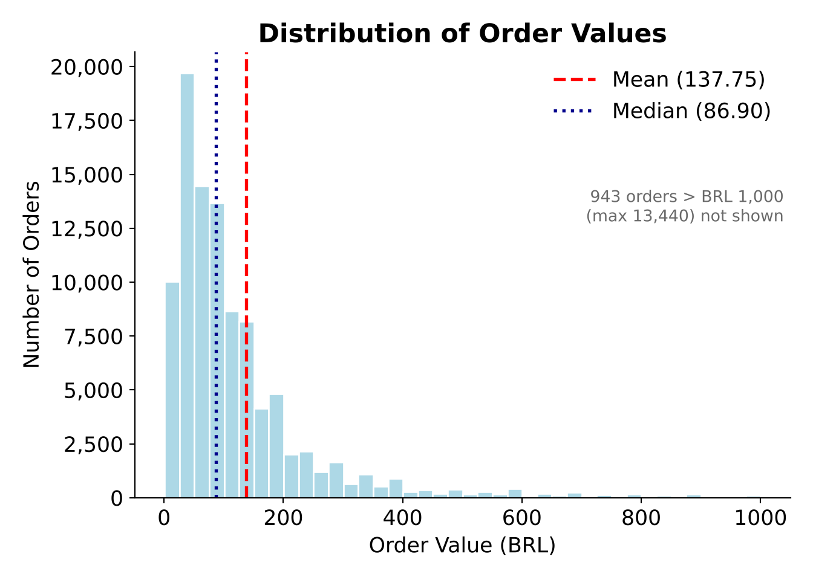
Figure 1: delivery times are right-skewed. Most orders arrive within about 5-15 days, but a long tail stretches past 60 days (maximum 209) and pulls the mean (12.09) above the median (10), so management should watch prolonged deliveries rather than rely on the average alone. Figure 2: most purchases are low in value, with 943 orders above BRL 1,000 pulling the mean well above the median, consistent with the outlier analysis.
Figure 3. Distribution of Review Scores  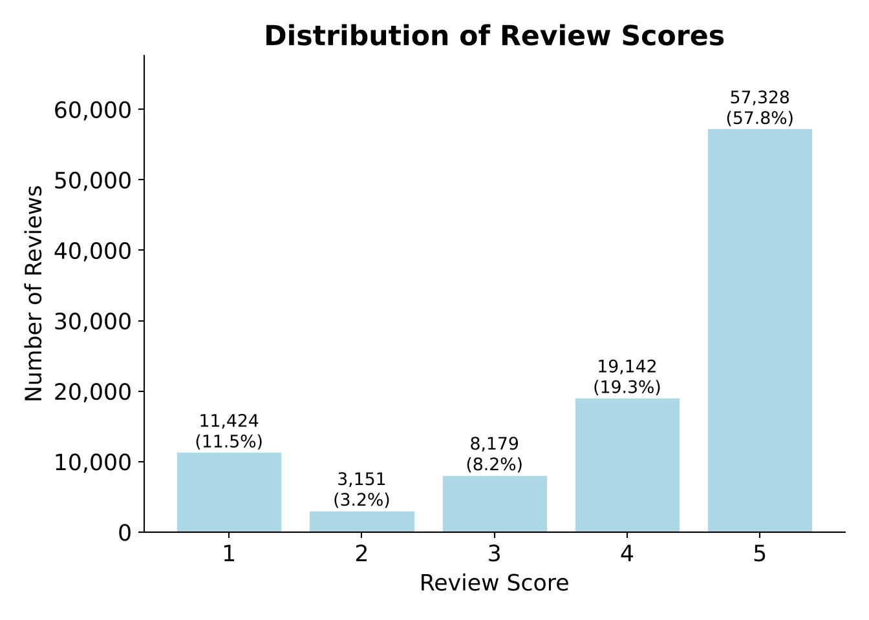 | Figure 4. Delivery Time by Late Status  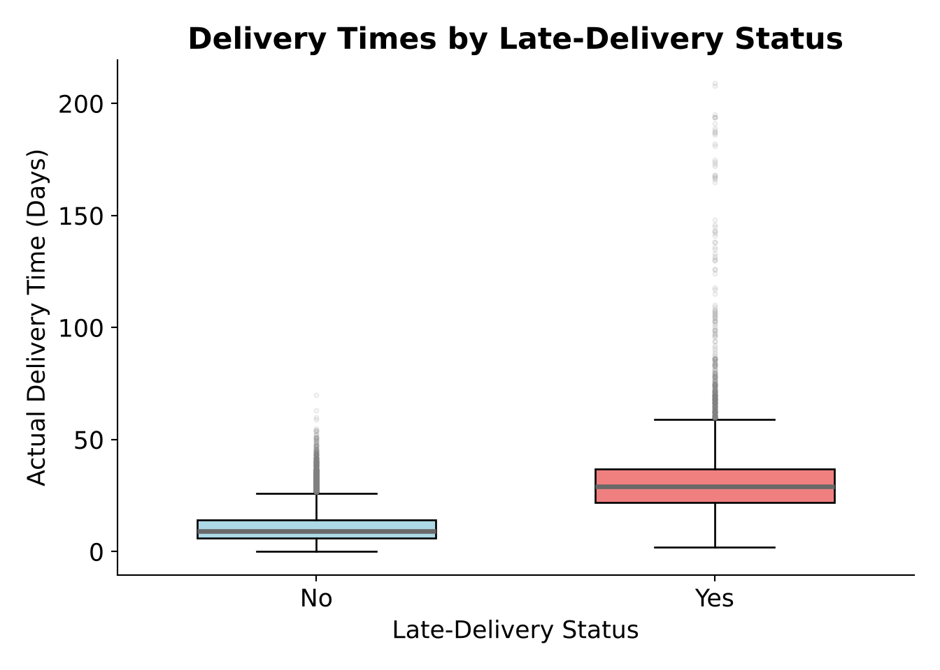
Figure 3: 57,328 reviews gave 5 stars and 19,142 gave 4 stars (77.1% combined), but 14.7% gave 1 or 2 stars. Satisfaction is generally favorable, yet this sizable group of low ratings keeps the average (4.09) below the 4.20 target. Figure 4: late orders have a median delivery time of 29 days versus 9 days for on-time orders, with a far wider spread reaching 209 days. Late deliveries are not just minor misses; they include substantially prolonged fulfillment.
Figure 5. Customer Review Score vs. Delivery Time (jittered, with linear trend and daily mean; x-axis truncated at 60 days)
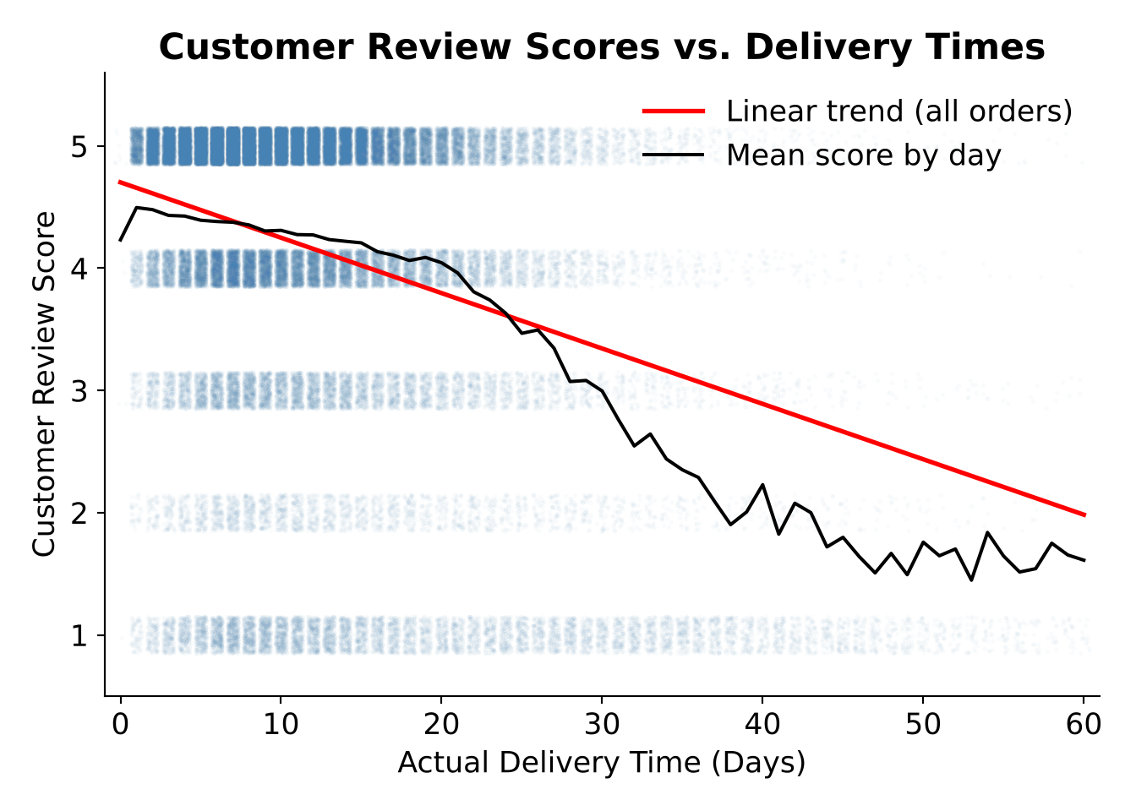
The downward-sloping trend line shows that longer deliveries are associated with lower ratings (r = -0.33). The pattern is strongest at the extremes: the average score falls from 4.38 for orders delivered within 10 days to 2.18 for orders taking more than 30 days, and 56.8% of those slowest orders received 1 star, compared with 5.8% of orders delivered within 10 days. Because the data are observational, this shows association, not proof that slow delivery causes low ratings.

Confidence intervals
Table 6. 95% Confidence Intervals Compared with Case Targets
Metric | Estimate | Lower 95% | Upper 95% | Method | Target | Conclusion
Mean delivery time (days) | 12.09 | 12.03 | 12.15 | t-interval | ≤ 13 | Target met
Mean review score | 4.09 | 4.08 | 4.09 | t-interval | ≥ 4.20 | Not met
Late-delivery rate (%) | 7.87 | 7.70 | 8.04 | Wilson score | ≤ 10% | Target met

- Delivery time: we are 95% confident the true average is between 12.03 and 12.15 days. Because the entire interval is below 13 days, the evidence supports that the delivery-time target is being met.
- Review score: the interval of 4.08 to 4.09 lies entirely below 4.20, so the evidence indicates that the satisfaction target is not being met. Restricted to reviews of delivered orders, the mean is 4.16 (4.15–4.16), still below target.
- Late-delivery rate: the interval of 7.70% to 8.04% lies entirely below 10%, so the evidence supports that the late-delivery target is being met. Counting only the 96,476 delivered orders, the rate is 8.11% (7.94%–8.29%), and the conclusion is unchanged.

Discussion and Recommendations

Answers to management's questions
- Is the average delivery-time target met? Yes. Both the point estimate (12.09 days) and the full confidence interval are below 13 days.
- Is the late-delivery rate consistent with the 10% target? Yes. The observed 7.87% (8.11% of delivered orders) is below 10%, and the whole interval lies below the benchmark.
- Does the evidence support an average review score of at least 4.20? No. The estimate of 4.09 is below target and the whole interval lies below 4.20.
- How do delivery performance and satisfaction relate? Longer deliveries are associated with lower ratings (Figure 5), late orders take about three times as long as on-time orders (Figure 4), and customers with late orders rated 2.57 on average versus 4.21 for on-time orders. This is an association; other factors may also influence ratings.
- Are conclusions sensitive to extreme delivery times? Not for the delivery-time target: removing the 5,025 outliers lowers the mean to 10.56 days, and the conclusion is unchanged. The outliers matter for the customer experience, however, because they coincide with the lowest ratings.

Priorities for management
- Reduce late and extremely long deliveries. Average speed and the late-delivery rate are already on target, so the greatest gain lies in the 7,827 late orders and the 5,025 orders taking more than 28.5 days. Identify common factors behind these orders, such as region, carrier or product category, and target them.
- Treat delivery reliability as a customer-satisfaction lever. Orders delivered on time already average 4.21 (4.29 when undelivered orders are excluded), above the 4.20 target, while late orders average 2.57. Preventing late deliveries is the most direct, evidence-based route toward the 4.20 target.
- Tighten how lateness is measured and keep monitoring all three targets. Count an order as late only when it arrives after the estimated date rather than on it, and exclude undelivered orders from the denominator. With about 100,000 orders the intervals are already narrow, so even small changes in these measures will show up clearly.

Conclusion
The marketplace meets its average delivery-time and late-delivery targets, but customer satisfaction is below the 4.20 target. Late orders score far lower than on-time orders, so management should concentrate on the small share of late and unusually long deliveries, which are most closely associated with poor ratings, and track all three measures with confidence intervals to judge whether improvements are working.

