When need to get Previous and Order By ASC, use LAG. NULL is first row from group.

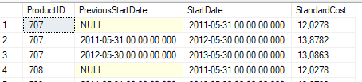

When need to get Previous and Order By DESC, use LEAD. NULL is last row from group.

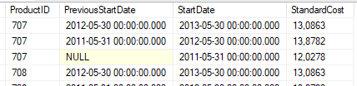

When need to get Next and Order By ASC, use LEAD. NULL is last row from group.

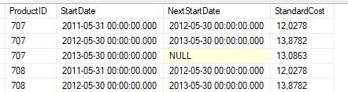

When need to get Next and Order By DESC, use LAG. NULL is first row from group.

