Photogram Documentation

Final project

Igor rayt

2016

Contents

PROJECT CHARTER 1

PROJECT NAME 1

BUISINESS PURPOSE 1

PROJECT ROLES/RESPONSOBILITIES 1

TECHNICAL ARCHETECTURE 1

EVENTS TABLE 2

USE CASE DIAGRAM 3

USE CASE DESCRIPTION 4

USER INTERFACE PROTOTYPES 10

ERD DIAGRAM 21

HELP SYSTEM 21

REFERENCES 22

# PROJECT CHARTER

## PROJECT NAME

Photogram

## BUISINESS PURPOSE

This project is being undertaken with the goal of creating the way users can share their photos with each other. This app will allow user take photo, uploaded it on server, give it name and description.

## PROJECT ROLES/RESPONSOBILITIES

Igor Rayt – analysis, planning, design, UI design, UX design, developing, testing, documentation assembling

## TECHNICAL ARCHETECTURE

* Html
* CSS
* JavaScript along with JQuery libraries
* MySQL database server and queries

# EVENTS TABLE

|  |  |  |  |  |
| --- | --- | --- | --- | --- |
| EVENT | SOURCE | USE CASE# | RESPONSE | DESTINATION |
| User wants to create account | User | UC01 | Create account page is displayed | User |
| User wants to log in | User | UC02 | Log in page is displayed | User |
| User wants to view photo feed | User | UC03 | Photo feed page is displayed | User |
| User wants to look for other users | User | UC04 | Search page is displayed | User |
| User wants to view other user’s photos | User | UC05 | Other user’s page is displayed | User |
| User wants to view his photos | User | UC06 | User’s page is displayed | User |
| User wants to change settings | User | UC07 | Settings page is displayed | System |
| User wants to change password | User | UC08 | Change password page is displayed | System |
| User wants to comment a photo | User | UC09 | Comment page is displayed | User |
| User wants to delete his comment | User | UC10 | User’s comment deleted | System |
| App runs time | System | UC11 | Database has been created if not existed | System |
| User wants to add photo | User | UC12 | App runs camera to capture photo, than it shows add photo page | User |

# USE CASE DIAGRAM

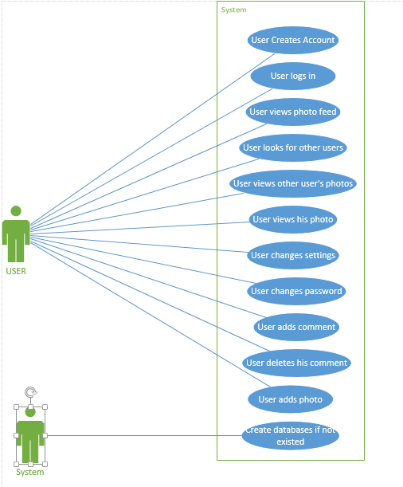

# USE CASE DESCRIPTION

|  |  |  |  |  |
| --- | --- | --- | --- | --- |
| Use case # | UC01 | | | |
| Use case name | Create Account | | | |
| Scenario | User is a new user | | | |
| Triggering event | User clicks create account button | | | |
| Brief description | The user clicks the create account button, enters the his information and submits | | | |
| Actors | User | | | |
| Related use cases |  | | | |
| Pre-conditions | There shouldn’t be another user with the same username or email | | | |
| Post-conditions |  | | | |
| Flow of events | User | | System | |
| 1. | Click create account button | 2. | Display create account page |
| 3. | Enter his information and taps create account button | 4. | Insert new user to database |
| Exceptions | User already exists, show error message. Input error, show error message | | | |

Table 1: UC01-Create Employee

|  |  |  |  |  |
| --- | --- | --- | --- | --- |
| Use case # | UC02 | | | |
| Use case name | Log In | | | |
| Scenario | User wants to log in | | | |
| Triggering event | User clicks log in button | | | |
| Brief description | User enter his log in information, click log in button | | | |
| Actors | User | | | |
| Related use cases |  | | | |
| Pre-conditions | User must has account in the app | | | |
| Post-conditions |  | | | |
| Flow of events | User | | System | |
| 1. | Enters his log in information and presses log in button | 2. | Log user into up |
| Exceptions | Log in information wrong, show error message | | | |

Table 2: UC02- Create Account

|  |  |  |  |  |
| --- | --- | --- | --- | --- |
| Use case # | UC03 | | | |
| Use case name | View Photo Feed | | | |
| Scenario | Person wants to view photo feed | | | |
| Triggering event | User clicks home button | | | |
| Brief description | User clicks home button and views photo feed | | | |
| Actors | User | | | |
| Related use cases | Log in | | | |
| Pre-conditions | User must be logged in the app | | | |
| Post-conditions |  | | | |
| Flow of events | User | | System | |
| 1. | User clicks home button | 2. | Display photo feed |
| Exceptions |  | | | |

Table 3: UC03- View Photo Feed

|  |  |  |  |  |
| --- | --- | --- | --- | --- |
| Use case # | UC04 | | | |
| Use case name | Look For Other Users | | | |
| Scenario | Person wants to view other user’s photos | | | |
| Triggering event | User enters other user’s username into search input | | | |
| Brief description | User clicks search window button, when enters other user’s username into search input if he can’t find him in displayed list, then presses user info to go on his page | | | |
| Actors | User | | | |
| Related use cases | View Other User’s Photos | | | |
| Pre-conditions | User must be logged in the app | | | |
| Post-conditions | There should be more than one user in the app database | | | |
| Flow of events | User | | System | |
| 1. | User presses search button | 2. | Displays search page and other users on the page |
| 3. | If user can’t find needed user, he types his username into search bar | 4. | Systems filters user |
| 5. | User taps on needed user info | 6. | Shows other user’s page |
| Exceptions |  | | | |

Table 4: UC04- Look For Other Users

|  |  |  |  |  |
| --- | --- | --- | --- | --- |
| Use case # | UC05 | | | |
| Use case name | View Other User’s Photos | | | |
| Scenario | User wants to view other user’s photo | | | |
| Triggering event | User clicks on other user information | | | |
| Brief description | User chooses other user to view his information and photos | | | |
| Actors | User | | | |
| Related use cases | Look For Other Users | | | |
| Pre-conditions | User must be logged in the app | | | |
| Post-conditions |  | | | |
| Flow of events | User | | System | |
| 1. | User taps on needed user info | 2. | Shows other user’s page |
| Exceptions |  | | | |

Table 5: UC05- View Other User’s Photos

|  |  |  |  |  |
| --- | --- | --- | --- | --- |
| Use case # | UC06 | | | |
| Use case name | View User’s Photo | | | |
| Scenario | User wants to view his photos | | | |
| Triggering event | User clicks on my profile button | | | |
| Brief description | User clicks on my profile button and views his info and photos | | | |
| Actors | User | | | |
| Related use cases |  | | | |
| Pre-conditions | User must be logged in the app | | | |
| Post-conditions |  | | | |
| Flow of events | User | | System | |
| 1. | User clicks on my profile button | 2. | Display user’s page with his information and photos |
| Exceptions |  | | | |

Table 6: UC06- View User’s Photo

|  |  |  |  |  |
| --- | --- | --- | --- | --- |
| Use case # | UC07 | | | |
| Use case name | Change Settings | | | |
| Scenario | User wants to change his Last Name/First Name/Username/Email | | | |
| Triggering event | User clicks settings button | | | |
| Brief description | User wants to change his information | | | |
| Actors | User | | | |
| Related use cases |  | | | |
| Pre-conditions | User must be logged in app | | | |
| Post-conditions |  | | | |
| Flow of events | User | | System | |
| 1. | Clicks settings button | 2. | Display settings page |
| 3. | Changes his information and taps change information button | 4. | Changes user information and his record in database |
| Exceptions | User with the same username or email already exists, show error. Input invalid, show error message | | | |

Table 7: UC07- Change Settings

|  |  |  |  |  |
| --- | --- | --- | --- | --- |
| Use case # | UC08 | | | |
| Use case name | Change Password | | | |
| Scenario | Person wants to change password | | | |
| Triggering event | User taps change password link | | | |
| Brief description | User wants to update password to make account more secure | | | |
| Actors | User | | | |
| Related use cases |  | | | |
| Pre-conditions | User must be logged on into app | | | |
| Post-conditions |  | | | |
| Flow of events | User | | System | |
| 1. | User taps change password link | 2. | Display change password page |
| 3. | Enter old password, new password and password confirmation, then taps change password button | 4. | Changes password |
| Exceptions | New password doesn’t match to old one, show error message. New password and password confirmation don’t match, show error message | | | |

Table 8: UC08- Change Password

|  |  |  |  |  |
| --- | --- | --- | --- | --- |
| Use case # | UC09 | | | |
| Use case name | Add Comment | | | |
| Scenario | Person liked the photo and wants add comment to it | | | |
| Triggering event | User taps add comment button | | | |
| Brief description | Person liked the photo and wants add comment to it. User taps add comment button under the photo description. | | | |
| Actors | User | | | |
| Related use cases |  | | | |
| Pre-conditions | User must be logged on, there should be at least one photo in database | | | |
| Post-conditions |  | | | |
| Flow of events | User | | System | |
| 1. | Taps add comment link | 2. | Displays add comment page |
| 3. | Enters comment to the textarea and taps add comment button | 4. | Adds comment to photo comments |
| Exceptions | Comment string is empty, show error message | | | |

Table 9: UC09- Add Comment

|  |  |  |  |  |
| --- | --- | --- | --- | --- |
| Use case # | UC10 | | | |
| Use case name | Delete User’s Comment | | | |
| Scenario | Person didn’t like his comment and wants to delete it | | | |
| Triggering event | User clicks on delete button next to him comment | | | |
| Brief description | Person didn’t like his comment and wants to delete it. User clicks on delete button next to him comment | | | |
| Actors | User | | | |
| Related use cases | Add Comment | | | |
| Pre-conditions | User must be logged on and must add at least one comment | | | |
| Post-conditions |  | | | |
| Flow of events | User | | System | |
| 1. | User taps delete button | 2. | Deletes comment |
| Exceptions |  | | | |

Table 10: UC10- Delete User’s Comment

|  |  |  |  |  |
| --- | --- | --- | --- | --- |
| Use case # | UC11 | | | |
| Use case name | Create Databases | | | |
| Scenario | Person runs app first time | | | |
| Triggering event | First start of app | | | |
| Brief description | Person runs app first time. There is no database created | | | |
| Actors | System | | | |
| Related use cases |  | | | |
| Pre-conditions | There is no database created, app runs first time | | | |
| Post-conditions |  | | | |
| Flow of events | User | | System | |
| 1. | Runs app first time | 2. | Create database with needed tables |
| Exceptions |  | | | |

Table 11: UC11- Create Databases

|  |  |  |  |  |
| --- | --- | --- | --- | --- |
| Use case # | UC12 | | | |
| Use case name | Add Photo | | | |
| Scenario | Person wants to add photo to app to share with other users | | | |
| Triggering event | User taps add photo button | | | |
| Brief description | User taps add photo button, camera runs to capture photo, than app photo page appear | | | |
| Actors | User | | | |
| Related use cases |  | | | |
| Pre-conditions | User must be logged in | | | |
| Post-conditions |  | | | |
| Flow of events | User | | System | |
| 1. | Runs app first time | 2. | Create database with needed tables |
| Exceptions |  | | | |

Table 12: UC12- Create Databases

# USER INTERFACE PROTOTYPES

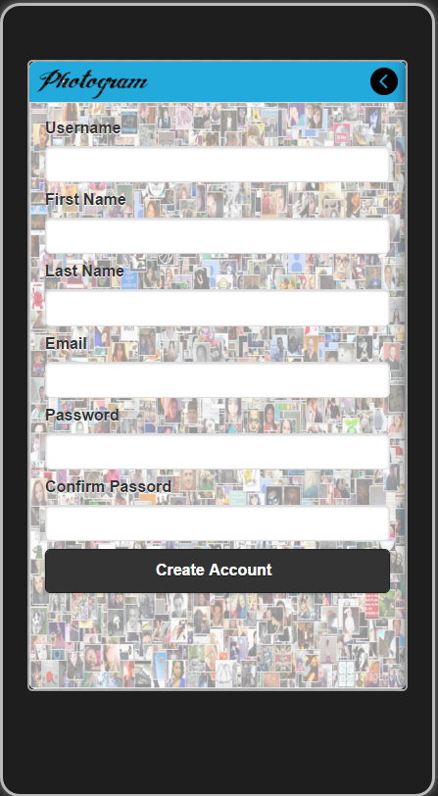

Figure 1: Screen 1 – Create Account

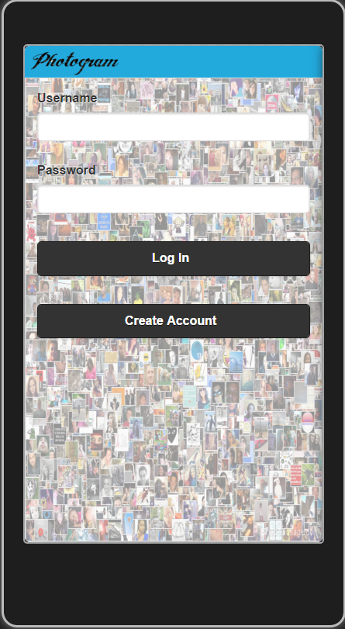

Figure 2: Screen 2 – Log In

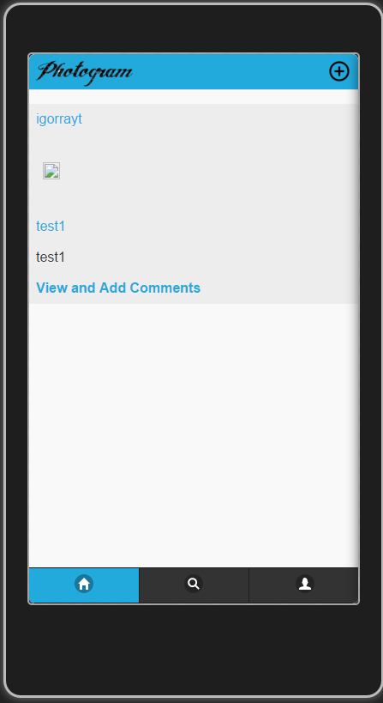

Figure 3: Screen 3 – View Photo Feed

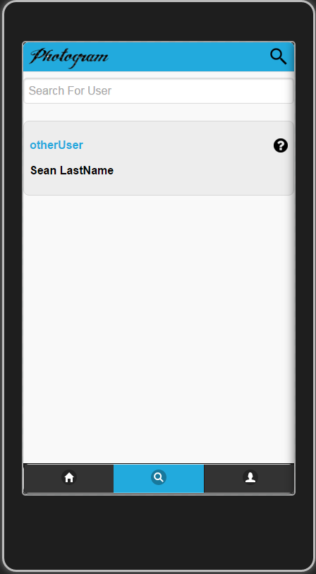

Figure 4: Screen 4 – Search For Other Users

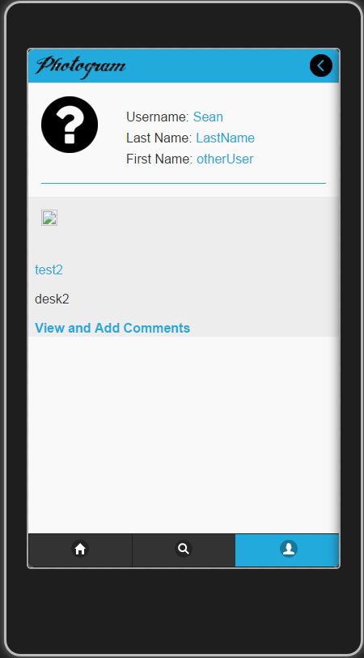

Figure 5: Screen 5 – View Other User’s Photo

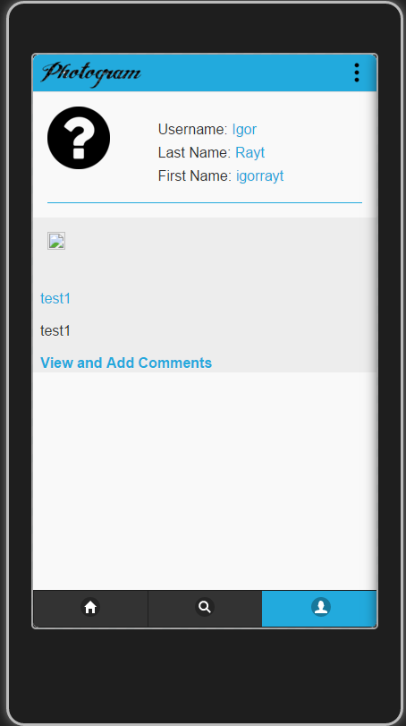

Figure 6: Screen 6 – View User’s Photo

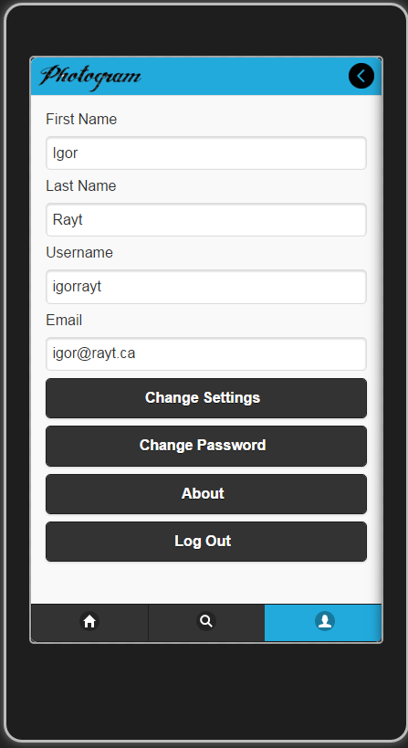

Figure 7: Screen 7 – Change Settings

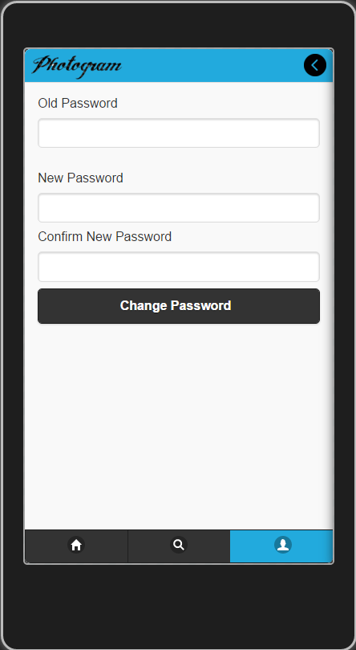

Figure 8: Screen 8 – Change Password

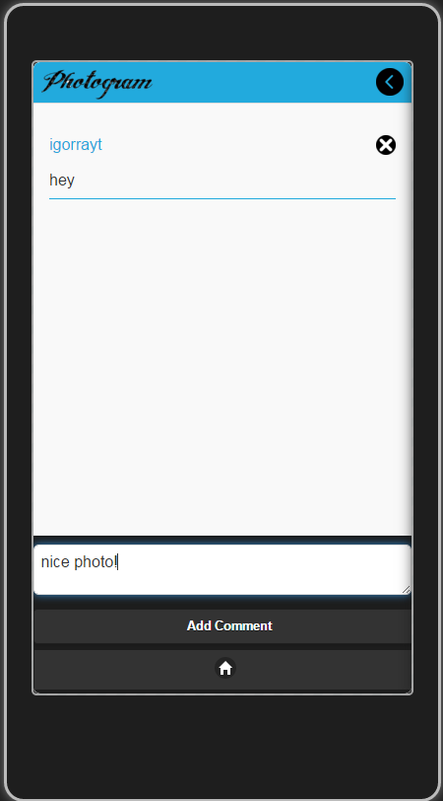

Figure 9: Screen 9 – Add Comment

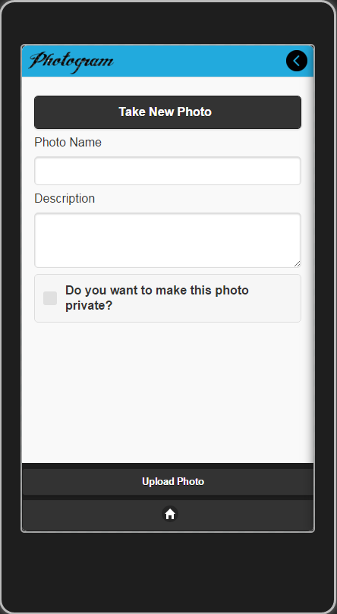

Figure 10: Screen 10 – Add Photo

# ERD DIAGRAM

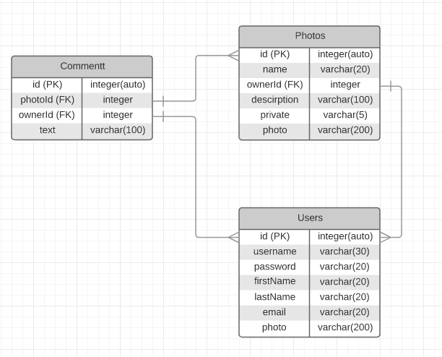

Figure 11: Entity Relationship Diagram (ERD) for Photogram

# HELP SYSTEM

The Photogram App allows user to comment and share photos with each over. It also has private feature in case if you want to upload photo for personal use and restricted the access to it for other users.

* To use Photogram, first user must create account, than he must log in. Since this point, user have access to other non-private Users photo.
* To upload the photo, User should tap addPhoto button on the top right corner of the home screen.
* If user wants to view other User’s photo, he should tap search button in the screen footer. System will bring up list of user, to filter them, user should start typing needed username into search box, than type on user info box to go on his page.
* To comment photos there is button under every photo description, it will bring up addComment screen where user can type and leave comment to chosen photo.
* To view user’s information, he should press on right profile button in app footer, System will bring up display with user’s information and photos.
* To change setting, user must press menu button in the top right corner on user’s profile page, it will bring him to settings screen where he can updated his info, change password, see info about developers and log out.

# REFERENCES

1. jQuery [www. jquery.com](https://jquery.com/)
2. Cordova <https://cordova.apache.org/>
3. WebStorm <https://www.jetbrains.com/webstorm/>
4. Java SE [http://www.oracle.com/](http://www.oracle.com/technetwork/java/javase/downloads/index.html)
5. Android SDC [http://developer.android.com/](http://developer.android.com/sdk/index.html)