cPath Architectural Overview

Last Updated: March 1, 2004
I. Introduction 2
II. Tools and Libraries 2
III. Architectural Overview 3
IV. cPath Database Schema 4
A. Import Table 4
B. Core cPath Tables 5
C. External Database Tables 6
V. cPath Application Logic 7
A. Package Structure 7
B. From Browser Request to System Response 8
C. Style Sheets, JSP Templates and JSP Custom Tags 10
D. Web Application Configuration 11
VI. Development Practices 12
A. Automated Build Process 12
B. Coding Standards 13
C. Unit Testing 13
D. Documentation 13
VII. Background Reading 13

I. Introduction
This document provides an architectural overview of the cPath database and web application. Information about the database schema, application logic, servlet architecture, configuration, and development practices is provided.

II. Tools and Libraries
cPath is currently built with the following open source tools and libraries:

- Apache Tomcat: open source servlet/jsp engine. Information available at: http://jakarta.apache.org/tomcat/.

- Ant: used for the cPath build and deployment process. Information available at: http://ant.apache.org/.

- Castor: Java/XML Binding Framework. Information available at: http://www.castor.org/.

- Checkstyle: open source toolkit for checking coding conventions. cPath adheres to the Sun Java coding conventions. Information available at: http://checkstyle.sourceforge.net/.

- CVS: used for source control and revision tracking. Information available at: http://www.cvshome.org/.

- Jakarta Database Connection Pool (DBCP): provides a database connection pool for connecting to relational databases. Information available at: http://jakarta.apache.org/commons/dbcp/index.html

- JDOM: Java XML API. Information available at: http://www.jdom.org.

- JUnit: used for all cPath unit tests. Information available at: http://www.junit.org.

- Log4j: open source logging framework. Information available at: http://logging.apache.org/log4j/docs/.

- Lucene: open source text indexer; provides cPath full text search functionality. Information available at: http://jakarta.apache.org/lucene/docs/index.html.

- Maven: Maven is a “Java project management and project comprehension tool”. We currently use Maven to automatically generate the cPath Developer site every 24 hours.

- MySQL: Backend database is built in MySQL. Information available at: http://www.mysql.com.

- Struts: open source framework for building web applications. Information available at: http://jakarta.apache.org/struts/.

- Xerces: fast, validating XML Parser. Information available at: http://xml.apache.org/xerces-j/.

III. Architectural Overview
cPath is a database driven web site that uses a traditional three-tier architecture (see Figure 1):

- The first tier consists of client applications, including web browsers and third-party applications, such as Cytoscape (http://cytoscape.org/). Web browsers communicate with cPath by issuing HTTP requests, and receiving HTML in response. Other client applications communicate with cPath by issuing HTTP requests, and receiving XML in response.

- The second tier consists of Java code running in the open source Jakarta Tomcat servlet engine. This layer consists of core Java classes, Java Servlets, Java Server Pages, and custom JSP Tags.

- The third tier consists of a backend database running MySQL. The MySQL database stores individual pieces of data, and XML document fragments. cPath uses JDBC and the Jakarta database connection pool to communicate with MySQL.

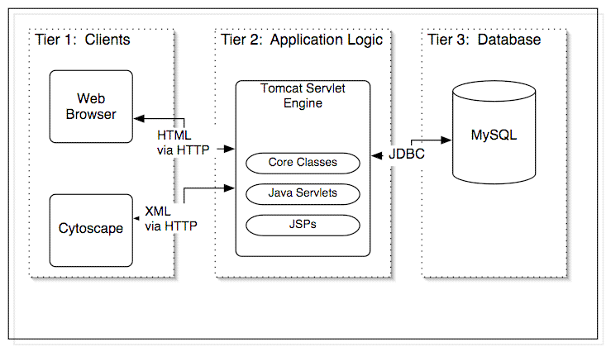

Figure 1: cPath Three-Tier Architecture.

In the discussion that follows, we first describe the database schema and then proceed to the application logic.

IV. cPath Database Schema

All cPath data is stored in MySQL. The cPath database schema consists of eight relational tables. These tables are grouped into four sets:

- import table: used for importing new data into cPath.
- core entity tables: used to store core entities, such as interactors and interactions, and internal/external links.
- external database tables: used to store information about external databases, such as SWISS-PROT, NCBI, etc.
- administrative tables: used for logging and caching purposes.

Details on each set of tables is provided in the sections below.

A. Import Table

The import table contains information about XML/text records, which are scheduled for import into cPath. For example, if an administrator wants to import a new PSI-MI file, the XML data is first loaded into the import table, where it is logged, and recorded. From here, the XML document is parsed and chopped into its constituent parts and loaded into the core cPath tables. The import table contains the following structure:

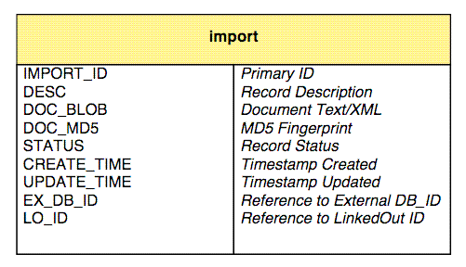

B. Core cPath Tables
The cPath core consists of three tables: cpath, internal_link, and external_link. The cpath table contains core entities, such as interactors and interactions. Each entity record contains a short name, description and type. Type must be specified as either: PHYSICAL_ENTITY or INTERACTION. Each record also contains an XML document fragment, written in PSI-MI format. To obtain the full information for an entity, the cPath code must extract and parse the specified XML document fragment.

The internal_link table stores links between cPath records. For example, a cPath interaction record will specify bidirectional links between the interaction record and all its interactors. The external_link table records links to external databases, such as SWISS-PROT, NCBI, etc. Information about these external databases is provided in the next section.

The core cPath tables are defined with the following structure:

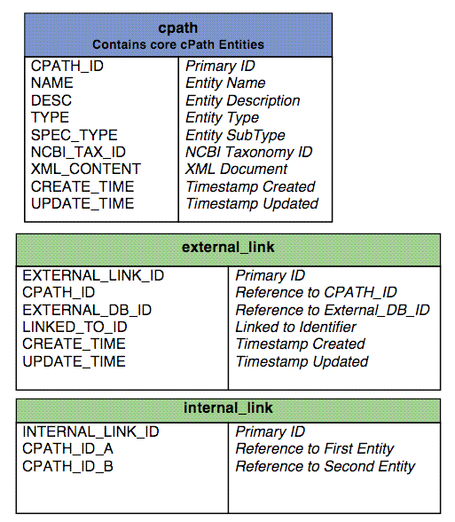

C. External Database Tables
The external database tables provide a general mechanism for linking to external data sources. The external_db_cv table contains controlled vocabulary terms, which match a specific database. For example, cPath recognizes: SWISS-PROT, SWP, and SWISSPROT. The external_database table contains URLs for connecting to the external database. The pattern %ID% is replaced dynamically with the linked to ID. For example, here is a URL for connecting to SWISS-PROT:

http://us.expasy.org/cgi-bin/niceprot.pl?%ID%

The external database tables are defined with the following structure:

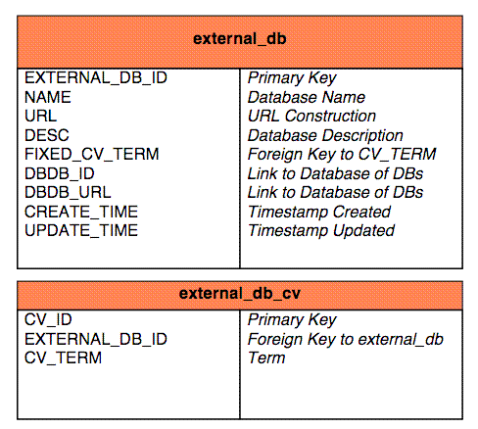

V. cPath Application Logic

A. Package Structure

Application logic for cPath is written in Java, and is specified in the package: org.mskcc.pathdb. It contains the following package structure:

Package | Description
action | Struts Action Classes. Each action class corresponds to a user-initiated action.
controller | Classes for processing and validating web service API requests.
form | All Struts Action Forms. Each class corresponds to an HTML form.
lucene | Classes for connecting to the Lucene Full Text Search engine.
model | JavaBean objects which encapsulate cPath records, such as ImportRecord, CPathRecord, etc.
servlet | All cPath Servlets.
sql | All Database Access code.
taglib | All Custom JSP Tags.
task | Long-term Tasks, which require multi-threading execution.
test | All JUnit Unit Tests.
tool | All Command Line Utilities and Programs.
util | Misc. Utility classes, such as an XML validator, cross-site scripting filter, etc.
xdebug | Live Debugging/Diagnostics Facility.
xmlrpc | XML-RPC Services for uploading new data into cPath.

B. From Browser Request to System Response
Each time a web browser makes a request to cPath, the application logic layer handles the processing of the request, and the generation of dynamic HTML/XML pages. To aid in the processing of web requests, cPath utilizes the open source Struts Framework. The Struts framework provides a number of built-in advantages, including: clean separation of logic and presentation, form validation, centralization of request handling, and centralization of exception handling.

Flow through the application layer proceeds as follows (see Figure 2):

- All user requests go through the central cPathServlet class. This class provides a central spot for all cPath initialization and configuration.

- Based on the URL requested, Struts will check the Struts.xml configuration file, and determine which action class is invoked. Action classes represent user request actions, such as “run a full text search”, or “get all interactions for yeast”.

- All cPath action classes inherit from the BaseAction class, and all password protected administrator classes inherit from the AdminBaseAction class (see Figure 3). The base action classes provide a common framework for capturing exceptions, gathering real-time web diagnostics, and protecting specific resources via HTTP authentication.

- Some action classes will require access to the MySQL database. In that case, the action class will make calls to a Data Access Object, or DAO. The DAO encapsulates all database access code, and connects to MySQL via the shared database connection pool. There is one DAO object for each cPath table. For example, the ImportDao class provides access to the cPath import table.

- All final HTML construction is completed in Java Server Pages, and custom JSP tags.

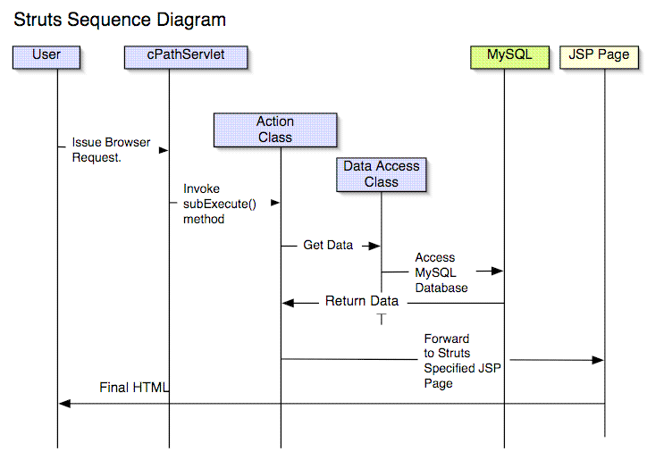

Figure 2: Data flow within the Application Logic Layer.

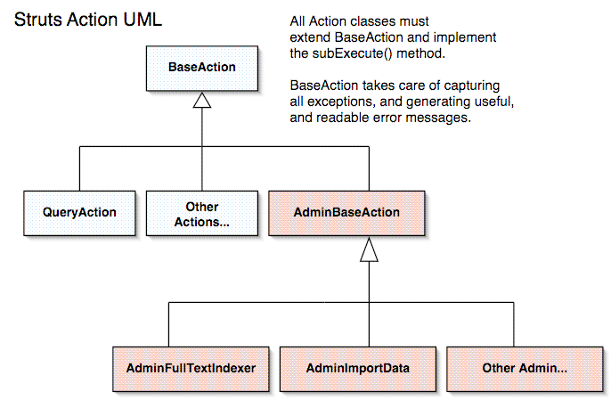

Figure 3: UML Diagram of the Struts Action Classes. Each Action class corresponds to a user-requested action.

C. Style Sheets, JSP Templates and JSP Custom Tags

cPath is built using open source CSS style sheets created at http://style.tigris.org. Tigris provides a cross-browser compatible set of style sheets and open source icons. This enables cPath to have a very professional look, with minimal effort. It also enables us to easily provide a “printer-friendly” version of all cPath pages.

All presentation is done via Java Server Pages (JSPs) and custom JSP tags. The WEB-INF/jsp/global directory contains a number of reusable JSP components which are used throughout the site. These include the following:

JSP Component | Description
header.jsp | Global header component, used on all cPath pages.
footer.jsp | Global footer component, used on all cPath pages.
tabs.jsp | Global tabs component, seen at the top of all cPath pages.
navbar.jsp | Global navigation bar component, seen in left column of all cPath pages.
xdebug.jsp | Global component used to output real-time web diagnostics.

The custom JSP tags provide reusable tags, which can be inserted into any cPath page. All cPath custom tags are defined in: WEB-INF/tag-lib/cbio-taglib.tld. A summary of all custom tags is provided below:

JSP Custom Tag | Description | Example Usage
DiagnosticsTable | Outputs internal tests used in the Admin cPath self-test page. | <cbio:diagnosticsTable />
ErrorMessage | Centralizes all display of error messages to the user. | <cbio:errorMessage throwable=  "<%= exception %>"/>
HtmlTable | Base Class for all Custom JSP Tags which create HTML tables. | Not used directly.
InteractionTable | Displays a list of matching interactions. | <cbio:interactionTable interactions="<%= interactions %>" protocolRequest="<%= protocolRequest %>"/>
InteratorTable | Displays all information about a specific interactor. | <cbio:interactorTable />
SearchResultsTable | Displays results from a full-text search. | <cbio:searchResultsTable protocolRequest=  "<%= protocolRequest %>"/>
TaskTable | Displays all admin tasks (in progress and completed tasks are shown.) | <cbio:taskTable/>

D. Web Application Configuration

cPath configuration is centralized in four files.

File | Description
cpath/web/WEB-INF/web.xml | The main configuration file for the cPath web application. Here, you can modify the Struts debugging level, the user/name password for connecting to cPath, and the admin user/name password for accessing administrative functionality.
cpath/web/WEB-INF/struts-config.xml | The main configuration file for the Struts Framework. This file specifies all the action URLs, HTML form objects, and JSP pages.
cpath/config/cpathResources.properties | Defines a number of String constants used throughout the cPath site. All user error messages are defined here.
cpath/project.xml | Maven configuration file. Used to automatically generate the cPath developer site.

VI. Development Practices

A. Automated Build Process

The cPath build process is automated with Ant. A number of Ant targets are defined:

Target | Description
Main Development Targets
all | Performs a complete and clean build.
check | Runs CheckStyle on all source code.
clean | Deletes all build files and starts fresh.
compile | Compiles all Java sources.
Test Targets
boot | Loads Bootstrap data into MySQL. Required for running JUnit Tests.
test | Runs JUnit Test Suite.
Local Tomcat Development Targets
install | Installs cPath to local development servlet container.
list | Lists installed applications on servlet container.
reload | Reloads cPath application on servlet container.
remove | Removes cPath application on servlet container.
Deployment / WAR Targets
deploy_war | Deploy WAR to cBIO Production server.
war | Creates binary WAR distribution.

B. Coding Standards

cPath adheres to the Sun Java coding standards (information is available at: http://java.sun.com/j2se/javadoc/writingdoccomments/) Coding standards are enforced via the ant checkstyle target. To see if your code adheres to the standards, run “ant check”.

C. Unit Testing

cPath uses the JUnit testing framework (http://www.junit.org). All unit tests are organized into suites, and all suites are organized into org.mskcc.pathdb.test.AllTest. To run all cPath tests, run “ant test”. To create a new test, create the new test, and add is to the correct package suite.

D. Documentation

cPath uses the open source Maven toolkit (http://maven.apache.org/) for automatically generating the cPath developer site every 24 hours. All documentation is stored in cpath/xdocs.

VII. Background Reading

If you are new to cPath or new to any of the open source libraries used by cPath, the following background articles and books may be extremely helpful.

- If you are new to CVS, check out the official CVS manual, available at: http://www.cvshome.org/docs/manual/cvs-1.11.13/cvs.html. Refcards.com also makes a handy one-page CVS quick reference guide, available: http://www.refcards.com/about/cvs.html.

- If you are new to Java Servlets or Java Server Pages, check out the Sun tutorial at: http://java.sun.com/docs/books/tutorial/servlets/. We also highly recommend Marty Hall, Core Servlet and Java Server Pages (Prentice Hall, 2nd Edition 2003) – details are available at: http://www.coreservlets.com.

- If you are new to the Jakarta Tomcat Servlet Engine, check out the Tomcat Application Developer Guide at: http://jakarta.apache.org/tomcat/tomcat-4.0-doc/appdev/. This is a must-read, as it provides an overview of using Ant and Tomcat together, saving you many hours of development effort.

- If you are new to Ant, check out the Ant Manual online at: http://ant.apache.org/manual/. We also highly recommend Tilly & Burke, Ant: The Definitive Guide (O’Reilly & Associates, 2002).

- If you are new to Struts, check out the Struts user guide at: http://jakarta.apache.org/struts/userGuide/index.html. The user guide is not great, and we therefore recommend Chuck Cavaness, Programming Jakarta Struts (O’Reilly & Associates, 2002).

- If you are new to JUnit, check out the JUnit Cookbook at: http://junit.sourceforge.net/doc/cookbook/cookbook.htm. For additional background on JUnit and why automated testing is so important, see Martin Fowler, Refactoring (Addison Wesley, 2000).

- If you are new to XML processing in Java, check out Elliotte Rusty Harold, Processing XML with Java (Addison-Wesley, 2002). Complete contents of the book are available online at: http://cafeconleche.org/books/xmljava/. This is an excellent book, and covers JDOM and Xerces.

- If you are new to Lucene, check out the Lucene FAQ at: http://lucene.sourceforge.net/cgi-bin/faq/faqmanager.cgi.

- If you are new to Maven, documentation is available at the Maven site: http://maven.apache.org/. However, the documentation is very spotty, and not very up-to-date. The best way to learn maven is by example – take a look at the documents in cpath/xdocs.

Eventually, we will extend support to BioPax.

