 | Summer Scholarship Scheme 2010/2011  Application Form

Title of Project: Navier-Stokes Equations on Riemannian Manifolds

Project Leaders/Supervisors: Igor Rychkov

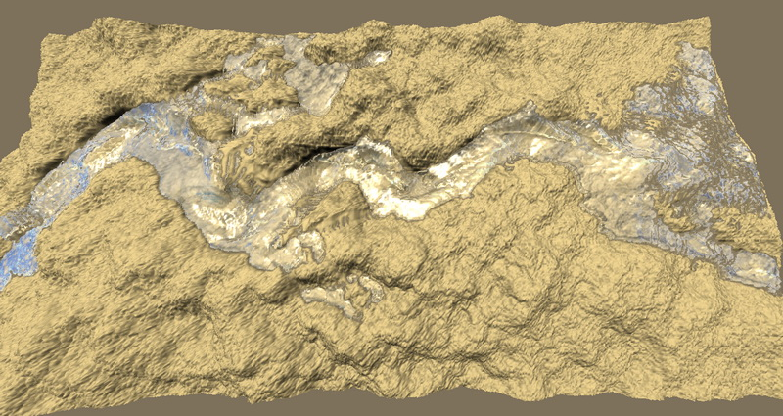
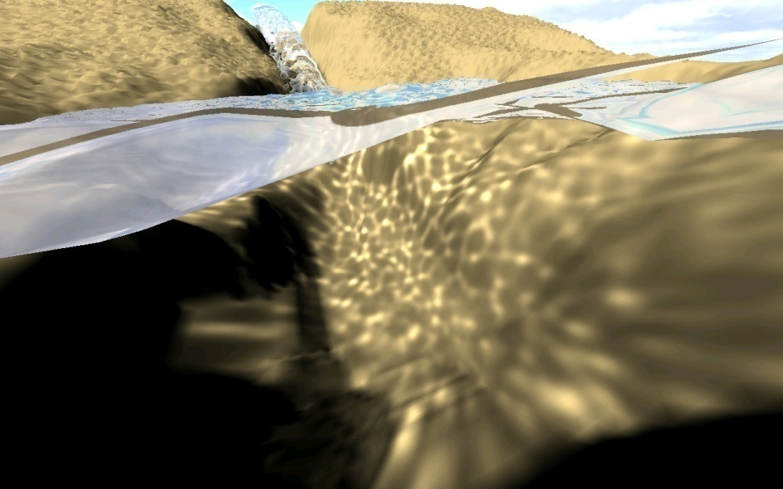
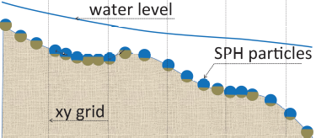
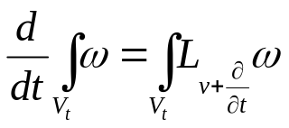Brief outline of project: Derivation of fluid flow equations on general Riemannian manifolds is less straightforward than on the usual Euclidean space with the standard basis. It requires one to go back to understanding how the physical vector fields “feel” the underlying geometry. Thereafter the problem can be reformulated in the language of differential forms, metric tensor, covectors, exterior and Lie derivatives. We will consider a specific example of a Riemannian manifold which is a “curved” terrain z=f(x,y) embedded in the 3D Euclidean space and derive Navier-Stokes equations for various 2D fluids on it. The practical role of these equations would be to replace the shallow-water equations ubiquitous in the geophysical flow modelling where the terrain is considered flat. A 2d model of the river flow, for example, is a foundation of so-called reduced complexity particle-based landscape evolution models where the flat terrain assumption may be inadequate.

Benefits student will gain from involvement in the project:

This would make a nice closing project for a modern vector calculus course whereby it connects to the differential geometry and touches on a real world fluid dynamics application. The benefits include

- Practical usage of vector calculus
- Inspirational entry into differential geometry - a language of modern physics
- Exercise in modelling an important problem in fluvial dynamics

Academic level of student sought:
Proficiency in vector calculus
Basic knowledge of differential geometry and fluid dynamics

Has this project also been submitted to the university scheme? Yes / No

