Use case diagrams-

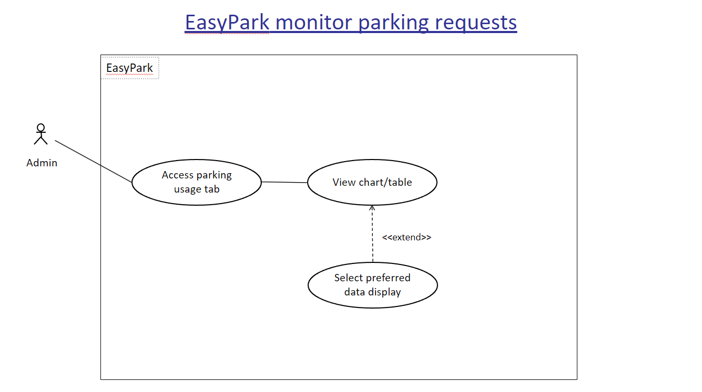

Figure 1. Use case diagram of the admin monitoring parking requests

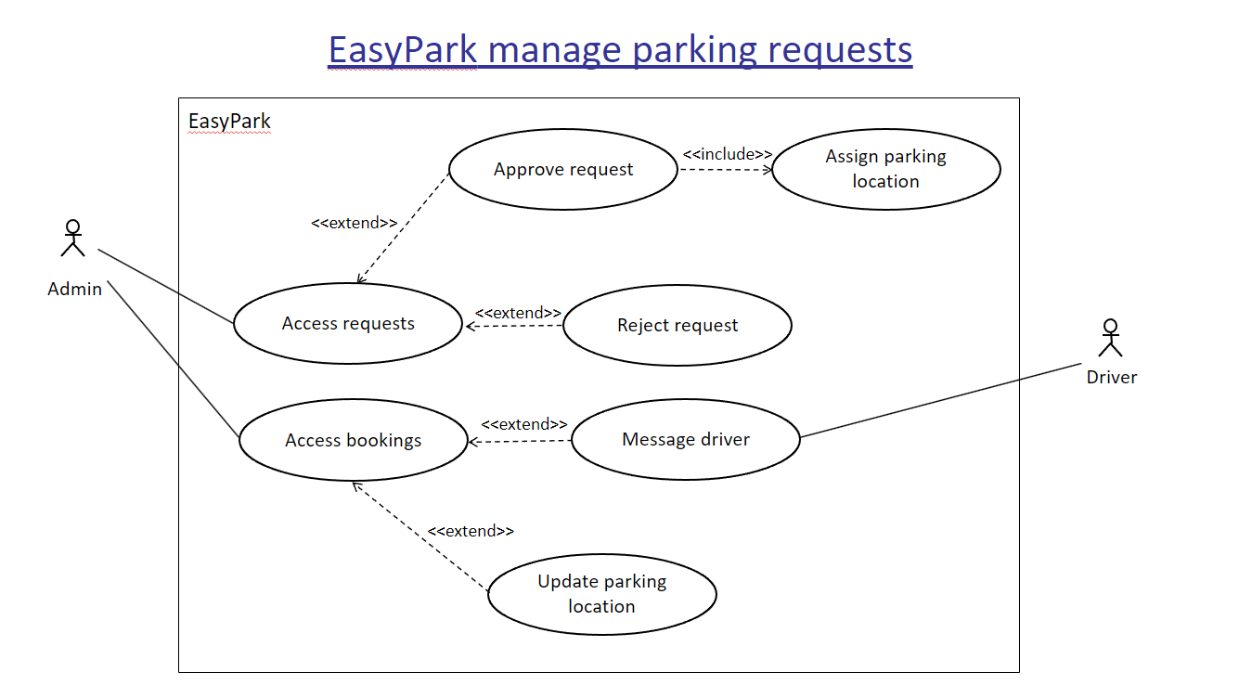

Figure 2. Use case diagram of the admin managing parking requests

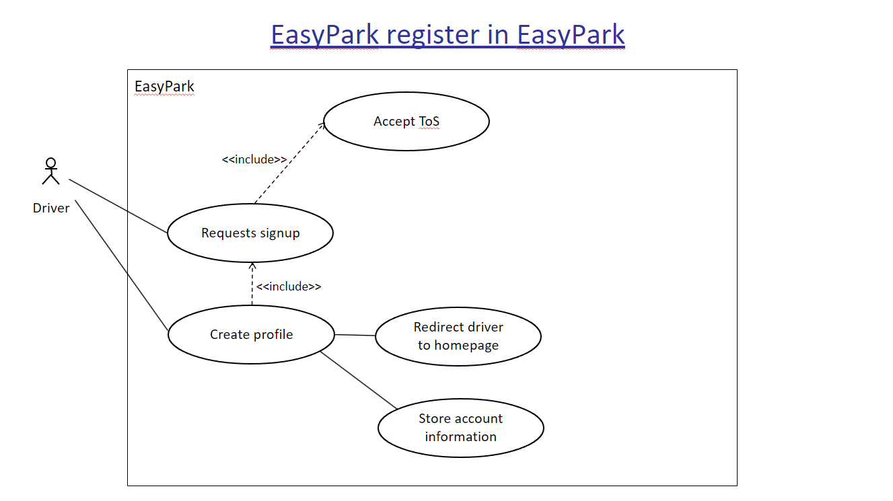

Figure 3. Use case diagram of a driver user registering with the system

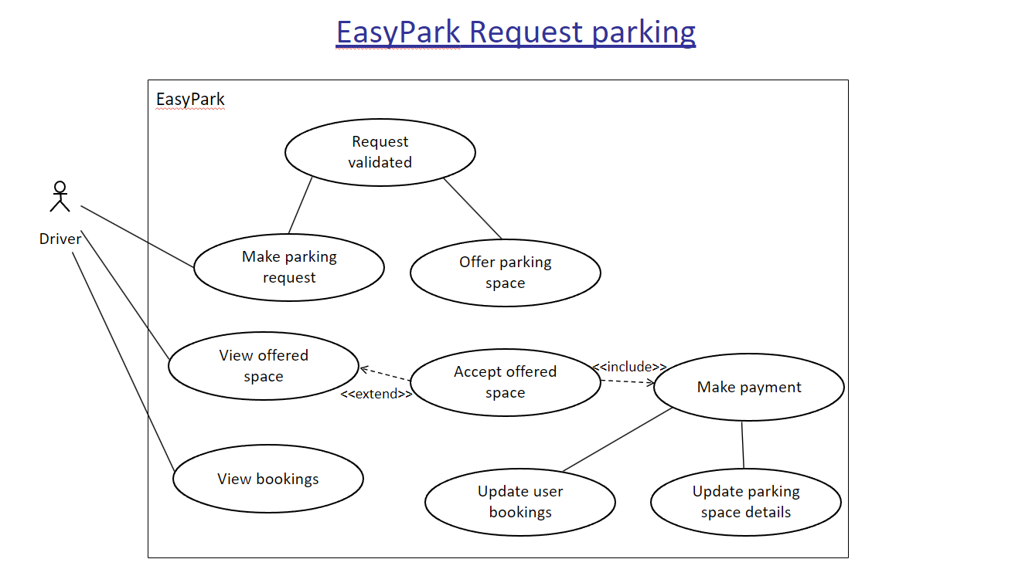

Figure 4. Use case diagram of a driver user requesting parking

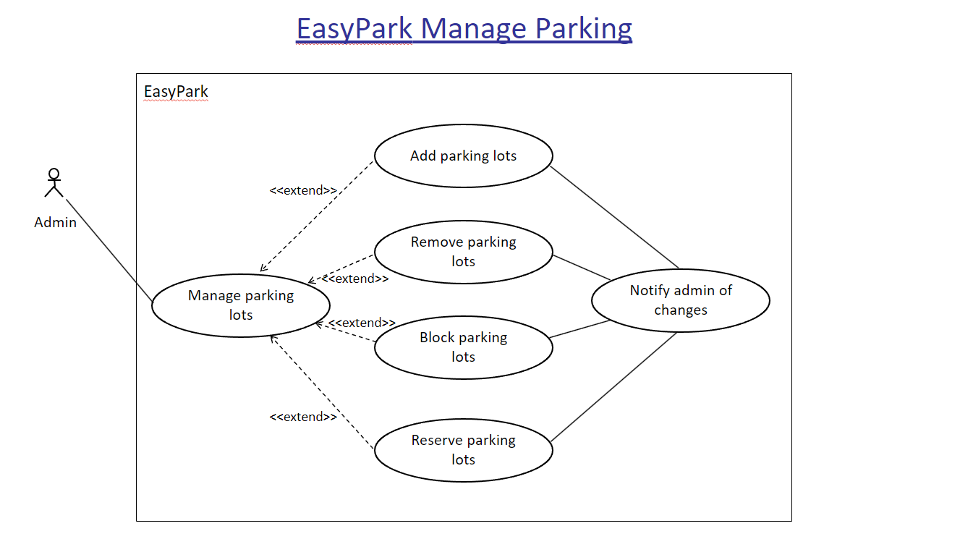

Figure 5. Use case diagram of the admin managing parking