FreeEsVCLComponents

1. Add “Source” folder to library path

(Tools->Options->Delphi Options->Library->Library path):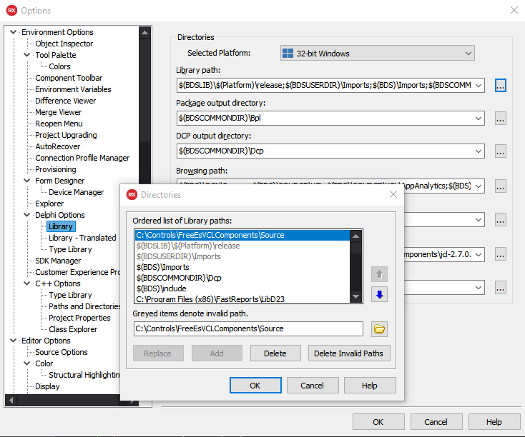

1. Open package:

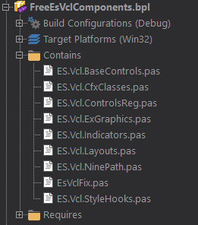

1. Install:

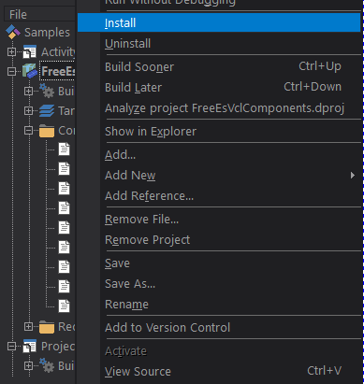

1. Done!