Minor changes applied to previous MEDSLIK-II 2.01 code

All changes applied to the past MEDSLIK II code (v2.01) were tracked and discussed below. The original code is shown on the left-hand panel while the adapted code, hereinafter MEDSLIK-II v3.0, is shown on the right.

# Changes applied to RUN/medslik_II.sh

MEDSLIK-II calculation of the required number of meteo-oceanographic files to perform a simulation was updated.

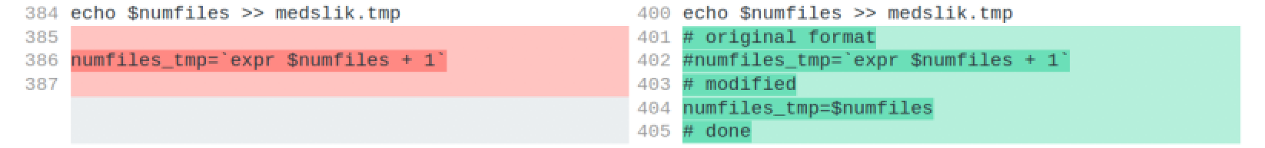

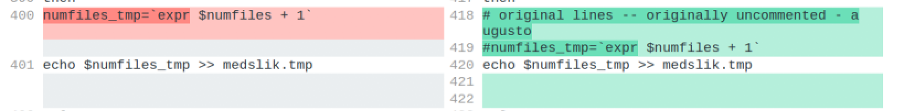

Python call has been updated.



# 

read_oil_data.py

# Changes applied to RUN/MODEL_SRC/lat_lon.for

The maximum expected displacement of a spill has been enlarged encompassing cases of spills at very energetic parts of the global ocean



# Changes applied to RUN/MODEL_SRC/Extract_II.for

MEDSLIK-II calculation of the required number of meteo-oceanographic files to perform a simulation was updated.

The horizontal accuracy of MEDSLIK-transformed current fields has been increased to encompass coastal very high-resolution model outputs



Ocean fields are no longer read step-by-step but all 24 timesteps at once.

