JUGAAD INNOVATION

Submitted By

Name - DEBJEET SEN

University Roll No - 30005021023

REG NO - 213002005010023

Submitted for the partial fulfillment of the degree of

Bachelor of Business Administration

Under

Maulana Abul Kalam Azad University of Technology, West Bengal

(formerly known as West Bengal University of Technology)



**Maulana Abul Kalam Azad University of Technology, West Bengal**

**STUDENT’S DECLARATION**

I hereby declare that the Project Work with the title **“THE IMPACT OF ARTIFICIAL INTELLIGENCE ON INNOVATION”** submitted by me under the supervision of **RATUL MUKHERJEE** for the partial fulfilment of the degree of **Bachelor of Business Administration** at the **Maulana Abul Kalam Azad University of Technology,** Haringhata, is my original work. It has not been submitted earlier to any other institution for the fulfilment of the requirement for any course of study.

I also declare that no chapter of this project in whole or in part has been incorporated in this report from any earlier work done by others or by me. However, extracts of any literature which has been used for this report have been duly acknowledged providing details of such literature in the references.

All the information and data presented in this project are authentic and have been collected through legitimate sources. The data analysis and interpretations presented in this report are based on my own understanding and analysis of the data. Any external sources used in this report have been appropriately cited and referenced.

**Place: Nadia, West Bengal Signature:** ………………………………...

**Date: 24th June 2024**

**Name: DEBJEET SEN**

**Roll No.: 30005021023**

**ACKNOWLEDGEMENT**

A project of this enormity depends upon many people for its success. So, I take this opportunity to thank the people who guided me in this project.

I am thankful to my institution, **Maulana Abul Kalam Azad University of Technology, Haringhata, West Bengal**, for providing me with the opportunity to conduct this research.

I express my sincere and deep gratitude to **Prof. Sujit Mukherjee (Head of the Department, BBA)** for giving me the privilege of conducting research on “IMPACT OF ARTIFICAL INTELLIGENCE ON INNOVATION” for the completion Bachelor of Business Administration.

I would also like to take this opportunity to express my sincere gratitude to my term paper guide, **Ratul Mukherjee**, for lending a helping hand and solving doubts at any time. He has been a source of constant inspiration and has made my learning experience worthwhile. This term paper would not have been possible without his support and valuable time.

**Place: Nadia, West Bengal Signature:** ………………………………...

**Date: 24th June 2024**

**Name: DEBJEET SEN**

**Roll No.: 30005021023**

Table of Contents

**STUDENT’S DECLARATION** 2

**CHAPTER 1** 7

**1.1.** **INTRODUCTION** 7

**1.2. LITERATURE REVIEW:** 11

**CHAPTER 2** 13

**2.1. OBJECTIVES** 13

**2.2. RESEARCH METHODOLOGY** 14

**CHAPTER 3** 15

**3.1. DATA COLLECTION** 15

**1.** **Primary Data** 15

**2.** **Secondary Data** 17

**3.2. DATA ANALYSIS** 18

**3.3. RESEARCH FINDINGS &** 19

**INTERPRETATION OF RESULTS** 19

CHAPTER 4 27

**4.1. CONCLUSION** 27

**5.1.** **LIMITATIONS OF THE PROJECT** 29

**5.2.** **Future Research Directions** 30

**CHAPTER 6** 31

**6.1. BIBLIOGRAPHY** 31

CHAPTER 7 32

**7.1. Survey on Jugaad Innovation** 32

ABSTRACT

Jugaad, a term from Hindi that refers to a creative solution or easy workaround, embodies a particular kind of creativity that is common in settings with limited resources. Flexibility, thrift, and adaptation define jugaad innovation, which focuses on coming up with original and effective ideas when working with constrained resources. This essay examines the ideas and methods of jugaad creativity and shows how it differs from more conventional, structured approaches to innovation. It explores the cultural and contextual elements that support jugaad, highlighting its potential applications in rich economies as well as its significance in developing ones. Through an analysis of actual cases from many industries, including technology, healthcare, and education, the research emphasizes the effectiveness and significance of jugaad in promoting sustainable development and equitable progress. It also tackles the drawbacks and objections of jugaad, offeringa fair assessment of its place in the world of innovation. Businesses and politicians looking to promote a more resilient and flexible approach to innovation that can thrive in a world that is becoming more complicated and dynamic can learn a lot from the insights obtained from jugaad innovation.

# **CHAPTER 1**

* 1. **INTRODUCTION**

Jugaad innovation describes a process of bottom-up innovation and can create efficient solution at low costs. Jugaad is not only a factor influencing management, but also a real “cultural revolution.” It applies to all manners of everyday life from the individual who develops a novel way to air condition their home, create a shower head out of a water bottle, or build a water pump using the wheel of a motorcycle. If we look closely, we can see that it is embedded throughout the entire culture.

We should believe that Jugaad is a perfect representation of innovation in culture. When faced with the necessity to complete a task, applying all the resources available is frequently critical. The core notion of Jugaad is to be flexible, frugal, and inclusive when finding a solution. It is a concept that everyone can benefit from as we approach our daily lives and business challenges. When faced with tough challenges, there is no doubt that scarcity is the mother of innovation. Jugaad Innovation is full of case studies of people and organizations that sought opportunity in adversity, or did more with less, or chose flexibility over rigidity with powerful results.

The link between jugaad innovation and sustainable development is highly relevant in the context of rural development. Prior research has indicated that Jugaad innovation significantly contributes to sustainable development. Moreover, sustainable development has increasingly become a vital topic in various areas, especially in the Global South, with various types of business models. Jugaad Innovation plays a crucial role in explicitly addressing the basic needs of the low-income customers in rural areas who face limited access to essential products and services such as healthcare, clean water, sanitation, and energy. Moreover, Jugaad innovation offers an inclusive, pro-poor business approach that fosters learning, generates, and utilizes new knowledge, and expands the capabilities and opportunities for individuals with low incomes in rural areas.

Here are two well-known examples of jugaad innovation. In the desert of Gujarat there is a village known as Ramakrishna Nagar. A potter Mansukh Bhai Prajapati, is the inventor of “MITTICOOL” - a clay fridge worth Rs. 2000. This fridge is completely biodegradable and uses no electricity. Mansukh Bhai started selling Mitti cool from his village initially. He, then went on to sell across

India and then internationally. He started training the other villagers specially women in his village in pottery. These villagers then mass produced his products in the factory.

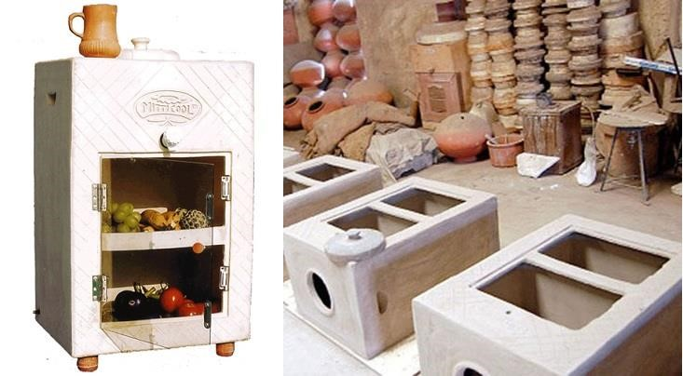

Some Jugaad entrepreneurs make their constraints work for them such as Kanak Das from Morigaon in Assam, who has invented a bike that runs faster on our country’s bumpy, crater-filled roads. A shock absorber fitted on the bike’s front wheel compresses and releases energy into its back wheel as a propulsive force. Kanak Das innovation has been patented with the support of India’s National Innovation Foundation.

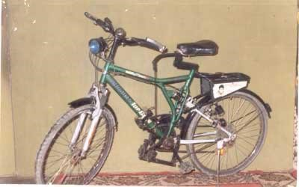

Jugaad innovation can be distilled into six guiding principles which anchor the six practices of highly effective innovators in complex settings like emerging economies.

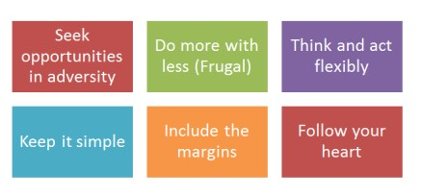

**These six principles are-**

* **Seek opportunity in adversity-** Reframe the problem. Take something that is a threat or seems like adversity and turn it into an opportunity. For example - Mansukh Bhai Prajapati credited his success to an earthquake that had caused a lot of devastation in his village. After the earthquake, one of the newspaper articles had a photo of a pot smashed into pieces captioned, ‘poor man’s fridge broken.’ This statement was the eureka moment for Prajapati. Despite the adversity faced, Prajapati saw an opportunity to find a solution, one that is now enjoyed by many people in 9 states and more than 63 cities. The MittiCool has received 90 awards, and many companies have adopted the concept in manufacturing items such as the nonstick pans.

* **Do more with less-** Do not default to asking for more. Think about what you already have in a new way to create even better solutions. This frugal principle can help firms in both emerging and developed economies optimize the use of scarce financial and natural resources while delivering high value to a greater number of customers. For instance, Sunil Mittal of Bharti Airtel (India) developed business models to cost effectively deliver agricultural and telecom services, respectively to the masses.

* **Think and act flexibly-** Be passionate and use that to move ideas forward. Jugaad innovators do not just think outside the box: they create a whole new box. Their nonlinear thinking often yields breakthrough ideas that turn conventional wisdom on its head and help to shape entire new markets and industries.

* **Keep it simple-** Complexity can cause problems. More choices are not necessarily better than fewer. Jugaad innovators are not obsessed with perfection. Offering a good enough product to use is better than taking a long time to perfect the offering. In the Jugaad world, practice makes for improvement, not perfection. Companies looking to survive must not only think and act flexibly, but they must also offer solutions that are easy to use.
* **Include the margin-** Know your customers and include them in your problem-solving process. In the current crisis, companies must continuously ask themselves how they can better serve consumers who are looking for affordable products or services. The sweet spot is striking a balance between quality and affordability. On the onset of the COVID 19 pandemic in Kenya, Safaricom took some steps that ensured that it serves the marginal segment of the society. The telco waived fees on its mobile money transfer service M-Pesa for transactions below Ksh1,000 ($10) to allow customers to use cashless modes of payment as part of the measures to prevent the transmission of Covid-19.

* **Follow your heart-** Be passionate and use that to move ideas forward. Specially, jugaad entrepreneurs employ intuition, empathy and passion - qualities that are increasingly just as important as analytical thinking in navigating environment that is ever more diverse, interconnected, and unpredictable. For instance, Kishore Biyani the founder of Big Bazaar, one of India’s largest and most successful retail chains did not use management consultants to validate his idea of launching retail stores that look, feel, and even smell like chaotic street bazaars. When he launched his new store format, he trusted his intuition and was fired by his empathy for Indian consumers more than any analysis.

The most striking thing about jugaad innovators in emerging markets is their frugal mindset. These entrepreneurs and managers whether they come from Argentina, Brazil, India, China, Kenya, or the Philippines are constantly looking for new ways to do more with less and deliver greater value to consumers at a lower cost. We believe that such mindset is a rational response to the pervasive scarcity in their environment. For jugaad entrepreneurs, being frugal is not a luxury -- it is the key to survival.

## **1.2. LITERATURE REVIEW:**

Jugaad innovation, originating from India, represents a grassroots approach to innovation that emphasizes flexibility, frugality, and creativity in resource-constrained environments. This review synthesizes the existing literature on jugaad innovation, exploring its principles, applications, benefits, and challenges. It aims to provide a comprehensive understanding of how jugaad can contribute to sustainable and inclusive growth, both in emerging markets and globally.

**Principles and Characteristics of Jugaad Innovation**

The foundational principles of jugaad innovation include frugality, simplicity, flexibility, and inclusivity. Radjou, Prabhu, and Ahuja (2012) highlight that jugaad is an "innovative fix" or "simple work-around," emphasizing the ability to do more with less . They argue that jugaad is a mindset that thrives in scarcity, leveraging limited resources to create effective solutions.

**Applications in Various Sectors**

1. **Healthcare**:
   * Govindarajan and Trimble (2012) discuss how Indian healthcare providers use jugaad to deliver affordable and accessible care. For instance, the Aravind Eye Care System uses innovative methods to perform high-quality eye surgeries at a fraction of the cost in developed countries .
2. **Technology**:
   * Prabhu and Jain (2015) explore how jugaad innovation has influenced the Indian tech industry. Companies like Tata and Mahindra have developed cost-effective products such as the Tata Nano car and Mahindra’s fuel-efficient tractors by applying jugaad principles .
3. **Education**:
   * Bhaduri and Kumar (2011) examine how jugaad is applied in educational contexts to improve access and quality. Low-cost educational tools and mobile classrooms are examples of jugaad solutions that address the educational needs of underprivileged communities .

**Benefits of Jugaad Innovation**

Jugaad innovation offers several benefits, particularly in resource-constrained environments. It promotes:

* **Cost Efficiency**: Solutions are designed to be affordable, making essential goods and services accessible to a larger population (Radjou et al., 2012) .
* **Flexibility and Adaptability**: Jugaad encourages adaptability to changing circumstances and constraints, which is crucial in volatile environments (Prabhu & Jain, 2015) .
* **Sustainability**: By utilizing existing resources efficiently and minimizing waste, jugaad contributes to sustainable development (Govindarajan & Trimble, 2012) .

**Challenges and Criticisms**

Despite its advantages, jugaad innovation faces several criticisms and challenges:

* **Scalability**: Birtchnell (2011) argues that jugaad solutions, while effective on a small scale, often struggle to scale up without losing their cost advantages and simplicity .
* **Quality and Safety Concerns**: Some jugaad innovations may compromise on quality and safety due to their frugal nature. This can be a significant issue in sectors like healthcare and engineering (Kumar & Bhaduri, 2014) .
* **Lack of Formal Structure**: Radjou et al. (2012) note that jugaad lacks the formal processes and structures of traditional innovation methods, which can lead to inconsistent results .

**Global Relevance and Adaptation**

Jugaad innovation, though rooted in the Indian context, has global relevance. Radjou and Prabhu (2015) argue that businesses in developed economies can learn from jugaad to foster a more resilient and agile approach to innovation. The COVID-19 pandemic, for instance, has underscored the need for adaptable and resource-efficient solutions worldwide .

Jugaad innovation represents a valuable paradigm for addressing complex challenges in resource-constrained settings. By embracing its principles of frugality, flexibility, and creativity, organizations can develop sustainable and inclusive solutions. However, addressing the challenges of scalability, quality, and formalization is crucial for maximizing the potential of jugaad on a global scale. Further research and case studies are needed to explore how jugaad can be systematically integrated into mainstream innovation practices.

# **CHAPTER 2**

## **2.1. OBJECTIVES**

1. To assess the level of awareness and understanding of the concept of frugal innovation among educated individuals in Kolkata, including professionals, academics, and entrepreneurs.

1. To identify the key sectors or domains where frugal innovation initiatives are most prevalent in Kolkata and the surrounding regions.

1. To examine the drivers and motivations behind the adoption of frugal innovation practices among the educated residents of Kolkata.

1. To explore the challenges and barriers that hinder the widespread implementation and scaling of frugal innovation solutions in Kolkata.

1. To analyze the perceived impact of frugal innovation on addressing socio-economic challenges and promoting sustainable development in the region.

1. To understand the perceptions, attitudes, and willingness of educated individuals in Kolkata to support, invest in, or participate in frugal innovation initiatives in the future.

## **2.2. RESEARCH METHODOLOGY**

Research methodology refers to the strategies, techniques, and approaches used by researchers to conduct a study and gather relevant data to answer specific research questions or test hypotheses. It encompasses the overall framework within which the research is conducted and involves various steps and procedures aimed at ensuring the validity and reliability of the research findings.

Here are some key components and considerations typically involved in research methodology:

**1.Research Design:** This involves planning the overall structure of the study, including the type of study, data collection methods, and sampling techniques.

**2.Research Methods:** These are the specific techniques and procedures used to collect and analyze data. Methods can include surveys, experiments, interviews, observations, case studies, content analysis, etc.

**3.Sampling:** This determines how participants or subjects will be selected for the study. This involves choosing a representative sample from the larger population to ensure the findings can be generalized.

* **Sample Size -** The sample size drawn is 60 which are local educated residents of Kolkata.
* **Research Tools -** Tools or instruments used to collect data, such as surveys, questionnaires, interview guides, or experimental protocols.

**4.Data Collection:** Gathering relevant information or data using the chosen methods. This could involve administering surveys, conducting experiments, gathering documents, or observing behaviors.

**5.Data Analysis:** Examining and interpreting the collected data to draw meaningful conclusions. This can involve statistical analysis, content analysis, or other methods depending on the nature of the data.

# **CHAPTER 3**

## **3.1. DATA COLLECTION**

Data collection is a crucial phase in research where relevant information and evidence are gathered to address research questions or objectives. The methods chosen for data collection depend on the nature of the research, the type of data required, and the research design. Here are some common methods and considerations for data collection:

## **Primary Data**

Primary data refers to original data collected firsthand by researchers directly from their source of interest, typically through surveys, interviews, observations, or experiments. This data is specific to the research objectives and is gathered for the purpose of addressing specific research questions or hypotheses. Primary data collection involves direct interaction with subjects or phenomena being studied. Here are common methods used to collect primary data.

**Common Methods of Primary Data Collection:**

**1.1 Surveys:**

* **Description:** Surveys involve gathering information from a sample of respondents using standardized questionnaires or structured interviews.
* **Types:** Online surveys, paper-based surveys, telephone interviews, faceto-face interviews.
* **Advantages:** Allows for efficient collection of data from a large sample; responses can be quantitatively analyzed.
* **Considerations:** Designing clear and concise questions, selecting appropriate sampling techniques, and ensuring high response rates.

* 1. **Questionnaires:**

Questionnaires are generally designed to collect large numbers of quantitative data. Questionnaires are generally less expensive and time consuming than interviews and observation, but they also introduce a much larger chance of nonresponse and nonresponse error. The distribution of online questionnaires is easy and fast. Online questionnaires are usually created as “web forms” with a database to store the answers and statistical software to provide statistical analysis.

Online questionnaires are often used to gain a deeper understanding of consumers’ opinions and preferences.

In this study, we have used a survey method using online questionnaire to collect primary data from educated residents of Kolkata.

**Advantages of online questionnaires:**

* It makes the most of the ability of the Internet to provide access to groups and individuals who would be difficult, if not impossible, to reach through other channels.
* A wide geographical area can be covered in the survey.
* The automatic processing of the survey saves further costs, time, and energy.
* Respondents can answer at their convenience.

**Disadvantages of online questionnaires:**

* Researchers often encounter problems with regard to sampling.
* Self-selection and extremely low response rates make it difficult to establish the representativeness of the sample and generalize the findings.
* Computer literacy is a must.
* Respondent must be willing to complete the survey.

* 1. **Observations:**
* **Description:** Observations involve systematically watching and recording behaviors, events, or phenomena in their natural setting.
* **Types:** Participant observation (where the researcher is actively involved) or non-participant observation (where the researcher is a passive observer).
* **Advantages:** Provides firsthand qualitative data, allows for studying behaviors in real-time contexts.
* **Considerations:** Minimizing observer bias, maintaining objectivity, and recording observations accurately.

**Challenges of Primary Data Collection:**

* **Resource-Intensive:** Primary data collection can be time-consuming and require significant resources.
* **Skill Requirement:** Researchers need expertise in designing and implementing data collection methods.
* **Ethical Considerations:** Ensuring ethical standards are met in interacting with participants and handling data.

## **Secondary Data**

Secondary data refers to data that has been collected by someone else for a purpose other than the current research study. This type of data is readily available and can be accessed through various sources such as published literature, official statistics, organizational records, and data repositories. Researchers use secondary data to complement or support their own research objectives. Here are common sources and examples of secondary data:

**Common Methods of Secondary Data Collection:**

* **Books and Articles**
* **Internet**

In this study, we have read two main books on Jugaad Innovation written by Navi Rajdou, Jaideep Prabhu and Simone Ahuja. Also, we have read many published research articles. Additionally, we have browsed the internet for more resources. We have mentioned all these sources of information in our Bibliography. With the help of these information, we have written this report, prepared the presentation and developed the online questionnaire.

**Challenges of Using Secondary Data:**

Quality and Reliability: The quality and reliability of secondary data may vary depending on the source and how it was collected.

* **Limited Control:** Researchers have limited control over the design and collection methods used to gather secondary data.
* **Incomplete Information:** Secondary data may lack specific details or variables required for the current research study.
* **Potential Bias:** Data collected for one purpose may not perfectly align with the needs or objectives of the current research, leading to potential biases.

## **3.2. DATA ANALYSIS**

After data collection, the next step is data analysis, where collected data are processed, interpreted, and synthesized to generate meaningful insights and conclusions. Depending on the research design and data collected, appropriate analytical techniques (quantitative or qualitative) are applied to address research questions or test hypotheses.

**Methods of Data Analysis**

1. **Regression Analysis -** Regression analysis is a powerful method for understanding the relationship between a dependent and one or more independent variables. It is applied in economics, finance, and social sciences. By fitting a regression model, one can make predictions, analyze cause-andeffect relationships, and uncover trends within your data.

1. **Statistical Analysis -** Statistical analysis encompasses a broad range of techniques for summarizing and interpreting data. It involves descriptive statistics (mean, median, standard deviation), inferential statistics (hypothesis testing, confidence intervals), and multivariate analysis. Statistical methods help make inferences about populations from sample data, draw conclusions, and assess the significance of results.

1. **Cohort Analysis -** Cohort analysis focuses on understanding the behavior of specific groups or cohorts over time. It can reveal patterns, retention rates, and customer lifetime value, helping businesses tailor their strategies.

1. **Content Analysis -** It is a qualitative data analysis method used to study the content of textual, visual, or multimedia data. Social sciences, journalism, and marketing often employ it to analyze themes, sentiments, or patterns within documents or media. Content analysis can help researchers gain insights from large volumes of unstructured data.

1. **Factor Analysis -** Factor analysis is a technique for uncovering underlying latent factors that explain the variance in observed variables. It is commonly used in psychology and the social sciences to reduce the dimensionality of data and identify underlying constructs. Factor analysis can simplify complex datasets, making them easier to interpret and analyze.In this study, we have used mainly pie charts and bar graphs to discuss about the findings. We show these diagrams in the next section on Research Findings.

## **3.3. RESEARCH FINDINGS &**

## **INTERPRETATION OF RESULTS**

**Our sample size is 60.**

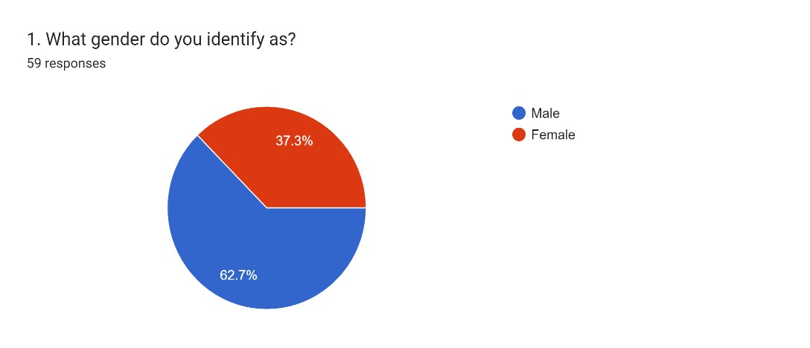

**FINDINGS:** Among our respondents, majority are male (62.7%) whereas only 37.3% are female.

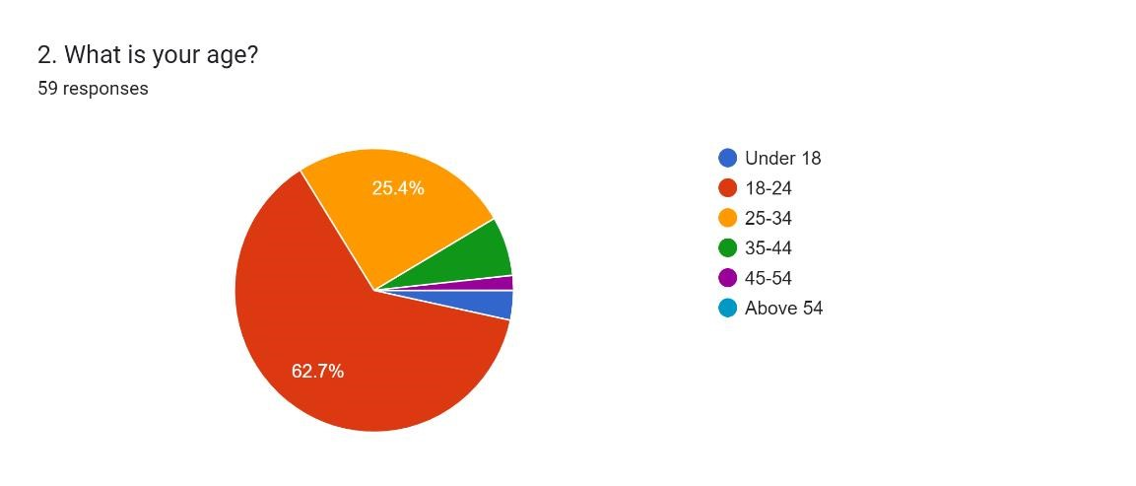

FINDINGS: Here majority of our respondents are in the age group of 18-24 yrs. (62.7%) and about 25.4% are in the age group of 25-34 yrs.

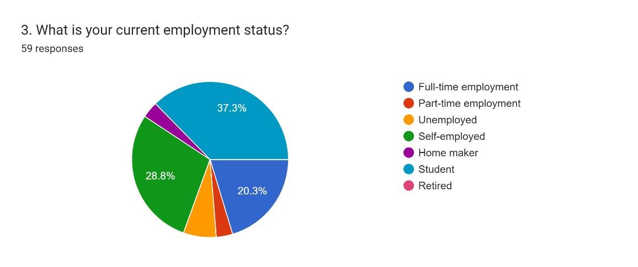

FINDINGS: Among our respondents, students form the largest group (37.3% of all the respondents). The next largest group of respondents include self- employed (28.8% of the all respondents). The third largest group (20.3%) is that of full-time employed persons.

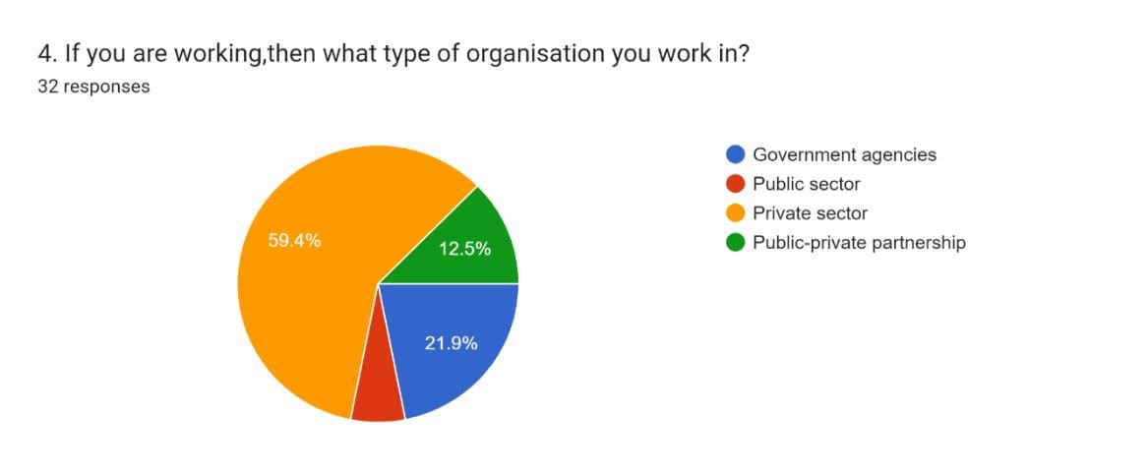

FINDINGS: Here the largest group of respondents belong to the private sector (59.4% of all respondents) and the second largest group of respondents works in government agencies.

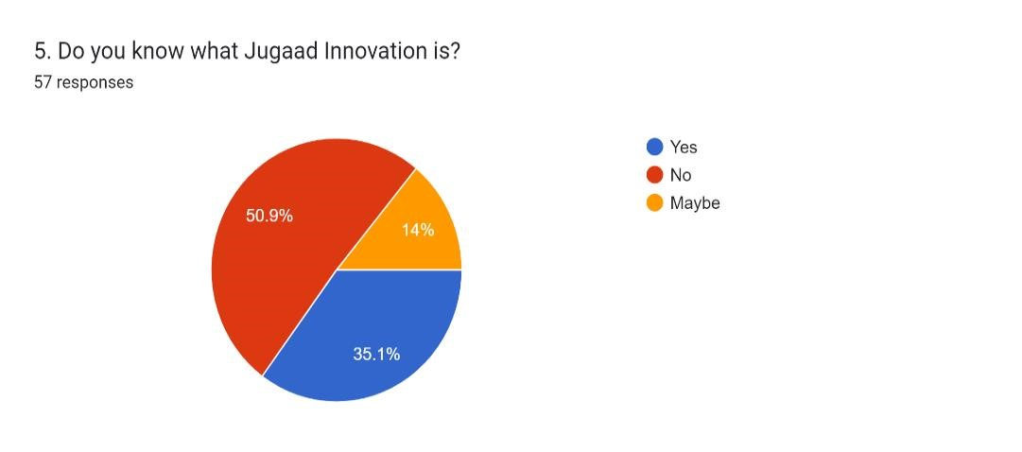

FINDINGS: About only 35.1% of our respondents know what jugaad innovation is. 50.9% of our respondents do not know about jugaad innovation.

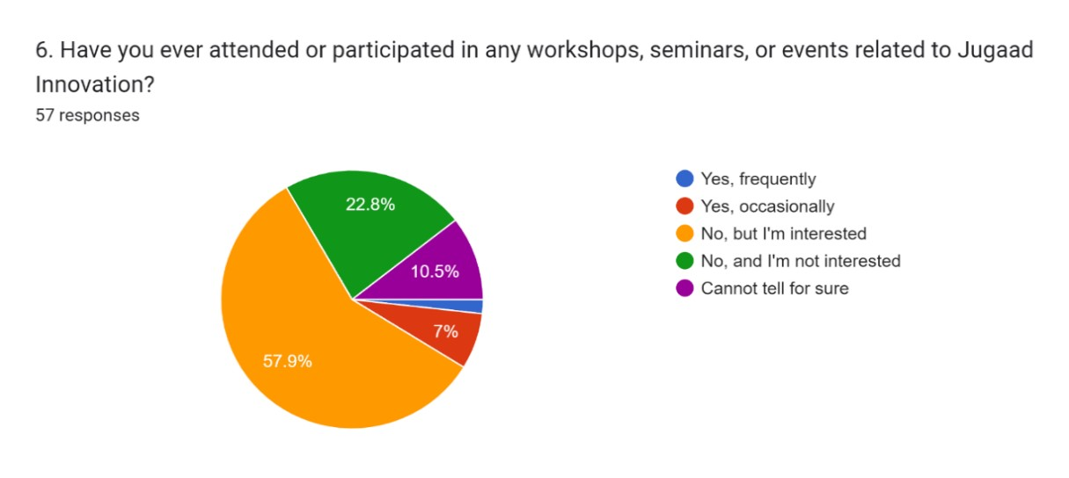

FINDINGS: Here majority of our respondents said that they have not attended any worshop or seminar on jugaad innovation but are interested in

attending (57.9%). About 8.8% of our respondents have attended workshops or seminars on jugaad innovation. Out of this 8.8%, 7% have attended workshops or seminars on jugaad innovation occasionally.

Forms response chart. Question title: 7. Have you ever been involved in or contributed to a Jugaad Innovation project?
. Number of responses: 57 responses.

FINDINGS: About only 5.3% of our respondents have been involved in or contributed to a jugaad innovation project. However, majority of our respondents (84.2%) did not contribute to a jugaad innovation project.

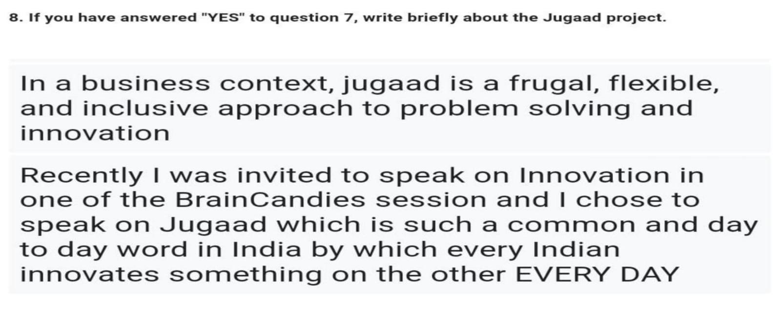

FINDINGS: Above are some responses about what our respondents think or know about jugaad innovation.

Forms response chart. Question title: 9. Which of the following sector do you think has the most potential for Jugaad Innovation in Kolkata?
. Number of responses: 53 responses.

FINDINGS: Our respondents believe that the transportation sector has the maximum potential for jugaad innovation in Kolkata. Another sector that has high potential for jugaad innovation is healthcare.

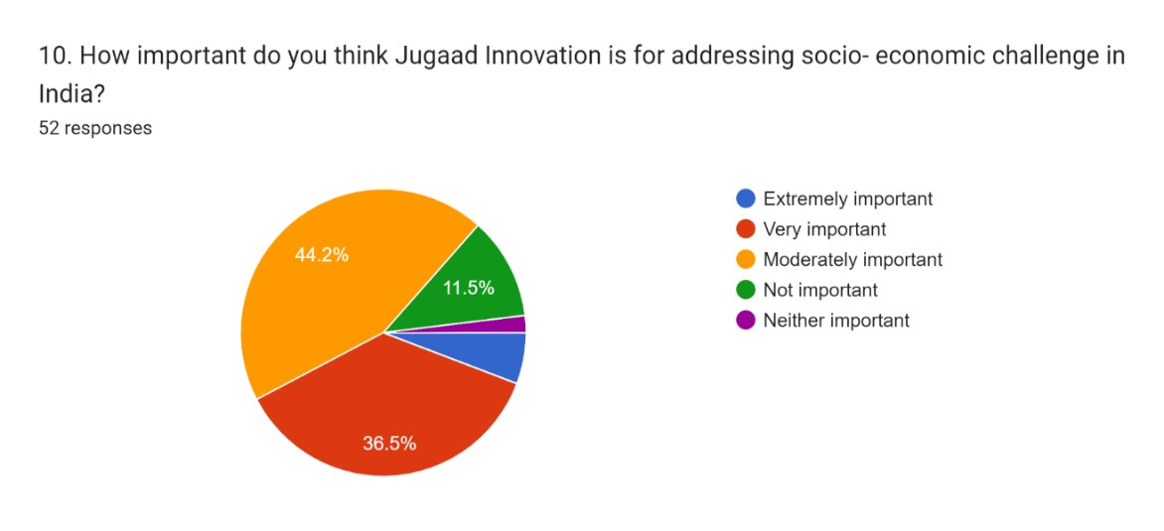

FINDINGS: Here majority of our respondents (44.2%) said that jugaad innovation is moderately important for addressing socio-economic challenges in India. About 36.5% of our respondents said that jugaad innovation is very important.

Forms response chart. Question title: 11. How likely are you to support or invest in a Jugaad Innovation initiative in the future?
. Number of responses: 54 responses.

FINDINGS: About 50% of our respondents will support or invest in a jugaad innovation initiative in the future. In contrast, 18.6% will not support or invest in a jugaad innovation in the future.

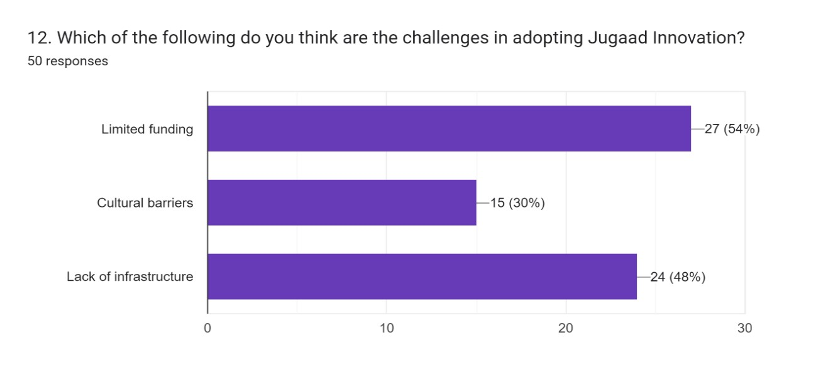

FINDINGS: Here the largest group of respondents have selected limited funding (54%) and the second largest group of respondents have selected lack of infrastructure (48%) as the challenges in adopting jugaad innovation.

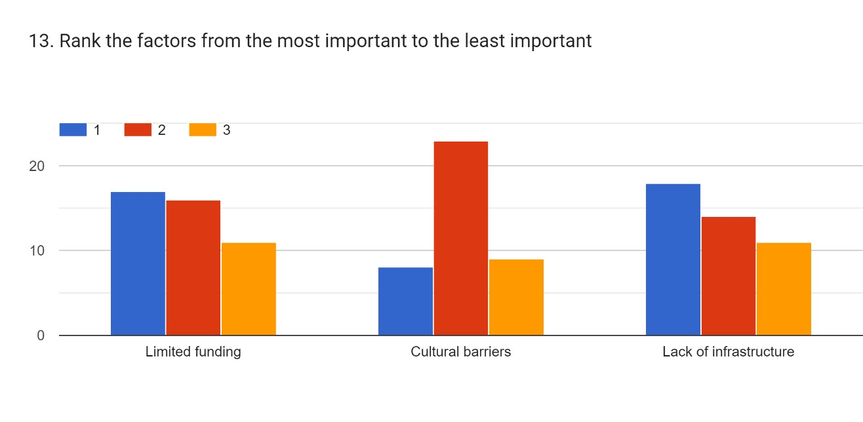

FINDINGS: This is how respondents have ranked the barriers in adopting the jugaad innovation. Majority have chosen rank 1 as “lack of infrastructure” and “ cultural barriers” are mostly ranked 2.

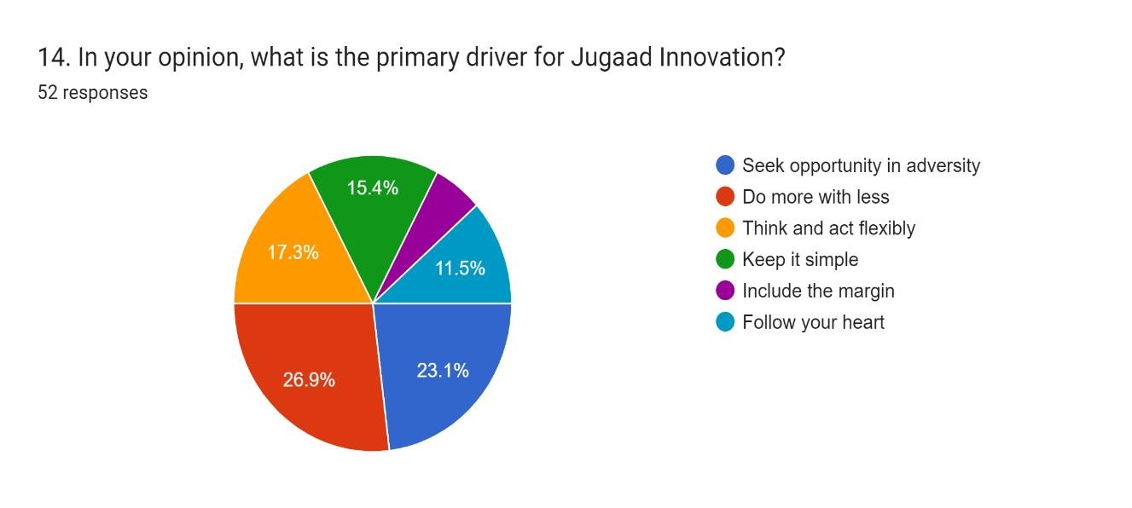

FINDINGS: Most of the respondents (26.9%) think that “Do more with less” is the primary driver of jugaad innovation and the second largest group of respondents (23.1%) selected “seek opportunity in adversity.”

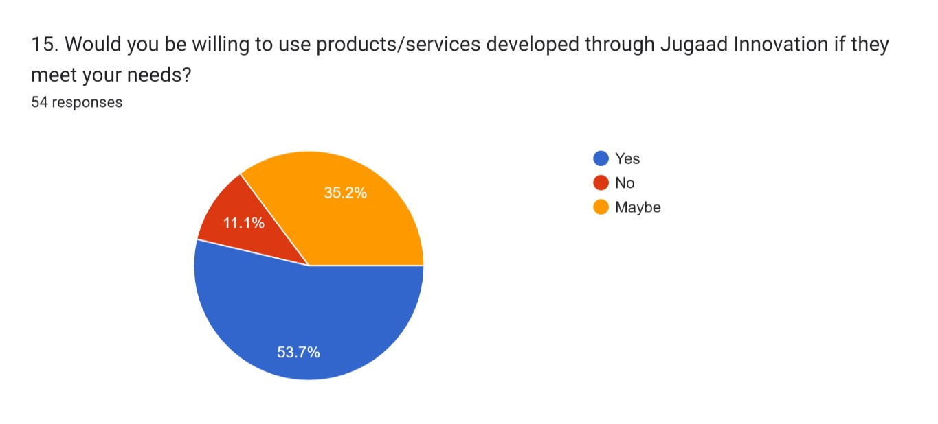

FINDINGS: Majority of the respondents (53.7%) are willing to use product /service developed through jugaad innovation. And 35.2% said that they may use product / service developed though jugaad innovation.

# CHAPTER 4

## 

## **4.1. CONCLUSION**

In this research paper, we have explored the concept of jugaad innovation and its awareness among educated residents of Kolkata. Jugaad, originating from India, embodies a unique approach to problem-solving characterized by resourcefulness, improvisation, and a mindset of doing more with less. Through a comprehensive analysis of existing literature and case studies, we have gained valuable insights into the nature, principles, and applications of jugaad innovation.

Our primary research findings highlight several key points:

When we embarked on a journey to find out about the consumer awareness on jugaad innovation among educated residents of Kolkata we realized that there is still room for educating Kolkata residents about jugaad innovation. Further, we found that limited funding is the main barrier in adopting jugaad innovation. This is interesting because jugaad innovation works well under conditions of resource constraint and limited funding. We also found that there is scope for arranging workshops and/or seminars on jugaad innovation in Kolkata. We also found that according to our respondents, transportation, healthcare and energy are the three most promising sectors where Jugaad Innovation can be employed. Interestingly, a large portion of our respondents are willing to embrace Jugaad Innovation in the future.

Our secondary research yielded the following insights:

Firstly, jugaad innovation represents a grassroots approach to innovation that thrives in resource-constrained environments. It emphasizes the importance of creativity and resilience in overcoming challenges and finding simple yet effective solutions to complex problems. Secondly, the principles of jugaad have broader implications beyond developing countries. Organizations worldwide are increasingly embracing jugaad-inspired practices to foster agility, flexibility, and cost-efficiency in innovation processes.

Furthermore, we have identified the potential drawbacks and criticisms associated with jugaad, including concerns about sustainability, quality, and scalability. While jugaad offers quick fixes and immediate solutions, its longterm viability and impact on sustainable development warrant careful consideration. Moving forward, our research underscores the need for a balanced approach that combines the strengths of jugaad with structured innovation frameworks. By integrating jugaad principles with formal innovation processes, organizations can harness the benefits of both frugality and rigor to drive sustainable innovation.

In conclusion, the study of jugaad innovation offers valuable lessons for entrepreneurs, managers, policymakers, and researchers alike. Embracing jugaad's spirit of ingenuity and resilience can inspire innovative thinking and foster inclusive growth in diverse contexts. However, it is essential to approach jugaad with a critical lens, recognizing its strengths while addressing its limitations for sustainable and responsible innovation. As we navigate an increasingly complex and interconnected world, understanding and leveraging the principles of jugaad innovation can pave the way for transformative solutions that address pressing societal and environmental challenges.

This research paper contributes to the ongoing discourse on jugaad innovation. innovation. We hope that our findings stimulate further research and practical applications that harness the power of jugaad innovation to create positive impact and meaningful change.

CHAPTER 5

## **LIMITATIONS OF THE PROJECT**

While this research study aimed to explore the phenomenon of Jugaad Innovation and its awareness, certain limitations were encountered throughout the research process. It is important to acknowledge these limitations to provide a comprehensive understanding of the study's scope and potential constraints.

1. **Sample Size and Diversity:** One of the primary limitations of this study was the relatively small and homogeneous sample used for data collection. The research predominantly focused on a specific geographical region - Kolkata, which may limit the generalizability of findings to broader contexts or diverse populations practicing Jugaad Innovation.
2. **Data Collection Challenges:** Data collection posed challenges in accessing firsthand accounts or detailed case studies of Jugaad Innovation practices. Limited availability of comprehensive data sources restricted the depth of analysis and exploration of various facets of Jugaad within different organizational settings.
3. **Cultural and Contextual Variations:** Jugaad Innovation is deeply rooted in cultural and contextual factors, which may vary significantly across regions and industries. This study may not have captured the full spectrum of Jugaad practices. Perhaps a focus on rural areas would have thrown more light on actual Jugaad Innovation projects undertaken by villagers.
4. **Ethical Considerations:** Ethical considerations, particularly related to intellectual property rights and attribution of Jugaad practices, posed constraints on the study. Certain organizations or individuals may be hesitant to disclose proprietary information or innovative strategies, limiting access to comprehensive data.
5. **Time and Resource Constraints:** The study was conducted within a limited timeframe and with constrained resources, which impacted the depth and breadth of the research. More extensive fieldwork and indepth interviews with practitioners of Jugaad Innovation could have provided richer insights but were not feasible within the scope of this project.

## **Future Research Directions**

Despite these limitations, this study lays the groundwork for future research endeavours in the field of Jugaad Innovation. Future studies could address these limitations by:

* Employing larger and more diverse samples to enhance generalizability.
* Conducting longitudinal studies to track the evolution and sustainability of Jugaad practices over time.
* Collaborating with practitioners and organizations to gain access to proprietary information and firsthand insights into Jugaad strategies.
* Exploring cross-cultural variations in Jugaad Innovation practices and their implications for global innovation ecosystems.

# **CHAPTER 6**

## **6.1. BIBLIOGRAPHY**

The research-based project is compiled with key works exploring the objectives, data, analysis, research methodology, of Jugaad innovation across various domains from the following books articles and websites:

**BOOKS:**

* Radjou, N., Prabhu, J., & Ahuja, S. (2012). Jugaad innovation: Think frugal, be flexible, generate breakthrough growth. John Wiley & Sons.

* Radjou, N., & Prabhu, J. (2019). Do better with less: Frugal innovation for sustainable growth. Penguin Random House India Private Limited.

**ARTICLES:**

* Chakravarty, S. (2022). Resource constrained innovation in a technology intensive sector: Frugal medical devices from manufacturing firms in South Africa. Technovation, 112, 102397.

* Hossain, M., Park, S., & Shahid, S. (2023). Frugal innovation for sustainable rural development. Technological Forecasting and Social Change, 193, 122662.

* Sarkar, S., & Mateus, S. (2022). Doing more with less-how frugal innovations can contribute to improving healthcare systems. Social Science & Medicine, 306, 115127.

**WEBSITES:**

* www.elsevier.com/locate/socscimed
* Parmesh.net
* link.springer.com
* https://mitticool.com
* ideasforleaders.com

# CHAPTER 7

## **7.1. Survey on Jugaad Innovation**

1. **What gender do you identify as?**

* Male
* Female
* Other

1. **What is your age?**

* Under 18
* 18-24
* 25-34
* 35-44
* 45-54
* Above 54

1. **What is your current employment status?**

* Full-time employment
* Part-time employment
* Unemployed
* Self-employed
* Home maker
* Student
* Retired

1. **If you are working, then what type of organisation you work in?**

* Government agencies
* Public sector
* Private sector
* Public-private partnership

1. **Do you know what Jugaad Innovation is?**

* Yes
* No
* Maybe

1. **Have you ever attended or participated in any workshops, seminars, or events related to Jugaad Innovation?**

* Yes, frequently
* Yes, occasionally
* No, but I’m interested
* No, and I’m not interested
* Cannot tell for sure

1. **Have you ever been involved in or contributed to a Jugaad Innovation project?**

* Yes
* No
* Not sure

1. **If you have answered 'YES’ to question 7, write briefly about the Jugaad project.**

* **_____________________________________________________**

1. **Which of the following sectors do you think has the most potential for Jugaad Innovation in Kolkata?**

* Healthcare
* Energy
* Education
* Transportation
* Retail
* Hotels & Restaurants
* Tourism
* FMCG
* Gems & Jeweler
* Banking & Insurance
* Computers & Peripherals
* Logistics
* Any other please mention

1. **How important do you think Jugaad Innovation is for addressing socio-economic challenge in India?**

* Extremely important
* Very important
* Moderately important
* Not important
* Neither important

1. **How likely are you to support or invest in a Jugaad Innovation initiative in the future?**

* Very likely
* Likely
* Very unlikely
* Unlikely
* No comments

1. **Which of the following do you think is the biggest challenge in adopting Jugaad Innovation?**

* Limited funding
* Cultural barriers
* Lack of infrastructure

1. **Rank the factors from the most important to the least important.**

|  |  |  |  |
| --- | --- | --- | --- |
|  | **1** | **2** | **3** |
| 1. Limited funding | o | o | o |
| 1. Cultural barriers | o | o | o |
| 2. Lack of infrastructure | o | o | o |

1. **In your opinion, what is the primary driver for Jugaad Innovation?**

* Seek opportunity in adversity
* Do more with less
* Think and act flexibly
* Keep it simple
* Include the margin
* Follow your heart
* Any other please mention

1. **Would you be willing to use products/services developed through Jugaad Innovation if they meet your needs?**

* Yes
* No
* Not sure