Project:

Task Management System.

NTRODUCTION TO MY PROJECT

* I have developed a Web application that can help a given Person in the management of their Task and the user who make those task.
* In this web application the User managing Task can:
* Record, update, delete, and display data regarding to Task.
* Data are saved automatically into a database.
* They can also Upload a file.
* In this system user will be able to log in and log out in system also regarding user management user will be able to see his/her profile and will have access to the task according to the user's loge din.

Solution:

I built a web application that will help me manage those and the tasks that he or she performs on his or her work.

View my project.

I managed to build the back end and for the front end, I did not have a chance to have it running but through my code, you check what I tried to do.

Project Demo.

The following is the Task management Diagram.

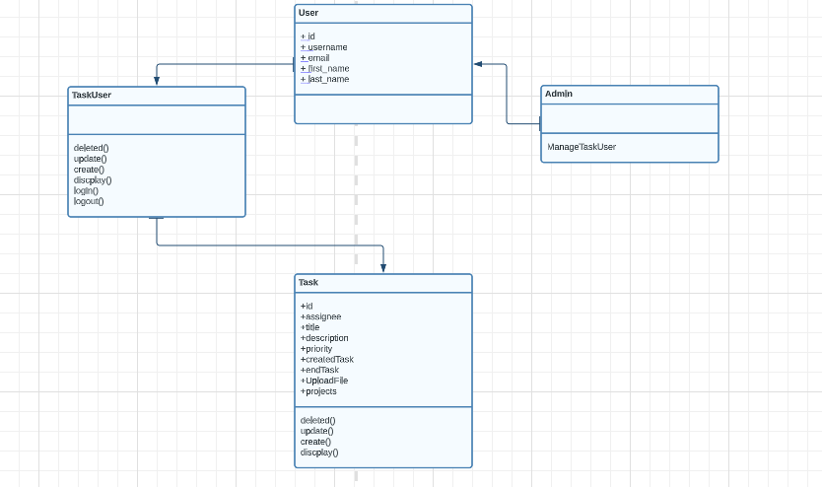

The following is how you can access my API because is hosted on