**INFORMATION SECURITY**

**LAB MIDTERM**

**Name**

**Syed Hamid Ali Shah**

**Reg no**

**Sp24-Bse-013**

**Submitted to**

**Maam Ambreen Gul**

**Date**

**20-10-2025**

**Question no 01**

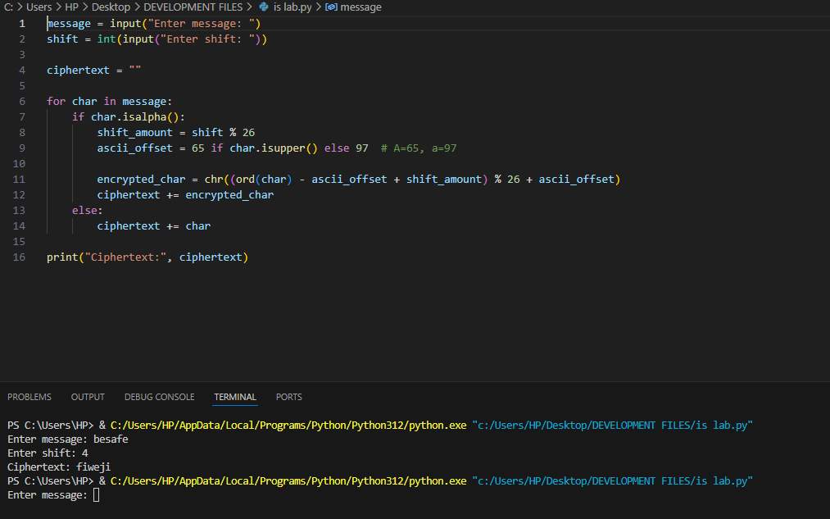

**Question02**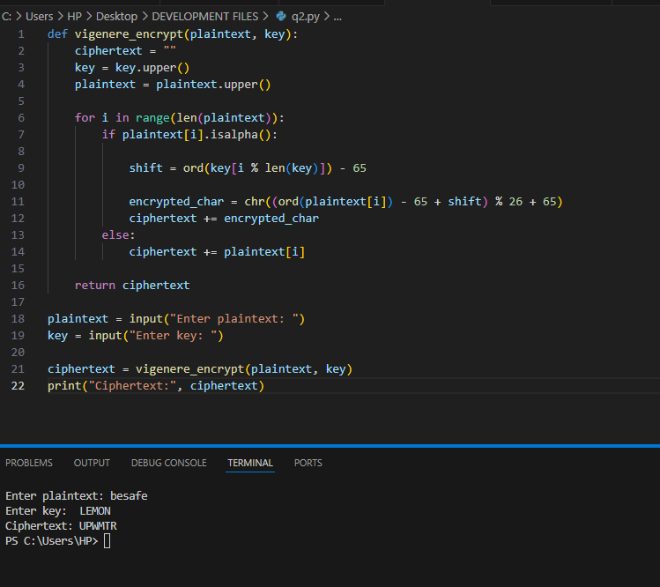

**Question no o3 part b**

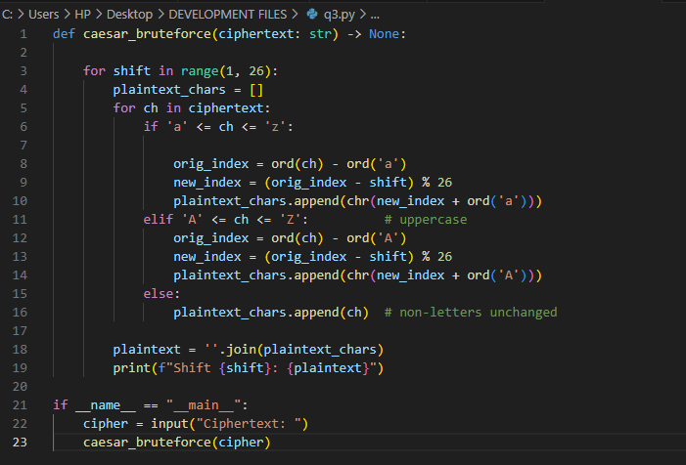

**Output**

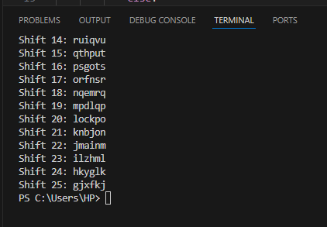

**Question no 04**

**a)** One difference between DES and AES:  
DES uses a **56-bit key**, while AES uses **128, 192, or 256-bit keys**.

**b)** AES block size and one key size:  
AES block size is **128 bits**, and one key size is **128 bits**.

**c)** One reason why AES is more secure than DES:  
AES has a **larger key size**, making it much harder to break by brute-force attacks.