**Source Code:**

**print_array.c**

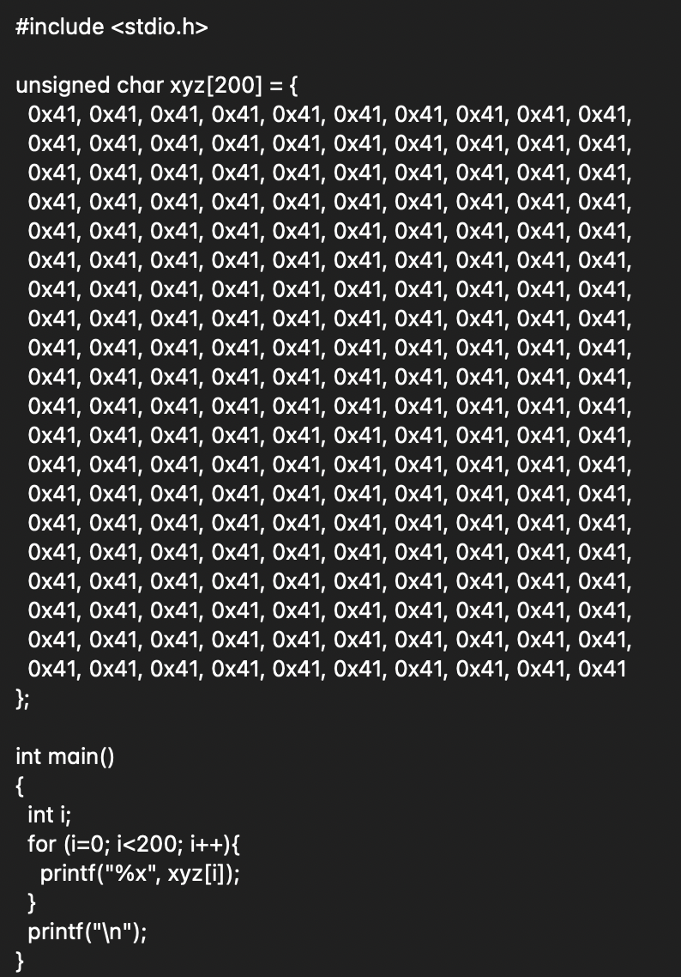

**benign_evil.c**

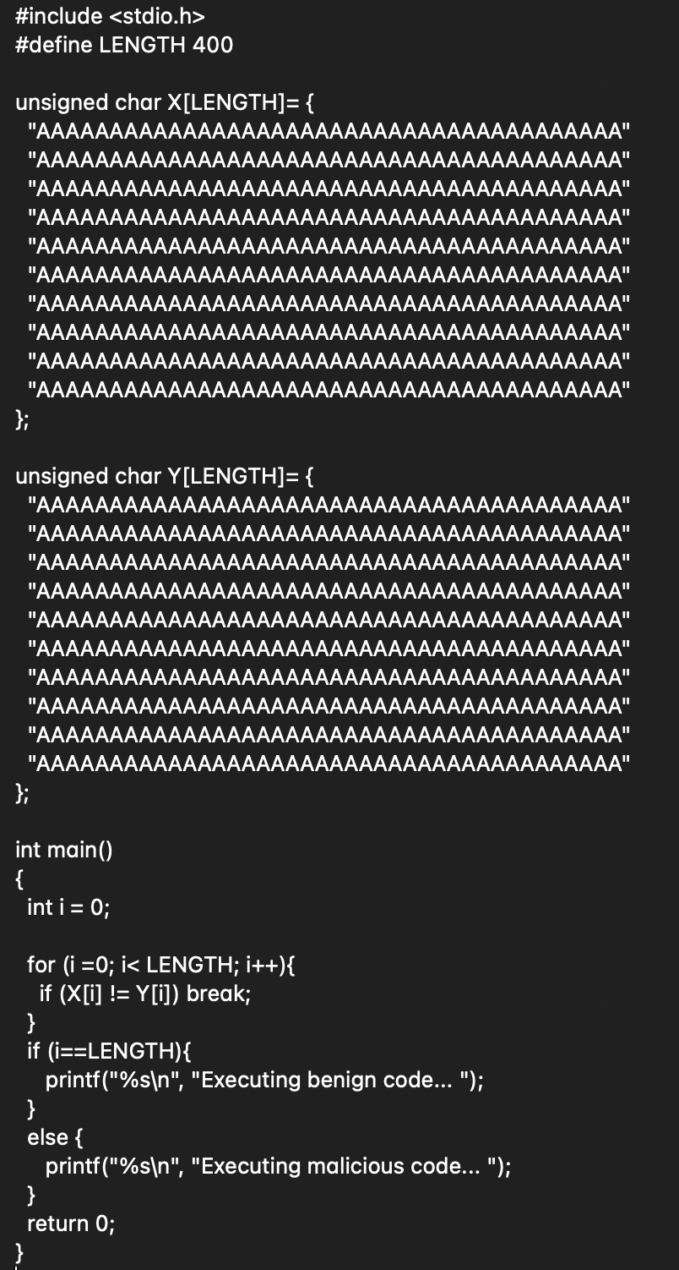

**find_nonce.c**

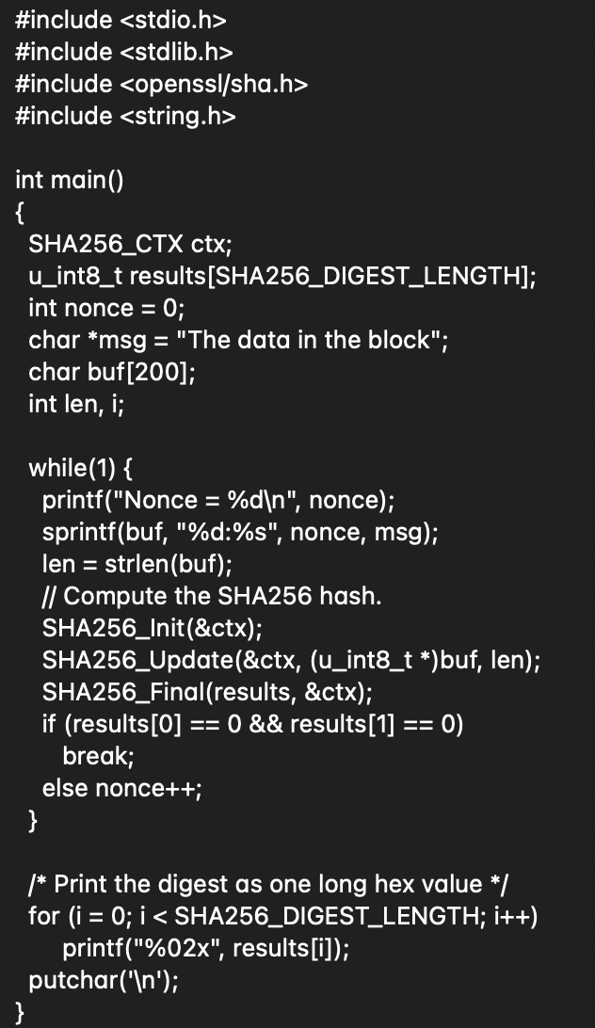

**LAB 9**

**MD5 Collision Attack Lab**

**Task 1: Generating Two Different Files with the Same MD5 Hash**

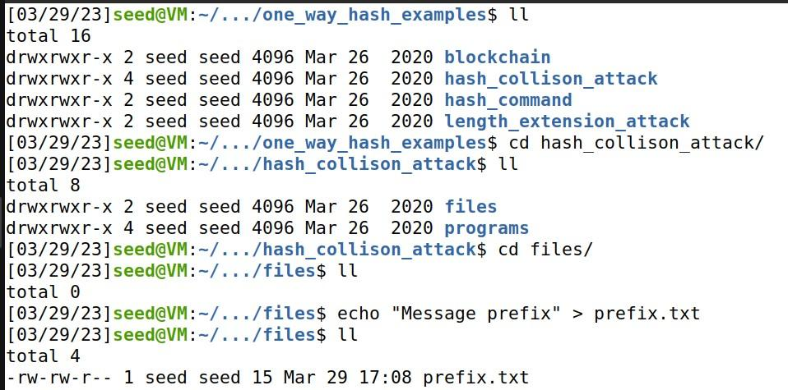

To generates two output files

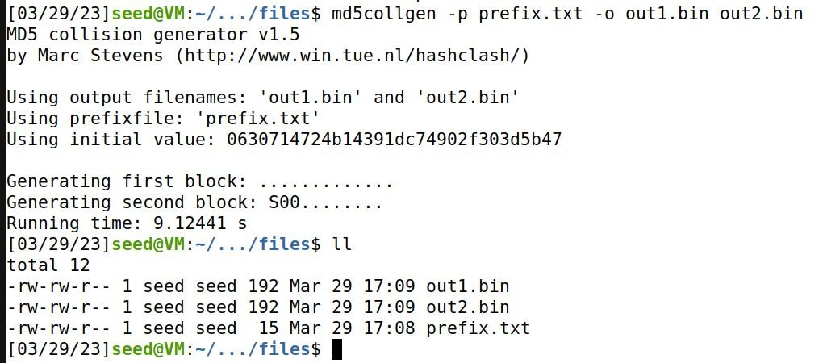

To check whether the output files are distinct or not using the diff command.

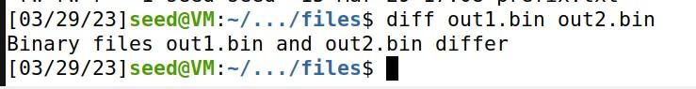

To check the MD5 hash of each output file.

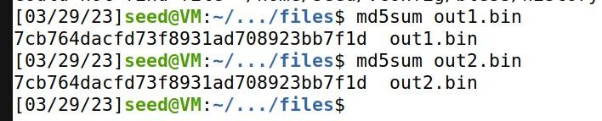

**Task 2: Understanding MD5’s Property**

To concatenates the contents of file2to the contents of file1, and places the result in file3.

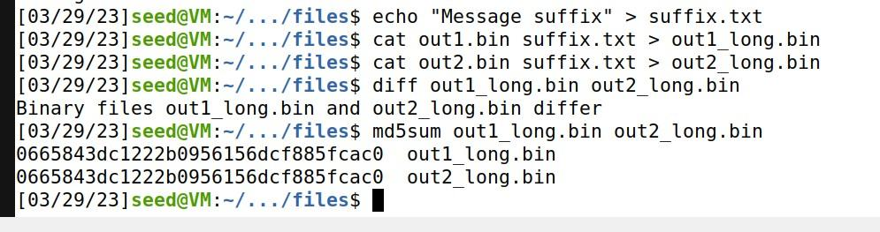

**Task 3: Generating Two Executable Files with the Same MD5 Hash**

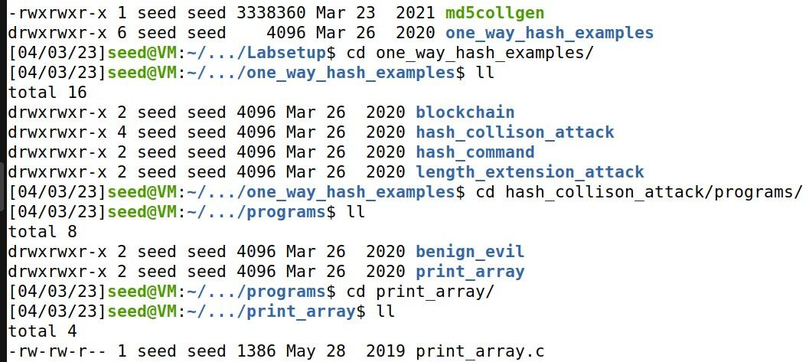

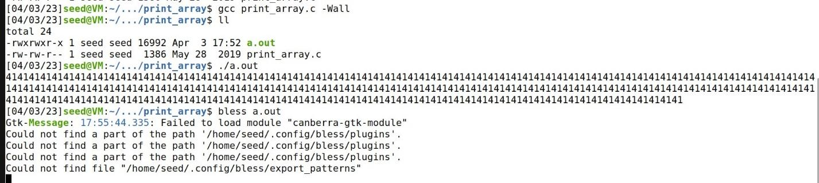

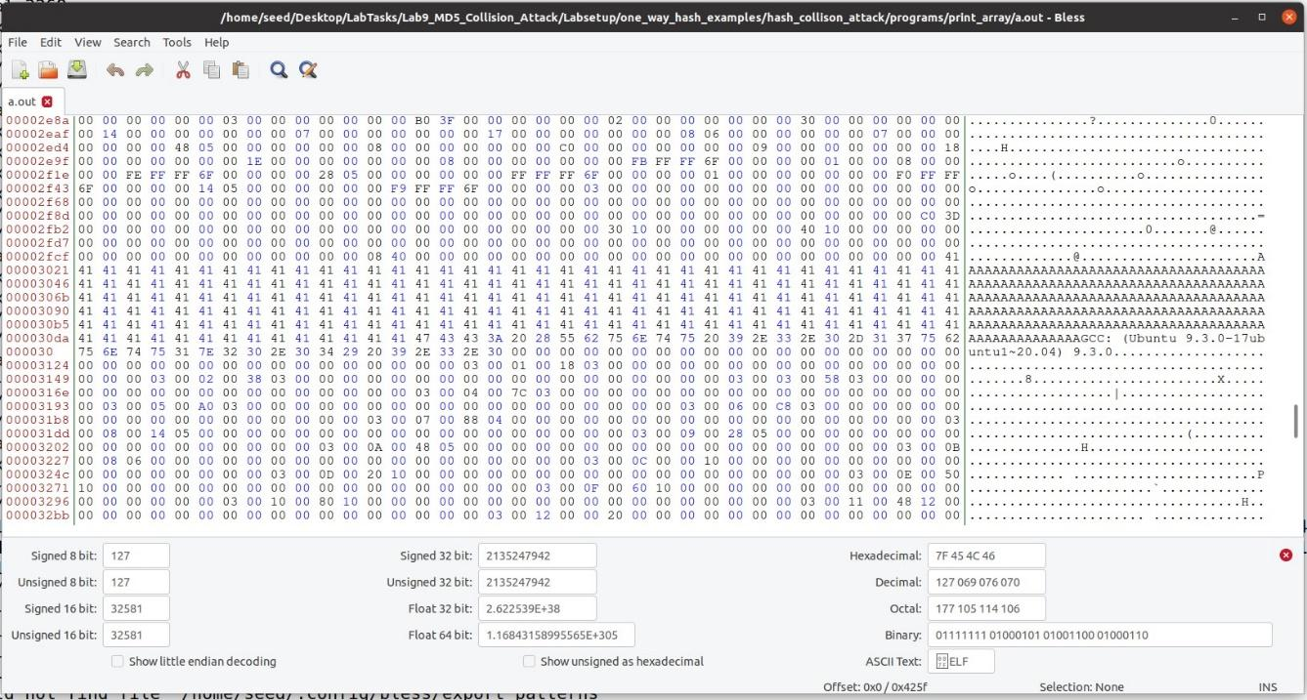

To get Prefix

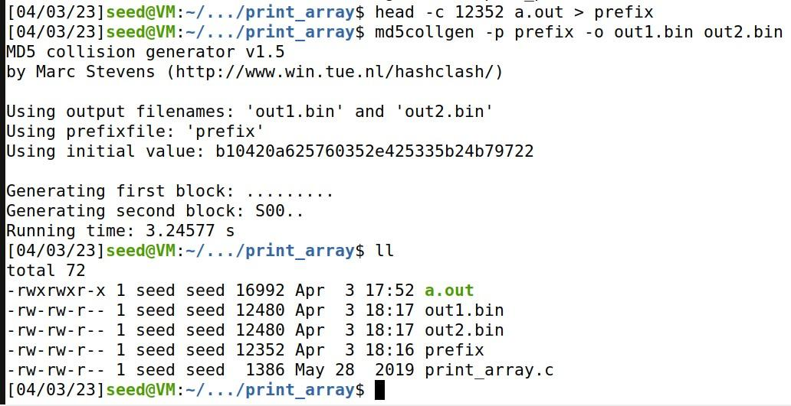

For Suffix and to compare:

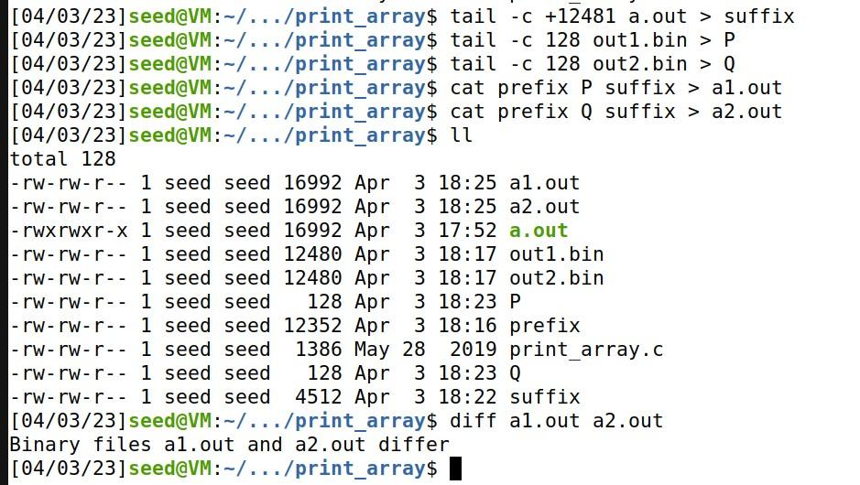

To print out what they each contain, we have:

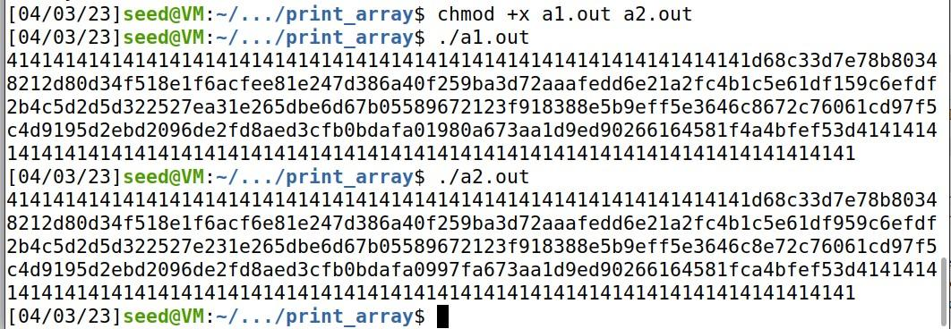

The final results shows they are identical

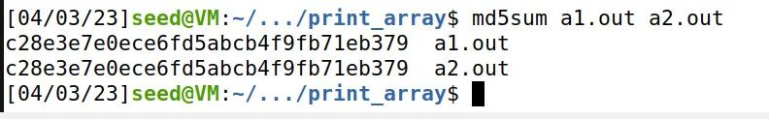

**Task 4: Making the Two Programs Behave Differently**

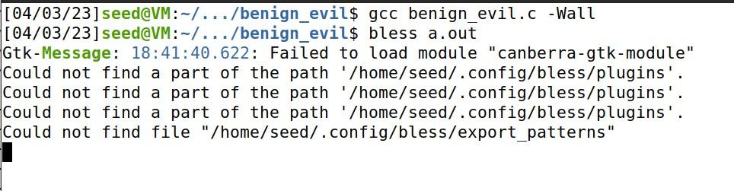

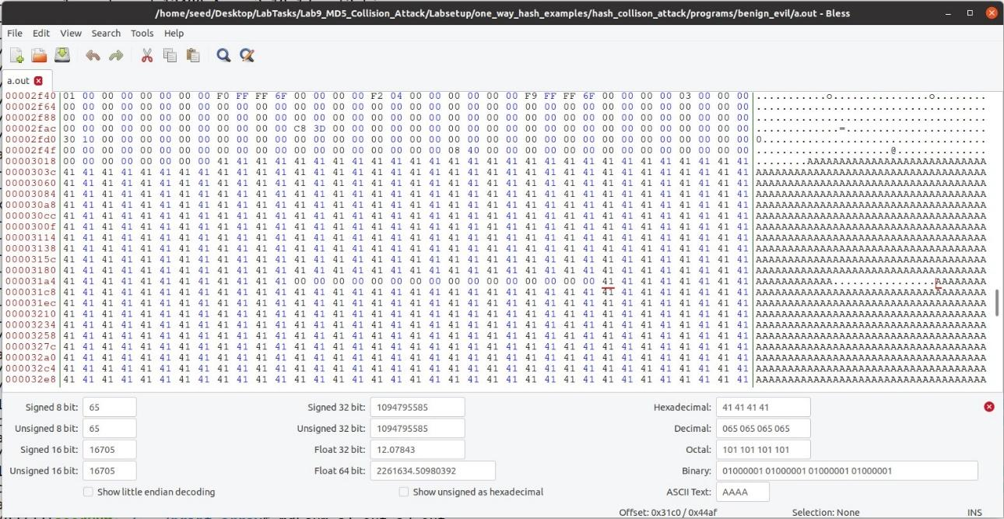

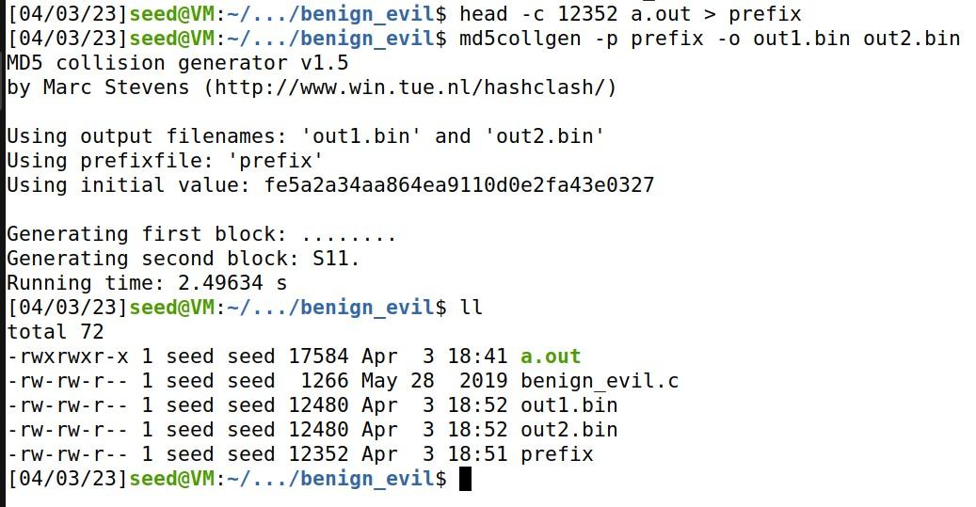

To compare:

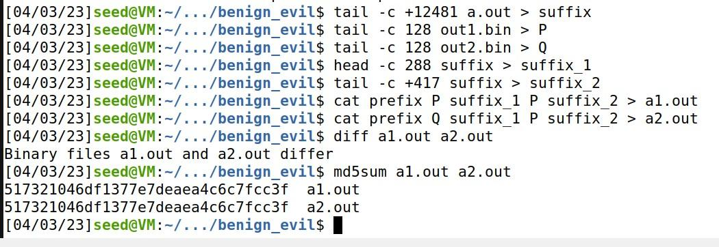

For final results, we have:

