Fundamentals of Drawing & Practice:
- Alternative Project: Object Characters Storyboard
- Artist (Solo): Ihita Pillutla
- Roll Number: SC25UCOM015

Obj Files (will upload in drive):
Object 1 - Sphere
Object 2 - Ring
Object 3 - Cube
Object 4 - Spear
Object 5 - Cylinder

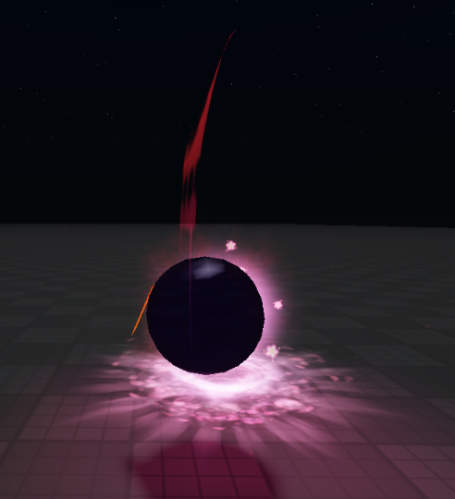
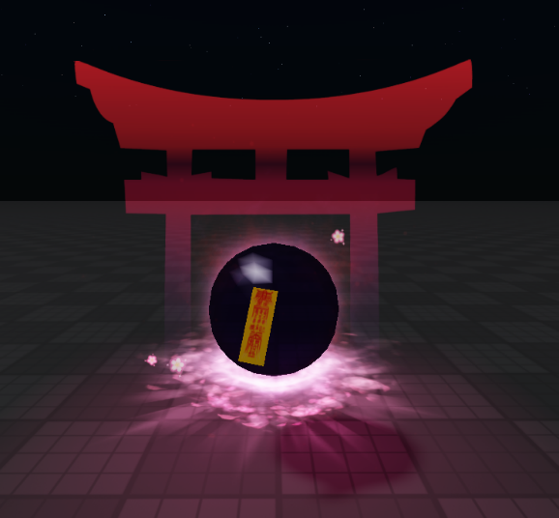
FRONT/BACK/SIDE VIEWS:
Object 1:

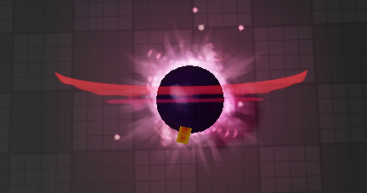

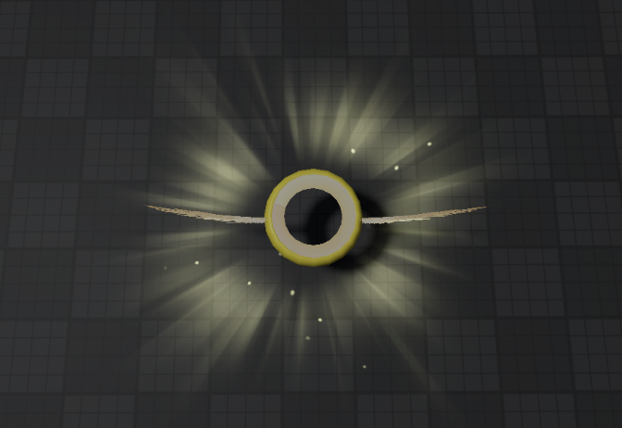
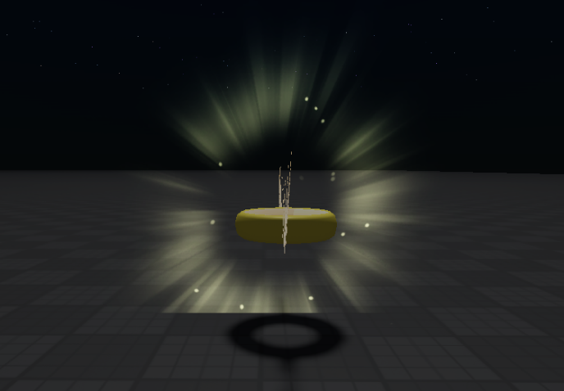
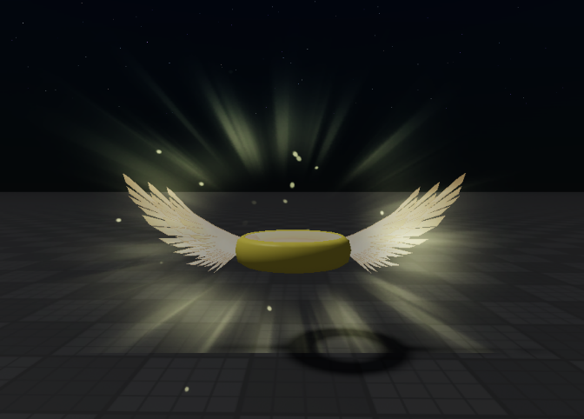
Object 2:

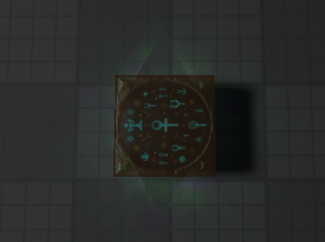
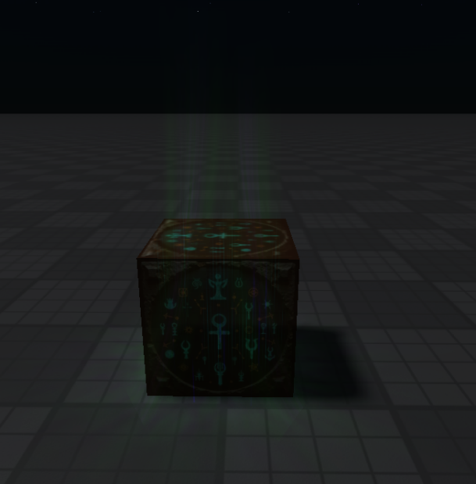
Object 3:

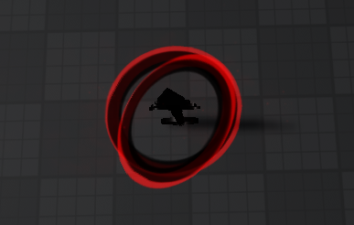
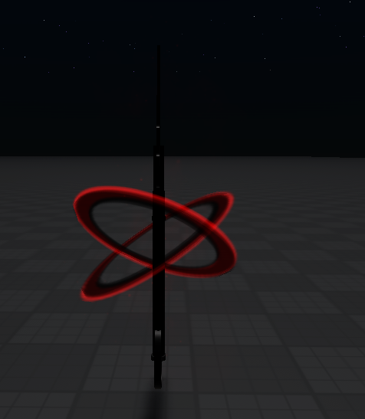
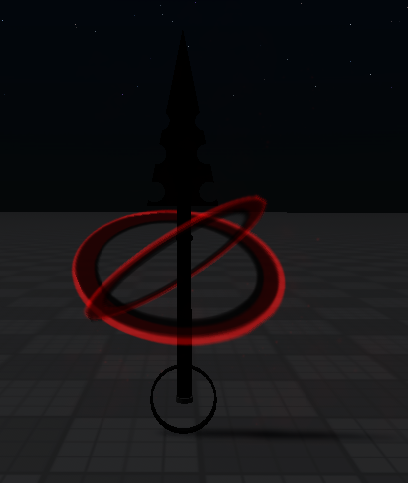
Object 4:

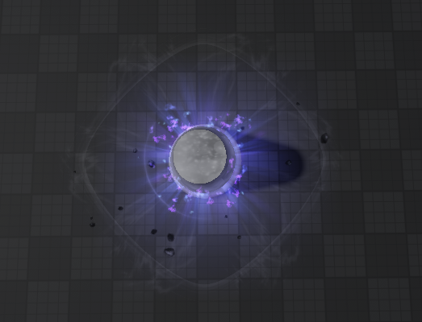
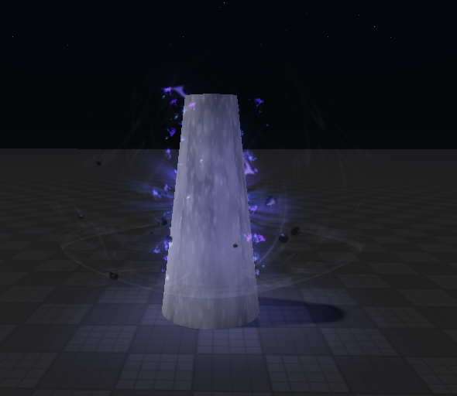
Object 5:
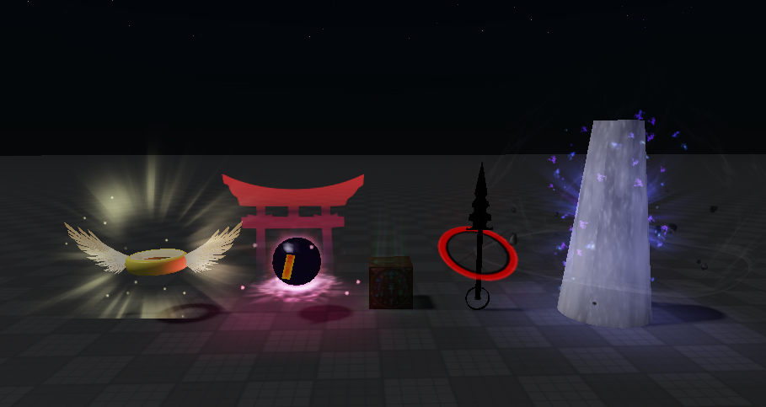
Object line-up:

OBJECT INTO CHARACTER:
- Sphere: A sealed shrine orb – “Kaizen”
- Ring: A heavenly halo – “Akane”
- Cube: A sealed curse box – “Sugu”
- Cone: A spearhead – “Bankai”
- Cylinder: A monolith – “Mao”

1-PARAGRAPH EXPLANATION:
In this project, I designed five unique 3D objects based on simple geometric forms and transformed them into anime-inspired relic characters. Each object uses at least one primitive and multiple operations, then evolves into a character with distinct abilities, themes, and visual effects. The final storyboard follows these five relics (Kaizen, Akane, Sugu, Bankai, and Mao) as they unite to seal a cosmic rift threatening their world. Instead of fighting each other, the characters combine their powers in a coordinated, cinematic sequence. The project explores shape language, effects design, character building, and storytelling inside Roblox Studio.

15-FRAME STORYBOARD

(in the drive link)

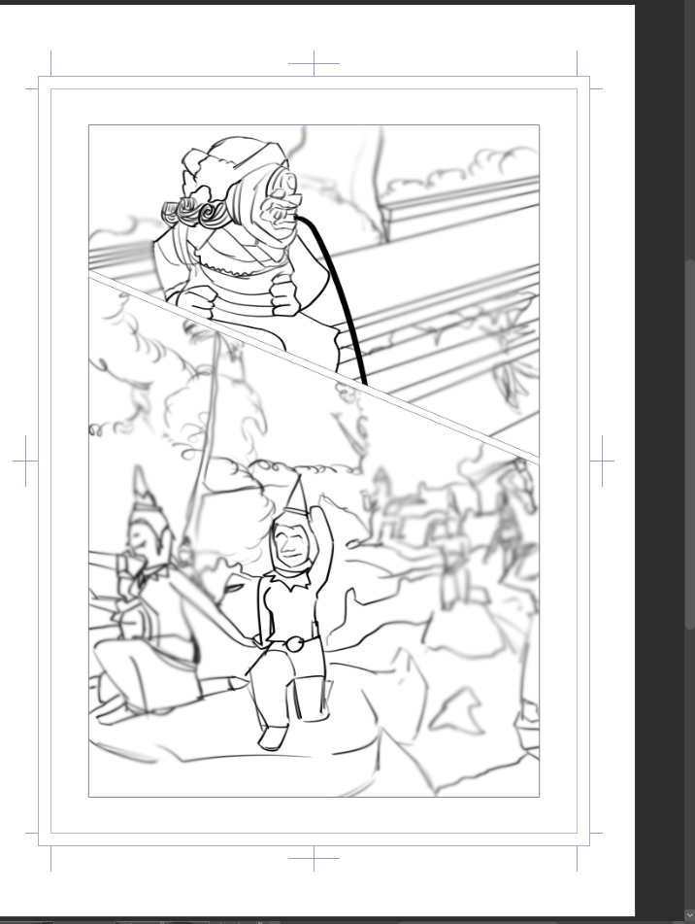
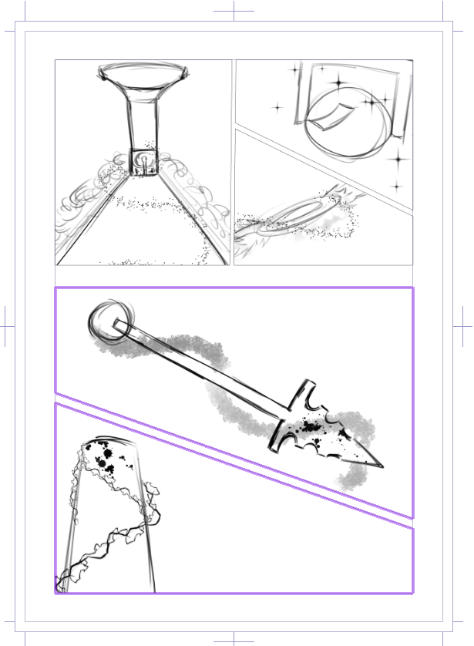
PROGRESS:

RELFECTION:
Working on this project taught me how much creativity can come from simple geometric shapes. By starting with basic primitives and then styling them with lighting, particles, and textures, I realized how much personality an object can hold before it even becomes a character. Designing the five relics helped me understand visual storytelling; especially how color, glow, and shape language communicate mood. The storyboard was my favorite part because it connected all the objects into a single narrative. Overall, this project pushed my imagination, improved my control over RStudio tools, and made me think more like a designer than a player.

