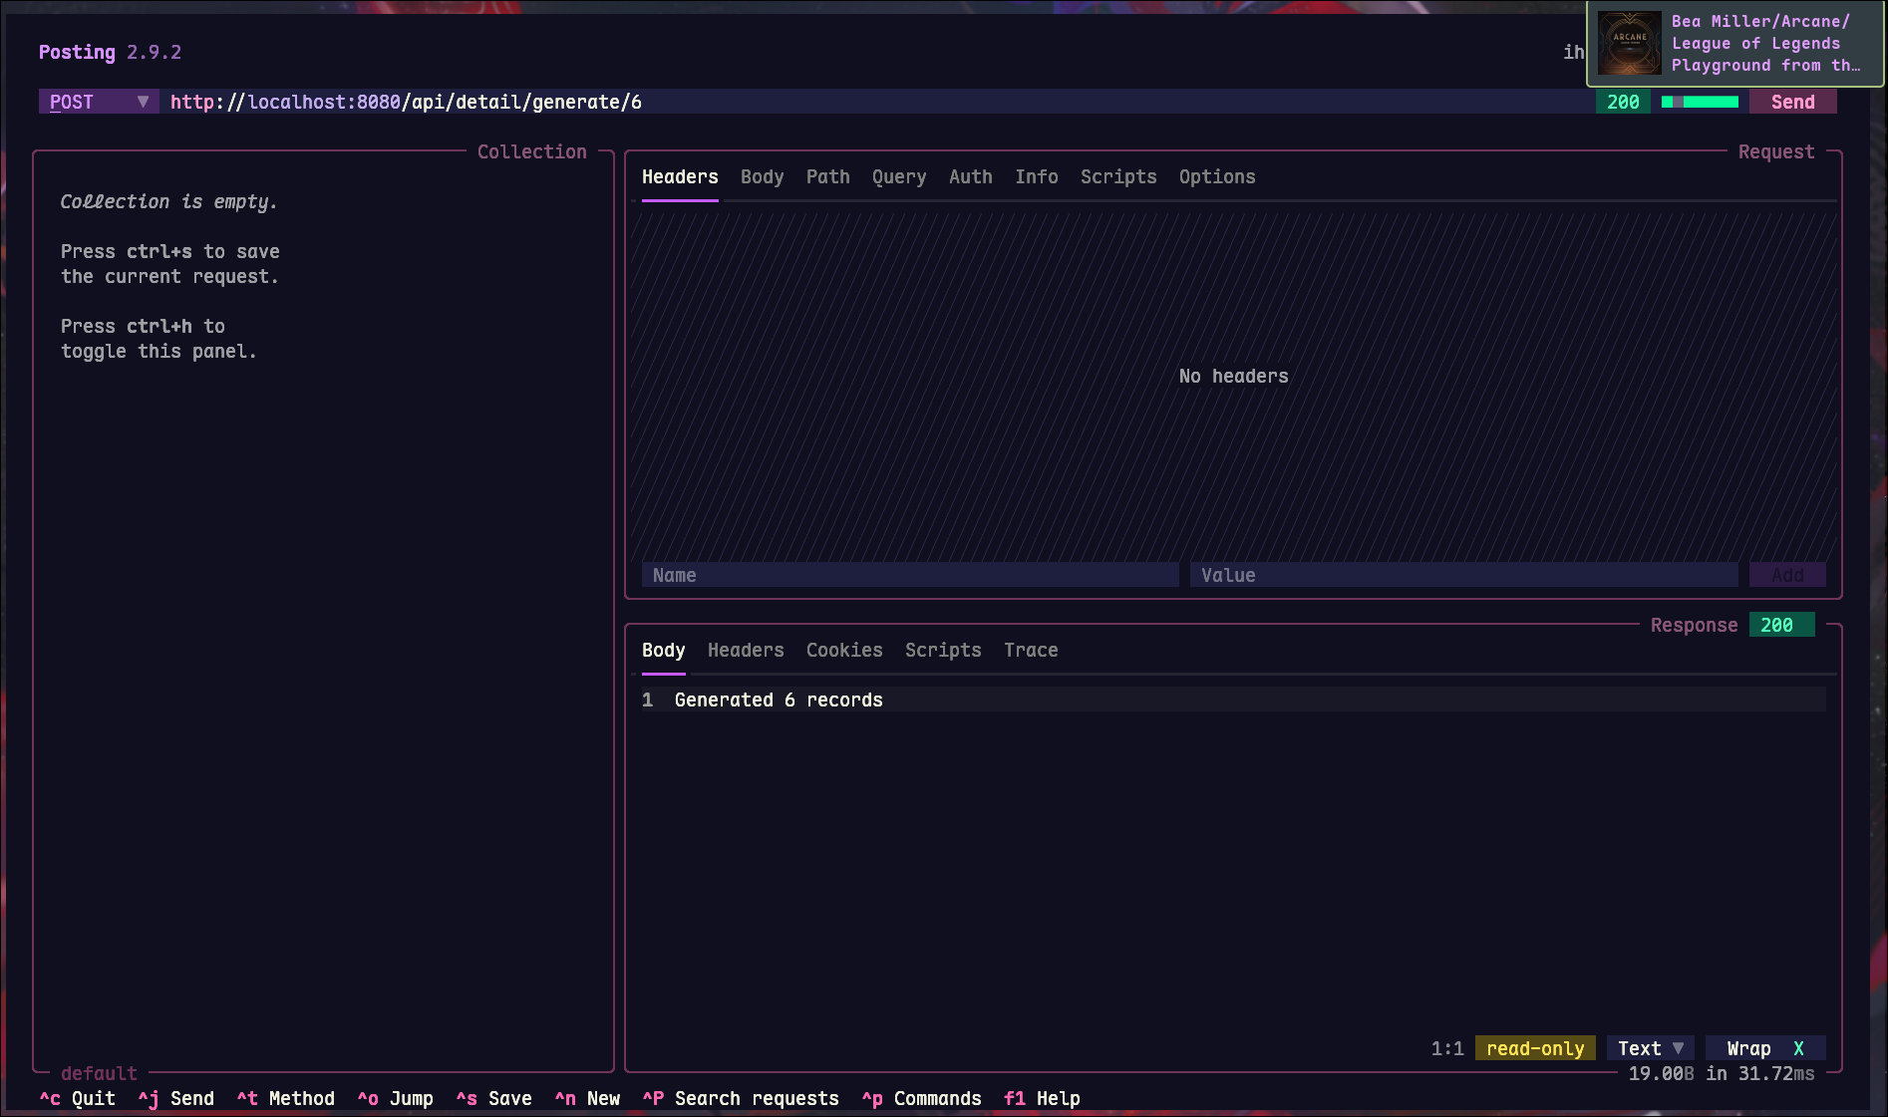
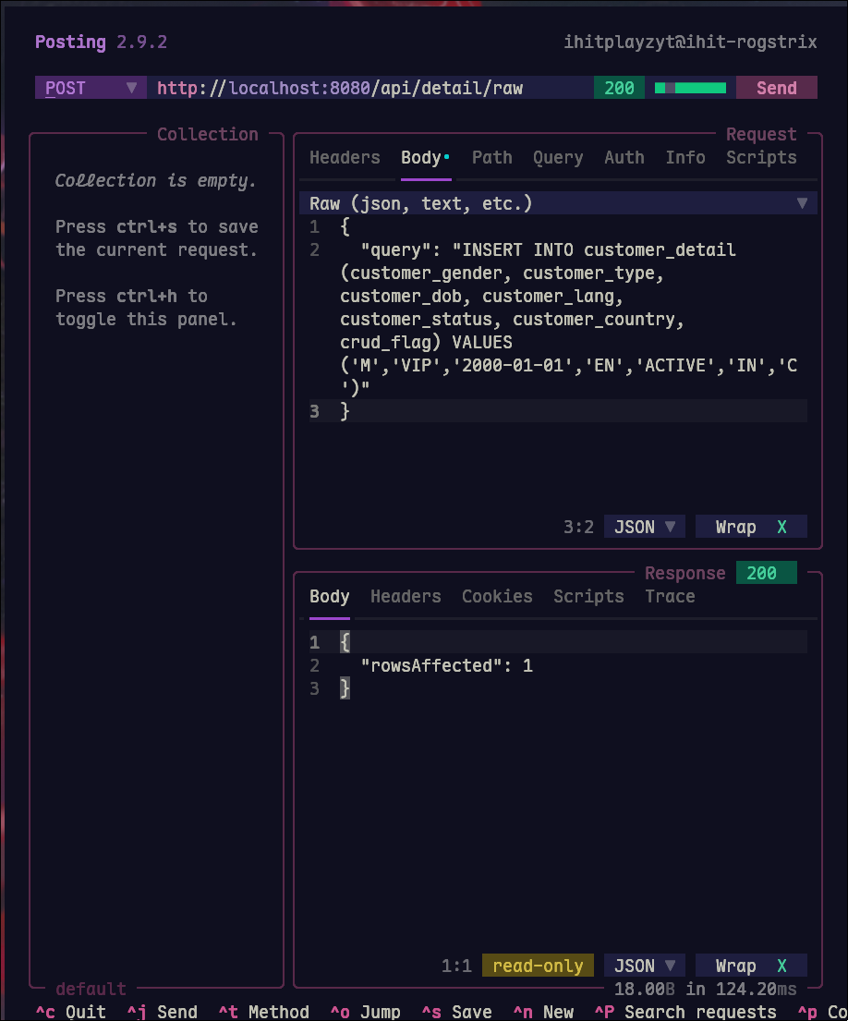
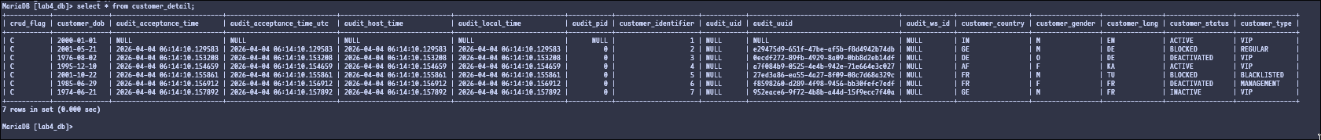

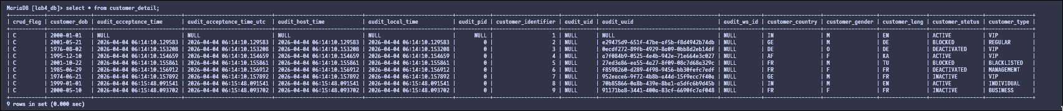
Name - Ihit R Acharya
Reg - 240958198
Roll - 48
Fintech - A

Fintech Lab - 9
Bulk customer generation

Customer generation using a raw query and random

Customer generation using a csv file

