# Use case diagram

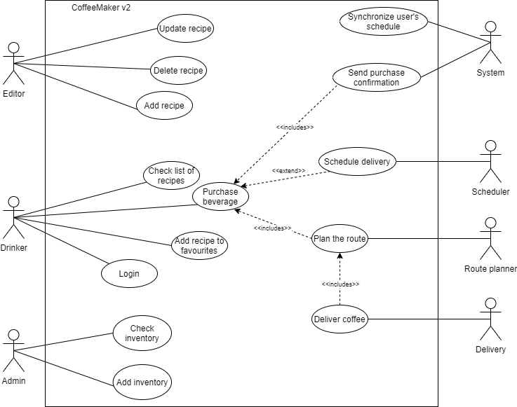

# Use case description

|  |  |  |
| --- | --- | --- |
| USE CASE 14 | Deliver coffee | |
| Goal in Context | After the beverage was purchased, drinker expects it to be delivered to him | |
| Scope & Level | Company, User Goal | |
| Preconditions | Drink is purchased, Route is planned | |
| Success End Condition | Drinker receives ordered coffee, customer is happy; we receive the money | |
| Failed End Condition | We have not sent the goods; Buyer has not spent the money.  Drinker did not receive ordered coffee, customer is sad; we did not receive the money. | |
| Primary,  Secondary Actors | Drinker  Delivery | |
| Trigger | Delivery request with a route comes in | |
| DESCRIPTION | Step | Action |
|  | 1 | Route planner send a delivery request |
|  | 2 | Delivery checks the route |
|  | 3 | Delivery send the unit to deliver the coffee |
|  | 4 | Drinker receives his coffee |
| EXTENSIONS | Step | Branching Action |
|  | 3a | If the delivery floor is higher than 0, then delivery sends the drone to deliver the coffee |
|  | 3b | If the delivery floor is 0 or lower, then delivery sends the robot to deliver the coffee |