TEAM PROJECT - Final Report 2026, Team 9, Computer Science
Inverse Kinematics Visualizer
Ihor Huz¹, Ihor Zhuravchak¹, Kuba Kałużniak¹, Hlib Bokatov¹, Moamen Salem¹, Anas Abdellatif¹

¹Lodz University of Technology, International Faculty of Engineering, Lodz, Poland
Supervisor: Natalia Walczak (e-mail: natalia.walczak.1@p.lodz.pl)

ABSTRACT This report documents the development of an interactive Inverse Kinematics (IK) Visualizer, a tool that lets users see and manipulate a simulated 6-joint robotic arm in real time, observing how different IK algorithms solve the problem of positioning the arm's end-effector. The system is built on a Godot Engine frontend connected to a Python math backend via UDP socket. Development passed through theoretical groundwork, a working 2D prototype, 3D scene assembly, and 3D solver for an unconstrained stick arm and
a constrained robotic arm. Performance evaluation was conducted by measuring per-step solve time and the number of frames required to reach several target positions. Results showed that FABRIK converges fastest but with the highest computational cost, Jacobian Damped Least Squares offers the lowest per-step cost but requires the most iterations, and CCD provides an intermediate trade-off consistent with the theoretical properties of each method.
KEYWORDS CCD, Damped Least Squares, FABRIK, Godot Engine, inverse kinematics, Jacobian matrix, Python, robotic arm simulation

I. INTRODUCTION
A. BACKGROUND
Inverse kinematics is the problem of finding joint angles that place a robot arm's endpoint at a desired position [1].
It appears in robotics, animation, and game engines anywhere a chain of connected segments must reach
a target [2]. Unlike forward kinematics, where you set angles and compute where the tip ends up, inverse kinematics works backwards: you know where you want the tip to be and must figure out how to get there. There is rarely a single clean solution, and the mathematics can become unstable near certain arm configurations called singularities [3]. In moving from continuous physical motion to digital simulation, these mathematical models often require simplification to balance computational efficiency with the fidelity of the control signals [4].
For students encountering this topic for the first time, the subject is notoriously difficult to grasp from equations alone. Our project builds a real-time, interactive visualizer to make the behavior of different algorithms visible and comparable [5, 6, 7, 8, 9].
B. PROBLEM STATEMENT
There is no widely available, interactive tool that lets
a student switch between IK algorithms on the same arm and observe the qualitative differences in how each one moves not just whether it reaches the target, but how. Textbooks describe these differences in theory; our tool aims to show them in practice.

II. IDEA FINDING
Before starting the implementation, the team studied the most common inverse kinematics methods. We focused on numerical approaches because they can be applied to a wide variety of robotic structures.
The main algorithms selected for the project were CCD (Cyclic Coordinate Descent), FABRIK (Forward and Backward Reaching Inverse Kinematics), and Jacobian Damped Least Squares (DLS). Each algorithm has different advantages and disadvantages. CCD is simple and reliable, FABRIK usually produces smooth movements, and Jacobian DLS can generate natural-looking motion when properly configured.
To make comparisons easier, we decided to implement all algorithms within the same application so users can observe the differences directly.
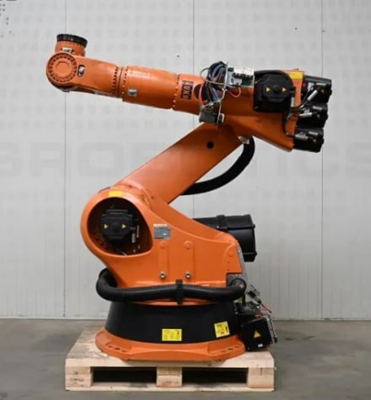

FIGURE 1. Six-degree-of-freedom KUKA robot – the base for the project model.
III. SOLUTION IMPLEMENTATION
The project consists of two main components. The first is a frontend built in Godot Engine 4.7 using GDScript, responsible for rendering the robotic arm, handling user input, and managing the camera. The second is a backend written in Python 3.13 that performs all inverse kinematics calculations using NumPy for vector and matrix operations and Python's standard socket, json, and math libraries. The arm models were created in Blender and exported as FBX files for import into Godot. The two components communicate through a UDP socket on port 5005 using JSON encoded messages, exchanging one request-response pair per frame. The overall architecture and data flow between the two components are shown in Figure 2.

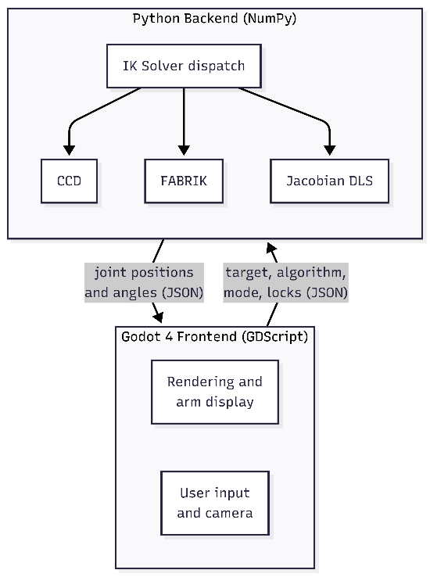
FIGURE 2. System architecture. The Godot frontend sends the target position, selected algorithm, render mode, and joint-lock state to the Python backend over a UDP socket. The backend runs the chosen solver and returns the computed joint positions and angles
Development was divided into several stages. During the first weeks, the team focused on learning the theoretical background of inverse kinematics, transformation matrices, and Jacobian methods. After that, the overall architecture of the application was designed.
The first successful implementation was a two-dimensional robotic arm controlled by a FABRIK solver (Figure 3). The arm consisted of several connected segments rendered in a 2D Godot scene; the user could drag a target point with the mouse, and the arm updated in real time to follow it. This early version validated the FABRIK algorithm on a simple chain and confirmed that the Godot-to-Python UDP communication was fast enough for frame-by-frame solving.

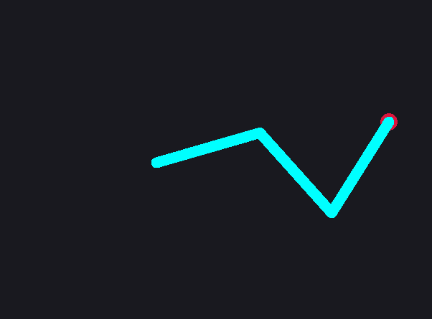
FIGURE 3. The initial 2D prototype – a multi-segment arm following a draggable target using the FABRIK solver.
After completing the 2D version, the team moved to a three-dimensional environment. A six degree of freedom robotic arm was assembled in Godot as a hierarchy of nodes, where each joint is a child of the previous one so that rotations propagate down the chain as they would on a physical arm. Each joint was assigned a fixed rotation axis and angle limits, and segment lengths were set to match the model. Manual joint controls were added so each joint could be rotated individually and the kinematics chain verified by hand.
One challenge that appeared during development was
the difference between an ideal mathematical model and
the actual constrained robotic arm used in the 3D scene. Some solutions generated by the algorithms were mathematically valid but could not be reproduced by the real arm configuration [10, 11].

The algorithms were connected to the 3D model one at a time. CCD was integrated first, as its joint-by-joint angle adjustment maps directly onto the constrained arm. The Jacobian DLS solver was next, using a damped least-squares step computed from the arm's Jacobian to move the end-effector toward the target. FABRIK was integrated last and required the most effort, since its position-based output had to be projected back onto the arm's valid joint axes. Each solver shares the same base - it receives the current joint state and target and returns updated joint angles - so the active algorithm can be switched at runtime through a dropdown menu.
IV. SYSTEM DESCRIPTION
The system is fully functional with all three inverse kinematics algorithms – CCD, FABRIK, and Jacobian Damped Least Squares – operating in real time on a DOF-constrained six-joint robotic arm. The Godot-Python communication layer, built on UDP with JSON-encoded messages, runs at interactive frame rates and maintains accumulated joint state across solver iterations.

The robotic arm is assembled in the Godot scene using a hierarchy of FBX models imported from Blender, each placed at the correct segment offset (Figure 4). Every joint respects its designated rotation axis (Y for the two yaw joints, Z for the four pitch joints) and its angle limits – unbounded yaw for J0 and J3, ±90° pitch for J1, J2, J4, and J5. The arm rest pose points upward along the Y axis, and all joint angles are accumulated and wrapped frame-to-frame to prevent unbounded drift.
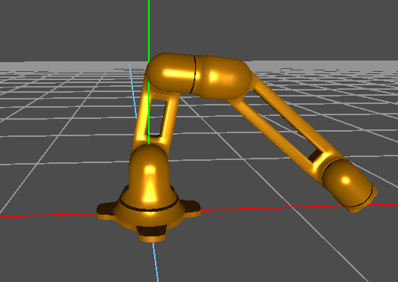
FIGURE 4. The six-joint robotic arm assembled in Godot from imported FBX models

The CCD solver and the Jacobian DLS solver both operate in joint space and share a common architecture: each iteration computes a per-joint adjustment in the parent-local frame, applies angle clamping, and performs a full forward-kinematics pass to update the arm's position. A singularity-safe angle extraction formula using R_parent_T transformation ensures that the solver and FK chain remain consistent.

The FABRIK solver follows a different approach. Because pure FABRIK operates on positions rather than angles, the solver runs an unconstrained 3D FABRIK pass and then projects the resulting positions onto the vertical plane defined by the base yaw joint. One-DOF joint angles are extracted from the projected positions, clamped to their limits, and passed through FK to produce the final arm configuration. Eight such pass-and-project iterations per frame provide convergence in roughly seven frames, though the approach trades per-step cost for speed.

Several interactive features have been added beyond the core solvers:
- Motion trail: pressing T toggles a cyan gradient trail that traces the last 300 endpoint positions, making convergence paths visible.
- Joint locking: individual joints can be frozen by selecting them with the 1–6 keys and pressing L. Locked joints are skipped by all three solvers – CCD and Jacobian zero out their contributions, FABRIK restores their previous angles after each pass. This lets users observe how the arm adapts when specific degrees of freedom are removed.
- Manual joint override: selecting a joint with the 1–6 keys enters manual mode, where Q and W adjust the joint angle directly. Pressing R returns control to the IK solver.
- Stick arm mode: pressing V switches between the FBX-rendered robot arm and a skeleton-style stick arm, allowing users to inspect the underlying joint positions without visual clutter.
- Height control: the Up and Down arrow keys raise and lower the target sphere smoothly for three-dimensional reach tests.
A sidebar menu provides algorithm selection via a dropdown and displays the current mode, selected joint, and lock status.
Communication uses UDP on port 5005 with one request-response cycle per frame. The Godot frontend sends the target position, the selected algorithm identifier, the render mode, and the joint lock state. The Python server responds with the computed joint positions and angles. An out-of-reach guard clamps the target to within the arm's maximum reach, and a dedicated singularity handler for the Jacobian solver resets accumulated angles to the neutral vertical pose when the target is unreachable, preventing joint-velocity divergence.

The codebase is organized into a shared math engine with separate solver modules for the constrained robot arm and the unconstrained stick arm, and a Godot project containing the scene, the main bridge script, and the FBX model files.
V. EVALUATION AND RESULTS
To compare the three solvers quantitatively, each was measured on an identical workload. A standalone benchmark client sent the same set of six fixed target positions - covering near, mid, far, high, and low points in the workspace - to the running server, repeating each target 200 times, with initial warm-up samples discarded. Per-step solve time was recorded by a timer placed around the solver call in the Python server, while the number of frames needed to converge was measured separately in Godot by counting the one-iteration messages required for the end-effector to reach the target. Because the system performs one solver iteration per message, solve time is the cost of a single step, while frames to converge is how many steps are needed to reach the target.

TABLE 1. Average solver performance over the benchmark workload.
Algorithm | Solve avg (ms) | Solve Median (ms) | Solve P95 (ms) | Solve max (ms) | Frames to Converge
CCD | 0.732 | 0.945 | 1.221 | 2.557 | ~22
FABRIK | 3.730 | 4.705 | 5.907 | 12.046 | ~7
Jacobian  (DLS) | 0.272 | 0.261 | 0.728 | 1.609 | ~70

The results align with the theoretical characteristics of each method [12, 13, 14]. FABRIK is the most expensive per message - averaging 3.73 ms against under 1 ms for the other two - which is exactly what we'd expect, since robot FABRIK runs an 8 iteration loop with up to 20 inner passes inside every single message. It recovers this cost through convergence speed, reaching the target in roughly seven frames. Jacobian DLS shows the opposite trade-off: its per-step math is the cheapest of the three (median 0.261 ms), but its small step size means it approaches the target gradually, taking around 70 frames to converge. CCD is the balanced middle option. Its average solve time (0.732 ms) sits between the other two, it converges in about 22 frames - between FABRIK's 7 and Jacobian's 70. For an interactive teaching tool, predictability is an advantage. These average trade-offs are summarized in Figure 5.
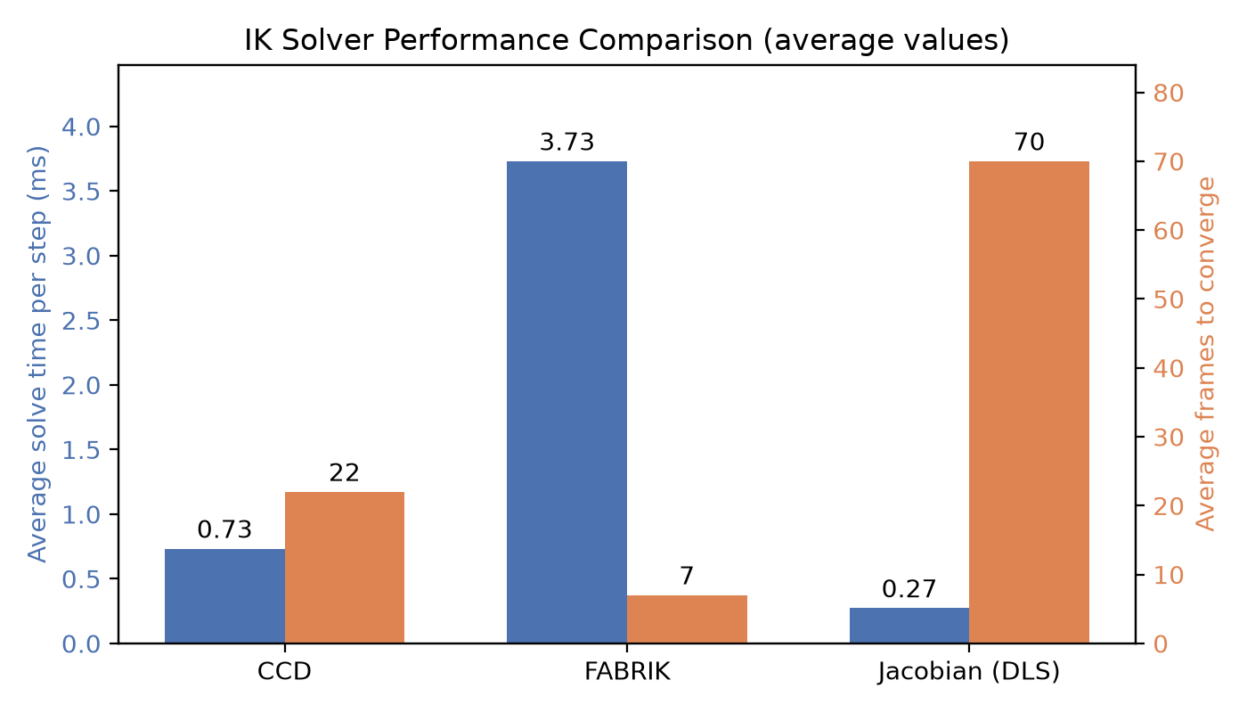FIGURE 5. Average per-step solve time (ms) versus average frames to converge for each solver. CCD is balanced, Jacobian is cheapest per step but slowest to converge, and FABRIK converges fastest but at the highest per-step cost.
VI. LIMITATIONS AND FUTURE WORK
Several features remain for future work. A DOF axis visualization mode – three-dimensional arrows at each joint showing its rotation axis – has been designed but not yet implemented. A side-by-side comparison view that runs all three algorithms simultaneously on separate arms would further strengthen the educational value. The FABRIK solver, while functional, converges to a target more slowly and less consistently than CCD or Jacobian in certain workspace regions; further refinement of its plane-projection step is ongoing.
VII. CONCLUSIONS AND PERSPECTIVES
The project has delivered a functional interactive inverse kinematics visualizer. All three algorithms – CCD, FABRIK, and Jacobian Damped Least Squares – operate in real time on a DOF-constrained six-joint robotic arm, and users can switch between them, freeze individual joints, trace convergence paths, and manually override joint angles through the Godot interface. By providing an interactive platform, the tool aligns with research emphasizing that virtual simulation environments are essential for teaching complex robotics concepts [5, 6, 7] and fostering computational thinking in educational settings [8, 9]. The two-process architecture proved effective: Python handles the mathematical core independently of Godot's rendering layer, making the solvers straightforward to develop, debug, and compare.
The evaluation in Section V confirmed that the three solvers exhibit distinct, theory-consistent trade-offs: FABRIK provides rapid, singularity-free convergence [12], CCD offers a computationally light but sometimes oscillatory approach [13], and Jacobian Damped Least Squares provides mathematically robust solutions, particularly useful for navigating the singularities that often complicate 6-DOF manipulation [3, 10, 11, 14]. These differences are observable interactively within a single application – the primary educational goal of the project, which mirrors industrial and academic efforts to bridge the gap between abstract kinematic theory and practical robotic implementation [1, 2, 4]. The project has provided practical experience in robotics mathematics, real-time system design, and cross-platform software integration. The resulting tool is ready for classroom use in its current form and offers a clear foundation for the improvements outlined above.
APPENDIX
GitHub Repository: https://github.com/IhorHuz/IK-Visualizer-Team9.git
ACKNOWLEDGMENT
The team would like to sincerely thank our project supervisor for the guidance, support, and valuable feedback provided throughout the development of this project. Their advice helped us solve technical challenges and improve the quality of our work.

We would also like to thank all members of the team for their commitment, cooperation, and continuous effort during
the semester. This project would not have been possible without the contributions, teamwork, and dedication of every team member.
REFERENCES
- Ali, Mohammed M.; Liu, Hui; Stoll, Norbert; Thurow, Kerstin (2016). "Kinematic Analysis of 6-DOF Arms for H20 Mobile Robots and Labware Manipulation for Transportation in Life Science Labs". Journal of Automation, Mobile Robotics & Intelligent Systems. https://doi.org/10.14313/jamris_4-2016/30
- Qiu, Xingyu (2024). "Forward Kinematic and Inverse Kinematic Analysis of A 3-DOF RRR Manipulator". Advances in Engineering Research. https://doi.org/10.2991/978-94-6463-518-8_50
- Asgari, Milad; Bonev, Ilian A.; Gosselin, Clément (2024). "Singularity Analysis of Kinova’s Link 6 Robot Arm via Grassmann Line Geometry". 2024 IEEE International Conference on Robotics and Automation (ICRA). https://doi.org/10.1109/icra57147.2024.10610252
- Giordano, Jacopo (2024). "Robotic Manipulation in Space". University of Padova. https://research.unipd.it/retrieve/6751e48a-82c6-4b6d-8132-50a38f9a61c8/tesi_definitiva_Jacopo_Giordano.pdf
- Brito, Thadeu; Lima, José; Braun, João (2020). "A DOBOT Manipulator Simulation Environment for Teaching Aim with Forward and Inverse Kinematics". Lecture Notes in Electrical Engineering. https://doi.org/10.1007/978-3-030-58653-9_29
- Arenas-Rosales, Filemon et al. (2023). "Virtual UR5 Robot for Online Learning of Inverse Kinematics". Robotics. https://doi.org/10.3390/robotics12010023
- Xu, Xiao et al. (2018). "Robotic Kinematics Teaching System with Virtual Reality, Remote Control and On-Site Laboratory". International Journal of Mechanical Engineering Education. https://doi.org/10.1177/0306419018807376
- Benitti, Fabiane Barreto Vavassori (2012). "Exploring the Educational Potential of Robotics in Schools: A Systematic Review". Computers & Education. https://doi.org/10.1016/j.compedu.2011.10.006
- Glezou, Katerina V. (2021). "Robotics as a Powerful Vehicle Toward Learning and Computational Thinking in Secondary Education". IGI Global. https://doi.org/10.4018/978-1-7998-6717-3.ch001
- Donelan, Peter. (2010). “Kinematic Singularities of Robot Manipulators”. Advances in Robot Manipulators. https://doi.org/10.5772/9548
- Villalobos, Jessica; Sanchez, Irma Y.; Martell, Fernando (2022). “Singularity Analysis and Complete Methods to Compute the Inverse Kinematics for a 6-DOF UR/TM-Type Robot”. Robotics. https://doi.org/10.3390/robotics11060137
- Aristidou, A., & Lasenby, J. (2011). “FABRIK: A fast, iterative solver for the Inverse Kinematics problem.” Graphical Models. https://doi.org/10.1016/j.gmod.2011.05.003
- Olsen, A. L., & Petersen, H. G. (2010). “Inverse kinematics by numerical and analytical cyclic coordinate descent.” Robotica. https://doi.org/10.1017/s026357471000038x
- Buss, Samuel. (2004). “Introduction to inverse kinematics with Jacobian transpose, pseudoinverse and damped least squares methods”. IEEE Transactions in Robotics and Automation.

