**Prerequisites:**

Generated 1000 text posts.

**Description:**

1. Define low load based on the results from Task 7.
2. Perform long-time testing.
3. Gather all needed metrics.
4. Calculate KPI.
5. Try to identify any issues based on the results.
6. Prepare detailed report.

The number of the posts: 1000

**User role:**  
                admin  
                editor  
                anonymous

**Goals:**

* Get an experience on durable/longevity/stability testing.
* Get an experience on load parameters definition for the long-time testing.
* Learning how to identify bottlenecks and possible issues for long-time running systems.

**Defining low load:**

In script from 7 task thread groups with different scenarios were used. Workload of this script was 200 users for anonymous scenario, and 2 users for editor and admin scenarios separately. (Algorithms of their actions are mentioned in the end of file) Ramp up and duration was 600 ms for all script.

After performing capacity test was found, that from approximately 05:10 system starts behaving not stable, CPU starts growing till 100% and don`t get down till the end of test. Also errors start occurring. Amount of transaction falling, and response time starts growing. So, capacity of the system with mentioned workload model and workload profile is 104 users.

For performing low load test was decided to use such workload model:

* number of threads: 30 anonymous + 2 admins + 2 editors;
* ramp up: 90000 ms(3 second for connecting for each user);
* duration: 21600000 ms (6 hours).

Such duration was chosen because less time could not bring actual results regarding stability of the system. So, test should have been long and such amount of time satisfies such condition.

**Results:**

From results below we can see, that system works stable till 03:42:00. CPU did not get overloaded, throughput was also stable since all users started using the site. Issues occurs, but just couple on almost 4 hours of test. At approximately 03:42:00 system fell, response time was increased in several times, a lot of issue started occurring, CPU reached 100 % and didn`t get down a lot till 04:26:00. At approximately 04:26:00 system started recovery and in 15 minutes fully got stabilized. During these 15 minutes throughput was jumping from 7 to 23 tps, but then got normalized, CPU also fell till average 20-50 % load, issue stopped occurring a lot.

So, as already mentioned system can be used by 34 users with different roles for more than 3:30 hours. Also we can say, that system can recover in 44 minutes and work stable, but with some losses in performance.

|  |  |  |  |
| --- | --- | --- | --- |
|  | Period of stability 00:00:00-03:42:00 | Period of down 03:42:00-04:26:00 | Period of recovery 04:26:00-06:00:00 |
| Throughput | 13-15 tps | 8-10 tps | 13-15 tps; up to 23 tps |
| Response time | <100 ms - first half, 300-400 ms - second half | >1000 ms, up to 7300 ms | <200 ms, up to 400 ms |
| CPU | 20-40% load; up to 100%; | 95-100% | 20-50% load, up to 100% |
| Memory | 75-88% | 70-86% | 81-87% |
| Test issues | 0.04% | | |

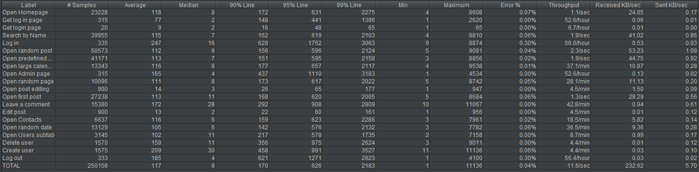

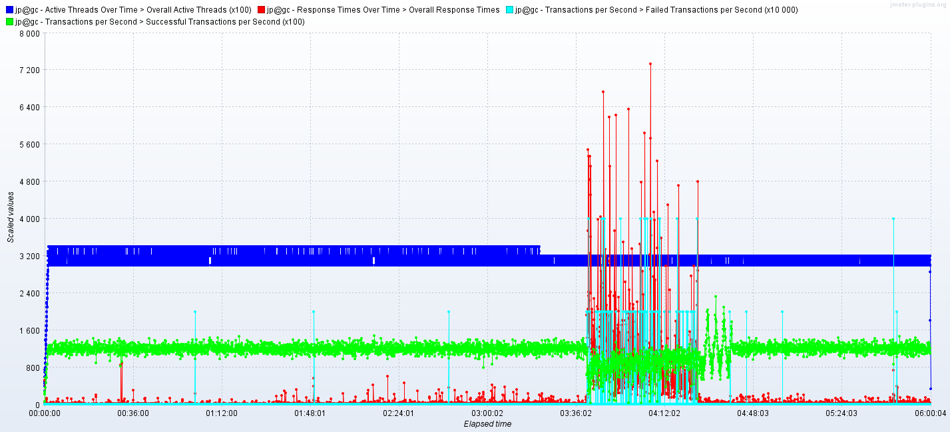

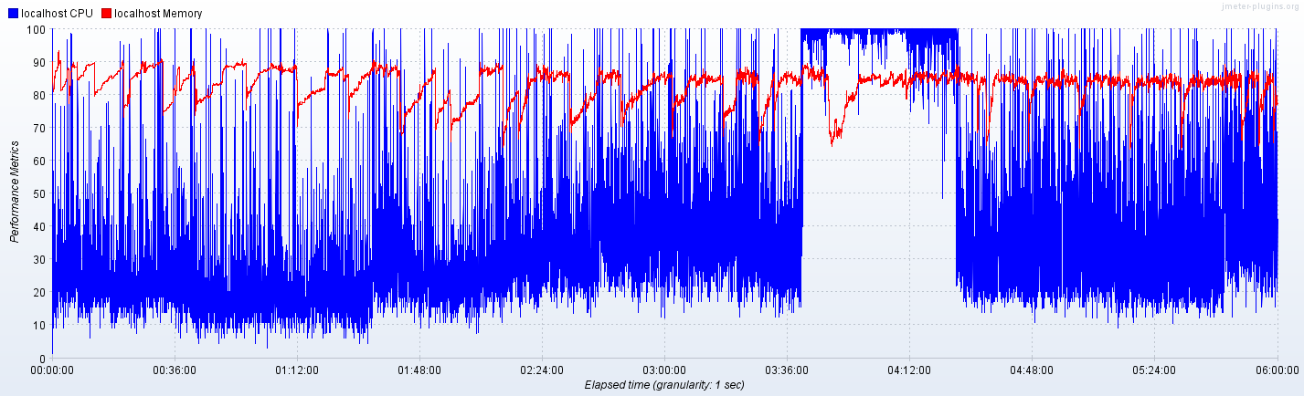

**Scenarios:**

**Anonymous scenario:**

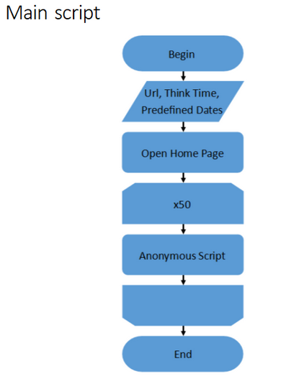

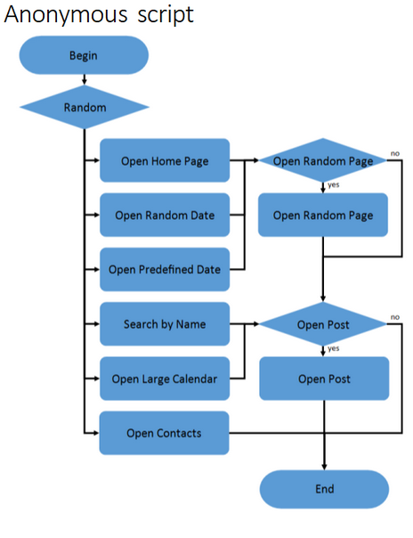

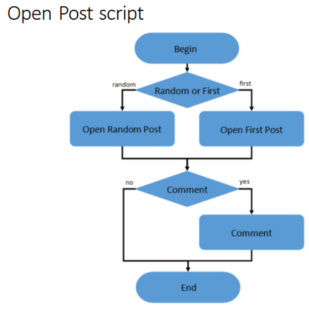

**Admin scenario:**

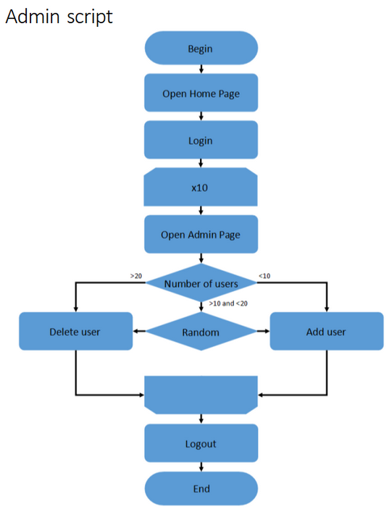

**Editor scenario:**

